Supplementary Materials
Millennial-scale land-surface temperature and soil moisture reconstruction derived from Last Glacial European loess sequences
Charlotte Prud’homme^{1,2*}, Peter Fischer³, Olaf Jöris⁴, Sergey Gromov⁵, Mathias Vinnepand³, Christine Hatté⁶, Hubert Vonhof⁷, Olivier Moine⁸, Andreas Vött³, Kathryn E. Fitzsimmons^{1,9}
*Corresponding author: charlotte.prudhomme@unil.ch

This pdf file contains Supplementary Figures 1 to 4 and Supplementary Tables 1 to 2 with the following titles :

Supplementary Fig. 1: Stratigraphy and oxygen and carbon isotope composition of earthworm calcite granules from Schwalbenberg profile RP1.

Supplementary Fig. 2: Stratigraphy and oxygen and carbon isotope composition of earthworm calcite granules from Nussloch profile P8.

Supplementary Fig. 3: Seasonal wind regime and precipitation statistics obtained for present day and LGM conditions at the Schwalbenberg site.

Supplementary Fig. 4: Seasonal wind regime and precipitation statistics obtained for present day and LGM conditions at the Nussloch site.

Supplementary Table 1: Radiocarbon dating from earthworm calcite granules for Schwalbenberg and Nussloch profiles.

Supplementary Table 2: Schwalbenberg RP1: Bacon age model and stable isotopic composition of the ECG.

Supplementary Table 3: Nussloch P8: Bacon age model and stable isotopic composition of the ECG.

Supplementary Fig. 1: Stratigraphy and oxygen and carbon isotope composition of earthworm calcite granules from Schwalbenberg profile RP1. On the profile, black segments indicate the position of stable isotope analyses and dark blue squares represent radiocarbon dating samples.

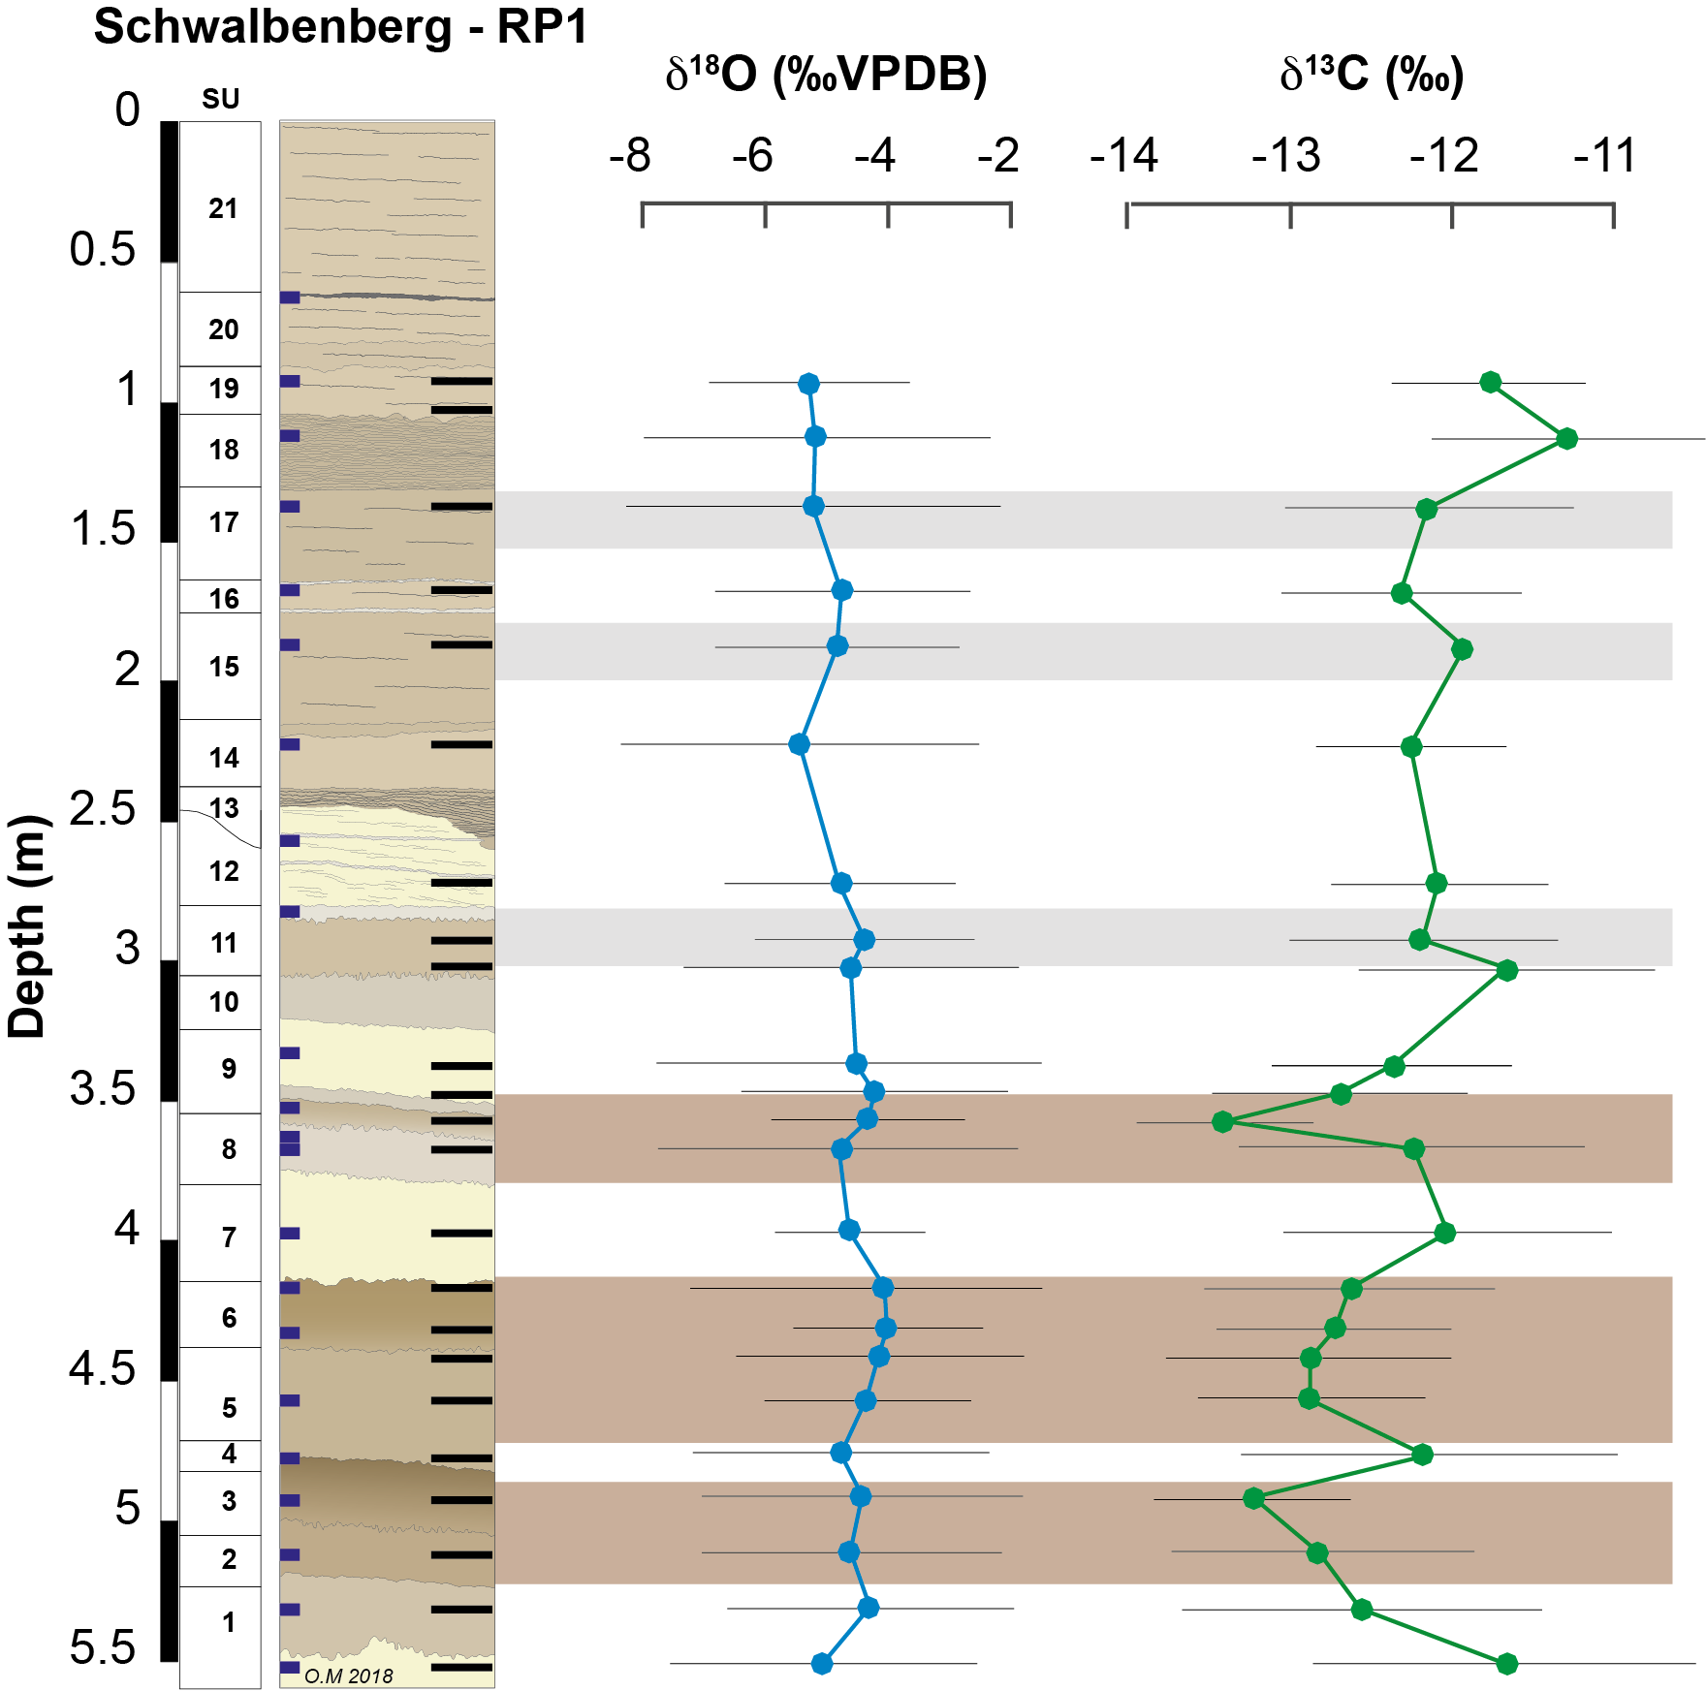

Supplementary Figure 2: Stratigraphy and oxygen and carbon isotope composition of earthworm calcite granules from Nussloch profile P8. On the profile, black segments indicate the position of stable isotope analyses and dark blue squares represent radiocarbon dating samples. The stratigraphy follows ref^{1,2}.

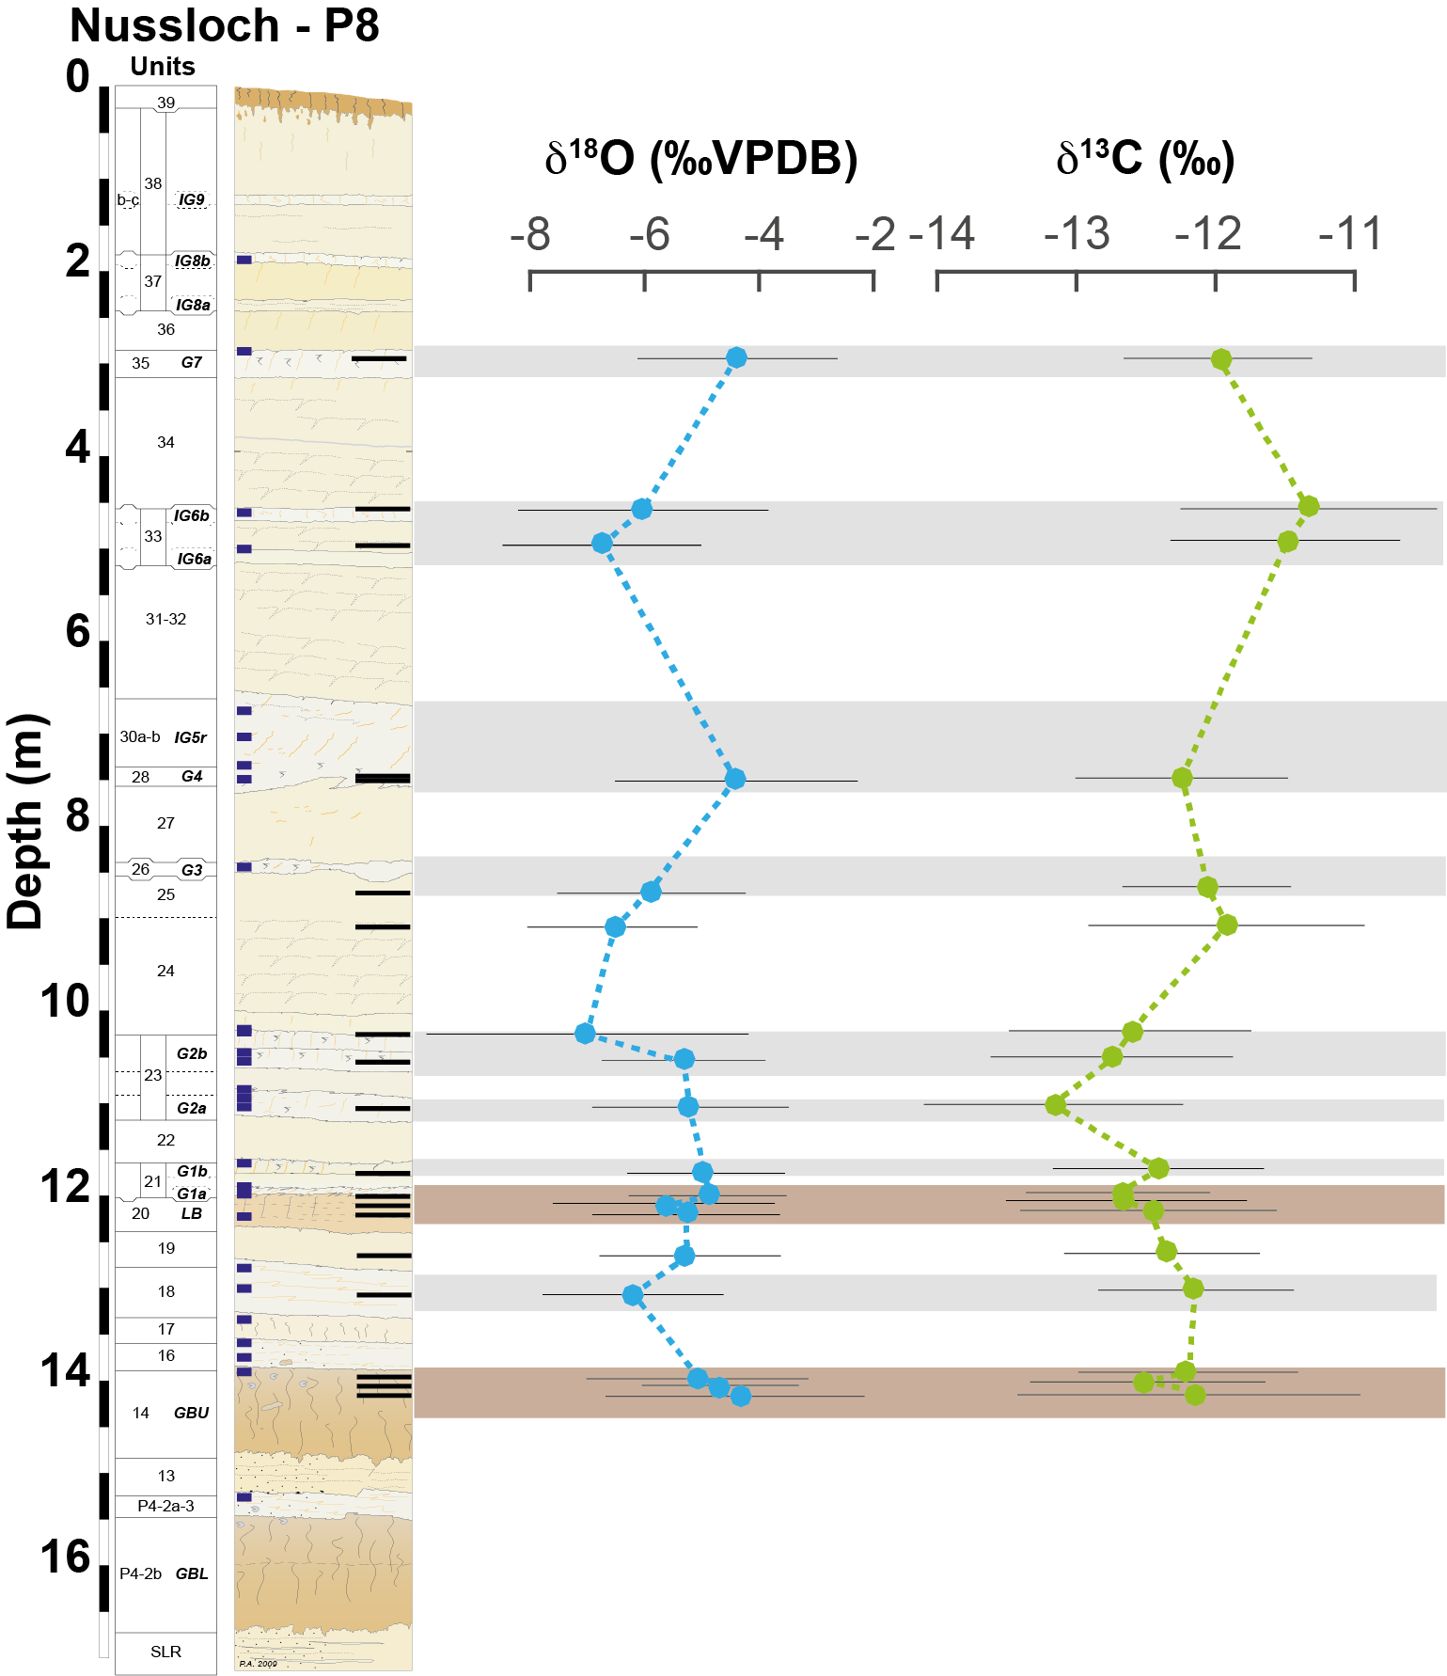

Supplementary Figure 3: Seasonal wind regime and precipitation statistics obtained for present day (top row) and LGM (bottom row) conditions at the Schwalbenberg site for the four-year quarters. Shaded green area presents the average precipitation flux at given wind direction/strength (percent of total – scale at the bottom of the figure). Sector line plots show wind speed (black), wind occurrence (red solid), precipitation rate (blue dashed) and total precipitation (red dashed, normalised) distribution about rhumbs. Thin solid/long-dashed line circles visualise the scalar/absolute winds and their directions, respectively; thin-dashed circle shows wind vector. Note that wind direction is meteorological (from where wind blows). Further statistics tabled: V_{S} and V_{R} − absolute and scalar wind speed [m/s], R_{w} and R_{p} − rhumbs of maximum wind and precipitation occurrence [percent], Q − wind steadiness (V_{S} /V_{R} ratio), r_{xy} − wind zonal and meridional components correlation, σ_{r} − wind vector SD [m/s], λ − wind absolute speed to ratio, Σ(P): total annual precipitation [mm].

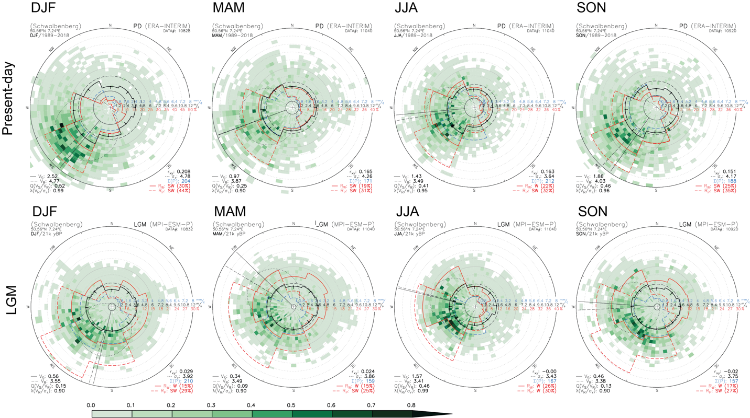

Supplementary Figure 4: Seasonal wind regime and precipitation statistics obtained for present day (top row) and LGM (bottom row) conditions at the Nussloch site for the four years quarters. Same captions as above (Supplementary Fig. 3).

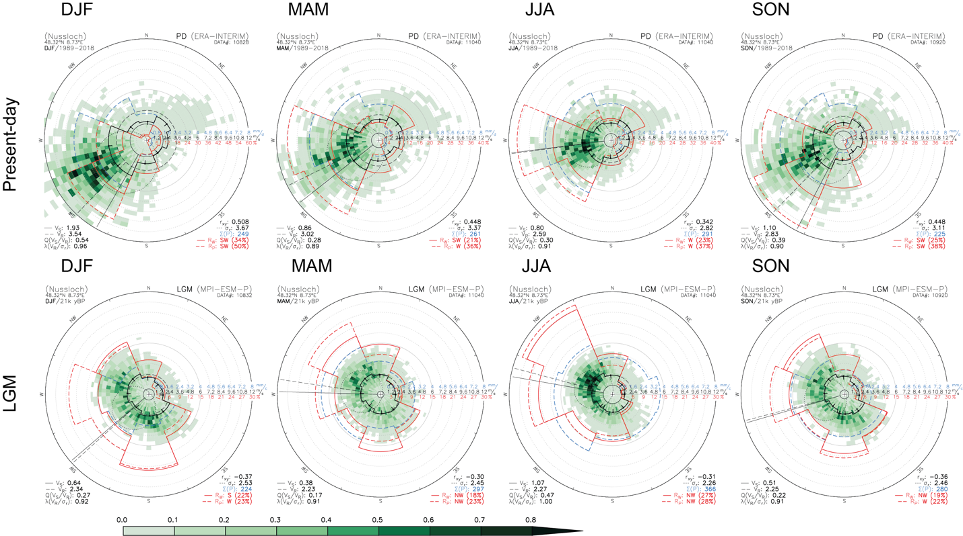

Supplementary Table 1: Radiocarbon dating from earthworm calcite granules for Schwalbenberg RP1 and Nussloch P8 profiles. (Separate file).
* SU: Stratigraphical unit
Lab code: instrument and introduction mode: [a] EA-GIS ECHo-gas source, [b] ECHo-solid source
** Age model using BACON 2.2 software³ and IntCAL20⁴ data set.

Supplementary Table 2: Schwalbenberg RP1: Bacon age model and stable isotopic composition of the ECG. Mean and standard deviations (SD) of oxygen and carbon composition (‰VPDB) values of the earthworm calcite granules (ECG) recovered from Schwalbenberg profile. Samples are located along the stratigraphic sequences and each layer has a corresponding age obtained by Bayesian modelling³ from ¹⁴C dating shown in supplementary Table 1. b.s. - below surface; SU – stratigraphic unit; SD standard deviation.

RP1 |  | Bayesian Modelling |  | ECG isotope data
Level  (cm b.s.) | SU | Med. age  (Cal BP) | SD  (0.95) | Mean δ¹⁸O  (‰ VPDB) | SD  (1σ) | Mean δ¹³C  (‰ VPDB) | SD  (1σ)
90-95 | 19 | 22416 | 87 | -5.3 | 1.7 | -11.8 | 0.6
110-115 | 18 | 22462 | 106 | -5.2 | 1.8 | -11.3 | 0.9
135-140 | 17 | 22689 | 145 | -5.2 | 1.9 | -12.2 | 0.9
165-170 | 16 | 22923 | 140 | -4.8 | 1.9 | -12.3 | 0.8
185-190 | 15 | 23267 | 292 | -4.8 | 1.8 | -11.9 | 0.9
220-225 | 14 | 24123 | 378 | -5.4 | 2.0 | -12.3 | 0.6
270-275 | 12 | 31208 | 524 | -4.8 | 1.5 | -12.1 | 0.7
290-295 | 11 | 31733 | 495 | -4.4 | 2.0 | -12.2 | 0.9
300-305 | 11 | 31941 | 521 | -4.6 | 2.2 | -11.7 | 0.9
335-340 | 9 | 32646 | 469 | -4.5 | 1.8 | -12.4 | 0.7
345-350 | 9-8 | 32844 | 431 | -4.2 | 1.8 | -12.7 | 0.8
355-360 | 8b | 33105 | 343 | -4.3 | 1.6 | -13.4 | 0.5
365-370 | 8a | 33375 | 313 | -4.8 | 1.8 | -12.2 | 1.1
395-400 | 7 | 34038 | 291 | -4.6 | 1.2 | -12.0 | 1.0
415-420 | 6 | 34447 | 298 | -4.1 | 1.8 | -12.6 | 0.9
430-435 | 6 | 34756 | 341 | -4.0 | 1.4 | -12.7 | 0.7
440-445 | 5 | 34951 | 384 | -4.2 | 1.7 | -12.9 | 0.9
455-460 | 5 | 35268 | 398 | -4.4 | 1.4 | -12.9 | 0.7
475-480 | 4 | 35871 | 541 | -4.8 | 2.1 | -12.2 | 1.2
490-495 | 3 | 37024 | 534 | -4.4 | 1.7 | -13.2 | 0.6
510-515 | 2 | 37388 | 652 | -4.6 | 2.0 | -12.8 | 0.9
530-535 | 1-2 | 38097 | 750 | -4.3 | 2.0 | -12.6 | 1.1
550-555 | 1 | 39316 | 900 | -5.1 | 2.4 | -11.7 | 1.2

Supplementary Table 3: Nussloch NUSSP8: Bacon age model and stable isotopic composition of the ECG. Mean and standard deviations (SD) of oxygen and carbon composition (‰VPDB) values of the earthworm calcite granules (ECG) recovered from Nussloch profile. Samples are located along the stratigraphic sequences and each layer has a corresponding age obtained by Bayesian modelling³ from ¹⁴C dating shown in Supplementary Table 1. b.s. - below surface.
NUSSP8 |  | Bayesian Modelling |  |  | ECG isotope data
Level  (cm b.s.) | Horizons | Med. age  (Cal BP) | SD  (0.95) | Mean δ¹⁸O  (‰ VPDB) | SD  (1σ) | Mean δ¹³C  (‰ VPDB) | SD  (1σ)
295-300 | G7 | 23485 | 337 | -4.4 | 1.8 | -12.0 | 0.7
460-465 | IG6b | 24646 | 336 | -6.0 | 2.2 | -11.3 | 0.9
495-500 | IG6a | 25060 | 341 | -6.7 | 1.8 | -11.5 | 0.8
750-755 | G4 (P4) | 27470 | 244 | -4.4 | 2.1 | -12.2 | 0.8
870-875 | U25/G3 | 29040 | 427 | -5.9 | 1.6 | -12.1 | 0.6
910-915 | 24 | 29373 | 424 | -6.5 | 1.4 | -11.9 | 1.0
1025-1030 | G2a | 30320 | 321 | -7.0 | 2.8 | -12.6 | 0.9
1055-1100 | G2b | 30714 | 348 | -5.3 | 1.4 | -12.7 | 0.9
1105-1110 | G2d | 31889 | 524 | -5.2 | 1.7 | -13.2 | 0.9
1175-1180 | G1 | 33761 | 535 | -4.9 | 1.3 | -12.4 | 0.8
1200-1205 | LB | 34967 | 620 | -4.9 | 1.3 | -12.7 | 0.6
1210-1215 | LB | 35627 | 878 | -5.7 | 1.9 | -12.7 | 0.9
1220-1225 | LB | 36091 | 868 | -5.3 | 1.6 | -12.5 | 0.9
1265-1270 | 19 | 40044 | 429 | -5.3 | 1.5 | -12.4 | 0.7
1305-1310 | Gm3 | 42331 | 654 | -6.2 | 1.6 | -12.1 | 0.7
1395-1400 | GBU | 44089 | 858 | -5.1 | 1.9 | -12.2 | 0.8
1405-1410 | GBU | 44262 | 907 | -4.6 | 1.4 | -12.5 | 0.8
1415-1415 | GBU | 44450 | 954 | -4.4 | 2.3 | -12.2 | 1.2

Supplementary References:
1. Antoine, P. et al. Rapid and cyclic aeolian deposition during the Last Glacial in European loess: a high-resolution record from Nussloch, Germany. Quaternary Science Reviews 28, 2955–2973 (2009).
2. Prud’homme, C., Moine, O., Mathieu, J., Saulnier-Copard, S. & Antoine, P. High-resolution quantification of earthworm calcite granules from western European loess sequences reveals stadial–interstadial climatic variability during the Last Glacial. Boreas 48, 257–268 (2019).
3. Blaauw, M. & Christeny, J. A. Flexible paleoclimate age-depth models using an autoregressive gamma process. Bayesian Analysis 6, 457–474 (2011).
4. Reimer, P. J. et al. The IntCal20 Northern Hemisphere Radiocarbon Age Calibration Curve (0-55 cal kBP). Radiocarbon 62, 725–757 (2020).

