Supplementary Material
Synthesis, in-vitro biological evaluation, and molecular docking study of novel spiro-β-lactam-isatin hybrids
Aliasghar Jarrahpour^{1*}. Zahra Jowkar¹. Zahra Haghighijoo². Roghayeh Heiran^{3*}. Javad Ameri Rad¹. Véronique Sinou⁴. Christine Latour⁴. Jean M. Brunel⁵. Namık Özdemir⁶
¹ Department of Chemistry, College of Sciences, Shiraz University, Shiraz 71946-84795, Iran
² Medicinal and Natural Products Chemistry Research Center, Shiraz University of Medical Sciences, Shiraz, Iran.
³ Department of Chemistry, Estahban Higher Education Center, Estahban 74519 44655, Iran
⁴ UMR-MD3 Relation hoˆte-parasites, Physiopathologie and Pharmacologie, Faculte´ de pharmacie, Aix-Marseille Universite´, Bd Jean Moulin, 13385 Marseille, France
⁵ Centre de Recherche en Cancerologie de Marseille (CRCM), CNRS, UMR7258, Institut Paoli Calmettes, Aix-Marseille Universite´, UM 105, Inserm, U1068, F-13009 Marseille, France
⁶ Department of Mathematics and Science Education, Faculty of Education, Ondokuz Mayıs University, 55139 Samsun, Turkey
Corresponding authors: Tel.: +98 7153234501, +987136137101; Fax: +98 7153234502
* Roghayeh Heiran
somaieheiran@gmail.com
Aliasghar Jarrahpour
jarahpor@shirazu.ac.ir, aliasghar6683@yahoo.com
Contents
Experimental Section (S1) 3
Antibacterial activity of new compounds 3
In-vitro antimalarial activity of new compounds 4
Table 1. Crystal data and structure refinement parameters for 4e. 5
Figure S1. IR, ¹H-NMR and ¹³C-NMR spectra of 1'-Allyl-3-phenoxy-1-(p-tolyl)spiro[azetidine-2,3'-indoline]-2',4-dione (4a) 6
Figure S2. IR, ¹H-NMR and ¹³C-NMR spectra of 1'-Allyl-3-(2,4-dichlorophenoxy)-1-(p-tolyl)spiro[azetidine-2,3'-indoline]-2',4-dione (4b) 8
Figure S3. IR, ¹H-NMR and ¹³C-NMR spectra of 1'-Allyl-1-(4-iodophenyl)-3-phenoxyspiro[azetidine-2,3'-indoline]-2',4-dione (4c) 10
Figure S4. IR, ¹H-NMR and ¹³C-NMR spectra of 1'-Allyl-1-(4-(dimethylamino)phenyl)-3-(naphthalen-1-yloxy)spiro[azetidine-2,3'-indoline]-2',4-dione (4d) 12
Figure S5. IR, ¹H-NMR and ¹³C-NMR spectra of 1'-Allyl-3-(4-chlorophenoxy)-1-(4-(dimethylamino)phenyl)spiro[azetidine-2,3'-indoline]-2',4-dione (4e) 14
Figure S6. IR, ¹H-NMR and ¹³C-NMR spectra of 1'-Allyl-1-(4-(dimethylamino)phenyl)-3-phenoxyspiro[azetidine-2,3'-indoline]-2',4-dione (4f) 16
Figure S7. IR, ¹H-NMR and ¹³C-NMR spectra of 1'-Allyl-3-(2,4-dichlorophenoxy)-1-(4-(dimethylamino)phenyl)spiro[azetidine-2,3'-indoline]-2',4-dione (4g) 18
Figure S8. IR, ¹H-NMR and ¹³C-NMR spectra of 1'-Allyl-1-(4-methoxyphenyl)-3-phenoxyspiro[azetidine-2,3'-indoline]-2',4-dione(4h) 20
Figure S9. IR, ¹H-NMR and ¹³C-NMR spectra of 2-(1H-Benzo[d][1,2,3]triazol-1-yl)-N-(3-(4-chlorophenoxy)-2',4-dioxospiro[azetidine-2,3'-indolin]-1-yl)acetamide (6a) 22
Figure S10. IR, ¹H-NMR and ¹³C-NMR spectra of 2-(1H-Benzo[d][1,2,3]triazol-1-yl)-N-(3-(2,4-dichlorophenoxy)-2',4-dioxospiro[azetidine-2,3'-indolin]-1-yl)acetamide (6b) 24

Experimental Section (S1)

Antibacterial activity of new compounds
Antimicrobial activity of the compounds was studied by determination of minimal inhibitory concentrations (MIC) according to the NCCLS guidelines M7-A2 using the microbroth dilution methods. The bacteria strains were grown on trypticase soy agar (Becton Dickinson) at 37 °C for 24h. Inocula were prepared in TCE (tryptone 0.1 %, NaCl 8 %, wt/vol) by adjusting the turbidity at 623 nm to obtain 1-3 10⁵ CFU/mL. Antimicrobial activities of the compounds were determined by using a broth microdilution method performed in sterile 96-well microplates. All compounds were solubilized in methanol at a concentration of 5 mg/mL and were transferred to each microplate well (in all cases concentrations of the desired molecules in methanol do not exceed 2 % of the total proportion), in order to obtain a two-fold serial dilution in 100 µL of broth and 100 µL of inocula containing 2-6 10⁵ CFU of each bacteria and yeast were added to each well. A number of wells were reserved for positive controls, inoculum viability and solvent effect. After 24 hours of incubation, MIC was defined for each agent from duplicate observations as the lowest concentration of compound allowing no visible growth.

In-vitro antimalarial activity of new compounds
The chloroquine-resistant P. falciparum strain K1 (Southeast Asia) was in vitro cultured in complete medium consisting of RPMI 1640 (In Vitrogen) supplemented with 27.5 mM NaHCO₃, 20 mg/L gentamycin, and 10 % human serum. Parasites were grown at 37°C in human O+ red blood cells at a 6 % haematocrit under a 5 % CO₂, 10 % O₂ and 85 % N₂ atmosphere. Cultures were synchronized by sorbitol treatments. Stock solutions of lactam derivatives were prepared in sterile DMSO (10 mM) and later dilutions were with complete culture medium. Increasing concentrations of lactam derivatives (100 µL/well, top concentration = 50 µM) were distributed in a 96-well plate; DMSO (0.5 % vol/vol, top concentration) was distributed for control. Then, 100 µL from a culture containing > 95 % ring (0-20 h postinvasion) at a 0.8 % parasitemia and 3 % haematocrit in complete medium was added per well. The plates were incubated at 37 °C in presence of 5 % CO₂, 85 % N₂ and 10 % O₂ for 72 h. After culture the plates were frozen down at 20 °C. Parasite susceptibility was tested in parallel against chloroquine diphosphate (Sigma-Aldrich) (final concentrations : 6.25-3200 nM). Parasite growth inhibition was quantified using a homemade HRP2 ELISA assay based on pfHRP2 detection. Dose-response curves and drug concentrations inhibiting parasite growth by 50 % (IC₅₀) using duplicate-well data for each drug concentration were determined using ICESTIMATOR (http://www.antimalarial-icestimator.net/MethodIntro.htm).

Table 1. Crystal data and structure refinement parameters for 4e.
CCDC depository | 2129553
Color/shape | Colorless/prism
Chemical formula | C₂₇H₂₄ClN₃O₃
Formula weight | 473.94
Temperature (K) | 296(2)
Wavelength (Å) | 0.71073 Mo Kα
Crystal system | Monoclinic
Space group | P2₁/c (No. 14)
Unit cell parameters
a, b, c (Å) | 11.7806(17), 8.7964(9), 24.168(4)
α, β, γ (°) | 90, 95.454(12), 90
Volume (Å³) | 2493.1(6)
Z | 4
D_{calc.} (g/cm³) | 1.263
μ (mm⁻¹) | 0.186
Absorption correction | Integration
T_{min.}, T_{max.} | 0.9371, 0.9912
F₀₀₀ | 992
Crystal size (mm³) | 0.45 × 0.14 × 0.06
Diffractometer | STOE IPDS II
Measurement method | ω scan
Index ranges | −14 ≤ h ≤ 14, −10 ≤ k ≤ 10, −28 ≤ l ≤ 26
θ range for data collection (°) | 1.693 ≤ θ ≤ 25.049
Reflections collected | 17041
Independent/observed reflections | 4422/1149
R_{int.} | 0.3414
Refinement method | Full-matrix least-squares on F²
Data/restraints/parameters | 4422/132/337
Goodness-of-fit on F² | 1.023
Final R indices [I > 2σ(I)] | R₁ = 0.1531, wR₂ = 0.3328
R indices (all data) | R₁ = 0.3373, wR₂ = 0.4874
Δρ_{max.}, Δρ_{min.} (e/Å³) | 0.55, −0.65

Figure S1. IR, ¹H-NMR and ¹³C-NMR spectra of 1'-Allyl-3-phenoxy-1-(p-tolyl)spiro[azetidine-2,3'-indoline]-2',4-dione (4a)
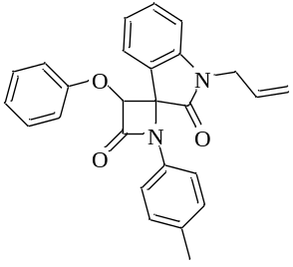
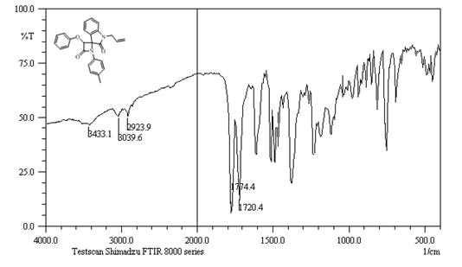

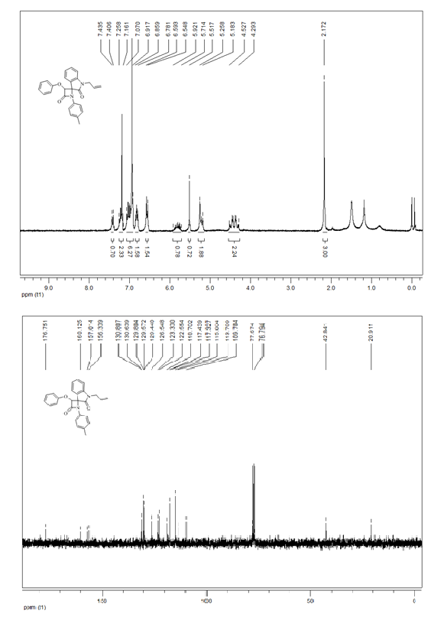

Figure S2. IR, ¹H-NMR and ¹³C-NMR spectra of 1'-Allyl-3-(2,4-dichlorophenoxy)-1-(p-tolyl)spiro[azetidine-2,3'-indoline]-2',4-dione (4b)
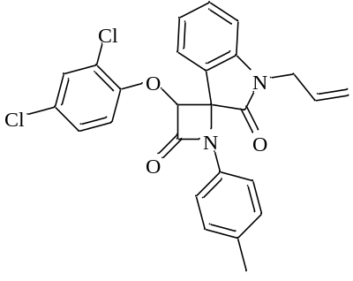

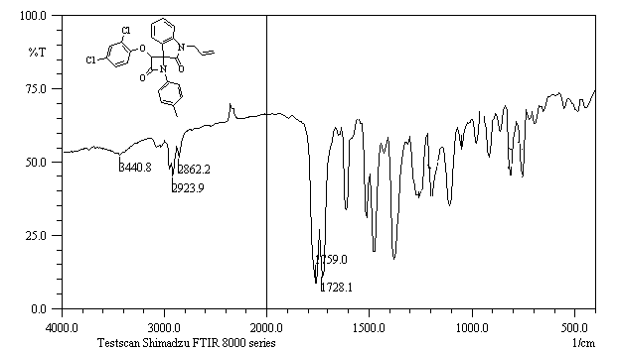
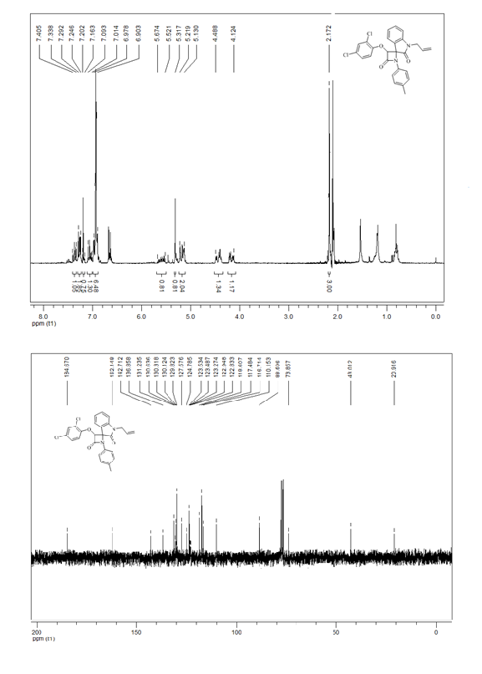

Figure S3. IR, ¹H-NMR and ¹³C-NMR spectra of 1'-Allyl-1-(4-iodophenyl)-3-phenoxyspiro[azetidine-2,3'-indoline]-2',4-dione (4c)
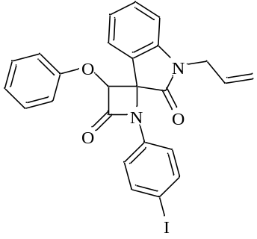
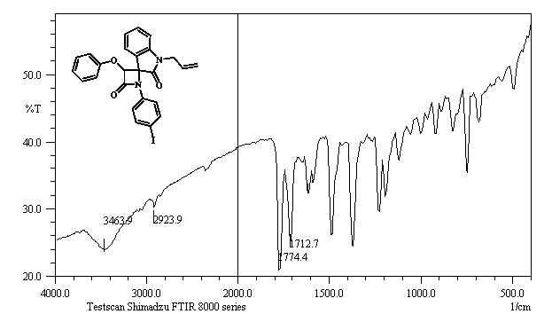
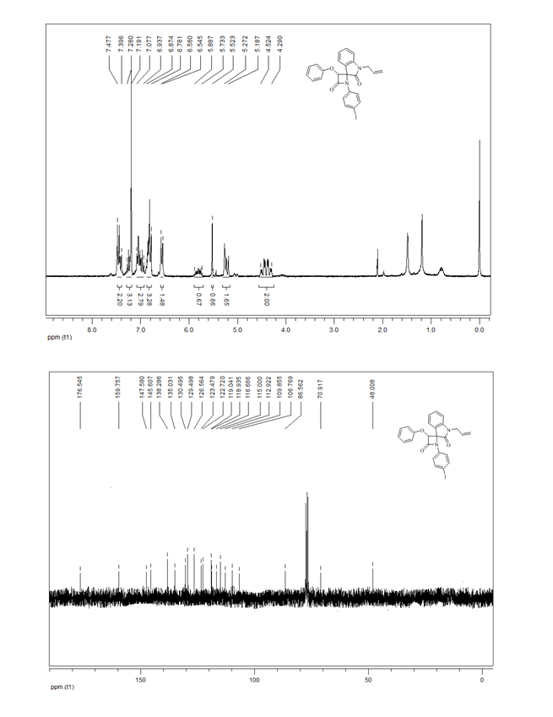

Figure S4. IR, ¹H-NMR and ¹³C-NMR spectra of 1'-Allyl-1-(4-(dimethylamino)phenyl)-3-(naphthalen-1-yloxy)spiro[azetidine-2,3'-indoline]-2',4-dione (4d)
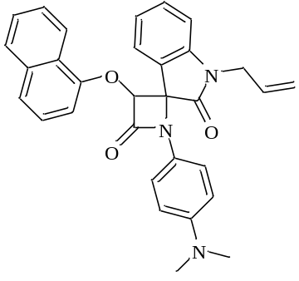

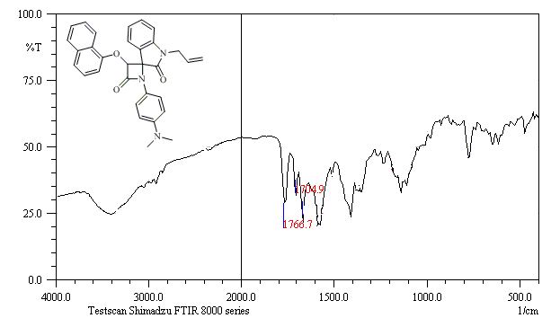
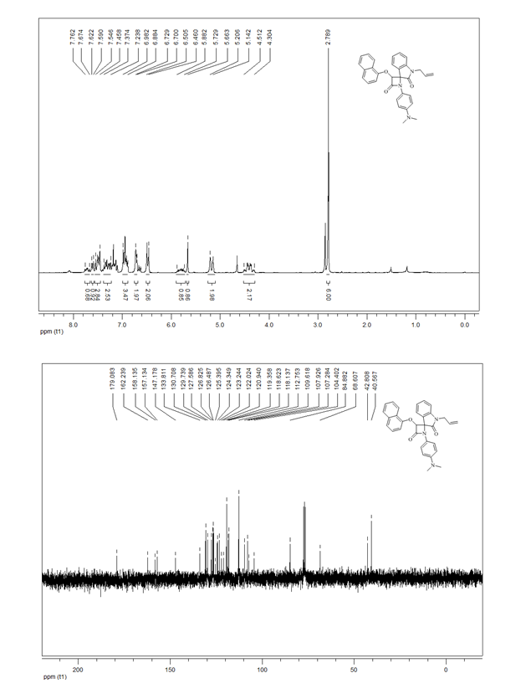

Figure S5. IR, ¹H-NMR and ¹³C-NMR spectra of 1'-Allyl-3-(4-chlorophenoxy)-1-(4-(dimethylamino)phenyl)spiro[azetidine-2,3'-indoline]-2',4-dione (4e)
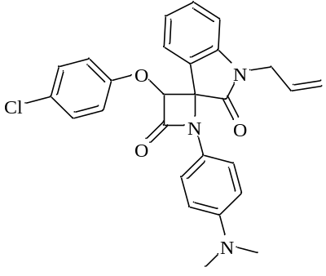
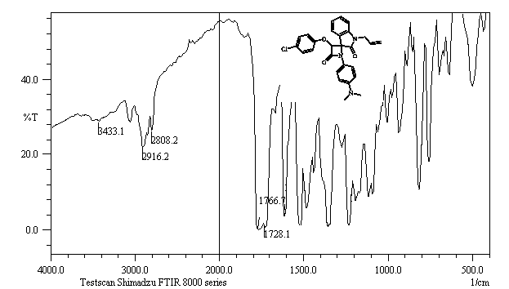
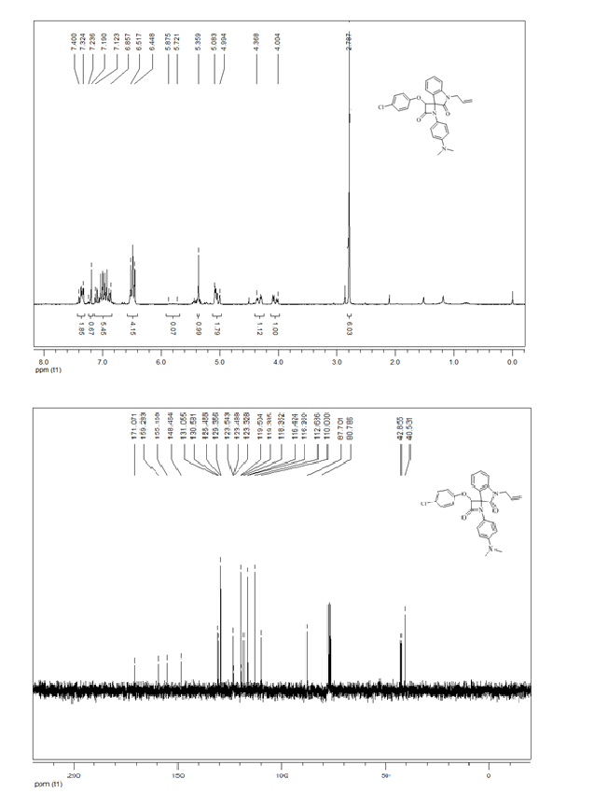

Figure S6. IR, ¹H-NMR and ¹³C-NMR spectra of 1'-Allyl-1-(4-(dimethylamino)phenyl)-3-phenoxyspiro[azetidine-2,3'-indoline]-2',4-dione (4f)
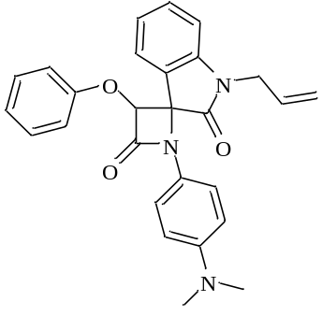
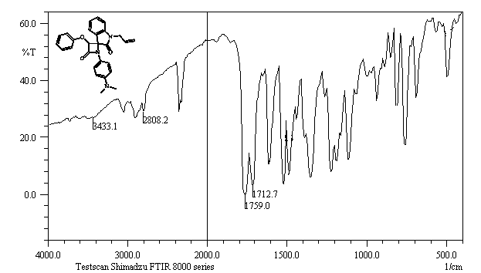
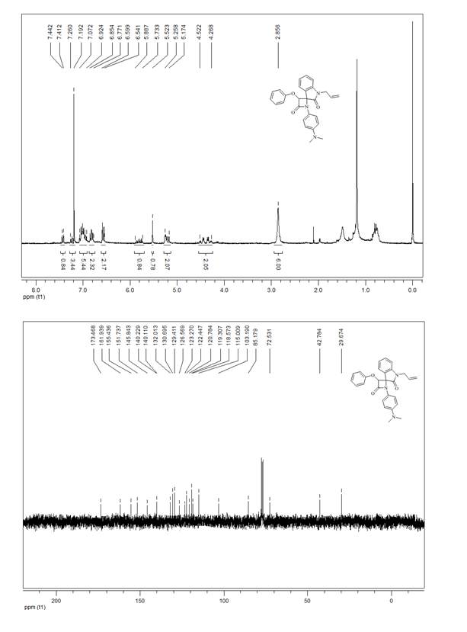

Figure S7. IR, ¹H-NMR and ¹³C-NMR spectra of 1'-Allyl-3-(2,4-dichlorophenoxy)-1-(4-(dimethylamino)phenyl)spiro[azetidine-2,3'-indoline]-2',4-dione (4g)

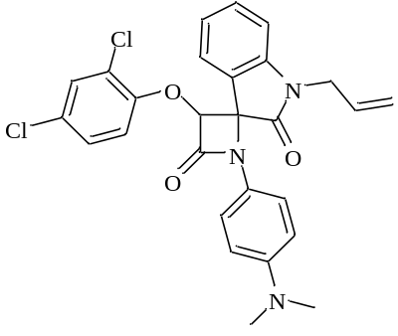
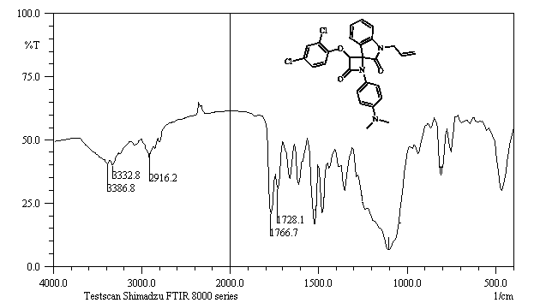
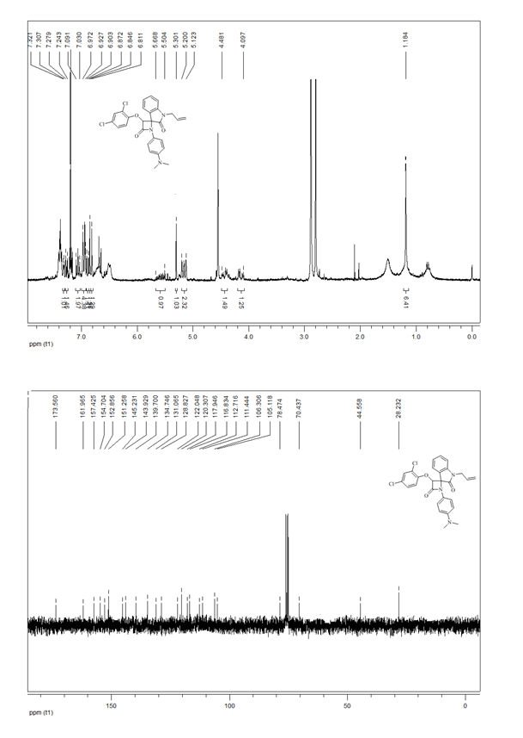

Figure S8. IR, ¹H-NMR and ¹³C-NMR spectra of 1'-Allyl-1-(4-methoxyphenyl)-3-phenoxyspiro[azetidine-2,3'-indoline]-2',4-dione(4h)
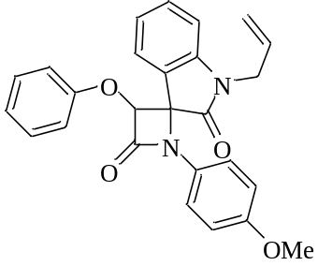

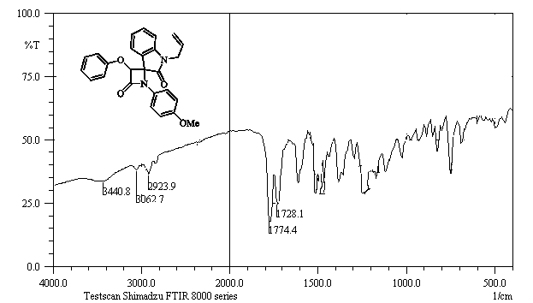
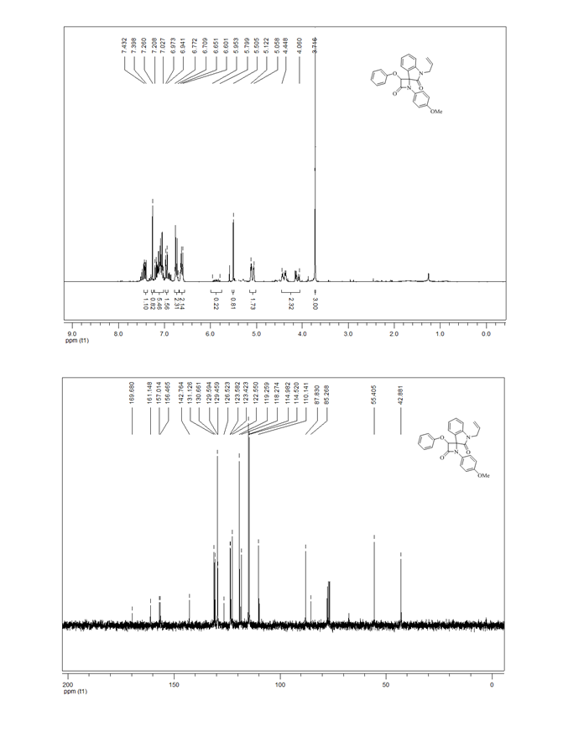

Figure S9. IR, ¹H-NMR and ¹³C-NMR spectra of 2-(1H-Benzo[d][1,2,3]triazol-1-yl)-N-(3-(4-chlorophenoxy)-2',4-dioxospiro[azetidine-2,3'-indolin]-1-yl)acetamide (6a)

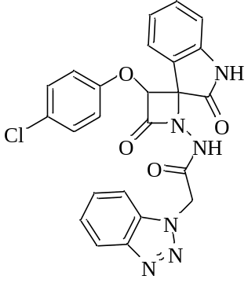
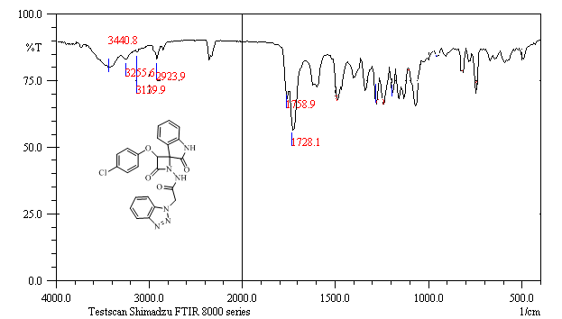
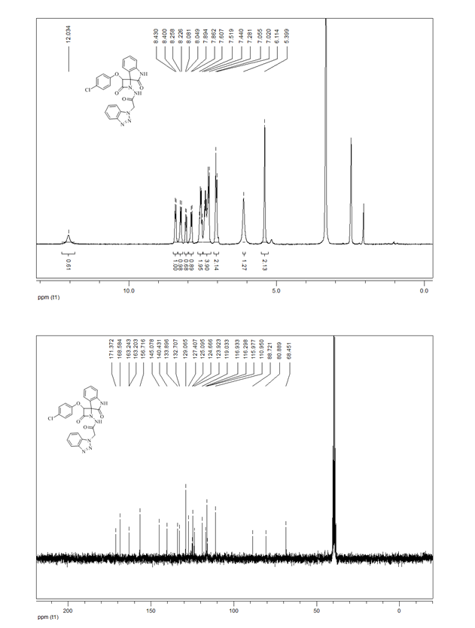

Figure S10. IR, ¹H-NMR and ¹³C-NMR spectra of 2-(1H-Benzo[d][1,2,3]triazol-1-yl)-N-(3-(2,4-dichlorophenoxy)-2',4-dioxospiro[azetidine-2,3'-indolin]-1-yl)acetamide (6b)
