Supplementary Information

Direct identification of interfacial degradation in blue phosphorescent OLEDs using nanoscale chemical depth profiling
Soohwan Sul^{2§}, Gustavo F. Trindade^{1§}, Joonghyuk Kim^{2§}, Rasmus Havelund^{1§}, Sungjun Park², Youngsik Shin², Hye Jin Bae², Young Mo Sung², L. Matjacic¹, Yongsik Jung², Jungyeon Won², Woo Sung Jeon², Hyeonho Choi², Hyo Sug Lee², Jae-Cheol Lee²⁺, Jung-Hwa Kim^{2*} and Ian S. Gilmore^{1*}

§ Equal contribution

¹ National Physical Laboratory, Hampton Road, TW11 0LW, United Kingdom
² Samsung Advanced Institute of Technology, Samsung Electronics Co., Ltd., 130 Samsung-ro, Suwon, 16678, Republic of Korea
⁺ Present address: Korea Research Institute of Material Property Analysis (KRIMPA), 712, Nongseo-dong 455, Yongin, 17111, Republic of Korea
*Corresponding authors
*E-mail: jh1179.kim@samsung.com
*E-mail: ian.gilmore@npl.co.uk,
ORCID
ISG: 0000-0002-0981-2318
RH: 0000-0001-7316-9761
GFT: 0000-0001-6998-814X
LM: 0000-0003-4765-2877
SS: 0000-0001-7466-9151

Supplementary Table 1. Electrical and photochemical degradation of the blue OLED devices and device characteristics.

Device label | Degradation method | Luminescence  relative to initial | EQE_{max} (%) | EQE at 1000 nit (%) | EL/PL peak (nm) | J at 5 V (mA/cm²) | V_{d} at 1000 nit V (V)
T70 | Electrical degradation | 70% EL | 12.8 | 12.5 | 469 | 0.57 | 6.10
T95 | Electrical degradation | 95% EL | 17.5 | 16.4 | 469 | 0.70 | 5.85
PL55 | Photo-degradation using 400-nm laser | 55% PL
T100 | None | Pristine  (100% EL) | 19.1 | 17.4 | 469 | 0.69 | 5.83

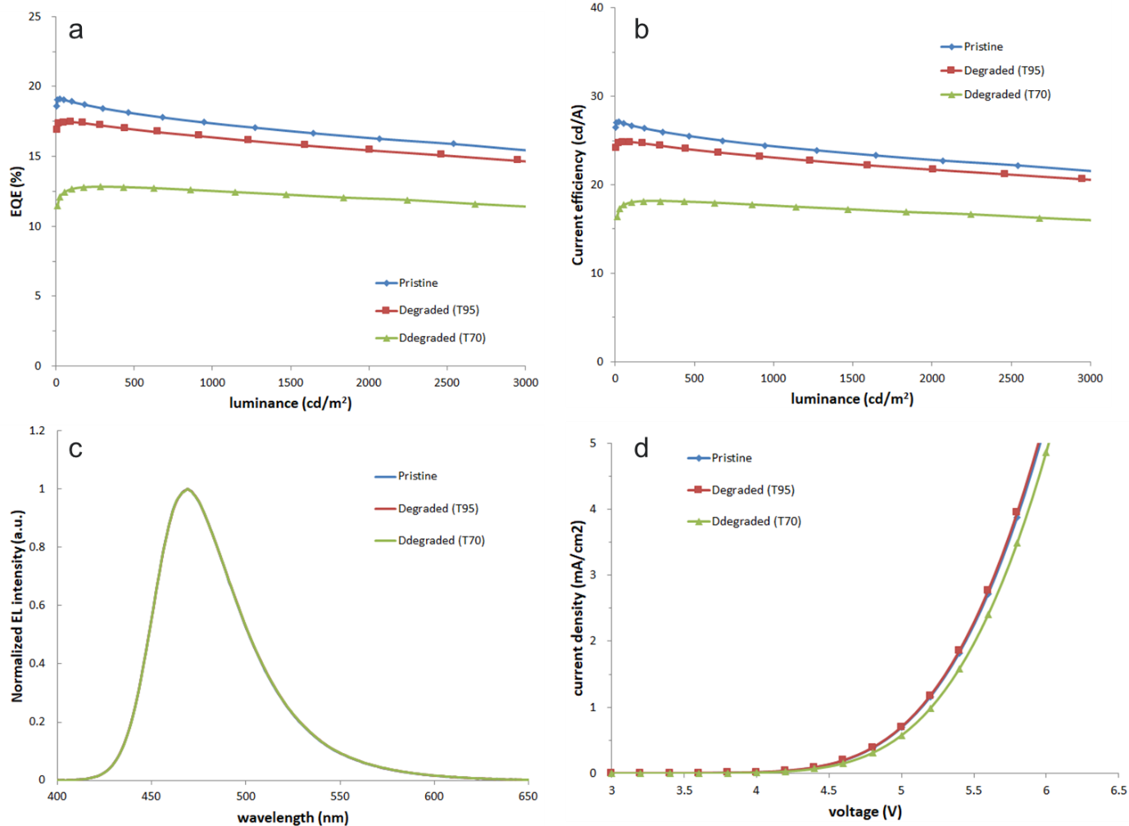
Supplementary Figure 1. External quantum efficiency (a) and current efficiency (b) as a function of luminance, electroluminescence spectra (c), and current density vs. voltage plot (d) for T₁₀₀, T₉₅, and T₇₀ devices.

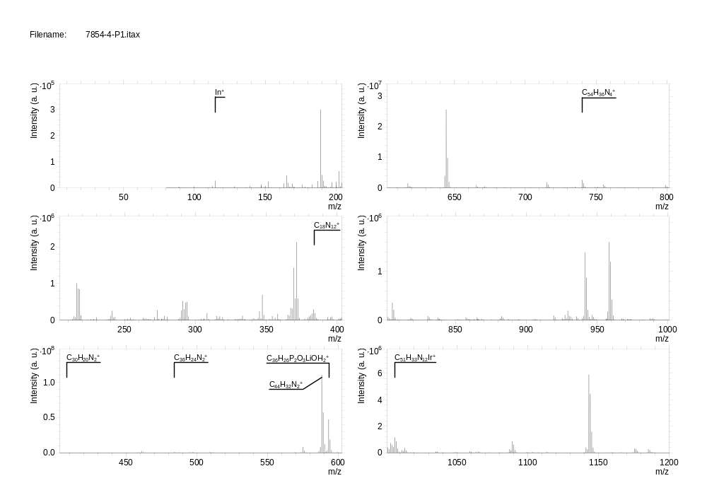
Supplementary Figure 2: Full mass spectrum from pristine device. The mass spectrum represents an overall depth profile acquired using 5 keV Ar₂₀₀₀⁺ cluster primary ion beam.

Supplementary Table 2. Characteristic molecular ions in the depth profile of the devices.
Material | m/z | Assignment |  | Mass deviation (ppm)
DBFPO:Liq | 593.1613 | C₃₆H₂₆P₂O₃LiOH₂⁺ | [M+ LiOH₂]⁺ | -0.5
mCBP | 484.1930 | C₃₆H₂₄N₂⁺ | M⁺ | -1.0
blue Ir dopant | 1006.2590 | C₅₁H₃₃N₁₂Ir⁺ | M⁺ | -0.5
mCP | 408.1619 | C₃₀H₂₀N₂⁺ | M⁺ | -0.5
TCTA | 740.2929 | C₅₄H₃₆N₄⁺ | M⁺ | -0.8
NPB | 588.2550 | C₄₄H₃₂N₂⁺ | M⁺ | -1.8
HAT-CN | 384.0364 | C₁₈N₁₂⁺ | M⁺ | 0.1
ITO | 114.9033 | In⁺ |  | -0.4

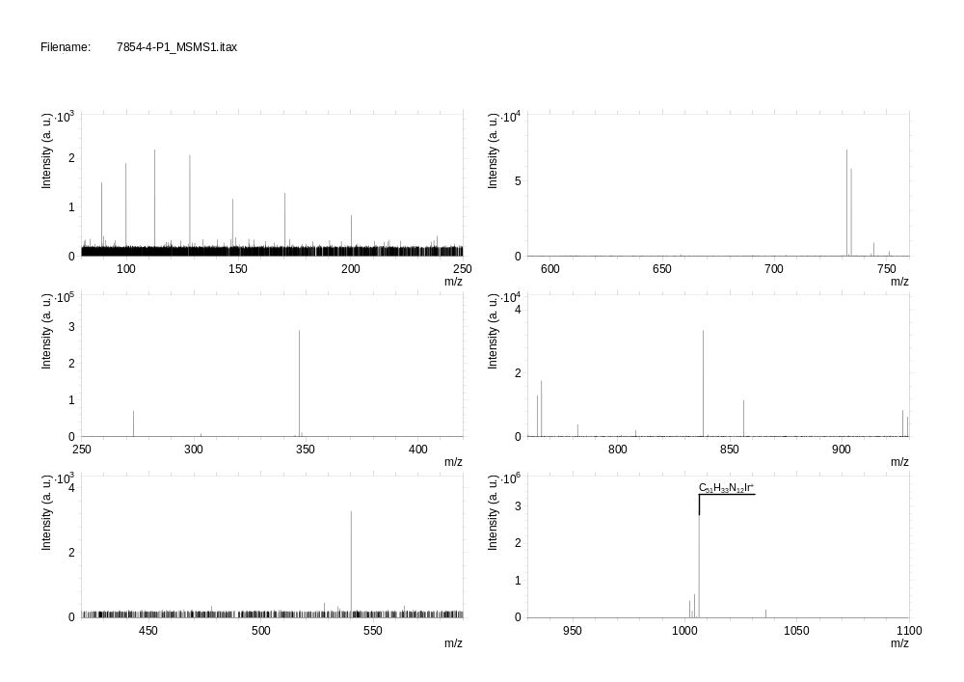
Supplementary Figure 3: MS/MS mass spectrum from m/z 1006.2569. In order to achieve a collision induced dissociation of the host material, pre-sputtering was performed to reach the EML. The MS/MS analysis was then undertaken using N₂ gas to fragment at 20 NCE (Nominal Collison Energy). Both the pre-sputtering and MS/MS were acquired using 5 keV Ar₂₀₀₀⁺ cluster primary ion beam.

Supplementary Table 3. Peak list from MS/MS mass spectrum from a pristine device (precursor m/z 1006.2569)
m/z | 112.7207 | 112.7265 | 273.1134 | 303.1560 | 303.1601 | 345.1135 | 347.1290
m/z | 348.1325 | 540.0919 | 732.1354 | 734.1511 | 743.1411 | 744.1444 | 751.1538
m/z | 764.1254 | 766.1409 | 782.1357 | 808.1665 | 838.1758 | 856.1863 | 927.2026
m/z | 929.2180 | 1002.2346 | 1003.2334 | 1004.2410 | 1005.2492 | 1006.2569

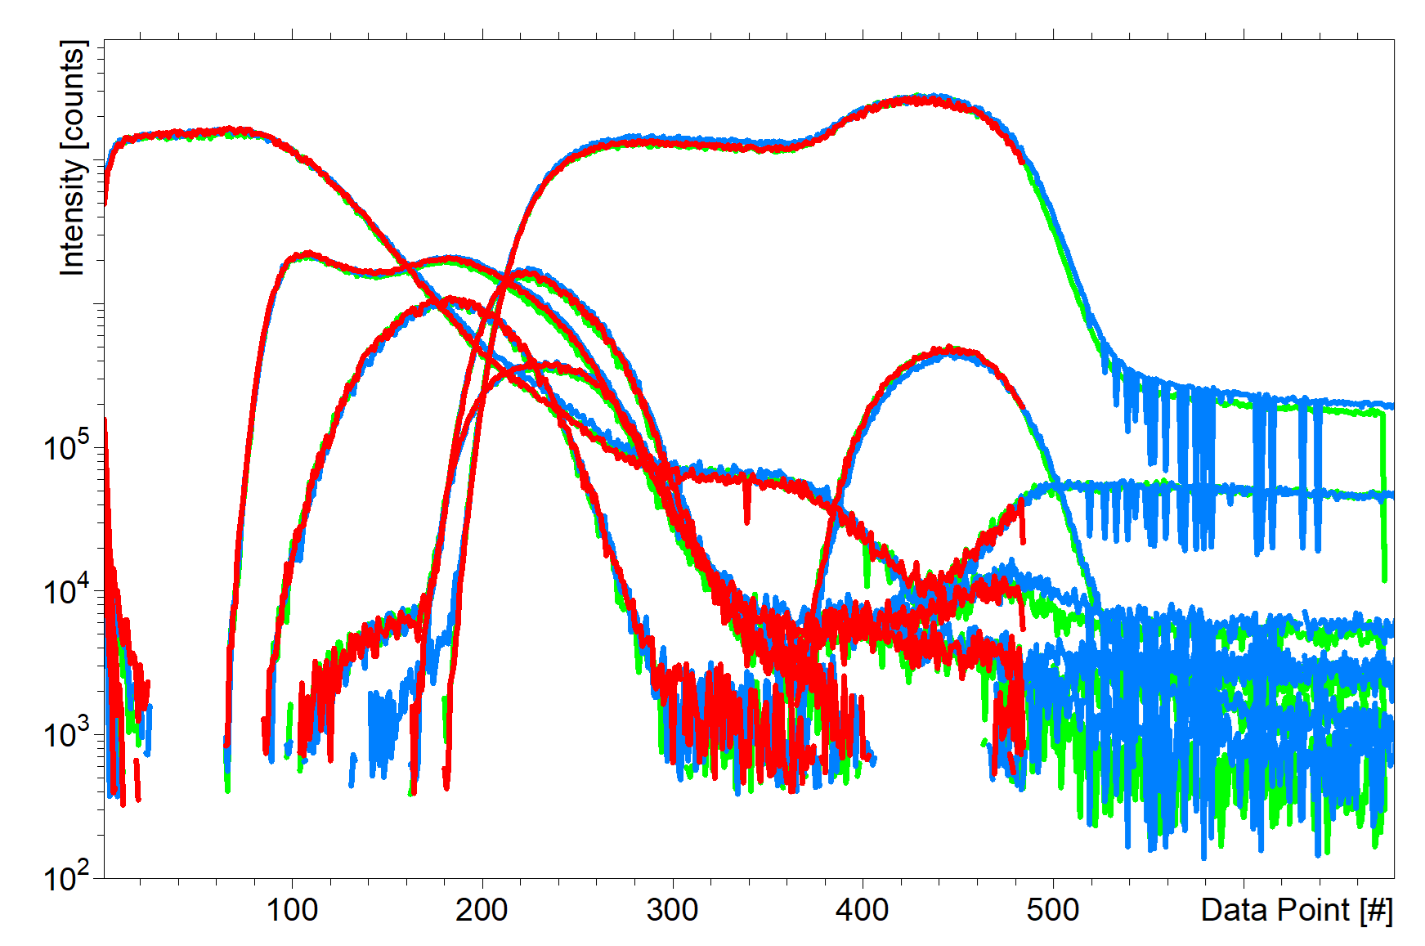
Supplementary Figure 4: Technical repeatability with three repeat depth profiles recorded from different areas of the same device (T₁₀₀). The profiles are essentially indistinguishable from each other demonstrating good measurement repeatability.

Supplementary Note 1: Unsupervised data analysis of joint depth profiles
Unsupervised multivariate analysis was carried out using secondary ion masses as the variables and depth levels as observations. For each dataset, Surface Lab 7.2 (IONTOF GmbH) was used to perform an automated peak search on the total spectra restricted only to peaks with intensity higher than 10⁵ counts and masses between m/z 200 and m/z 1200. Peak areas were then exported for each observation. Principal component analysis (PCA) was performed using the simsMVA software¹ on a joint dataset containing all depth levels for the profiles of all devices as observations (Supplementary Figure 3a). Prior to PCA, data was mean centred and Poisson scaled to account for heteroscedasticity. PC 5 results shows that the PL55 has an enhancement of thermal degradation product NPB-N C₃₄H₂₇N₂⁺ in the NPB layer of the PL55 device, which is likely induced by the laser irradiation²³ (Supplementary Figures 5b, 6a-c).

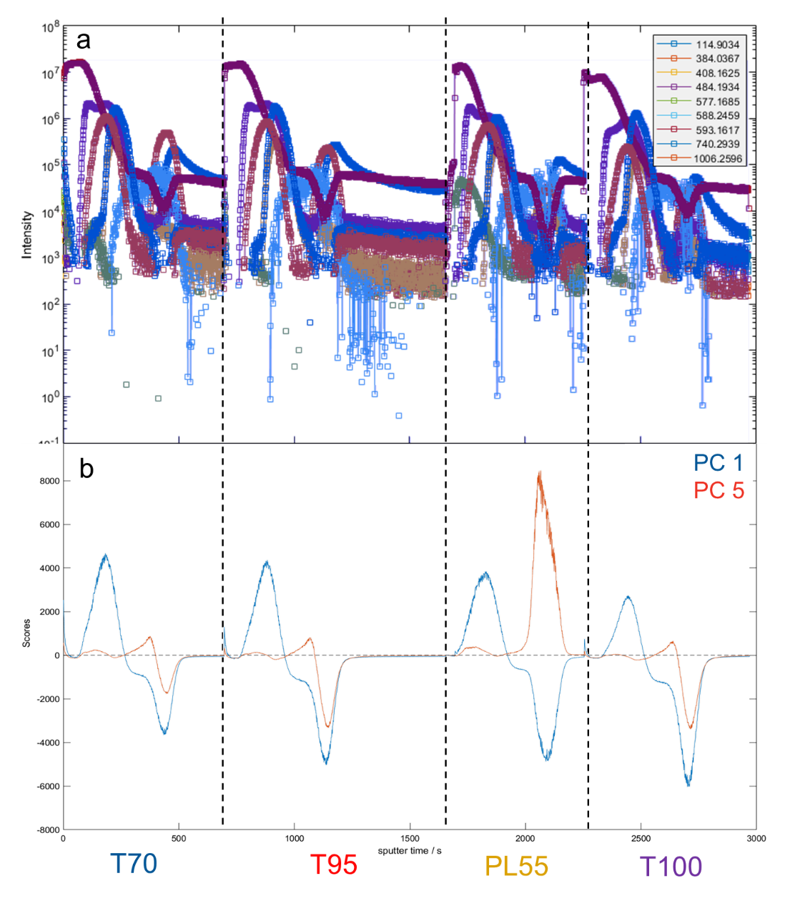
Supplementary Figure 5: a Joint dataset for all depth profiles of all devices. Profiles of ions from Supplementary Table 2 are shown for reference. b PCA scores profiles for PC 1 (blue) and PC 5 (red).

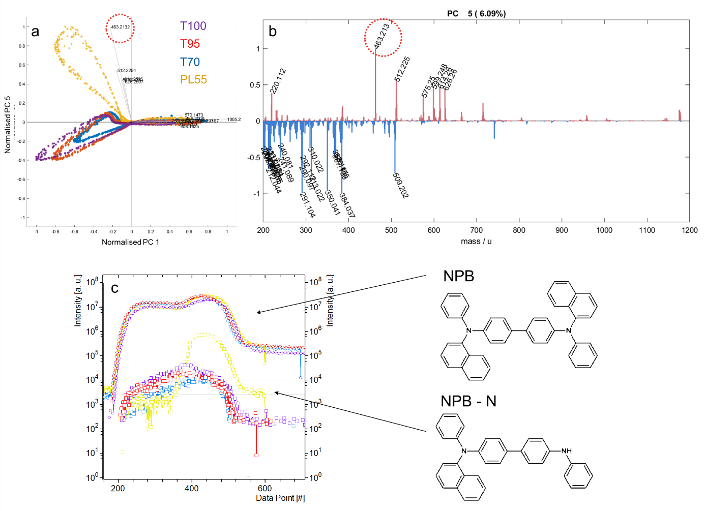
Supplementary Figure 6: a Scatter biplot of principal components 1 and 5 analysis with points colour coded based on device depth profile. b Loadings of PC5. The red circle shows the NPB-N ion that is more intense for the PL55 device, indicating thermal degradation. c Overlaid depth profiles for each device showing the NPB molecular ion and the NPB-N ion enhanced for the PL55 device (yellow curves).

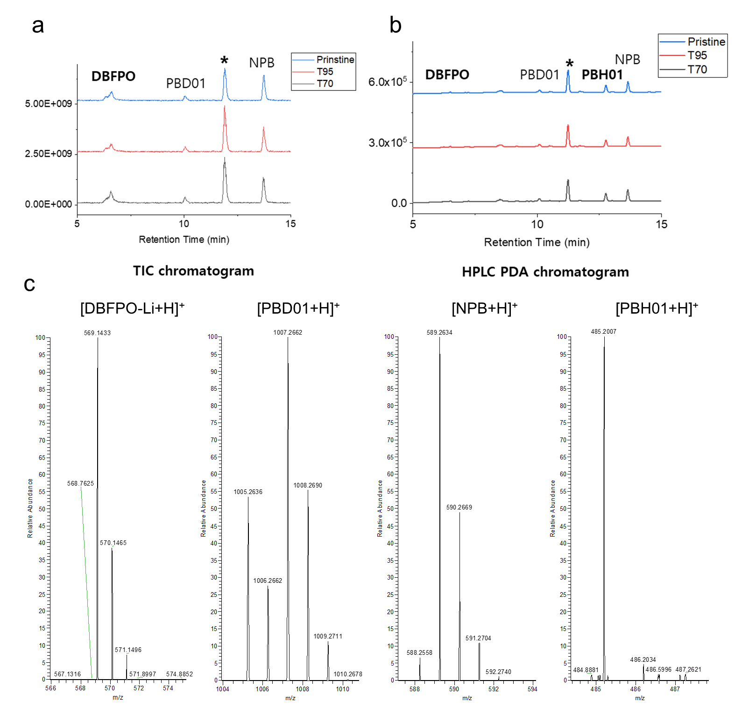
Supplementary Figure 7: LC-MS analysis. a LC-MS chromatogram (total ion current). b HPLC PDA chromatogram * impurity. c Corresponding mass spectra at specific retention times

Supplementary Note 2: Comparison between ToF and Orbitrap depth profiles
Supplementary Figures 6a compares the ToF and the Orbitrap mass spectra from the emissive layer in Device T95. Supplementary Figures 6b shows a depth profile obtained from a degraded device using Bi₃⁺ primary ions and the ToF mass analyser. The poorer mass resolving power, increased fragmentation and higher background in the ToF spectrum are evident. The poorer spectral quality causes some molecular profiles to show high backgrounds in layers where the corresponding materials are not present. The high mass resolving power becomes even more important when looking for the potential degradation products as these peaks have low intensities and, in most cases, have neighbouring peaks within 200 ppm. Only one of the five ions in Table 1 is clearly detected using the ToF mass analyser. Whilst the Orbitrap mass analyser in most aspects is superior, the conventional dual beam approach offers some valuable complementarities. Studies show that small fragment ion depth profiles in general reflects the compositional variation better whereas molecular ions often are strongly affected by matrix effects. An advantage of the ToF mass analyser is the ability to analyse smaller ions than the Orbitrap mass analyser, which has a lower limit at m/z 50. In these devices, the lithium and oxygen profiles could be of interest.

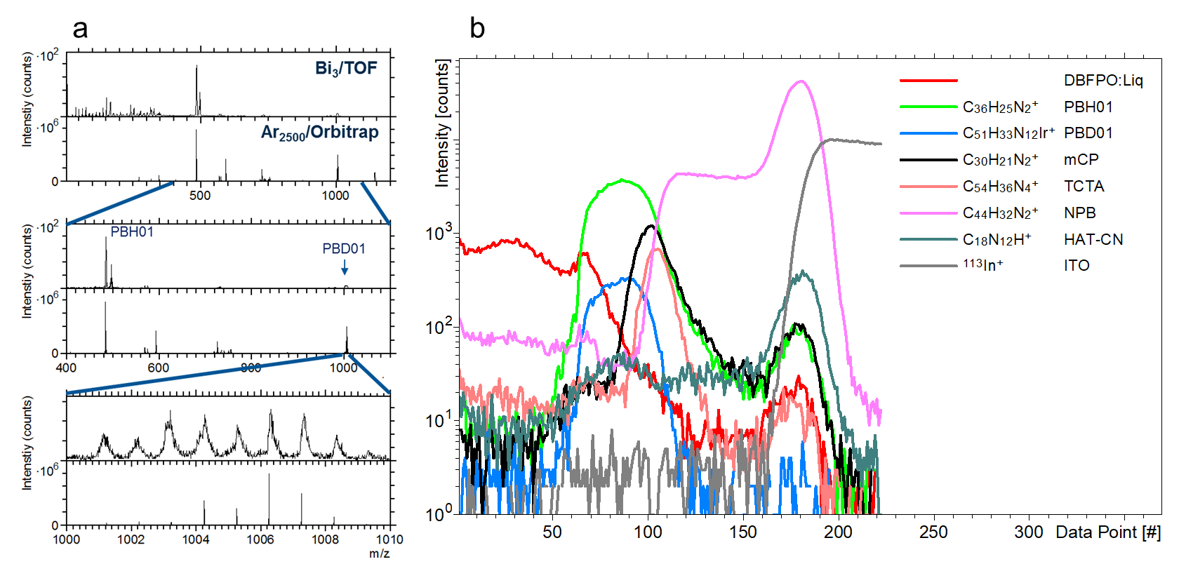
Supplementary Figure 8: a Comparison of spectra obtained from the emissive layer in the Samsung device using the Bi₃⁺/ToF and the Ar₂₅₀₀⁺/Orbitrap. b Depth profile obtained from a degraded device using Bi₃⁺ primary ions and the ToF mass analyser.

