Supplementary information belonging to the manuscript:

Multidisciplinary lifestyle interventions in the management of resistant hypertension

Eugenia Espinel¹*, Maria Antonia Azancot¹, Alba Gomez², Anna Beneria³, Anna Caraben¹, Laura Andurell⁴, Pilar Delgado⁵, Helena Castañé⁶*, Jorge Joven⁶, Daniel Seron¹

¹Department of Nephrology, Hospital Universitari de la Vall d’Hebrón, Universitat Autònoma de Barcelona, Spain.
²Department of Physical Medicine and Rehabilitation, Hospital Universitari de la Vall d’Hebrón, Universitat Autònoma de Barcelona, Spain.
³Department of Psychiatry, Hospital Universitari de la Vall d’Hebrón, Universitat Autònoma de Barcelona, Spain.
⁴Department of Endocrinology and Nutrition, Hospital Universitari de la Vall d’Hebrón, Universitat Autònoma de Barcelona, Spain.
⁵Department of Neurology, Hospital Universitari de la Vall d’Hebrón, Universitat Autònoma de Barcelona, Spain.
⁶Unitat de Recerca Biomèdica, Hospital Universitari de Sant Joan, Institut d'Investigació Sanitària Pere Virgili, Universitat Rovira i Virgili, Reus, Spain.

Subject terms: hypertension, obesity, therapeutics, weight management

Corresponding author: Helena Castañé, Unitat de Recerca Biomèdica, Hospital Universitari de Sant Joan, Institut d'Investigació Sanitària Pere Virgili, Universitat Rovira i Virgili, Reus, Spain. E-mail: helena.castane@iispv.cat

Lead clinician and co-corresponding author: Eugenia Espinel, Department of Nephrology, Hospital Universitari de la Vall d’Hebrón, Universitat Autònoma de Barcelona, Spain. E-mail: 13047eeg@comb.cat
Contents

Supplementary Table S1 | 3
Supplementary Table S2 | 4
Supplementary Figure S1 | 5
Supplementary Figure S2 | 6
Supplementary Figure S3 | 7
Supplementary Figure S4 | 8

Supplementary Table S1. Laboratory assessments in blood and urine.
 | Baseline | After intervention | p-value
Blood
Renin (ng/(mL h)) | 3.3 ± 0.7 | 5.9 ± 1.5 | 0.005
Aldosterone (nmol/L) | 0.6 ± 0.1 | 0.6 ± 0.05 | 0.874
ACTH (pmol/L) | 4.7 ± 0.5 | 4.1 ± 0.3 | 0.157
Creatinine (μmol/L) | 91.8 ± 6 | 94.2 ± 4.8 | 0.431
Estimated GFR (mL/min/1.73 m²) | 75,9 ± 17,4 | 73,2 ± 14,5 | 0.213
Uric acid (mmol/L) | 0.4 ± 0.02 | 0.4 ± 0.02 | 0.092
Sodium (mmol/L) | 139.8 ± 0.4 | 139 ± 0.5 | 0.096
Potassium (mmol/L) | 4 ± 0.1 | 4.1 ± 0.1 | 0.375
Calcium (mmol/L) | 9.8 ± 0.4 | 9.5 ± 0.2 | 0.172
Phosphorus (inorganic) (mmol/L) | 1.1 ± 0.04 | 1.1 ± 0.03 | 0.375
Hemoglobin (g/L) | 148.2 ± 4 | 146 ± 0.3 | 0.519
ESR (mm/H) | 26.5 ± 4 | 27.4 ± 3.5 | 0.784
CRP (mg/dL) | 0.5 ± 0.1 | 0.4 ± 0.1 | 0.032
Glucose (mmol/L) | 6.9 ± 0.5 | 6.3 ± 0.5 | 0.211
HbA1c (% of total Hb) | 6.5 ± 0.3 | 6.4 ± 0.3 | 0.428
PTH (ng/L) | 79.5 ± 11.2 | 92.2 ± 15.9 | 0.221
Vitamin D3 (nmol/L) | 47.2 ± 4.3 | 54.2 ± 4.6 | 0.153
LDL-cholesterol (mmol/L) | 3 ± 0.1 | 3 ± 0.2 | 0.885
HDL-cholesterol (mmol/L) | 1.1 ± 0.03 | 1.2 ± 0.04 | 0.234
Triglycerides (mmol/L) | 1.9 ± 0.2 | 1.8 ± 0.3 | 0.772
Total cholesterol (mmol/L) | 4.9 ± 0.1 | 4.8 ± 0.2 | 0.483
Urine
Albumin (mg/24h urine) | 115.9 ± 61.7 | 71.6 ± 18.5 | 0.008
Protein (mg/24h urine) | 343.7 ± 102.4 | 149 ± 29 | 0.010
Sodium (mmol/L) | 138.3 ± 13.7 | 167.2 ± 14.2 | 0.203
Potassium (mmol/L) | 69.5 ± 5.2 | 71.6 ± 5.6 | 0.628
Metanephrines (μmol/L) | 387.7 ± 76.87 | 519.5 ± 90.5 | 0.449
UACR (mg/g) | 40 (17-100) | 23 (7-80) | 0.008
ACTH: adrenocorticotropic hormone; CRP: C-reactive protein; ESR: erythrocyte sedimentation rate; GFR: glomerular filtration rate; Hb: hemoglobin; HbA1c: glycated hemoglobin; HDL: high density lipoprotein; LDL: low density lipoprotein; PTH: parathyroid hormone; UACR: urine albumin-to-creatinine ratio represented by median and interquartile range.

Supplementary Table S2. Clinical characteristics of extreme obese patients that underwent bariatric surgery.
 | Before BS | 12 months after BS | p-value
Age (years) | 50.5 ± 11.4 | -
Sex, men, n (%) | 18 (36) | -
BMI (kg/m²) | 56 ± 6.9 | 33.1 ± 4.9 | 2x10⁻¹⁸
SBP (mmHg) | 143.4 ± 20.3 | 132 ± 16.6 | 2x10⁻⁴
DBP (mmHg) | 79.8 ± 14.3 | 73.6 ± 10.2 | 0.006
Hypertension, n (%) | 48 (100) | 20 (41.7) | 2x10⁻⁵
Type 2 diabetes mellitus, n (%) | 21 (43.8) | 7 (14.6) | 2x10⁻⁴
Dyslipidemia, n (%) | 26 (54.2) | 3 (6.3) | 2x10⁻⁵
ACE-ARBs, n (%) | 48 (100) | 26 (54.2) | 3x10⁻⁷
Diuretics, n (%) | 48 (100) | 10 (20.8) | 6x10⁻⁸
Other hypotensive drugs, n (%) | 10 (20.8) | 1 (2.1) | 0.004
Average daily medication | 2.1 ± 0.3 | 0.8 ± 0.7 | 9x10⁻⁷

ACE-ARBS: angiotensin converting enzyme inhibitors and angiotensin-receptor blockers; BMI: body mass index; BS: bariatric surgery; DBP: diastolic blood pressure; SBP: systolic blood pressure.

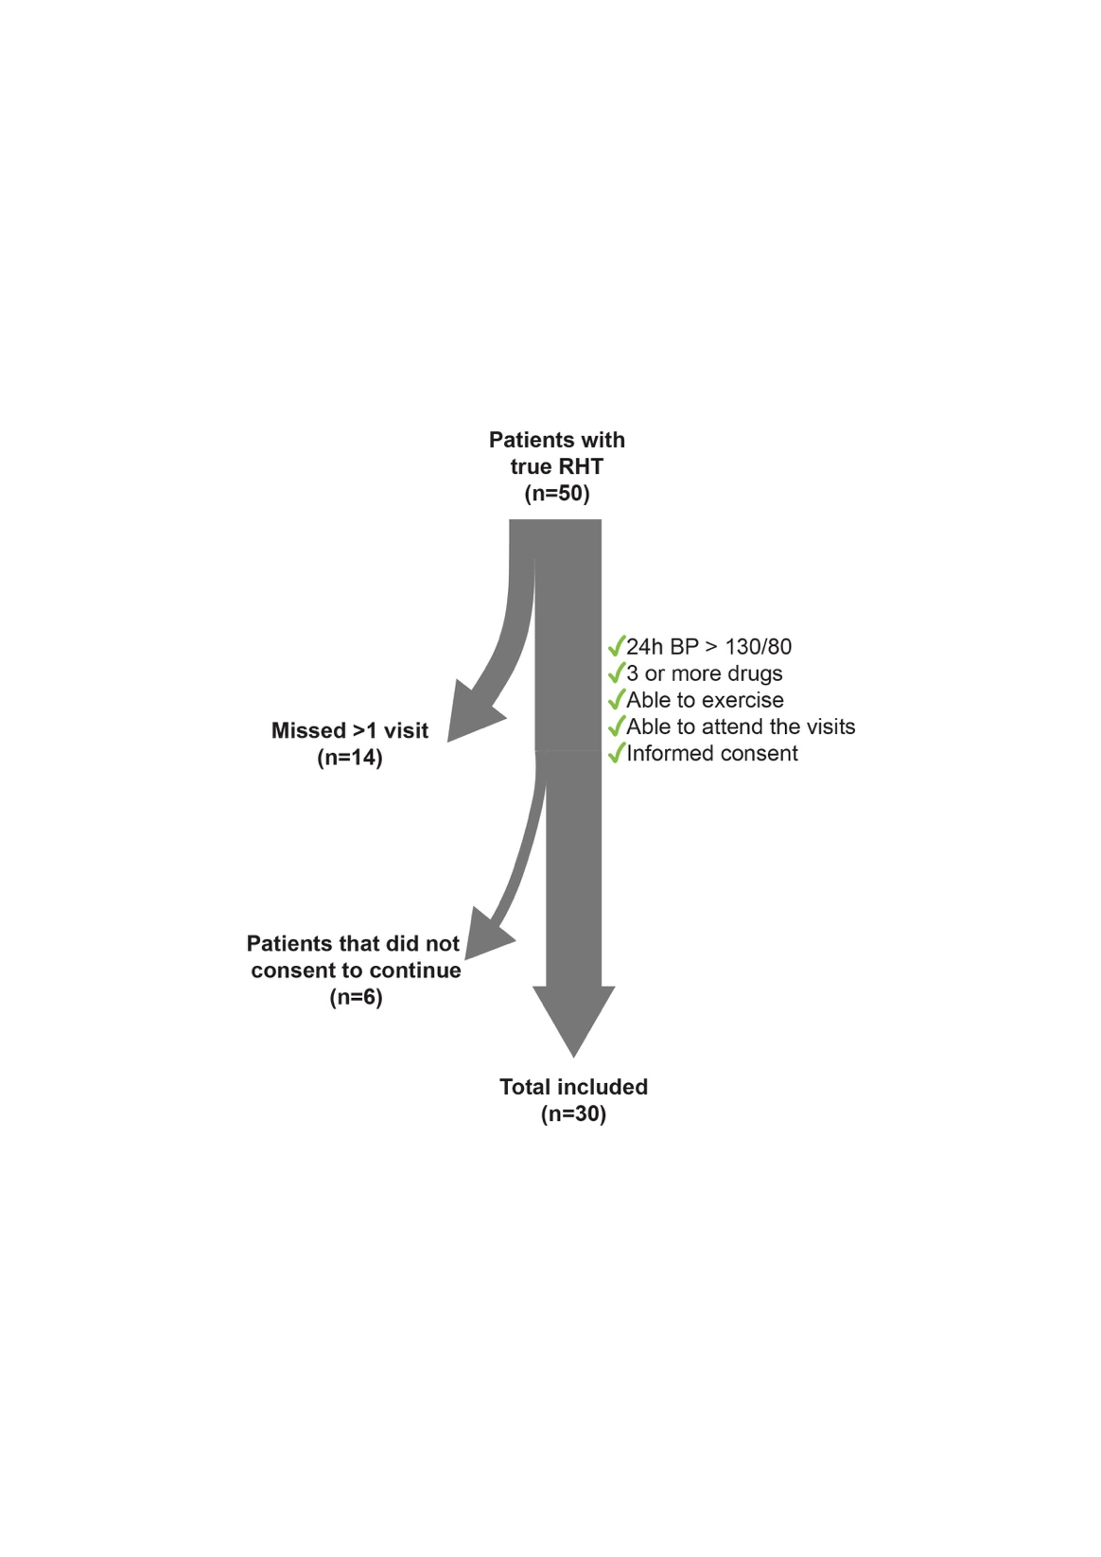
Supplementary Figure S1. Details on trial enrollment. As per protocol, patients who failed to attend all programmed visits were withdrawn from the study.

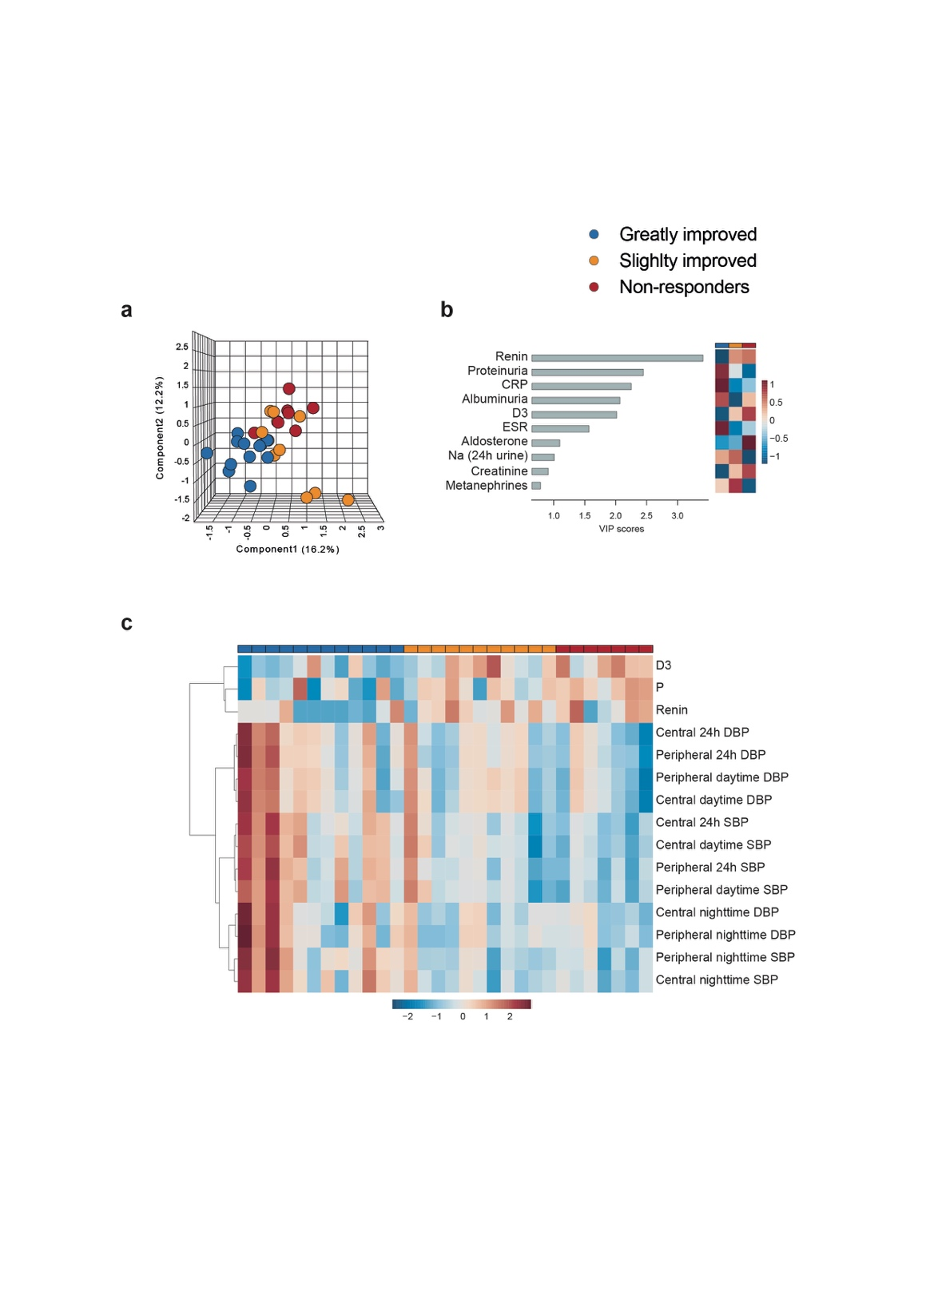
Supplementary Figure S2. Multivariate analysis distinguished patients with different response. (a) Synchronized three-dimensional plots of Partial Least Square – Discriminant Analysis (PLS-DA). (b) Variable importance in projection (VIP) scores of PLS-DA with their relative concentration according to response. (c) Hierarchically clustered heatmap of the top 15 variables with the most discriminant capacity.
CRP: C-reactive protein; D3: vitamin D3; DBP: diastolic blood pressure; ESR: erythrocyte sedimentation rate; GFR: glomerular filtration rate; P: phosphorus (inorganic); SBP: systolic blood pressure.

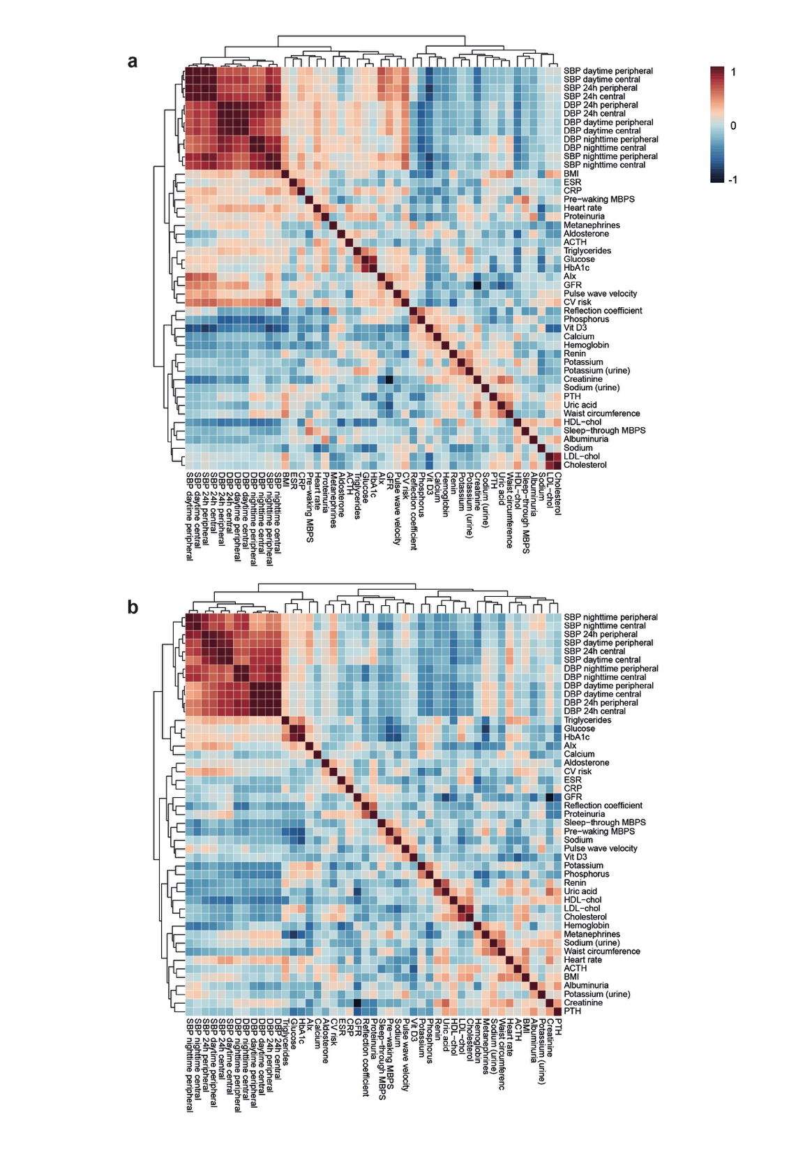
Supplementary Figure S3. Hierarchically clustered correlation heatmaps. Associations between blood pressure and cardiovascular risk were higher at baseline (a) than after intervention (b).
ACTH: adrenocorticotropic hormone; AIx: augmentation index; BMI: body mass index; CRP: C-reactive protein; CV: cardiovascular; DBP: diastolic blood pressure; ESR: erythrocyte sedimentation rate; GFR: glomerular filtration rate; HbA1c: glycated hemoglobin; HDL-chol: high-density lipoprotein cholesterol; LDL-chol: low-density lipoprotein cholesterol; MBPS: morning blood pressure surge; PTH: parathyroid hormone; SBP: systolic blood pressure; Vit D3: vitamin D3.
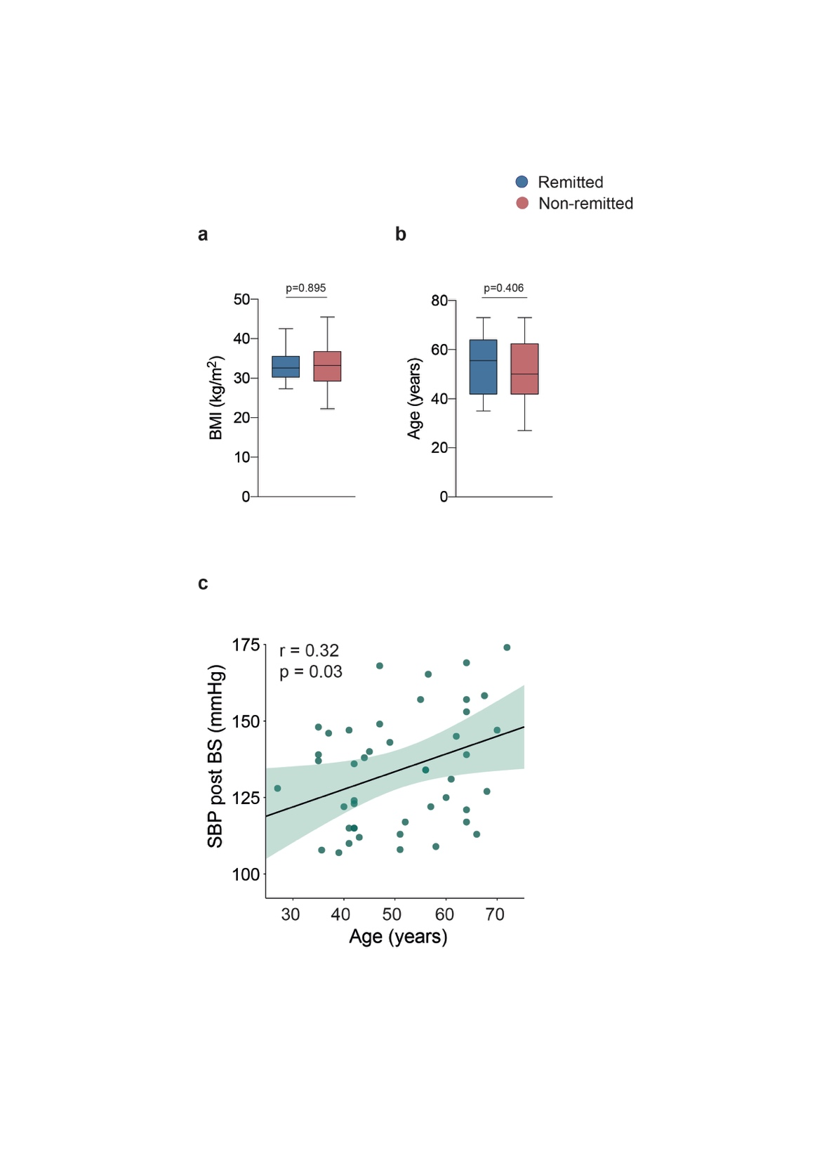
Supplementary Figure S4. Hypertension remission after surgery was dramatic but limited to a significant proportion of patients. Patients with remission had similar (a) reduction in body weight and (b) there were no significant differences in age. (c) Correlation between age and systolic blood pressure.
BMI: body mass index; BS: bariatric surgery; SBP: systolic blood pressure.

