Supplementary information text
Supplementary Tables
Table S1 The primer sequences of Cd and Fe uptake/transport-related genes for qRT-PCR.
Table S2 The P availability content in acid soil.
Table S3 The agronomic traits of FP36 under different Cd and P levels in soil culture.

Table S1 The primer sequences of Cd and Fe uptake/transport-related genes for qRT-PCR.
Gene | Former primers (5’-3’) | Reverse primers (5’-3’)
OsNRAMP1 | GTGATTGCTTCCGATATTCCA | CAACCTCCAGTTTCCTTACCC
OsNRAMP5 | CAGCAGCAGTAAGAGCAAGATGG | GGGAGGTCGTTGTGGATGAGC
OsHMA2 | CAATCCCAAATCGTCAAGGC | CAGCGACACGACCAGAAGAAG
OsHMA3 | AGCCTCCAAGAAGCCAACTG | CAACATTTGGCAACGACGG
OsIRT1 | CGTCGTTCAGGTCCTCGAGATAG | CATCTGGTGGAAGCACATCGC
OsYSL2 | CTAAGAAAGCGACAGATGAGGAT | AACAAGACCAGCAATGACACC
OsYSL15 | AGCAGGGCTCACGGACATCA | TGCTTCACCAGGGTGCCAAC
OsIRO2 | GCTCAGCCACAACGCCTACGA | AACTGAACCCGCCACATTGCT
OsNAS2 | TGTTTGTGCTTCTGTGGGGT | TCGTCGTTGTCCCCTAGAGT
OsFRDL1 | TCACCAATGCTAAGGCCTGC | AACCACGGAAAACACCCTG
OsPT2 | GACGAGACCGCCCAAGAAG | TTTTCAGTCACTCACGTCGAGAC
OsActin | AGGAAGGCTGGAAGAGGACC | CGGGAAATTGTGAGGGACAT

Table S2 The P availability content in acid soil.
Classification of P_{ava} content in acid soil  (mg/kg) | Treatment | Soil P_{ava} content  (mg/kg)
Extreme low-P_{ava} (< 5.5) | +0 mg/kg P | 0.06 ± 0.01d
Low-P_{ava} (5.5-16) | +80 mg/kg P | 8.02 ± 0.26c
Intermediate-P_{ava} (17-34) | +160 mg/kg P | 22.59 ± 0.90b
High-P_{ava} (35-56) | +240 mg/kg P | 35.62 ± 2.76a
P_{ava}, P availability. Data are means ± standard deviation (SD) (n = 3). The different lowercase letters following the data with a column present indicated the level of significance at P < 0.05.

Table S3 The agronomic traits of FP36 under different Cd and P levels in soil culture.
Treatment |  | Plant height  (cm) | Shoot dry weight  (g) | Seed-setting rate  (%) | 1,000-grain weight  (g)
Cd (mg/kg) | P (mg/kg)
0 | 0 | 100.35 ± 3.41bc | 37.20 ± 3.34e | 25.65 ± 2.69bc | 45.80 ± 2.87ab
0 | +80 | 100.90 ± 1.29bc | 44.38 ± 2.38cd | 27.67 ± 1.80b | 47.17 ± 0.48a
0 | +160 | 104.15 ± 2.81a | 51.76 ± 2.81a | 39.48 ± 4.84a | 47.39 ± 2.67a
0 | +240 | 102.57 ± 1.93ab | 48.27 ± 2.64ab | 36.78 ± 3.66a | 46.47 ± 2.06ab
1.0 | 0 | 98.92 ± 1.43c | 34.68 ± 3.78e | 22.77 ± 1.61c | 44.19 ± 2.79b
1.0 | +80 | 99.65 ± 1.45c | 41.29 ± 1.52d | 24.64 ± 2.22bc | 46.37 ± 0.96ab
1.0 | +160 | 101.15 ± 1.26bc | 48.26 ± 2.12ab | 37.15 ± 2.00a | 46.29 ± 1.34ab
1.0 | +240 | 101.03 ± 3.69bc | 47.13 ± 1.52bc | 35.92 ± 1.98a | 46.16 ± 0.64ab
FP36 was cultured in acid soil (pH = 4.8, soil background level of total P was 180 mg/kg) until mature period. Data were means ± standard deviation (SD) (n ≥ 3). The different lowercase letters following the data with a column present indicated the level of significance at P < 0.05.

Supplementary Figures
Fig. S1 The relative expression of OsFRDL1 (A), OsPT2 (B), OsNRAMP5 (C), OsHMA2 (D), and OsHMA3 (E) in the roots of FP36.
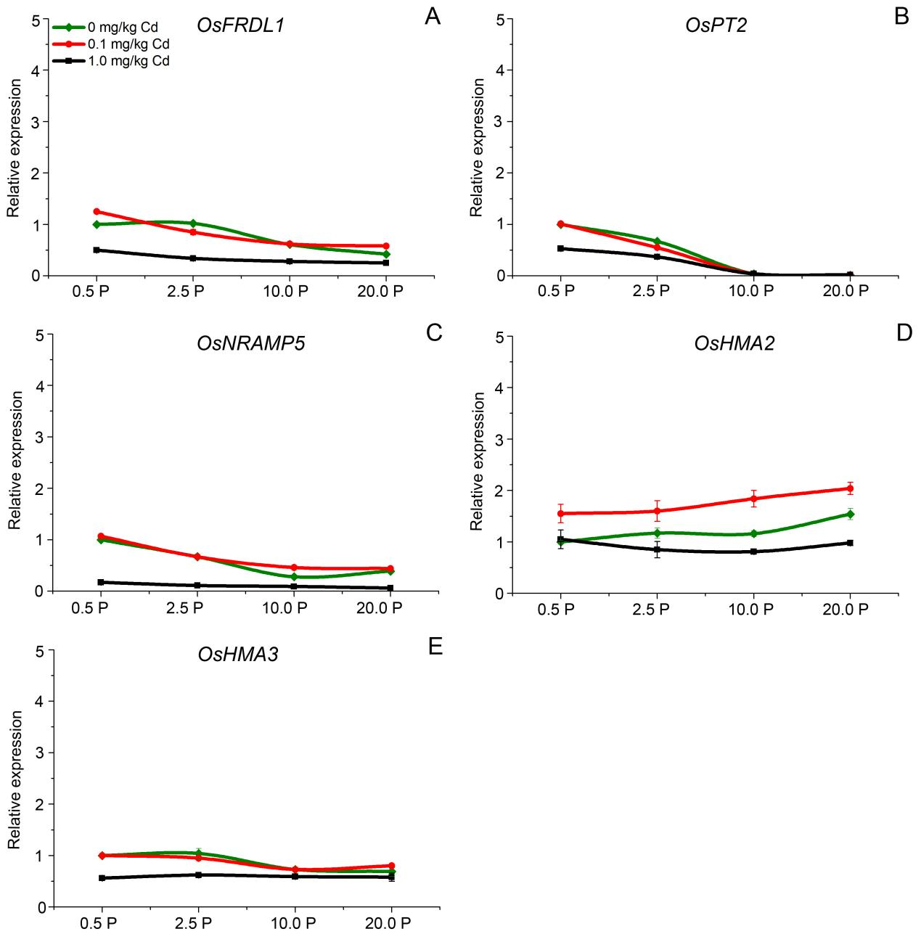
Fig. S1 The relative expression of OsFRDL1 (A), OsPT2 (B), OsNRAMP5 (C), OsHMA2 (D), and OsHMA3 (E) in the roots of FP36. The rice plant (FP36) was exposed to three Cd concentration (0, 0.1, 1.0 mg/kg) and four P levels (0.5, 2.5, 10.0, 20.0 mg/kg) solution for 30 d. Data were from three replicated experiments, and represent means ± standard deviation (SD).

