Additional file
Growth-promoting effects of press water from the mechanical drying of Douglas fir wood chips on lignocellulolytic fungi

Manfred J. Reppke^{1†}, Rebecca Gerstner¹, Elisabeth Windeisen-Holzhauser², Klaus Richter², J. Philipp Benz^{1,3*}

*Correspondence: benz@hfm.tum.de
¹Professorship of Fungal Biotechnology in Wood Science, Holzforschung München, TUM School of Life Sciences, Technical University of Munich, Hans-Carl-von-Carlowitz-Platz 2, 85354 Freising, Germany
²Chair of Wood Science, Holzforschung München, TUM School of Life Sciences, Technical University of Munich, Winzererstr. 45, 80797 Munich, Germany
³Institute for Advanced Study, Technical University of Munich, Lichtenbergstraße 2a, 85748 Garching, Germany
This file contains:
Figure S1
Figure S2
Figure S3
Figure S4
Figure S5
Table S1
Table S2

Supplemental Figures
Fig. S1 Concentration of dissolved sugars in Douglas-fir PW without bark measured in a HPAEC-PAD. Error bars represent the standard deviation (n=3).

Fig. S2 Physico-chemical analysis of press water from Douglas-fir with bark (PWB). a Concentration of macro solids, micro solids and dissolved substances. b Mass percentage of hydrolysate, acid soluble aromatics, and acid insoluble residues of PWB solids after acid hydrolysis. c concentration of dissolved sugars measured with a HPAEC-PAD.

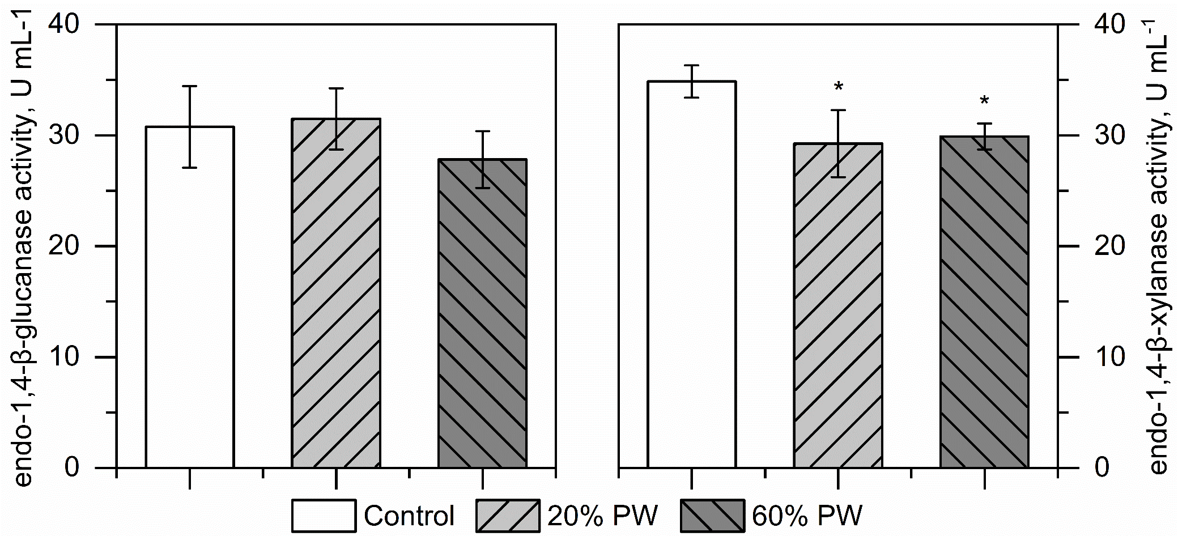
Fig. S3 Endoglucanase and endoxylanase activities of T. reesei RUT-C30 culture supernatants in the presence of increasing PW (% v/v) concentrations. Cultivation in MA medium with 1 % Avicel at 30 °C and 250 rpm. Significant differences (p>0.05) relative to the control are indicated by asterisks.
Fig. S4 Absorbance scan of the culture supernatants of G. applanatum, T. versicolor, and P. chrysosporium cultivated in 50% PW with potato dextrose yeast medium (PDY) in shaking flasks with 30 mL medium, at 100 rpm (50 mm throw), 28 °C. Absorbance in the range of 230 – 800 nm was measured in UV transparent cuvettes. Error bars indicate the standard deviation of biological triplicates. The control was not measured in replicates.

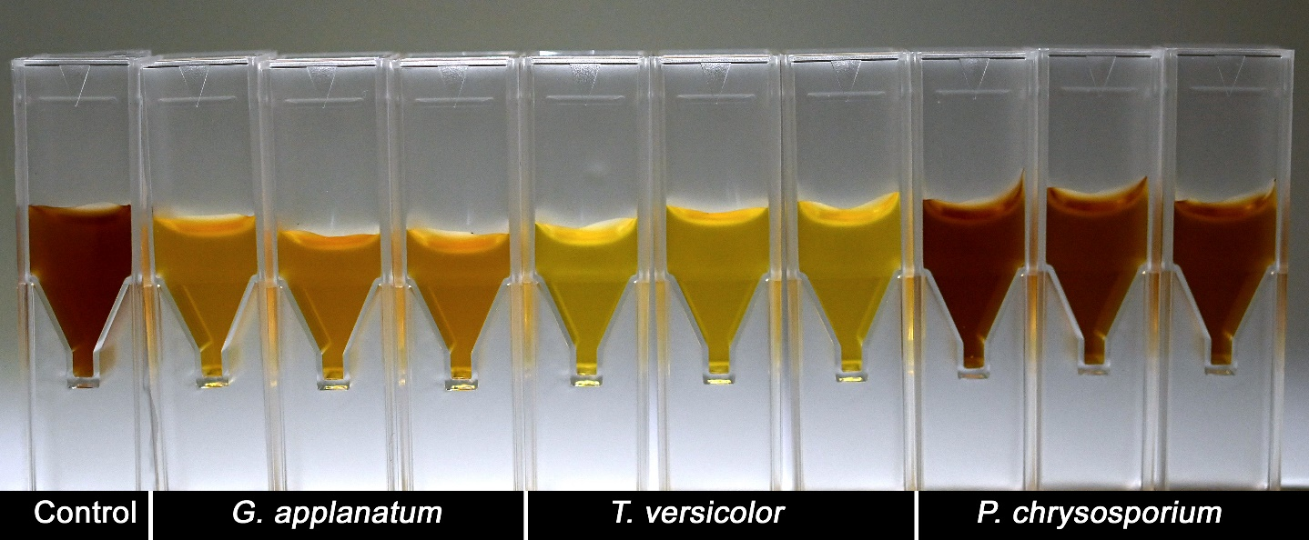
Fig. S5 Photograph of the culture supernatants of G. applanatum, T. versicolor, and P. chrysosporium cultivated in 50% PW with potato dextrose yeast medium (PDY) in shaking flasks with 30 mL medium, at 100 rpm (50 mm throw), 28 °C.
Fig. S6 Chromatogram of the GC/MS of the hydrophobic fraction of dissolved substances in the PW, concentrated with a C18ec SPE cartridge. Chemical formulas for 3-(4-Hydroxyphenyl)-1-propanol and taxifolin are showed. N.i., not identified.

Supplementary Tables
Table S1: Ion concentration in PW Douglas-fir with bark relative to Mandels-Andreotti medium (MA)
 | PW |  |  | MA-medium
 | mg L⁻¹ | mM |  | mM | covered by PW, %
PO₄³⁻ | 34.5 | 0.36 |  | 14.7 | 2.5
SO₄²⁻ | 29.6 | 0.31 |  | 11.85 | 2.6
NH₄⁺ | 4.78 | 0.26 |  | 21.19 | 1.3
NO₃⁻ | < 5 | - |  | - | -
Na⁺ | 50.8 | 2.21 |  | - | -
Ca²⁺ | 133 | 3.32 |  | 2.72 | 122.0
Mg²⁺ | 40.1 | 1.65 |  | 1.22 | 135.2
K⁺ | 109 | 2.79 |  | 14.7 | 19.0
Trace elements
Fe²⁺ | 49.3 | 0.88 |  | 0.02 | 4414.0
Mn²⁺ | 13.8 | 0.25 |  | 0.01 | 2511.9
Zn²⁺ | 1.34 | 0.02 |  | 0.005 | 409.8

Table S2: Compositional analysis of Douglas-fir wood chips (pressed and unpressed) expressed in % of the total weight
 | Extractives | Lignin  insoluble | Lignin  soluble | Rha | Man | Ara | Gal | Xyl | Glu | Sum
 | [%] | [%] | [%] | [%] | [%] | [%] | [%] | [%] | [%] | [%]
pressed | 1.36 | 27.6 | 0.6 | < 0,1 | 13.6 | 0.9 | 2.7 | 3.7 | 46.6 | 97.1
not pressed | 1.53 | 27.3 | 0.7 | < 0,1 | 12.8 | 0.9 | 2.7 | 3.5 | 45.7 | 95.1

