Secondary Attack Rates, Transmission, Incubation and Serial Interval Periods of first SARS-CoV-2 Omicron variant cases in a northern region of Spain.
Supplementary Materials

"This supplementary material is hosted by Eurosurveillance as supporting information alongside the article [Title], on behalf of the authors, who remain responsible for the accuracy and appropriateness of the content. The same standards for ethics, copyright, attributions and permissions as for the article apply. Supplements are not edited by Eurosurveillance and the journal is not responsible for the maintenance of any links or email addresses provided therein."

Table S1. Delta and Omicron cases in Cantabria who underwent contact-tracing program by age group, symptomatic and vaccination state
 | Omicron |  |  | Delta
Age group | n | Had symptoms  n (%) | Unvaccinated  n (%) | n | Had symptoms  n (%) | Unvaccinated  n (%)
< 11 | 59 | 41 (69%9 | 59 (100%) | 270 | 153 (57%) | 270 (100%)
12-17 | 36 | 26 (72%) | 31 (86%) | 46 | 28 (61%) | 31 (67%)
18-29 | 121 | 111 (92%) | 68 (56%) | 107 | 84 (79%) | 44 (41%)
30-39 | 88 | 77 (88%) | 62 (70%) | 204 | 166 (81%) | 70 (34%)
40-49 | 125 | 117 (94%) | 89 (71%) | 331 | 261 (79%) | 94 (28%)
50-59 | 119 | 106 (89%) | 85 (71%) | 280 | 213 (76%) | 63 (22%)
60-69 | 43 | 37 (86%) | 35 (81%) | 265 | 214 (81%) | 48 (18%)
70-79 | 8 | 6 (75%) | 6 (75%) | 139 | 107 (77%) | 17 (12%)
> 80 | 14 | 8 (57%) | 12 (86%) | 53 | 30 (57%) | 7 (13%)
Total | 622 | 534 (86%) | 453 (73%) | 1708 | 1263 (74%) | 646 (38%)

Figure 2A. Transmission periods for Delta cases in Cantabria, November 2021
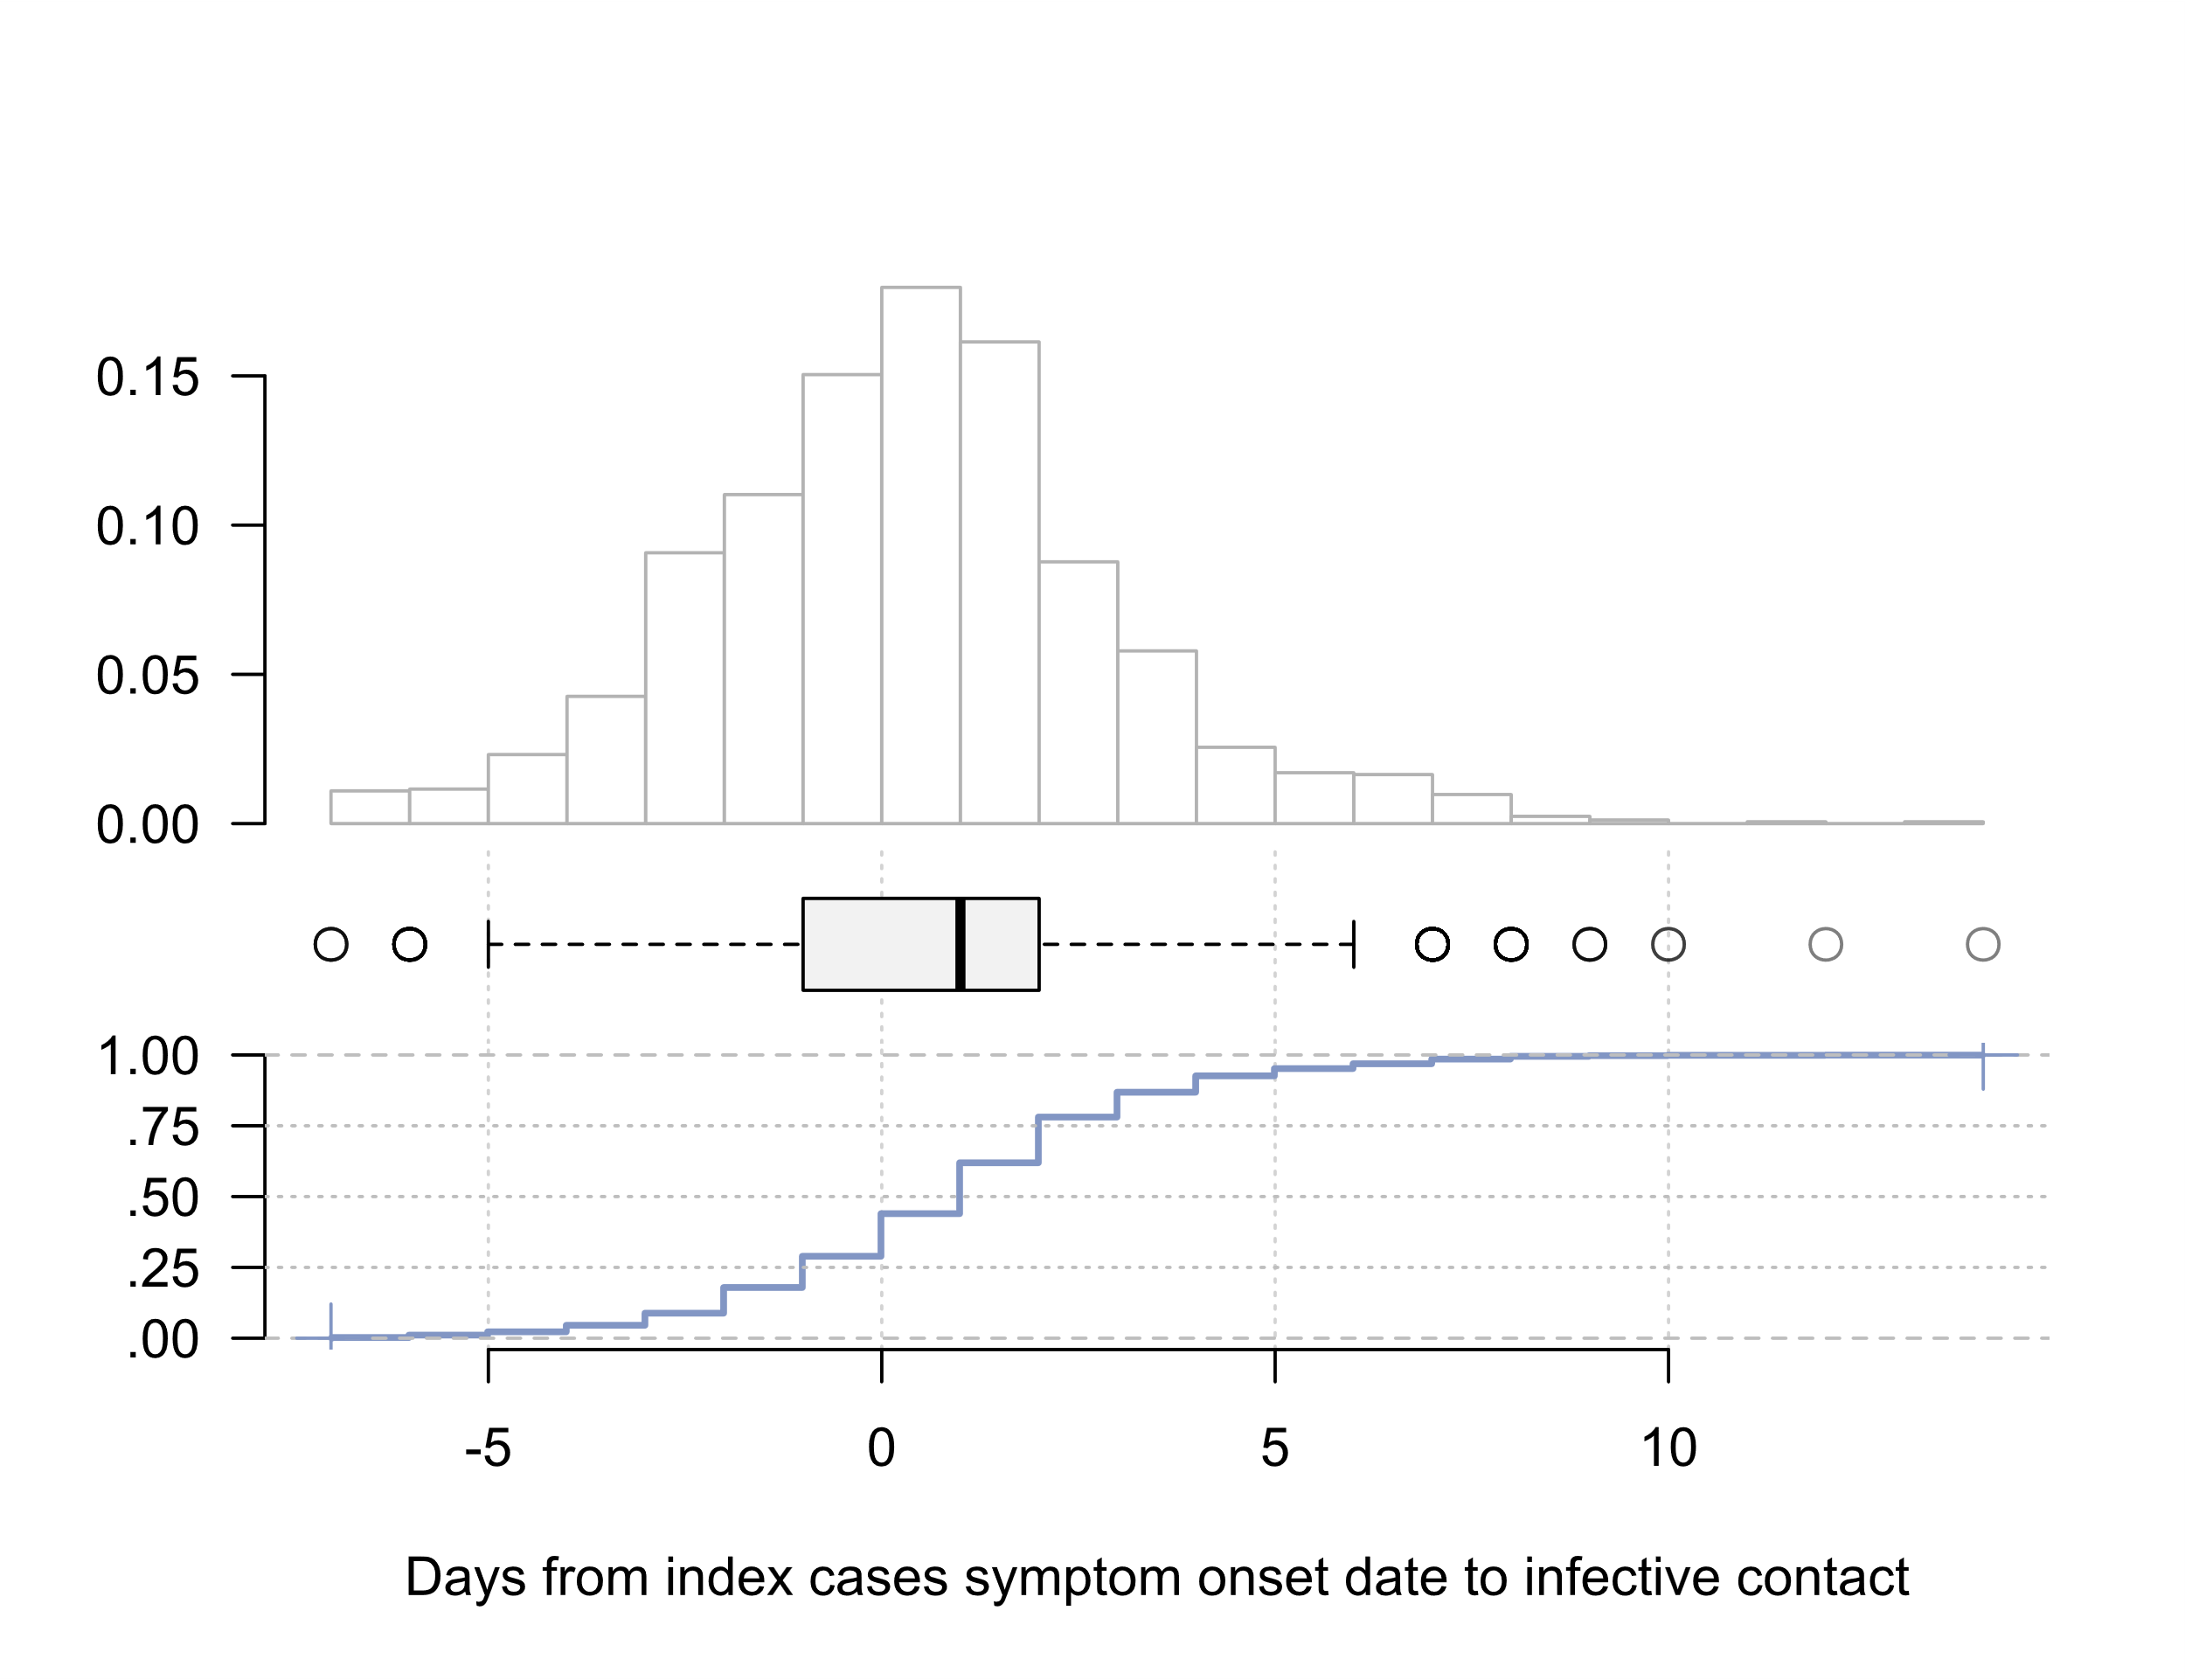
Density plot for the distribution of the calculated time periods (upper figure), boxplot (middle figure) and cumulative distribution function (bottom figure). The x axis is common for the three figures.

Figure 2B. Incubation periods for Delta cases in Cantabria, November 2021
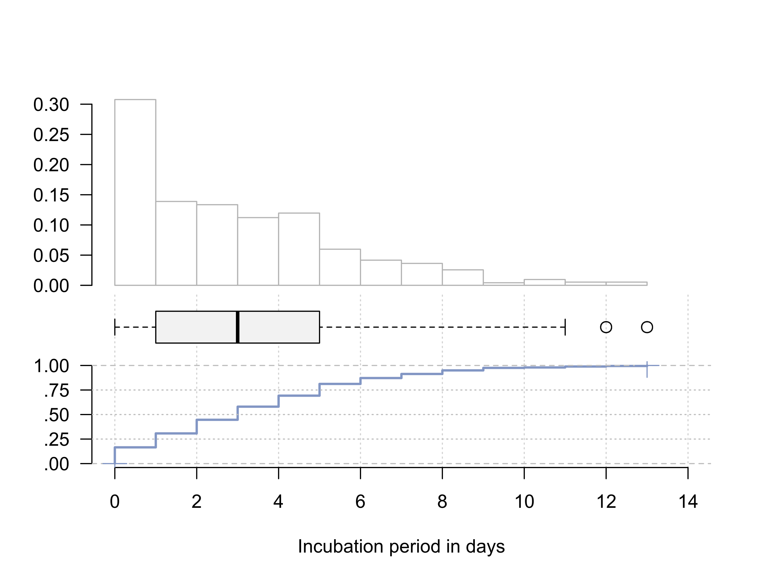
Density plot for the distribution of the calculated time periods (upper figure), boxplot (middle figure) and cumulative distribution function (bottom figure). The x axis is common for the three figures.

Figure 2C. Serial Interval periods for Delta cases in Cantabria, November 2021
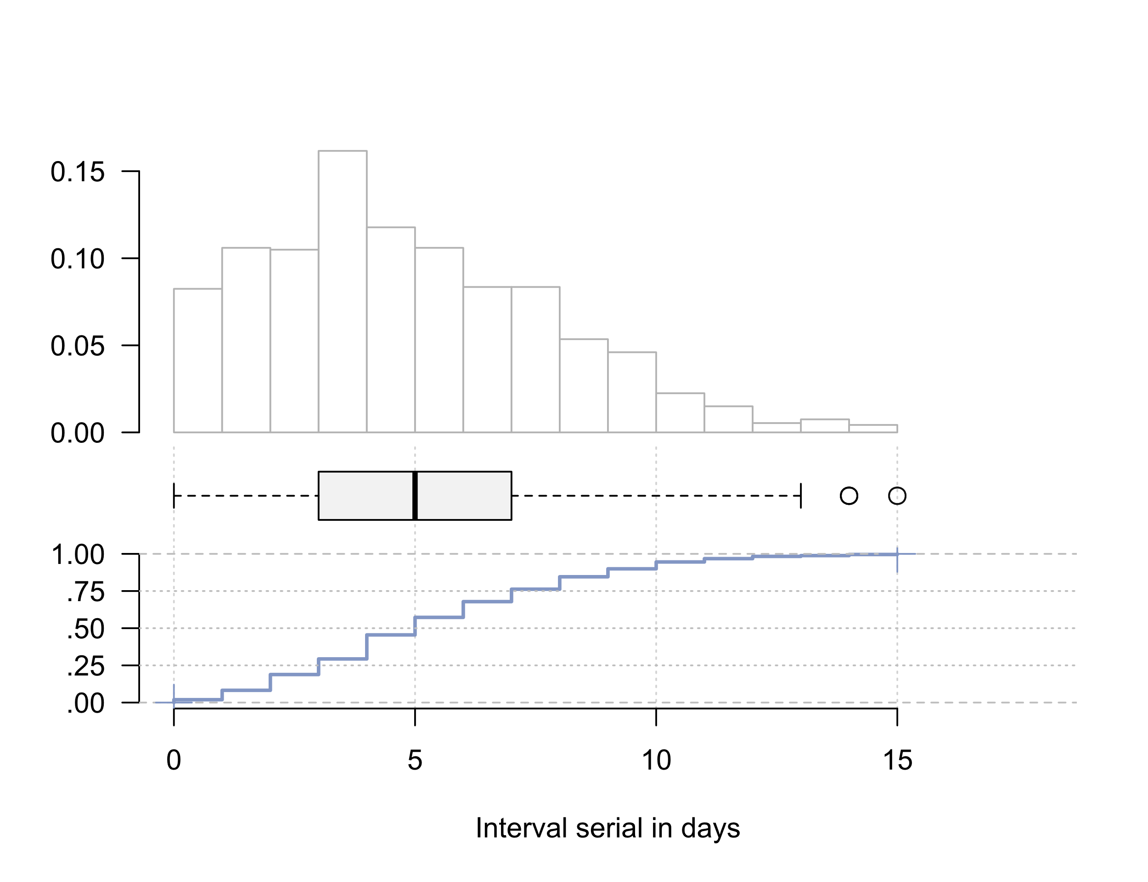
Density plot for the distribution of the calculated time periods (upper figure), boxplot (middle figure) and cumulative distribution function (bottom figure). The x axis is common for the three figures.

