DFT analysis of valproic acid adsorption onto Al₁₂/B₁₂-N₁₂/P₁₂ nanocages with solvent effects
Jamelah S.Al-Otaibi^{a*}, Y.Sheena Mary^{b}, Y.Shyma Mary^{b}
ª Department of Chemistry, College of Science, Princess Nourah bint Abdulrahman University, P.O. Box 84428, Riyadh 11671, Saudi Arabia

^{b} Thushara, Neethinagar-64, Pattathanam, Kollam, Kerala, India
*author for correspondence: jamelah2019@rediffmail.com

Fig.S1a DOS spectrum of VLA
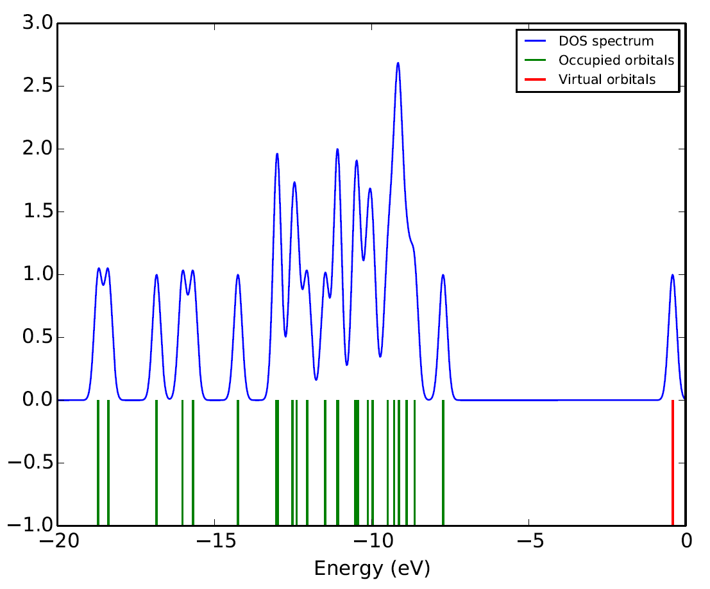

Fig.S1b DOS spectrum of (a) Al12N12 and (b) VLA-Al12N12
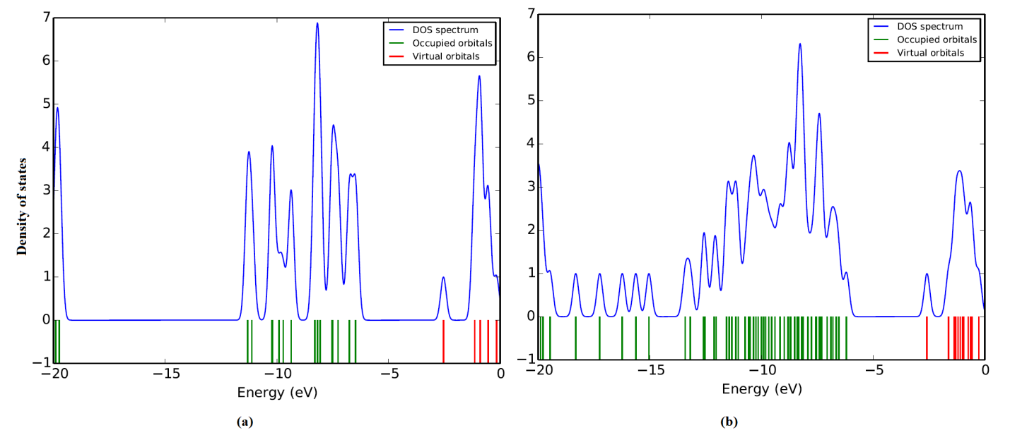
Fig.S1c DOS spectrum of (a) Al12P12 and (b) VLA-Al12P12
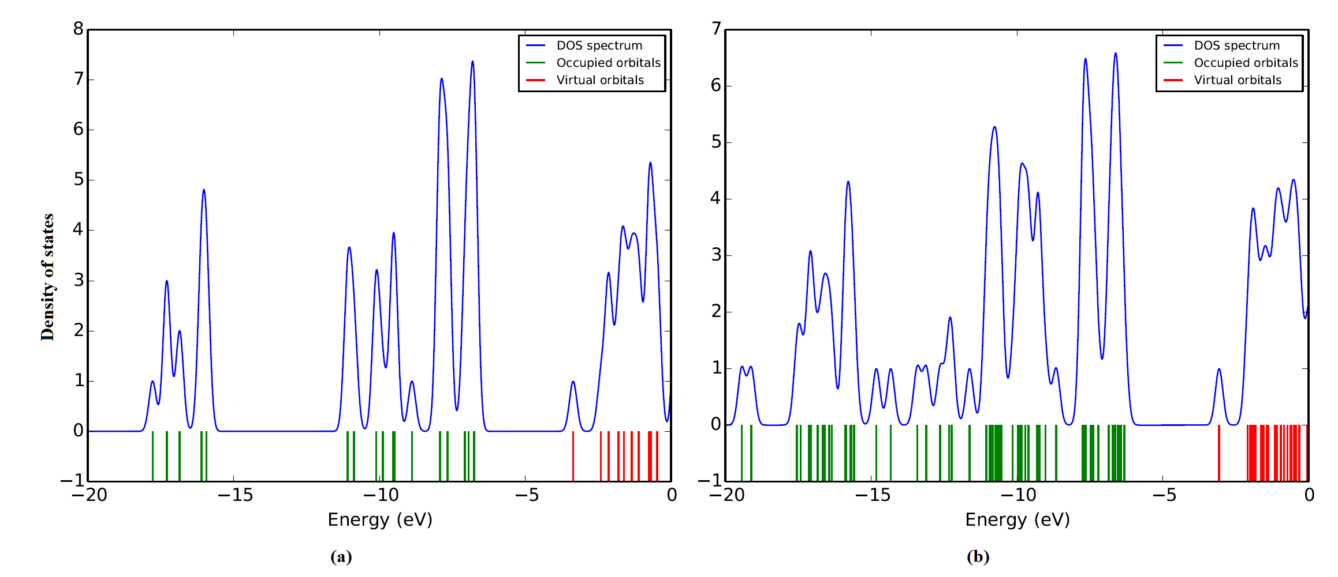
Fig.S1d DOS spectrum of (a) B12N12 and (b) VLA-B12N12
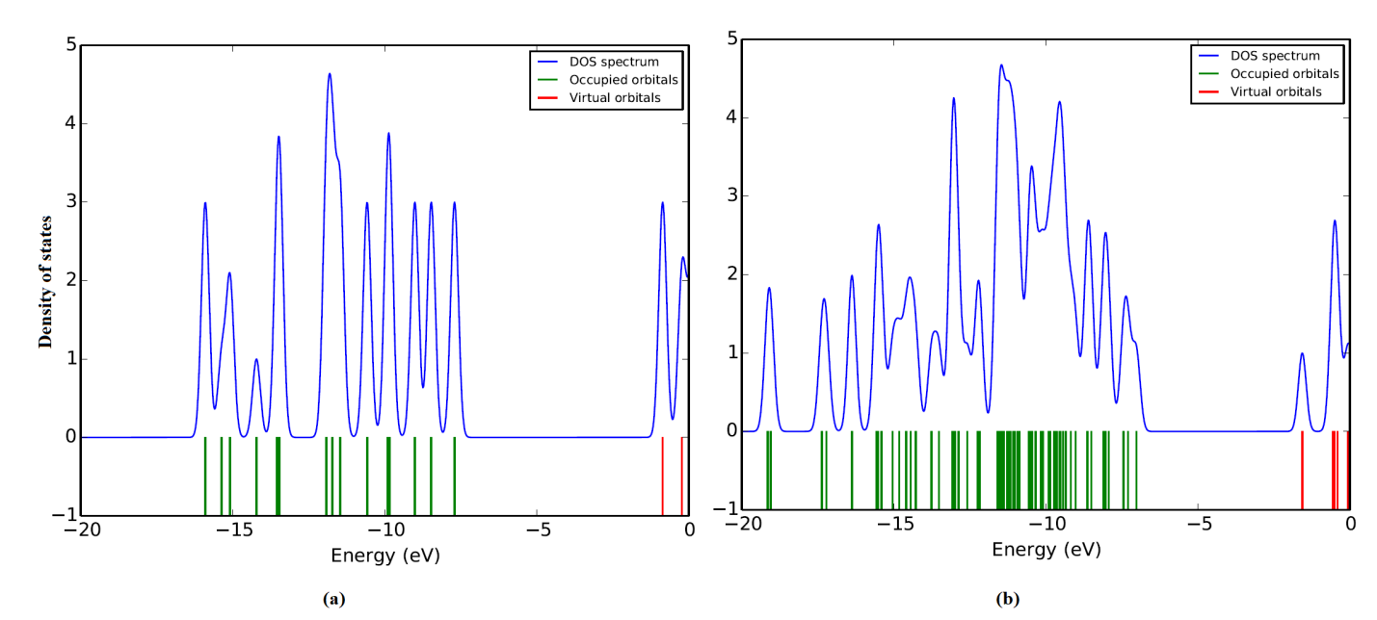
Fig.S1e DOS spectrum of (a) B12P12 and (b) VLA-B12P12
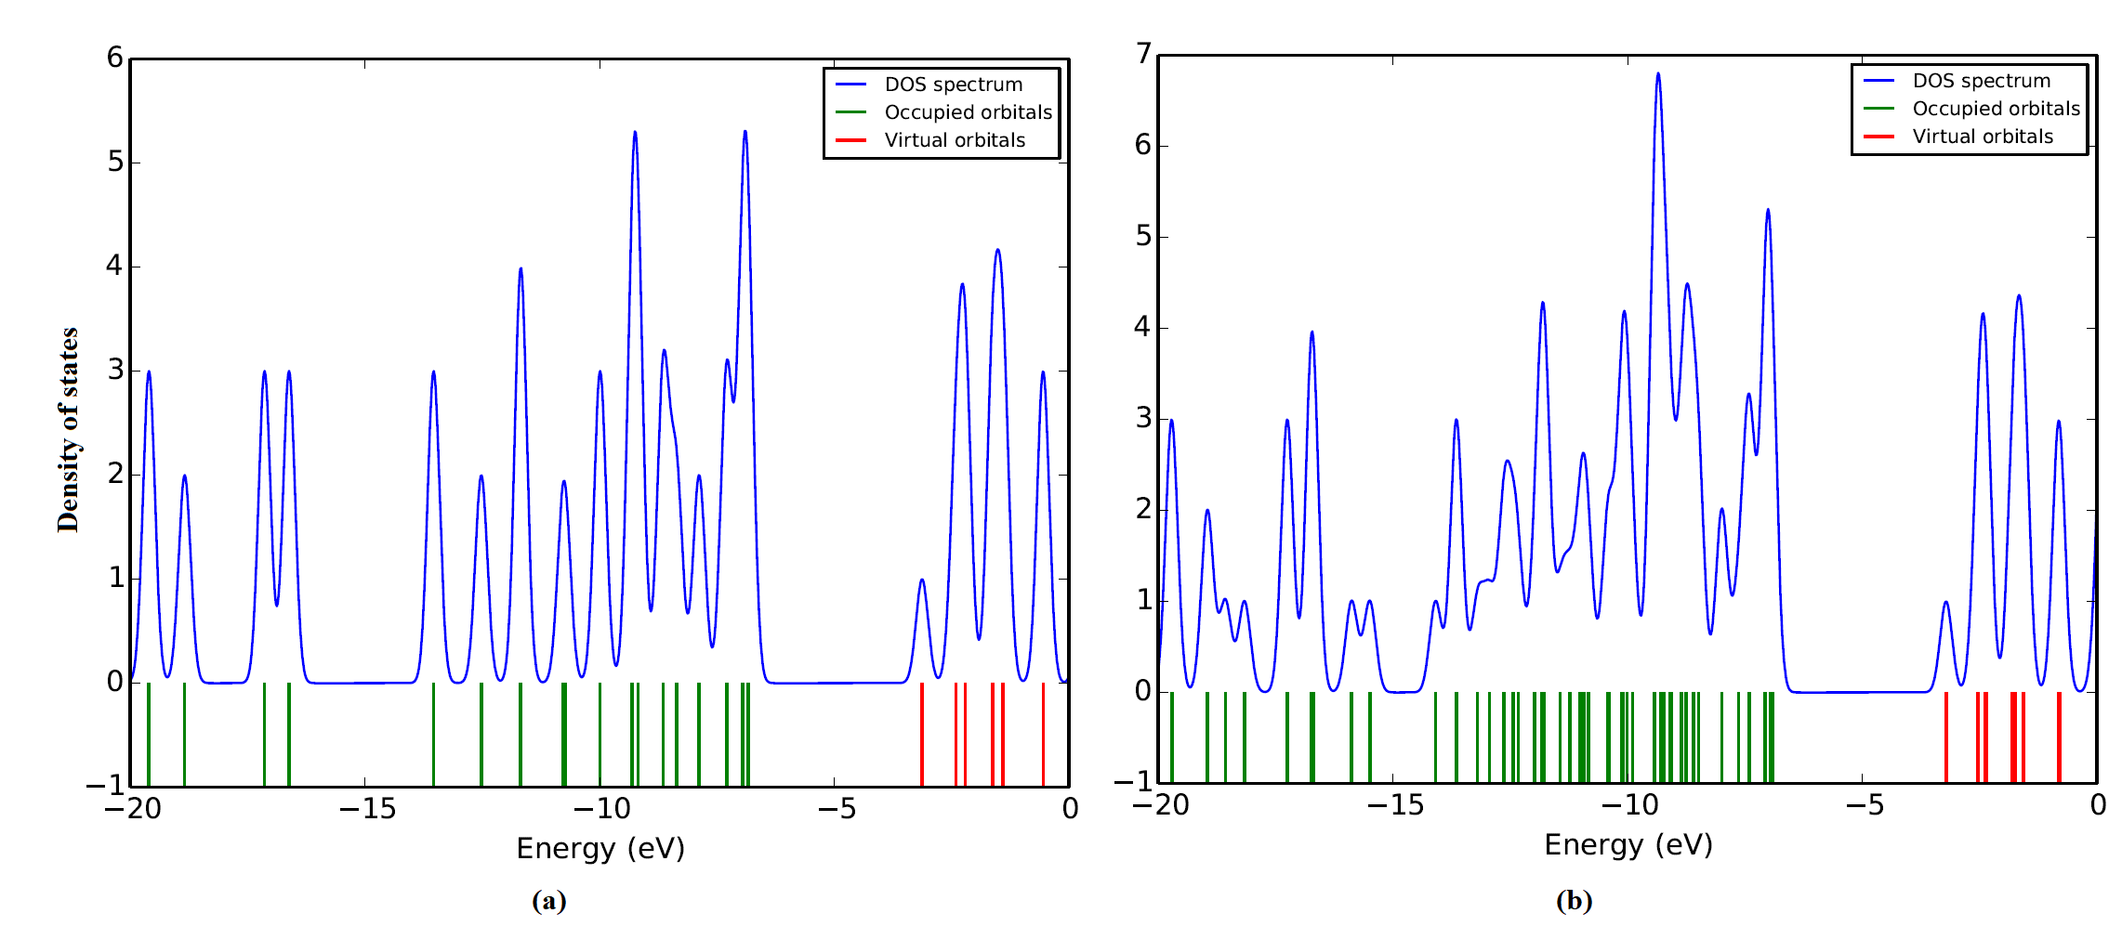

Fig.S2a Theoretical Raman spectrum of VLA

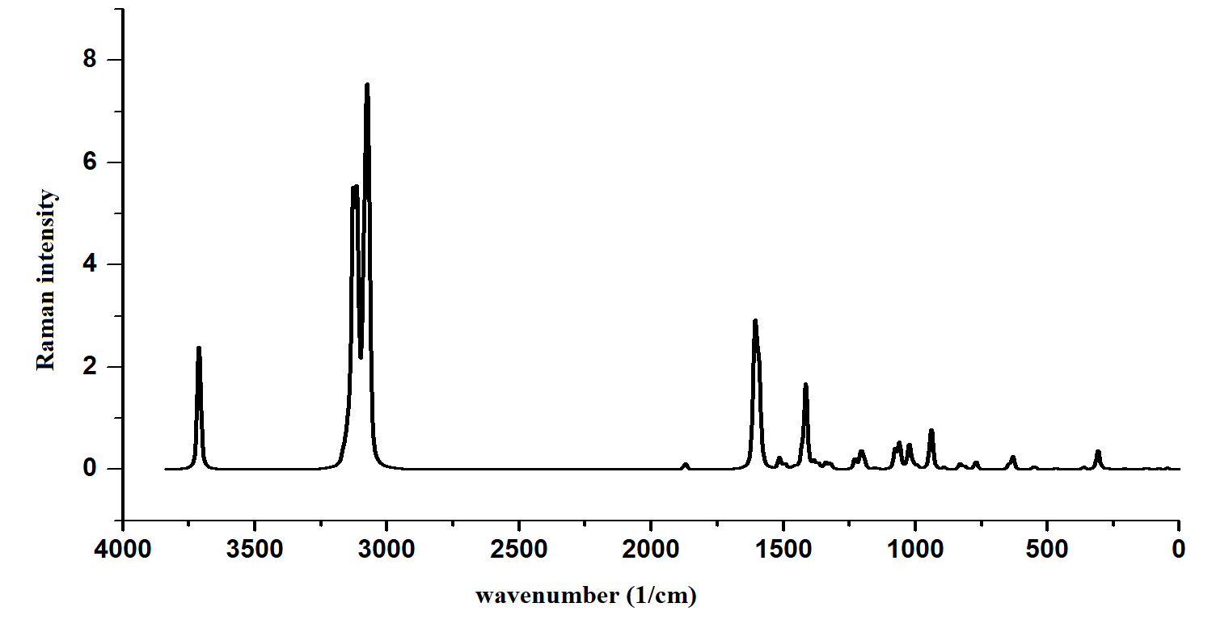

Fig.S2b Theoretical Raman spectrum of VLA-NCs in the range 3500-2000 cm⁻¹
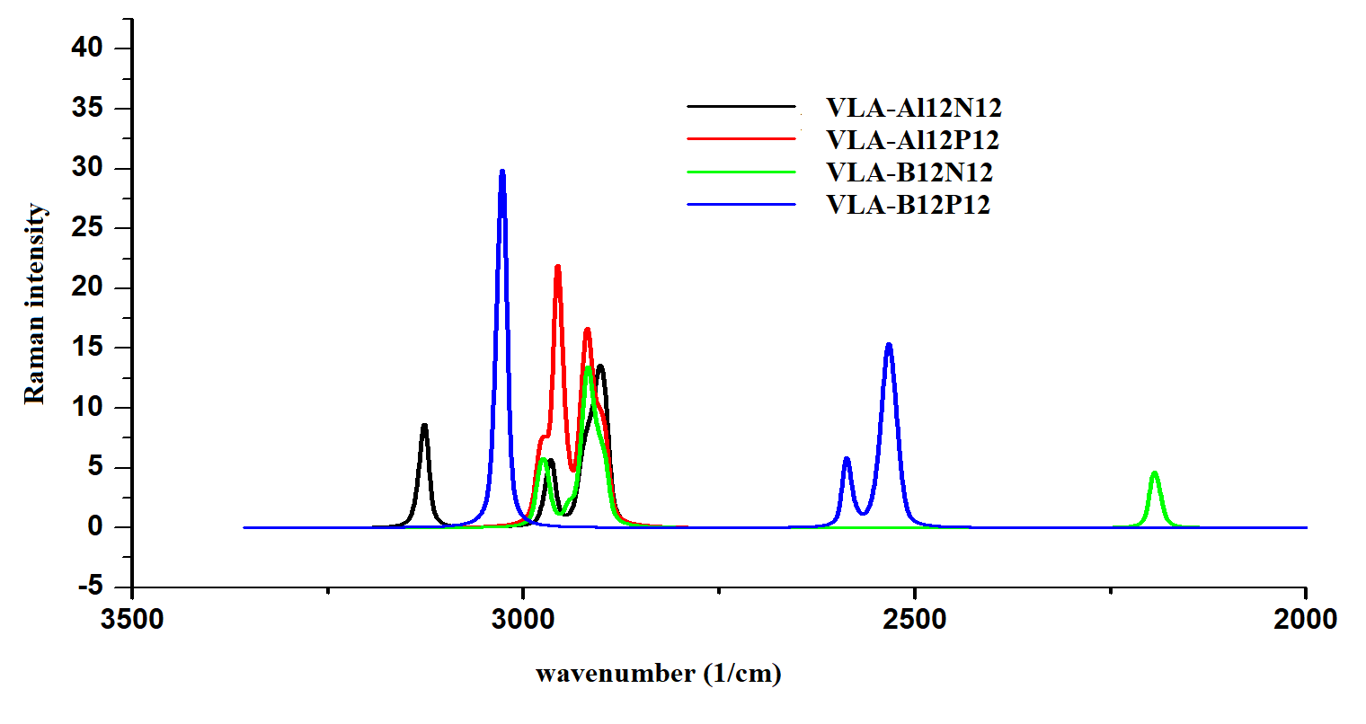
Fig.S2c Theoretical Raman spectrum of VLA-NCs in the range 2000-0 cm⁻¹

