Figure S1: Overview of modeling approach and signature analysis.
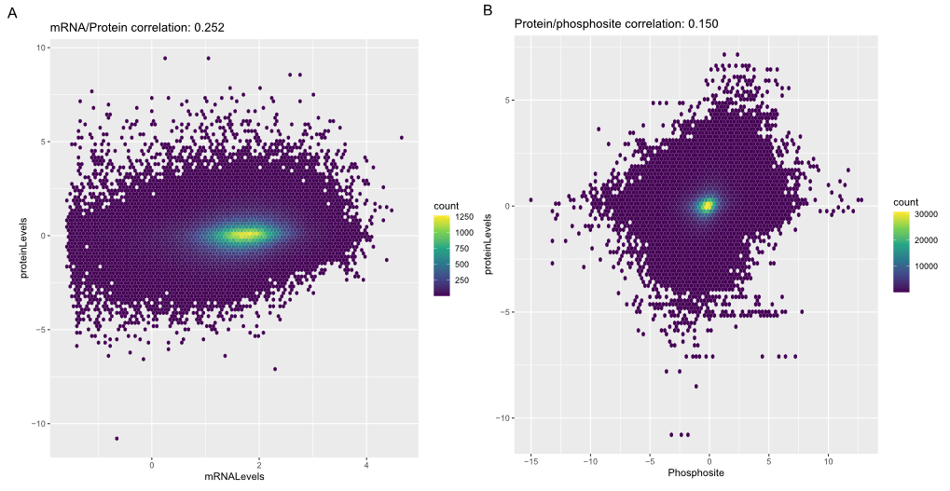Figure S2: Correlation analysis of mRNA, protein, and phosphosite across all patient samples.
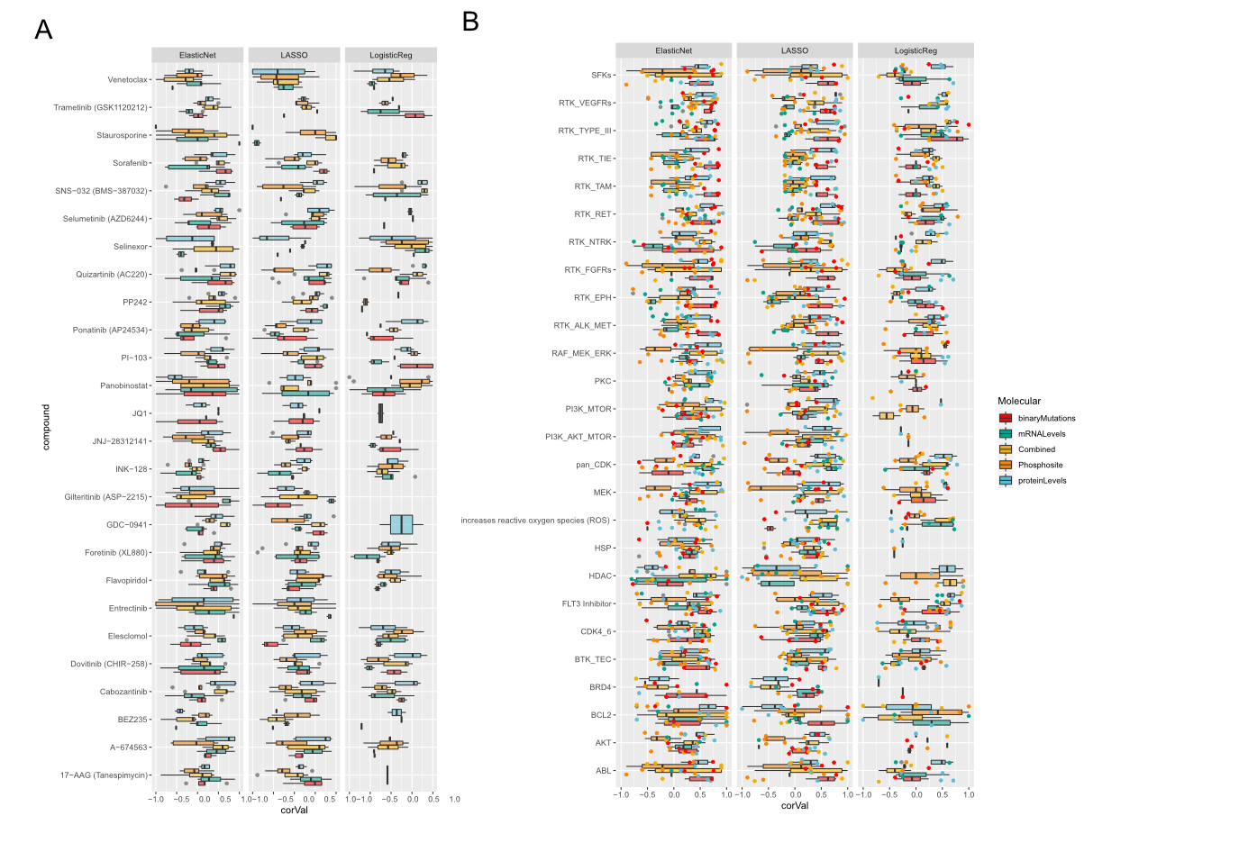 Figure S3: Correlation of held-out test data with predicted values across various model and data combinations. (A) Spearman rank correlation of predicted AUC of drug response across individual drugs measured using a Logistic regression, LASSO regression, and Elastic Net regression. We evaluated each model using mutation data (red), mRNA levels, (green), protein levels (blue), phosphosite measuremetns (orange) or all data elements combined (yellow). (A) Performance of each of the cross-validated models separated out by drug. (B) Performance of each of the models trained by drug family.

