Supporting information

A Columnar Liquid Quasicrystal - Honeycomb with Triangular, Square and Trapezoidal Cells
Xiangbing Zeng^{1,}*, Benjamin Glettner², Ute Baumeister², Bin Chen², Goran Ungar^{1,3}, Feng Liu³ & Carsten Tschierske²
¹Department of Materials Science and Engineering, Sheffield University, Sheffield S1 3JD, UK.
²Institute of Chemistry, Martin Luther University Halle-Wittenberg, Kurt-Mothes-Strasse 2, Halle/Saale D-06120, Germany.
³State Key Laboratory for Mechanical Behaviour of Materials, Shaan-xi International Research Centre for Soft Matter, Xi’an Jiaotong University, Xi’an, 710049, P. R. China.
*x.zeng@shef.ac.uk

1. Synthesis and analytical data
Compound 1 was synthesized as reported in ref. ^{S} and purified by columns chromatography, eluent: CHCl₃/MeOH = 10/1 (V/V), followed by repeated crystallization from ethyl acetate; colorless solid; ¹H-NMR (CDCl₃, J/Hz, 400 MHz) = 7.50 (d, ³J(H,H) = 8.7, 2 H, Ar-H), 7.49 (d, 3J(H,H) = 8.7, 2 H, Ar-H), 7.30 (d, ³J(H,H) = 7.7, 1 H, Ar-H), 7.16 (dd, ³J(H,H) = 7.7, ⁴J(H,H) = 1.5, 1 H, Ar-H), 7.11 (d, ⁴J(H,H) = 1.5, 1 H, Ar-H), 6.93 (d, ³J(H,H) = 8.7, 2 H, Ar-H), 6.88 (d, ³J(H,H) = 8.7, 2 H, Ar-H), 4.11 (t, ³J(H,H) = 4.6, 2 H, OCH₂), 3.96 (t, ³J(H,H) = 5.9, 2 H, OCH₂), 3.94 ((t, ³J(H,H) = 5.9, 2 H, OCH₂), 3.91 (s, 2 H, OCH₂), 3.73 (t, ³J(H,H) = 4.6, 2 H, OCH₂), 3.63-3.50 (m, 12 H, OCH₂), 1.81-1.75 (m, 4 H, CH₂), 1.49-1.41 (m, 4 H, CH₂), 1.39-1.20 (m, 28 H, CH₂), 0.89-0.86 (m, 6 H, CH₃). ¹³C-NMR (CDCl₃, 126 MHz)  = δ 175.03 (C=O), 158.80, 158.13, 155.93, 140.87, 133.09, 130.78, 130.52, 130.41, 128.92, 127.96, 119.51, 114.77, 113.89, 111.46 (Aryl-C), 70.76, 70.28, 69.84, 69.73, 69.59, 69.21, 68.33, 68.09, 68.00 (OCH₂), 31.90, 31.59, 29.68, 29.64, 29.61, 29.46, 29.36, 29.34, 29.26, 26.10, 25.73, 22.66, 22.59 (CH₂), 14.09, 14.01 (CH₃). HRMS (m/z): [M+H+Na]⁺ calcd. for C₅₀H₇₆O₉Na, 843.5382; found: 843.5354. Anal. calc. for C₅₀H₇₅O₉Na·0.5 H₂O: C, 70.47; H, 8.99 %. Found: C, 70.74; H, 8.84 %.

Figure S1. ¹H-NMR spectrum of compound 1 (CDCl₃, 400 MHz).

Figure S2. ¹³C-NMR spectrum of compound 1 (CDCl₃, 126 MHz).

2. Methods
2.1 Optical methods and DSC
Phase transitions were determined by polarizing microscopy (Leica DMR XP) in conjunction with a heating stage (FP 82 HT, Mettler) and controller (FP 90, Mettler) and by differential scanning calorimetry (DSC 8000, Perkin Elmer) at heating/cooling rates of 10 K min⁻¹ (peak temperatures). If not otherwise noted transition temperatures and –enthalpies were taken from the second heating and cooling curve. Optical investigation was carried out under equilibrium conditions between glass slides which were used without further treatment, sample thickness was ~15 µm. A full wavelength retardation plate was used to determine the sign of birefringence. Optical micrographs were taken using a Leica MC120HD camera.

2.2 X-ray scattering experiments and data analysis
Powder X-ray scattering and aligned samples. Powder X-ray investigations were carried out with a Guinier film camera (Huber), samples in glass capillaries (∅ 1 mm) in a temperature-controlled heating stage, quartz-monochromatized CuK_{α} radiation, 30 to 60 min exposure time, calibration with the powder pattern of Pb(NO₃)₂. Aligned samples were obtained on a glass plate. Alignment was achieved upon slow cooling (rate: 1 K⋅min⁻¹ – 0.01 K⋅min⁻¹) of a small droplet of the sample and takes place at the sample–glass or at the sample–air interface, with domains fiber-like disordered around an axis perpendicular to the interface. The aligned samples were held on a temperature-controlled heating stage and the diffraction patterns were recorded with a 2D detector (HI-STAR, Siemens).

Synchrotron X-ray diffraction experiments. High-resolution small-angle powder diffraction experiments were recorded on Beamline I22 of the Diamond Light Source. Samples were held in evacuated 1 mm capillaries. A modified Linkam hot stage was used, with a hole for the capillary drilled through the silver heating block and mica windows attached to it on both sides. A 2D detector was used to record the diffraction pattern which is then converted by integration into 1D q-space. Q calibration and linearization were verified using several orders of layer reflections from silver behenate and a series of n-alkanes. To keep samples dry, the samples prepared in glass capillaries were vacuumed in melt and then sealed.

Grazing incidence X-ray diffraction (GIXRD) experiments were carried out on Beamline BM28, ESRF at Grenoble, and station BL40B2 at Spring-8, Japan. Thin film samples were prepared from melt on silicon substrates. The diffraction patterns were recorded on 2D CCD detectors. The thin film samples were placed on top of a heating stage for temperature control. To keep the samples dry, the samples were flushed with dry helium at BM28, and kept under vacuum at Spring-8, during the GIXRD.

Reconstruction of electron density maps. Fourier reconstruction of the electron density was carried out using the general formula for 2-d periodic systems:

ρ(xy) = Σ_{hk} F(hk) exp[2πi(hx+ky)] = Σ_{hk} exp[2πi(hx+ky) + iφ(hk)]

Specific formulae for the different plane groups can be found in International Tables of Crystallography.

2.3 Simulation of diffraction intensities of DDLQC
The easiest way to calculate the Fourier transform of a dodecagonal quasiperiodic structure is to view it as a 2D cut in a 4D periodic structure with dodecagonal symmetry.^{S} Each lattice vector in the imaginary 4D periodic structure can be expressed as
$L^{4D} = n_{0}a_{0}+n_{1}a_{1}+n_{2}a_{2}+n_{3}a_{3}$,
where a₀, a₁, a₂ and a₃ are the basis vectors of the 4D dodecagonal lattice and n₀, n₁, n₂ and n₃ are integers. The projection of the 4D basis vectors in the real 2D space (also called the parallel space) in Cartesian coordinates are
$$a_{j∥}=a_{∥}\left(\cos{\frac{jπ}{6}},\sin{\frac{jπ}{6}}\right), j=0,1,2,3.$$
The projection of the 4D basis vectors in other two-dimensional space (called the perpendicular space as it is perpendicular to the real or the parallel space) in Cartesian coordinates are
$$a_{j⊥}=a_{⊥}\left(\cos{\frac{j5π}{6}},\sin{\frac{j5π}{6}}\right), j=0,1,2,3.$$
For simplicity normally it is assumed that a|| = a⊥ = a and a is the characteristic length of the quasiperiodic lattice. The 4D reciprocal lattice vectors q_{j} can be defined with the condition that $a_{j}∙q_{k}=2πδ_{jk}$.
The 4D periodic structure is decorated at each lattice point with a super-atom in 4D, the electron density of which can be expressed by function f(r||)g(r⊥). The Fourier transform of the 4D super-atom is therefore F(q||)G(q⊥), where F(q||) and G(q⊥) are the Fourier transform of f(r||) and g(r⊥) in the parallel and perpendicular spaces respectively.
The electron density of the 4D periodic structure ρ(r) can thus be expressed as
$$ρ\left(r\right)=\sum_{h1,h2,h3,h4}{F\left(q_{∥}=h_{0}q_{0∥}+h_{1}q_{1∥}+h_{2}q_{2∥}+h_{3}q_{3∥}\right)G\left(q_{⊥}=h_{0}q_{0⊥}+h_{1}q_{1⊥}+h_{2}q_{2⊥}+h_{3}q_{3⊥}\right)\exp\left(iq_{∥}{∙r}_{∥}\right)exp\left(iq_{⊥}{∙r}_{⊥}\right)}$$
Therefore a 2D cut of the 4D structure at $r_{⊥}=0$$$ρ\left(r_{∥}\right)=\sum_{h1,h2,h3,h4}{F\left(q_{∥}(h_{1},h_{2},h_{3},h_{4}\right))G\left(q_{⊥}(h_{1},h_{2},h_{3},h_{4})\right)\exp\left(iq_{∥}{∙r}_{∥}\right)}$$
Function g(r⊥) defines the shape of the super-atom in the perpendicular space, and for the generation of a quasiperiodic structure in the parallel space,
$$g\left(r_{⊥}\right)=\left\{\begin{matrix}1 & r_{⊥}∈A \\ 0 & r_{⊥}∉A\end{matrix}\right.$$
Where A is a shape with dodecagonal symmetry in the perpendicular space. A superatom on a 4D lattice point L(n₀, n₁, n₂, n₃)=L||+L⊥ would only contribute to the $ρ\left(r_{∥}\right)$ at $r_{⊥}=0$, if –L⊥$∈A$. Normally A is central symmetric so this is equivalent to L⊥$∈A$ and
$$ρ\left(r_{∥}\right)=f(r_{∥})⨂δ(L_{∥},L_{⊥}∈A)$$
Therefore, the decoration in the parallel space, of a quasiperiodic lattice defined by the selection rule that $L_{⊥}∈A$, by convolution with $f(r_{∥})$ at each lattice point, has its Fourier transform at reciprocal lattice point
$$F(h_{0},h_{1},h_{2},h_{3})= F\left(q_{∥}(h_{0},h_{1},h_{2},h_{3}\right))G\left(q_{⊥}(h_{0},h_{1},h_{2},h_{3})\right)$$
And diffraction intensity
$$I\left(h_{0},h_{1},h_{2},h_{3}\right)∝|F\left(h_{0},h_{1},h_{2},h_{3}\right)|^{2}$$

2.4 Fourier transform of the acceptance domains
The acceptance domains used to generate the quasiperiodic lattice are defined in Figure 4a of the main text. There are two types of lattice points, the first (blue dots in Figure 4b) defined by the blue (3 overlapping squares) acceptance domains, which we shall call the inner acceptance domain. There is also an outer acceptance domain, the boundary of which are two overlapping hexagons, and its difference with the inner domain defines the second type of lattice points (the pink ones inside octagons, Figure 4b).
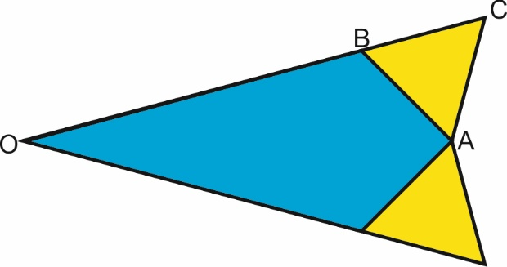
Figure S3. A sector of the inner and outer acceptance domains.
Fourier Transform of the inner (3 squares) acceptance domain is that of the blue shape shown in Figure S3, plus its equivalents (rotation by 30° for 12 times altogether). The coordinate of A is (1,0), B is $\left(\frac{3+\sqrt{3}}{6},\frac{3-\sqrt{3}}{6}\right)$.
$$F_{B}=\int_{0}^{\frac{3+\sqrt{3}}{6}}{dx\int_{-(2-\sqrt{3})x}^{(2-\sqrt{3})x}{cos⁡(q_{x}x+q_{y}y)dy}}+\int_{\frac{3+\sqrt{3}}{6}}^{1}{dx\int_{x-1}^{1-x}{cos⁡(q_{x}x+q_{y}y)dy}}=F_{B}^{A}+F_{B}^{B}$$
$$F_{B}^{A}=\int_{0}^{\frac{3+\sqrt{3}}{6}}{dx\int_{-\left(2-\sqrt{3}\right)x}^{\left(2-\sqrt{3}\right)x}{\cos\left(q_{x}x+q_{y}y\right)dy}}=\int_{0}^{\frac{3+\sqrt{3}}{6}}{dx}{\left.\frac{\sin\left(q_{x}x+q_{y}y\right)}{q_{y}}\right|}_{y=-\left(2-\sqrt{3}\right)x}^{y=\left(2-\sqrt{3}\right)x}=\int_{0}^{\frac{3+\sqrt{3}}{6}}{\frac{sin⁡\{\left[q_{x}+{\left(2-\sqrt{3}\right)q}_{y}\right]x\}}{q_{y}}dx}-\int_{0}^{\frac{3+\sqrt{3}}{6}}{\frac{sin⁡\{[\left(q_{x}-{\left(2-\sqrt{3}\right)q}_{y}\right]x\}}{q_{y}}dx}$$
$$=\frac{1-cos⁡\{\frac{3+\sqrt{3}}{6}\left[q_{x}+{\left(2-\sqrt{3}\right)q}_{y}\right]\}}{q_{y}\left[q_{x}+{\left(2-\sqrt{3}\right)q}_{y}\right]}-\frac{1-cos⁡\{\frac{3+\sqrt{3}}{6}\left[q_{x}-{\left(2-\sqrt{3}\right)q}_{y}\right]\}}{q_{y}\left[q_{x}-{\left(2-\sqrt{3}\right)q}_{y}\right]}$$
In special cases
$$F_{B}^{A}=\left\{\begin{aligned}\frac{1}{6} { q}_{x}=q_{y}=0 \\ \frac{1}{3}\frac{sin⁡(\frac{3+\sqrt{3}}{6}q_{x})}{\frac{3+\sqrt{3}}{6}q_{x}}-\frac{1}{6}{\left(\frac{\sin\left(\frac{3+\sqrt{3}}{12}q_{x}\right)}{\frac{3+\sqrt{3}}{12}q_{x}}\right)}^{2} { q}_{y}=0 \\ \frac{1}{6}{\left(\frac{sin⁡(\frac{3+\sqrt{3}}{6}q_{x})}{\frac{3+\sqrt{3}}{6}q_{x}}\right)}^{2}{ q}_{x}=±(2-\sqrt{3})q_{y}\end{aligned}\right.$$
$$F_{B}^{B}=\int_{\frac{3+\sqrt{3}}{6}}^{1}{dx\int_{x-1}^{1-x}{\cos\left(q_{x}x+q_{y}y\right)dy}}=\int_{\frac{3+\sqrt{3}}{6}}^{1}{dx}{\left.\frac{\sin\left(q_{x}x+q_{y}y\right)}{q_{y}}\right|}_{y=x-1}^{y=1-x}=\int_{\frac{3+\sqrt{3}}{6}}^{1}{\frac{sin⁡\left[{(q}_{x}-q_{y})x+q_{y}\right]}{q_{y}}dx}-\int_{\frac{3+\sqrt{3}}{6}}^{1}{\frac{sin⁡\left[{(q}_{x}+q_{y})x-q_{y}\right]}{q_{y}}dx}$$
$$=\frac{cos⁡[q_{x}-\frac{3-\sqrt{3}}{6}(q_{x}-q_{y})]-\cos{q_{x}}}{q_{y}(q_{x}-q_{y})}-\frac{cos⁡[q_{x}-\frac{3-\sqrt{3}}{6}(q_{x}+q_{y})]-\cos{q_{x}}}{q_{y}(q_{x}+q_{y})}$$

In special cases
$$F_{B}^{B}=\left\{\begin{aligned}\frac{2-\sqrt{3}}{6} { q}_{x}=q_{y}=0 \\ -\frac{1}{3}\frac{\sin\left(\frac{3+\sqrt{3}}{6}q_{x}\right)}{\frac{3+\sqrt{3}}{6}q_{x}}+\frac{2(\cos{\frac{3+\sqrt{3}}{6}q_{x}}-\cos{q_{x}})}{q_{x}^{2}} { q}_{y}=0 \\ \frac{3-\sqrt{3}}{6}\frac{\sin{q_{x}}}{q_{x}}+\frac{\cos{q_{x}}-\cos{{\frac{\sqrt{3}}{3}q}_{x}}}{2q_{x}^{2}}{ q}_{x}=±q_{y}\end{aligned}\right.$$
Fourier Transform of the outer (2 hexagons) acceptance domain is that of the blue shape + yellow plus its equivalents (rotation by 30°, 12 times altogether). The coordinate of A is (1,0), C is $\left(\frac{3+2\sqrt{3}}{6},\frac{\sqrt{3}}{6}\right)$.
$$F_{O}=\int_{0}^{1}{dx\int_{-(2-\sqrt{3})x}^{(2-\sqrt{3})x}{cos⁡(q_{x}x+q_{y}y)dy}}+2\int_{1}^{\frac{3+2\sqrt{3}}{6}}{cos⁡(q_{x}x)dx\int_{(2+\sqrt{3})(x-1)}^{(2-\sqrt{3})x}{cos⁡(q_{y}y)dy}}=F_{O}^{C}+F_{O}^{D}$$

$$F_{O}^{C}=\frac{1-cos⁡\left[q_{x}+{\left(2-\sqrt{3}\right)q}_{y}\right]}{q_{y}\left[q_{x}+{\left(2-\sqrt{3}\right)q}_{y}\right]}-\frac{1-cos⁡\left[q_{x}-{\left(2-\sqrt{3}\right)q}_{y}\right]}{q_{y}\left[q_{x}-{\left(2-\sqrt{3}\right)q}_{y}\right]}$$
In special cases
$$F_{O}^{C}=\left\{\begin{aligned}2-\sqrt{3} { q}_{x}=q_{y}=0 \\ 2(2-\sqrt{3})\frac{sinq_{x}}{q_{x}}-(2-\sqrt{3})\frac{\sin^{2}q_{x}}{q_{x}^{2}} { q}_{y}=0 \\ (2-\sqrt{3})\frac{\sin^{2}q_{x}}{q_{x}^{2}}{ q}_{x}=±(2-\sqrt{3})q_{y}\end{aligned}\right.$$

$$F_{O}^{D}=\frac{2}{q_{y}}\left(\frac{\cos\left[q_{x}+{\left(2-\sqrt{3}\right)q}_{y}\right]-\cos{\{{\frac{3+2\sqrt{3}}{6}\left[q_{x}+{\left(2-\sqrt{3}\right)q}_{y}\right]}}\}}{q_{x}+{\left(2-\sqrt{3}\right)q}_{y}}-\frac{\cos\left[q_{x}-{\left(2-\sqrt{3}\right)q}_{y}\right]-\cos{\{{\frac{3+2\sqrt{3}}{6}\left[q_{x}-{\left(2-\sqrt{3}\right)q}_{y}\right]}}\}}{q_{x}-{\left(2-\sqrt{3}\right)q}_{y}}+\frac{\cos{q_{x}}-\cos{\{q_{x}+{\frac{2\sqrt{3}-3}{6}\left[q_{x}+{\left(2+\sqrt{3}\right)q}_{y}\right]}}\}}{q_{x}+{\left(2+\sqrt{3}\right)q}_{y}}-\frac{\cos{q_{x}}-\cos{\{q_{x}+{\frac{2\sqrt{3}-3}{6}\left[q_{x}-{\left(2+\sqrt{3}\right)q}_{y}\right]}}\}}{q_{x}-{\left(2+\sqrt{3}\right)q}_{y}}\right)$$
In special cases
$$F_{O}^{C}=\left\{\begin{aligned}\frac{7}{6}\sqrt{3}-2 { q}_{x}=q_{y}=0 \\ -\left(4-2\sqrt{3}\right)\frac{sinq_{x}}{q_{x}}+4\sqrt{3}\frac{cosq_{x}-cos{\frac{3+2\sqrt{3}}{6}q}_{x}}{q_{x}^{2}} { q}_{y}=0 \\ \end{aligned}\right.$$
For the four terms of F_{O}^{D}, in addition
$$F_{O}^{D}\left(1\right)=0 when q_{x}=-(2-\sqrt{3})q_{y}$$
$$F_{O}^{D}\left(2\right)=0 when q_{x}=(2-\sqrt{3})q_{y}$$
$$F_{O}^{D}\left(3\right)=-\frac{\sqrt{3}}{3}\frac{sinq_{x}}{q_{x}} when q_{x}=-(2+\sqrt{3})q_{y}$$
$$F_{O}^{D}\left(4\right)=-\frac{\sqrt{3}}{3}\frac{sinq_{x}}{q_{x}} when q_{x}=(2+\sqrt{3})q_{y}$$

2.5 Decoration of the lattice points
As stated in the main text, we used a cylindrical function f(r) to decorate each lattice point of the quasiperiodic lattice. f(r) has an electron density minimum at r = 0 (representing the aliphatic chains at the corners of the columns), and a maximum at r = $ρa_{∥}$, representing the high electron density polar groups which tend to accumulate at the centres of the tiles at a particular distance $ρa_{∥}$ from the corners (Fig. 4f, top).
$$f\left(r\right)=δ\left(r=ρa_{∥}\right)⊗A_{1}g\left(r,σ_{1}\right)-A_{2}g(r,σ_{2})$$
Here $g\left(r,σ_{1}\right)$ is a Gaussian function with standard deviation $σ_{1}$. The reason for the selection of this function is that it produces a very good match to the experimental electron density maps, and its Fourier transform in 2D can be readily calculated.
We have also added the condition that the integration of f(r) is 0, therefore the Fourier transform of f(r), F^{deco}(q) should be 0 at q=0, and
$$F^{deco}\left(q\right)∝J_{0}\left(qρa_{∥}\right)\exp{(-2q^{2}σ_{1}^{2})}-\exp{(-2q^{2}σ_{2}^{2})}$$
Combining the above equations, the structure factor of a diffraction peak can be calculated using
$$F\left(h_{0},h_{1},h_{2},h_{3}\right)=\left[2*F_{inner}\left(q_{⊥}\right)+3*F_{outer}\left(q_{⊥}\right)\right]*F^{deco}\left(q_{∥}\right)$$
Here F_{inner} is the Fourier transform of the inner acceptance domain, F_{outer} that of the outer acceptance domain, the coefficients 2 and 3 take into account that there are 5 pairs of molecules joining at each blue lattice point, but only 3 pairs of molecules (on average) joining each pink lattice point.
Fitting to the experimental diffraction intensities are carried out using ρ, σ₁, and σ₂ as fitting parameters, and the best-fit values are ρ = 0.605a||, σ₁ = 0.141a||, and σ₂ = 0.746a||.

3. Additional Data
3.1 DSC traces
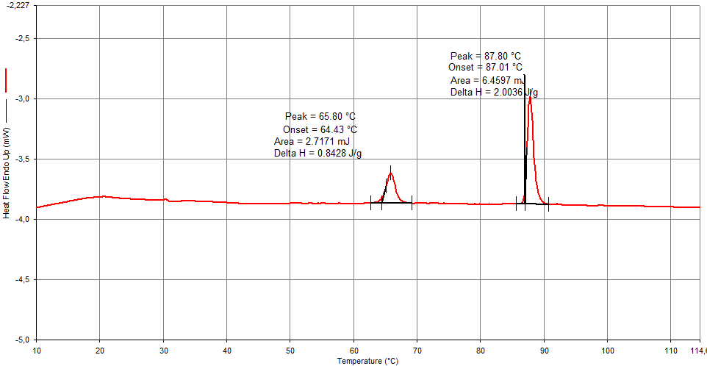
a)
CLQC
p4gm^{L}
Heating
Iso
Col_{hex} + Cr
Col_{hex}
b)
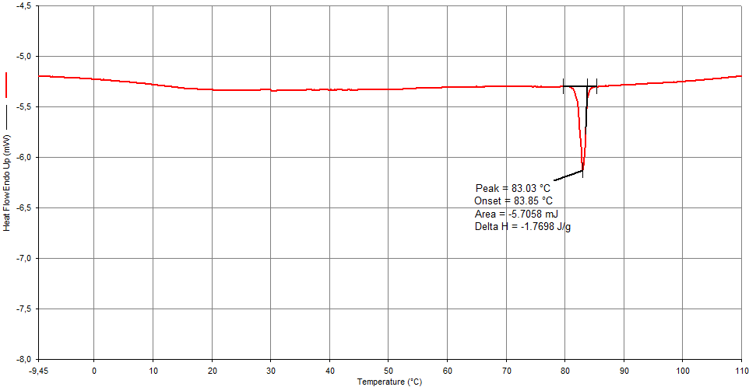
Cooling
P6/mmm
Iso
p4gm^{L}
Col_{hex}C
CLQC
c)
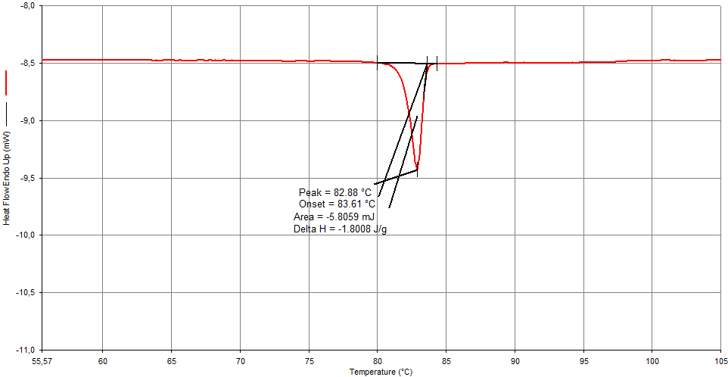
CLQC
P6/mmm
Iso
p4gm^{L}
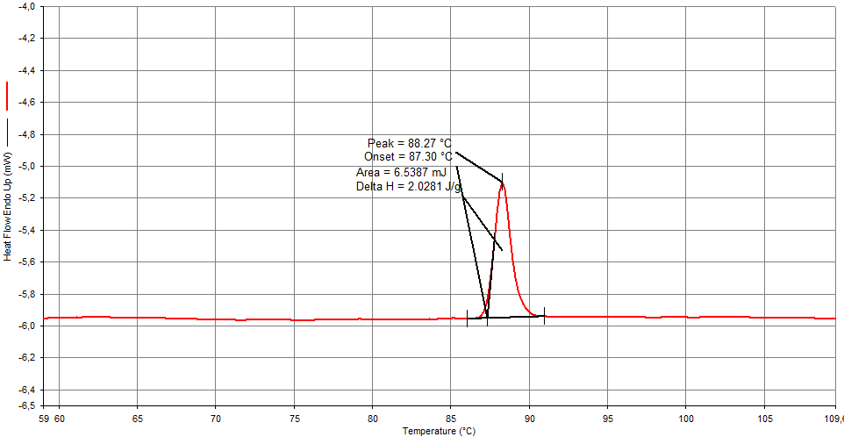
p4gm^{L}
CLQC
Col_{hex}C
Iso
d)
Figure S4. DSC traces of 1 (10K min⁻¹): a) second heating, b) second cooling; the peak around 88 °C on heating involves both, the CLQC→P6/mmm and the P6/mmm→ Iso transition; the peak at 66 °C is likely to be due to a partial crystallization. The continuous phase transition without measurable enthalpy were taken from the SAXS data.; c,d) show cooling to 55 °C with following heating, note the absence of the peak at 66 °C.

3.2 Textures
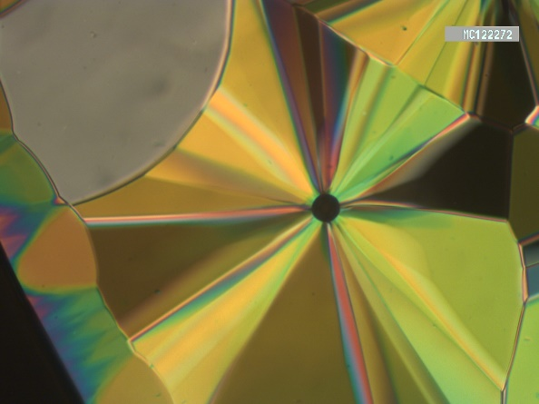  P6/mmm, 83 °C  100 μm  (a) | 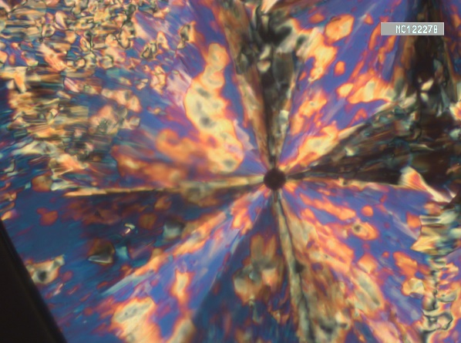  CLQC, 77 °C  (b)
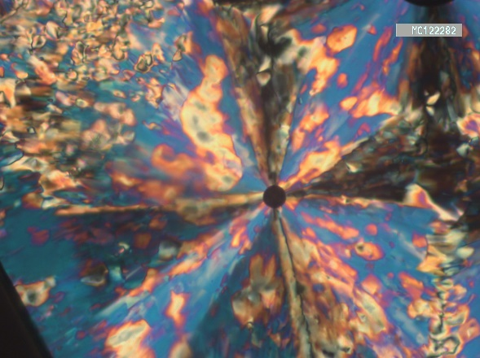  p4gm^{L}, 67 °C  (c) | 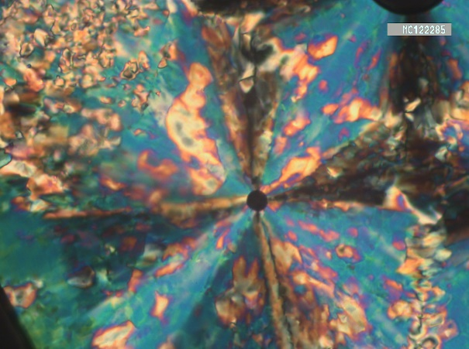  p6mm, 35 °C  (d)
Figure S5. Textures of 1 a s observed on cooling between crossed polarizer at the given temperatures in the indicated LC phases. There is a clear change from 3D-Hex to the columnar phases by a transition from a mosaic-like to a “spherulitic” texture, as typical for columnar phases. No significant textural changes can be found at the transitions between the distinct columnar phases (CLQC-p4mg^{L}-Col_{hex}), only the birefringence color changes slightly, indicating an increasing birefringence due to a continuously increasing orientational order parameter at lowering temperature. The dark area at the bottom left is an area not covered by the sample.

Phase transitions of compound 1 (T/°C [ΔH/kJmol⁻¹]):

Cr₁ 46 Cr₂ 66 [41.1]ª (Col_{hex} 60 [-] p4gm^{L} 72 [-] CLQC 80 [-] 3D-Hex 88 [2.0] Iso

Melting transitions were taken from the very first heating scan; The 3D-Hex to Iso transition was the same in the first and subsequent heating scans; The continuous phase transition without enthalpy were taken from the SAXS data.

ª includes both crystalline phases

3.3 Additional XRD data
3.3.1 WAXS data
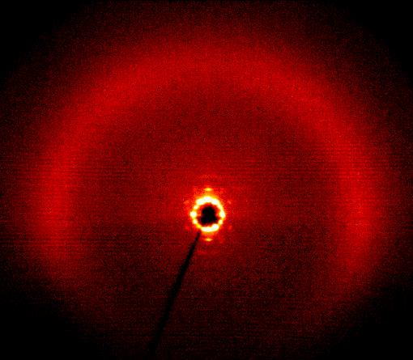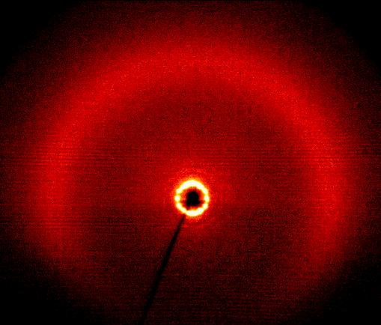
40 °C Col_{hex} 70 °C p4gm^{L}
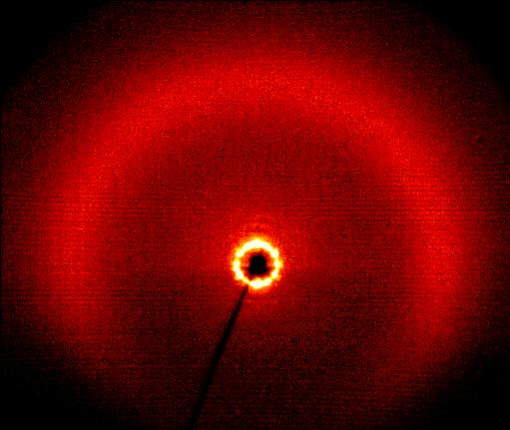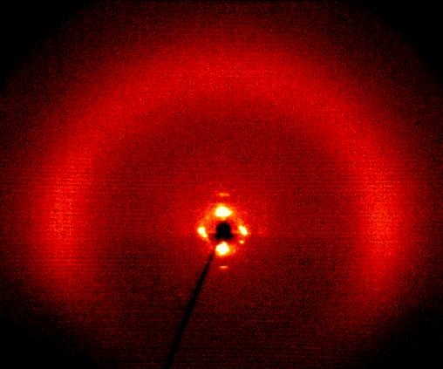
80 °C CLQC 85 °C P6/mmm
Figure S6. WAXS patterns of partially surface aligned samples of 1 at the indicated temperatures (sample on a glass plate); in all mesophases the WAXS is diffuse confirming LC phases.

3.3.2 Data from Synchrotron experiments
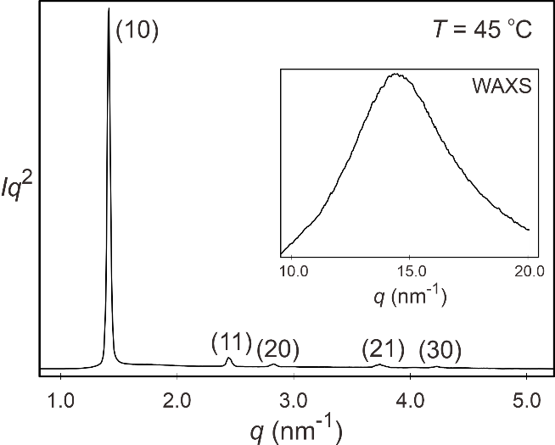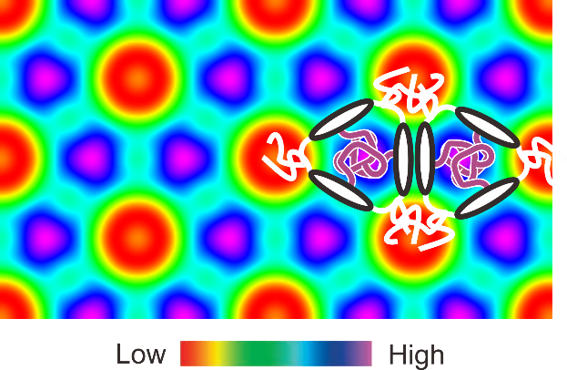
b)
a)
Figure S7. (a) Diffraction pattern of 1 at 45 °C with indexation and (b) Reconstructed ED map of the Col_{hex}Δ/p6mm phase.

Table S1. Experimental and calculated d-spacings of the observed SAXS reflections of the Col_{hex}Δ/p6mm phase in compound 1 at T = 45ºC. All intensities values are Lorentz corrected with correction for multiplicity.
(hk) | d_{obs.} – spacing (nm) | d_{cal.} – spacing (nm) | intensity | phase
(10) | 4.45 | 4.45 | 100.0 | π
(11) | 2.57 | 2.57 | 3.8 | 0
(20) | 2.22 | 2.22 | 1.4 | π
(21) | 1.68 | 1.68 | 1.1 | 0
(30) | 1.48 | 1.48 | 1.0 | 0
a_{hex} = 5.14 nm

Table S2. Experimental and calculated d-spacings of the observed SAXS reflections of the p4gm^{L} phase in compound 1 at T = 70 ºC. All intensities values are Lorentz corrected with correction for multiplicity. Phases used in reconstructing the electron density map shown in Fig. 2b are also listed.
(hk) | d_{obs.} – spacing (nm) | d_{cal.} – spacing (nm) | intensity | phase
(21) | 7.46 | 7.46 | 0.2 | π
(22) | 5.90 | 5.90 | 0.2 | 0
(31) | 5.27 | 5.27 | 2.8 | 0
(32) | 4.63 | 4.63 | 0.3 | π
(40) | 4.17 | 4.17 | 10.9 | π
(41) | 4.05 | 4.05 | 59.5 | 0
(33) | 3.93 | 3.93 | 100.0 | 0
(51) | 3.28 | 3.27 | 0.9 | π
(52) | 3.09 | 3.10 | 0.1 | 0
(53) | 2.86 | 2.86 | 1.5 | 0
(60) | 2.78 | 2.78 | 1.5 | 0
(54) | 2.60 | 2.60 | 0.3 | 0
(81) | 2.07 | 2.07 | 1.8 | /
(74) | 2.07 | 2.07 | 1.8 | /
(66) | 1.98 | 1.97 | 2.9 | /
(10,1) | 1.66 | 1.66 | 2.3 | /
(95) | 1.62 | 1.62 | 0.5 | /
(87) | 1.57 | 1.57 | 1.0 | /
(11,2) | 1.49 | 1.49 | 0.4 | /
a_{p4mg}^{L} = 16.68 nm

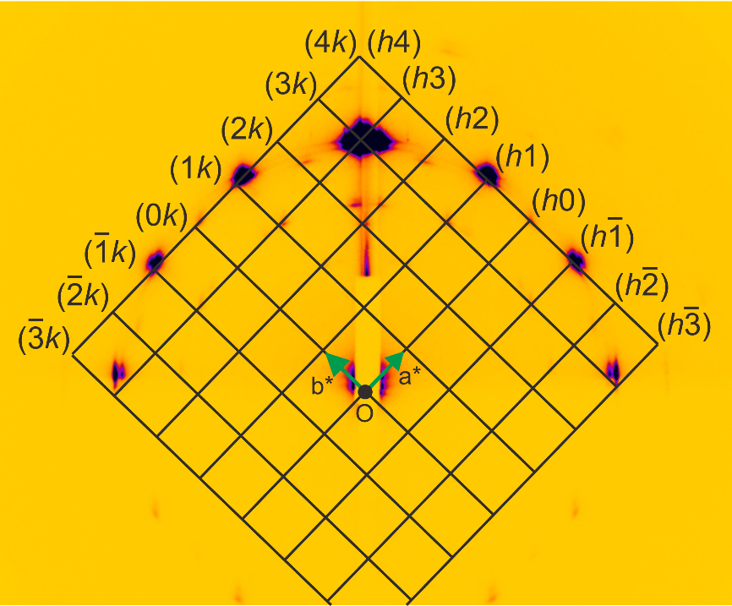
a)
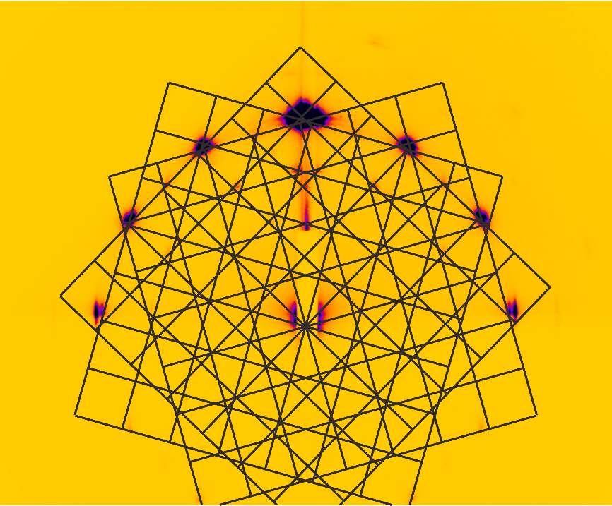
b)
Figure S8. GISAXS pattern of the p4mg^{L} phase, recorded at 70°C, (a) with indexation and (b) additional orientations.

Table S3. Indices of diffraction peaks, and comparison of experimental and calculated d-spacings and intensities of the CLQC phase. The best-fit characteristic length a// (the length of the basis vector in real space) of the phase is 4.46 nm. For comparison, the side length of the tiles in the p4gm^{L} phase at 70°C is virtually the same, 4.47 nm.
Index | d-spacing  exp. (nm) | d-spacing  cal. (nm) | Intensity  Powder | Intensity  GISAXS | Intensity Calculated
(1000) | 7.70 | 7.72 | 0.13 | 0.27±0.01 | 0.00
(1001) | 5.43 | 5.46 | 0.83 | 1.26±0.08 | 3.82
(1010) | 4.42 | 4.46 | 0.28 | 0.64±0.06 | 0.31
(1100) | 3.99 | 4.00 | 100 | 100±2 | 100
(2000) | - | 3.36 | 0 | 0 | 0.74
(1101) | 3.29 | 3.22 | 0.20 | 0.07±0.01 | 0.07
(1110) | 2.83 | 2.83 | 2.00 | 1.7±0.2 | 1.99
(2100) | 2.65 | 2.65 | 0.09 | 0.06±0.01 | 0.66
(1111) | - | 2.31 | 0 | 0 | 0.05
(2110) | - | 2.13 | 0 | 0.045±0.004 | 0.00
(1210) | 2.07 | 2.07 | 2.87 | 1.16±0.06 | 1.98
(2200) | 2.00 | 2.00 | 0.89 | 0.31±0.03 | 0.00
(1211) | - | 1.79 | 0.00 | 0.02±0.01 | 0.02
(1220) | 1.67 | 1.67 | 0.44 | 0.19±0.02 | 0.05
(1310) | - | 1.63 | 0.00 | 0.09±0.03 | 0.02
(3200) | - | 1.60 | 0.00 | 0.015±0.004 | 0.00

Table S4. Mapping of the CLQC indices to these of the imaginary p4gm^{XL} phase, and the intensities and phases used in reconstructing the electron density map shown in Fig. 2c.
DDLQC  Index | p4gm^{XL}  Index | Intensity | Multiplicity | Phase
(1001) | (60)  (53) | 0.83 | 4  8 | 0  0
(1010) | (72)  (55) | 0.28 | 8  4 | 0  π
(1100) | (80)  (74) | 100 | 4  8 | 0  0
(1110) | (11,3)  (88) | 2.00 | 8  4 | 0  0
(1210) | (15,4) (11,11) | 2.87 | 8  4 | π  0

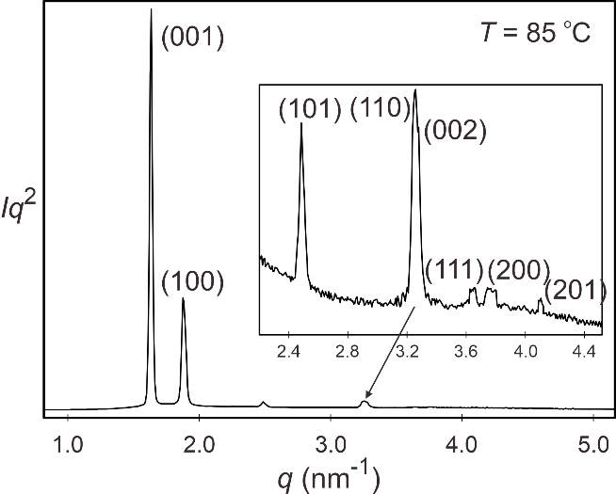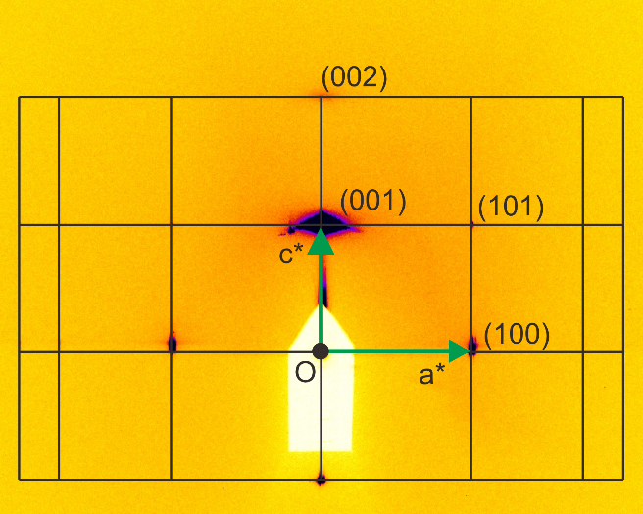
a)
b)

Figure S9. Diffraction patterns of 1 at 85 °C (3D-Hex/P6/mmm): a) powder pattern and b) GISAXS pattern with indexations.

Table S5. Experimental and calculated d-spacings of the observed SAXS reflections of the 3D-Hex/ P6/mmm phase in compound 1 at T = 85ºC. All intensities values are Lorentz corrected with correction for multiplicity.
(hkl) | d_{obs.} – spacing (nm) | d_{cal.} – spacing (nm) | intensity | phase
(001) | 38.5 | 38.5 | 100.0 | 0
(100) | 33.4 | 33.4 | 12.8 | 0
(101) | 25.2 | 25.2 | 0.3 | π
(002) | 19.3 | 19.2 | 0.6 | π
(110) | 19.3 | 19.3 | 1.9 | 0
(111) | 17.2 | 17.2 | 0.08 | π
(200) | 16.7 | 16.7 | 0.13 | 0
(201) | 15.3 | 15.3 | 0.02 | π
a = 3.85 nm, c = 3.85 nm

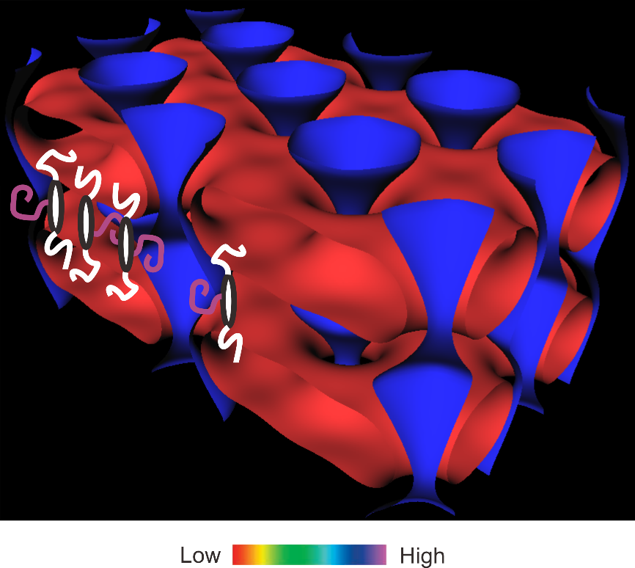
Figure S10. Reconstructed ED map of the 3D-Hex/P6/mmm phase, a lamellar phase perforated by with channeled layer structure.

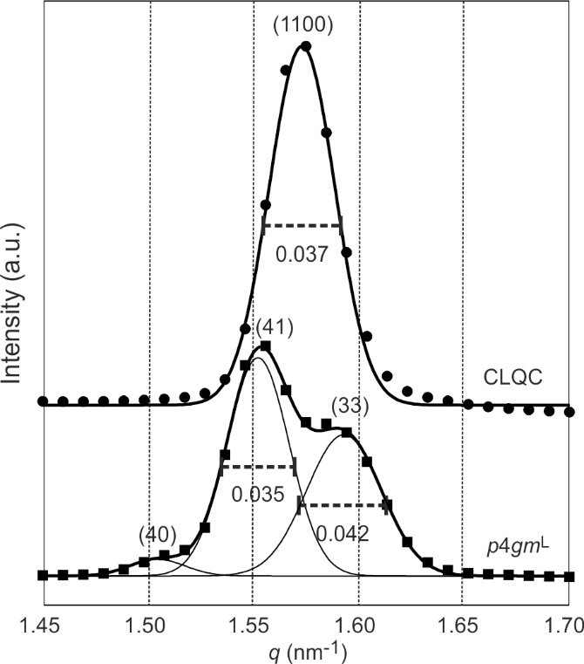
Figure S11. Comparison of peak widths (FWHM) of the strongest diffraction peaks of the CLQC and p4gm^{L} phases. The resolved overlapping (41) and (33) peaks of p4gm^{L} show similar FWHM to that of the (1100) peak of CLQC. The FWHM of the direct beam is estimated to be 0.022 nm⁻¹. The crystal domain size, estimated by 2*π/Δq, is ~0.4 μm in both phases.

References

S Chen, B.; Baumeister, U.; Pelzl, G.; Kumar Das, M.; Zeng, X. B.; Ungar, G, Tschierske, C. J. Am. Chem. Soc., 2005, 127, 16578-16591, Supporting Information
S Steurer, W., Deloudi, S. Crystallography of quasicrystals. Concepts, Methods and Structures. Springer-Verlag, London, 2009.

