Pre-clinical 2D and 3D toxicity response to a panel of nanomaterials; Comparative assessment of NBM-induced liver toxicity
Melissa Anne Tuttya,b, Gabriele Vellaa,b,, Adriele Prina-Melloa,b,c
aNanomedicine and Molecular Imaging Group, Clinical Medicine, Trinity Translational Medicine Institute (TTMI), Trinity College Dublin, St James’s Hospital, Dublin 8, Ireland
b Laboratory for Biological Characterization of Advanced Materials (LBCAM), TTMI, Trinity College Dublin, St James’s Hospital, Dublin 8, Ireland
c Trinity St James’s Cancer Institute, Trinity College Dublin, St James’s Hospital, Dublin 8, Ireland

SUPPLEMENTARY INFORMATION

Corresponding Author:
Dr. Melissa Anne Tutty
Email: tuttym@tcd.ie
ORCID: 0000-0002-6705-2492

Prof. Adriele Prina-Mello
Email: prinamea@tcd.ie

Keywords: nanobiomaterials; 3D culture; spheroids; cytotoxicity; viability; HepG2; liver spheroid; 3Rs.

Supplementary

Supplementary Figure 1
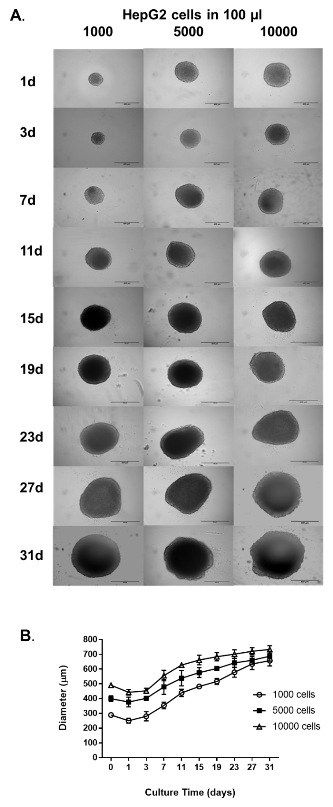
Supplementary Figure 1. Effect of cell seeding concentration on HepG2 spheroid formation. (A) Representative brightfield microscopy images of HepG2 spheroids formed by CellStar® cell repellent plates starting from cell seeding concentrations of 1,000, 5,000 and 10,000 cells per 100 µl culture medium. Scale bar = 400 µm. (B) Changes in spheroid diameter (µm) over 31 days in culture. Data are represented as mean ± SEM (n_{replicates} = 10).

Supplementary Figure 2

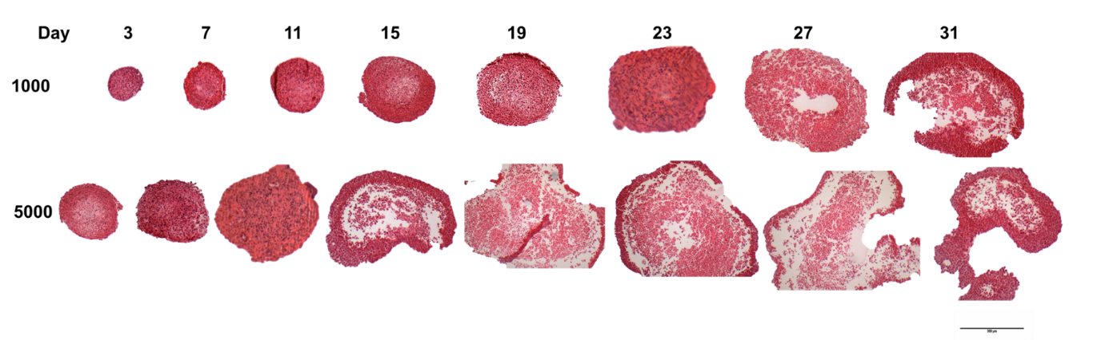
Supplementary Figure 2. Internal spheroid structure and morphology. Spheroids were created using CellStar® cell repellent plates from 1000 and 5000 HepG2 cells in 100 µl cell culture medium Spheroids were fixed in PFA after 3, 7, 11 15, 19, 23, 27 and 31 days in culture, before being suspended in agarose, dehydrated in increasing concentrations of ethanol, paraffin embedded, sectioned and stained with H&E. Images are representative of the specimens and show mid-section of the spheroids. Scale bar = 300 µm.

Supplementary Figure 3
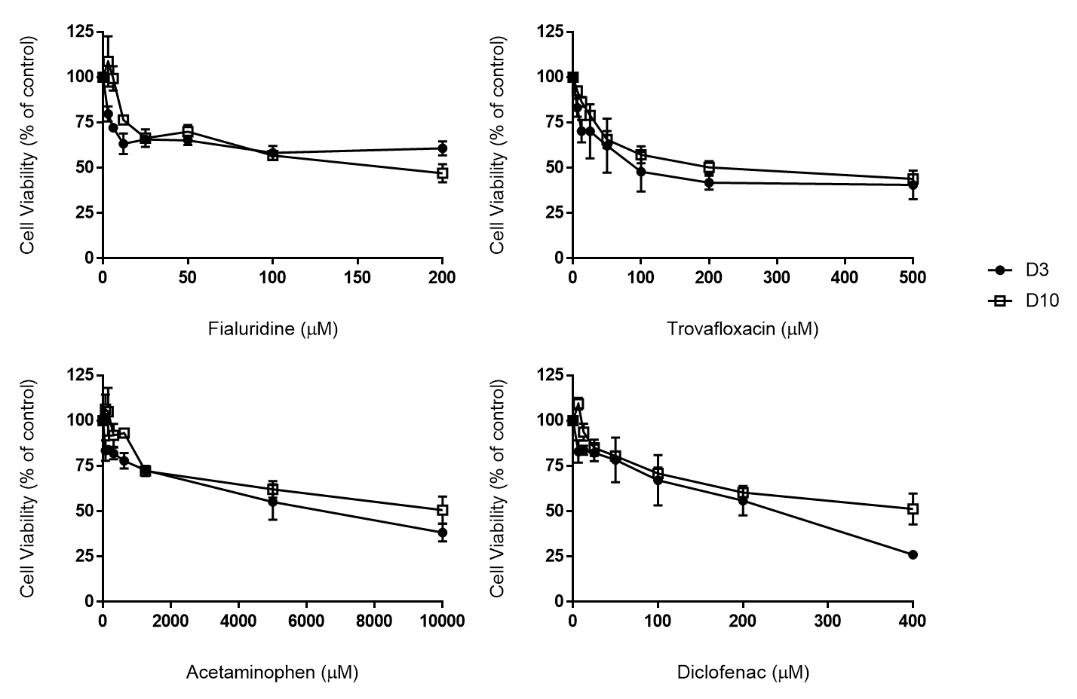
Supplementary Figure 3. Effect of culture time on spheroid response to hepatotoxins. Spheroids were cultured for both 3-day or 10-day and then incubated with the four chosen hepatotoxins (acetaminophen, diclofenac, fialuridine, and trovafloxacin) with repeated dosing at day 5 and day 12. Cell viability was determined using ATP quantification and results plotted as a percentage of untreated control. Data are represented as mean ± SEM (n=3 in duplicate). Changes were not statistically different (multiple t-tests with Bonferroni Dunn method).

