Characterization and transcriptomic analysis of a novel yellow-green leaf wucai (Brassica campestris L.) germplasm
Libing Nie^{1,2}, Yushan Zheng^{1,2}, Liting Zhang^{1,2}, Ying Wu^{1,2}, Shidong Zhu^{1,2,3}, Jinfeng Hou^{1,2,3}, Guohu Chen^{1,2}, Xiaoyan Tang^{1,2}, Chenggang Wang^{1,2,3,*} and Lingyun Yuan^{1,2,3, *}
¹ College of Horticulture, Vegetable Genetics and Breeding Laboratory, Anhui Agricultural University, 130 West Changjiang Road, 230036 Hefei, Anhui, China;
² Provincial Engineering Laboratory for Horticultural Crop Breeding of Anhui, 130 West of Changjiang Road, 230036 Hefei, Anhui, China;
³ Wanjiang Vegetable Industrial Technology Institute, Maanshan, Anhui, 238200, China
*Corresponding author: Lingyun Yuan and Chenggang Wang
Tel/Fax: +86 0551-65786212. E-mail: ylyun99@163.com
Tel./Fax: +86 0551-65786212. E-mail: cgwang@ahau.edu.cn
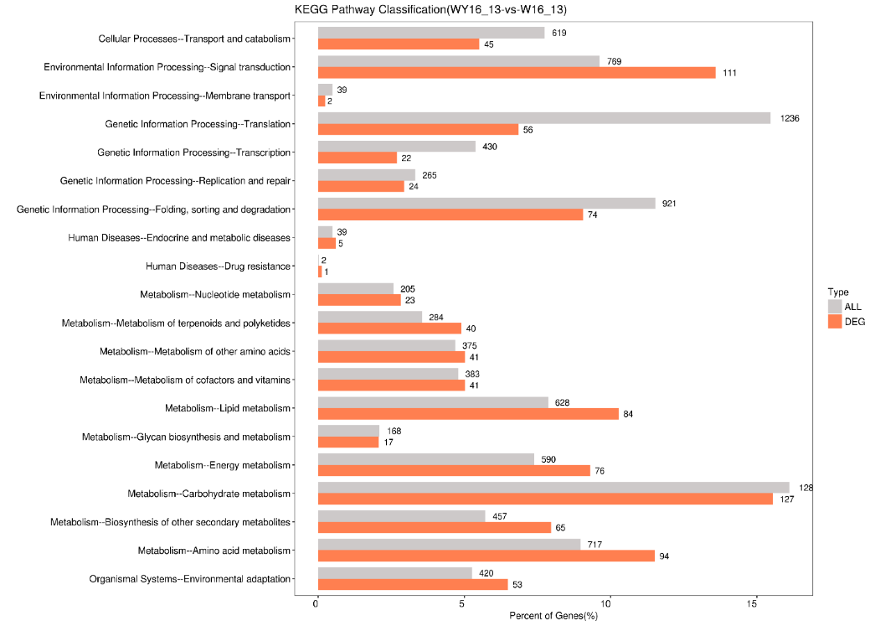
Figure S1 Comparison of the distribution of differentially expressed genes and all genes at KEGG Level 2. The Y-axis represents the Level 2 pathway term; The X-axis represents the ratio (%) of the total number of genes annotated to each Level 2 metabolic pathway (differentially expressed genes) and all genes annotated to the KEGG pathway.
Table S1
DEGs of Porphyrin and chlorophyll metabolism.
Gene_ ID | P val | Up  Down | Description | Synonym
LOC103848843 | 9.19E-06 | Up | chlorophyllase-2, chloroplastic | CLH2
LOC103854720 | 4.75E-05 | Up | glutamate--tRNA ligase, cytoplasmic | GltX
LOC103833353 | 0.023049137 | Up | probable chlorophyll(ide) b reductase NYC1, chloroplastic | NYC1
LOC103839225 | 0.005667918 | Up | chlorophyllase-2, chloroplastic | CLH2
LOC103847911 | 1.18E-06 | Down | heme oxygenase 1, chloroplastic | HO1
LOC103872768 | 6.48E-10 | Down | chlorophyllase-1 | CLH1
LOC103844881 | 0.015429744 | Down | protochlorophyllide reductase A, chloroplastic | PORA
LOC103861694 | 4.63E-09 | Down | protochlorophyllide reductase B, chloroplastic-like | PORB
LOC103867162 | 1.31E-09 | Down | protochlorophyllide reductase B, chloroplastic | PORB
Table S2
DEGs of photosynthesis and photosynthesis–antenna proteins.
Gene_ ID | P val | Up  Down | Description | Synonym
Photosynthesis - antenna proteins
LOC103828916 | 6.53E-131 | Down | Chlorophyll a-b binding protein 1, chloroplastic | LHCB1.3
LOC103828920 | 3.94E-17 | Down | Chlorophyll a-b binding protein 1, chloroplastic | LHCB1.3
LOC103829997 | 1.37E-28 | Down | Chlorophyll a-b binding protein 6, chloroplastic | LHCA1
LOC103835251 | 1.34E-37 | Down | Chlorophyll a-b binding protein 3, chloroplastic | LHCB1.2
LOC103836017 | 1.82E-28 | Down | Chlorophyll a-b binding protein CP24 10A, chloroplastic | CAP10A
LOC103837002 | 8.39E-89 | Down | Chlorophyll a-b binding protein 2.4, chloroplastic | LHCB2.4
LOC103838443 | 3.19E-69 | Down | Photosystem I chlorophyll a/b-binding protein 3-1, chloroplastic | LHCA3
LOC103841392 | 4.10E-31 | Down | Chlorophyll a-b binding protein 6, chloroplastic | LHCA1
LOC103842881 | 2.08E-64 | Down | Chlorophyll a-b binding protein CP24 10A, chloroplastic | CAP10A
LOC103844887 | 2.78E-60 | Down | Chlorophyll a-b binding protein 3, chloroplastic | LHCB3
LOC103850412 | 4.74E-67 | Down | Chlorophyll a-b binding protein CP29.1, chloroplastic | LHCB4.1
LOC103857533 | 2.74E-46 | Down | Chlorophyll a-b binding protein 1, chloroplastic | CAB1
LOC103858561 | 4.86E-40 | Down | Chlorophyll a-b binding protein CP26, chloroplastic | LHCB5
LOC103860327 | 0.0059129 | Down | Chlorophyll a-b binding protein 2.1, chloroplastic | LHCB2.1
LOC103862822 | 3.05E-59 | Down | Photosystem I chlorophyll a/b-binding protein 2, chloroplastic | LHCA2
LOC103865334 | 7.71E-64 | Down | Chlorophyll a-b binding protein 1, chloroplastic | CAB1
LOC103867454 | 3.54E-94 | Down | Chlorophyll a-b binding protein 1, chloroplastic | CAB1
LOC103867457 | 1.59E-18 | Down | Chlorophyll a-b binding protein 1, chloroplastic | CAB1
LOC103867814 | 9.14E-30 | Down | Chlorophyll a-b binding protein 1, chloroplastic | CAB1
LOC103870577 | 2.69E-80 | Down | Chlorophyll a-b binding protein CP29.2, chloroplastic | LHCB4.2
LOC103872378 | 8.56E-31 | Down | Chlorophyll a-b binding protein CP24 10A, chloroplastic | CAP10A
LOC103873241 | 1.22E-89 | Down | Chlorophyll a-b binding protein 4, chloroplastic | LHCA4
LOC103875194 | 2.57E-127 | Down | Chlorophyll a-b binding protein 2.4, chloroplastic | LHCB2.4
Photosynthesis
LOC103828782 | 3.286E-47 | Down | Photosystem I reaction center subunit III, chloroplastic | PSAF
LOC103829589 | 1.567E-41 | Down | Oxygen-evolving enhancer protein 1-1, chloroplastic | PSBO1
LOC103832382 | 4.557E-09 | Down | Photosystem II 10 kDa polypeptide, chloroplastic | PSBR
LOC103832805 | 0.0009125 | Down | Photosystem I reaction center subunit VI, chloroplastic | PSAH
LOC103836470 | 1.94E-26 | Down | Oxygen-evolving enhancer protein 2, chloroplastic | PSBP
LOC103836610 | 3.64E-14 | Down | Photosystem II repair protein PSB27-H1, chloroplastic | PSB27-1
LOC103836715 | 2.889E-15 | Down | Photosystem I reaction center subunit II-1, chloroplastic | psaD1
LOC103837509 | 5.067E-28 | Down | Photosystem I reaction center subunit N, chloroplastic | PSAN
LOC103837695 | 6.545E-19 | Down | Oxygen-evolving enhancer protein 1-1, chloroplastic | PSBO1
LOC103839762 | 2.053E-45 | Down | Oxygen-evolving enhancer protein 3-2, chloroplastic | PSBQ2
LOC103843400 | 9.395E-30 | Down | Photosystem I subunit O | PSAO
LOC103843499 | 5.38E-13 | Down | Oxygen-evolving enhancer protein 2, chloroplastic | PSBP
LOC103844017 | 1.518E-36 | Down | Oxygen-evolving enhancer protein 2, chloroplastic | PSBP
LOC103844493 | 4.194E-27 | Down | Photosystem II repair protein PSB27-H1, chloroplastic | PSB27-1
LOC103855224 | 2.312E-05 | Down | Photosystem I reaction center subunit N, chloroplastic | PSAN
LOC103855346 | 2.357E-34 | Down | Oxygen-evolving enhancer protein 1-1, chloroplastic | PSBO1
LOC103867933 | 4.122E-05 | Down | Oxygen-evolving enhancer protein 2-1, chloroplastic | PSBP1
LOC103871027 | 8.415E-41 | Down | Photosystem I reaction center subunit V, chloroplastic | PSAG
LOC103833816 | 5.413E-10 | Down | Photosystem I reaction center subunit III, chloroplastic | PSAF
LOC103835217 | 4.345E-37 | Down | Photosystem I reaction center subunit psaK, chloroplastic | PSAK
LOC103871224 | 1.258E-21 | Down | Photosystem I reaction center subunit VI, chloroplastic | PSAH
LOC103872730 | 1.868E-28 | Down | Oxygen-evolving enhancer protein 1-2, chloroplastic | PSBO2
LOC103873821 | 4.10E-23 | Down | Photosystem I reaction center subunit N, chloroplastic | PSAN
Table S3
The expression patterns of ELIPs and GLKs.
Gene_ ID | P val | Fold Change | Up  Down | Description | Synonym
LOC103868967 | 2.31E-05 | 2.067757892 | Up | Early light-induced protein 1, chloroplastic | ELIP1
LOC103842594 | 1.48E-04 | 0.378326295 | Down | Transcription activator GLK1-like | GLK1
LOC103828162 | 1.50E-14 | 106.0942967 | Up | Transcription activator GLK1 | GLK1
LOC103827922 | 4.65E-08 | 0.333549755 | Down | Transcription activator GLK2-like | GLK2

Table S4
Primer sequences for qRT-PCR.
Gene name | Primer name | Primer sequence (5’->3’)
BnaActin | primer F | TGGGTTTGCTGGTGACGAT
 | primer R | TGCCTAGGACGACCAACAATACT
LOC103867162 | primer F | TACACTCTTCCCTCCGTTT
 | primer R | TCCCACACTTTACGAGCCTT
LOC103844881 | primer F | GAGCTTCCCGACGAACAATC
 | primer R | AGAACCACAAGCGAGAGAC
LOC103872768 | primer F | GGAACTTACCCCGTCGTCT
 | primer R | ATCACTTTTCCAGCATCGTC
LOC103854720 | primer F | TGACCCTGTTTACTACCGTTG
 | primer R | AACTCTCCTCAACCCCATA
LOC103833353 | primer F | GTCATCGTTACATCTCGCAG
 | primer R | GTCATCGTTACATCTCGCAG
LOC103861694 | primer F | TTCAAAGCGTCTCATTATCGTC
 | primer R | CAGTTTCTTCATGGTAACG
LOC103847911 | primer F | ACAACATCTACTTCGCCCACA
 | primer R | ATTCTTTTCTTCTCTCGTCCACT
LOC103848843 | primer F | GCTGCTACAAAACGACGCCAT
 | primer R | AAGCCATAGGAAGAGACATGCAAC
LOC103835251 | primer F | CTGCGTCTTCCCTGAGTTGT
 | primer R | TGAGTAGCCCAAATAGCC
LOC103850412 | primer F | CCCTTCTCCATCTCGACG
 | primer R | AGCCATCTTCTCAGGGTCA
LOC103828920 | primer F | TTTGGCTATTTGGGCTACTC
 | primer R | ACATAGCCAATCTTCCGTTC
LOC103854145 | primer F | AACTCCGTGTCTTTCTTACC
 | primer R | AGCCACAACTGATCCAACG
LOC103871027 | primer F | GCCCATCCGTCGTCATAAGCC
 | primer R | GTGACCAATAGAACCCCAAGC
LOC103872378 | primer F | CCATCGCACCTTTCTCTTTC
 | primer R | CGAAATTCTCAGCGGTCCT
LOC103875194 | primer F | CAATCCAGCACTCCTCTTTCGC
 | primer R | CTGTGTCCCAACCGTAGTCTCC
LOC103867457 | primer F | TCCTCCCCTGCCTTAGCC
 | primer R | TGTCCCATCCGTAGTCACC
LOC103860327 | primer F | CCCTCAAGCCCTCCAACGA
 | primer R | GTGTCCCAGCCGTAGTCTCC
LOC103844887 | primer F | AACCCCGTCTTACCTCACC
 | primer R | AAGATTTGTGAACCGGCTTT
LOC103831013 | primer F | ACCACTAAAACCCACCGTCT
 | primer R | TGTTGAAGAGCACCCATCC

