Supporting Information

Ultra-rapid and highly efficient enrichment of organic pollutants via magnetic nanoparticles/mesoporous nanosponge compounds for ultrasensitive nanosensors
Lingling Zhang¹, Rui Hao¹, Hongjun You^{2,*}, Hu Nan³, Yanzhu Dai³, Jixiang Fang^{1,*}
¹School of Electronic Science and Engineering, Faculty of Electronic and Information Engineering, Xi’an Jiaotong University, Xi’an, Shann xi, 710049, China
²School of Science, Xi’an Jiaotong University, Xi’an, Shann xi, 710049, China
³School of Microelectronics, Faculty of Electronic and Information Engineering, Xi’an Jiaotong University, Xi’an Jiaotong University, Xi’an, Shann xi, 710049, China

¹To whom correspondence may be addressed. E-mail: jxfang@mail.xjtu.edu.cn, hjyou@mail.xjtu.edu.cn

The Supporting Information includes:
Part S1: Materials and Characterization
Part S2: Supplementary Figure 1 to Supplementary Figure 14

Materials. β-cyclodextrin (β-CD, ≥98.0%) and tetrafluoroterephthalonitrile (TFT, ≥99.0%)，Tetrahydrofuran (THF, anhydrous, ≥99.9%), N,N-Dimethylformamide (DMF, anhydrous, ≥99.8%), potassium carbonate (K₂CO₃, anhydrous, ≥99.5%), gold chloride trihydrate (HAuCl₄·3H₂O, ≥99.9%), Bisphenol A (BPA, ≥99.0%), Bisphenol S (BPS, ≥99.0%), 1-naphthyl amine (1-NA, ≥99.0%), 2-naphthol (2-NO, ≥99.5%)and carbendazim (≥99.0%) was obtained from Shanghai Aladdin Biochemical Technology Co., Ltd and used without further purification. Parathion (≥99.0%) was bought from J&K Scientific Ltd. Iron chloride hexahydrate (FeCl₃·6H₂O, ≥99.0%), trisodium citrate (C₆H₅Na₃O₇, ≥99.5%), ethylene glycol (EG, (CH₂OH)₂, ≥99.5%), sodium acetate trihydrate (CH₃COONa, ≥99.0%), ethanol (CH₃CH₂OH, ≥95.0%), dichloromethane (CH₂Cl₂, ≥99.5%) and hydrochloric acid (HCl, 95%) were purchased from Sinopharm Chemical Reagent Co., Ltd. Norit ROW 0.8 supra extruded activated carbon (NAC) pellets were purchased from Sigma Aldrich and ground into a fine powder before use. Φ13 mm needle cartridge poly tetra fluoroethylene (PTFE) membrane filter with bore diameter of 0.22 µm was purchased from Tianjin Jinteng Experiment Equipment Co. Ltd. Teflon membrane (polytetrafluoroethylene, PTFE) with 0.1μm pore size, 70 μm thickness and glass microfiber filter (Whatman no.1820-047) were purchased from Whatman Corporation. Perfluorinated fluids (Krytox, GPL105) were purchased from Dupont Corporation. Millipore ultrapure water (≥18 MΩ) was used in all experiments.
Characterization. The morphology of the product was characterized via transmission electron microscope (TEM, JEOL JEM-2100 with an accelerating voltage of 200 kV). The UV-vis spectra were recorded via ultraviolet-visible spectroscopy (Agilent, Carry 60). Surface area measurements were conducted on an ASAP 2020 Plus HD88. Infrared spectroscopy (FT-IR) was obtained by Micro-Infrared Spectroscopy (MIR, Bruker VERTEX70). The fluorescence spectra in this study were directly in solution by fluorescence spectrophotometer (Horiba PL spectrometer, Fluorolog-3), with 280 nm excitation wavelength, 5 nm slit width and 450W power xenon lamp. SERS signals were measured using a portable Raman spectrometer (BWTEK, i-Raman), with a 785 nm laser, using 40× objective, 20 s integration time, and 5% laser power (15 mW).

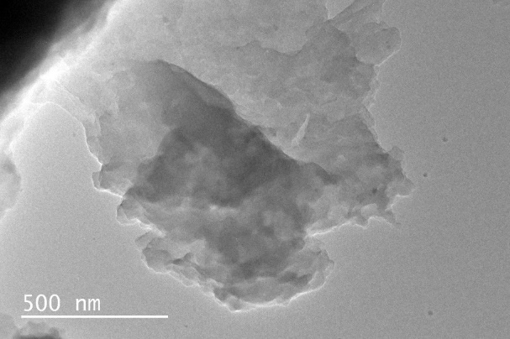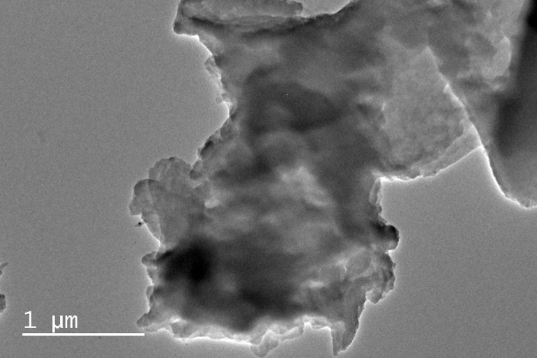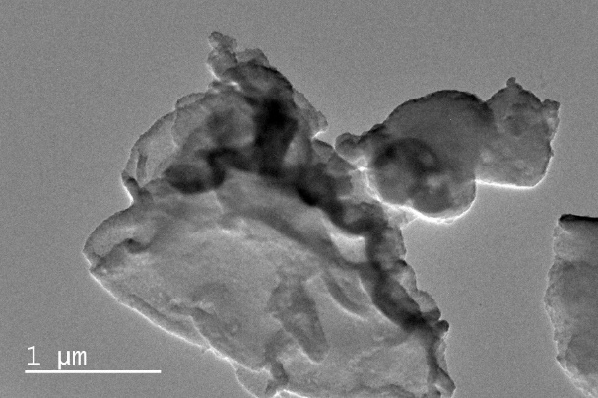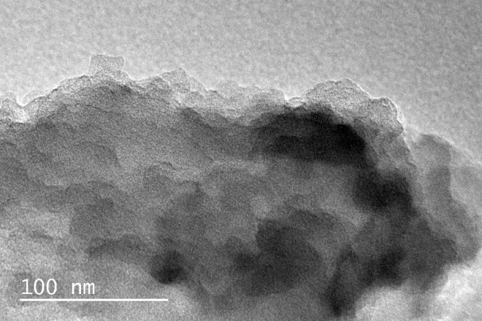
a
b
c
d
Supplementary Figure 1 | Characterization of the cyclodextrin polymers. TEM images of porous β-CD polymer (PCDP).

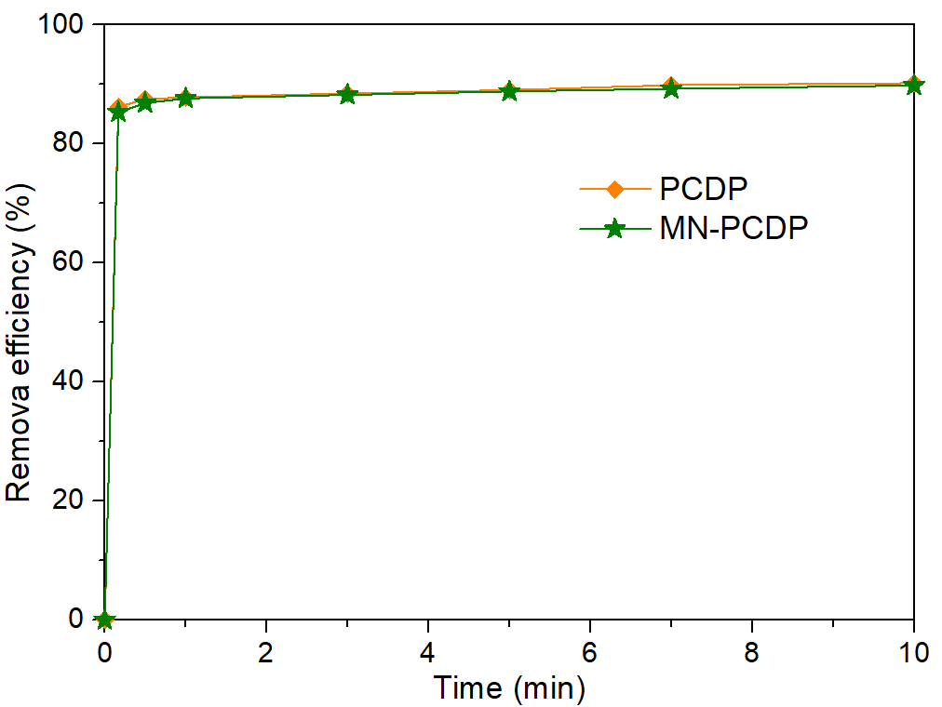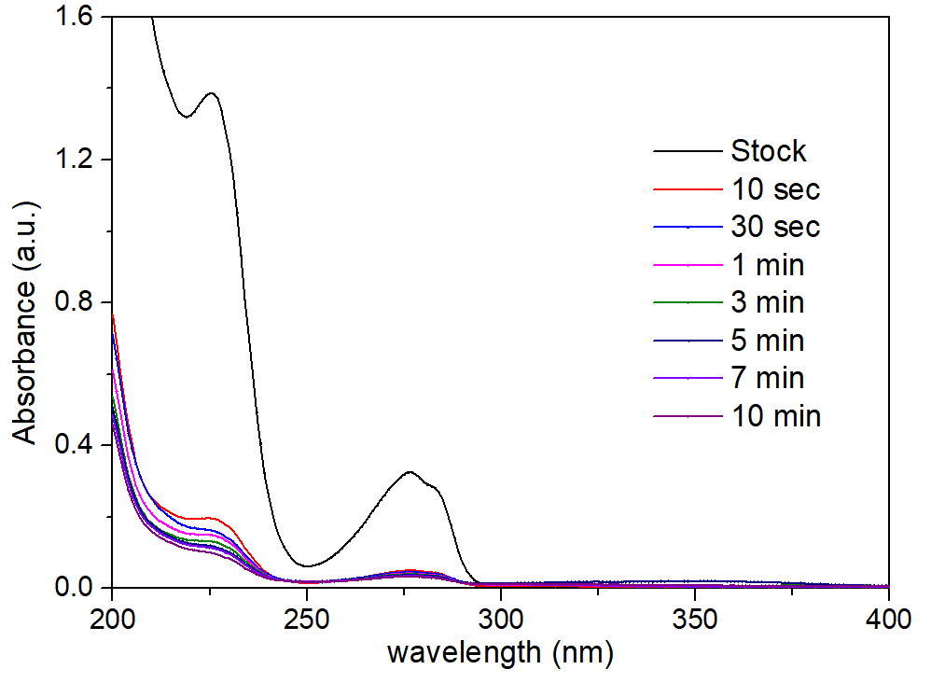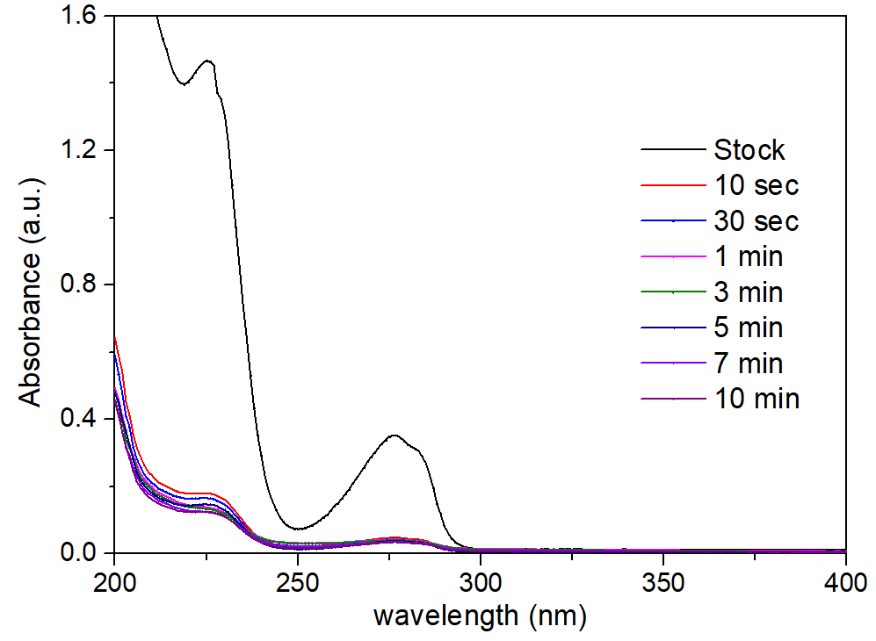
a
b
c
Supplementary Figure 2 | Uptake of pollutants by PCDP and MN-PCDP. UV–vis spectra recorded as a function of contact time for BPA (0.1 mM) using a PCDP and b MN-PCDP as adsorbent with concentration of 1 mg mL⁻¹. c Time-dependent adsorptions of BPA (0.1 mM) about a PCDP and b MN-PCDP.

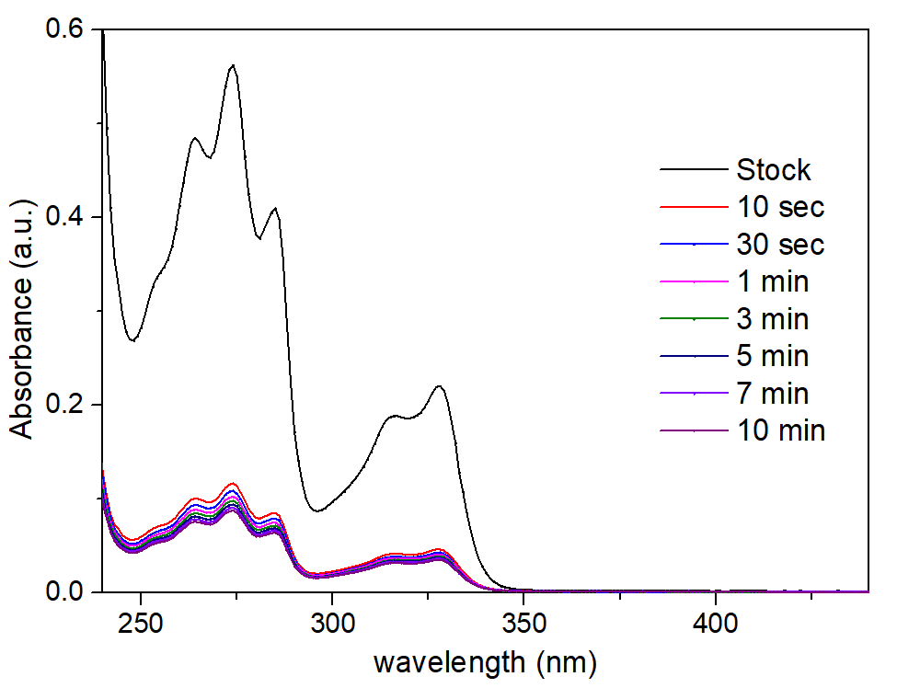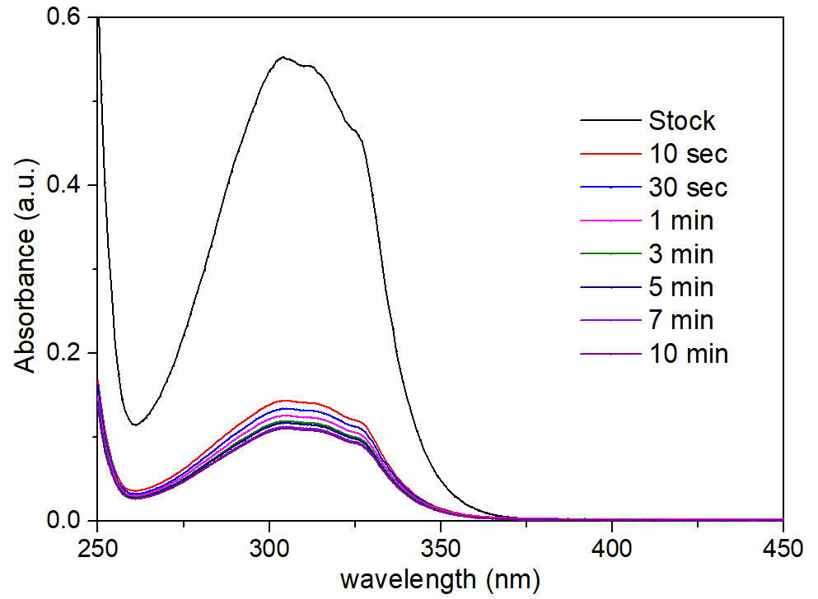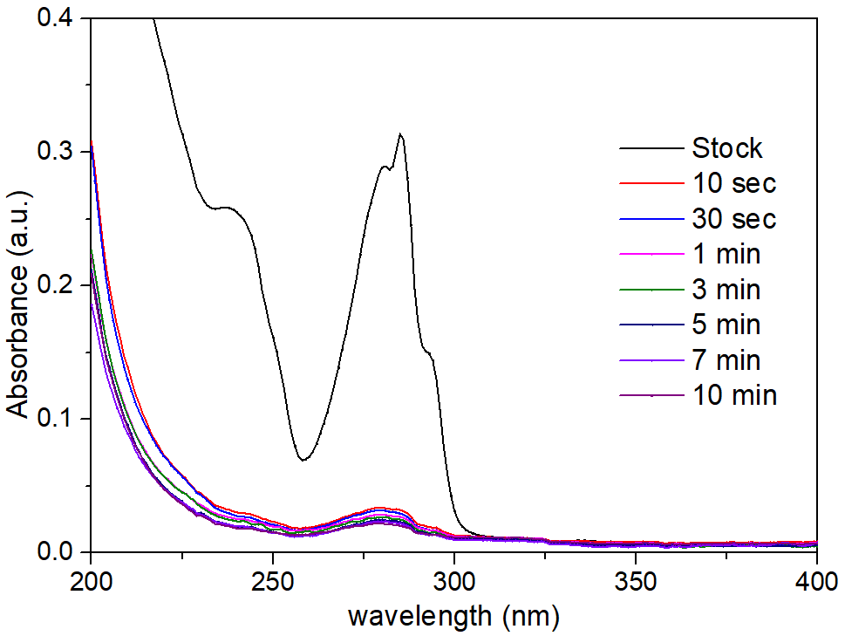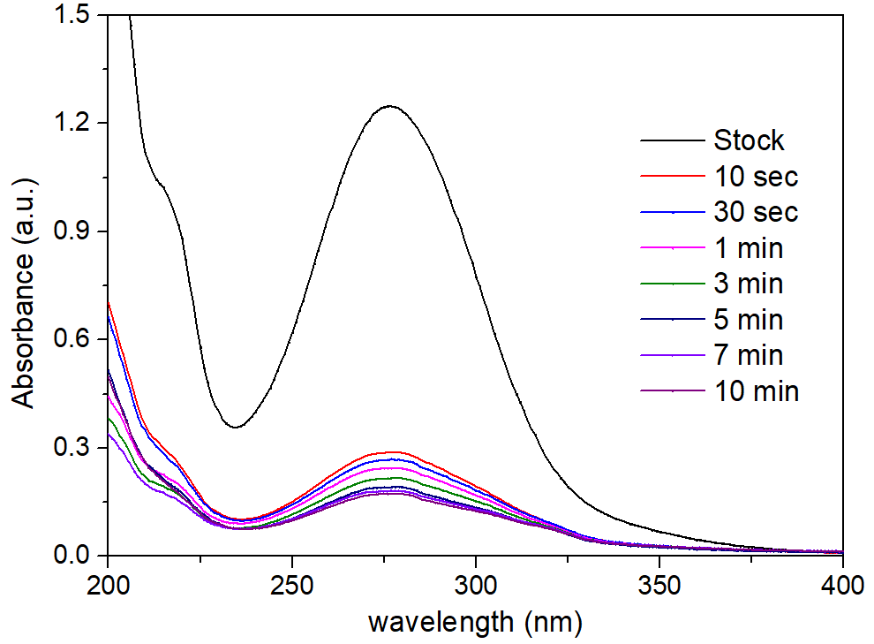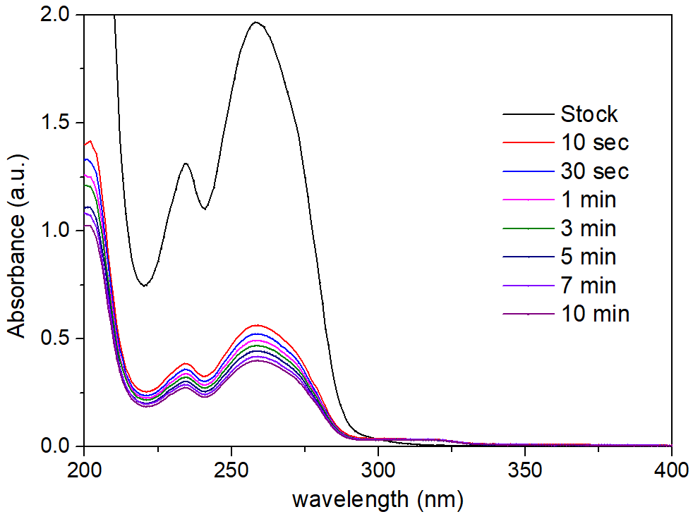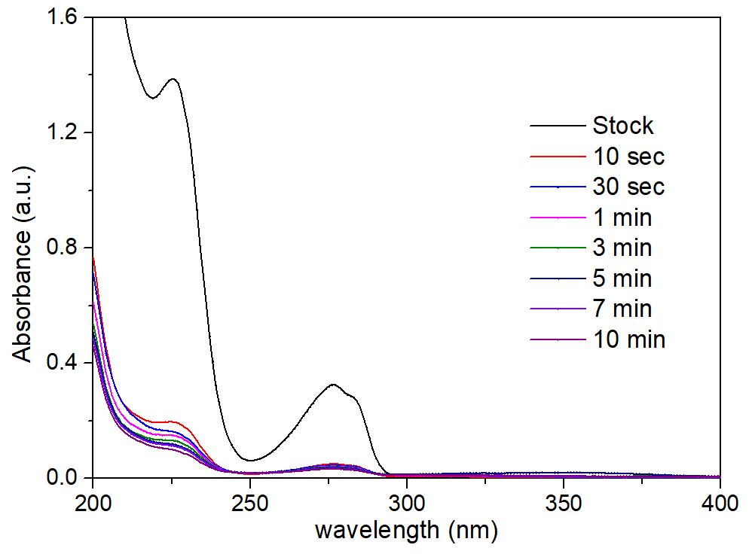
BPS
BPA
Parathion
a
b
c
d
Carbendazim
1-NA
2-NO
e
f
Supplementary Figure 3 | Uptake of pollutants by MN-PCDP. UV–vis spectra recorded as a function of contact time from a BPA, b BPS, c parathion, d carbendazim, e 1-NA and f 2-NO with 0.1 mM by MN-PCDP (1 mg mL⁻¹).

Supplementary Table 1 | The removal efficiency of pollutants with contact time using MN-PCDP adsorbent.
Removal efficiency (%) | BPA | BPS | Parathion | Carbendazim | 1-NA | 2-NO
10 sec | 85.34 | 72.86 | 79.66 | 89.74 | 74.79 | 80.04
30 sec | 86.86 | 74.95 | 80.94 | 90.59 | 76.52 | 81.50
1 min | 87.65 | 76.47 | 82.44 | 91.37 | 77.99 | 82.54
3 min | 88.24 | 77.74 | 84.23 | 92.07 | 79.19 | 83.33
5 min | 88.82 | 79.04 | 86.15 | 92.68 | 79.61 | 84.06
7 min | 89.27 | 80.39 | 86.35 | 92.99 | 80.47 | 84.66
10 min | 89.92 | 81.33 | 86.96 | 93.58 | 80.82 | 85.20

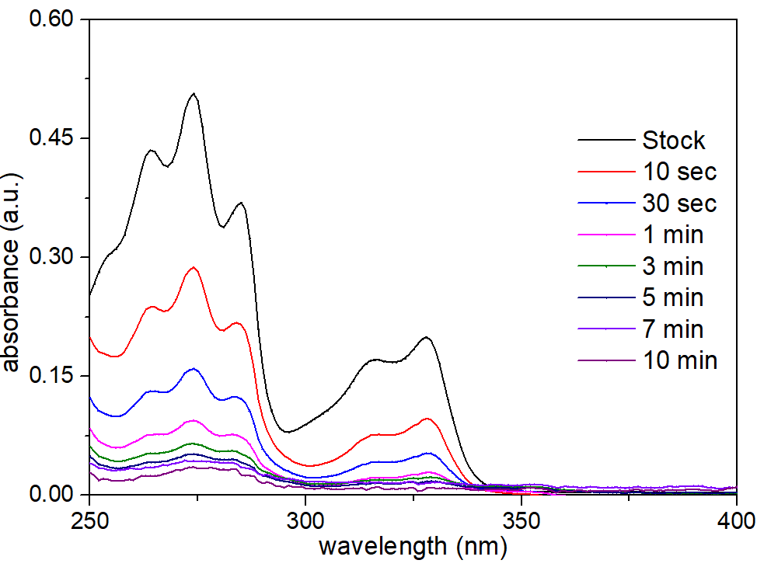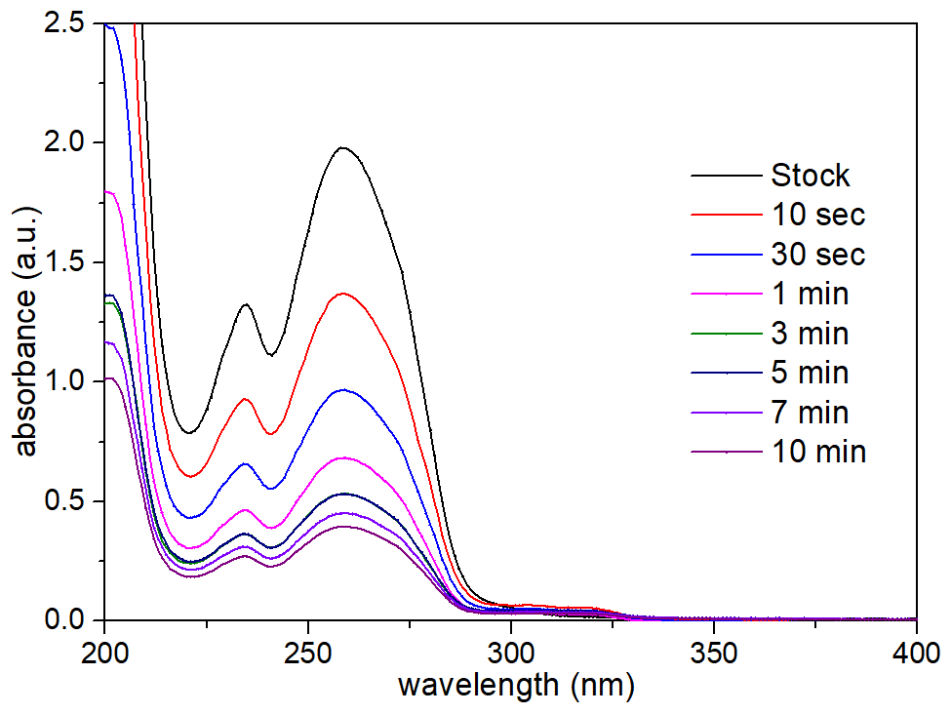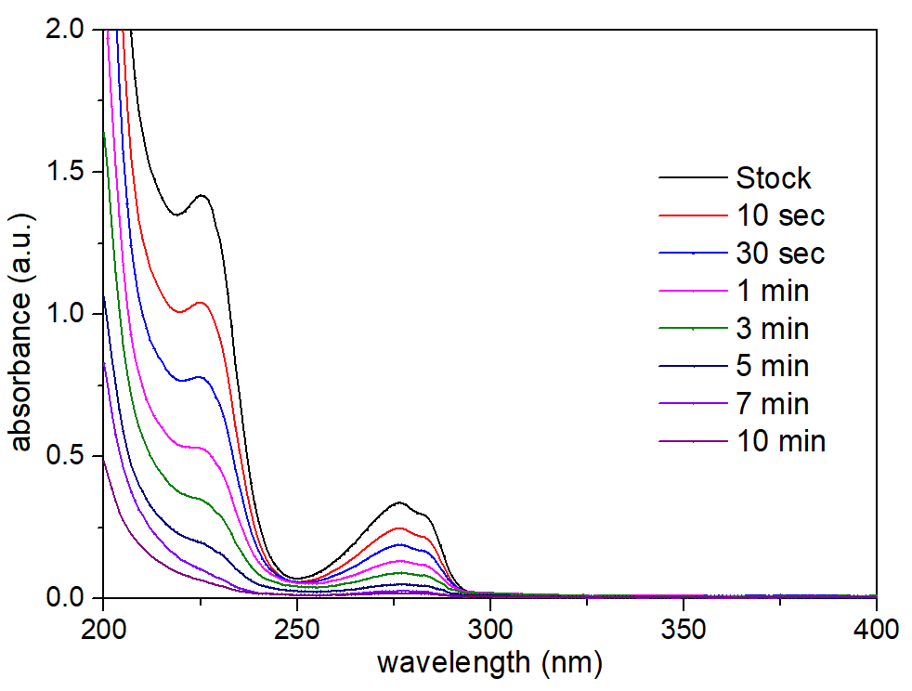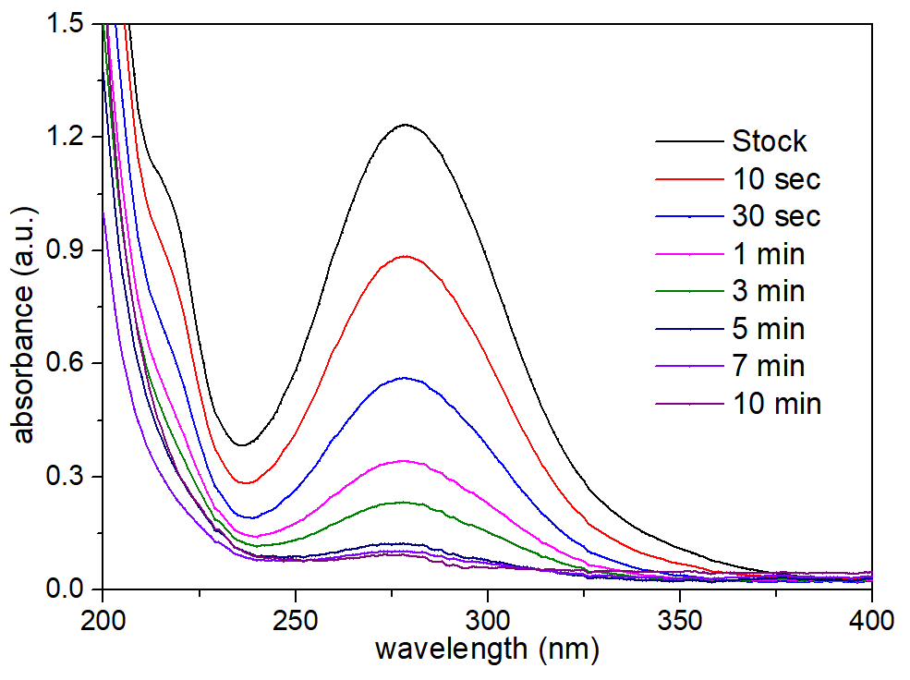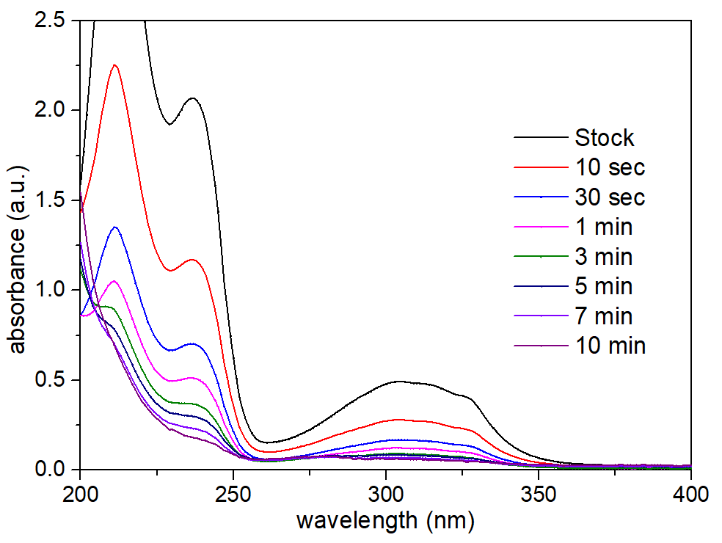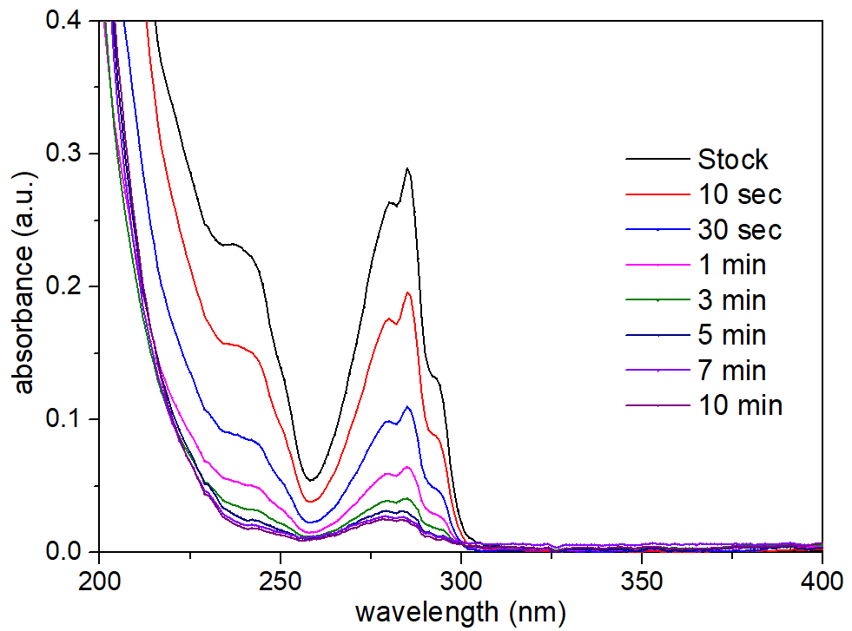
BPA-NAC
a
BPS-NAC
b
1-NA-NAC
2-NO-NAC
e
Parathion-NAC
Carbendazim-NAC
c
d
f
Supplementary Figure 4 | Uptake of pollutants by NAC. UV–vis spectra recorded as a function of contact time from a BPA, b BPS, c parathion, d carbendazim, e 1-NA and f 2-NO with 0.1 mM by NAC (1 mg mL⁻¹) in 20 mL pollutants.

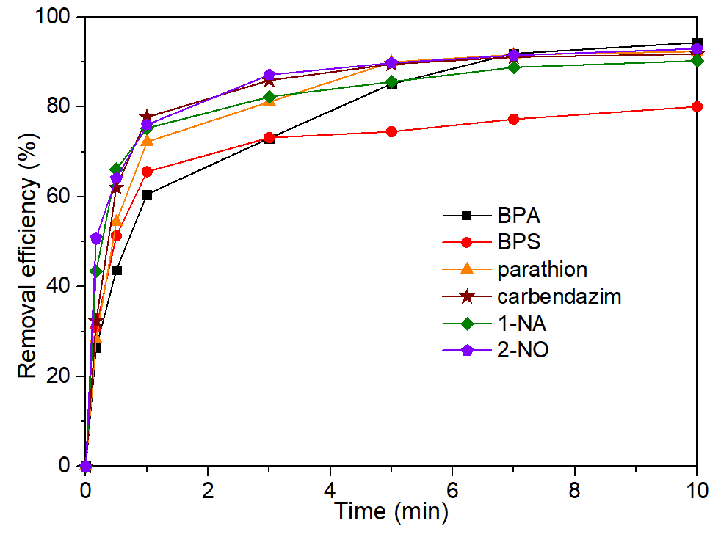
Supplementary Figure 5 | Uptake of pollutants by NAC. Time-dependent adsorption of a BPA, b BPS, c parathion, d carbendazim, e 1-NA and f 2-NO with 0.1 mM by NAC (1 mg mL⁻¹).

Supplementary Table 2 | The removal efficiency of pollutants with contact time using NAC.
Removal efficiency (%) | BPA | BPS | Parathion | Carbendazim | 1-NA | 2-NO
10 sec | 26.45 | 30.93 | 28.26 | 32.30 | 43.45 | 50.87
30 sec | 43.71 | 51.29 | 54.44 | 62.05 | 66.07 | 64.10
1 min | 60.54 | 65.57 | 72.22 | 77.71 | 75.28 | 76.06
3 min | 73.05 | 73.17 | 81.11 | 85.92 | 82.27 | 87.14
5 min | 85.13 | 73.21 | 90.00 | 89.52 | 85.60 | 89.78
7 min | 91.88 | 77.27 | 91.63 | 91.10 | 88.82 | 91.47
10 min | 94.31 | 80.07 | 92.35 | 91.77 | 90.28 | 92.98

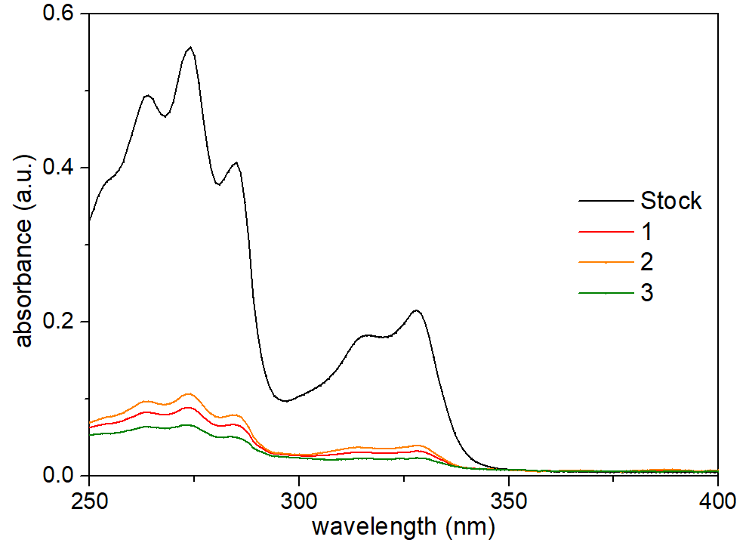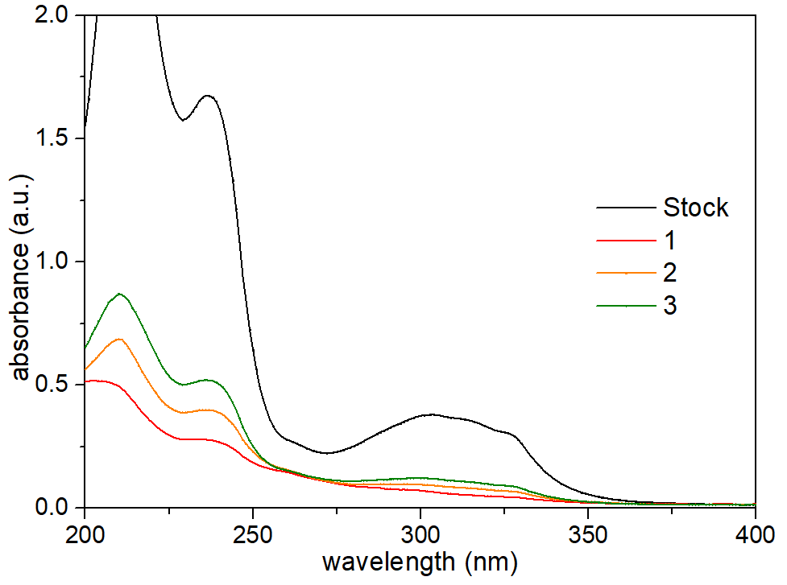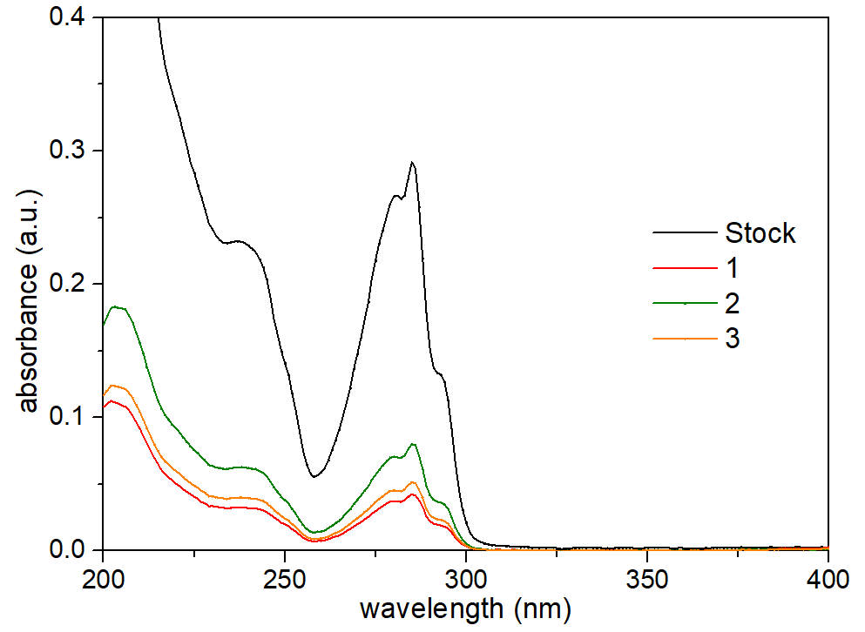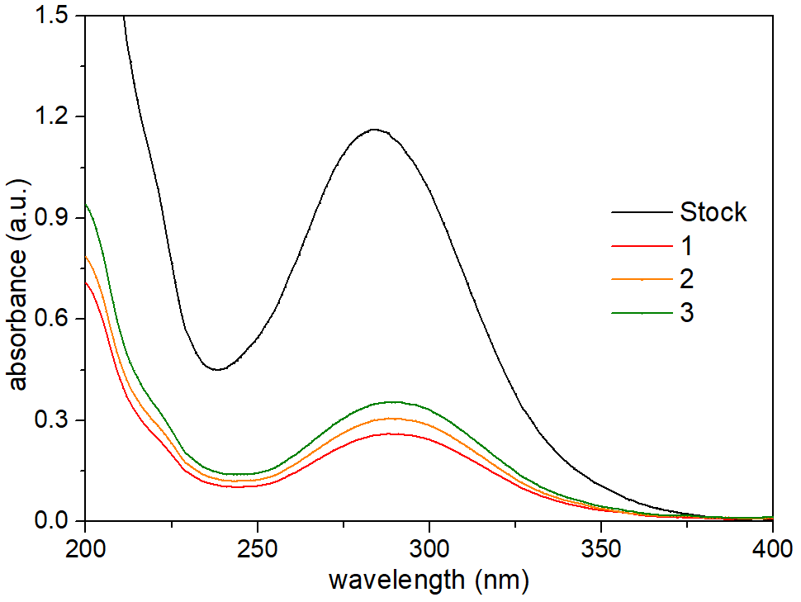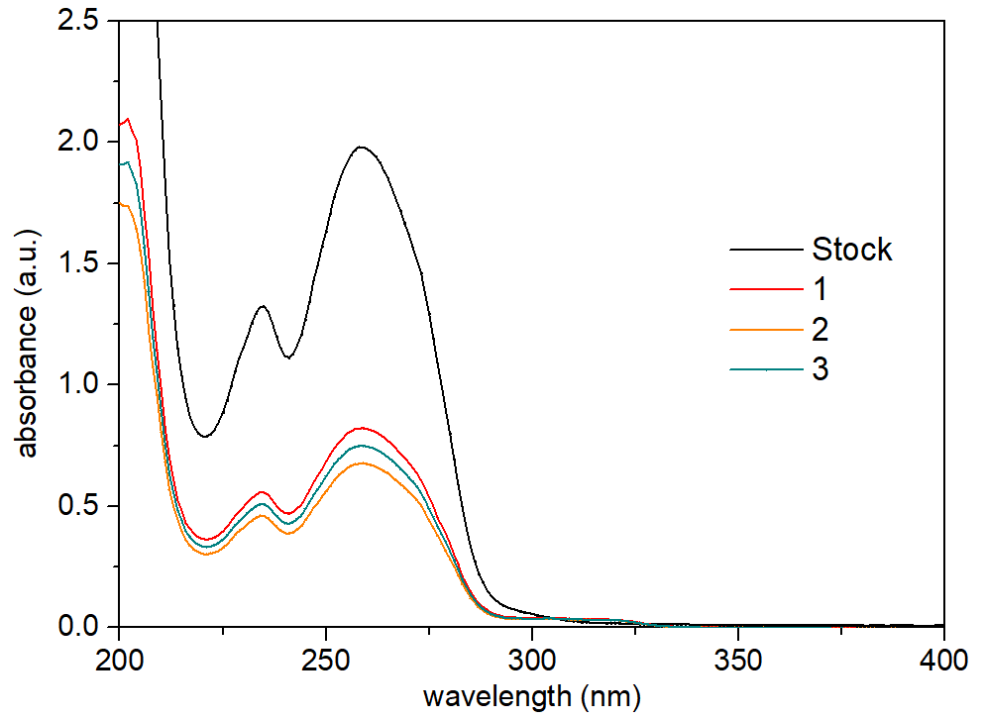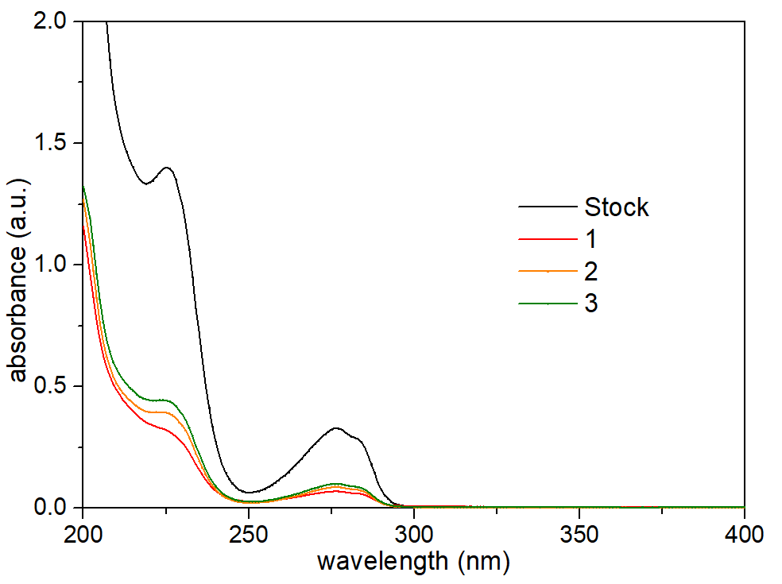
Parathion
BPS
BPA
1-NA
2-NO
Carbendazim
a
b
c
d
e
f
Supplementary Figure 6 | Uptake of pollutants by a thin layer of MN-PCDP. UV–vis spectra recorded as a function of contact time from 5 mL of a BPA, b BPS, c parathion, d carbendazim, e 1-NA and f 2-NO with 0.1 mM through a thin layer of MN-PCDP (5 mg) in 30 sec.

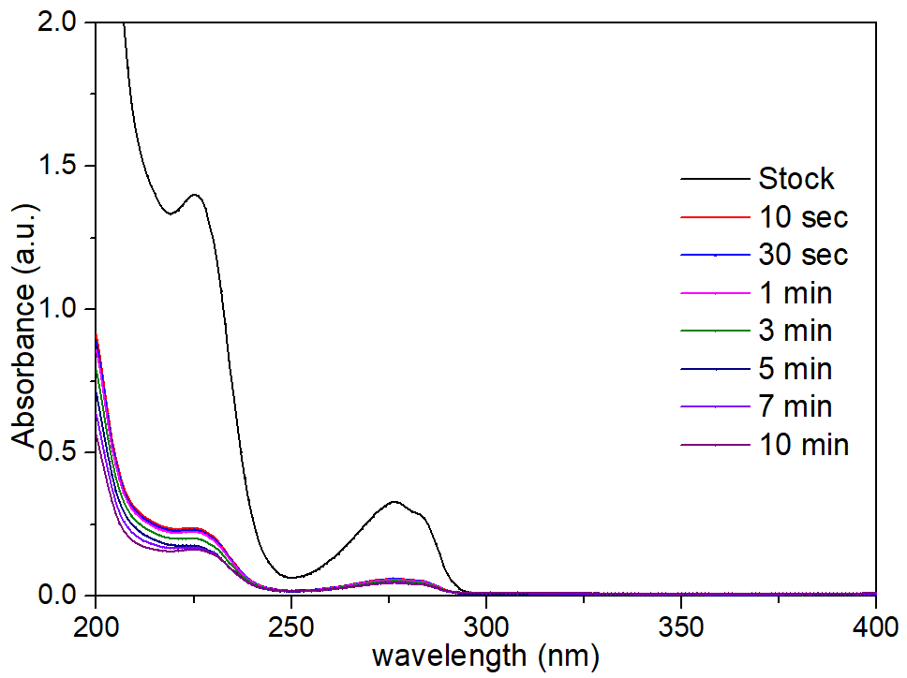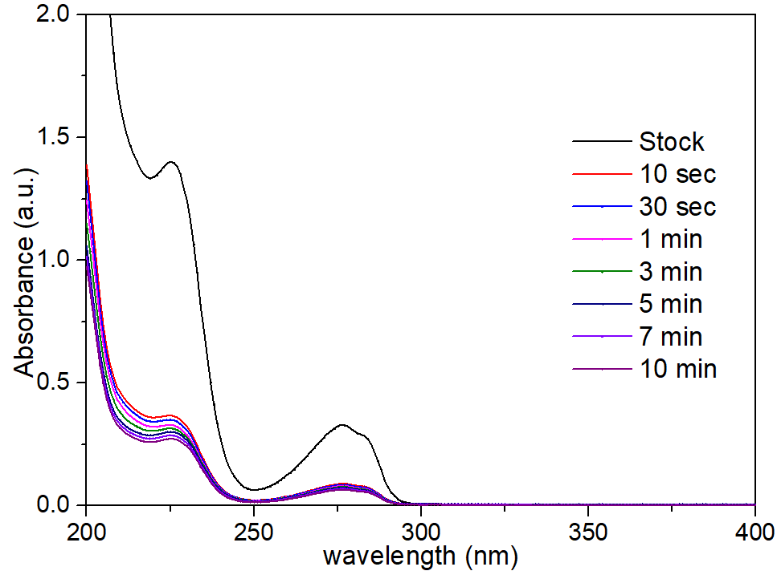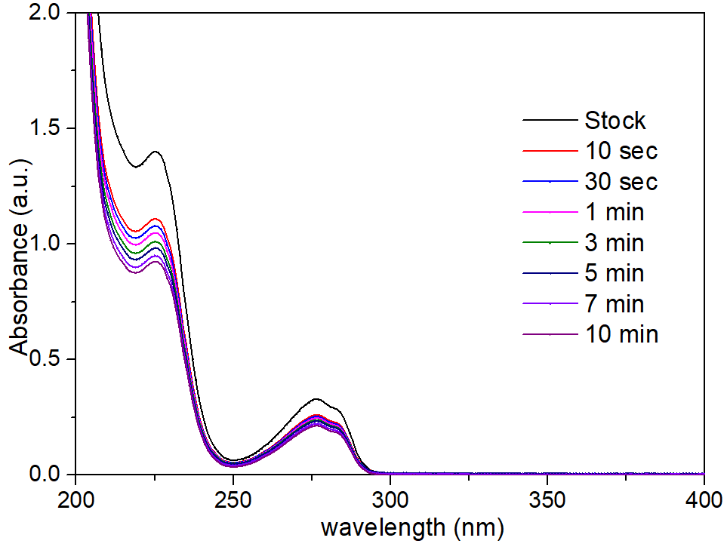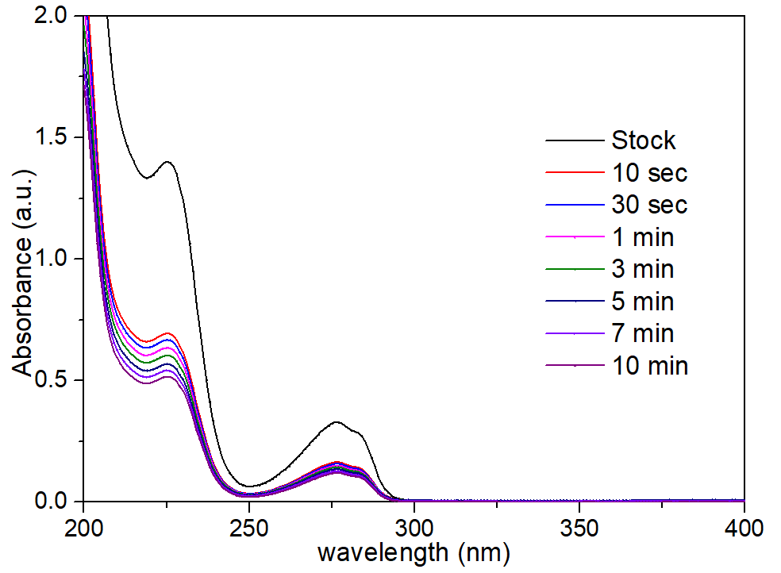
0.1 mg mL⁻¹
0.25 mg mL⁻¹
0.5 mg mL⁻¹
0.75 mg mL⁻¹
a
b
c
d
Supplementary Figure 7 | Uptake of pollutants by MN-PCDP. UV–vis spectra recorded as a function of contact time of BPA (0.1 mM, 100 mL) using different dosage of MN-PCDP.

Supplementary Table 3 | The removal efficiency of BPA with contact time using different dosage MN-PCDP
Removal efficiency (%) | 0.1 mg/mL | 0.25 mg/mL | 0.5 mg/mL | 0.75 mg/mL | 1 mg/mL
10 sec | 20.78 | 50.05 | 73.65 | 81.07 | 84.85
30 sec | 22.97 | 51.96 | 76.95 | 81.58 | 86.26
1 min | 25.12 | 54.29 | 78.50 | 82.12 | 87.09
3 min | 27.47 | 57.25 | 78.98 | 83.76 | 87.94
5 min | 29.09 | 60.37 | 79.36 | 85.57 | 88.43
7 min | 32.42 | 63.40 | 79.74 | 85.70 | 89.17
10 min | 35.07 | 65.65 | 80.01 | 85.83 | 89.82

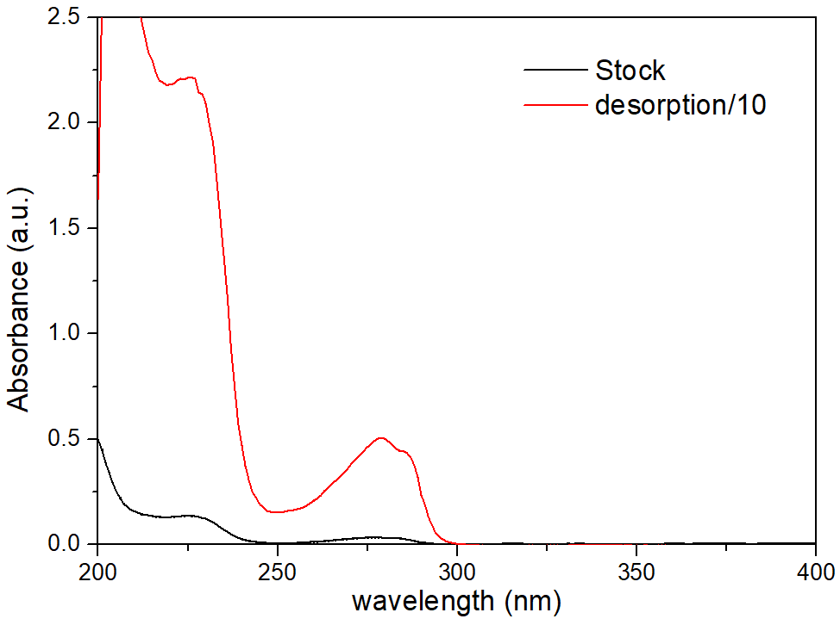
Supplementary Figure 8 | Desorption of BPA (0.01 mM, 100 mL) by MN-PCDP. UV–vis spectra of BPA in initial (black) and after enrichment (red) using MN-PCDP (1 mg mL⁻¹).

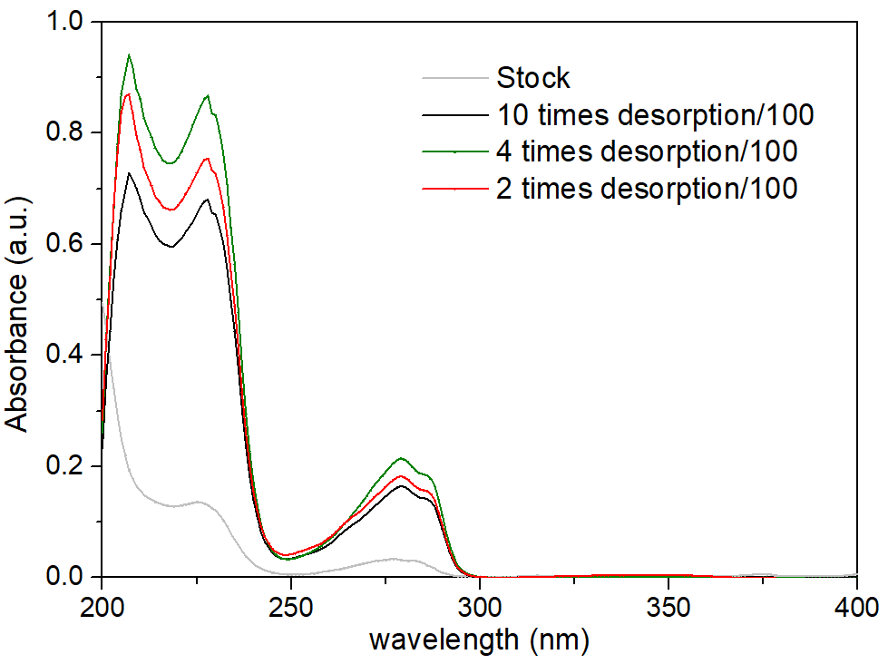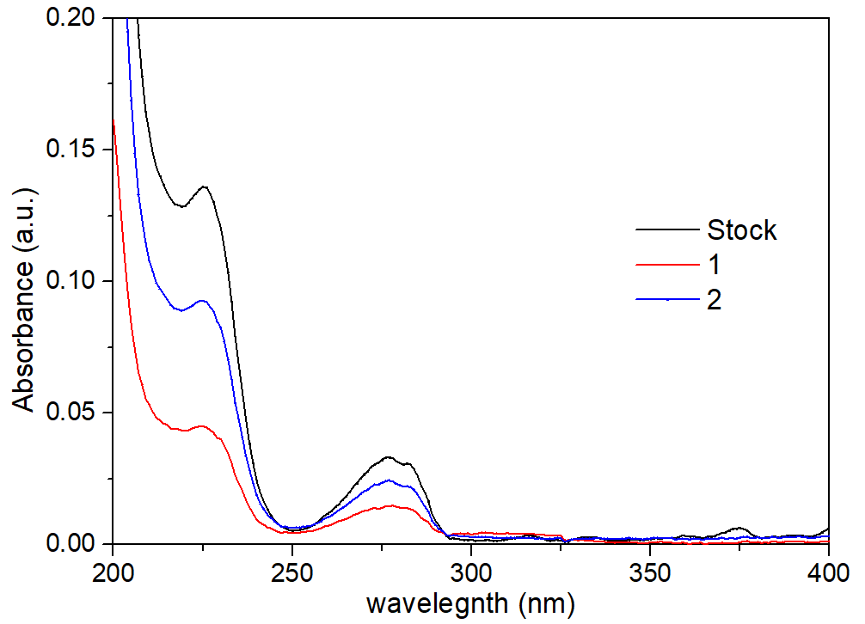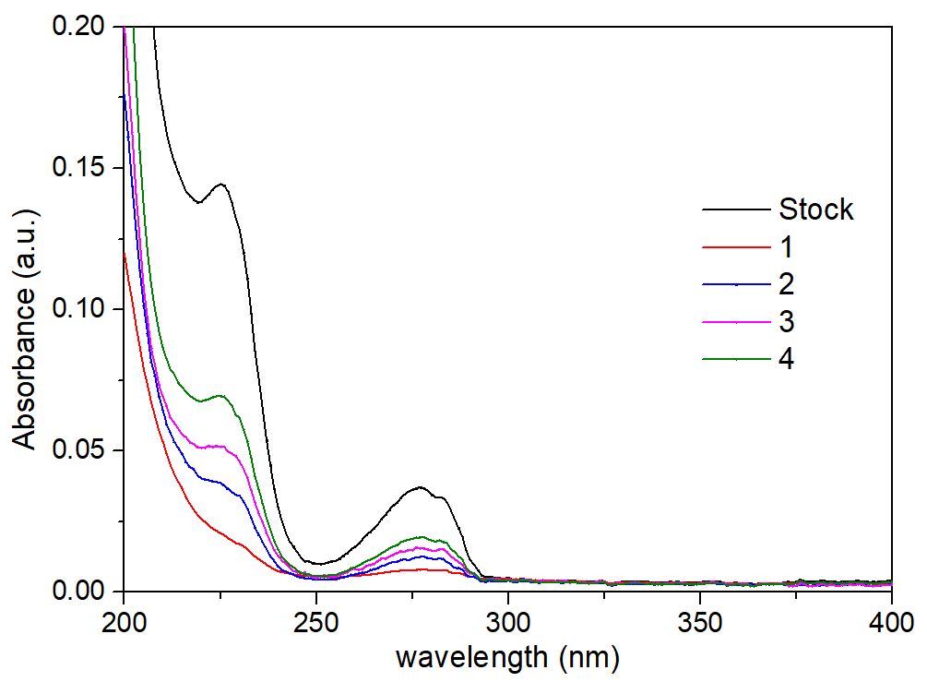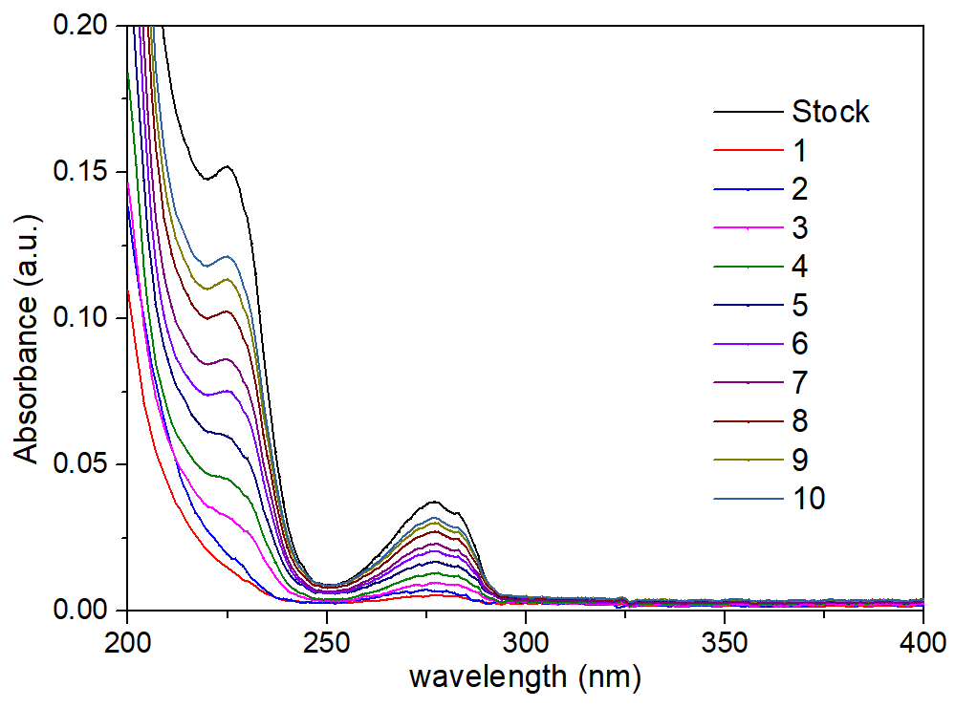
a
b
c
d
Supplementary Figure 9 | Adsorption and desorption of pollutants by MN-PCDP. UV–vis spectra recorded as a function of different cycles by MN-PCDP for removal BPA (0.01 mM) in different methods: a 100 mL for 10 times, b 250 mL for 4 times and c 500 mL for 2 times. d UV–vis spectra recorded desorption of pollutants by MN-PCDP in above three methods.

Supplementary Table 4 | The removal efficiency of BPA in constant cycles by different method in Figure S9
Removal efficiency (%) | 100 mL for 10 times | 250 mL for  4 times | 500 mL for  2 times
1 | 88.54 | 78.56 | 55.80
2 | 82.78 | 66.15 | 26.65
3 | 74.36 | 57.85
4 | 65.27 | 47.76
5 | 54.85
6 | 44.96
7 | 38.56
8 | 27.01
9 | 19.19
10 | 14.31
Average | 50.98 | 62.58 | 41.22

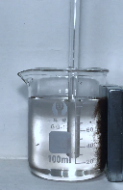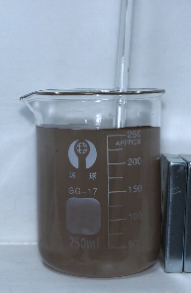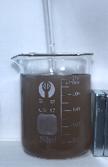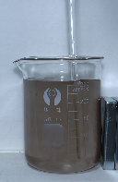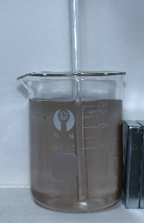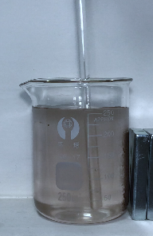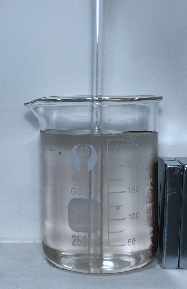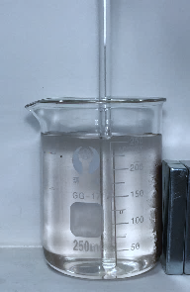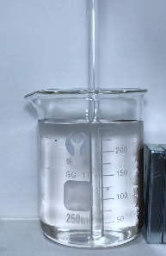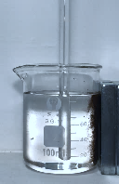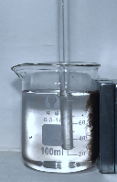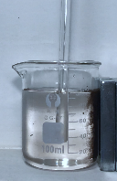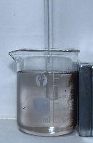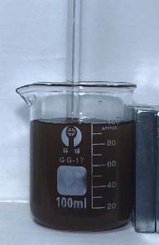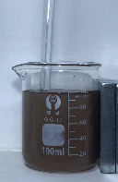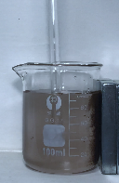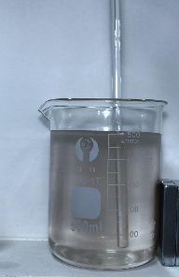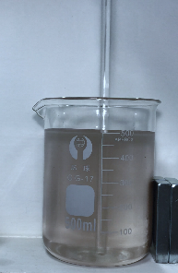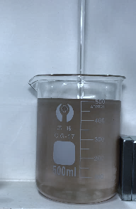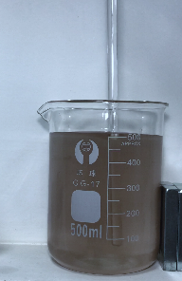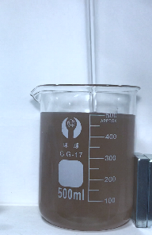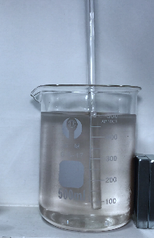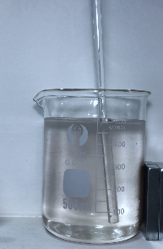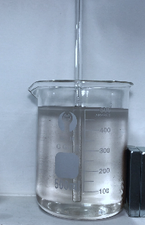
b
0 sec
15 sec
30 sec
45 sec
60 sec
90 sec min
120 sec
150 sec min
0 sec
15 sec
30 sec
45 sec
60 sec
75 sec min
90 sec
120 sec min
a
0 sec
30 sec
60 sec

120 sec min
90 sec

150 sec min
180 sec min
210 sec min
c

Supplementary Figure 10 | Images constant times about magnetic separation of MN-PCDP in a 100 mL, b 250 mL and c 500 mL pollution solution.

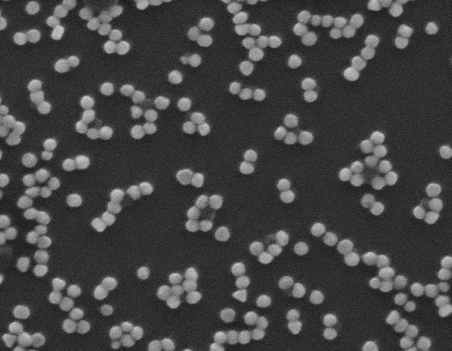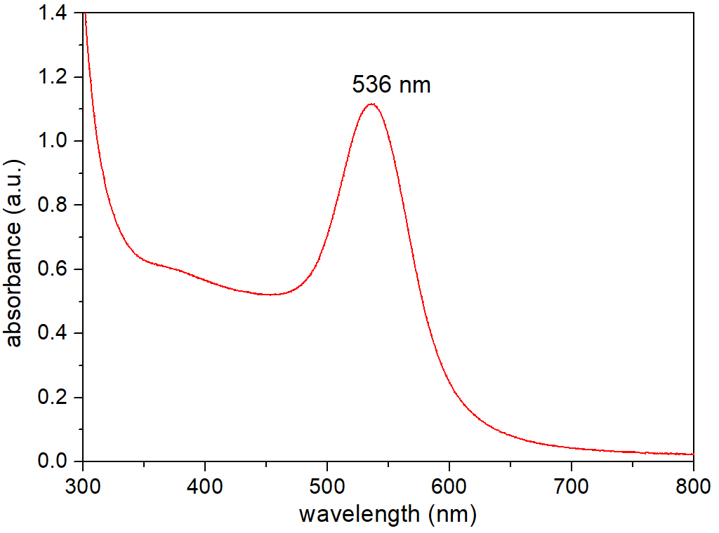
a
500 nm
b
Supplementary Figure 11 | a SEM image and b UV-vis spectroscopy of Au NPs with ~55 nm in diameter.

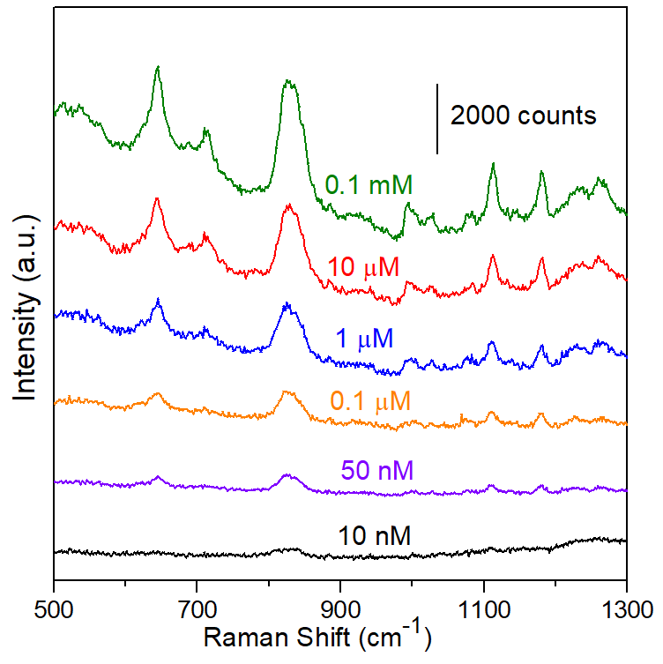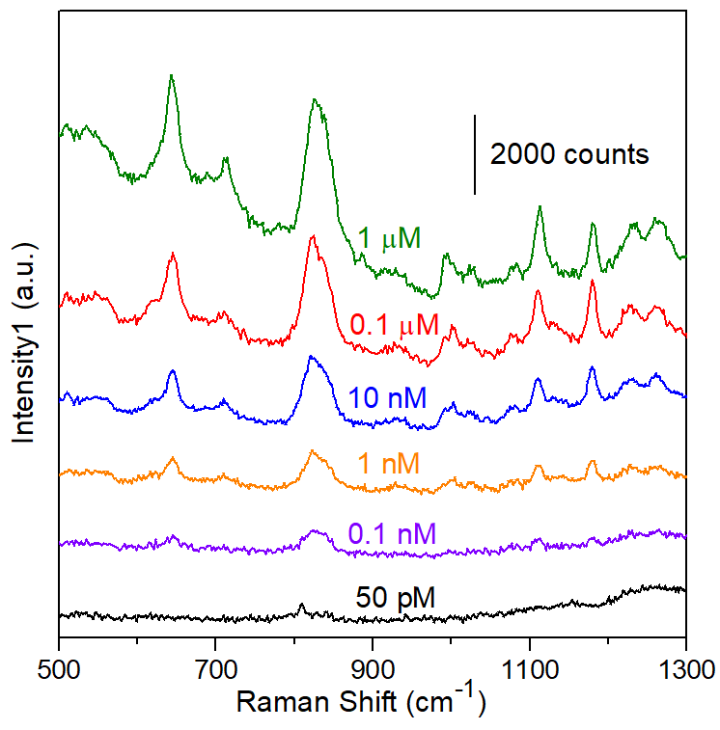
BPA
BPA enrichment
a
b

Supplementary Figure 12 | Enhanced Raman spectra of BPA a before and b after the enrichment of MN-PCDP adsorbent. The characteristic peaks of BPA were at 645, 830, 1108 and 1179 cm⁻¹.

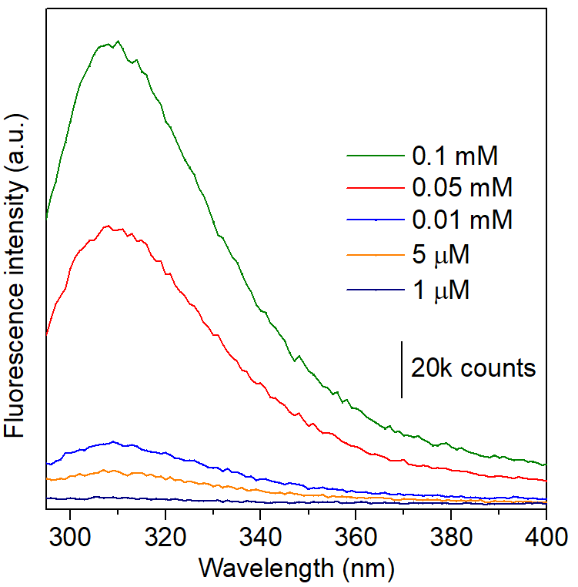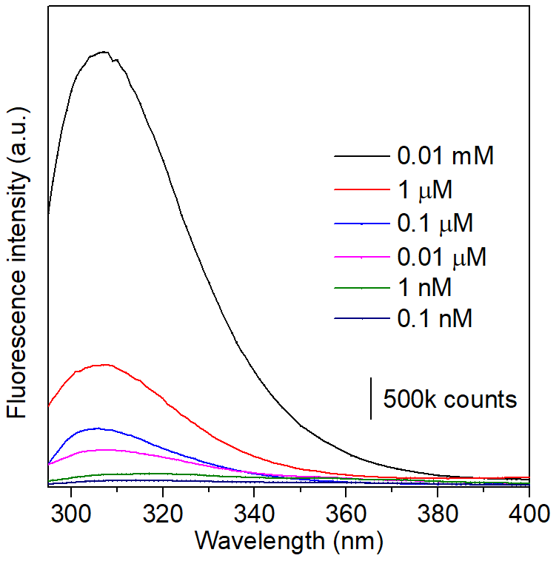
a
b
Supplementary Figure 13 | Fluorescence spectra of BPA a before and b after the enrichment of MN-PCDP adsorbent.

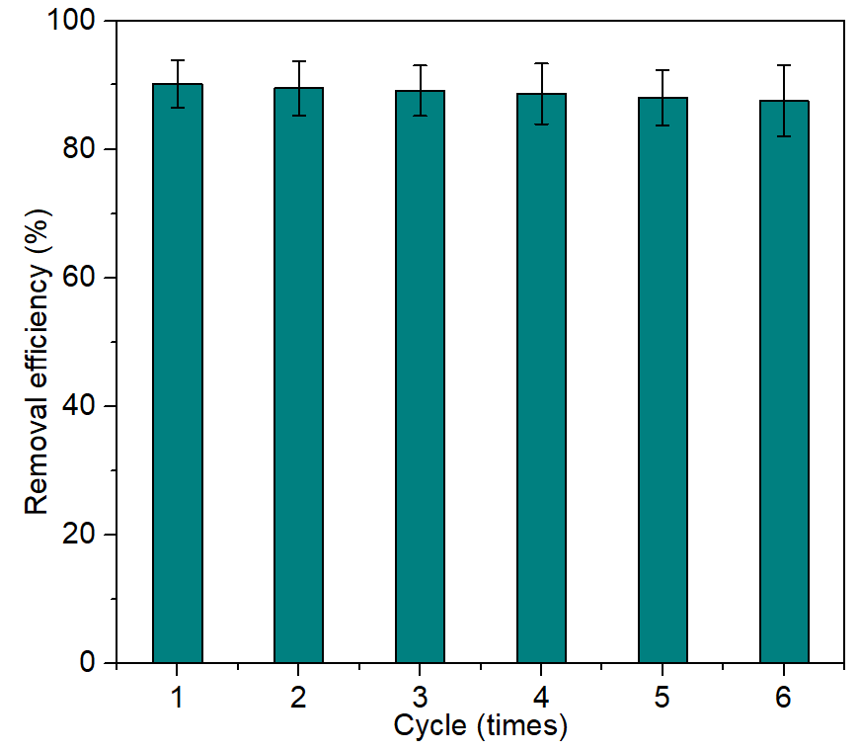
Supplementary Figure 14 | The average removal efficiency of BPA by MN-PCDP after consecutive regeneration cycles. MN-PCDP was regenerated by washing with ethanol at room temperature. The data are reported as the average of triplicate experiments with adsorption time of 1 min and washing time of 10 min.

