Supplemental figure and figure legends
Supplemental Figure 1. Generation of Srr-knockdown N2A cell line with Srr-specific shRNA. The plasmids expressing scrambled shRNA(NC),sh336,sh445,and sh597 were transiently transfected into N2A cells and the Srr mRNA and SR protein levels were examined to evaluate knockdown efficacy. A,The cells were harvested for immunoblotting against SR and GAPDH was used as an internal loading control. B,The ratios between SR/GAPDH proteins were averaged from triplicate cultures. sh336 vs.NC, **p=0.001; sh445 vs.NC, **p=0.001; sh597 vs.NC,**p=0.007. C,The ratios between Srr/β-actin mRNAs were averaged from triplicate cultures. sh336 vs.NC,**p=0.002; sh445 vs.NC,**p=0.006;sh597 vs.NC,**p=0.006. One-way ANOVA was used to compare the differences. The plasmid expressing scrambled shRNA(NC,D) or sh445(sh445,E) was stably transfected into N2A cells and the survival cells were screened by addition of G418. F,The stably-transfected cells were harvested for immunoblotting against SR and GAPDH. The SR protein levels and Srr mRNA were used to examine knockdown efficacy. G,The ratios between SR/GAPDH proteins were averaged from triplicate cultures. sh336 vs.NC, ***p<0.0001. H,The ratios between Srr mRNA/β-actin mRNAs were averaged from triplicate cultures. sh336 vs.NC, ***p<0.0001. Student’s t-test was used to compare the differences.

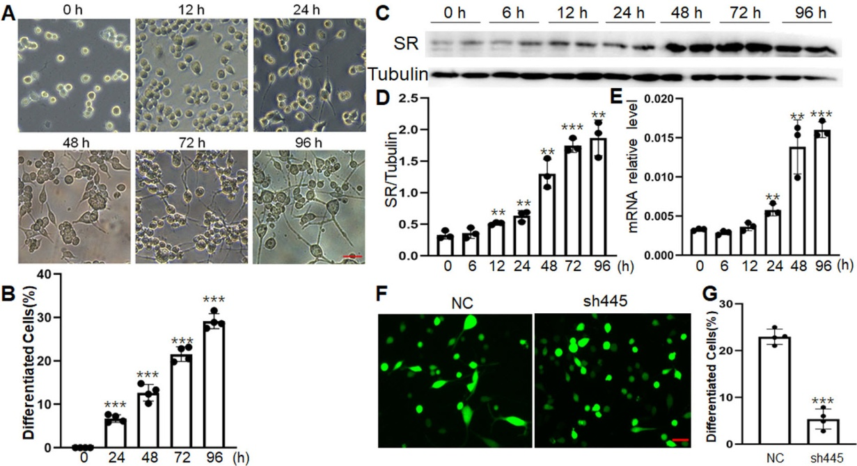
Supplemental figure 2. All-trans retinoic acid(RA) induced N2A differentiation which was dependent on SR expression. A and B,N2A cells were coated on coverslip sitting in 12-well plate at the density of 80,000 cells/well,cultured in DMEM plus 10% FBS. After 24 hours, the culture media were switched into DMEM plus 1% FBS containing 20 µM RA. The cells were fixed with 4% paraformaldehyde at different timepoints(24-96 hours) of treatment. The images were taken under phase-contrast microscope. ***p<0.0001 vs.non-treatment. C,D,E,N2A cells were cultured as above. After 24 hours, the culture media were switched into DMEM plus 1% FBS containing 20 µM RA. The cells were harvested for immunoblotting against SR. ***p<0.0001, **p<0.001vs.0 timepoint. F,G,N2A(sh445) or Srr^{wt} N2A neurons(NC) were plated in 150,000 cells/well in 6-well plates,cultured in DMEM plus 10% FBS. After 24 hours,the culture media were switched into DMEM plus 1% FBS containing 20 µM RA. After treatment by RA for 48 hours,the images were acquired under fluorescence microscope and the differentiated cells were counted and quantified. Scale bar,50 µm.
Supplemental Figure 3. Addition of D-serine did not rescue the differentiation deficit in Srr^{kd}-N2A. A,The Srr^{kd}-N2A(sh445) cells were plated in 6-well plates at the density of 400,000 cells/well,cultured in DMEM plus 10% FBS. After 24 hours in culture,the media were switched into DMEM plus 1% FBS containing 1mM VPA plus 20 µM D-serine(sh445 D-ser) or into DMEM plus 1% FBS containing 1mM VPA(sh445). After 48 hours,the images were acquired under fluorescence microscope. B,The differentiated neurons were quantified as described in the materials and methods. The percentages of differentiated neurons were calculated as the ratios between differentiated neurons and total neurons. The ratios were averaged from triplicate culture preparations and 9-15 randomly selected fields were quantified for each culture preparation. The percentage of differentiated neurons(9.27+/-0.74%) in Srr^{kd}-N2A(sh445) was similar as the number of the differentiated Srr^{kd}-N2A cells with addition of D-serine(9.58+/-1.50%). P=0.755.

Supplemental Figure 4. Cell-cycle related proteins were not altered between in Srr^{kd}-N2A(sh445) or Srr^{wt} N2A neurons(NC) under regular culture condition. The Srr^{kd}-N2A(sh445) or Srr^{wt} N2A neurons(NC) was plated in 6-well plates at the density of 400,000 cells/well. After cultured in DMEM plus 10% FBS until ~70% confluency,the cells were harvested for immunoblotting against CyclinD1(A),P21(B),P27(C),pH3(D),p-Rb(E),and Ki67(F).

