Supporting information

A Liquid-pressure-adaptive Superhydrophobic Surface

Yao Tan ^{1†}, Jinlong Yang ^{1†}, Yong Li ^{1,2}, Xiaomei Li ^{1,3}, Qian Wu ¹, Yue Fan ^{1,4}, Fanfei Yu ¹, Jiaxi Cui ¹, Longquan Chen ^{1,5}, Dehui Wang ^{1,6}, Xu Deng ^{1,7}*

† These authors contributed equally to this work

* Corresponding Author(s) E-mail: dengxu@uestc.edu.cn

1. Institute of Fundamental and Frontier Sciences, University of Electronic Science and Technology of China, Chengdu 610054, P. R. China

2. Digital Media Art, Key Laboratory of Sichuan Province, Chengdu 610021, P.R. China

3. Max Planck Institute for Polymer Research, Ackermannweg 10, 55128 Mainz, Germany

4. School of Materials Science and Engineering, Sun Yat-sen University, Guangzhou, 510275, P. R. China

5. School of Physics, University of Electronic Science and Technology of China, Chengdu 610054, P. R. China

6. Yangtze Delta Region Institute (Huzhou), University of Electronic Science and Technology of China, Huzhou 313001, P. R. China.

7. Shenzhen Institute for Advanced Study, University of Electronic Science and Technology of China, Shenzhen 518110, P. R. China

Supporting note
Superhydrophobic stability characterization. Considering the discrete mushroom-like micropillars used in our model superhydrophobic surface with the height of pillar close to 30 μm, the breakthrough pressure (P_{θ}) by depinning has been used to characterize the stability of the structures rather than breakthrough pressure by sagging.¹ This is also in accordance to the results of the experiments (Figures 2e-f). For discrete mushroom-like micropillars, the $P_{θ}$ is calculated from the force balance at the TPCL at critical pinning state, as shown in Figure S14. ¹
$P∙A_{interface}=γ{∙l}_{contact line}∙\sin\left(δθ\right)$ (S1)
where $A_{interface}=D^{2}-πR^{2}$ is the interface area, $γ$ is the surface tension of the liquid, $l_{contact}=D^{2}-πR^{2}$ is the length of contact line, and $δθ=θ-ψ$ is the pinning angle. Here, R is the radius of the pillar, D is the spacing,$θ$ is equilibrium contact angle and $ψ$ is the local geometry angle. Thus, when the pinning angle reaches to its minimum ($δθ=θ-ψ_{min}$) at the breakthrough pressure, $P_{θ}$ is written as
$P_{θ}=2πRγ\sin\left(θ-ψ_{min}\right)/(D^{2}-πR^{2})$ (S2)
Via calculation, the theoretical value of $P_{θ}$ for a rigid sample ($γ=72.8 mN·m^{-1}$, D= 100 μm, R=17.5 μm, $θ-ψ_{min}\sim 90°$) equals to 0.9 kPa.
For soft materials like PDMS, the radius of cap is determined by its original dimensions (R₀), the initial deformation induced by surface tension ($R_{γ}'$) and deformation induced by the dynamic pressure ($∆R_{P}$).
$R=R_{0}+R_{γ}'+∆R_{P}$ (S3)
The surface-tension-induced deformation has been studied in the literature using a drop placed on a soft surface or a soft sphere placed at the water-oil interface. The force analysis of three-phase contact line (TPCL) at P=0 kPa is illustrated in Figure S6.² The surface tension of the liquid is balanced by an average yield stress. From experiment data and theoretical analysis, the height of the ridge is related to $\text{G}\text{'}$, $γ$, and geometry. Here, we assume the ridge pulled by the surface tension to scale as follows
$R_{γ}^{'}\sim C_{1}γ/G'$ (S4)
where $C_{1}$ is the geometry constrain that is related to initial dimension of the micro sphere. The surface-tension-induced stretch is proportional to surface tension but inversely proportional to the modulus.
The deformation induced by the pressure is calculated using a classical stress-strain model for a confined sphere of elastomer under compression. $∆R_{P}$ scales as
$∆R_{P}\sim {C_{2}P/G}^{'}$ (S5)
Here, $C_{2}$ is a parameter of geometry constrain. Eq. S5 indicates that the pressure-induced deformation is proportional to the pressure but inversely propositional to the modulus.
Since the initial radius of the soft cap ($R_{0}+R_{γ}'$) keeps constant in the applications, the liquid-pressure-induced deformation facilitate the cap to adapt its radius and therefore the stability of the surface to the liquid pressure.

Supporting Videos
Video S1. Deformation of the soft head of LPASS in changing applied pressure recorded by LSCM. The wetting ridge growing with the infiltration pressure increasing process was recorded by laser scanning confocal microscopy (NIKON A1, 20 × dry objective) in fluorescence mode. The experiment condition is: 25 ℃ (temperature) and 40% humidity. For LPASS samples, scan time is 5.34 min per picture, size is 234.375×70.833 μm².

Video S2. Deformation of water-air interface of the LPASS recorded by LSCM. The water-air interface was deformed with the infiltration pressure increasing process which was recorded by laser scanning confocal microscopy (NIKON A1, 20 × dry objective) in reflection mode. The experiment condition is: 25 ℃ (temperature) and 40% humidity, For LPASS samples, scan time is 2.21 min per picture, the size of vertical view is 548.697×317.970 μm², the size of x-z cross section is 548.697×270.385 μm².

Video S3. Lateral adhesion force measurement of water droplet on the LPASS. A 5 μL water droplet was deposited on the surface with the force sensor stuck in the droplet. The surface underneath the droplet was moved at constant velocity =0.51 mm·s⁻¹, which was controlled by a Micro Drive Stepper Motor Stage (ZOLIX, MAR100-90, China). The whole process was recorded at 75 frames per second by a high-speed camera (Photron, Fastcam SA5).

Video S4. Impact process of water drop on the control surface and the LPASS. A Water droplet impacted on the control surface and the LPASS. We=48.8, droplet diameter is 2.6 mm. The whole process was recorded at 5000 frames per second by a high-speed camera (Photron, Fastcam SA5).

Video S5. Droplet impact and rolling process on the LPASS. Water droplets rolling on the LPASS. The Weber number is 47.1, and the droplet diameter is 2.6 mm. The whole process was recorded at 10000 frames per second by a high-speed camera (Photron, Fastcam SA5).

Video S6. Contact line impalement process at critical velocity in the micro-flow channel. The process was recorded by laser scanning confocal microscopy (NIKON A1, 20 × dry objective) in reflection mode, the yellow color in the video is the water-air interface or reflection artifacts (small circle dots) the dark circle array is the location of the composite microstructure of micropillar and PDMS hemisphere top. Size: 1012.941×310.588 μm².

Supporting figures
Figure S1. Fabrication process and topological structure of the control surface and the LPASS. Combination of hard and soft lithography. Micropillar is first made of the SU-8 photoresist and then coated with PDMS hemispheres.

Figure S2. Wettability of the different LPASS. The plot showing the advancing (θadv, blue square symbol), receding (θrec, red round symbol), and the Cassie state apparent (θ*, black dotted line) contact angle of water droplet (5 μL) on the LPASS with different distance. The scale bar is 1 mm.
Figure S3. SEM images of the LPASS and the control surface with different solid fraction. (a) Structural size: spacing ratio (space:diameter)=2:1, D=50 μm, d=25 μm, R=17.5 μm, f=38.48%. (b) Structural size: spacing ratio=3:1, D=75 μm, d=25 μm R=17.5 μm, f=17.10%. (c) Structural size: spacing ratio=4:1, D=100 μm, d=25 μm R=17.5 μm, f=9.62%. (d) Structural size: spacing ratio=5:1, D=125 μm, d=25 μm R=17.5 μm, f=6.16%. (e) Structural size: spacing ratio=20:7, D=100 μm, d=35 μm, f=9.62%. The scale bar is 100 μm.

Figure S4. Schematic of the infiltration pressure measurement of LPASS in a liquid micro chamber. The infiltration pressure was measured in a microchannel with three-layer sandwich structure as shown in the illustration. The liquid pressure in the chamber was control by lifting the motorized stage.

Figure S5. The definition of the wetting ridge. The wetting ridge is at the three-phase contact line (TPCL), which is determined by the 3D contour confocal image. And the value of the height of wetting ridge is determined by the fluorescence intensity distribution curve in the X-direction, we plot the measured values for the intensity in the X-direction (white arrow, inset). Subtracting the X-direction spacing between the undeformed PDMS hemisphere top D₁ (a) and the deformed PDMS hemisphere top D₂ (b) intensity peaks are the height of two wetting ridges (D₂-D₁).

Figure S6. The force analysis of LPASS at TPCL. The deformation due to the balance between liquid surface tension γ and a composite stress (σ_{s}) from interfacial tension and yield stress.

Figure S7. The influence of dimension, $γ$ and $G^{'}$ on the wetting ridges. (a) Wetting ridges produced by water droplets (5 μL) on LPASS with three different dimensions. (b) The stretch of wetting ridge as a function of the radius of the soft cap. (c) Wetting ridges produced by droplets with four different surface tensions at the TPCL. The $γ_{30\% ethanol}$ = 32 mN·m⁻¹, $γ_{20\% ethanol}$ = 39 mN·m⁻¹, $γ_{10\% ethanol}$ = 50 mN·m⁻¹, $γ_{water}$ = 73 mN·m⁻¹. (d) The stretch of wetting ridge as a function of the surface tension of liquid. (e) Wetting ridges produced on LPASS with three different $G^{'}$. (f) The stretch of wetting ridge as a function of the reverse of $G^{'}$. In (b), (d) and (f), the blue symbols are the experimental profiles and the dotted line represents the fitting line.
Figure S8. Compression cycle test on three PDMS samples with different modulus. Measured three cuboid PDMS samples (the length is 10 mm, the width is 6 mm, the thickness is 3 mm) from 10 repeatable compression cycles under 10 kPa pressure.

Figure S9. The relaxation process and relaxation time of PDMS samples. After 20% strain is generated on PDMS samples by stretch in DMA, the stress is released immediately and the recoverable strain is recorded with time. The inset is the time required to relax to 90% of the original length of PDMS samples with different cross-linker ratios.

Figure S10. Correlation between breakthrough pressure and the applied pressure of 10:1 and 25:1 cross-linker ratio LPASS. The theory dashed line is calculated by Eqs. S2-S5. The color area represents the contribution of the surface tension (orange) and pressure (green) to the enhancement of infiltration pressure.

Figure S11. Lateral adhesion force measurement. (a) Standard curve of load force verse elastic deflection, and from the fitting equation, k is 186.9 mN·m⁻¹. The inset was used to determined k experimentally by placing droplets of different sizes and measuring the deflection due to the droplet weight, namely load force. (b) Velocity dependence of lateral adhesion forces of a water droplet (3 µL) on the LPASS in the kinetic regime.

Figure S12. Impact process of water droplet on horizontally placed LPASS. (a) Selected snapshots show the complete rebound of droplets impacting on the LPASS (We=48.8, droplet diameter: 2.6 mm). Red dotted circle is the microdroplet which was pulled down by the LPASS which cross-linker ratio is 25:1 during the rebound process. (b) Impact phase diagram as a function of curing ratio. (c) Contact time of a bouncing droplet follows the scaling law:$τ\sim (ρ{D_{droplet}}^{3}γ^{-1})^{1/2}$,³ which is consistent with theoretical analysis on superhydrophobic surfaces, so the impact on the LPASS also behaved superhydrophobic-like bouncing.

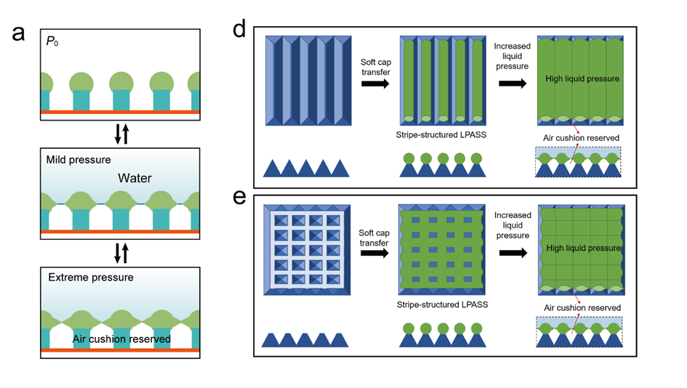
Figure S13. Schematic of the switch mechanism. When the LPASS is at the proper spacing, the effect of the switch could be produced at the soft field to protect the air cushion underneath.

Figure S14. Geometry of the mushroom-like micropillars and the parameters for the calculation of breakthrough pressure.

Supporting table
Table S1. Wettability of the flat films
Samples | $$θ (°)$$ | $$θ_{adv} (°)$$ | $$θ_{rec} (°)$$ | $$θ_{roll-off} (°)$$
Flat fluorinated SU-8 film | 120±2 | 120±3 | 82±2 | NR
Flat fluorescent PDMS film | 101±1 | 118±3 | 82±3 | NR
LPASS | 151±1 | 151±4 | 128±3 | 9±3
Note: Apparent contact angle was measured using 5 $μL$ water droplet. Advancing angle, receding angle and roll-off angle was measure using 10 $μL$ water droplet. “NR” means the water droplet did not roll off the surface even when the surface was tilted to exceed 90°. Errors are standard deviations obtained from at least 3 independent measurements.

Table S2. Mechanical properties of five PDMS surfaces measured at 1 Hz.
Samples | $$G^{'} (kPa)$$ | $$G^{''} (kPa)$$ | $δ$ ($deg)$
PDMS5:1 | 2077.87 | 208.21 | 5.72
PDMS10:1 | 741.41 | 80.85 | 6.22
PDMS25:1 | 76.88 | 9.28 | 6.88
PDMS50:1 | 17.06 | 3.70 | 11.86
PDMS75:1 | 0.73 | 0.54 | 39.6
Note: The phase angle$δ=atan⁡(G^{''}/G^{'})$

Table S3. The contribution percentage of $γ$ and $P$ on the stability of LPASS.
Samples | Curing ratios | $$γ (\%)$$ | $$P (\%)$$
D100 μm-R17.5 μm | 10:1  25:1  50:1 | 0.4  5  25 | 0.1  2.5  12
D40 μm-R5.8 μm | 10:1  25:1  50:1 | 0.6  6  29 | 0.4  5  20
D20 μm-R3 μm | 10:1  25:1  50:1 | 0.6  5.7  27 | 1  8  50

Reference
1. Tuteja A., Choi W., Mabry J., McKinley G., Cohen robust omniphobic surfaces. Proceedings of the National Academy of Sciences 105(47):18200-18205 (2008).
2. Bico J., Reyssat É. & Roman B. Elastocapillarity: When surface tension deforms elastic solids. Annual Review of Fluid Mechanics 50, 629-659 (2018).
3. Hao C., et al. Superhydrophobic-like tunable droplet bouncing on slippery liquid interfaces. Nature Communications 6(1):1-7 (2015).

