Expression and Prognostic Significance of m6A-Related Genes in TP53-mutant Non-small-cell Lung Cancer

Zhuochen Zhao¹⁺, Junhu Wan¹⁺, Manman Guo¹, Yangxia Wang¹, Zhengwu Yang¹, Zhuofang Li¹, Liang Ming¹

Figure S1
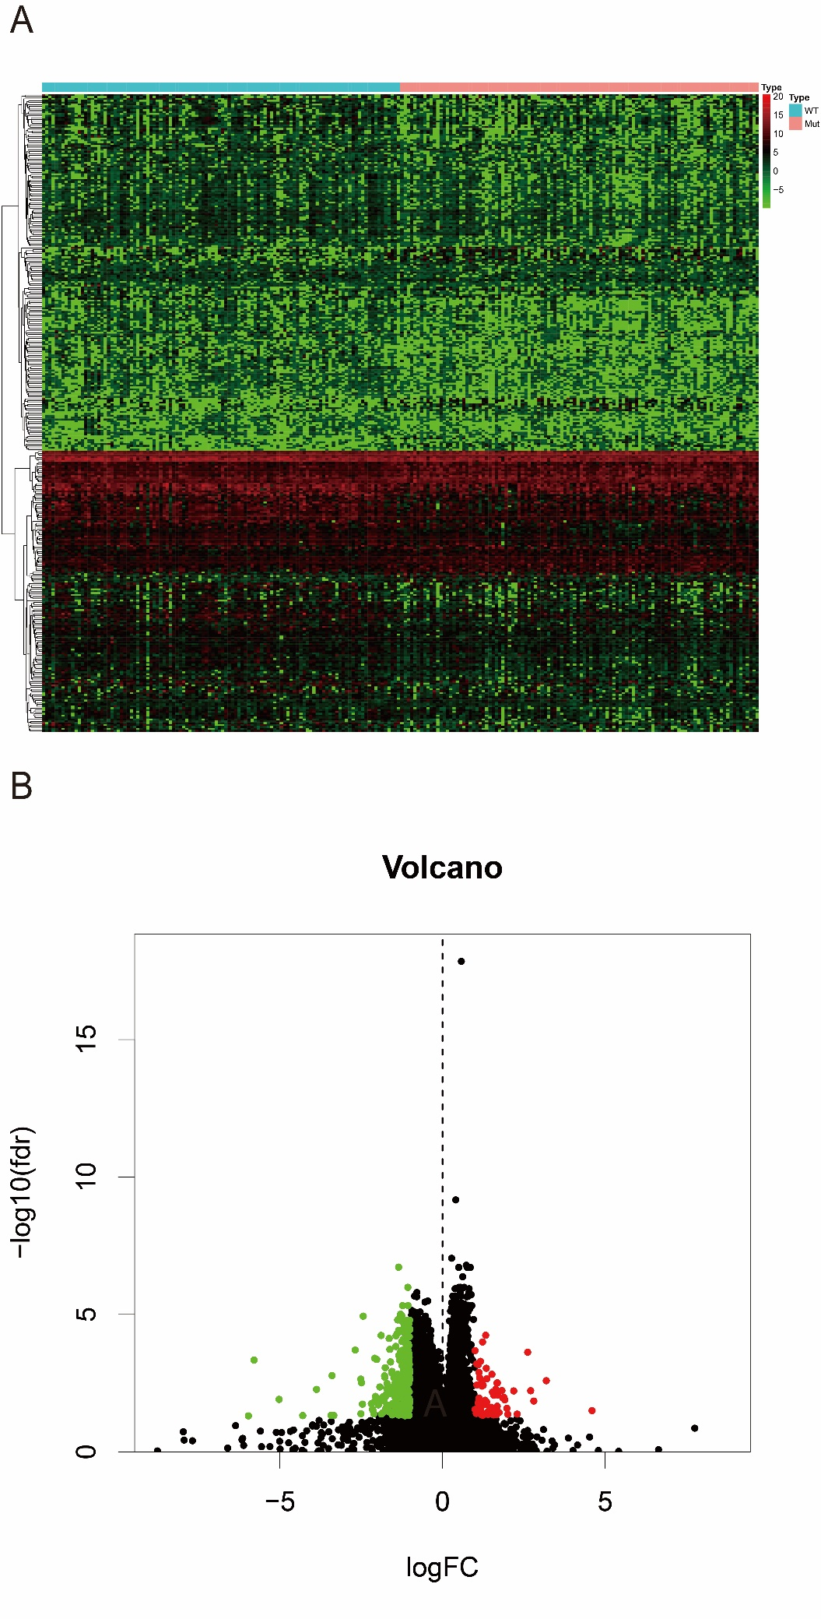
Figure S2
