EXTENDED DATA

Extended Data Figure 1.

Extended Data Fig. 1. Clinical characteristics and antibiotic exposures in the last 2 weeks or during sampling in outpatient subjects with upper respiratory tract (URT) infection or mild COVID-19. *Statistical analyses by Fisher’s exact test; p<0.05.

Extended Data Figure 2.

Extended Data Fig. 2. Co-existing disorders before admission to the hospital, treatments during hospital stay and outcomes in inpatients with moderate or severe COVID-19. Patients with severe illness required admission to an intensive care unit. The median length of hospital stay was measured in days. The statistical analyses were either performed using the *Fisher’s exact test or the #Wilcoxon test.
Extended Data Figure 3.

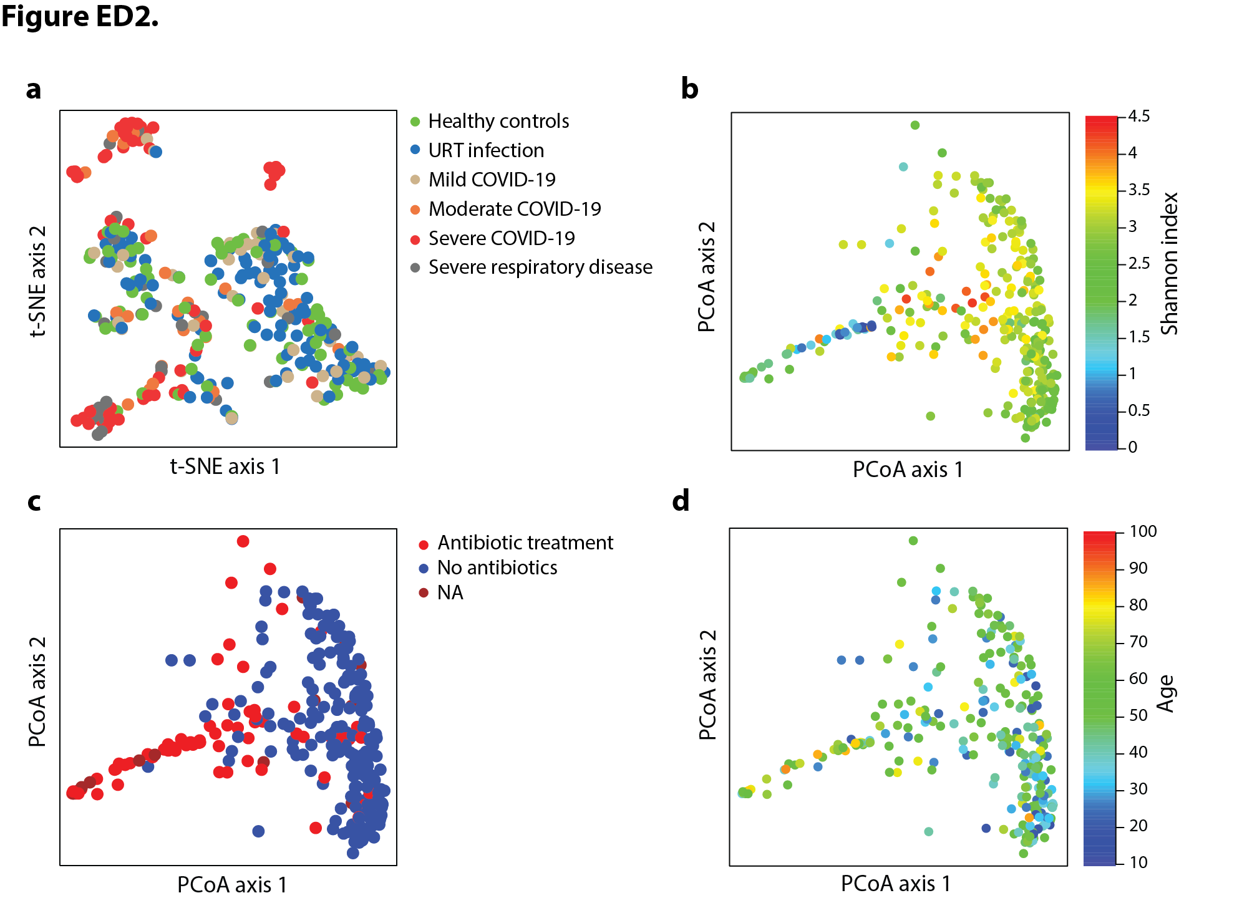

Extended Data Fig. 3. Compositional diversity in the oropharyngeal microbiome associated with COVID-19 severity and clinical variables. a, The microbiome composition from all groups are shown according to the t-distributed stochastic neighbor embedding (t-SNE) algorithm. Each point represents a single oropharyngeal sample color-coded by assignment to control or COVID-19 groups. b-d, Principal coordinates analyses (PCoA) based on species-level Bray-Curtis dissimilarity with biospecimen from all six groups; most variation was driven by Shannon index (PERMANOVA F=25.3; p=0.002), whereas antibiotic exposure (PERMANOVA F=1.5; p=0.084) and age (PERMANOVA F=1.7; p=0.084) had only a moderate impact on compositional variation. NA, data not available for 7 participants.

Extended Data Figure 4.

Extended Data Fig. 4. Baseline demographic characteristics of patients with moderate and severe COVID-19 admitted to a hospital vs. patients admitted to an intermediate or intensive care unit because of pulmonary infections and severe respiratory condition other than COVID-19; no significant difference in age distribution was observed between the three groups (Kruskal-Wallis test: p=0.054).

Extended Data Figure 5.

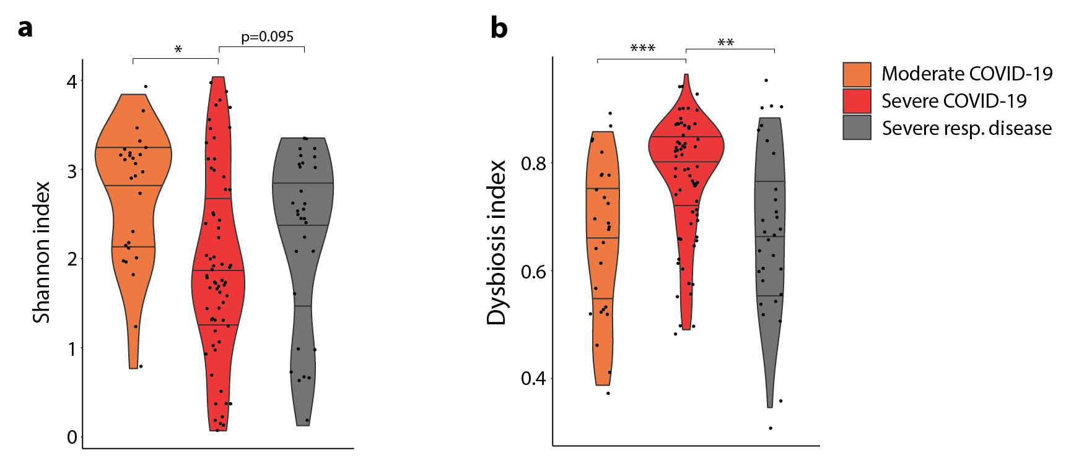

Extended Data Fig. 5. a, Alpha diversity displayed as Shannon index, and b, dysbiosis scores of oropharyngeal microbiomes samples from moderate and severe COVID-19 affected patients (n=27 and 66 samples) and from patients with SARS-CoV-2 negative, severe respiratory disease admitted to an ICU (n=30). *p<0.05, **p<0.01, ***p<0.001 (Wilcoxon test).

Extended Data Figure 6.

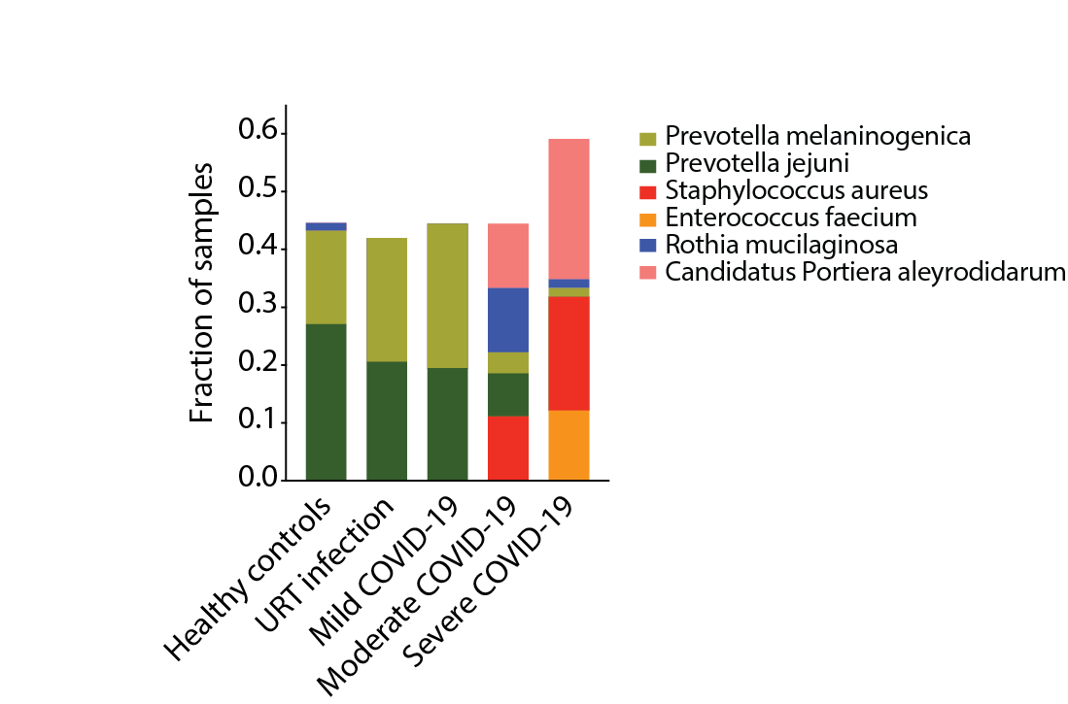

Extended Data Fig. 6. Taxonomic diversity in the oropharyngeal microbiome. Fraction of samples with taxa that contributed to domination events (relative abundance > 0.3 per sample; present in ≥ 10% of samples per subgroup) color-coded per group / COVID-19 severity on the bottom (healthy controls, URT infection, mild, moderate and severe COVID-19).

Extended Data Figure 7.

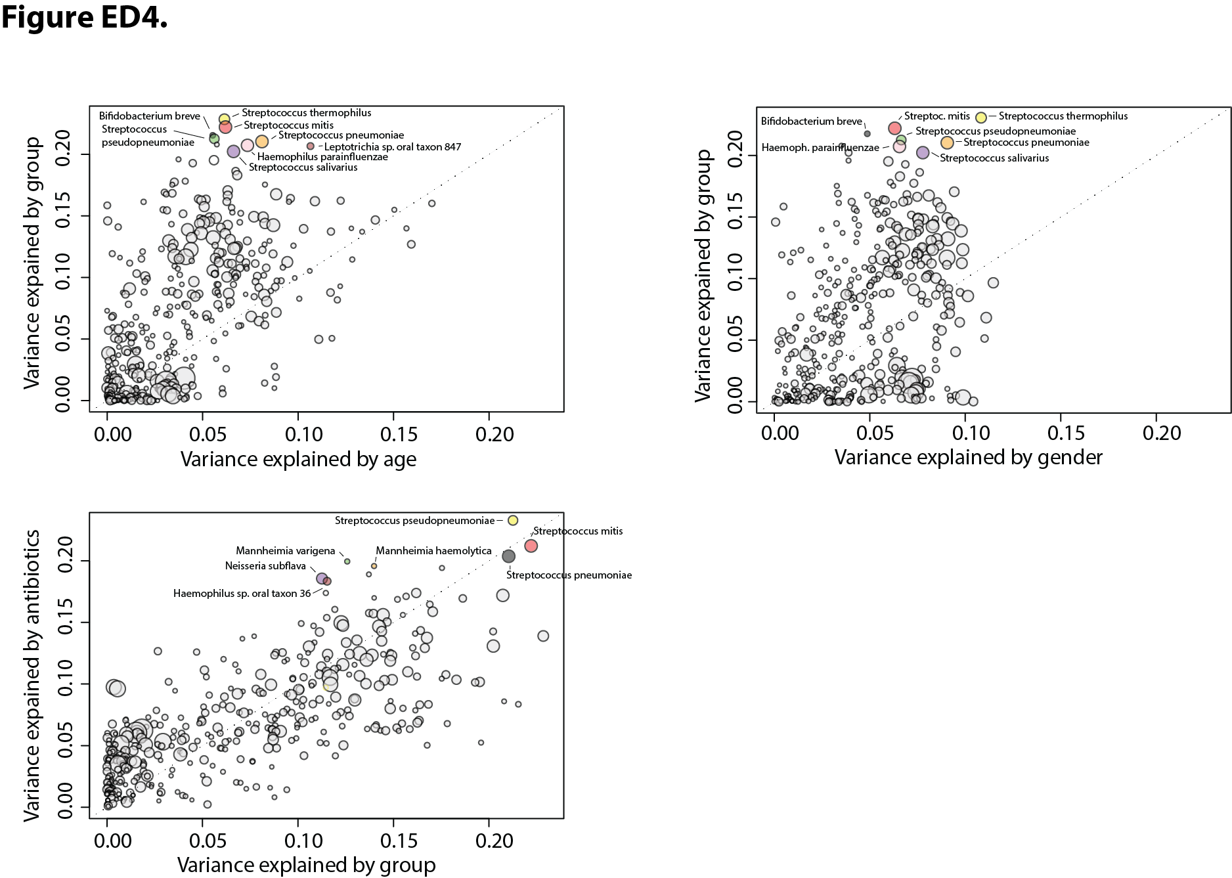

Extended Data Fig. 7. Analysis of variance using ranked abundance data of taxa shows many species to differ between moderate and severe COVID-19 (i.e., group), less for antibiotic treatment, but not between gender and age (binarized in young vs. old [>65y]).

Extended Data Figure 8.

Extended Data Fig. 8. Schematic representation of the implemented random forest (RF)-based machine learning pipeline. For details, see Methods section.

Extended Data Figure 9.

Extended Data Fig. 9. Co-existing disorders before admission to the hospital, treatments during hospital stay and outcomes in inpatients stratified into the training and validation cohort; patients from Heidelberg area (Heidelberg University Clinic, University Hospital Mannheim and Thoraxklinik Heidelberg), and patients from the other medical centers grouped into the validation set (University Clinic Regensburg, University Clinic Frankfurt, Klinikum rechts der Isar of Technical University Munich, and University Heart Center Freiburg). The statistical analyses were either performed using the *Fisher’s exact test or the #Wilcoxon test.

Extended Data Figure 10.

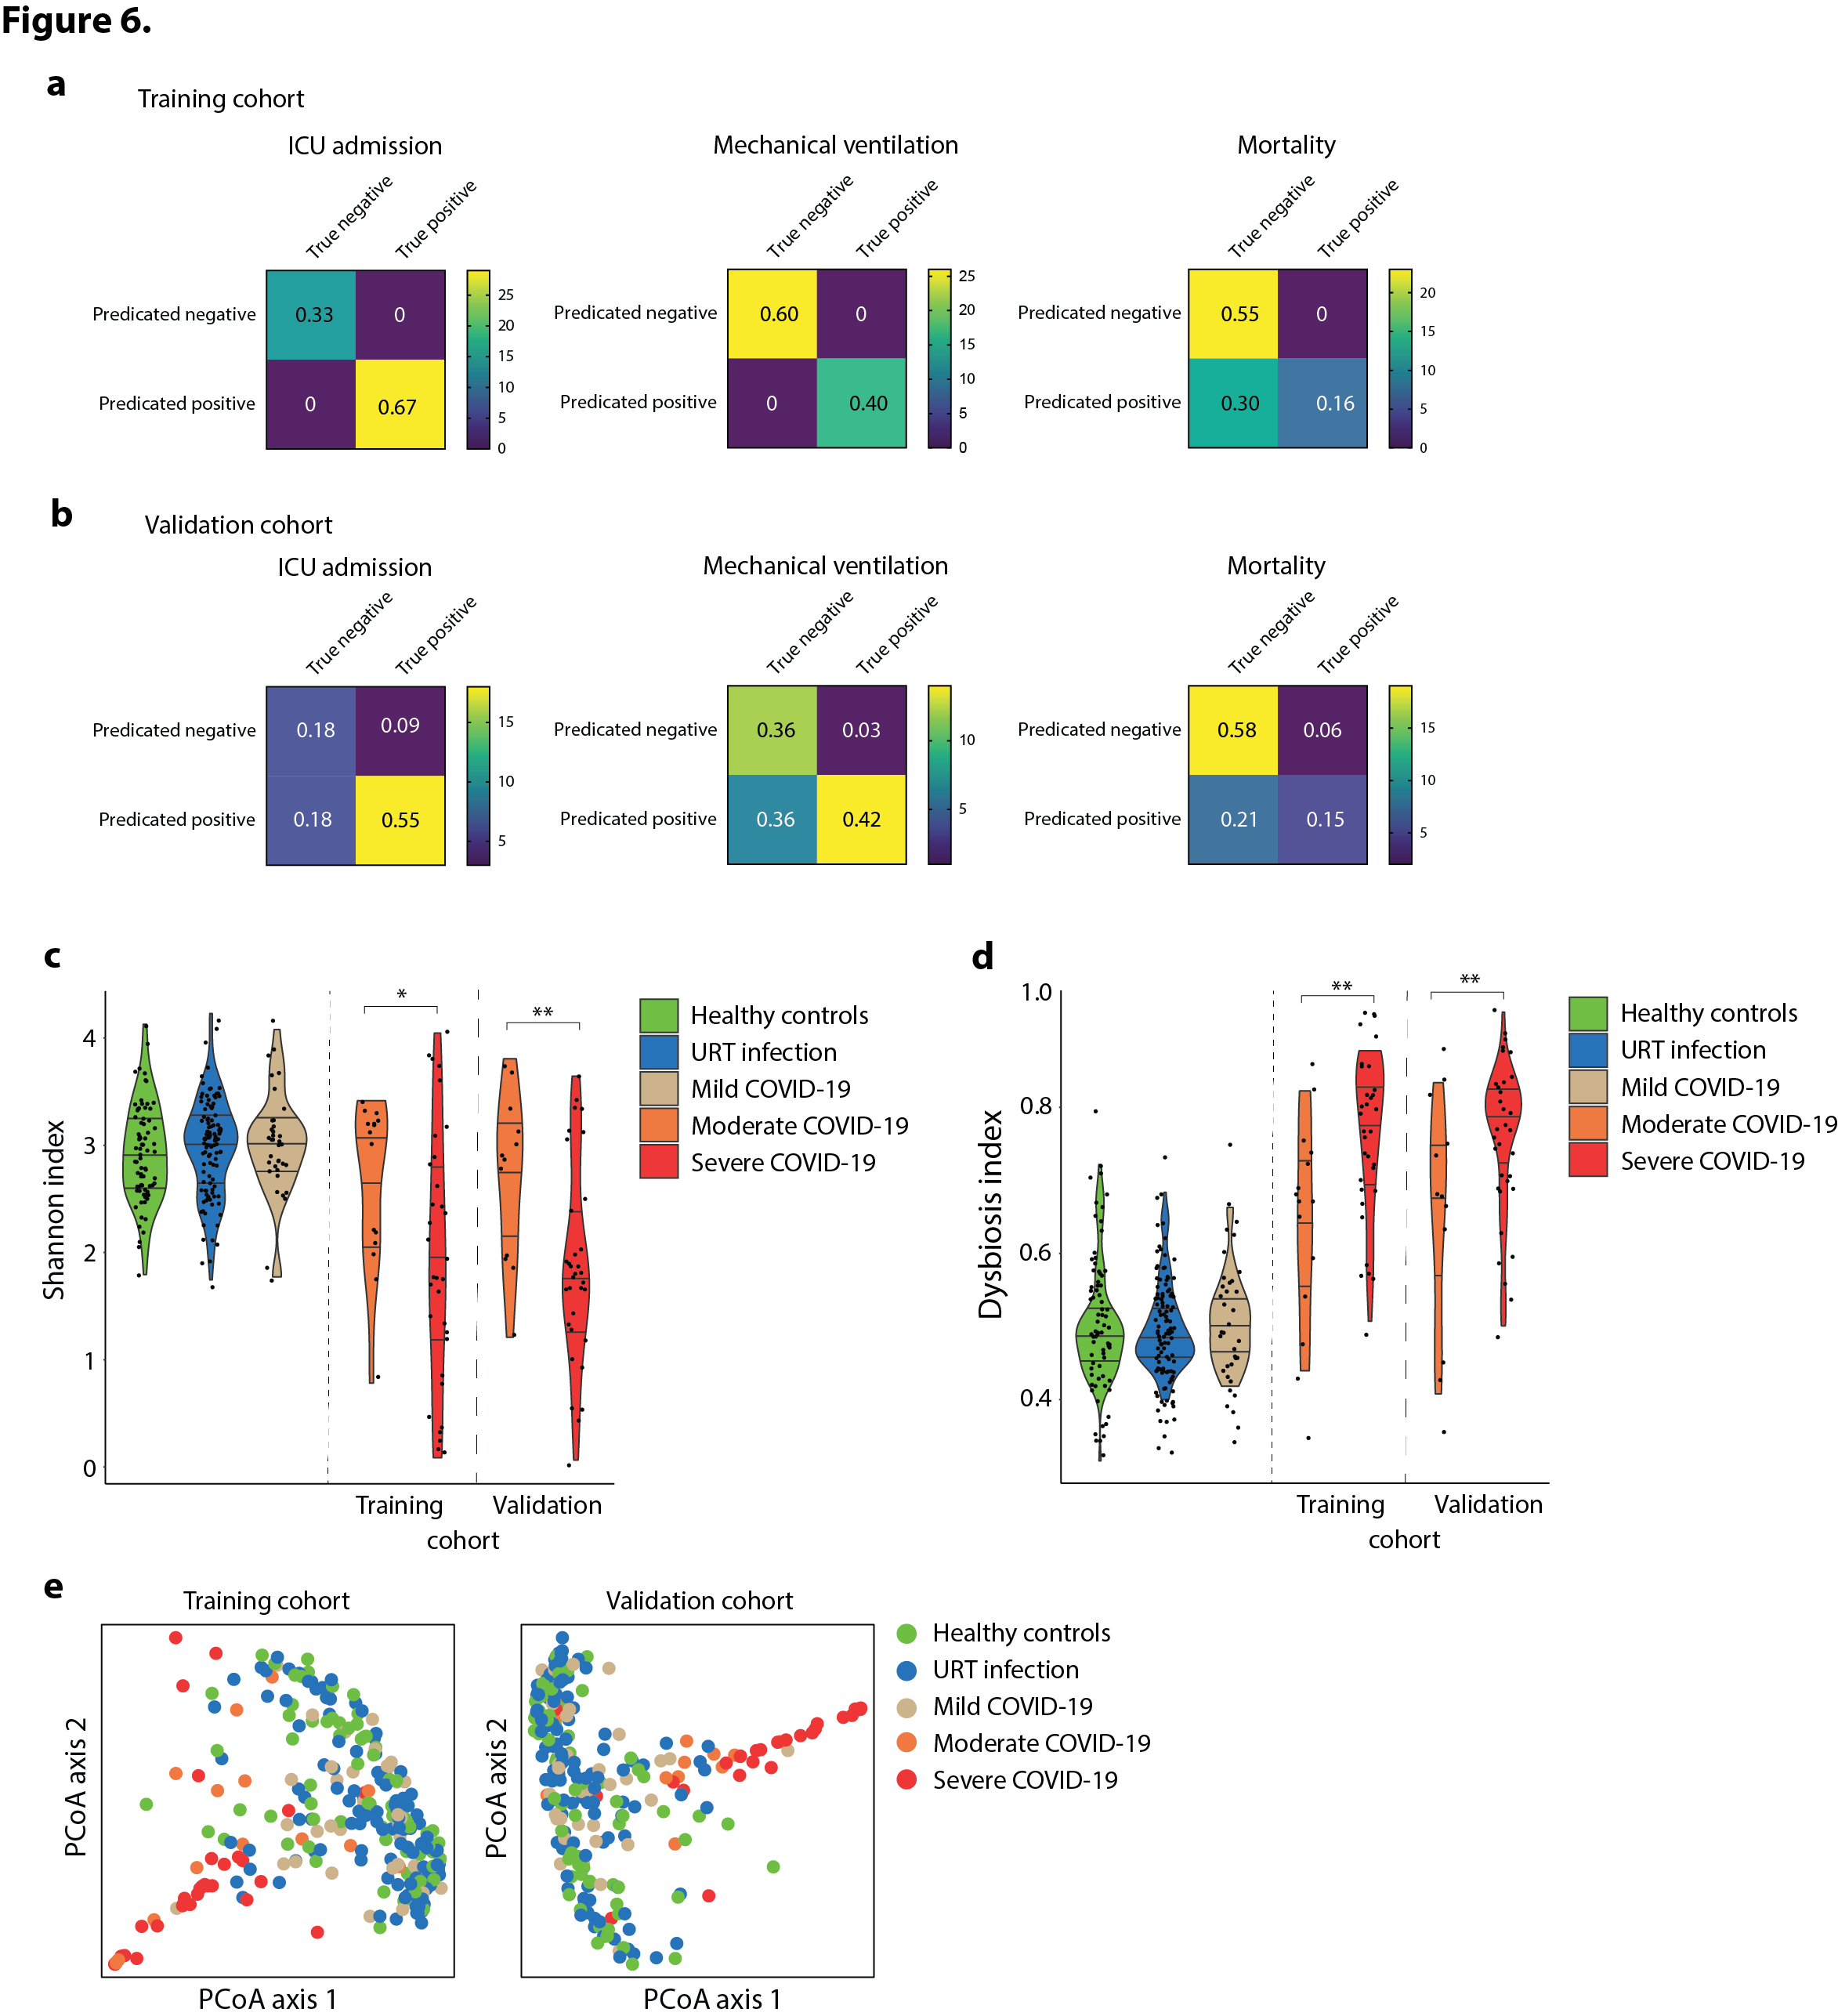

Extended Data Fig. 10. The multi-centric cohort of hospitalized patients with moderate and severe COVID-19 was separated into a training and validation sub-cohort. The training set consisted of patients from Heidelberg area (Heidelberg University Clinic, University Hospital Mannheim and Thoraxklinik Heidelberg; N = 15 moderate, 33 severe cases), and the patients from the other medical centers were grouped into the validation data set (University Clinic Regensburg, University Clinic Frankfurt, Klinikum rechts der Isar of Technical University Munich, and University Heart Center Freiburg; N = 12 moderate and 33 severe COVID-19 cases). a, Normalized confusion matrices for the training cohort depicting the RF’s predictions of the three major clinical outcomes in the training and b, the validation cohort; normalized values in the box, and absolute counts are color-coded. c, Shannon index and d, dysbiosis index after data stratification into the training and validation cohort; data from healthy controls, patients with URT infections and mild COVID-19 were plotted as reference. e, PCoAs on species composition after stratification plotted against oropharyngeal microbiome of healthy controls, URT infection and mild coronavirus infection. *p<0.05, **p<0.01 (Wilcoxon test).

Extended Data Figure 11.

Extended Data Fig. 11. Univariate logistic regression analyses applied on Shannon and dysbiosis indices for the major clinical outcomes ICU admission, mechanical ventilation, ECMO treatment and mortality in hospitalized COVID-19 patients in Heidelberg hospitals (training cohort) and other German hospitals (validation cohort). OR, odds ratio; CI, confidence interval.

Extended Data Figure 12.

Biomarker | Cohort | Clinical outcomes | Model | Significant results | Reference
Lactic dehydrogenase (LDH), lymphocyte counts and C-reactive protein (CRP) | 485 patients, region of Wuhan, China | COVID-19 severity | Prediction (Multi-tree XGBoost model) | AUC scores for validation sets for LHD: 0.92; LHD, lymphocyte counts:0. 94; LHD, lymphocyte counts and CRP: 0.95 | Yan et al., 2020 ¹
HNC-LL score (hypertension, neutrophil counts, CRP, lymphocyte counts, and LDH) | 442 patients, region from Honghu and Nanchang, China | COVID-19 severity | Prediction model (multivariate analyses) | Lymphocyte counts (<1.1 x 10⁹/L): OR=0.290; neutrophil counts (>6.3 x 10⁹/L): OR=2.815; LDH (>245 U/L): OR=2.903; CRP (≥10 mg/L): OR=4.133 | Xiao et al., 2020 ²
Lymphocytes counts, procalcitonin (PCT), D-dimer, and CRP | 452 patients from Zhongnan, Wuhan and from Leishenshan Hospital, China | COVID-19 mortality | Prediction model (LASSO model) | AUC score for combined model: 0.0919; lymphocyte counts: OR=3.668; PCT: OR=20.745; D-dimer: OR=4.458 | Shang et al., 2020 ³
Neutrophil: lymphocyte ratio, LDH, bilirubin and clinical variables | Nationwide cohort in China (n=1590) | COVID-19 severity | Prediction model (LASSO model and logistic regression) | AUC score for combined model: 0.88; Neutrophil:lymphocyte ratio: OR=1.06; LDH: OR=1.002; bilirubin: OR=1.15 | Liang et al., 2020 ⁴
CD4+ T cell count, D-dimer, and neutrophil: lymphocyte ratio (NLR) | 79 patients from Zhejiang, China | COVID-19 severity | Prediction model (logistic regression and AUROC analyses) | CD4+ T cell count, D-dimer, and NLR combined AUC: 0.865; CD4+ T cell counts: OR=0.995 | Song et al., 2020 ⁵
Serum IL-6, IL-8 and TNF-α | 1484 patients, Mount Sinai Health System hospital, New York City | COVID-19 severity and mortality | Prediction model (Cox proportional hazards models) | IL-6: hazard ratio (HR)=2.23; IL-8 HR=1.41; TNF-α HR=1.50 | Del Valle et al., 2020 ⁶
Neutrophil:VD2 T-cell ratio | 54 patients, National Centre for Infectious Diseases (NCID), Singapore | COVID-19 mortality | Prediction by receiver operating curve (ROC) analysis | Neutrophils:VD2 T-cells in patients with pneumonia: AUC: 0.845; and with hypoxia: AUC: 0.911 | Carissimo et al., 2020 ⁷
Serum chemistry laboratory parameters | 398 patients, UTMB, Galveston | COVID-19 mortality | Prediction model (logistic regression classifier, SVM) | CRP, blood urea nitrogen, serum calcium, albumin and lactic acid combined AUC: 0.93 | Booth et al., 2020 ⁸
Serum proteoms and metaboloms | 46 patients, Taizhou hospital, China | COVID-19  severity | Prediction by random forest model to build ROCs | 22 proteins and 7 metabolites combined: AUC: 0.957 | Shen et al., 2020 ⁹

Extended Data Fig. 12. Summary of clinical studies using immune cell counts and serum parameters as predictors of COVID-19 severity and mortality. Abbreviations: LDH, lactic dehydrogenase; CRP, C-reactive protein; PCT, procalcitonin; NLR, neutrophil:lymphocyte ratio; LASSO, least absolute shrinkage and selection operator; AUROC, area under the receiver operating characteristic; ROC: receiver operating characteristic; AUC, area under curve; SVM, support vector machine; OR, odds ratio; HR, hazard ratio.

References

1. Yan, L. et al. An interpretable mortality prediction model for COVID-19 patients. Nat. Mach. Intell. 2, 283–288 (2020).
2. Xiao, L. shan et al. Development and validation of the HNC-LL score for predicting the severity of coronavirus disease 2019. EBioMedicine 57, 102880 (2020).
3. Shang, Y. et al. Scoring systems for predicting mortality for severe patients with COVID-19. EClinicalMedicine 24, 100426 (2020).
4. Liang, W. et al. Development and validation of a clinical risk score to predict the occurrence of critical illness in hospitalized patients with COVID-19. JAMA Intern. Med. 180, 1081–1089 (2020).
5. Song, C. Y., Xu, J., He, J. Q. & Lu, Y. Q. Immune dysfunction following COVID-19, especially in severe patients. Sci. Rep. 10, 1–11 (2020).
6. Del Valle, D. M. et al. An inflammatory cytokine signature predicts COVID-19 severity and survival. Nat. Med. 26, (2020).
7. Carissimo, G. et al. Whole blood immunophenotyping uncovers immature neutrophil-to-VD2 T-cell ratio as an early prognostic marker for severe COVID-19. Nat Commun 11, 5243 (2020).
8. Booth, A. L., Abels, E. & McCaffrey, P. Development of a prognostic model for mortality in COVID-19 infection using machine learning. Mod. Pathol. (2020).
9. Shen, B. et al. Proteomic and Metabolomic Characterization of COVID-19 Patient Sera. Cell 182, 59-72.e15 (2020).

