Association between miR-30a/SNAI1 gene polymorphisms and the risk of diabetic kidney disease
Cailian Yang^{1,2}, Tao Tong^{1,3}, Mingfang Sun^{1,4}, Bo Zhou^{1,5}.
1.Department of Endocrinology, the First Affiliated Hospital of Chongqing Medical University,Chongqing,400000,China. 2.1808622838@qq.com; 3.tong_tong123@163.com; 4.189659280@qq.com; 5.zhoubo915@126.com
supplementary information
1.miR-30a RS2222722 CC genotype
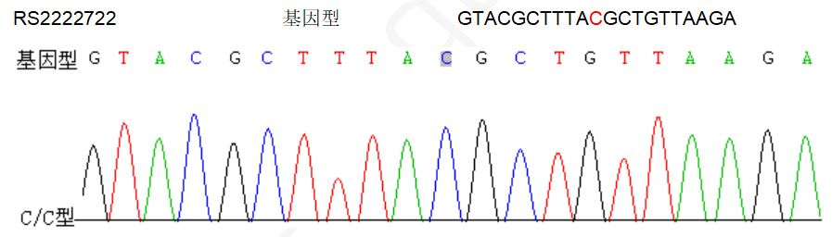
2.miR-30a RS2222722 CT genotype
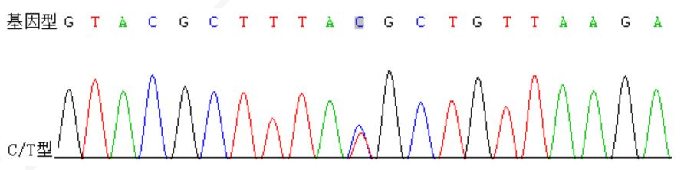
3.miR-30a RS2222722 TT genotype
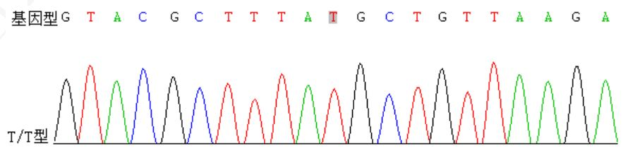
4.SNAI1 RS1543442 AA genotype
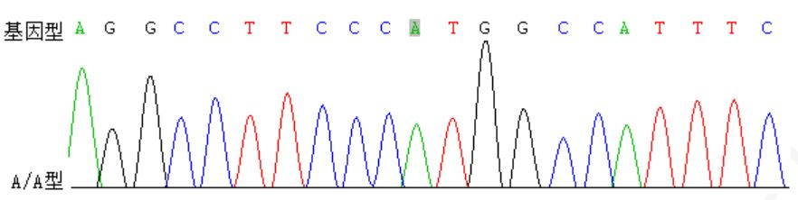

5.SNAI1 RS1543442 AG genotype
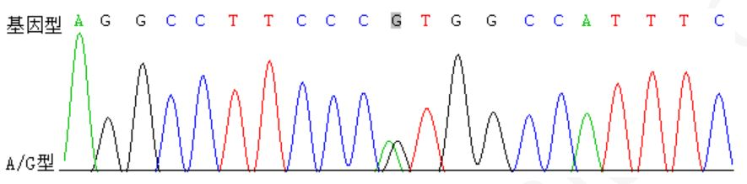
6.SNAI1 RS1543442 GG genotype
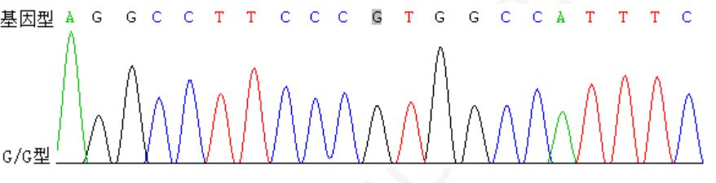
7.Electrophoresis results of PCR products
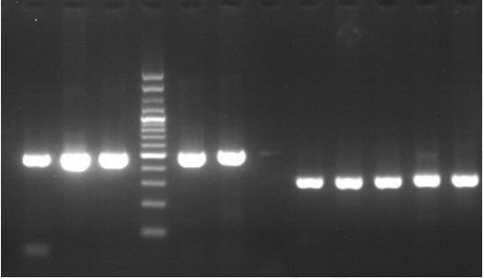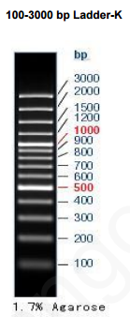

8.Electrophoresis results of DNA
