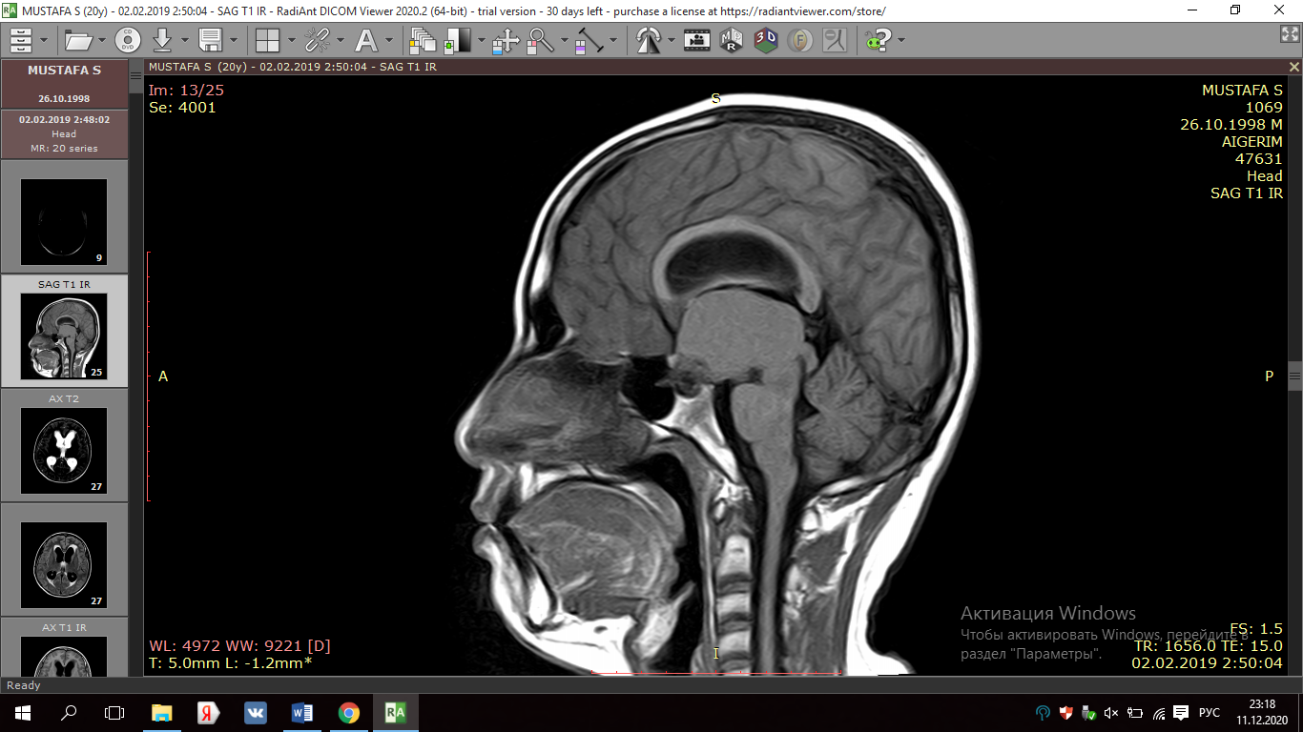 | Relation of sphenoid sinus to the sella turcica (sagittal section of the sphenoid bone). Conchal type
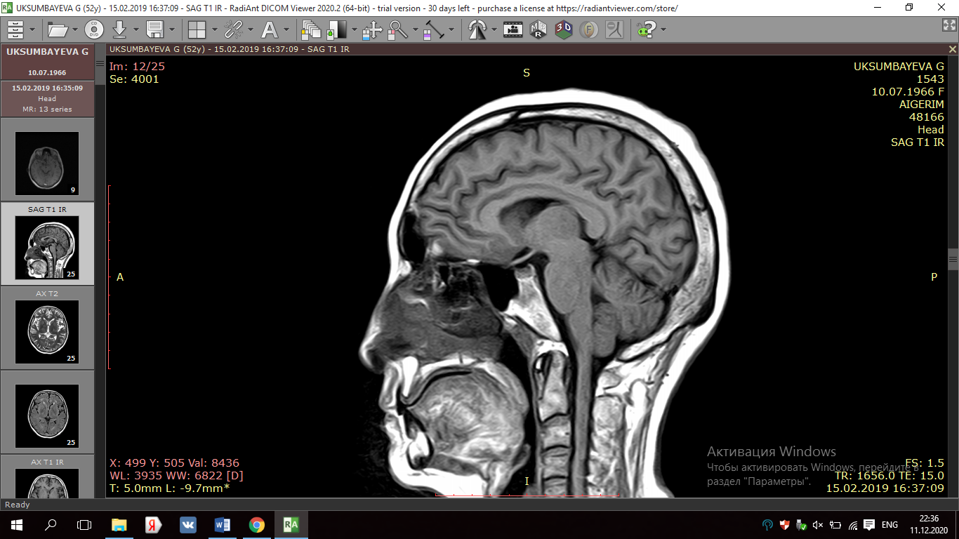 | Relation of sphenoid sinus to the sella turcica (sagittal section of the sphenoid bone). Presellar type
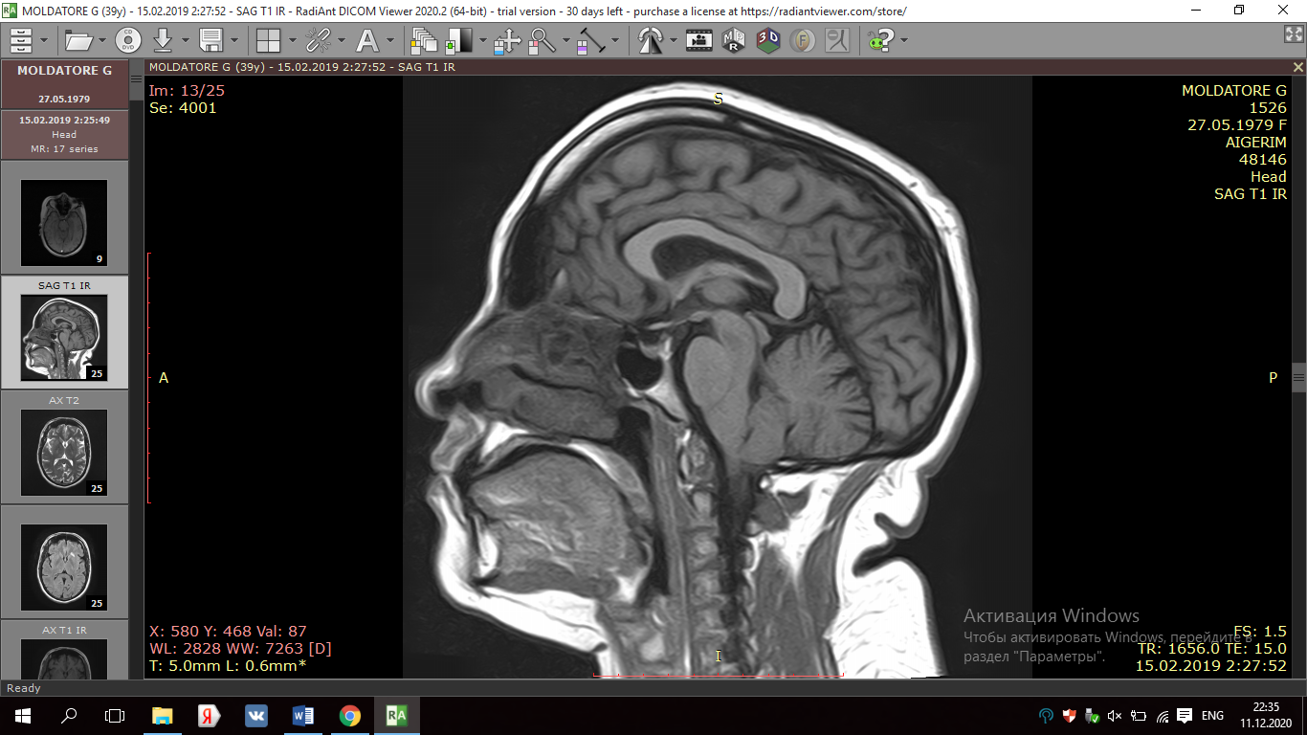 | Relation of sphenoid sinus to the sella turcica (sagittal section of the sphenoid bone). Sellar type
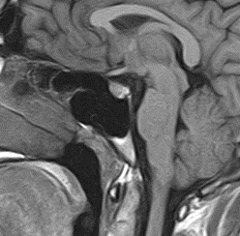 | Relation of sphenoid sinus to the sella turcica (sagittal section of the sphenoid bone). Postsellar type

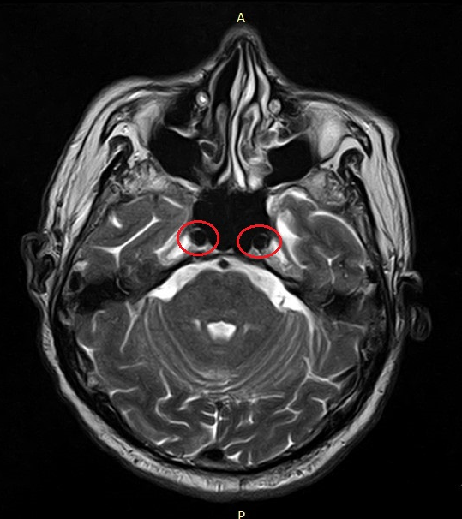 | Internal carotid arteries protrusion  (horizontal plane)
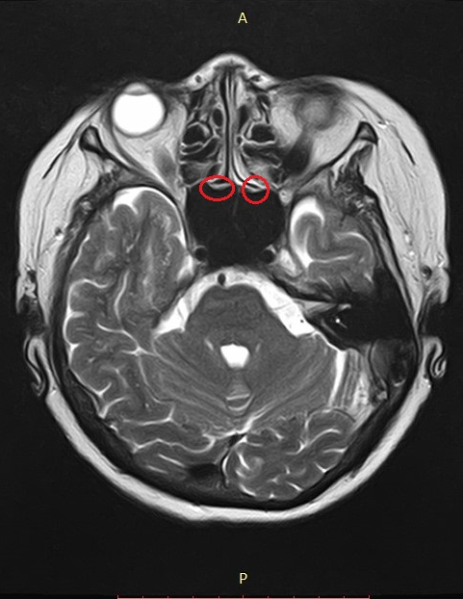 | Optic nerve protrusion  (horizontal plane)

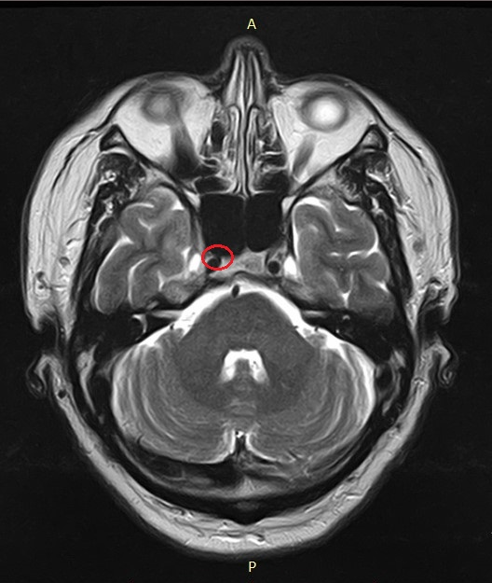 | Internal carotid artery dehiscence  (horizontal plane), right side.

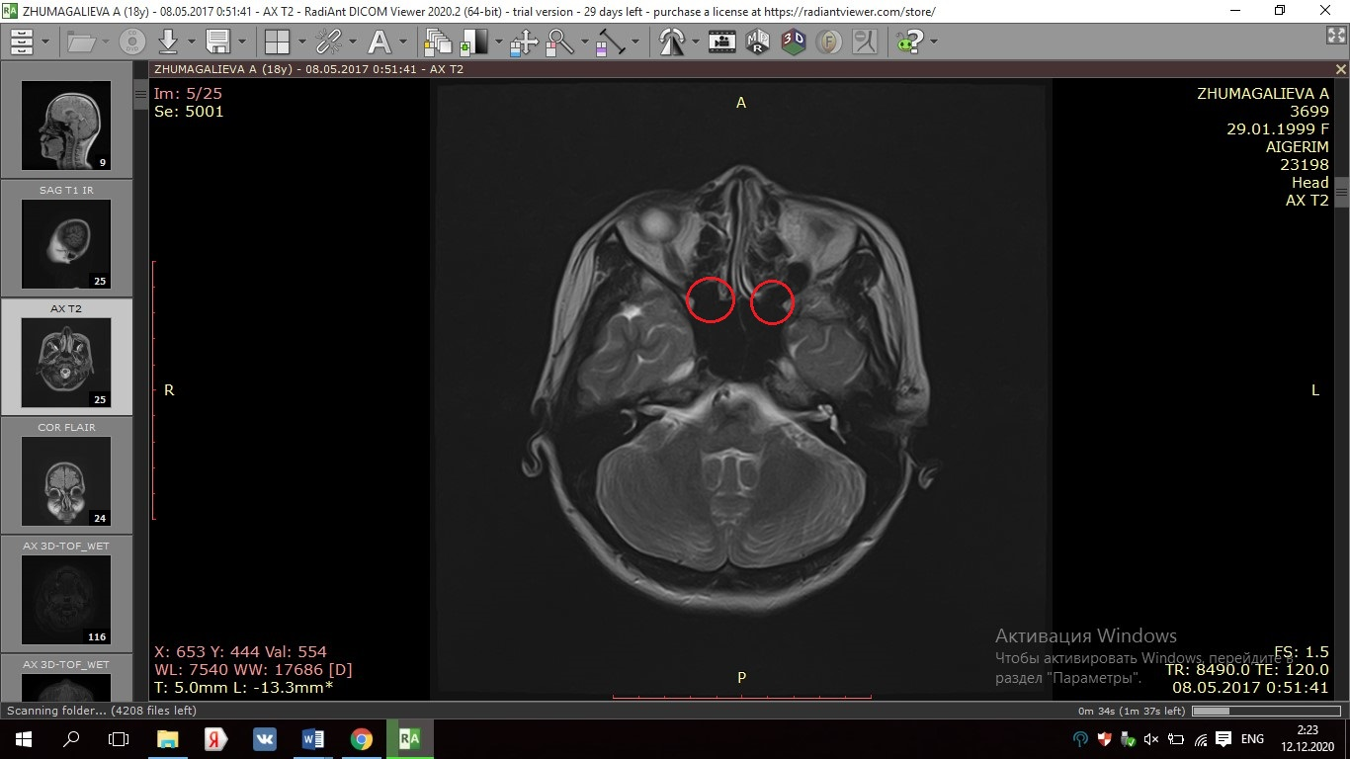 | Optic nerve dehiscence  (horizontal plane), right side.

