ELECTRONIC SUPPLIMENTARY MATRIALS

TITLE
Modelling of lung cancer therapy; modelled and real-world impact of targeted therapy and immunotherapy in the Netherlands

AUTHORS
Zakile A. Mfumbilwa,¹ (ORCID: https://orcid.org/0000-0002-9705-7227 )
Janneke A. Wilschut,^{1,2} (ORCID: https://orcid.org/0000-0002-4921-227X )
Martijn J.H.G. Simons,^{3,4} (ORCID: https://orcid.org/0000-0001-5248-1676 )
Bram Ramaekers,^{3,4} (ORCID: https://orcid.org/0000-0001-5785-9228 )
Manuela Joore,^{3,4} (ORCID: https://orcid.org/0000-0002-5649-6768 )
Valesca Retel,⁵ (ORCID: https://orcid.org/0000-0002-5624-3234 )
Christine M. Cramer-van der Welle,⁶
Franz M.N.H. Schramel,⁶
Ewoudt M.W. van de Garde,^{7,8} and
Veerle M.H. Coupé ^{1*} (ORCID: https://orcid.org/0000-0002-9553-9791 )

AUTHOR AFFILIATION
¹ Department of Epidemiology and Data Science, Amsterdam Public Health, Amsterdam UMC, Vrije Universiteit Amsterdam, de Boelelaan 1117, Amsterdam, the Netherlands.
² Dutch Institute for Clinical Auditing, Leiden, the Netherlands.
³ Department of Clinical Epidemiology and Medical Technology Assessment, Maastricht University Medical Centre+, Maastricht, the Netherlands.
⁴ Maastricht university, Care And Public Health Research Institute (CAPHRI), Maastricht, the Netherlands.
⁵ Department of Health technology and Services research, University of Twente, Enschede, the Netherlands.
⁶ Santeon Hospital Group, Santeon, Herculesplein 38, 3584 AA Utrecht, The Netherlands.
⁷ Division of Pharmacoepidemiology and Clinical Pharmacology, Department of Pharmaceutical Sciences, Utrecht University, Utrecht, the Netherlands
⁸ Department of Clinical Pharmacy, St. Antonius Hospital, Utrecht/Nieuwegein, the Netherlands

* Address correspondence to Veerle M.H. Coupé, Decision modelling and Health Care Evaluation, Department of Epidemiology and Data Science, Amsterdam UMC, location Vumc, PO Box 7057, 1007 MB, Amsterdam, the Netherlands.
Email address: v.coupe@amsterdamumc.nl (Coupé, V.M.H.)
A.1 Methods
Fitting of parametric multistate-statistical model (par MSSM)
The fitting of parametric multistate-statistical model (MSSM) is carried out as a series of nested competing risk models accounting for competing events (e.g., from L1T to L2T vs from L1T to Death) and delayed entry (left truncation) for in-transit events (i.e., from L2T to L3 and from L3T to Death) [43], [69].
For each possible time to event (from event i to event j), a cause-specific hazard model is defined as follows:
$h_{ij}\left(t\right)=h_{0j}\left(t\right)exp⁡(β_{k}^{T}X_{kl})$ equation (A1)
where $h_{0j}(t)$ is a time dependent baseline hazard of moving from event $i$ to event $j$. $h_{ij}(t)$ is the hazard function of moving from event $i$ to event $j$ at time $t$. $β_{k}^{T}$ is the transposed vector of model coefficients associated with covariate $X_{kl}$, with $l$ = 1, 2, … $n_{ij}$. $n_{ij}$ – total number of patients at risk at $t$ = 0 for moving from event $i$ to event $j$.
Equation (A1) can be fitted using a parametric or non-parametric framework, and fitting goes as follow;
- For fitting a specific event-time distribution, patients who experience a competing event are censored at the time of the competing event.
- For event time from in-transit events (from L2T to L3T, from L2T to Death, and from L3T to Death), patients are not at risk for these movement until they have progressed to event L2T or L3T, respectively.
For a parametric framework, a specification of the distribution function of the baseline hazard h_{0ij}(t) for all time to events is required [44]. In this study we restricted ourselves to three proportional hazard (PH) distribution functions i.e., Exponential, Weibull, and Gompertz. Based on visual inspection, gompertz distribution with monotonic hazard was the best distribution for time from L1T to L2T and L1T to Death, exponential distribution gives the best fit for time from L2T to L3T and L2T to Death. Because of the limited number of patients at risk for time from L3T to Death, an exponential distribution was chosen. Covariates for each time-to-event model were selected based on backward selection (cutoff p-value < 0.05).

Construction of the microsimulation model: non-personalized strategy
The microsimulation model was implemented as follow; Patients’ profiles were sampled according to the distributions, associations, and parameters described in the methods section 2.3. First, we sampled baseline attributes; gender, year of diagnosis, age at diagnosis, CCI, PS. Later, conditional on baseline attributes, we sampled the treatment decision (BSC or treated). For treated patients, the type of systemic chemotherapy (cisplatin containing doublets or carboplatin containing doublets) was sampled taking into account the baseline attributes. Distributions and parameters used to sample patients’ baseline attributes and treatment decisions are given in Table A6.
Under the non-personalized strategy; for patients who progressed to second- and third-line chemotherapy. In second and third line we assumed that patients have equal prognosis regardless of the type of chemotherapy. Therefore, in second and third line, no specification of chemotherapy regimens.
Lastly, patients’ disease pathways were sampled conditional upon patients’ attributes and treatment decisions. Time to event was drawn from the fitted parametric distributions and background mortality as described in section 2.3. For competing events, the event with the shortest event time was taken as occurred event for that patient. At any disease event, patients could die due to other causes (DoC) described by background mortality. The process was carried on until all patients were in absorption event (Death).

Note: Sampling from truncated Gompertz decrH.
Mathematically, a Gompertz distribution with monotonic decreasing hazard (call it, Gompertz decrH) has a non-zero probability for a patient to have infinite event time (patient can live forever) [70]. When Gompertz decrH is used in the presented model, the simulation was constrained such that all simulated patients have finite event time (i.e., no patient lives forever). The constrain was implemented by resampling a patient’s event time until at least one of the possible competing times to event from “event i” has finite event time. Thus, to say, sampling from “truncated Gompertz decrH” distribution.
The consequence of truncation is that simulated data from truncated Gompertz have higher hazard (shorter time to events i.e., event time distribution is shifted to the left) compared to the actual hazard used to simulate the data. Thus, to say, the hazard rate re-estimated from simulated data (outHR) is higher than the hazard rate used to obtain the simulated data (inHR). The magnitude of difference between outHR and inHR depends on the strength of inHR. The lower inHR, the higher the number of patients with “infinite time” to be resampled, the higher the difference between outHR and inHR.
For the non-personalized strategy (patients treated with first-line chemotherapies), only 0.8 percent of patients had their event time from L1T to L2T and DEATH resampled after first having “infinite time” in both time to event (i.e., from L1T to L2T and from L1T to DEATH). For personalized strategy however (patients treated with first-line targeted therapies or immunotherapy), about 12 percent of patients had their event time from L1T to L2T and DEATH resampled after first having “infinite time” in both times to event (i.e., from L1T to L2T and L1T to DEATH).
In order to simulate a randomized treatment (RCT) effect for targeted therapy or immunotherapy compared to chemotherapy in the personalized strategy, the progression free hazard for L1T to L2T and from L1T to DEATH (inHR) had to be calibrated. Calibration was done such that simulated results for outHR equal the progression-free hazard rate from the RCT (rctHR). The outHR was re-estimated by a coxPH model with cut-off time of 20 months from start of first-line treatment to mimic a limited follow up in RCT. For example, for EGFR subgroup treated with first line gefitinib, inHR of 0.38 was used to have outHR of 0.43 which matches to rctHR in a network meta-analysis [37]. Table A4 provides the rctHR and inHR for each molecular subgroup simulated in the personalized strategy. For the Immunotherapy treated subgroup, inHR was given under 23 percent long-term survivor fraction and 0 percent long-term survivor fraction as described in section 2.4 of the main text.
A.2 Tables
Table A1. Distribution of baseline characteristics for patients with advanced (inoperable) non-squamous NSCLC diagnosed between 2008 - 2014
Variable | Non-squamous Cell
Variable | Systemic | BSC | All
Year (%)
2008 | 82 (10.7) | 211 (14.7) | 293 (13.3)
2009 | 91 (12.0) | 205 (14.3) | 296 (13.5)
2010 | 95 (12.5) | 208 (14.5) | 303 (13.8)
2011 | 109 (14.3) | 2015 (15.0) | 324 (14.8)
2012 | 137 (18.0) | 195 (13.6) | 332 (15.1)
2013 | 126 (16.6) | 192 (13.4) | 318 (14.5)
2014 | 121 (16.0) | 209 (14.6) | 330 (15.0)
Gender (%)
Male | 432 (56.8) | 849 (59.2) | 1281 (58.3)
Female | 329(43.2) | 587 (40.8) | 915 (41.7)
Age
Mean ± std. Error | 62.5 ± 0.350 | 68.9 ± 0.289 | 66.7 ± 0.234
PS (%)
Good (0 -1) | 640 (84.1) | 731 (50.9) | 1371 (62.4)
Bad (2 – 4) | 86 (11.3) | 598 (41.7) | 684 (31.1)
Unknown | 35 (4.6) | 106 (7.4) | 141 (6.4)
CCI (%)
Good (1 – 2) | 718(94.3) | 1266 (88.2) | 1984 (90.3)
Bad (> 2) | 43(5.7) | 169 (11.8) | 212 (9.7)
Histology (%)
Adenocarcinoma | 564 (74.1) | 956 (66.6) | 1520 (69.2)
Large cell | 89 (11.7) | 223 (15.5) | 312 (14.2)
Other or NOS | 108 (14.2) | 256 (17.8) | 364 (16.6)
First Line Treatment (%)
Cisp. D
Cisplatin-pemetrexed | 291 (38.2) | - | 291 (13.3)
Cisplatin-gemcitabine | 90 (11.8) | - | 90 (4.1)
Carbo. D
Carboplatin-pemetrexed | 195 (25.6) | - | 195 (8.9)
Carboplatin-gemcitabine | 87 (11.4) | - | 87 (4.0)
Bevacizumab-carboplatin- paclitaxel | 60 (7.9) | - | 60 (2.7)
Carboplatin-docetaxel | 38 (5.0) | - | 38 (1.7)
BSC | - | - | 65.34
Total | 761 (34.7) | 1435 (65.3) | 2196 (100)
Note: PS, Eastern Cooperative Oncology Group performance status; CCI, Charlson comorbidity index; Year, year of diagnosis; Age, age at diagnosis; BSC, best supportive care; Syst, systemic chemotherapy; Cisp. D, Cisplatin doublet chemotherapy; Carbo. D, Carboplatin doublet chemotherapy; std. Error – standard error of the mean. NB., This table provides description of 2196 non squamous cell patients received standard chemotherapy or best supportive care, for more details on the complete cohort, we refer to [24].
Table A2. Bivariate association of baseline characteristics and first-line treatment decision for patients with advanced (inoperable) non-squamous NSCLC diagnosed between 2008 – 2014
Variables |  | Methods | Test-statistic and pvalues |  |  | % sim. pv <0.05
Variable 1 | Variable 2 |  | Statistic | df | pvalue
Year | Gender | χ² | 1.94 | 6 | 0.925 | 6
 | PS | χ² | 91.87 | 12 | <0.0001 | 100
 | CCI | χ² | 5.291 | 6 | 0.507 | 5
 | Treat (Syst or BSC) | χ² | 19.82 | 6 | 0.003 | 97
 | Syst  (Cisp. D or Carb. D) | χ² | 8.01 | 6 | 0.237 | 7
 | Age | Anova | 1.971 | 6; 2189 | 0.064 | 6
Gender | PS | χ² | 2.97 | 2 | 0.227 | 25
 | CCI | χ² | 14.34 | 1 | 0.0002 | 98
 | Treat (Syst or BSC) | χ² | 1.078 | 1 | 0.299 | 44
 | Syst  (Cisp. D or Carb. D) | χ² | 4.07 | 1 | 0.044 | 8
 | Age | ttest | 6.10 | 1865.7 | <0.0001 | 100
PS | CCI | χ² | 24.89 | 2 | <0.0001 | 100
 | Treat (Syst or BSC) | χ² | 240.87 | 2 | <0.0001 | 100
 | Syst  (Cisp.D or Carb. D) | χ² | 10.61 | 2 | 0.005 | 93
 | Age at Diagnosis | Anova | 46.18 | 2; 2193 | <0.0001 | 100
CCI | Treat (Syst or BSC) | χ² | 20.70 | 1 | <0.0001 | 100
 | Syst  (Cisp. D or Carb. D) | χ² | 1.60 | 1 | 0.2059 | 100
 | Age | ttest | -8.86 | 273.9 | <0.0001 | 100
Treat (Syst or BSC) | Age | ttest | 14.14 | 1727.7 | <0.0001 | 100
Type of Syst  (Cisp. D or Carb. D) | Age | ttest | -4.96 | 758.8 | <0.0001 | 100
χ², Chi-square test of association; Anova, one way analysis of variance; ttest, two independent samples student’s T test PS, Eastern Cooperative Oncology Group performance status; CCI, Charlson comorbidity index; Year, year of diagnosis; Age, age at diagnosis; BSC, best supportive care; Syst, systemic chemotherapy; Cisp. D, Cisplatin doublet chemotherapy; Carbo. D, Carboplatin doublet chemotherapy; % sim. pv ≤ 0.05, proportion of simulations with p-value less than 0.05, out of 1000 runs each with 2196 patients.
Table A3. Prevalence of molecular biomarkers in the population
Biomarker (subgroup) | Proportion | Standard error | Reference
EGFR_{(classic)}ª | 0.07 | 0.008 | [28]
EGFR_{(non-classic)}^{b} | 0.01 | 0.001 | [28]
ALK | 0.02 | 0.002 | [28]
ROS1 | 0.019 | 0.002 | [30]
BRAF_{(V600E)} | 0.021 | 0.002 | [27]
NTRK_{(1,2,3)} | 0.0017 |  | [31]
MET_{(amp / exon 14 sk)} | 0.014 | 0.001 | [27]
RET | 0.017 | 0.002 | [27]
KRAS | 0.28 | 0.029 | [28]
No / Unknown | 0.5473^{c} | - | -
For those tested for PD-L1
PD-L1 ≥50% | 0.25^{d} |  | [29]
PD-L1 < 50% | 0.75e | - | [29]
ª Classic activating EGFR mutations (exon 19 deletions and exon 21 L858R point mutations);
^{b} Non- classic activating EGFR mutations, resistance mutations, and other mutations;
^{c} 1 minus sums all molecular markers
^{d} out of patients with No / unknown molecular biomarkers or had KRAS / MET / RET mutations.
^{e} 1 minus PD-L1 ≥50%.
Table A4. First-line treatment and PF HR per molecular subgroup
Biomarker | 1L Treat | Control | PFS HR | Reference | inHR
EGFR_{(classic)}ª | Gefitinib | PDCT | 0.43 (0.37 – 0.49) | [37] | 0.3817
EGFR_{(classic)}ª | Erlotinib | PDCT | 0.36 (0.30 – 0.43) | [37] | 0.2518
EGFR_{(classic)} | Prognostic value | - | 0.82 (0.66 – 1.03) | [38] (dig)^{c} | 0.8009
EGFR_{(non-classic)} ^{b} | Afatinib | PDCT | 0.40 (0.20 – 0.83) | [38]^{c} | 0.2586
ALK | Alectinib | Crizotinib | 0.47 (0.34 – 0.65) | [32] | 0.7822
ALK | Crizotinib | PDCT | 0.45 (0.35 – 0.60)  0.212^{d} | [33] | 0.0032^{d}
ALK | Prognostic value |  | 0.80 (0.70 – 0.90) | [52]
ROS1 | Crizotinib | - | 0.45 (0.35 – 0.60) | [33], [71]^{e} | 0.3339
BRAF_{(V600E)} | Dabrafenib and Trametinib | - | 0.67 (0.53 – 0.84) | [67], [72] ^{f} | 0.6247
NTRK_{(1,2,3)} | Larotrectinib | - | 0.82 (0.66 – 1.03) | [38], [73]^{g} | 0.8100
MET_{(amp / exon 14 sk)} | depends PDL1 | - | - | - | -
RET | depends PDL1 | - | - | - | -
HER2 | depends PDL1 | - | - | - | -
KRAS | depends PDL1 | - | - | - | -
No / Unknown | Depends PDL1 | - | - | - | -
Long-term survivor fraction |  |  |  |  | 23% | 0%
PD-L1 ≥50% | Pembrolizumab | PDCT | 0.50 (0.37 – 0.68) | [36] | 0.7546 | 0.4070
PD-L1 ≥50% | Pembro & Chemo | PDCT | 0.36 (0.25 – 0.52) | [34] | 0.4376 | 0.1995
PD-L1 1-49% | Pembro & Chemo | PDCT | 0.55 (0.34 – 0.90) | [34] | 0.8715 | 0.4726
1L Treat, first-line treatment; Control, control arm treatment in randomized control trial (RCT); PFS HR, progression free hazard rate; inHR, calibrated hazard rate used in Truncated Gompertz distribution to simulate cohort with novel treatment effect as the one observed in RCT (i.e., PF HR).
ª Classic activating EGFR mutations (exon 19 deletions and exon 21 L858R point mutations).
^{b} Non- classic activating EGFR mutations, resistance mutations, and other mutations.
^{c} Special request to the author to provide PFS HR, method used can be obtained from original work of [38].
^{d} Direct comparison to PDCT: - 0.47*0.45 = 0.212.
^{e} No literature evidence for PFS HR, it was assumed that treatment effect will be the same as crizotinib in ALK patients.
^{f} No literature evidence for PFS HR, it was assumed that treatment effect will be the same as dabrafenib and trametinib in BRAF_{val600} patients compared to dabrafenib and placebo.
^{g} No literature evidence for PFS HR, we assumed that the treatment effect will be the same as prognostic value of EGFR _{(classic)}.

Table A5. Second line treatment recommendation with assumed PF HR per molecular subgroup and per first line treatment
Biomarker | 1L Treat | 2L Treat | PPFS HR | Treat arm vs Control arm | References
EGFR _{(classic)} | Gefitinib | Cis + Pem | N/A | - | -
 | Erlotinib | Cis + Pem | N/A | - | -
EGFR _{(non-classic)} | Afatinib | Cis + Pem | N/A | - | -
ALK | Alectinib | Lorlatinib | 0.49 (0.37 – 0.64) | Crizotinib vs CTª | [74]
ROS1 | Crizotinib | Cis + Pem | N/A
BRAF _{(V600E)} | Dabraf & Tramet | PDL1 >= 50: Pemb | 0.59 (0.44 – 0.78) | Pembro (2 gm/kg) vs CT | [35]
 |  | PDL1 < 50: Pemb + Chem | 0.59 (0.44 – 0.78) | Pembro (2 gm/kg) vs CT ^{b} | [35]
NTRK _{(1,2,3)} | Larotrectinib | Cis + Pem | N/A | - | -
MET _{(amp / exon 14 sk)} | depends PDL1 | - | - | - | -
RET | depends PDL1 | - | - | - | -
HER2 | depends PDL1 | - | - | - | -
KRAS | depends PDL1 | - | - | - | -
No / Unknown | Depends PDL1 | - | - | - | -
PD-L1 ≥50% | Pembrolizumab | Cis + Pem | N/A | - | -
PD-L1 ≥50% | Pembro & Chemo | Docetaxel | N/A | - | -
PD-L1 1-49% | Pembro & Chemo | Docetaxel | N/A | - | -
1L Treat, first-line treatment; 2L Treat, second-line treatment; PPFS HR, post-progression free survival Hazard rate (i.e., Hazard rate on 2L Treat); CT, single dose chemotherapy (pemetrexed or docetaxel); Cis, Cisplatin, Pem, pemetrexed; Pembro, pembrolizumab; Chemo, chemotherapy (doublets); PDCT, platinum-based doublets; N/A, No adjustment on hazard rate, we assumed that the treatment effect in second line is independent of first line treatment i.e., patients who received chemotherapy after Immunotherapy / targeted therapy, they will have similar response as those received chemotherapy in first line and chemotherapy in second line. ¥ Trial investigated impact of Osimertinib compared to docetaxel-bevacizumab as third-line treatment for patients previous treated with first-line tyrosine kinase inhibitor (TKI) and second-line chemotherapy or first-line chemotherapy and second-line TKI.
ª Lorlatinib assumed to have similar effectiveness as second line crizotinib in ALK mutated patients.
^{b} Assumed the effect of second line pembrolizumab monotherapy.

Table A6. Regression model describing association between baseline characteristics and first-line treatment for patients with advance (inoperable) non-squamous NSCLC diagnosed between 2008 – 2014
Res. Var | Model type | Distribution | Scale | Covariate | Coefficient | 95% CI
Age | Linear | normal | Linear | Intercept | 67.88 | 67.28; 68.47
 |  |  |  | Gender: F | -2.90 | -3.83; -1.98
 |  |  |  | Sigma | 10.85
CCI
CCI (bad) | Logistic | Binomial | Logit | Intercept | -5.88 | -6.98; -4.83
 |  |  |  | Age | 0.06 | 0.04; 0.07
 |  |  |  | Gender: F | -0.49 | -0.81; -0.18
PS
PS (obs) | Logistic | Binomial | Logit | Intercept | 1.84 | 1.52; 2.19
 |  |  |  | Yr2009 | 1.16 | 0.55; 1.82
 |  |  |  | Yr2010 | 0.19 | -0.29; 0.68
 |  |  |  | Yr2011 | 1.11 | 0.53; 1.74
 |  |  |  | Yr2012 | 0.46 | -0.03; 0.97
 |  |  |  | Yr2013 | 2.52 | 1.59; 3.73
 |  |  |  | Yr2014 | 3.26 | 2.06; 5.08
PS (bad)ª | Logistic | Binomial | Logit | Intercept | -3.32 | -3.99; -2.66
 |  |  |  | Yr2009 | -0.01 | -0.37; 0.36
 |  |  |  | Yr2010 | 0.16 | -0.21; 0.52
 |  |  |  | Yr2011 | -0.04 | -0.39; 0.32
 |  |  |  | Yr2012 | -0.49 | -0.86; -0.12
 |  |  |  | Yr2013 | -0.21 | -0.57; 0.15
 |  |  |  | Yr2014 | -0.27 | -0.63; 0.08
 |  |  |  | Age | 0.04 | 0.03; 0.05
 |  |  |  | CCI: bad | 0.52 | 0.22; 0.83
Treat
Treat (sys) | Logistic | Binomial | Logit | Intercept | 2.78 | 2.12; 3.44
 |  |  |  | Yr2009 | 0.03 | -0.36; 0.42
 |  |  |  | Yr2010 | 0.27 | -0.12; 0.65
 |  |  |  | Yr2011 | 0.29 | -0.08; 0.67
 |  |  |  | Yr2012 | 0.57 | 0.21; 0.94
 |  |  |  | Yr2013 | 0.48 | 0.11; 0.85
 |  |  |  | Yr2014 | 0.41 | 0.04; 0.78
 |  |  |  | Age | -0.05 | -0.06; -0.04
 |  |  |  | PS: bad | -1.64 | -1.90; -1.39
 |  |  |  | PS: miss | -0.81 | -1.24; -0.40
 |  |  |  | CCI: bad | -0.39 | -0.77; -0.01
Type of Sys^{b}
Sys (Carbo) | Logistic | Binomial | Logit | Intercept | -2.51 | -3.52; -1.53
 |  |  |  | PS: bad | 0.58 | 0.11; 1.06
 |  |  |  | PS: miss | -0.87 | -1.65; -0.15
 |  |  |  | Age | 0.04 | 0.02; 0.06
Res. Var, response variable; Distribution, type of statistical distribution assumed for Res. Var; Model type, regression model type; Scale, scale of linear predictor used to model Res. Var via Model type (e.g., if Res. Var assumed to have normal scale, then scale is used to model via linear regression); 95% CI, 95% confidence interval of regression coefficients (lower; upper); Age, age at diagnosis; F, Female; sigma, standard error of linear regression; CCI, Charlson comorbidity Index, grouped as good or bad; PS, Eastern Cooperative Oncology Group Performance status (obs, PS was observed and grouped as bad or good; Yr, year of diagnosis; ª fitted on subset of patients with observed PS; Treat, decision to treat with systemic chemotherapy (Sys) or best supportive care (BSC); Type of Sys,Type of systemic thermotherapy administered, grouped as Carboplatin doublets (Carbo. D) and Cisplatin doublets (Cisp.D); ^{b} fitted on subset of patients received systemic chemotherapy.
Table A7. Time-to-event estimated of disease model (Fig 1)
Term | Trans01ª | Trans04ª | Trans12^{b} | Trans14 ^{b} | Trans23 ^{b} | Trans24 ^{b} | Trans34 ^{b}
Distribution | Log-logistic | Log-normal | Gompertz | Gompertz | Exponential | Exponential | Exponential
Shape | 0.9970* | -0.2110* | -0.2993⁺ | -0.3369⁺ | - | - | -
Intercept | -2.5490* | -1.3330* | 0.5231⁺ | 0.1003⁺ | -1.3590 | -0.252 | -0.363
Treat1g:  Carb. D | - | - | 0.1969 | 0.1457 | 0.4420 | 0.501* | 0.005
PS: | - | - | - | - | - | - | -
Bad | - | 0.8150* | - | 0.4295* | - | - | -
Unkn | - | 0.8250* | - | 0.2050 | - | - | -
Gender: Female | -0.107* | -0.1340* | -0.3281* | - | -0.814* | -0.510* | -
Age | - | - | -0.0233* | - | -0.044* | - | -
* Significant at alpha level of 0.05; ⁺ p-value / CI not reported; Carb. D, Carboplatin doublets, compared to Cisplatin doublets; PS, ECOG performance status (Bad i.e., 2 or higher, Unkn – unknown PS, compared to good i.e., 0 – 1); Age, age at diagnosis was measured in years; ª Fitted as sub-distribution model. ^{b} fitted as parametric multistate statistical model (par MSSM).
Table A8. Comparison of real-world, RCT, and modelled survival estimates
 | Real-world |  |  | RCT | Modelled
 | Netherlands | US
 | [16] | [18]ª | [19]^{b} |  | Cure rate: 0% | Cure rate: 23%
PD-L1 ≥ 50%; Pembrolizumab monotherapy |  |  |  | 5 year update Keynote-024 [55]
mPFS | 8.9 (3.7–14.1) | NA | NA | 7.7 (6.1-10.2) | 11.5 | 10.9
mOS | 15.8 (9.4–22.1) | NA | 15.3 (13.4-17.5) | 26.3 (18.3-40.4) | 13.6 | 13.1
Surv. Rate (%)
12 m | 57 | NA | 54.5 | NA | 53.8 | 52.3
24 m | NA | NA | 39.6 | NA | 29.6 | 35.9
36 m | NA | NA | 31.6 | 43.7 | 16.7 | 28.2
PD-L1 ≥ 50; Pembrolizumab + PDCT |  |  |  | 3 year update keynote-189 [75]
mPFS | NA | 8.8 (7.2-11.6) | NA | 11.1 (9.1-14.4) | 16.6 | 17.1
mOS | NA | 20.6 (14.8-NR) | 19.1 (15.5-22.1) | NR (20.4-NR) | 18.9 | 19.3
Surv. Rate (%)
6 m | NA | 80.7 (70.1-87.9) | NA |  | 80.5 | 78.4
12 m | NA | 65.1 (53.3-74.5) | 61.0 | 73.3 | 64.6 | 62.9
18 m | NA | 54.6 (42.2-65.5) | NA | NA | 51.7 | 52.1
24 m | NA | NA | 42.7 | 51.9 | 41.1 | 44.1
PD-L1 1-49%; Pembrolizumab + PDCT
mPFS | NA | 5.9 (4.6-8.1) | NA | 9.2 (7.8-13.1) | 10.4 | 9.3
mOS | NA | 16.3 (11.6-22.4) | 11.8 (10.5-13.5) | 21.8 (17.7-25.9) | 12.3 | 11.5
Surv. Rate (%)
6 m | NA | 76.0 (64.6-84.1) | NA | NA | 71.6 | 67.0
12 m | NA | 59.6 (47.5-69.8) | 49.1 | 71.7 | 50.6 | 48.9
18 m | NA | 47.5 (35.6-58.6) | NA | NA | 36.9 | 38.7
24 m | NA | NA | 29.5 | 44.3 | 27.2 | 32.6
ª Contains patients with only good performance status i.e., ECOG PS 0 - 1;
^{b} Study contains different type of Immuno-oncology therapies (I-O), for I-O monotherapy, 95% of patients had Pembrolizumab, and for I-O plus PDCT, 97% of patients had Pembrolizumab plus PDCT/CT; PDCT, platinum-based doublet chemotherapy;
CT, pemetrexed; Surv. rate, overall survival rate; mPFS, median progression-free survival time; mOS, median overall survival time; m, months. NA, not available; NR, not reached; US, United States of America; RCT, randomized control trial.
A.3 Figures
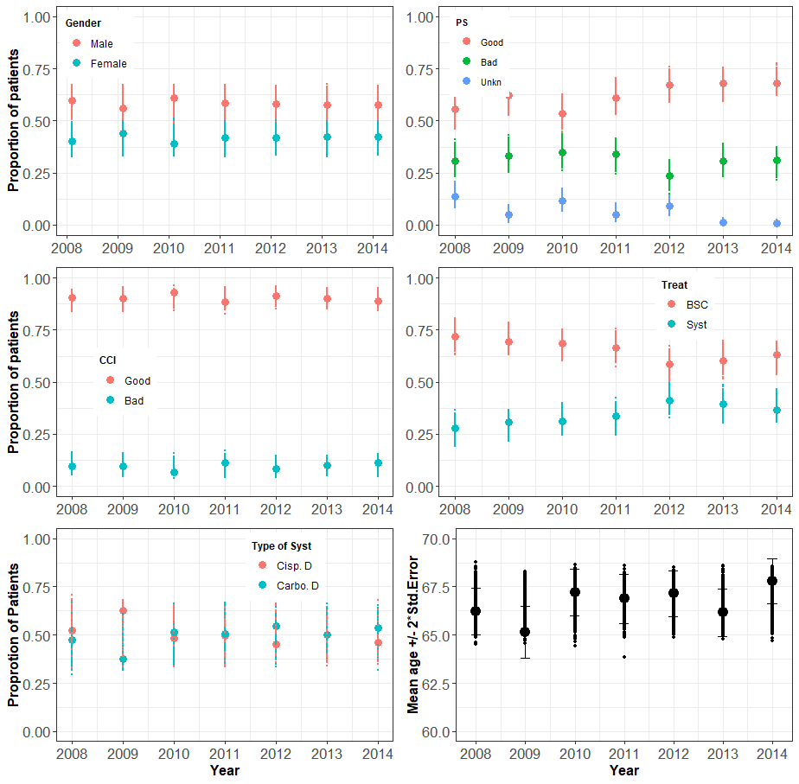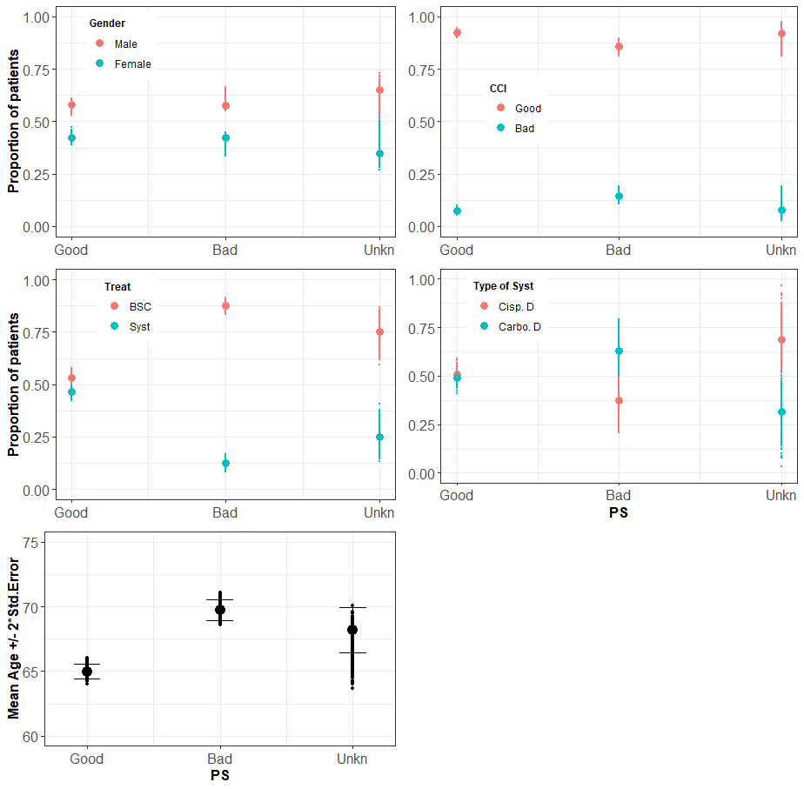
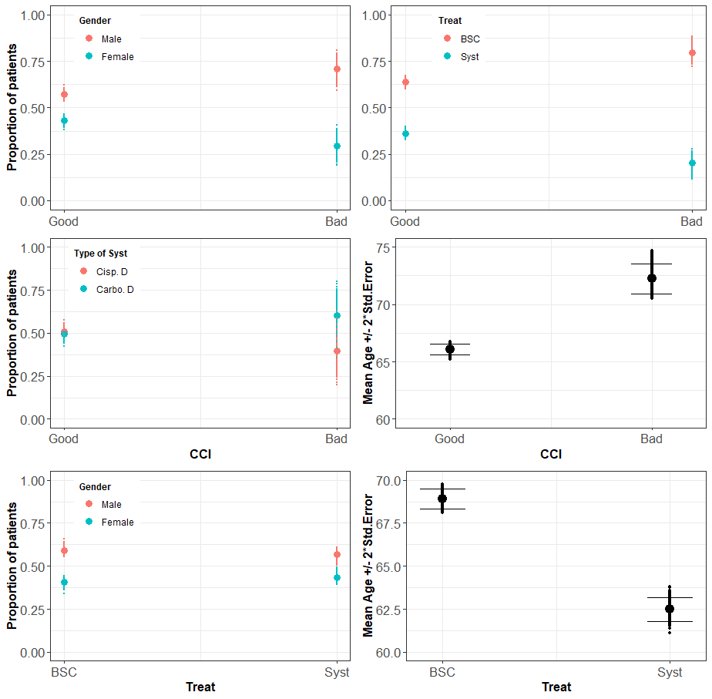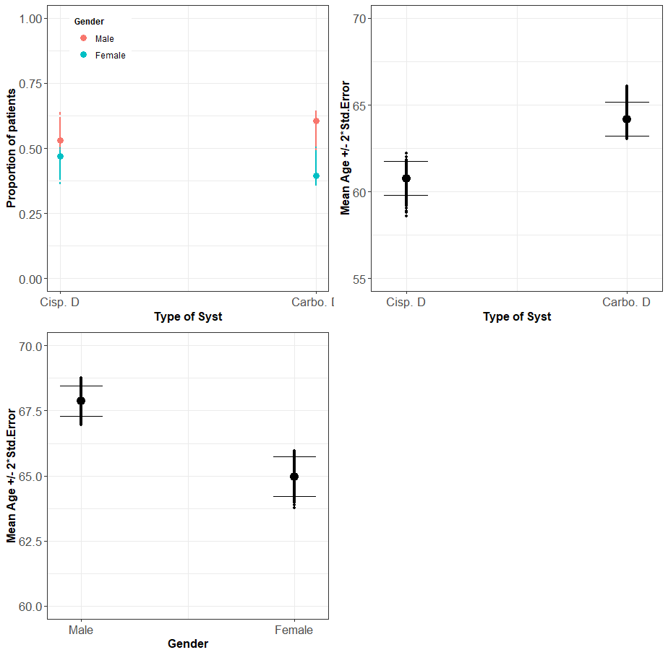
Figure A1. Comparison of modelled and observed bivariate association of baseline characteristics and treatment for advanced (inoperable) NSCLC.
Large dot, value observed from template dataset; points, values from 1000 runs of a model each with 2196 patients (sample size of template data). PS, Eastern Cooperative Oncology Group performance status; CCI, Charlson comorbidity index; BSC, best supportive care; Syst, systemic chemotherapy; Cisp. D, Cisplatin doublet chemotherapy; Carbo. D, Carboplatin doublet chemotherapy. N.B., Statistical test results are reported on ESM Table 2 on column “% sim. pv <0.05”.
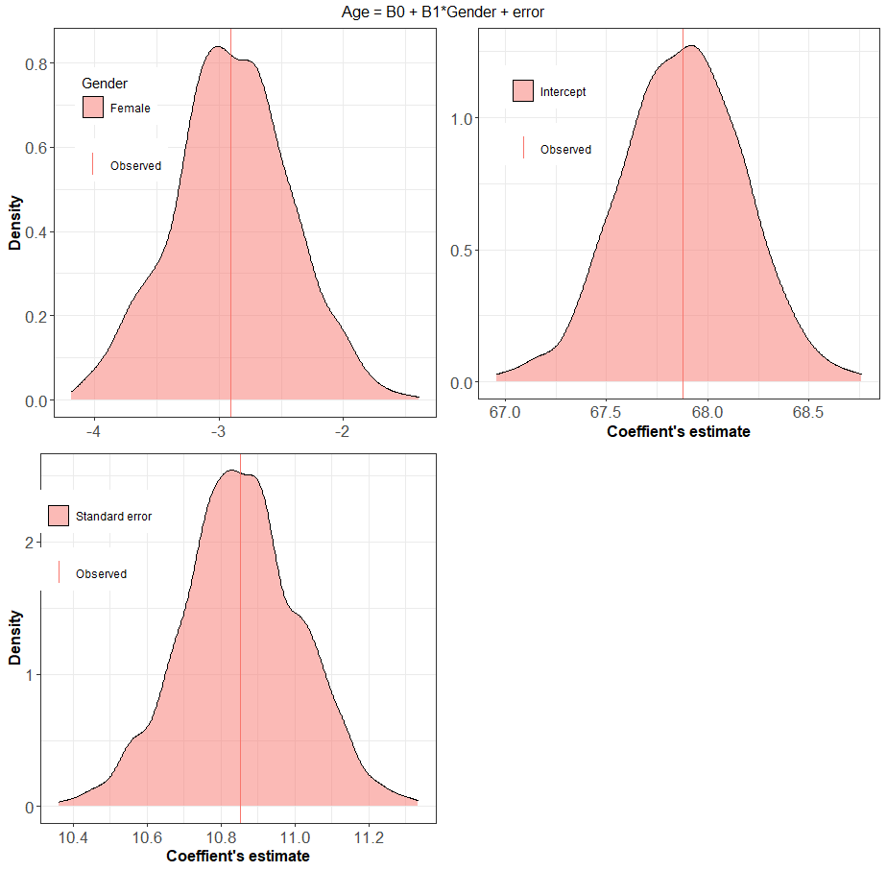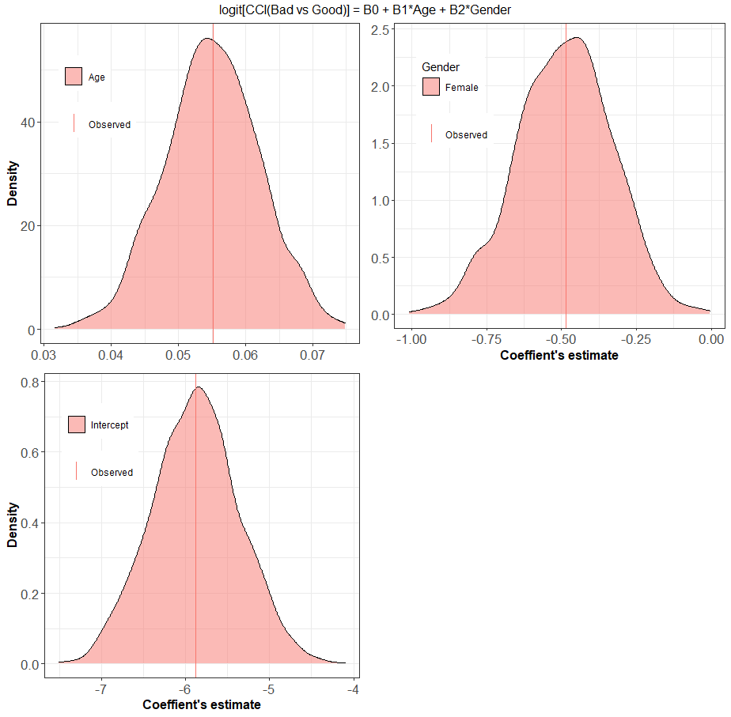
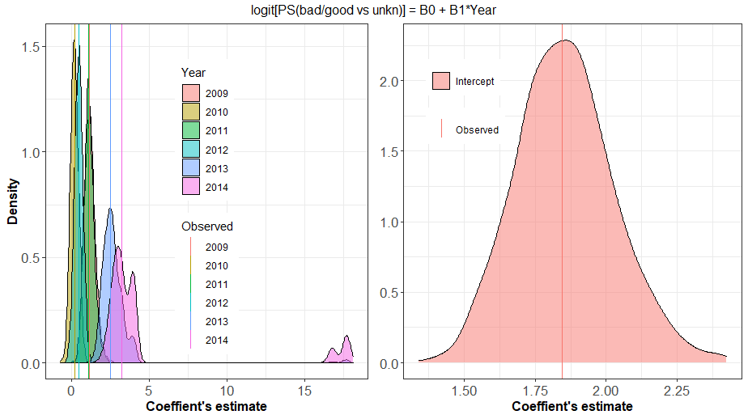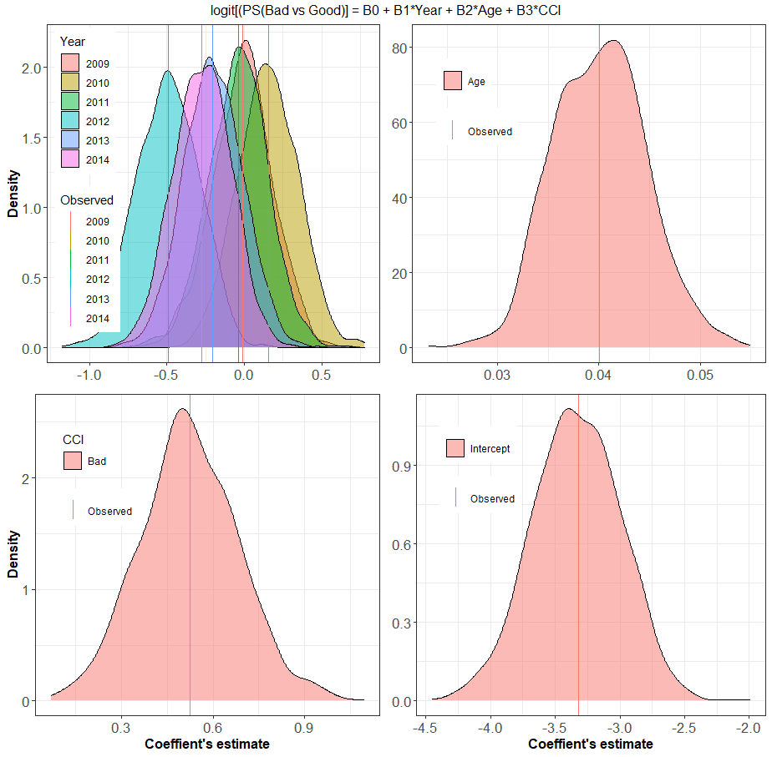
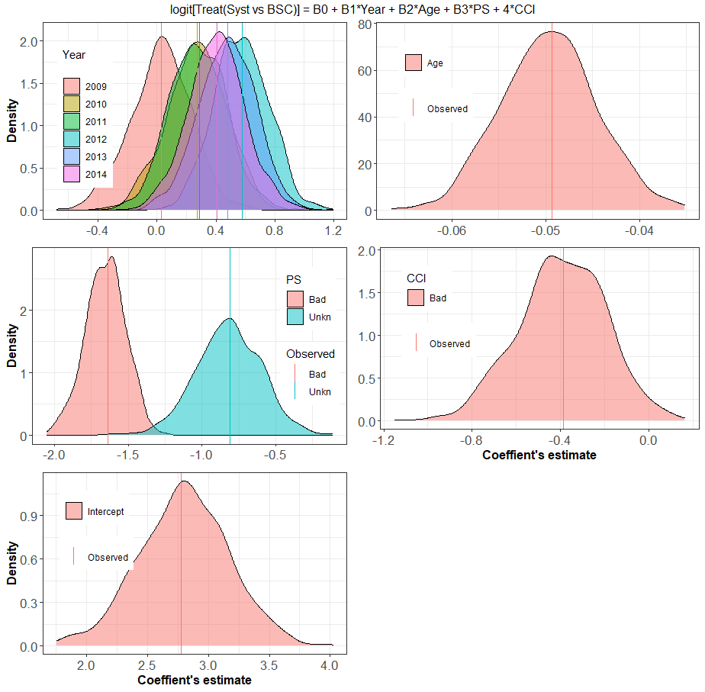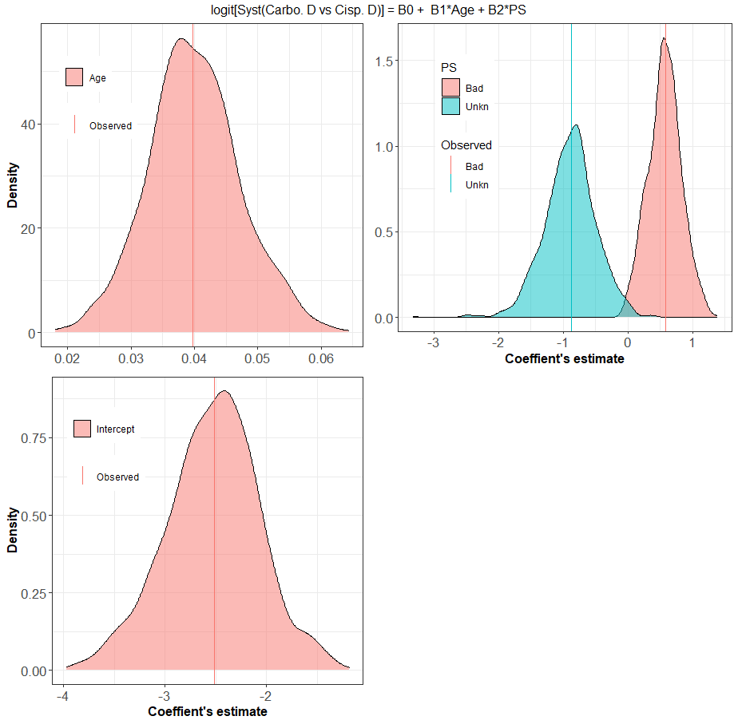
Figure A2. Distribution of parameters of regression models used to simulate baseline characteristics and treatment decision of base-case model.
The model equation is given on top of each panel; B0, intercept; error, random error with standard normal distribution; PS, Eastern Cooperative Oncology Group performance status; CCI, Charlson comorbidity index; Year, year of diagnosis; Age, age at diagnosis; BSC, best supportive care; Syst, systemic chemotherapy; Cisp. D, Cisplatin doublet chemotherapy; Carbo. D, Carboplatin doublet chemotherapy. Observed, parameter values obtained by fitting regression model on template dataset.

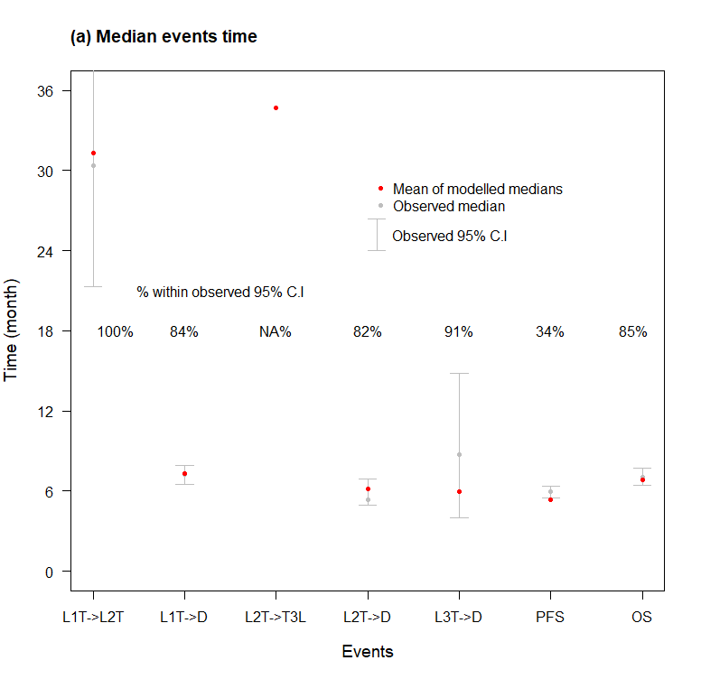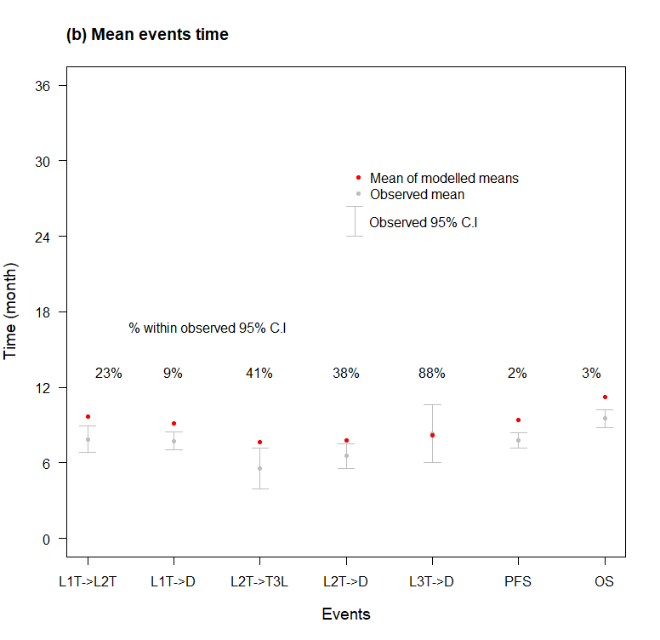
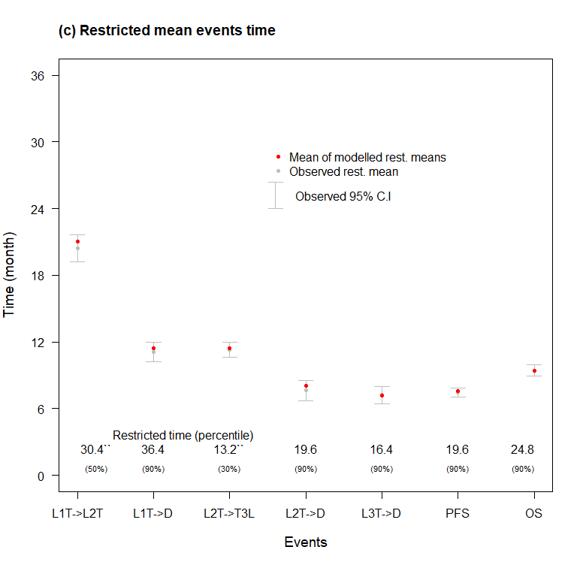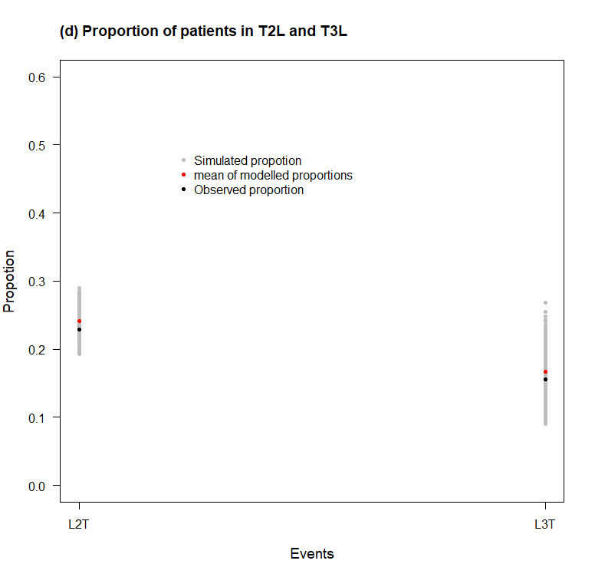
Figure A3. Comparison of modelled and observed event time summary under non-personalized strategy.
Modelled median, mean, restricted mean and proportion in L2T and L3T were assessed from 1000 runs of the non-personalized strategy; L1T, L2T, L3T, and D, are first-line, second-line, third-line treatment, and death, respectively.
C.I, confidence interval; PFS, first-line progression-free survival; OS, overall survival from first-line treatment. NA, not reached.
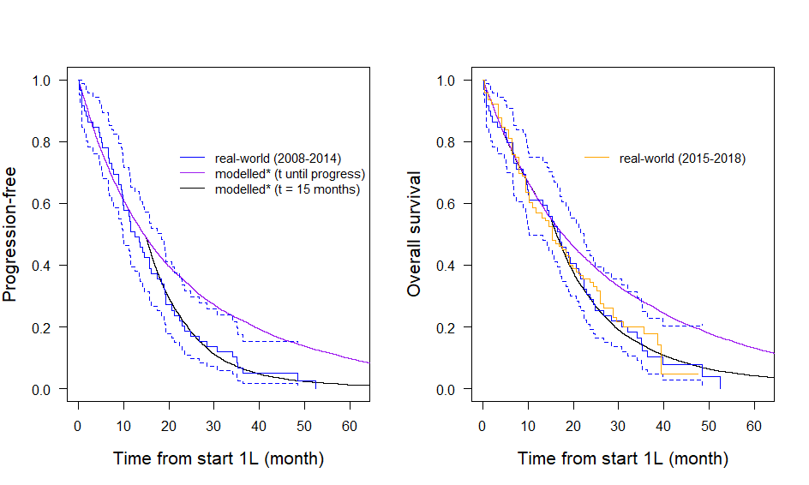
Figure A4. Comparison of modelled and real-world survival curves for patients with epidermal growth factor receptor (EGFR) mutation who had fist-line EGFR tyrosine kinase inhibitor (EGFR-TKI).
Durable benefit, EGFR-TKI benefit last until progression; limited benefit, EGFR-TKI benefit last up to 15 months.
EGFR-TKI were gefitinib or erlotinib;
Real-world included 52 Santeon patient’s level data diagnosed and treated between 2008 – 2014 (blue) [40], and a digitized OS curve of 147 overall survival curve of Santeon patients diagnosed and treated between 2015 – 2018 (Orange) [16]; 1L, start date of first-line systemic treatment;
Modelled was simulated such that, outHR for gefitinib was 0.43, erlotinib is 0.36 (NMA, [37]), and prognostic value of EGFR was 0.82 (pooled, [38]); outHR was estimated by censoring simulated time at 20 months; inHR was 0.38, 0.25, and 0.80 for gefitinib, erlotinib, and prognostic value of EGFR, respectively; EGFR-TKI benefit was assumed to wear out after 15 months.
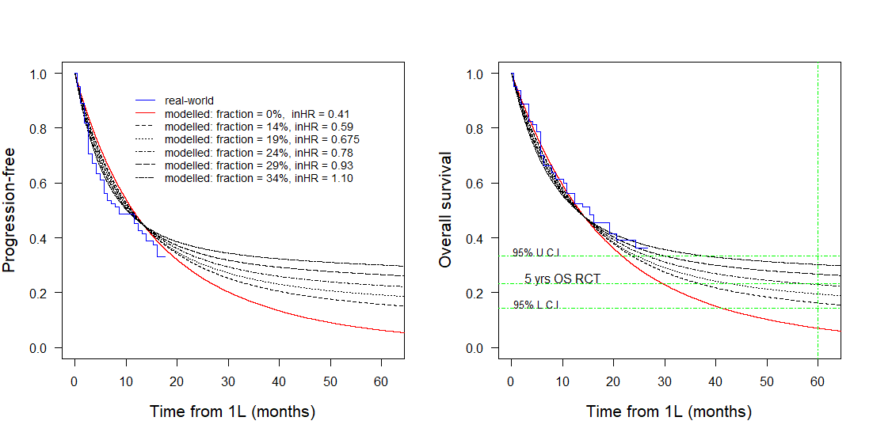
Figure A6. Deterministic sensitivity analysis, impact of cure rate on progression-free and overall survival for patients with PD-L1 50%, pembrolizumab monotherapy.
fraction, long-term survivor fraction, it varied from 14 percent to 35 percent in interval of 5 percent. inHR was selected resulted outHR was 0.50 [36];
* outHR was estimated with censoring of simulated time at 20 months. U.C.I, upper confidence interval; L.C.I, lower confidence interval; yrs, years, 5 yrs OS RCT, five-year overall survival from randomize control trial taken from Five-year update of Keynote – 001 [54].
- REFERENCES
[1] D. Planchard et al., “Metastatic non-small cell lung cancer: ESMO Clinical Practice Guidelines for diagnosis, treatment and follow-up.,” Ann. Oncol. Off. J. Eur. Soc. Med. Oncol., vol. 29, no. Suppl 4, pp. iv192–iv237, Oct. 2018, doi: 10.1093/annonc/mdy275.
[2] National Comprehensive Cancer Network, “Non-Small Cell Lung Cancer (version 3.2020),” 2020. https://www.nccn.org/professionals/physician_gls/pdf/nscl_blocks.pdf (accessed Mar. 05, 2020).
[3] D. van den Broek et al., “Implementation of Novel Molecular Biomarkers for Non-small Cell Lung Cancer in the Netherlands: How to Deal With Increasing Complexity,” Front. Oncol., vol. 9, Jan. 2020, doi: 10.3389/fonc.2019.01521.
[4] K. C. Arbour and G. J. Riely, “Systemic Therapy for Locally Advanced and Metastatic Non–Small Cell Lung Cancer,” JAMA, vol. 322, no. 8, p. 764, Aug. 2019, doi: 10.1001/jama.2019.11058.
[5] M. K. Nesline, T. Knight, S. Colman, and K. Patel, “Economic Burden of Checkpoint Inhibitor Immunotherapy for the Treatment of Non–Small Cell Lung Cancer in US Clinical Practice,” Clin. Ther., vol. 42, no. 9, pp. 1682-1698.e7, Sep. 2020, doi: 10.1016/j.clinthera.2020.06.018.
[6] J. J. Caro, A. H. Briggs, U. Siebert, and K. M. Kuntz, “Modeling Good Research Practices—Overview: A Report of the ISPOR-SMDM Modeling Good Research Practices Task Force-1,” Value Heal., vol. 15, no. 6, pp. 796–803, Sep. 2012, doi: 10.1016/j.jval.2012.06.012.
[7] National Institute for Health and Care Excellence, “Guide to the methods of technology appraisal [NICE Guideline No. 9],” Apr. 2013. Accessed: Jul. 07, 2021. [Online]. Available: http://www.nice.org.uk/media/D45/1E/GuideToMethodsTechnologyAppraisal2013.pdf.
[8] E. M. Krijkamp, F. Alarid-Escudero, E. A. Enns, H. J. Jalal, M. G. M. Hunink, and P. Pechlivanoglou, “Microsimulation Modeling for Health Decision Sciences Using R: A Tutorial,” Med. Decis. Mak., vol. 38, no. 3, pp. 400–422, Apr. 2018, doi: 10.1177/0272989X18754513.
[9] M. C. Weinstein et al., “Principles of good practice for decision analytic modeling in health-care evaluation: Report of the ISPOR task force on good research practices - Modeling studies,” Value Heal., vol. 6, no. 1, pp. 9–17, 2003, doi: 10.1046/j.1524-4733.2003.00234.x.
[10] M. S. Holleman, M. J. Al, R. Zaim, H. J. M. Groen, and C. A. Uyl-de Groot, “Cost-effectiveness analysis of the first-line EGFR-TKIs in patients with non-small cell lung cancer harbouring EGFR mutations.,” Eur. J. Health Econ., vol. 21, no. 1, pp. 153–164, Feb. 2020, doi: 10.1007/s10198-019-01117-3.
[11] C. Chouaid et al., “Cost-effectiveness analysis of pembrolizumab versus standard-of-care chemotherapy for first-line treatment of PD-L1 positive (&gt;50%) metastatic squamous and non-squamous non-small cell lung cancer in France,” Lung Cancer, vol. 127, pp. 44–52, Jan. 2019, doi: 10.1016/j.lungcan.2018.11.008.
[12] M. C. Barbier, E. Pardo, C. M. Panje, O. Gautschi, and J. E. Lupatsch, “A cost-effectiveness analysis of pembrolizumab with or without chemotherapy for the treatment of patients with metastatic, non-squamous non-small cell lung cancer and high PD-L1 expression in Switzerland,” Eur. J. Heal. Econ., vol. 22, no. 5, pp. 669–677, Jul. 2021, doi: 10.1007/s10198-021-01282-4.
[13] M. Westwood et al., “Epidermal growth factor receptor tyrosine kinase (EGFR-TK) mutation testing in adults with locally advanced or metastatic non-small cell lung cancer: a systematic review and cost-effectiveness analysis,” Health Technol. Assess. (Rockv)., vol. 18, no. 32, pp. 1–166, May 2014, doi: 10.3310/hta18320.
[14] M. J. H. G. Simons et al., “Early Cost Effectiveness of Whole-Genome Sequencing as a Clinical Diagnostic Test for Patients with Inoperable Stage IIIB,C/IV Non-squamous Non-small-Cell Lung Cancer,” Pharmacoeconomics, no. 0123456789, Aug. 2021, doi: 10.1007/s40273-021-01073-y.
[15] R. van Amerongen, V. p Retèl, V. M. H. Coupé, P. M. Nederlof, M. J. Vogel, and W. H. van Harten, “Next-generation sequencing in NSCLC and melanoma patients: a cost and budget impact analysis,” Ecancermedicalscience, vol. 10, pp. 1–16, Oct. 2016, doi: 10.3332/ecancer.2016.684.
[16] C. M. Cramer-van der Welle et al., “Real-world outcomes versus clinical trial results of immunotherapy in stage IV non-small cell lung cancer (NSCLC) in the Netherlands,” Sci. Rep., vol. 11, no. 1, p. 6306, Dec. 2021, doi: 10.1038/s41598-021-85696-3.
[17] K. L. Kehl, S. Greenwald, N. G. Chamoun, P. J. Manberg, and D. Schrag, “Association Between First-Line Immune Checkpoint Inhibition and Survival for Medicare-Insured Patients With Advanced Non-Small Cell Lung Cancer.,” JAMA Netw. open, vol. 4, no. 5, p. e2111113, May 2021, doi: 10.1001/jamanetworkopen.2021.11113.
[18] V. Velcheti, X. Hu, B. Piperdi, and T. Burke, “Real-world outcomes of first-line pembrolizumab plus pemetrexed-carboplatin for metastatic nonsquamous NSCLC at US oncology practices,” Sci. Rep., vol. 11, no. 1, p. 9222, Dec. 2021, doi: 10.1038/s41598-021-88453-8.
[19] D. Waterhouse et al., “Real-world outcomes of immunotherapy–based regimens in first-line advanced non-small cell lung cancer,” Lung Cancer, vol. 156, pp. 41–49, Jun. 2021, doi: 10.1016/j.lungcan.2021.04.007.
[20] X. G. L. V. Pouwels et al., “An economic evaluation of eribulin for advanced breast cancer treatment based on the Southeast Netherlands advanced breast cancer registry,” Acta Oncol. (Madr)., vol. 59, no. 9, pp. 1123–1130, Sep. 2020, doi: 10.1080/0284186X.2020.1775289.
[21] S. Davis, M. Stevenson, P. Tappenden, and A. J. Wailoo, “NICE DSU Technical Support Document 15: Cost-effectiveness modelling using patient-Level simulation,” Sheffield, Apr. 2014. [Online]. Available: www.nicedsu.org.uk.
[22] K. Degeling, H. Koffijberg, M. D. Franken, M. Koopman, and M. J. IJzerman, “Comparing Strategies for Modeling Competing Risks in Discrete-Event Simulations: A Simulation Study and Illustration in Colorectal Cancer,” Med. Decis. Mak., vol. 39, no. 1, pp. 57–73, Jan. 2019, doi: 10.1177/0272989X18814770.
[23] O. Okunade, J. Arora, A. Haverhals, and L. Niessen, “Collaborating for value: the Santeon Hospitals in the Netherlands,” International Consortium for Health Outcomes Measurement, 2017. www.ichom.org (accessed Jun. 21, 2021).
[24] C. M. Cramer-van der Welle et al., “Systematic evaluation of the efficacy-effectiveness gap of systemic treatments in metastatic nonsmall cell lung cancer.,” Eur. Respir. J., vol. 52, no. 6, p. 1801100, Dec. 2018, doi: 10.1183/13993003.01100-2018.
[25] G. D’Addario and E. Felip, “Non-small-cell lung cancer: ESMO Clinical Recommendations for diagnosis, treatment and follow-up,” Ann. Oncol., vol. 19, no. SUPPL. 2, pp. ii39–ii40, May 2008, doi: 10.1093/annonc/mdn081.
[26] G. D’Addario, M. Früh, M. Reck, P. Baumann, W. Klepetko, and E. Felip, “Metastatic non-small-cell lung cancer: ESMO Clinical Practice Guidelines for diagnosis, treatment and follow-up,” Ann. Oncol., vol. 21, no. SUPPL. 5, pp. v116–v119, May 2010, doi: 10.1093/annonc/mdq189.
[27] E. J. Jordan et al., “Prospective comprehensive molecular characterization of lung adenocarcinomas for efficient patient matching to approved and emerging therapies,” Cancer Discov., vol. 7, no. 6, pp. 596–609, 2017, doi: 10.1158/2159-8290.CD-16-1337.
[28] C. C. H. J. Kuijpers et al., “Association of molecular status and metastatic organs at diagnosis in patients with stage IV non-squamous non-small cell lung cancer,” Lung Cancer, vol. 121, pp. 76–81, Jul. 2018, doi: 10.1016/j.lungcan.2018.05.006.
[29] M. Dietel et al., “Real-world prevalence of programmed death ligand 1 expression in locally advanced or metastatic non–small-cell lung cancer: The global, multicenter EXPRESS study,” Lung Cancer, vol. 134, pp. 174–179, Aug. 2019, doi: 10.1016/j.lungcan.2019.06.012.
[30] F. Skoulidis and J. V. Heymach, “Co-occurring genomic alterations in non-small-cell lung cancer biology and therapy,” Nat. Rev. Cancer, vol. 19, no. 9, pp. 495–509, Sep. 2019, doi: 10.1038/s41568-019-0179-8.
[31] A. Forsythe, W. Zhang, U. Phillip Strauss, M. Fellous, M. Korei, and K. Keating, “A systematic review and meta-analysis of neurotrophic tyrosine receptor kinase gene fusion frequencies in solid tumors,” Ther. Adv. Med. Oncol., vol. 12, no. 6, p. 175883592097561, Jan. 2020, doi: 10.1177/1758835920975613.
[32] S. Peters et al., “Alectinib versus Crizotinib in Untreated ALK -Positive Non–Small-Cell Lung Cancer,” N. Engl. J. Med., vol. 377, no. 9, pp. 829–838, Aug. 2017, doi: 10.1056/NEJMoa1704795.
[33] B. J. Solomon et al., “First-Line Crizotinib versus Chemotherapy in ALK -Positive Lung Cancer,” N. Engl. J. Med., vol. 371, no. 23, pp. 2167–2177, Dec. 2014, doi: 10.1056/NEJMoa1408440.
[34] L. Gandhi et al., “Pembrolizumab plus Chemotherapy in Metastatic Non–Small-Cell Lung Cancer,” N. Engl. J. Med., vol. 378, no. 22, pp. 2078–2092, May 2018, doi: 10.1056/NEJMoa1801005.
[35] R. S. Herbst et al., “Pembrolizumab versus docetaxel for previously treated, PD-L1-positive, advanced non-small-cell lung cancer (KEYNOTE-010): a randomised controlled trial,” Lancet, vol. 387, no. 10027, pp. 1540–1550, Apr. 2016, doi: 10.1016/S0140-6736(15)01281-7.
[36] M. Reck et al., “Pembrolizumab versus Chemotherapy for PD-L1–Positive Non–Small-Cell Lung Cancer,” N. Engl. J. Med., vol. 375, no. 19, pp. 1823–1833, Nov. 2016, doi: c.
[37] M. S. Holleman, H. van Tinteren, H. J. M. Groen, M. J. Al, and C. A. Uyl-de Groot, “First-line tyrosine kinase inhibitors in EGFR mutation-positive non-small-cell lung cancer: a network meta-analysis,” Onco. Targets. Ther., vol. Volume 12, no. 1, pp. 1413–1421, Feb. 2019, doi: 10.2147/OTT.S189438.
[38] M. Simons et al., “Observed versus modelled lifetime overall survival of targeted therapies and immunotherapies for advanced non-small cell lung cancer patients – A systematic review,” Crit. Rev. Oncol. Hematol., vol. 153, no. June, p. 103035, Sep. 2020, doi: 10.1016/j.critrevonc.2020.103035.
[39] M. W. Hoyle and W. Henley, “Improved curve fits to summary survival data: application to economic evaluation of health technologies,” BMC Med. Res. Methodol., vol. 11, no. 1, p. 139, Dec. 2011, doi: 10.1186/1471-2288-11-139.
[40] R. Sluga, B. E. E. M. Van Den Borne, P. Roepman, B. J. M. Peters, E. A. Kastelijn, and F. M. N. H. Schramel, “Utilization of Molecular Testing and Survival Outcomes of Treatment with First- or Second-line Tyrosine Kinase Inhibitors in Advanced Non-small Cell Lung Cancer in a Dutch Population,” Anticancer Res., vol. 38, no. 1, pp. 393–400, Jan. 2018, doi: 10.21873/anticanres.12235.
[41] N. Latimer, “NICE DSU Technical Support Document 14: Undertaking survival analysis for economic evaluations alongside clinical trials - extrapolation with patient-level data.,” Sheffield, Jul. 2011. [Online]. Available: http://www.nicedsu.org.uk.
[42] K. J. Ishak, N. Kreif, A. Benedict, and N. Muszbek, “Overview of Parametric Survival Analysis for Health-Economic Applications,” Pharmacoeconomics, vol. 31, no. 8, pp. 663–675, Aug. 2013, doi: 10.1007/s40273-013-0064-3.
[43] H. Putter, M. Fiocco, and R. B. Geskus, “Tutorial in biostatistics: competing risks and multi-state models,” Stat. Med., vol. 26, no. 11, pp. 2389–2430, May 2007, doi: 10.1002/sim.2712.
[44] C. Williams, J. D. Lewsey, A. H. Briggs, and D. F. Mackay, “Cost-effectiveness Analysis in R Using a Multi-state Modeling Survival Analysis Framework: A Tutorial,” Med. Decis. Mak., vol. 37, no. 4, pp. 340–352, May 2017, doi: 10.1177/0272989X16651869.
[45] H. B. Wolff et al., “Cost-effectiveness of stereotactic body radiation therapy versus video assisted thoracic surgery in medically operable stage I non-small cell lung cancer: A modeling study,” Lung Cancer, vol. 141, pp. 89–96, Mar. 2020, doi: 10.1016/j.lungcan.2020.01.011.
[46] R Core Team, “R: A language and environment for statistical computing.” R Foundation for Statistical Computing, Vienna, Austria, 2020, [Online]. Available: https://www.r-project.org/.
[47] L. C. de Wreede, M. Fiocco, and H. Putter, “The mstate package for estimation and prediction in non- and semi-parametric multi-state and competing risks models,” Comput. Methods Programs Biomed., vol. 99, no. 3, pp. 261–274, Sep. 2010, doi: 10.1016/j.cmpb.2010.01.001.
[48] G. Broström, “eha: Event History Analysis. R package version 2.8.1,” CRAN. 2020, [Online]. Available: https://cran.r-project.org/package=eha.
[49] C. H. Jackson, “flexsurv: A Platform for Parametric Survival Modeling in R.,” J. Stat. Softw., vol. 70, no. 8, pp. 1–33, May 2016, doi: 10.18637/jss.v070.i08.
[50] J. Köhler and M. Schuler, “Afatinib, Erlotinib and Gefitinib in the First-Line Therapy of EGFR Mutation-Positive Lung Adenocarcinoma: A Review,” Onkologie, vol. 36, no. 9, pp. 5–5, 2013, doi: 10.1159/000354627.
[51] Z. Wang and S. Fang, “EGFR mutations as a prognostic and predictive marker in non-small-cell lung cancer,” Drug Des. Devel. Ther., vol. 8, p. 1595, Sep. 2014, doi: 10.2147/DDDT.S69690.
[52] Z. Wang et al., “Anaplastic lymphoma kinase gene rearrangement predicts better prognosis in NSCLC patients: A meta-analysis,” Lung Cancer, vol. 112, pp. 1–9, Oct. 2017, doi: c.
[53] M. M. Awad et al., “Long-Term Overall Survival From KEYNOTE-021 Cohort G: Pemetrexed and Carboplatin With or Without Pembrolizumab as First-Line Therapy for Advanced Nonsquamous NSCLC,” J. Thorac. Oncol., vol. 16, no. 1, pp. 162–168, Jan. 2021, doi: 10.1016/j.jtho.2020.09.015.
[54] E. B. Garon et al., “Five-Year Overall Survival for Patients With Advanced Non‒Small-Cell Lung Cancer Treated With Pembrolizumab: Results From the Phase I KEYNOTE-001 Study,” J. Clin. Oncol., vol. 37, no. 28, pp. 2518–2527, Oct. 2019, doi: 10.1200/JCO.19.00934.
[55] M. Reck et al., “Five-Year Outcomes With Pembrolizumab Versus Chemotherapy for Metastatic Non–Small-Cell Lung Cancer With PD-L1 Tumor Proportion Score ≥ 50%,” J. Clin. Oncol., vol. 39, no. 21, pp. 2339–2349, Jul. 2021, doi: 10.1200/JCO.21.00174.
[56] A. Bullement, N. R. Latimer, and H. B. Gorrod, “Survival Extrapolation in Cancer Immunotherapy: A Validation-Based Case Study,” Value Heal., vol. 22, no. 3, pp. 276–283, Mar. 2019, doi: 10.1016/j.jval.2018.10.007.
[57] M. Othus, A. Bansal, L. Koepl, S. Wagner, and S. Ramsey, “Accounting for Cured Patients in Cost-Effectiveness Analysis,” Value Heal., vol. 20, no. 4, pp. 705–709, Apr. 2017, doi: 10.1016/j.jval.2016.04.011.
[58] Y. H. To et al., “Circulating Tumour DNA as a Potential Cost-Effective Biomarker to Reduce Adjuvant Chemotherapy Overtreatment in Stage II Colorectal Cancer,” Pharmacoeconomics, vol. 39, no. 8, pp. 953–964, Aug. 2021, doi: 10.1007/s40273-021-01047-0.
[59] D. M. Eddy, W. Hollingworth, J. J. Caro, J. Tsevat, K. M. McDonald, and J. B. Wong, “Model Transparency and Validation: A Report of the ISPOR-SMDM Modeling Good Research Practices Task Force-7,” Value Heal., vol. 15, no. 6, pp. 843–850, Sep. 2012, doi: 10.1016/j.jval.2012.04.012.
[60] T. Feenstra, “Multi-use disease models: A blueprint for application in support of health care insurance coverage policy and a case study in Diabetes Mellitus.,” National Institute for Public Health and the Environment RIVM, Bilthoven, 2020. doi: 10.21945/RIVM-2020-0145.
[61] T. Mok et al., “Updated overall survival and final progression-free survival data for patients with treatment-naive advanced ALK-positive non-small-cell lung cancer in the ALEX study,” Ann. Oncol., vol. 31, no. 8, pp. 1056–1064, Aug. 2020, doi: 10.1016/j.annonc.2020.04.478.
[62] R. Ferrara et al., “Do immune checkpoint inhibitors need new studies methodology?,” J. Thorac. Dis., vol. 10, no. S13, pp. S1564–S1580, May 2018, doi: 10.21037/jtd.2018.01.131.
[63] M. Buyse, E. D. Saad, T. Burzykowski, and J. Péron, “Assessing Treatment Benefit in Immuno-oncology,” Stat. Biosci., vol. 12, no. 2, pp. 83–103, Jul. 2020, doi: 10.1007/s12561-020-09268-1.
[64] B. Huang and N. Ting, “Introduction to Special Issue on ‘Statistical Methods for Cancer Immunotherapy,’” Stat. Biosci., vol. 12, no. 2, pp. 79–82, Jul. 2020, doi: 10.1007/s12561-020-09281-4.
[65] E. Gibson et al., “Modelling the Survival Outcomes of Immuno-Oncology Drugs in Economic Evaluations: A Systematic Approach to Data Analysis and Extrapolation,” Pharmacoeconomics, vol. 35, no. 12, pp. 1257–1270, Dec. 2017, doi: 10.1007/s40273-017-0558-5.
[66] M. Huang, N. Latimer, Y. Zhang, P. Mukhopadhyay, M. Ouwens, and A. Briggs, “Estimating the Long-Term Outcomes Associated With Immuno-Oncology Therapies : Challenges and Approaches for Overall Survival Extrapolations,” Value & Outcomes Spotlight, no. February, pp. 28–30, 2018, [Online]. Available: https://www.ispor.org/publications/journals/value-outcomes-spotlight.
[67] G. V Long et al., “Dabrafenib and trametinib versus dabrafenib and placebo for Val600 BRAF-mutant melanoma: a multicentre, double-blind, phase 3 randomised controlled trial,” Lancet, vol. 386, no. 9992, pp. 444–451, Aug. 2015, doi: 10.1016/S0140-6736(15)60898-4.
[68] J. Karnon, J. Stahl, A. Brennan, J. J. Caro, J. Mar, and J. Möller, “Modeling using Discrete Event Simulation: A Report of the ISPOR-SMDM Modeling Good Research Practices Task Force-4,” Value Heal., vol. 15, no. 6, pp. 821–827, Sep. 2012, doi: 10.1016/j.jval.2012.04.013.
[69] J. Beyersmann, A. Allignol, and M. Schumacher, Competing Risks and Multistate Models with R. New York, NY: Springer New York, 2012.
[70] A. Christopher, P. Metcalfe, J. Amdahl, and M. C. Jackson, “Package ‘ flexsurv ,’” CRAN. 2019.
[71] A. T. Shaw et al., “Crizotinib in ROS1-rearranged advanced non-small-cell lung cancer (NSCLC): updated results, including overall survival, from PROFILE 1001,” Ann. Oncol., vol. 30, no. 7, pp. 1121–1126, Jul. 2019, doi: 10.1093/annonc/mdz131.
[72] R. J. Kelly, “Dabrafenib and trametinib for the treatment of non-small cell lung cancer,” Expert Rev. Anticancer Ther., vol. 18, no. 11, pp. 1063–1068, Nov. 2018, doi: 10.1080/14737140.2018.1521272.
[73] D. S. Hong et al., “Larotrectinib in patients with TRK fusion-positive solid tumours: a pooled analysis of three phase 1/2 clinical trials.,” Lancet. Oncol., vol. 21, no. 4, pp. 531–540, Apr. 2020, doi: 10.1016/S1470-2045(19)30856-3.
[74] A. T. Shaw et al., “Crizotinib versus Chemotherapy in Advanced ALK -Positive Lung Cancer,” N. Engl. J. Med., vol. 368, no. 25, pp. 2385–2394, Jun. 2013, doi: 10.1056/NEJMoa1214886.
[75] S. Gadgeel et al., “Updated Analysis From KEYNOTE-189: Pembrolizumab or Placebo Plus Pemetrexed and Platinum for Previously Untreated Metastatic Nonsquamous Non–Small-Cell Lung Cancer,” J. Clin. Oncol., vol. 38, no. 14, pp. 1505–1517, May 2020, doi: 10.1200/JCO.19.03136.

