SUPPLEMENTARY INFO
The Bayesian APC model is based on the methodology described by Riebler and Held [33]. The prevalence of overweight and obesity was modelled using a Bayesian binary logistic regression model including a logit-link function. The binary logistic regression model structure was formulated as ${logit⁡(P(y=1))}_{ijkl}=μ+a_{j}+p_{k}+c_{l}(+\sum_{c}{β_{c}x_{i})}$, where $μ$ is the intercept, $a_{j}$ the $j$th age-effect, $p_{k}$ the $k$th period-effect and $c_{l}$ the $l$th cohort-effect. The age, period and cohort effects were estimated using the random walk of second order (RW2).
Model priors (hyperparameters) were estimated based on a general linear mixed effects model (GLMER) by extracting the variance covariance for each of the random terms (age, period and cohort). Afterwards, log transformation on the inverse of the variance-covariance was calculated and applied as prior in the Bayesian INLA model ($initial= log(1/{vcov}$)).
The R code used for estimating the initial values of the RW2-models is:
fit_in1.mer0 <-
lmer(overweight ~ (1 | age_category) + (1 | year) + (1 | synthetic_cohort).
data = data)
vc0 <- as.data.frame(VarCorr(fit_in1.mer0))
vc0$init <- log(1 / vc0$vcov)

The R-code used for modelling the data based on a Bayesian INLA model:
proj_overweight <- inla(
as.numeric(as.character(overweight)) ~
f(age_category, model = "rw2",
hyper = list(prec = list(
initial = vc0$init[[2]],
scale.model = F,
param = c(1, 0.00005),
prior = "loggamma"
))) +
f(year, model = "rw2",
hyper = list(prec = list(
initial = vc0$init[[3]],
scale.model = F,
param = c(1, 0.00005),
prior = "loggamma"
))) +
f(synthetic_cohort, model = "rw2",
hyper = list(prec = list(
initial = vc0$init[[1]],
scale.model = F,
param = c(1, 0.00005),
prior = "loggamma"
))),
family = "binomial",
data = df_proj,
weights = df_proj$individual_weight,
quantile = seq(from = 0.001, to = 0.999, by = 0.001),
verbose = T,
control.compute = list(
dic = T,
waic = T,
cpo = T,
hyperpar = T,
mlik = T
),
control.predictor = list(compute = TRUE, link = 1)
)
Model validation
To calibrate and validate the Bayesian APC-model. different prior values were evaluated:
- Variance-Covariance value from GLMER.
- Fixed prior values at log(0.00001).
The Variance-Covariance values from the frequentist GLMER model showed the best fit on the observed data as depicted in figure 1. The average squared error between the observed data and the predicted values (RMSE) for overweight and obesity equals 0.003 and 0.001 respectively. The coefficient of determination equals 87.7% for overweight and 73.3% for obesity.

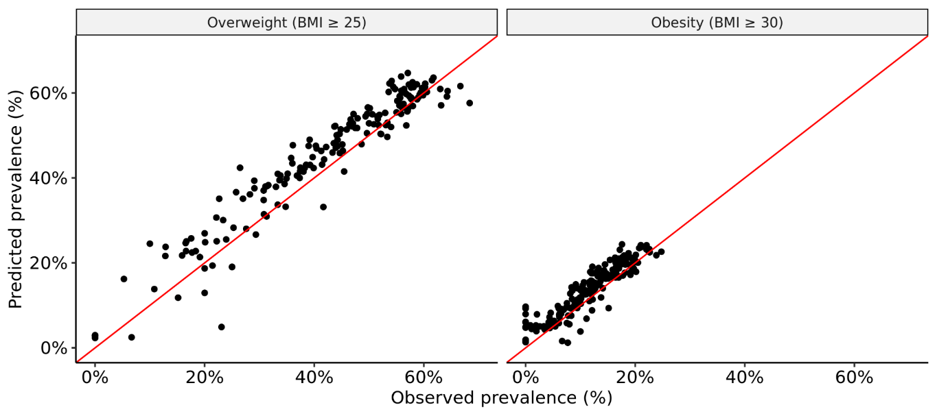

Model effects
Figure 2 and Figure 3 depict the different random APC effects for overweight and obesity, respectively.
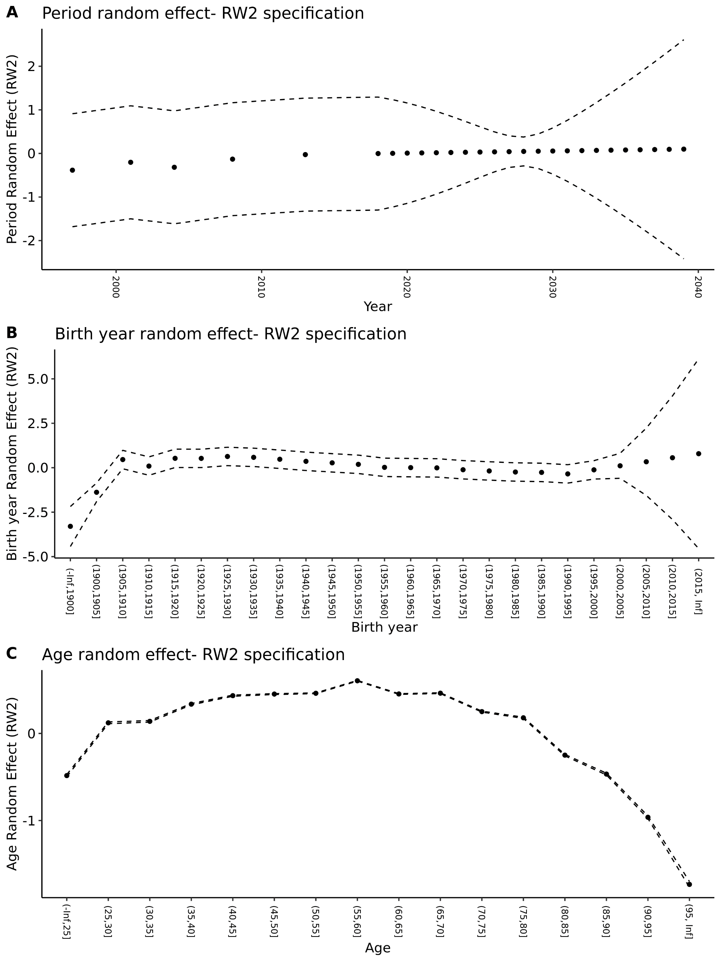
Figure 2: APC model effects of period (A). birth year (B). and age (C) for overweight.
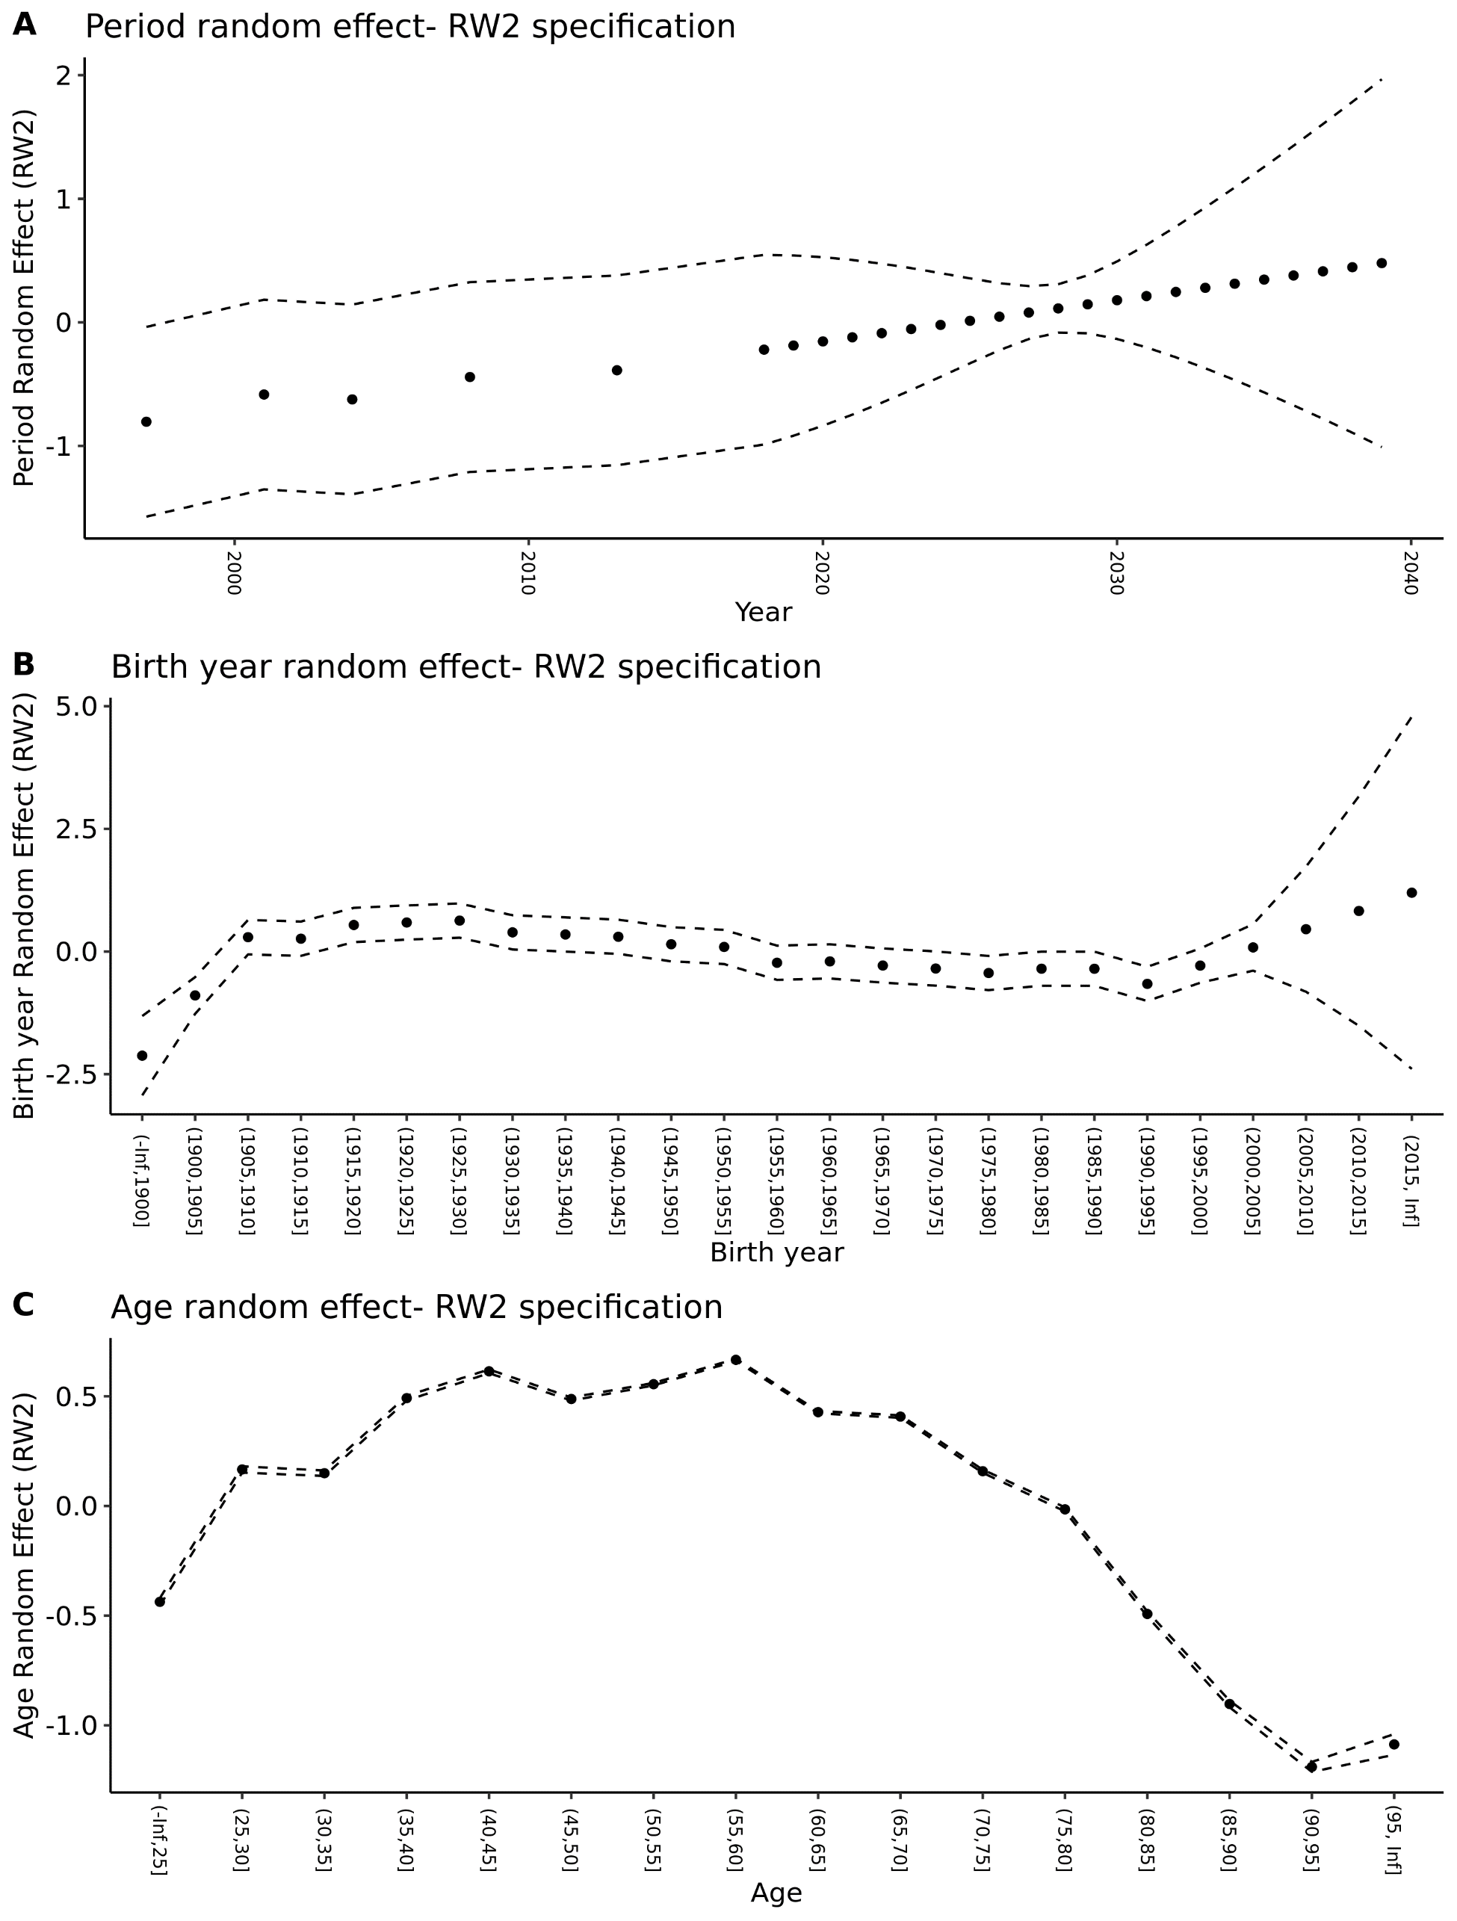
Figure 3: APC model effects of period (A). birth year (B). and age (C) for obesity.

