Supplementary materials

TITLE
Transgenic Forsythia plants expressing sesame cytochrome P450 produce beneficial lignans

AUTHORS
Tomotsugu Koyama¹, Erika Matsumoto¹, Toshimi Okuda¹, Jun Murata¹, Manabu Horikawa¹, Naoki Hata², Atsushi Okazawa³, Eiichiro Ono⁴, Honoo Satake¹

AFFILIATION
¹ Bioorganic Research Institute, Suntory Foundation for Life Sciences, Seikacho, Kyoto 619-0284, Japan
² Department of Biological Resources Management, School of Environmental Science, The University of Shiga Prefecture, 2500 Hassaka-cho, Hikone, Shiga 522-8533, Japan
³ Graduate School of Life and Environmental Sciences, Osaka Prefecture University, 1-1 Gakuen-cho, Naka-ku, Sakai 599-8531, Japan
⁴ Suntory Global Innovation Center (SIC) Ltd., Research Institute, Soraku-gun, Kyoto, 619-0284, Japan

Correspondence to: Honoo Satake, Ph.D.
Bioorganic Research Institute, Suntory Foundation for Life Sciences,
Seikacho, Kyoto 619-0284, Japan
Phone: +81-70-2288-1385
Fax: +81-774-98-6262
E-mail: satake@sunbor.or.jp

Legends to Supplementary Figures.

Supplementary Figure S1. The full images of electrophoresed gels.
Red rectangles were cut and pasted to prepare the Figure 2i, 2j, 3b and 3c.

Supplementary Figure S2. Synthesis of 2´-ethoxysesamin.
The reaction condition was followed the procedure reported previouslyª.
a Garcia, A. et al. Tetrahedoron 51, 8585-8598 (1995).
2´-ethoxysesamin: [α]D -13.0º (c 0.325, CHCl3), HRMS (ESI) calcd for C22H22O7Na [M+Na]+ 421.1258; found 421.1237. 1H and 13C NMR data show in Supplementary Table S2.

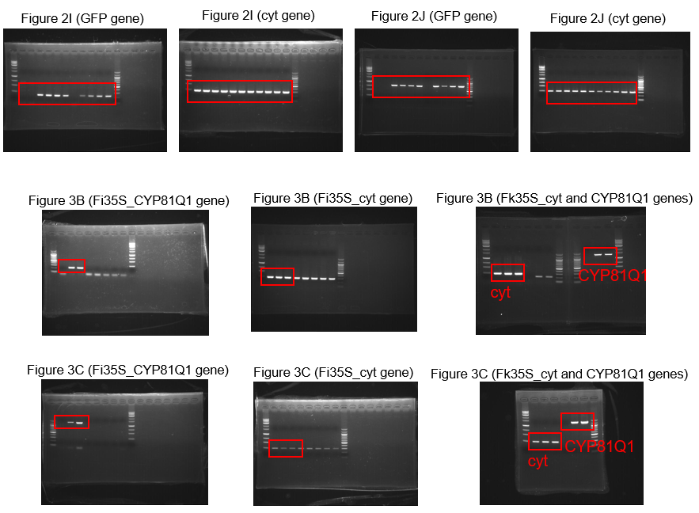

Supplementary Figure S1. Full images of electrophoresed gels.
Red rectangles were cut and pasted to prepare Figures 2i, 2j, 3b, and 3c.

Supplementary Figure S2. Synthesis of 2´-ethoxysesamin.
The reaction conditions followed procedures reported previously ª.
ª Garcia, A. et al. Tetrahedoron 51, 8585-8598 (1995).
2´-ethoxysesamin: [α]_{D} -13.0º (c 0.325, CHCl₃), HRMS (ESI) calcd for C₂₂H₂₂O₇Na [M+Na]⁺ 421.1258; found 421.1237. ¹H and ¹³C NMR data shown in Supplementary Table S2.

Supplementary Table S1. Primers used in this study.
Name | sequence |  |  | purpose
ctDNAFw | AGTTCGAGCCTGATTATCCC |  |  | amplification of cytochrome gene (Figure 2 and 3)
ctDNARv | GCATGCCGCCAGCGTTCATC |  |  | amplification of cytochrome gene (Figure 2 and 3)
Tk0356-GFPfw | ATGGTGAGCAAGGGCGAG |  |  | amplification of GFP gene (Figue2)
Tk0357-GFPrv | TTACTTGTACAGCTCGTCCATGC |  |  | amplification of GFP gene (Figue2)
CYP81Q1-3Fw | GGGACCCATATTTTCCATCC |  |  | amplification of CYP81Q1 gene (Figure 3b_Fi_CYP81Q1)
CYP81Q1-3Rv | TCAAGATCGCACAACTTTCG |  |  | amplification of CYP81Q1 gene (Figure 3b_Fi_CYP81Q1)
CYP81Q1 Fw | ATGGAAGCTGAAATGCTATATTCAGCT |  |  | amplification of CYP81Q1 gene (Figure 3b_FkCYP81Q1, Figure 3c)
CYP81Q1Rv | AACGTTGGAAACCTGACGAAGTTTTTC |  |  | amplification of CYP81Q1 gene (Figure 3b_FkCYP81Q1, Figure 3c)

Supplementary Table S2. ¹H and ¹³C NMR data of 2´-ethoxysesamin.ª
 | 2´-ethoxysesamin
 | ¹H (ppm) | Additional data of ¹H NMR^{b} | ¹³C (ppm)
1 | - |  | 135.0
2 | 6.86 | 1H, br.s | 106.7
3 | - |  | 148.1
4 | - |  | 147.3
5 | 6.77 | 1H, d, J = 8.04 Hz | 108.3
6 | 6.81 | 1H, br.d, J = 8.04 Hz | 119.7
7 | 4.64 | 1H, d, J = 6.15 Hz | 85.6
8 | 2.92 | 1H, m | 54.6
9a | 4.19 | 1H, dd, J = 6.8, 9.0 Hz | 71.3
9b | 3.92 | 1H, dd, J = 3.8, 9.0 Hz | 71.3
10a, b | 5.94 | 2H, app.s | 101.2
1´ | - |  | 127.3
2´ | - |  | 139.7
3´ | - |  | 136.2
4´ | - |  | 148.8
5´ | 6.49 | 1H, d, J = 8.01 Hz | 102.1
6´ | 6.85 | 1H, d, J = 8.01 Hz | 118.3
7´ | 5.03 | 1H, d, J = 4.53 Hz | 82.9
8´ | 3.03 | 1H, m | 54.1
9´a | 4.33 | 1H, app.br.t, J = 9.1 Hz | 73.6
9´b | 4.01 | 1H, dd, J = 5.0, 9.1 Hz | 73.6
10´a, b | 5.9 | 2H, app.d, J = 6.4 Hz | 101.0
11´a | 4.35 | 1H, dq, J = 9.3, 7.1 Hz | 67.6
11´b | 4.28 | 1H, dq, J = 9.3, 7.1 Hz | 67.6
12´ | 1.37 | 3H, t, J = 7.1 Hz | 15.8

ª 800 MHz for ¹H and 200 MHz for ¹³C NMR, Solvent: CDCl₃ through alumina to remove an acid.
^{b} Number of hydrogens, Multiplicity (app.; apparently, br.; broad, s; singlet, d; doublet, t; triplet, q; quartet, m; multiplet), Coupling constants.

