TITLE

Immune checkpoint molecules B7-H6 and PD-L1 co-pattern the tumor inflammatory microenvironment: associations and clinical significance in human breast cancer

AUTHORS
Boutheina Cherif^{1*},Hana Triki^{1,2}, Slim Charfi²,Lobna Bouzidi², Wala Ben Kridis³, Afef Khanfir³, Kais Chaabane⁴,Tahya Sellami-Boudawara², and Ahmed Rebai¹

Authors’ affiliation
¹Laboratory of Molecular and Cellular Screening Processes, Center of Biotechnology of Sfax, Sfax University, Sfax, Tunisia
²Department of Pathology, University Hospital Habib Bourguiba, Sfax, Tunisia
³Department of Medical Oncology, University Hospital Habib Bourguiba, Sfax, Tunisia
⁴Department of Gynecology, University Hospital Hédi Chaker, Sfax, Tunisia

*Corresponding author
E-mail: boutheina.cherif.cbs@gmail.com
boutheina.cherif@cbs.rnrt.tn
ORCID: https://orcid.org/0000-0002-6923-2948
Personal Phone: (+ 216) 99 825 555
Postal Address: Center of Biotechnology of Sfax, B.P 1177 Sfax 3018 Tunisia
Institutional Phone: (+ 216) 74 871 816 / 74 875 817
Institutional Fax: (+ 216) 74 87 58 18
Institutional website: http://www.cbs.rnrt.tn/

Supplementary Table: Associations of B7-H6 expression with PD-L1 and NK-TILs statutes in breast cancer tissues

ImmueParameter | All patients n = 156 | B7-H6 BCC |  | P-value | TILs-B7-H6 |  |  | P-value | PD-L1 BCC |  |  | P-value | TILs-PD-L1 |  |  | P-value
ImmueParameter | All patients n = 156 | <median n=96 | ≥ median n=60 | P-value | Low n = 126 | High n = 20 | Unknown n = 10 | P-value | <median n=125 | ≥ median n=31 |  | P-value | Low n = 58 | High n = 88 | Unknown n = 10 | P-value
TILs-B7-H6 |  |  |  | 0.91
Low | 126 | 81 | 45
High | 20 | 6 | 14
Unknown | 10 | 9 | 1
PD-L1 BCC |  |  |  | 0.57 |  |  |  | <0,01**
Low | 125 | 77 | 48 |  | 106 | 13 | 6
High | 31 | 19 | 12 |  | 20 | 7 | 4
TILs-PD-L1 |  |  |  | 0.088 |  |  |  | 0.026* |  |  | 0.28
Low | 58 | 40 | 18 |  | 58 | 0 |  |  | 50 | 8
High | 88 | 47 | 31 |  | 68 | 20 |  |  | 69 | 19
Unknown | 10 | 9 | 1 |  |  |  | 10 |  | 6 | 4
Nk-TILs |  |  |  | 0.35 |  |  |  | 0.041* |  |  | 0.023* |  |  |  |  | 0.028*
Low | 111 | 69 | 42 |  | 100 | 11 |  |  | 95 | 16 |  |  | 50 | 61
High | 35 | 18 | 17 |  | 26 | 9 |  |  | 24 | 11 |  |  | 8 | 27
Unknown | 10 | 9 | 1 |  |  |  | 10 |  | 6 | 4 |  |  |  |  | 10
Variable between groups presented in frequency tables evaluated by Chi-Square test. Two sided p-values are considered statistically significant if <0.05 and are indicated in bold.

Supplementary figure 1. B7-H6 and PD-L1 H-scores associations with TILs-PD-L1, TILs-B7-H6 and NK-TILs statutes in Her2 positive cancer subtype.
Boxplot representations of H-score PD-L1 distribution according to TILs-PD-L1 status (a, p = 0.0293), TILs-B7-H6 status (b, p = 0.0174) and NK-TILs status (c, p = 0.0293). Boxplot representations of H-score B7-H6 distribution according to TILs-PD-L1 status (d, p = 0.137), TILs-B7-H6 status (e, p =0.051) and NK-TILs status (f, p = 0.074).

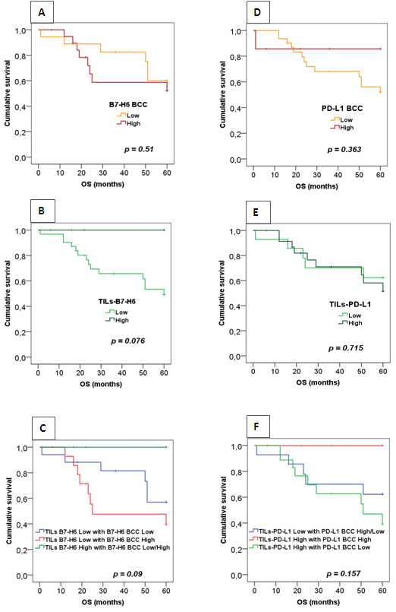
Supplementary figure 2. Survival analysis according to B7-H6 and PD-L1 expression in Her2 positive breast cancer tissues.

(a and d) Kaplan-Meier curves for OS stratified according to B7-H6 and PD-L1 expression by cancer cells (B7-H6 BCC) and (PD-L1 BCC) respectively. (b and e) Kaplan-Meier curves for OS stratified according to B7-H6 and PD-L1 expression by immune infiltrating cells (TILs-B7-H6) and (TILs-PD-L1) respectively. (c) OS curves according to B7-H6 expression by tumor and immune cells together leading to three subgroups; subgroup 1: TILs-B7-H6^{Low}/ B7-H6 BCC^{Low}, subgroup 2: TILs-B7-H6^{Low}/ B7-H6 BCC^{High} and subgroup 3: TILs-B7-H6^{High}/ B7-H6 BCC^{Low/High}. (f) OS curves according to PD-L1 expression by tumor and immune cells together leading to three subgroups; subgroup 1: TILs-PD-L1^{Low}/ PD-L1 BCC^{High/Low}, subgroup 2: TILs- PD-L1^{High}/ PD-L1 BCC^{High} and subgroup 3: TILs- PD-L1^{High}/ PD-L1 BCC^{Low}.

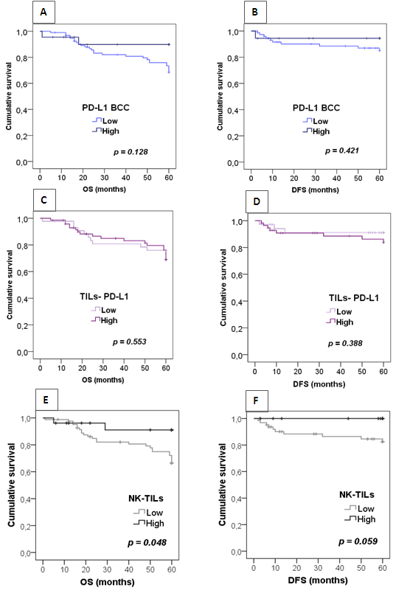
Supplementary figure 3. Survival analysis according to PD-L1 expression and NK-TILs status in breast cancer tissues.

(a-b) Kaplan-Meier curves stratified according to PD-L1 expression by cancer cells (PD-L1 BCC) for overall survival (OS) and disease free survival (DFS). (c-d) Kaplan-Meier curves stratified according to PD-L1 expression by immune infiltrating cells (TILs-PD-L1) for OS and DFS. (e-f) Kaplan-Meier curves stratified according to NK cell infiltration (NK-TILs) for OS and DFS.
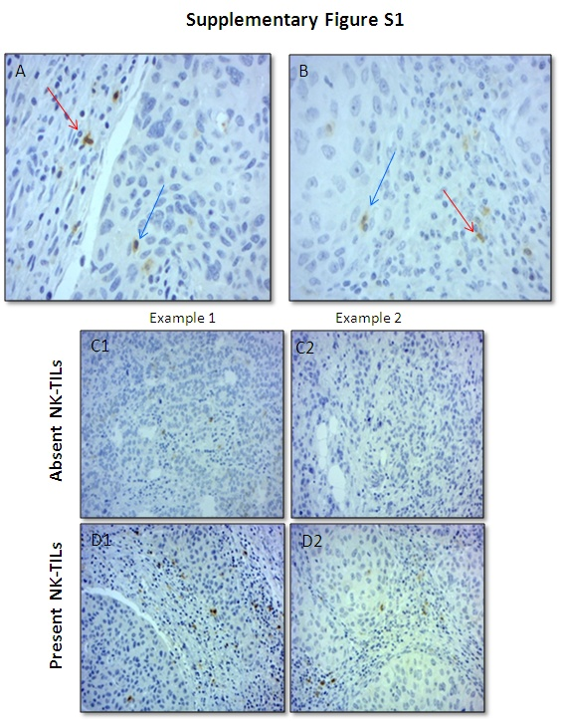
Supplementary figure 4. Immunohistochemical evaluation of CD56+ NK-TILs in breast cancer.
(a-b) Histological section showing CD56+NK cells localizations for intratumoral (blue arrows) and stromal (red arrows) areas. Representative images for absent (c1-c2) and present (d1-d2) CD56+NK cells. (Original magnification ×400)

