Supplementary information

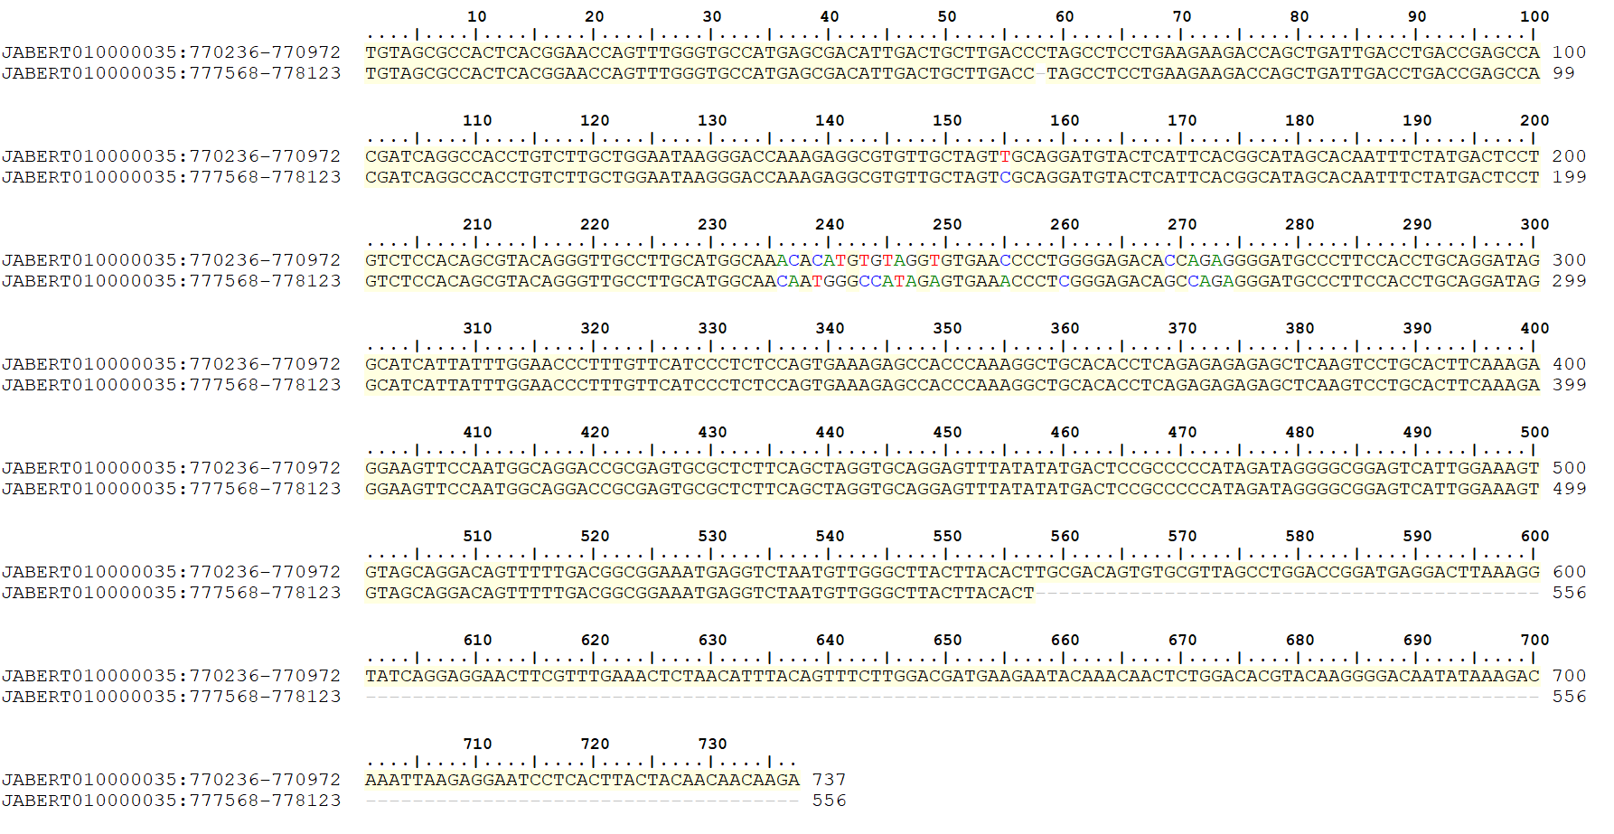

Supplementary figure S1. Alignment of the 561 bp repetitive sequences flanking the non-infectious IHHNV-EVE Cluster 1 located in LG35. The sequences are aligned in the same direction and share 98% identity (547/561 bp with 9/561 nucleotide gaps).
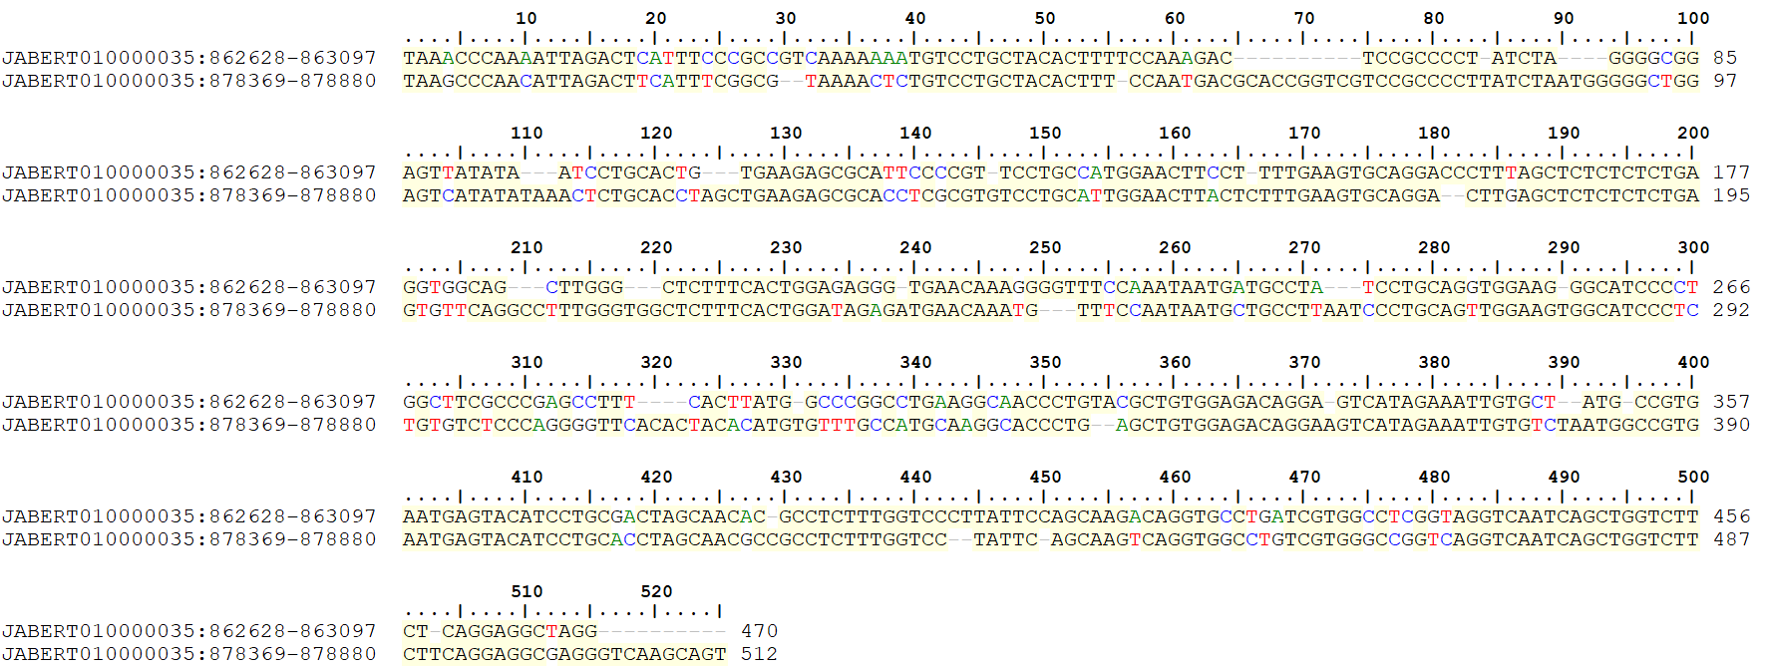

Supplementary figure S2. Alignment of the two 519 bp repetitive sequences flanking IHHNV-EVE Cluster 2 located on LG35. The sequences are aligned in the same direction and share 77% identity (400/519 bp with 66/519 nucleotide gaps).
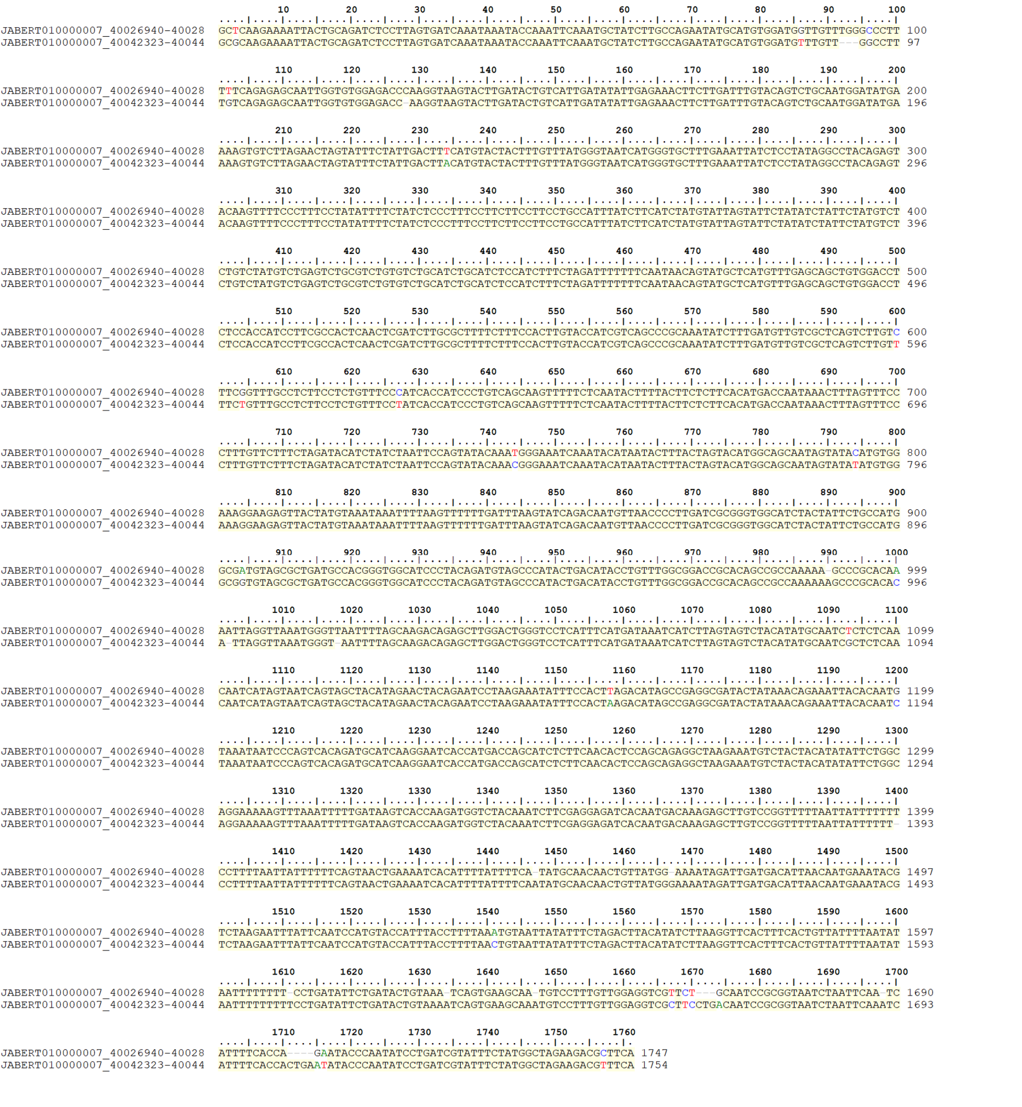

Supplementary figure S3. Alignment of the direct repetitive sequences flanking the infectious IHHNV-EVE Cluster 3 located on LG7. A total 1,758 bp were aligned and share 98% identity (1722/1758 bp with 21/1758 nucleotide gaps).

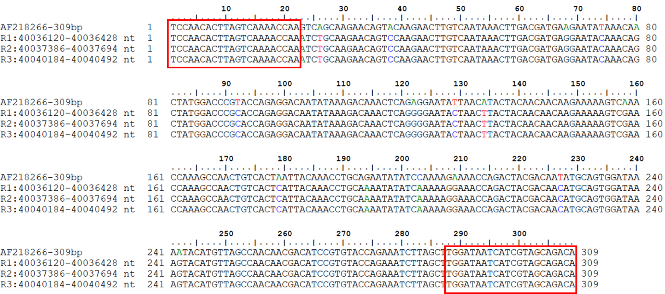

Supplementary figure S4. Multiple sequence alignment of potential 309 bp targets for the OIE- recommend IHHNV detection method from three repeats in IHHNV-EVE observed in LG 7 (R1-R3). The 309F/R primer positions are indicated by red rectangles. The primer sequences and potential amplicon sizes match 100% to those expected for infectious IHHNV.

