Supplementary Information for:

Dual water-electricity cooperation improves economic benefits and water equality in the Lancang-Mekong River Basin

Bingyao Zhang¹, Yu Li^{1*}, Chi Zhang^{1*}, Chunhong Hu², Guangtao Fu³, Ximing Cai⁴

¹School of Hydraulic Engineering, Dalian University of Technology, Dalian, Liaoning, China.

²China Institute of Water Resources and Hydropower Research, Beijing, China.

³ Centre for Water System, College of Engineering, Mathematics and Physical Sciences, University of Exeter, Exeter, UK.

⁴Department of Civil and Engineering, University of Illinois at Urbana-Champaign, Champaign, IL, USA.

*Correspondence to: liyu@dlut.edu.cn; czhang@dlut.edu.cn .

Contents:
Supplementary Figures:
Supplementary Figure 1: Topological map of relations among countries.
Supplementary Figure 2: Water deficit in various countries under different strategies.
Supplementary Figure 3: Electricity deficit or surplus and trade power in dual water-electricity cooperation.

Supplementary Note 1: Willingness function.
Supplementary Note 2: Linkage between water and electricity module.

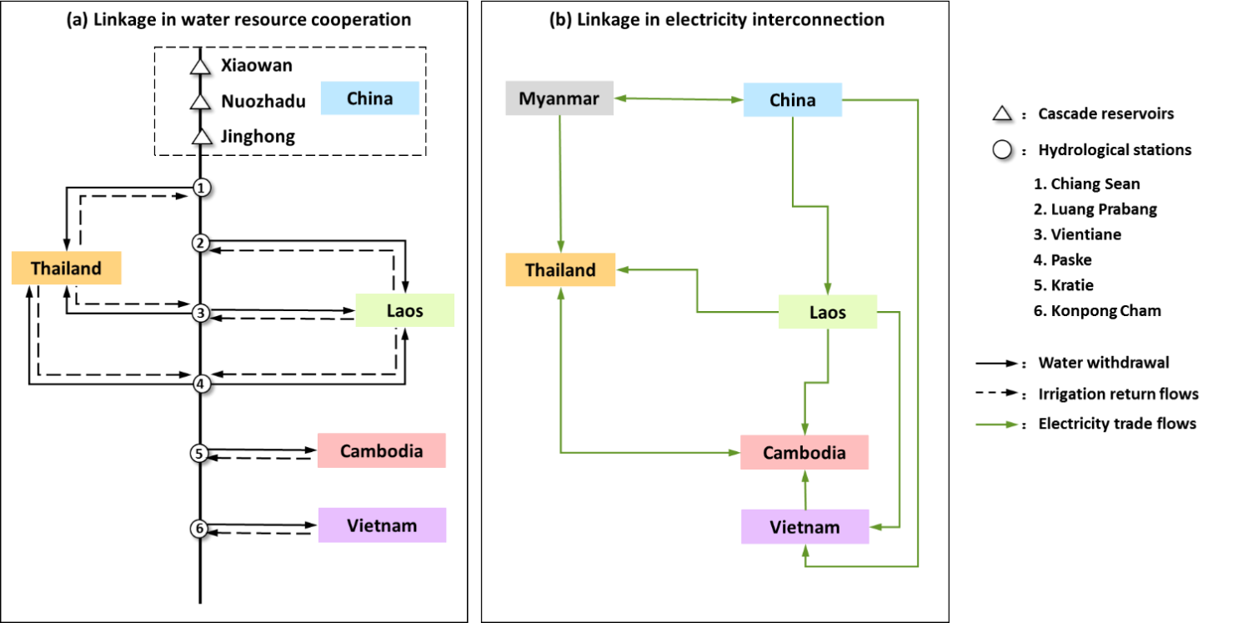
Supplementary Figure 1: Topological map of relations among countries.
Note: Myanmar is not considered in the water cooperation because it only accounts for 3% of the basin area and almost does not take water from the Mekong River; while its geographical location is important in electricity trade which connected China and Thailand.

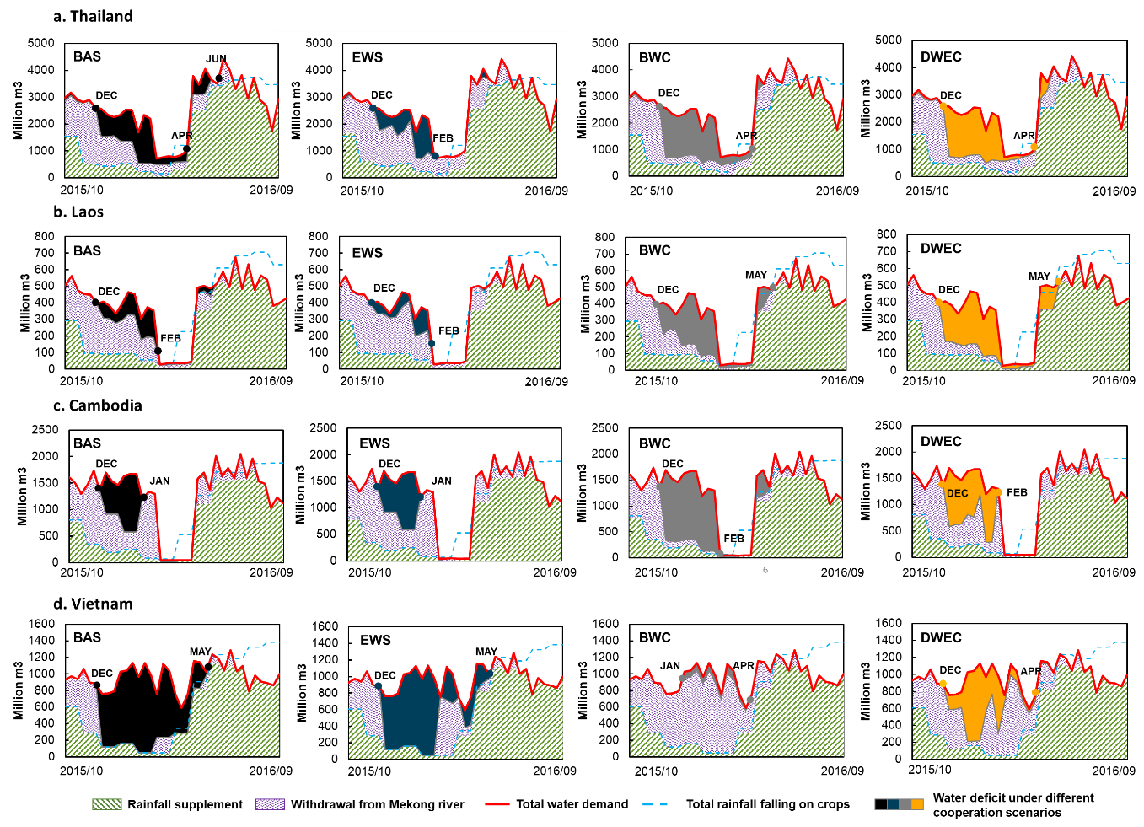
Supplementary Figure 2: Water deficit in various countries under different strategies: a. Thailand; b. Laos; c. Cambodia; d. Vietnam.
Note: The green shadow represents crops water need met by rainfall, and the purple shadow represents crops water need met by water withdrawal from Mekong River. When the rainfall and water withdrawal still do not meet the water demand of crops (red line), there is water deficit.
Acronyms: BAS, baseline with no cooperative action; EWS, Emergent Water Supplement; BWC, Basin-wide Water Cooperation; DWEC, Dual Water-Electricity Cooperation (BWC_CMin or BWC_WMax)

Description: Without cooperative action, downstream countries have different degrees of water shortage during dry periods, of which Vietnam is the most serious country. In emergent water supplement, as upstream China increase its outflow to downstream, the water deficit extent of downstream countries is alleviated. In basin-wide water cooperation, water also can be transferred among downstream countries to maximize the economic benefits of the entire basin. Thailand, Laos and Cambodia with lower unit water benefits transfer their partial water to Vietnam, which has higher unit water benefit, and thus, their water shortage becomes more serious. In dual water-electricity cooperation, water transfer is constrained by electricity trade capacity, and the amount of water transfers from Thailand, Laos and Cambodia is limited. Compared with BWC scenario, Thailand, Laos and Cambodia’s water deficit is improved in DWEC.

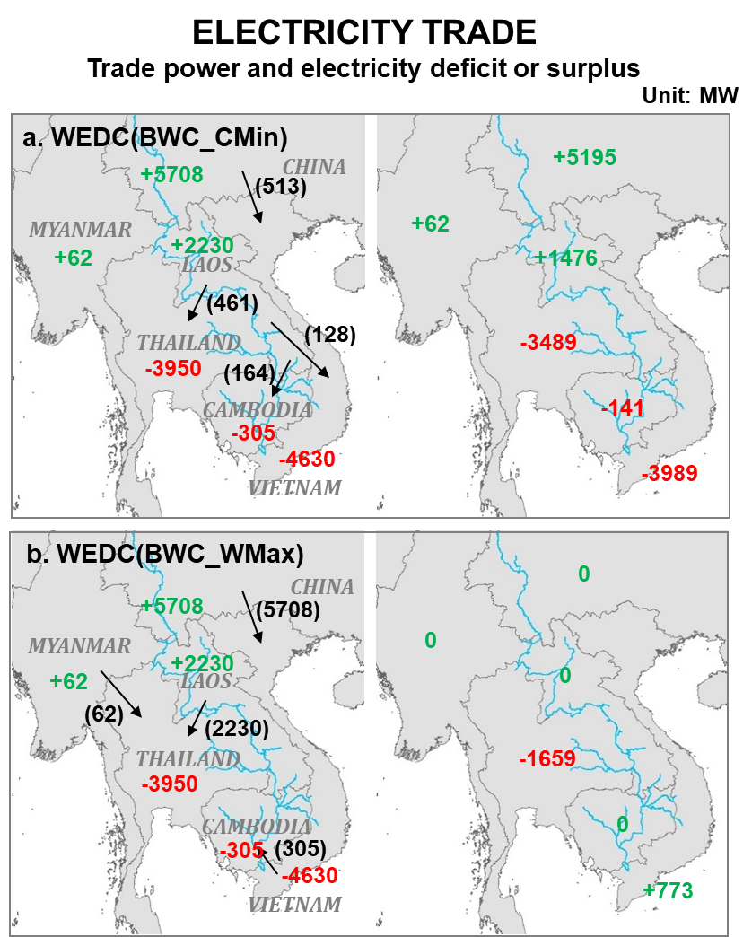
Supplementary Figure 3: Electricity deficit or surplus and trade power in dual water-electricity cooperation.
- Dual Water-Electricity Cooperation developed on Basin-wide Water Cooperation and aimed for Cost Minimization (BWC_CMin);
- Dual Water-Electricity Cooperation developed on Basin-wide Water Cooperation and aimed for Willingness Maximization (BWC_WMax);
Red number: electricity deficit; Green number: electricity surplus; values in (.) is the trade volume between two neighbor countries.

Supplementary Note 1: Willingness function.
We characterize the relationship between stakeholder’s willingness and trade volume by triangle function, and the corresponding formula representations are as follows:
- Type 1: Import appetite, water loss party. When the electricity trade compensates the water loss, the stakeholder begins to be willing to cooperate with others, and the willingness increase as the electricity trade expand, until reaches the balance point which the import electricity volume meet its deficit. The willingness can be described as follows:
$${WI}_{i}=\frac{{np}_{e,i}}{{np}_{e,i}×∆+B_{i}^{w}}×T_{i}^{im}+\frac{B_{i}^{w}}{{np}_{e,i}×∆+B_{i}^{w}} , T_{i}^{im}∈\left[-\frac{B_{i}^{w}}{{np}_{e,i}},∆\right]$$ | (1)
- Type 2: Export appetite, water loss party. Similar with the Type 1, the stakeholder begins to willing to cooperate with others as the water loss fully be compensated, until its abundant electricity is consumed by surrounding countries. The willingness can be described as follows:
$${WI}_{i}=\frac{p_{e}}{{np}_{e,i}×∆+B_{i}^{w}}×T_{i}^{ex}+\frac{B_{i}^{w}}{{np}_{e,i}×∆+B_{i}^{w}} , T_{i}^{ex}∈\left[-\frac{B_{i}^{w}}{{np}_{e,i}},∆\right]$$ | (2)
- Type 3: Import appetite, water beneficiary. The stakeholder benefits in water field, and partial loss in electricity trade can be tolerated. The loss in electricity means the trade development is not followed by the stakeholder’s appetite, i.e. export or excessive import. The willingness function can be described as follows:
$${WI}_{i}=\left\{\begin{aligned}\frac{{np}_{e,i}}{{np}_{e,i}×∆+B_{i}^{w}}×T_{i}^{im}+\frac{B_{i}^{w}}{{np}_{e,i}×∆+B_{i}^{w}}, T_{i}^{im}∈[0,\frac{B_{i}^{w}}{{np}_{e,i}}] \\ -\frac{{np}_{e,i}}{B_{i}^{w}}×T_{i}^{im}+\frac{{np}_{e,i}×∆}{B_{i}^{w}}+1, T_{i}^{im}∈(\frac{B_{i}^{w}}{{np}_{e,i}},∆] \\ -\frac{p_{e}}{{np}_{e,i}×∆+B_{i}^{w}}×T_{i}^{ex}+\frac{B_{i}^{w}}{{np}_{e,i}×∆+B_{i}^{w}}, T_{i}^{ex}∈[0,\frac{B_{i}^{w}}{{np}_{e,i}}]\end{aligned}\right.$$ | (3)
- Type 4: Export appetite, water beneficiary. Similar to Type 3, the stakeholder can undertake additional export or import within its water benefit. The willingness function can be described as follows:
$${WI}_{i}=\left\{\begin{aligned}\frac{{np}_{e,i}}{{np}_{e,i}×∆+B_{i}^{w}}×T_{i}^{ex}+\frac{B_{i}^{w}}{{np}_{e,i}×∆+B_{i}^{w}}, T_{i}^{ex}∈[0,\frac{B_{i}^{w}}{{np}_{e,i}}] \\ -\frac{{np}_{e,i}}{B_{i}^{w}}×T_{i}^{ex}+\frac{{np}_{e,i}×∆}{B_{i}^{w}}+1, T_{i}^{ex}∈(\frac{B_{i}^{w}}{{np}_{e,i}},∆] \\ -\frac{p_{e}}{{np}_{e,i}×∆+B_{i}^{w}}×T_{i}^{im}+\frac{B_{i}^{w}}{{np}_{e,i}×∆+B_{i}^{w}}, T_{i}^{im}∈[0,\frac{B_{i}^{w}}{{np}_{e,i}}]\end{aligned}\right.$$ | (4)

Supplementary Note 2: Linkage between water and electricity module.
The linkage between water and electricity module is taken by setting constraints. Considering the stakeholder’s possible role in the water field (loss or gain) and electricity trade (import or export), linkages are described as follows:
From water module to electricity module:
- Stakeholder with electricity import desire (i.e., demand is greater than generation) and water benefit loss in the dual cooperation, the loss in water cooperation is the lower limit for necessary electricity import.
$$-\frac{B_{i}^{w}}{{np}_{e,i}}≤T_{i}^{im}≤∆$$ | (5)
$$0≤T_{i}^{ex}≤0, i.e. T_{i}^{ex}=0$$ | (6)
- Stakeholder with electricity export desire (i.e., demand is less than generation) and water benefit loss in the dual cooperation, its loss in water cooperation is the lower limit for necessary electricity export.
$$0≤T_{i}^{im}≤0, i.e. T_{i}^{im}=0$$ | (7)
$$-\frac{B_{i}^{w}}{np_{e,i}}≤T_{i}^{ex}≤∆$$ | (8)
- Stakeholder with electricity import desire (i.e., demand is greater than generation) and water benefit gain in the dual cooperation, it can sustain additional import or export, and this part should not exceed its benefits gain in the water field.
$$0≤T_{i}^{im}≤\frac{B_{i}^{w} }{{np}_{e,i}}+∆$$ | (9)
$$0≤T_{i}^{ex}≤\frac{B_{i}^{w}}{np_{e,i}}$$ | (10)
- Stakeholder with electricity export desire (i.e., demand is less than generation) and water benefit gain in the dual cooperation, it can sustain additional export or import, and this part should not exceed its benefits gain in the water field.
$$0≤T_{i}^{im}≤\frac{B_{i}^{w}}{{np}_{e,i}}$$ | (11)
$$0≤T_{i}^{ex}≤\frac{B_{i}^{w} }{np_{e,i}}+∆$$ | (12)
Where $∆$ refers to the difference between the demand and generation, when demand is greater than generation, means electricity deficit, $∆$ = demand - generation; also when demand is less than generation, means electricity surplus, $∆$ = generation - demand; $B_{i}^{w}$ represents the benefits of stakeholder $i$ brought by water cooperation, the value is negative when benefit loss; ${np}_{e,i}$ represents the net electricity price of stakeholder $i$, it equals the electricity economic price minus the costs that the stakeholder must afford; $T_{i}^{im}$ and $T_{i}^{ex}$ represents the import and export electricity trade volume by stakeholder$i$; $i,j ∈N, N=1,2,⋯,6$.
From electricity module to water module, Stakeholder’s benefit loss in water would not be accepted when it exceeds electricity trade compensation capacity.
- Stakeholder with electricity import desire (i.e. demand is greater than generation), its electricity trade compensation capacity is determined by its own electricity import desire and electricity export provided by surrounding countries, as follows:
$$-\frac{B_{i}^{w}}{np_{e,i}}≤min\left(∆, \sum_{j≠i}{T_{j}^{im}}\right)$$ | (13)
- Stakeholder with electricity export desire (i.e. demand is less than generation), its electricity trade compensation capacity is determined by its own electricity export desire and electricity import provided by surrounding countries, as follows:
$$-\frac{B_{i}^{w}}{np_{e,i}}≤min\left(∆, \sum_{j≠i}{T_{j}^{ex}}\right)$$ | (14)

