Degradation of Bisphenol A and S in Wastewater during Cold Atmospheric Pressure Plasma Treatment

Ana Kovačič^{a,1}, Martina Modic^{b,1}, Nataša Hojnik^{b}, Anja Vehar^{a,c}, Tina Kosjek^{a,c}, David Heathª, James L. Walsh^{d}, Uroš Cvelbar ^{b,c}, Ester Heath^{a,c*}

ªDepartment of Environmental Sciences O2, Jožef Stefan Institute, Jamova 39, 1000 Ljubljana, Slovenia;
^{b}Laboratory for Gaseous Electronics F6, Jožef Stefan Institute, Jamova 39, 1000 Ljubljana, Slovenia; ^{c}Jožef Stefan International Postgraduate School, Jamova 39, 1000 Ljubljana, Slovenia
^{d}Department of Electrical Engineering and Electronics, University of Liverpool, 9 Brownlow Hill, Liverpool L69 3GJ, United Kingdom

¹Joint first authors

*corresponding author: ester.heath@ijs.si; tel. nr.: +386 1 477 35

SM-1 Materials and analysis

SM-1.1 General information of investigated compounds

Bisphenol A, BPS (all >98%), and an isotopically labelled BPA (BPA-d16, 98 %) were obtained from Sigma-Aldrich (St. Louis, USA) and isotopically labelled BPS (¹³C₁₂-BPS) from CanSyn Chem. Corp. (Toronto, Canada). The solvents ethyl acetate (EtAc, for organic residue analysis), methanol (MeOH, for organic residue analysis or ultra-gradient high-performance liquid chromatography (HPLC) grade), and hydrochloric acid (HCl, p.a.) were obtained from J. T. Baker (Deventer, Netherlands). Formic acid (FA; 99%) and ammonium fluoride (NH₄F, 99.8%) were purchased from Sigma Aldrich (St. Louis, USA). Oasis HLB Prime SPE cartridges were obtained from Waters (Massachusetts, USA). Samples were exposed to cold atmospheric pressure plasma (CAP) in cell culture dishes (Orange Scientific, Braine-l´Alleud, Belgium) and stirred on a magnetic mixer (C-MAG HS 7, IKA®-Werke GmbH &Co. KG, Staufen, Germany) throughout the treatments. Ultrapure water was prepared using the Milli-Q water purification system (Millipore Merck Direct-QTM) to a specific resistance of > 18.0 MΩ cm ⁻¹ at 25 °C and was used to prepare all aqueous solutions and mobile phases for LC-MS analysis. Samples injected directly were filtered through 0.2 µm regenerated cellulose membrane syringe filters (Phenomenex, Torrance, USA).

Table SM-1. Chemical structures, IUPAC names and CAS numbers of BPA and BPS.
Structure | Name | IUPAC name | Major use | CAS Number
 | Bisphenol A | 4,4′-(Propane-2,2-diyl)diphenol | raw material for epoxy resins, polycarbonate plastic, thermal paper | 80-05-7
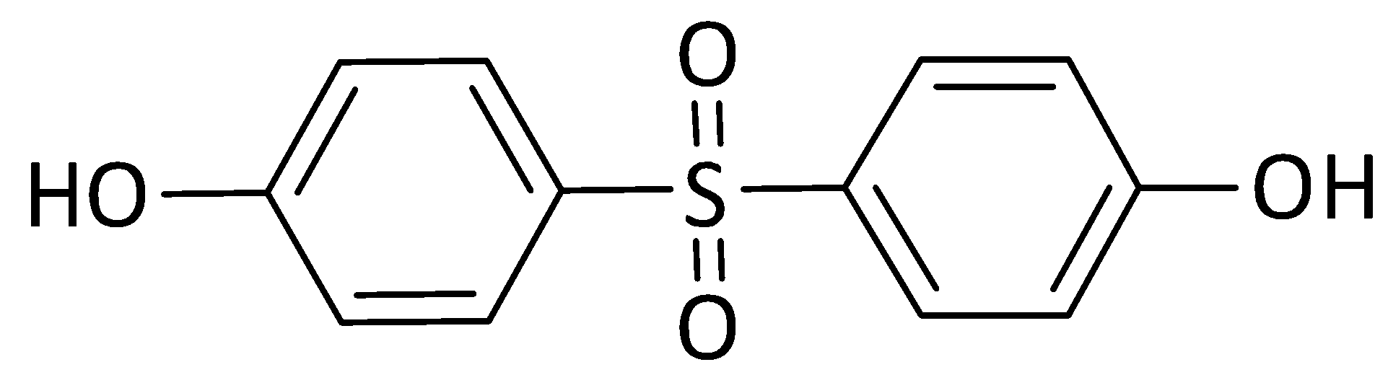 | Bisphenol S | 4,4'-sulfonyldiphenol | raw material for epoxy resins, cyclic carbonates, polyethersulfone (PES), thermal paper | 80-09-1

SM-1.2 Preparation of standard and working solutions

Stock solutions (≈ 1 mg mL⁻¹) were prepared by dissolving each compound in MeOH from which working standard solutions (1, 10, and 100 µg mL⁻¹) were prepared by appropriate dilution with MeOH. Similarly, an internal standard solution (10 and 0.1 µg mL⁻¹) in MeOH was prepared from the isotopically labelled compounds (1.0 mg mL⁻¹). Once prepared, all standards were stored in amber glass vials at 4 °C (maximum of 24 weeks) (Kovačič et al., 2019).

SM-1.3 Instrumental analysis

The analyses of ultrapure and WW samples were performed using an UHPLC-QqLIT-MS/MS, which consisted of a Shimadzu Nexera X2 UHPLC (Kyoto, Japan) coupled to a linear ion trap quadrupole 4500 QqLIT-MS/MS (Sciex, Framingham, MA, USA). The separation was achieved at 40 ◦C using a Poroshell 120 EC-C18 column (100 × 3 mm; 2.7 µm particle size, Agilent Technologies, USA). The mobile phase was ultrapure water with 1 mM NH₄F (A) and methanol with 1 mM NH₄F (B) at a flow rate of 0.3 mL min⁻¹. The 4500 QTRAP analyzer was operated under electrospray ionization (ESI) in negative mode with the following settings: curtain gas: 35 psi; collision gas: medium; source temperature: 550°C; ion spray voltage: -4.5 kV; ion source gas 1: 35 psi; ion source gas 2: 20 psi. Degradation kinetics: The injection volume was 1 and 5 µL for ultrapure and WW analysis, respectively. The mobile phase gradient was as follows: 0-1 min, 70% B; 1-5 min, 100% B; 6 min, 100% B; 6-7 min, 70 % B; 7-11 min; 70 % B. For detection of the parent compound, the mass spectrometer was operated in multiple reaction monitoring (MRM) mode. The transitions were optimized for the compound-dependent parameters, including declustering potential (DP), collision energy (CE), collision exit potential (CXP) and entrance potential (EP), as detailed in SI (Table SM-2). The data station operating software was Analyst v1.6.3.
Transformation product (TP) formation: The injection volume was 10 µL. The run started isocratically for 1 min at 10% B, then raised to 40% in 4 min, to 75% in 5 min, and finally to 95% in 1 min. The column was rinsed with 95% B for 4 min and re-equilibrated for 5 min at 10% B. The structural information of possibly formed TPs was obtained by acquiring an IDA scan cycle, including an enhanced precursor ions scan and a dependent enhanced product ion (EPI) scan. With the threshold of the ion intensity at 1000 counts per second (cps), the IDA criteria were set to allow the precursor ion of 133 and 93 and 108 product ions for the analysis of TPs of BPA and BPS, respectively, to trigger EPI scans. The EPI scan was in the range m/z 80−350, scanned at 10000 Da/s, under CE of -30 eV with a CE spread of 10 eV (30±10 eV).

Table SM-2 Retention time and the Qtrap optimized compound dependent MRM parameters.
Compound ID | RT [min] | MRM | DP [V] | CE [V] | CXP [V] | EP [V]
BPA | 3.97 | 227.0> 133.0 | -80 | -32 | -13 | -10
BPA | 3.97 | 227.0> 211.9 | -80 | -20 | -13 | -10
BPA-d₁₆ | 3.90 | 241.0> 223.0 | -80 | -22 | 5 | -10
BPA-d₁₆ | 3.90 | 241.0> 142.0 | -80 | -20 | 28 | -10
BPS | 2.26 | 248.9 > 108.0 | -100 | -32 | -9 | -10
BPS | 2.26 | 248.9 > 155.8 | -100 | -28 | -11 | -10
¹³C₁₂ BPS | 2.26 | 260.9 > 133.9 | -75 | -34 | -7 | -10
¹³C₁₂ BPS | 2.26 | 260.9 > 98.0 | -75 | -50 | -9 | -10

SM-1.4 Method validation
Based on sample matrix type, the UHPLC-Qtrap method was validated for ultrapure water analysis, WW influent and WW effluent samples. Sensitivity was evaluated in terms of limit of detection (LOD) and the limit of quantification (LOQ) using standard addition and calculated as 3-times and 10-times the standard deviation of the baseline divided by the slope of the calibration curves, respectively. The calibration range for the analysis of ultrapure samples consisted of six calibration points (1 ̶ 1000 µg L⁻¹) using the LOQ as the lowest calibration level and the highest calibration level selected according to applied experimental concentration. The calibration range for the analysis of WW samples consisted of nine calibration points (40 ̶ 4000 ng L⁻¹) using the LOQ as the lowest calibration level and the highest calibration level selected according to bisphenol concentrations in WW. The linearity was expressed as the correlation coefficient (R²) of the matrix-matched calibration curves. All validation parameters were measured over two calibration levels depending on the applied method: low (0.1 and 5 µg L⁻¹) and high (1 and 1000 µg L⁻¹) levels. Trueness was expressed as [(experimental value - spiked value)/spiked value] (n = 3). Method repeatability was calculated as the relative standard deviation (RSD) of three parallel samples (n = 3), while instrumental repeatability was determined as the RSD of three consecutive injections of the same sample (n = 3). The solid-phase extraction (SPE) efficiency is reported as the ratio between peak areas of analyte/internal standard spiked before and after SPE, whereas internal standard was spiked after SPE in both cases to cover instrument signal variations. Analyte recovery was calculated as a quotient of the response areas of the analytes spiked in the validation standards prior to SPE and the same amount of analytes. Matrix effect was determined as the ratio between the analyte's internal standard normalized peak area spiked into extracted WW matrix compared to the analyte peak area spiked into the solvent. To account for contamination, controls and procedural blanks were prepared and systematically included in each batch of analyses, while solvent blanks were analysed to evaluate potential carry-over.
Table SM-3. Validation parameters (instrumental repeatability, trueness, extraction recovery, and matrix effect at lower (LC) and higher calibration level (HC) and LOQ, linearity and concentration range) of an analytical method for BPA and BPS analysis in ultrapure, influent, and effluent samples.
Compound | Method (matrix) | Method repeatability |  | Instrumental repeatability |  | Trueness |  | Calibration |  |  | Recovery |  | Matrix effect |  | LOQ | Concentration  range
Compound | Method (matrix) | (RSD) |  | (RSD) |  | (%) |  |  |  |  | (%) |  | (%) |  | LOQ | Concentration  range
Compound | Method (matrix) | LC | HC | LC | HC | LC | HC | k | weight | R² | LC | HC | LC | HC | [ng L⁻¹] | [ng L⁻¹]
BPA | ultrapure water | 1.6 | 2.2 | 1.8 | 1.7 | 5.4 | 0.8 | 0.0069 | 1/x² | 0.9974 | / | / | / | / | 10 | 10 -1000
BPA | WW influent | 14.6 | 10.1 | 0.9 | 5.7 | 43 | 2.3 | 0.0425 | none | 0.9978 | 108 | 119 | 39 | 29 | 160 | 160-100
BPA | WW effluent | 7.7 | 5.5 | 2 | 1.3 | 10.2 | 10.6 | 0.0401 | none | 0.9947 | 97 | 105 | 57 | 53 | 40 | 40 -100
BPS | ultrapure water | 4.8 | 3.5 | 2.5 | 0.3 | 9.8 | 9.7 | 0.00685 | 1/x² | 0.9976 | / | / | / | / | 10 | 10 -1000
BPS | WW influent | 5.7 | 2.8 | 1.3 | 0.6 | 30 | 1 | 0.0393 | none | 0.9931 | 112 | 95 | 12 | 59 | 100 | 100-100
BPS | WW effluent | 3 | 5.4 | 1 | 1.9 | 6.3 | 9.6 | 0.0369 | none | 0.9962 | 89 | 101 | 37 | 29 | 40 | 40 -100

SM-2 Degradation kinetics

Table SM-4. Removal of bisphenols in ultrapure water including standard deviation (sd) and relative standard deviation (RSD) of parallels depending on the initial concentration c_{i}, time and power discharge of plasma treatment: high and low power discharge plasma (H-CAP and L-CAP).
Condition |  |  | BPA |  |  |  |  |  | BPS
c_{i}  [mg L⁻¹] | CAP | time [s] | Removal [%] |  |  |  |  |  | Removal [%]
c_{i}  [mg L⁻¹] | CAP | time [s] | parallel1 | parallel 2 | average | sd |  | RSD | parallel 1 | parallel 2 | average | sd | RSD
0.001 | H | 120 | 53 | 42 | 48 | 8 | 15 |  | 6 | 2 | 4 | 3 | 3
0.001 | H | 15 | 0 | -5 | -2 | 3 | 3 |  | -2 | 4 | 1 | 4 | 4
0.001 | H | 240 | 90 | 91 | 90 | 1 | 10 |  | 13 | 10 | 11 | 2 | 3
0.001 | H | 30 | 11 | 6 | 9 | 4 | 4 |  | -9 | -2 | -5 | 5 | 4
0.001 | H | 480 | 97 | 98 | 98 | 1 | 41 |  | 56 | 57 | 57 | 0 | 1
0.001 | H | 60 | 35 | 25 | 30 | 7 | 10 |  | -4 | -4 | -4 | 0 | 0
0.001 | L | 120 | 23 | 12 | 18 | 7 | 9 |  | 5 | 6 | 5 | 1 | 1
0.001 | L | 15 | -5 | -4 | -5 | 1 | 1 |  | 5 | 1 | 3 | 3 | 3
0.001 | L | 240 | 45 | 41 | 43 | 3 | 5 |  | 9 | 9 | 9 | 0 | 0
0.001 | L | 30 | 3 | 18 | 11 | 11 | 12 |  | -4 | -2 | -3 | 1 | 1
0.001 | L | 480 | 57 | 54 | 55 | 2 | 5 |  | 22 | 25 | 23 | 2 | 3
0.001 | L | 60 | 8 | 7 | 7 | 1 | 1 |  | 0 | 4 | 2 | 3 | 3
0.05 | H | 120 | 48 | 35 | 41 | 9 | 16 |  | 4 | 2 | 3 | 1 | 1
0.05 | H | 15 | -4 | 3 | -1 | 5 | 5 |  | 0 | -6 | -3 | 4 | 4
0.05 | H | 240 | 67 | 65 | 66 | 2 | 4 |  | 6 | 6 | 6 | 0 | 0
0.05 | H | 30 | 5 | 3 | 4 | 1 | 1 |  | 8 | 1 | 4 | 4 | 5
0.05 | H | 480 | 86 | 88 | 87 | 1 | 11 |  | 18 | 22 | 20 | 3 | 4
0.05 | H | 60 | 20 | 22 | 21 | 1 | 2 |  | 5 | 3 | 4 | 1 | 1
0.05 | L | 120 | 29 | 27 | 28 | 2 | 2 |  | 4 | 10 | 7 | 4 | 4
0.05 | L | 15 | 3 | 2 | 3 | 1 | 1 |  | 3 | 2 | 2 | 1 | 1
0.05 | L | 240 | 44 | 35 | 39 | 6 | 10 |  | 13 | 8 | 11 | 3 | 4
0.05 | L | 30 | 9 | 12 | 10 | 2 | 3 |  | 2 | 3 | 3 | 1 | 1
0.05 | L | 480 | 53 | 54 | 53 | 0 | 1 |  | 20 | 21 | 21 | 0 | 0
0.05 | L | 60 | 15 | 9 | 12 | 4 | 5 |  | 6 | 4 | 5 | 1 | 1
0.05-mix | H | 120 | 26 | 32 | 29 | 4 | 6 |  | -3 | 3 | 0 | 4 | 4
0.05-mix | H | 15 | -1 | -3 | -2 | 1 | 1 |  | -6 | -5 | -6 | 0 | 0
0.05-mix | H | 240 | 47 | 55 | 51 | 6 | 12 |  | 3 | 9 | 6 | 4 | 4
0.05-mix | H | 30 | 22 | 13 | 17 | 6 | 8 |  | 4 | -4 | 0 | 6 | 6
0.05-mix | H | 480 | 74 | 70 | 72 | 3 | 9 |  | 15 | 5 | 10 | 8 | 9
0.05-mix | H | 60 | 25 | 16 | 21 | 6 | 8 |  | 1 | -16 | -8 | 12 | 11
0.05-mix | L | 120 | 23 | 23 | 23 | 0 | 0 |  | 6 | 11 | 8 | 4 | 4
0.05-mix | L | 15 | 3 | 1 | 2 | 1 | 1 |  | 3 | 1 | 2 | 2 | 2
0.05-mix | L | 240 | 38 | 34 | 36 | 3 | 4 |  | 13 | 15 | 14 | 2 | 2
0.05-mix | L | 30 | 5 | 2 | 3 | 2 | 2 |  | 7 | 2 | 4 | 4 | 4
0.05-mix | L | 480 | 67 | 69 | 68 | 1 | 4 |  | 22 | 19 | 21 | 2 | 2
0.05-mix | L | 60 | 12 | 16 | 14 | 3 | 3 |  | 1 | 6 | 4 | 3 | 3
0.4 | H | 120 | 48 |  | 48 |  |  |  | -22 | -16 | -19 | 4 | 4
0.4 | H | 15 | 13 | 13 | 13 | 0 | 0 |  | 9 | 8 | 9 | 1 | 1
0.4 | H | 240 | 77 | 82 | 80 | 3 | 17 |  | 4 | 0 | 2 | 3 | 3
0.4 | H | 30 | 15 | 15 | 15 | 0 | 0 |  | 10 | 13 | 11 | 3 | 3
0.4 | H | 480 | 98 | 99 | 99 | 0 | 18 |  | 67 | 79 | 73 | 8 | 30
0.4 | H | 60 | 39 | 29 | 34 | 7 | 10 |  | 14 | -23 | -4 | 27 | 26
0.4 | L | 120 | 18 | 27 | 23 | 7 | 9 |  | 18 | 13 | 16 | 4 | 4
0.4 | L | 15 | 5 | 8 | 6 | 2 | 2 |  | 5 | 3 | 4 | 2 | 2
0.4 | L | 240 | 37 | 33 | 35 | 3 | 5 |  | 18 | 19 | 19 | 1 | 1
0.4 | L | 30 | 6 | 8 | 7 | 1 | 2 |  | 5 | 4 | 5 | 1 | 1
0.4 | L | 480 | 58 | 54 | 56 | 3 | 7 |  | 29 | 30 | 29 | 1 | 1
0.4 | L | 60 | 12 | 13 | 13 | 1 | 1 |  | 10 | 9 | 10 | 0 | 1
1 | H | 120 | 37 | 35 | 36 | 1 | 2 |  | 0 | 2 | 1 | 1 | 2
1 | H | 15 | 5 | 7 | 6 | 2 | 2 |  | -2 | -1 | -1 | 1 | 1
1 | H | 240 | 82 | 77 | 80 | 4 | 17 |  | 7 | 3 | 5 | 3 | 3
1 | H | 30 | 11 | 15 | 13 | 2 | 3 |  | -1 | -4 | -2 | 2 | 2
1 | H | 480 | 99 | 98 | 99 | 1 | 41 |  | 38 | 43 | 41 | 4 | 7
1 | H | 60 | 19 | 22 | 20 | 2 | 2 |  | 3 | 2 | 3 | 1 | 1
1 | L | 120 | 20 | 16 | 18 | 3 | 4 |  | 4 | 1 | 3 | 2 | 2
1 | L | 15 | 2 | 6 | 4 | 3 | 3 |  | -3 | -2 | -2 | 1 | 1
1 | L | 240 | 35 | 38 | 37 | 2 | 3 |  | 8 | 13 | 10 | 4 | 4
1 | L | 30 | 9 | 4 | 7 | 4 | 4 |  | -3 | 0 | -2 | 2 | 2
1 | L | 480 | 54 | 52 | 53 | 1 | 3 |  | 24 | 21 | 22 | 2 | 3
1 | L | 60 | 13 | 9 | 11 | 3 | 3 |  | 2 | 1 | 1 | 1 | 1
1-mix | H | 120 | 47 | 34 | 41 | 9 | 15 |  | -1 | -3 | -2 | 1 | 1
1-mix | H | 15 |  | 1 | 1 |  |  |  | -1 | -7 | -4 | 4 | 4
1-mix | H | 240 | 84 | 86 | 85 | 2 | 6 |  | 2 | 4 | 3 | 1 | 1
1-mix | H | 30 | 4 | 7 | 5 | 2 | 6 |  | -5 | -4 | -5 | 1 | 1
1-mix | H | 480 | 99 | 99 | 99 | 2 | 6 |  | 23 | 34 | 28 | 8 | 11
1-mix | H | 60 | 24 | 9 | 17 | 2 | 6 |  | 3 | -10 | -4 | 9 | 9
1-mix | L | 120 | 16 | 14 | 15 | 2 | 6 |  | -6 | -10 | -8 | 3 | 3
1-mix | L | 15 | 6 | 3 | 5 | 2 | 6 |  | 0 | -1 | 0 | 0 | 0
1-mix | L | 240 | 36 | 33 | 34 | 2 | 6 |  | -8 | -7 | -8 | 1 | 1
1-mix | L | 30 | 2 | 3 | 2 | 2 | 6 |  | -2 | -5 | -4 | 2 | 2
1-mix | L | 480 | 70 | 65 | 67 | 2 | 6 |  | 0 | -8 | -4 | 6 | 5
1-mix | L | 60 | 4 | 11 | 8 | 2 | 6 |  | -8 | 1 | -4 | 6 | 6

Table SM-5. Removal of bisphenol including standard deviation (sd) and relative standard deviation (RSD) of parallels in WW effluent (Ef) and influent (Inf).
Condition |  |  | BPA |  |  |  |  |  | BPA
WW | CAP | Removal [%] | Removal [%] |  |  |  |  |  | Removal BP [%]
WW | CAP | Removal [%] | parallel1 | parallel 2 | average | sd |  | RSD | parallel 1 | parallel 2 | average | sd |  | RSD
Ef | H | 0 | 0 | 0 | 0 | 0 | 0 |  | 0 | 0 | 0 | 0 | 0
Ef | H | 15 | 14 | 3 | 8 | 8 | 9 |  | 0 | 3 | 2 | 2 | 2
Ef | H | 30 | 7 | 6 | 7 | 0 | 0 |  | 2 | -1 | 1 | 2 | 2
Ef | H | 60 | 31 | 14 | 22 | 12 | 16 |  | -2 | -1 | -1 | 1 | 1
Ef | H | 120 | 44 | 49 | 46 | 3 | 7 |  | 7 | 3 | 5 | 3 | 3
Ef | H | 240 | 67 | 66 | 67 | 1 | 3 |  | 16 | 11 | 14 | 4 | 5
Ef | H | 480 | 86 | 71 | 79 | 11 | 51 |  | 50 | 45 | 48 | 3 | 6
Inf | H | 0 | 0 | 0 | 0 | 0 | 0 |  | 0 | 0 | 0 | 0 | 0
Inf | H | 15 | 13 | 0 | 7 | 9 | 10 |  | -9 | -24 | -17 | 11 | 10
Inf | H | 30 | -6 | 1 | -2 | 5 | 5 |  | -19 | -27 | -23 | 6 | 5
Inf | H | 60 | 18 | 27 | 22 | 6 | 8 |  | 1 | -4 | -1 | 4 | 4
Inf | H | 120 | 19 | -9 | 5 | 20 | 21 |  | 12 | -9 | 2 | 15 | 15
Inf | H | 240 | 62 | 77 | 70 | 10 | 35 |  | 12 | 16 | 14 | 3 | 4
Inf | H | 480 | 53 | 64 | 58 | 7 | 18 |  | 23 | 39 | 31 | 11 | 16

Table SM-6. Statistical analysis of bisphenol removal evaluating the statistically significant difference of specific condition obtained by appropriate statistical tests (p-value < 0.05: statistically significant difference between comparing samples (bisphenol_time_power discharge_concentration c₁=0.001, c₂=0.05, c₃=0.4, c₄=1.0 mg L⁻¹_type of matrix).

Sample |  |  |  | test | p-value
BPA_480_H | BPA_480_L | - | - | Mann-Whitney U | 7.396E-07
BPA_240_H | BPA_240_L | - | - | Mann-Whitney U | 7.396E-07
BPA_120_H | BPA_120_L | - | - | t-test | 0.00000233
BPA_60_H | BPA_60_L | - | - | t-test | 0.00003505
BPA_30_H | BPA_30_L | - | - | Mann-Whitney U | 0.0887
BPA_15_H | BPA_15_L | - | - | t-test | 0.94227
BPS_480_H | BPS_480_L | - | - | Mann-Whitney U | 0.0519
BPS_240_H | BPS_240_L | - | - | t-test | 0.1837
BPS_120_H | BPS_120_L | - | - | t-test | 0.0362
BPS_60_H | BPS_60_L | - | - | Mann-Whitney U | 0.16558
BPS_30_H | BPS_30_L | - | - | t-test | 0.9684
BPS_15_H | BPS_15_L | - | - | t-test | 0.20289
BPA_480_H/L_c1 | BPA_480_H/L_c2 | BPA_480_H/L_c3 | BPA_480_H/L_c4 | Kruskal-Wallis | 0.618
BPA_240_H/L_c1 | BPA_240_H/L_c2 | BPA_240_H/L_c3 | BPA_240_H/L_c4 | Kruskal-Wallis | 0.599
BPA_120_H/L_c1 | BPA_120_H/L_c2 | BPA_120_H/L_c3 | BPA_120_H/L_c4 | one-way anova | 0.86647
BPA_60_H/L_c1 | BPA_60_H/L_c2 | BPA_60_H/L_c3 | BPA_60_H/L_c4 | Kruskal-Wallis | 0.846
BPA_30_H/L_c1 | BPA_30_H/L_c2 | BPA_30_H/L_c3 | BPA_30_H/L_c4 | one-way anova | 0.7511
BPA_15_H/L_c1 | BPA_15_H/L_c2 | BPA_15_H/L_c3 | BPA_15_H/L_c4 | one-way anova | 0.0005772
BPS_480_H/L_c1 | BPS_480_H/L_c2 | BPS_480_H/L_c3 | BPS_480_H/L_c4 | Kruskal-Wallis | 0.0441
BPS_240_H/L_c1 | BPS_240_H/L_c2 | BPS_240_H/L_c3 | BPS_240_H/L_c4 | Kruskal-Wallis | 0.672
BPS_120_H/L_c1 | BPS_120_H/L_c2 | BPS_120_H/L_c3 | BPS_120_H/L_c4 | Kruskal-Wallis | 0.627
BPS_60_H/L_c1 | BPS_60_H/L_c2 | BPS_60_H/L_c3 | BPS_60_H/L_c4 | Kruskal-Wallis | 0.119
BPS_30_H/L_c1 | BPS_30_H/L_c2 | BPS_30_H/L_c3 | BPS_30_H/L_c4 | one-way anova | 0.000456
BPS_15_H/L_c1 | BPS_15_H/L_c2 | BPS_15_H/L_c3 | BPS_15_H/L_c4 | one-way anova | 0.010449
BPA | BPS | - | - | Mann-Whitney U | 8.98E-16
BPA_c2 | BPA_c2_mix | - | - | t-test | 0.65501
BPA_c4 | BPA_c4_mix | - | - | Mann-Whitney U | 0.9323
BPS_c2 | BPS_c2_mix | - | - | t-test | 0.26627
BPS_c4 | BPS_c4_mix | - | - | Mann-Whitney U | 0.24152
BPA_Inf | BPA_Ef | - | - | t-test | 0.35478
BPS_Inf | BPS_Ef | - | - | t-test | 0.19765
BPA_WW | BPS_WW | - | - | Mann-Whitney U | 0.001549
Ultrapure water | WW | - | - | Mann-Whitney U | 0.948

Fig. SM-1 Characterization of liquid RONS.

SM-3. Transformation product identification

Table SM-7. Detection of proposed TPs of BPA and BPS at different exposure times under H-CAP and L-CAP plasma conditions.
bisphenol | condition | H-CAP/L-CAP
bisphenol | TPs/time [s] | 15 | 30 | 60 | 120 | 240 | 480
BPA | BPA-272 | 1/1 | 1/1 | 1/1 | 1/1 | 1/1 | 1/1
BPA | BPA-243 | 0/1 | 1/1 | 1/1 | 1/1 | 1/1 | 0/1
BPA | BPA-133 | 1/1 | 1/1 | 1/1 | 1/1 | 1/1 | 0/1
BPA | BPA-125 | 1/1 | 1/0 | 1/1 | 1/1 | 1/1 | 1/1
BPS | BPS-294 | 1/1 | 1/1 | 1/1 | 1/1 | 1/1 | 1/1
BPS | BPS-265 | 1/1 | 1/1 | 1/1 | 1/1 | 1/1 | 1/1
BPS | BPS-173 | 0/0 | 1/1 | 1/1 | 0/0 | 1/1 | 1/1
BPS | BPS-125 | 1/1 | 1/0 | 1/1 | 1/1 | 1/1 | 1/1

SM-3.1 Extracted MS/MS spectrum of parent compounds and their TPs formed by cold atmospheric pressure plasma

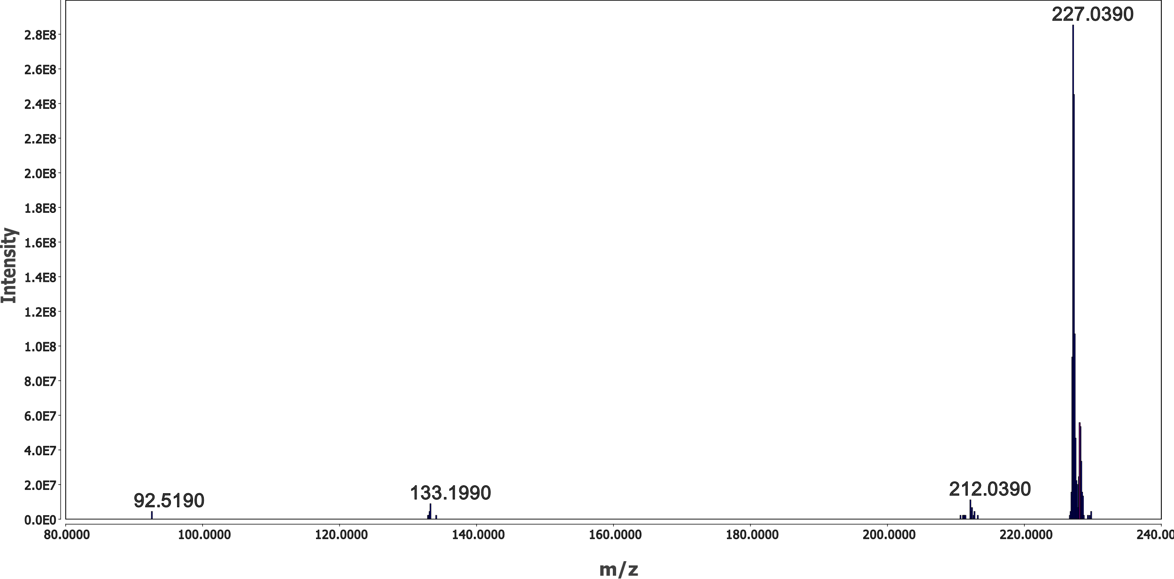
Fig. SM- 2 Extracted MS/MS spectrum of BPA.

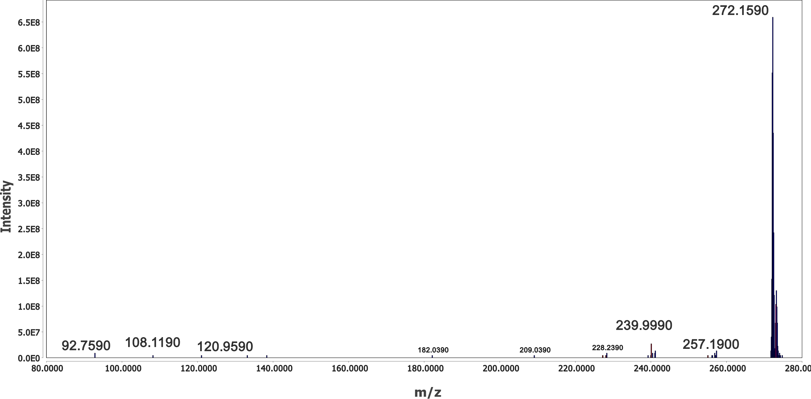
Fig. SM- 3 Extracted MS/MS spectrum of BPA-273.
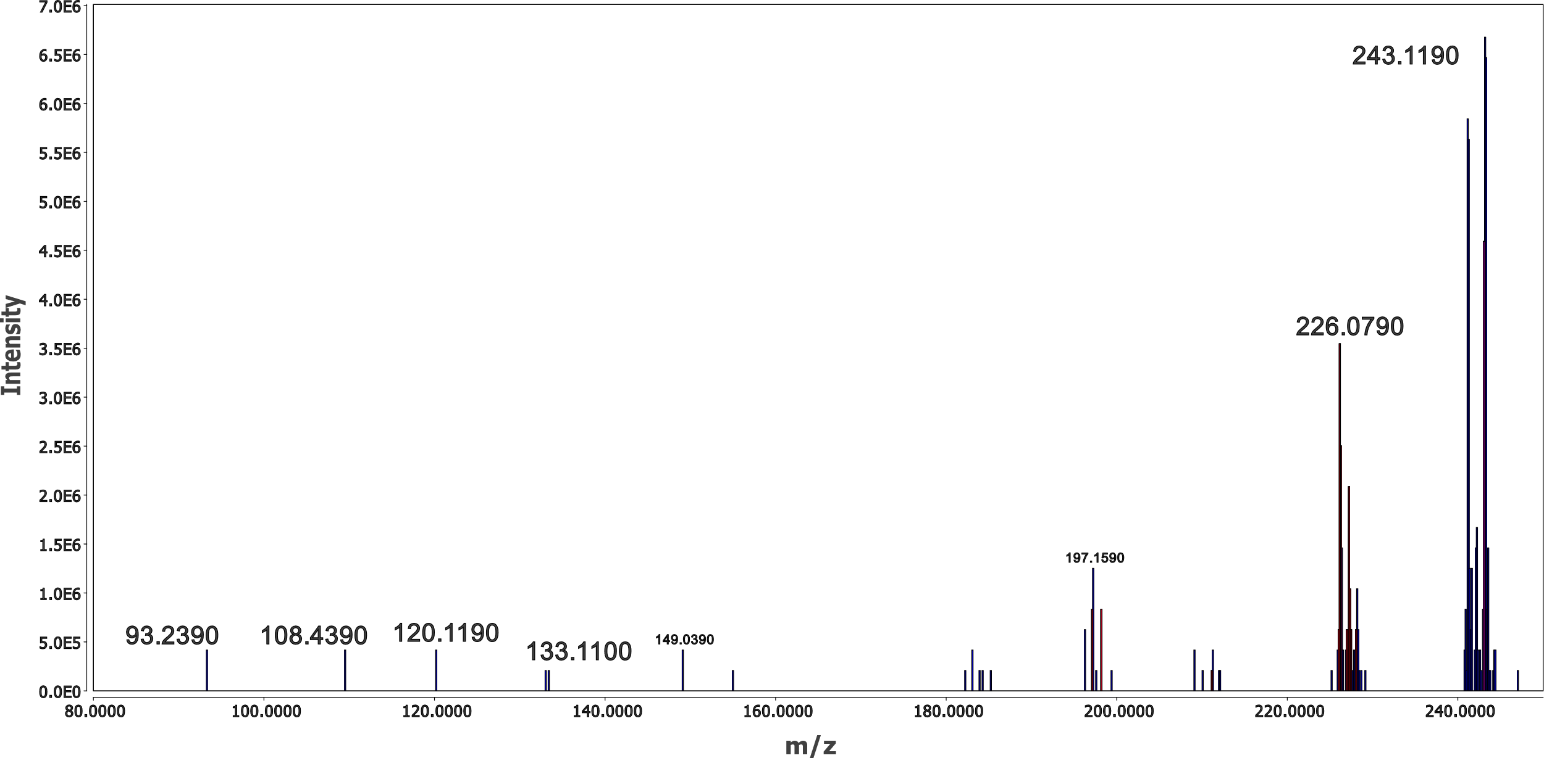
Fig. SM- 4 Extracted MS/MS spectrum of BPA-243.

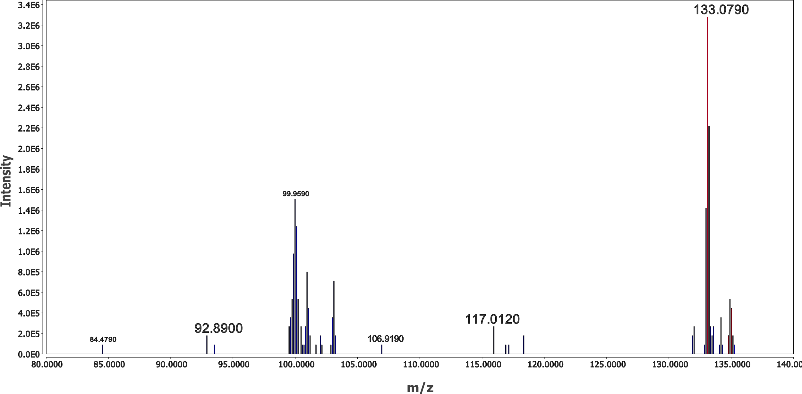
Fig. SM- 5 Extracted MS/MS spectrum of BPA-133.
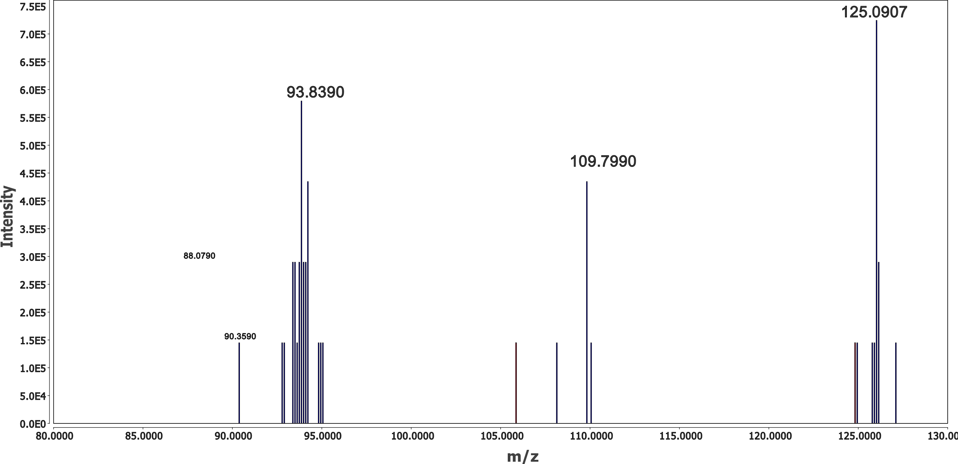
Fig. SM- 6 Extracted MS/MS spectrum of BPA-125.
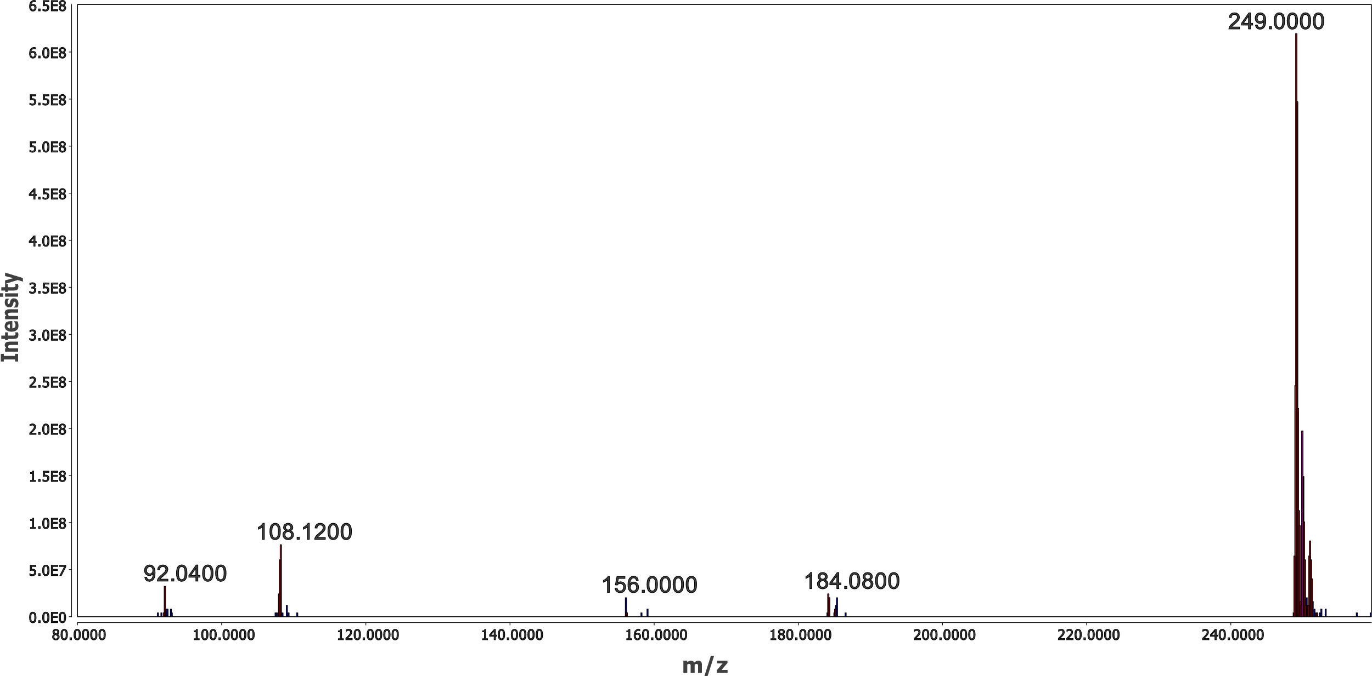
Fig. SM- 7 Extracted MS/MS spectrum of BPS.
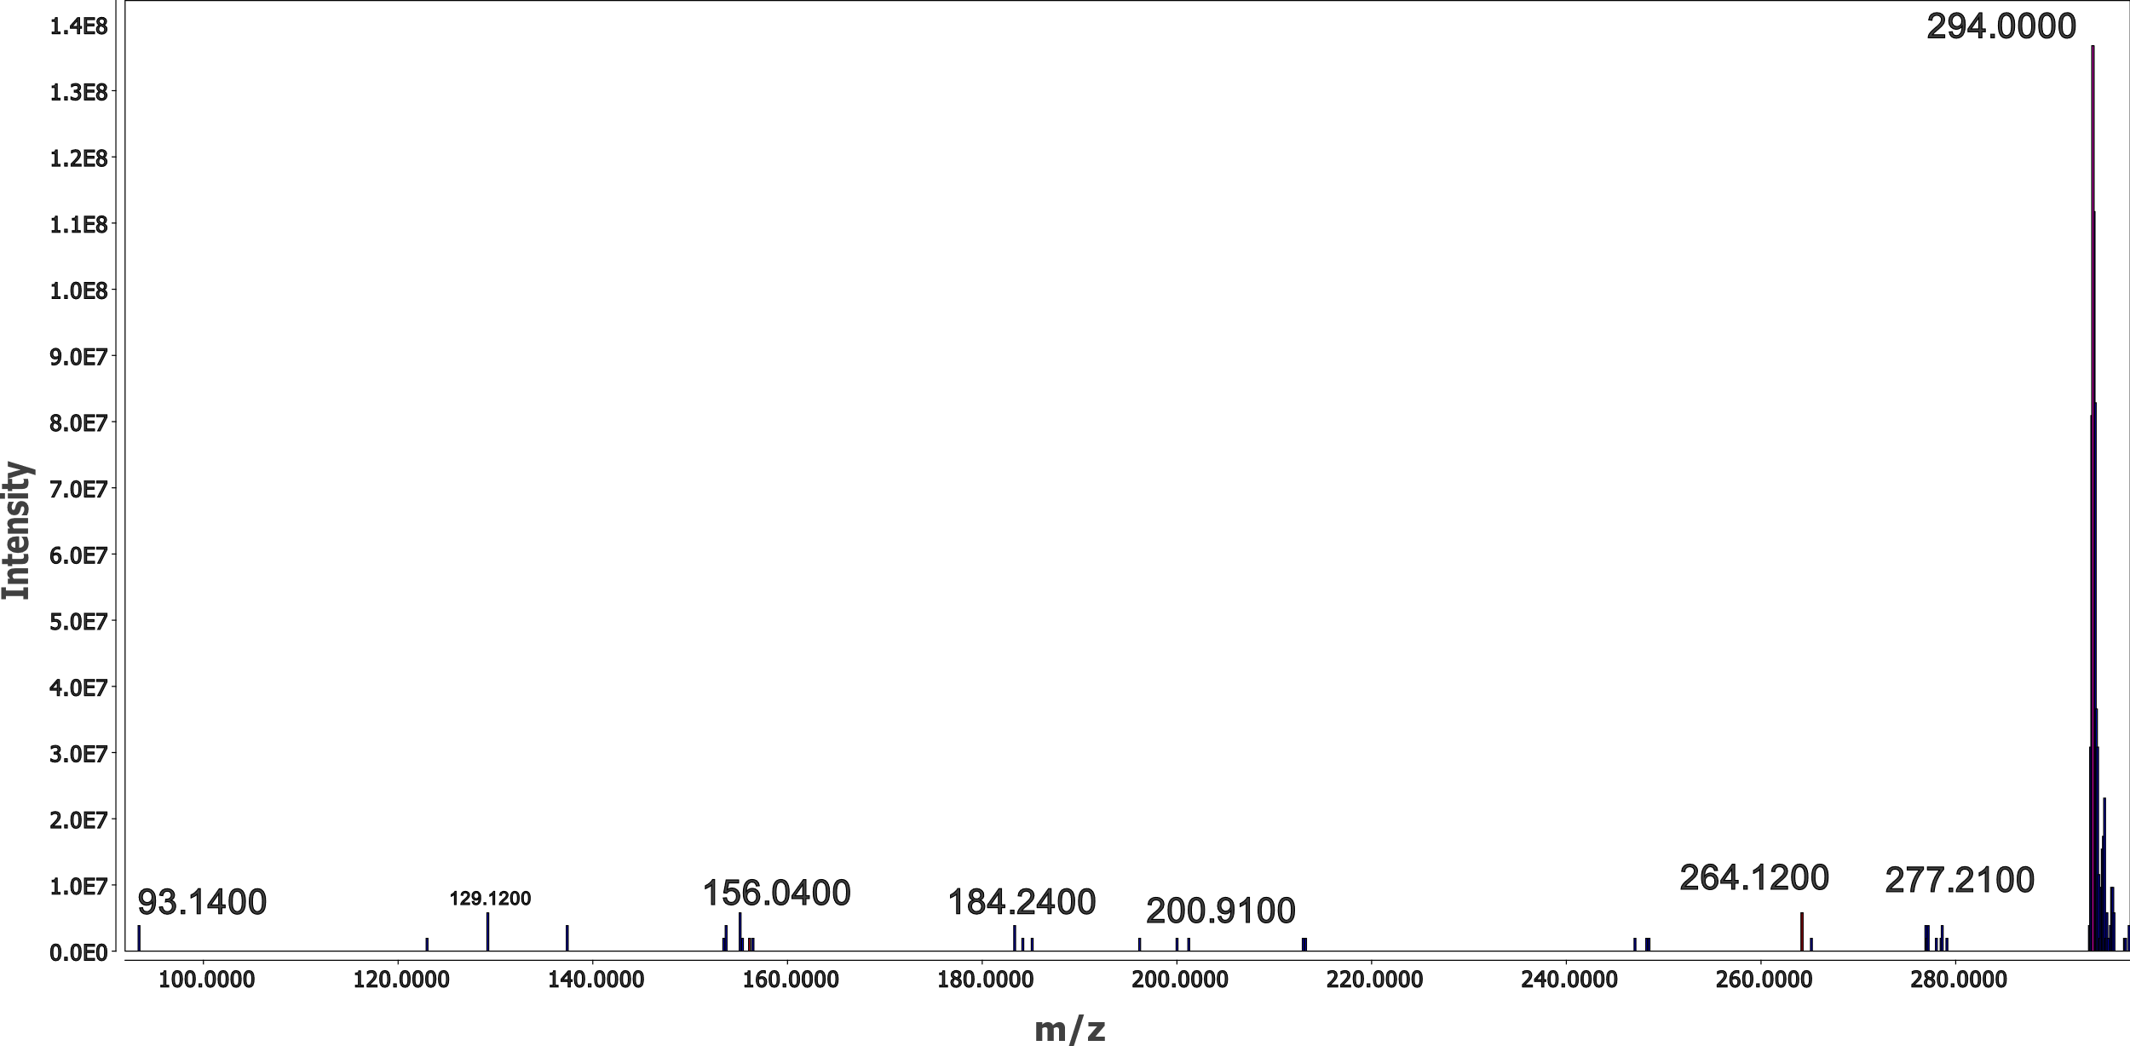
Fig. SM- 8 Extracted MS/MS spectrum of BPS-293.

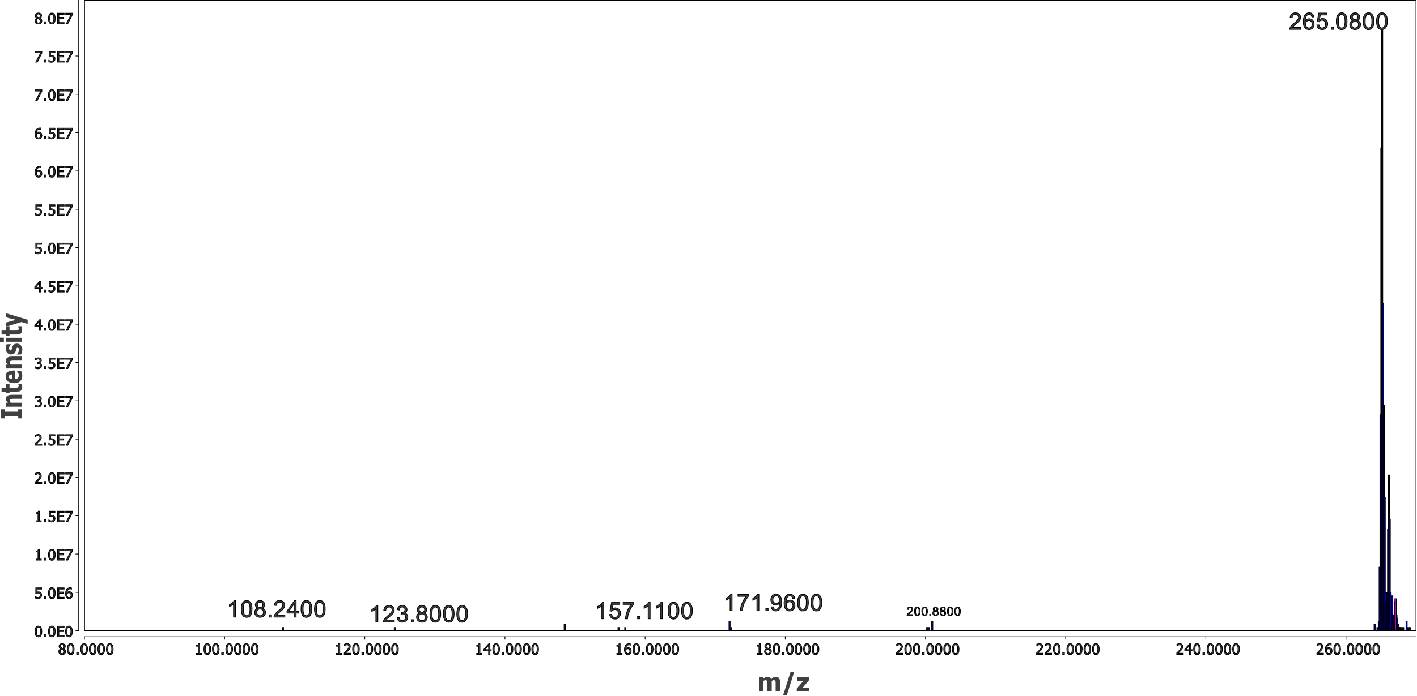
Fig. SM- 9 Extracted MS/MS spectrum of BPS-265.

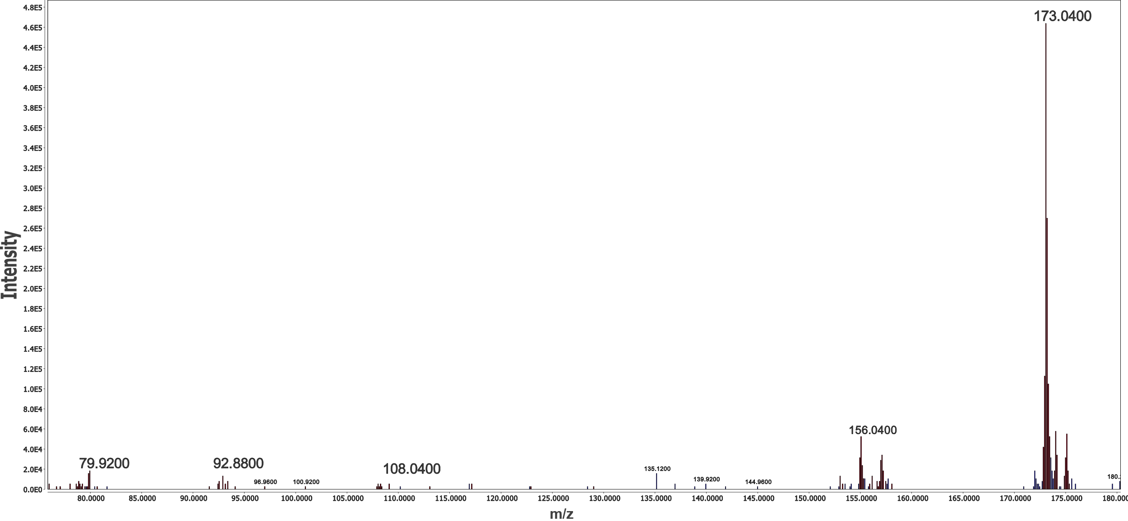
Fig. SM- 10 Extracted MS/MS spectrum of BPS-173.

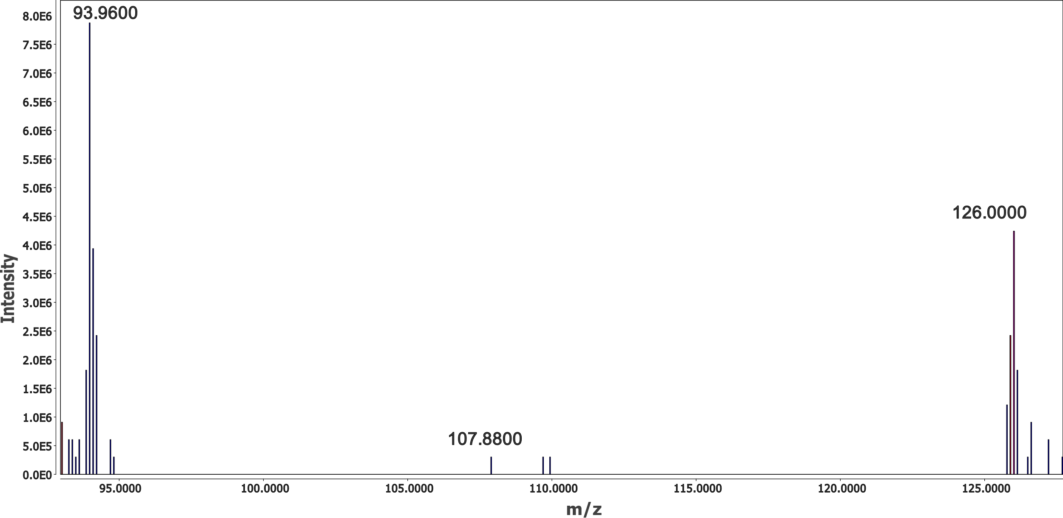
Fig. SM- 11 Extracted MS/MS spectrum of BPS-125.

