Table 2. Summary of the identified TPs, the possible parent compound, RT [min], diagnostic and theoretical [M-H]⁻ and proposed formula for the precursor and product ion mass.
Parent compound | Comp. ID | RT  [min] | Measured mass [M-H]⁻ | Theoretical mass [M-H]⁻ | Elemental formula | Diagnostic product ion mass | Theoretical product ion mass | Elemental composition of product ions | Proposed tentative structure
BPA | BPA | 14.25 | 227.04 | 227.1078 | C₁₅H₁₆O₂ | 92.5;  133.2;  212.0; | 93.0346;  133.0659;  211.1128 | C₆H₅O⁻  C₉H₉O⁻  C₁₅H₁₅O⁻ | 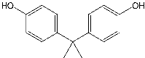
BPA | BPA-272 | 15.27 | 272.2 | 271.0976 | C₁₆H₁₆O₄ [M+CO₂]⁻ | 92.8;  108.0;  121.0;  240.1;  257.2 | 93.0346;  108.0217;  121.0290;  241.1234;  257.0819 | C₆H₅O⁻  C₇H₅O⁻  C₇H₅O₂⁻  C₁₅H₁₅O₂⁻  C₁₅H₁₅O₄⁻ | 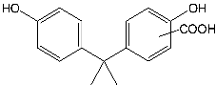
BPA | BPA-243 | 13.58 | 243.1 | 243.1027 | C₁₅H₁₆O₃  [M+OH]⁻ | 93.2;  108.4;  120.1;  133.1;  212.2;  226.1 | 93.0346;  108.0217;  121.0290;  133.0659;  211.1128;  227.1078 | C₆H₅O⁻  C₇H₅O⁻  C₇H₅O₂⁻  C₉H₉O⁻  C₁₅H₁₅O⁻  C₁₅H₁₅O₂- | 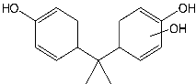
BPA | BPA-133 | 10.29 | 133.1 | 133.0659 | C₉H₁₀O | 92.9;  117.0 | 93.0346;  117.0704 | C₆H₅O⁻  C₉H₁₀⁻ | 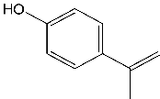
BPA | BPA-125 | 1.59 | 125.1 | 125.0244 | C6H6O3 | 93.8;  107.0; | 93.0346;  108.0217; | C₆H₅O⁻  C₆H₄O₂⁻ | 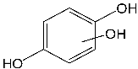
BPS | BPS | 11.34 | 249.0 | 249.0229 | C₁₂H₁₀O₄S | 92.0;  108.1;  156.0;  184.1 | 92.0262;  108.0217;  155.9887;  185.9992; | C₆H₄O^{•-}  C₆H₄O₂⁻  C₆H₅O₃S⁻  C₆H₄O₄S⁻ | 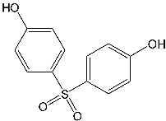
BPS | BPS-293 | 9.85 | 294.0 | 293.0123 | C₁₃H₁₀O₆S [M+CO₂]⁻ | 93.0;  156.0;  184.2;  264.1;  277.2 | 93.0346;  156.9965;  185.9992;  264.0098;  277.0176 | C₆H₅O⁻  C₆H₅O₃S⁻  C₆H₄O₄S⁻  C₁₂H₁₁O₂⁻  [M-CO]⁻ | 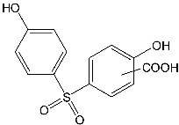
BPS | BPS-265 | 10.30 | 265.1 | 265.0176 | C₁₂H₁₀O₅S  [M+OH]⁻ | 108.2;  123.8;  157.1;  172.0 | 108.0217;  123.0088;  156.9965;  171.9836 | C₆H₄O₂⁻  C₆H₃O₃⁻  C₆H₅O₃S⁻  C₆H₄O₄S⁻ | 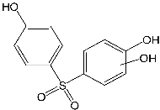
BPS | BPS-173 | 2.0 | 173.0 | 172.9914 | C₆H₆O₄S | 79.9;  92.9;  108.0;  156.0 | 79.9574;  93.0346;  108.0217;  156.9965 | SO₃⁻  C₆H₅O⁻  C₆H₅O₂⁻  C₆H₅O₃S⁻
BPS | BPS-125 | 1.6 | 126.0 | 125.0244 | C₆H₆O₃ | 93.9;  107.9 | 93.0346;  108.0217; | C₆H₅O⁻  C₆H₄O₂⁻ | 