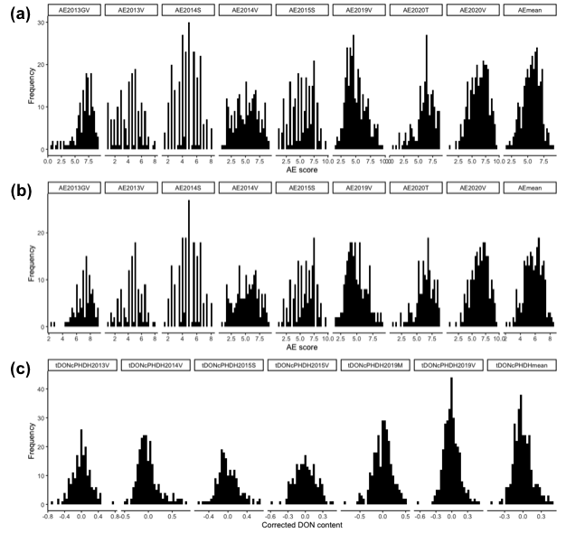

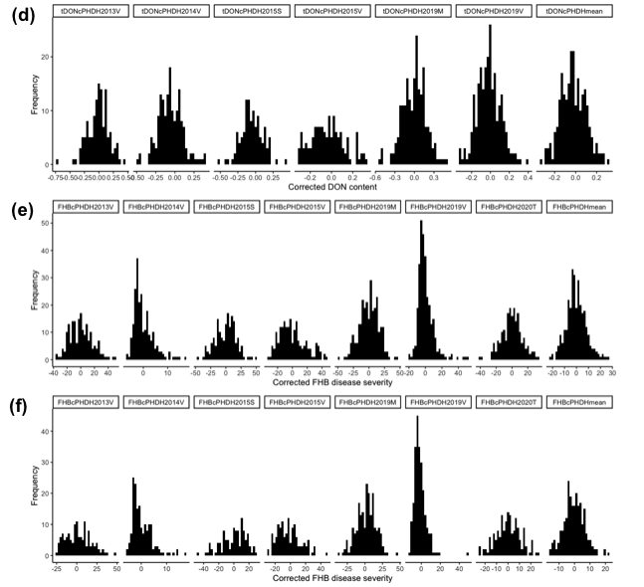

Supplementary figure 1: Histograms of distributions of (a) complete panel, (b) European panel for AE, (c) complete panel, (d) European panel for DONcPHDH and (e) complete panel, (f) European panel for FHBcPHDH for all tested years and across year means.

Supplementary figure 2: Principal Component Analysis showing the correlations among the traits AE, DONcPHDH and FHBcPHDH in different tested environments (years) and across-year means of respective traits.

Supplementary figure 3: Chromosome locations of quantitative trait loci (QTL) for FHB resistance that were detected in one or more environments. The positions of marker loci in Mega base pairs (Mbp) are shown along the left side of the linkage groups. Markers are shown on the right of the linkage groups. The most consistently significant detected markers for each QTL region are highlighted in both italics and blue colour.

(a)

(b)

(c)

(d)

(e)

(f)

Supplementary figure 4: Manhattan plots of traits AE (a and d), FHBcPHDH (b and e), and DONcPHDH (c and f) in complete panel and European panel respectively for 35K, red line represents significant threshold (-log10p = 3.0) and blue dotted line is FDR @ 0.05% based on across environment means.
(a)
(b)

(c)

(d) (e)

(f)

Supplementary figure 5: Manhattan plots of traits AE (a and d), FHBcPHDH (b and e), and DONcPHDH (c and f) in complete panel and European panel respectively for 25K, red line represents significant threshold (-log10p = 3.0) and blue dotted line is FDR @ 0.05% based on across environment means.

(a)

(b)

(c)

(d)

(e)

(f)

Supplementary figure 6: QQ-plots of traits AE (a and d), FHBcPHDH (b and e), and DONcPHDH (c and f) in complete panel and European panel respectively for 35K, red line represents significant threshold (-log10p = 3.0) and blue dotted line is FDR @ 0.05% based on across environment means.

(a)

(b)

(c)

(d)

(e)

(f)

Supplementary figure 7: QQ-plots of traits AE (a and d), FHBcPHDH (b and e), and DONcPHDH (c and f) in complete panel and European panel respectively for 35K, red line represents significant threshold (-log10p = 3.0) and blue dotted line is FDR @ 0.05% based on across environment means

Supplementary figure 8: Boxplot showing the haplotype effect of QTL Qfhb.nmbu.1A.1 on chromosome 1A based on the a) mean AE, b) mean corrected DON content, c) mean corrected FHB disease severity of complete panel, and d) mean AE, e) mean corrected DON content, f) mean corrected FHB disease severity of European panel. Wilcoxon method is used for pair-wise comparisons (***P < 0.0001, **P < 0.001, *P < 0.05, ns > 0.05). Comparisons with ns are not shown in this figure.

Supplementary figure 9: Boxplot showing the haplotype effect of QTL Qfhb.nmbu.3A.1 on chromosome 3A based on the a) mean AE, b) mean corrected DON content, c) mean corrected FHB disease severity of complete panel, and d) mean AE, e) mean corrected DON content, f) mean corrected FHB disease severity of European panel. Wilcoxon method is used for pair-wise comparisons (***P < 0.0001, **P < 0.001, *P < 0.05, ns > 0.05). Comparisons with ns are not shown in this figure.

Supplementary figure 10: Boxplot showing the haplotype effect of QTL Qfhb.nmbu.4B.1 on chromosome 4B based on the a) mean AE, b) mean corrected DON content, c) mean corrected FHB disease severity of complete panel, and d) mean AE, e) mean corrected DON content, f) mean corrected FHB disease severity of European panel. Wilcoxon method is used for pair-wise comparisons (***P < 0.0001, **P < 0.001, *P < 0.05, ns > 0.05). Comparisons with ns are not shown in this figure.

Supplementary figure 11: Boxplot showing the haplotype effect of QTL Qfhb.nmbu.5A.1 on chromosome 5A based on the a) mean AE, b) mean corrected DON content, c) mean corrected FHB disease severity of complete panel, and d) mean AE, e) mean corrected DON content, f) mean corrected FHB disease severity of European panel. Wilcoxon method is used for pair-wise comparisons (***P < 0.0001, **P < 0.001, *P < 0.05, ns > 0.05). Comparisons with ns are not shown in this figure.

Supplementary figure 12: Boxplot showing the haplotype effect of QTL Qfhb.nmbu.6A.1 on chromosome 6A based on the a) mean AE, b) mean corrected DON content, c) mean corrected FHB disease severity of complete panel, and d) mean AE, e) mean corrected DON content, f) mean corrected FHB disease severity of European panel. Wilcoxon method is used for pair-wise comparisons (***P < 0.0001, **P < 0.001, *P < 0.05, ns > 0.05). Comparisons with ns are not shown in this figure.

Supplementary figure 13: Boxplot showing the haplotype effect of QTL Qfhb.nmbu.7A.2 on chromosome 7A with KASP markers based on the a) mean AE, b) mean corrected DON content, c) mean corrected FHB disease severity of complete panel, and d) mean AE, e) mean corrected DON content, f) mean corrected FHB disease severity of European panel. Wilcoxon method is used for pair-wise comparisons (***P < 0.0001, **P < 0.001, *P < 0.05, ns > 0.05). Comparisons with ns are not shown in this figure.

A | B | C
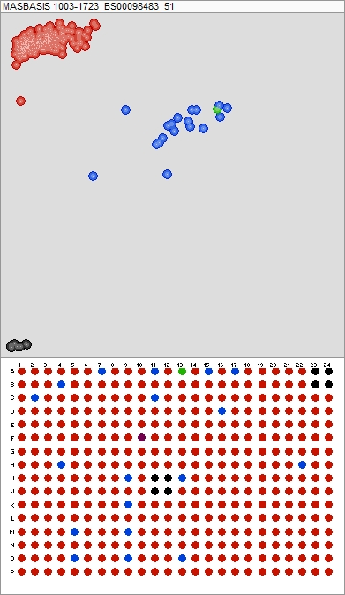 | 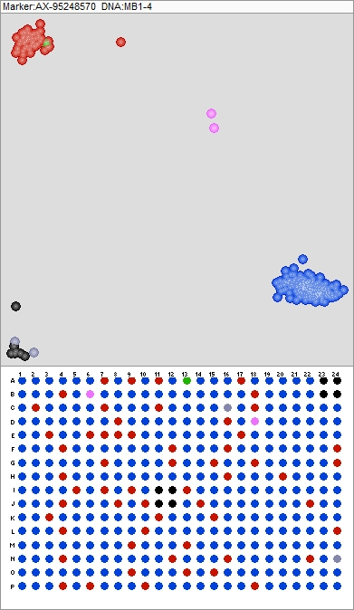 | 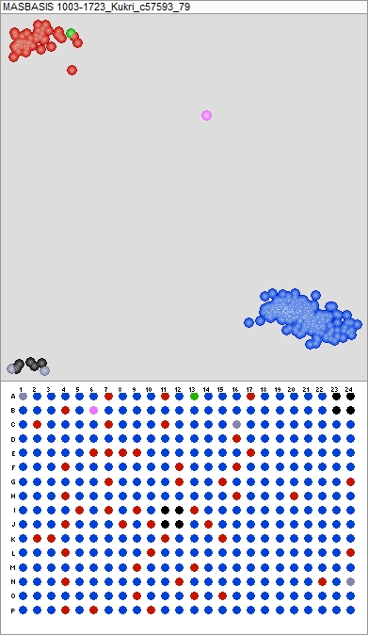
Supplementary figure 14: Cluster plots for the three KASP markers used for genotyping the NMBU spring wheat panel: a) BS00098483_51, b) AX-95248570, and c) Kukri_c57593_79. Genotype calls for allele one (FAM) and two (HEX) are indicated in blue and red, respectively. Heterozygous scores are shown in pink and negative controls in black. The source of the resistant allele of Qfhb.nmbu.7A.2, Ning8343, for is shown in green.

