Supplementary information (SI)
Bioengineered and bio-compatible silver nanoparticles from Thalictrum foliolosum DC and their biomedical applications

Sandip Kumar Chandraker¹, Mishri Lal¹, Preeti Dhruve², Amit Kumar Yadav¹,Rana P Singh², Rajender S. Varma³, Ravindra Shukla^{1*}

Contents
Table 1. FT-IR analysis: Probable functional groups TFLE and TF@AgNPs.
Fig. 1 Zeta particle size (a), and potential of bioengineered TF@AgNPs (b).
Table 2. Comparison of various AgNPs deployed as a sensor for the detection of H₂O₂.

Table 1. FT-IR analysis: Probable functional groups TFLE and TF@AgNPs.
TF-AgNPs wavenumbers | Probable function groups | TFLE wavenumbers | Probable function groups
668.0920 | Aromatic-H bending | 667.6488 | Aromatic-H bending
1006.6158 | O-C stretching | 922.4402 | C=C-H bending
1204.4297 | C-O stretch | 1213.1371 | C-O stretch
1355.2543 | O-H bend | 1715.6633 | C=O stretching
1534.1001 | N-H bend | 2361.8458 | C-H stretching
2361.2468 | C-H stretching | 2914.5658 | N⁺-H stretch

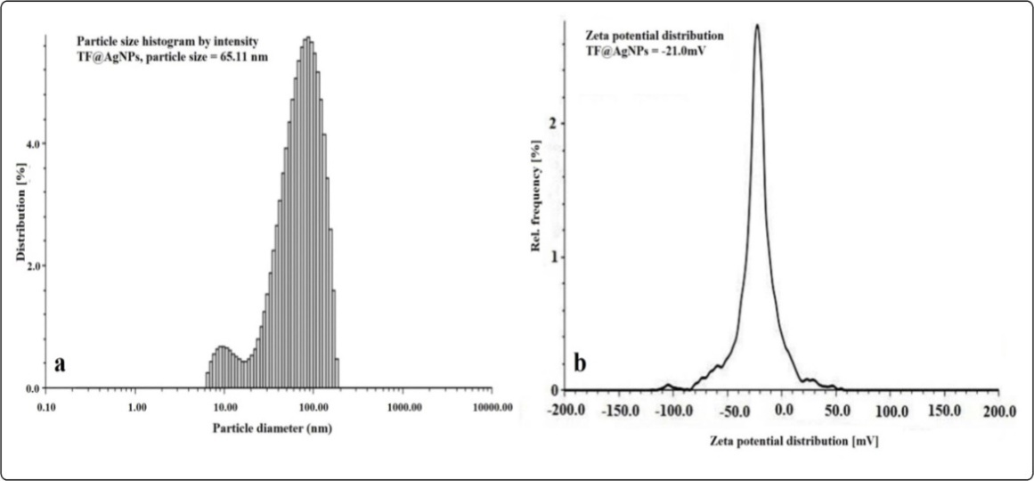
Fig. 1 Zeta particle size (a), and potential of bioengineered TF@AgNPs (b).
Table 2. Comparison of various AgNPs deployed as a sensor for the detection of H₂O₂.
S. No. | NPs | Plants | Part use | Sensing time | References
1. | Silver | Euphorbia hirta | Leaf | 25 min. | Kumar et al. (2016)
2. | Silver | Acacia | lignin | -- | Aadil et al. (2016)
3. | Silver | Acacia | Gum | 120 min | Alzahrani (2017)
4. | Silver | Atalantiamonophylla(L) Correa | Leaf | 25 min. | Mahadevan et al. (2017)
4. | Silver | Mangifera indica | Leaf | -- | Subramanian et al. (2017)
6. | Silver | Lithodorahispidula(Sm.) Griseb | Leaf | -- | Turunc et al. (2017)
7. | Silver | Lavender | Leaf | 30 min. | Kumar et al. (2016)
8. | Silver | Calliandrahaematocephala | Leaf | 20 min. | Raja et al. (2017)
9. | Silver | Wheat straw | Lignin | 15 min. | Saratale et al. (2019)
10. | Silver | Justicia adhatoda | Leaf | 15 min. | Chandraker et al. (2021)
11. | Silver | Thalictrum foliolosum DC. | Leaf | 21 min. | Present work

References
Aadil KR, Barapatre A, Meena AS, Jha H (2016) Hydrogen peroxide sensing and cytotoxicity activity of Acacia lignin stabilized silver nanoparticles. Int J Biol Macromol 82:39-47. https://doi.org/10.1016/j.ijbiomac.2015.09.072
Alzahrani E (2017) Colorimetric detection based on localised surface plasmon resonance optical characteristics for the detection of hydrogen peroxide using acacia gum–stabilised silver nanoparticles. Anal Chem Insights 12: 1177390116684686. https://doi.org/10.1177/1177390116684686
Chandraker SK, Lal M, Kumar A, Shukla R (2021) Justicia adhatoda L. mediated green synthesis of silver nanoparticles and assessment of their antioxidant, hydrogen peroxide sensing and optical properties. Mater Technol 1-11. https://doi.org/10.1080/10667857.2021.1949525
Kumar B, Smita K, Cumbal L (2016) Biosynthesis of silver nanoparticles using lavender leaf and their applications for catalytic, sensing, and antioxidant activities. Nanotechnol Rev 5(6):521-28. https://doi.org/10.1515/ntrev-2016-0041
Kumar V, Gundampati, RK, Singh DK, Bano D, Jagannadham MV, Hasan SH (2016) Photoinduced green synthesis of silver nanoparticles with highly effective antibacterial and hydrogen peroxide sensing properties. J Photochem Photobiol B 162:374-85. https://doi.org/10.1016/j.jphotobiol.2016.06.037
Mahadevan S, Vijayakumar S, Arulmozhi P (2017) Green synthesis of silver nano particles from Atalantia monophylla (L) Correa leaf extract, their antimicrobial activity and sensing capability of H₂O₂. Microb Pathogenesis 113:445-50. https://doi.org/10.1016/j.micpath.2017.11.029
Raja S, Ramesh V, Thivaharan V (2017) Green biosynthesis of silver nanoparticles using Calliandra haematocephala leaf extract, their antibacterial activity and hydrogen peroxide sensing capability. Arabian J Chem 10(2):253-61. https://doi.org/10.1016/j.arabjc.2015.06.023
Saratale RG, Saratale GD, Ghodake G, Cho SK, Kadam A, Kumar G, Jeon BH, Pant D, Bhatnagar A, Shin HS (2019) Wheat straw extracted lignin in silver nanoparticles synthesis: Expanding its prophecy towards antineoplastic potency and hydrogen peroxide sensing ability. Int J Biol Macromol 128:391-400. https://doi.org/10.1016/j.ijbiomac.2019.01.120
Subramanian L, Sabu T, Obey K (2017) Green synthesis of silver nanoparticles using aqueous plant extracts and its application as optical sensor. Int J Biosen Bioelectron 2 (3):82-85. DOI: 10.15406/ijbsbe.2017.02.00022
Turunc E, Binzet R, Gumus I, Binzet G, Arslan H (2017) Green synthesis of silver and palladium nanoparticles using Lithodora hispidula (Sm.) Griseb.(Boraginaceae) and application to the electrocatalytic reduction of hydrogen peroxide. Mater Chem Phys 202:310-19. https://doi.org/10.1016/j.matchemphys.2017.09.032

