Application of nanomagnetic NH₂.MIL-101(Fe)/ED as a retrievable and efficient catalyst for the synthesis of 2,6-diamino-4-Aryl-4H-Thiopyran- 3,5- dicarbonitrile derivatives
F. Matloubi Moghaddam*, Bagher Aghamiri, Aida Yazdani Motlagh and Atefeh Jarahiyan

Laboratory of Organic Synthesis and Natural Products, Department of Chemistry, Sharif University of Technology, Azadi Street, PO BOX 111559516, Tehran, Iran
*E-mail Address: matloubi@sharif.edu

Table of Contents
1. General remarks | Page 2
2. Experimental Procedure | Page 2
3. Characterization Data of Products | Page 3
4. ¹H NMR, ¹³C NMR Spectra of Products 5a-5o. | Page 8
5. Figures | Page 23

1. General remarks.

All solvents and starting materials were purchased from Merck and Sigma-Aldrich used without any additional purification. Analytical TLC was carried out using Merck 0.2 mm silica gel 60 F-254 Al-plates. ¹H NMR and ¹³C NMR spectra were recorded on a Bruker Avance DRX-500 machine using DMSO-d₆ and CDCl₃ as solvent and TMS as an internal standard at room temperature (DMSO-d₆ ¹HNMR: δ (ppm) =2.50 ppm ; CDCl₃ ¹HNMR: δ (ppm) =7.26 and ¹³C-NMR: δ (ppm) =77.00 ppm). Chemical shifts were reported in ppm scale. FT-IR spectra of samples were obtained on ABB Bomem MB100 spectrometer with potassium bromide (KBr) pellets. Melting points were determined using an Electrothermal 9100 apparatus and are uncorrected. The XRD patterns were accomplished on a PANalytical diffractometer with a copper target at 60 kV and 40 mA and Cu Kα (λ = 1.54 Å) for 2θ in the range of 0–80°. TGA results were investigated by taking on a STA504 TA instrument in the temperature range from room temperature to 800 °C heating rate of 20 °C min at nitrogen atmosphere. FE-SEM and TEM data were obtained on TESCAN–Mira III at 15 KV and Philips CM 120, 100 kV, respectively. The BET result was recorded with BELSORP – mini II.

2. Experimental Procedure.
To a solution of primary amines (1mmol) in DCM (1ml), Carbon disulfide (1mmol) was added and stirred at room temperature for 5 min. Then malononitrile (1.2mmol), and benzylidene malononitrile (1.2mmol) were added to previous mixture in the presence of magnetic NH₂.MIL-101(Fe)/ED (5mg) and stirred for more 30 min to afford the corresponding products (5a-5o) in high yield. To purify the product, the catalyst was separated from the mixture with the aid of an external magnet. The residue was filtered off and the precipitate was washed with chloroform. Then, to get rid of the remnants of impurities, the precipitate was poured into a beaker and a little amount of ethanol (less than 0.5 cc) was added to it. Then a little amount of water (0.5 cc) was added to the beaker until the organic product separated from ethanol as a solid precipitate. After final filtration, the pure products 5a-5o were dried in air and directly characterized by ¹H NMR, ¹³C NMR, FT-IR, CHN, X-ray crystallographic, and melting point analysis.

3. Characterization Data of Products

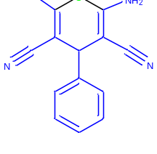
2,6-diamino-4-phenyl-4H-thiopyran-3,5-dicarbonitrile (5a)
White solid; yield 95 %; m.p. 186-188 °C; ¹H NMR (500 MHz, DMSO-d₆) δ 4.26 (1H, s), 6.87 (4H, s), 7.25 (3H, q, J = 7.0 Hz), 7.35 (2H, t, J = 7.5 Hz) ppm; ¹³C NMR (125 MHz, DMSO-d₆) δ 43.9, 72.6, 119.0, 127.2, 127.6, 129.2, 144.0, 151.7 ppm; IR (KBr) ν= 3433, 3395, 3316, 3197, 2183, 1634 cm⁻¹ .
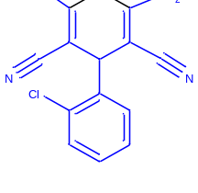
2,6-diamino-4-(2-chlorophenyl)-4H-thiopyran-3,5-dicarbonitrile (5b)
White solid; yield 90 %; m.p. 170-172 °C; ¹H NMR (500 MHz, DMSO-d₆) δ 4.79 (1H, s), 6.98 (4H, s), 7.28 (1H, t, J = 7.5 Hz), 7.36 (2H, quint, J = 5.5 Hz), 7.42 (1H, t, J = 7.5 Hz) ppm; ¹³C NMR (125 MHz, DMSO-d₆) δ 71.4, 118.8, 128.5, 129.5, 130.1, 130.2, 132.1, 141.3, 151.8 ppm ; IR (KBr) ν= 3436, 3405, 3321, 3203, 2182, 1629 cm⁻¹ .

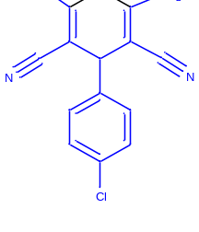
2,6-diamino-4-(4-chlorophenyl)-4H-thiopyran-3,5-dicarbonitrile (5c)

White solid; yield 93 %; m.p. 186-188 °C; ¹H NMR (500 MHz, DMSO-d₆) δ 4.31 (1H, s), 6.96 (4H, s), 7.25(2H, d, J = 10.0 Hz), 7.42 (2H, d, J = 10.0 Hz) ppm; ¹³C NMR (125 MHz, DMSO-d₆) δ 43.2, 72.2, 100.0, 119.1, 129.2, 142.9, 151.9 ppm ; IR (KBr) ν= 3431, 3390, 3319, 3194, 1633, 1588 cm⁻¹ .
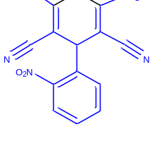
2,6-diamino-4-(2-nitrophenyl)-4H-thiopyran-3,5-dicarbonitrile (5d)
Yellow solid; yield 85 %; m.p. 172-174 °C; ¹H NMR (500 MHz, DMSO-d₆) δ 4.99 (1H, s), 7.09 (4H, s), 7.56 (2H, t, J = 10.0 Hz), 7.74 (1H, t, J = 10.0 Hz), 7.89 (1H, d, J = 10.0 Hz) ppm; ¹³C NMR (125 MHz, DMSO-d₆) δ 38.3, 71.0, 100.0, 118.6, 124.8, 129.4, 130.4, 134.3, 152.2 ppm; IR (KBr) ν= 3437, 3414, 3306, 3201, 2178,1627 cm⁻¹ .

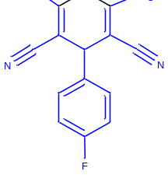
2,6-diamino-4-(4-fluorophenyl)-4H-thiopyran-3,5-dicarbonitrile (5e)
White solid; yield 90 %; m.p. 176-178 °C; ¹H NMR (500 MHz, DMSO-d₆) δ 4.30(1H, s), 6.84 (4H, s), 7.16 (2H, t, J = 9.0 Hz), 7.27 (1H, m) ppm; ¹³C NMR (125 MHz, DMSO-d₆) δ 43.0, 72.5, 115.9, 119.2, 129.0, 129.1, 140.2, 151.7 ppm; IR (KBr) ν= 3438, 3325, 3211, 2184, 1632 cm⁻¹ .

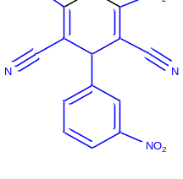
2,6-diamino-4-(3-nitrophenyl)-4H-thiopyran-3,5-dicarbonitrile (5f)

Yellow solid; yield 85 %; m.p. 214-216 °C; ¹H NMR (500 MHz, DMSO-d₆) δ 4.57(1H, s), 7.04 (4H, s), 7.70 (2H, m), 8.07 (1H, s), 8.14 (1H, d, J = 5.0 Hz) ppm; ¹³C NMR (125 MHz, DMSO-d₆) δ 43.0, 71.5, 119.0, 121.5, 122.8, 131.0, 134.0, 146.2, 148.5, 152.5; IR (KBr) ν= 3437, 3420, 3330, 3211, 3084, 2187, 1625.

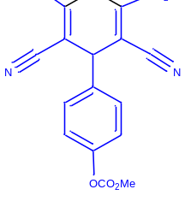
4-(2,6-diamino-3,5-dicyano-4H-thiopyran-4-yl)phenyl methyl carbonate (5g)
White solid; yield 82 %; m.p. 208-210 °C; ¹H NMR (500 MHz, DMSO-d₆) δ 3.83(3H, s) 4.40(1H, s), 7.02 (4H, s), 7.38 (2H, d, J = 10.0 Hz), 7.95(2H, d, J = 10.0 Hz) ppm; ¹³C NMR (125 MHz, DMSO-d₆) δ 43.6, 52.6, 71.82, 100.0, 119.1, 127.6, 130.3, 149.2, 152.1, 166.5; IR (KBr) ν= 3437, 3378, 3319, 3211, 2187, 1645.

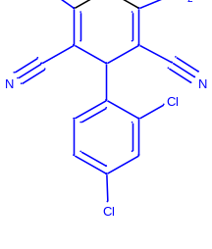
2,6-diamino-4-(2,4-dichlorophenyl)-4H-thiopyran-3,5-dicarbonitrile (5h)
White solid; yield 90 %; m.p. 210-212 °C; ¹H NMR (500 MHz, DMSO-d₆) δ 4.77 (1H, s), 7.00 (4H, s), 7.37 (2H, d, J = 5.0 Hz), 7.58 (1H, s) ppm; ¹³C NMR (125 MHz, DMSO-d₆) δ 70.9, 118.6, 128.7, 129.5, 131.7, 133.2, 140.3, 152.0; IR (KBr) ν= 3409, 3313, 3207, 2190, 1633 cm⁻¹.

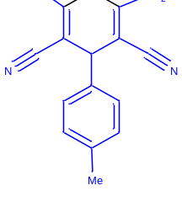
2,6-diamino-4-(p-tolyl)-4H-thiopyran-3,5-dicarbonitrile (5i)
White solid; yield 92 %; m.p. 184-186 °C; ¹H NMR (500 MHz, DMSO-d₆) δ 2.26 (3H, s), 4.19 (1H, s), 6.83 (4H, s), 7.17-7.03 (4H, m) ppm; ¹³C NMR (125 MHz, DMSO-d₆) δ 21.1, 43.6, 73.0, 119.3, 127.0, 129.8, 137.0, 140.9, 151.5; IR (KBr) ν= 3429, 3333, 3200, 2185, 1626 cm⁻¹.
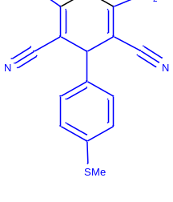
2,6-diamino-4-(4-(methylthio)phenyl)-4H-thiopyran-3,5-dicarbonitrile (5j)
White solid; yield 87 %; m.p. 174-176 °C; ¹H NMR (500 MHz, DMSO-d₆) δ 2.46 (3H, s), 4.24(1H, s), 6.94 (4H, s), 7.17 (2H, d, J = 10.0 Hz ), 7.25 (2H, d, J = 10.0 Hz) ppm; ¹³C NMR (125 MHz, DMSO-d₆) δ 15.4, 43.4, 72.5, 100.0, 119.3, 126.9, 127.8, 137.3, 140.7, 151.6; IR (KBr) ν= 3432, 3390, 3315, 3197, 2186, 1631 cm⁻¹.
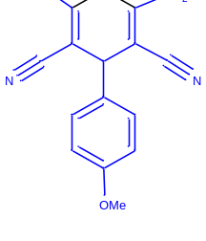
2,6-diamino-4-(4-methoxyphenyl)-4H-thiopyran-3,5-dicarbonitrile (5k)
Yellow solid; yield 85 %; m.p. 144-146 °C; ¹H NMR (500 MHz, DMSO-d₆) δ 3.74 (3H, s), 4.20 (1H, s), 6.88 (4H, s), 6.91 (2H, d, J = 10.0 Hz), 7.15 (2H, d, J = 10.0 Hz) ppm; ¹³C NMR (125 MHz, DMSO-d₆) δ 43.1, 55.6, 72.9, 114.5, 119.3, 128.2, 136.0, 151.3, 158.8; IR (KBr) ν= 3423, 3385, 3311, 3194, 2180, 1634 cm⁻¹ .
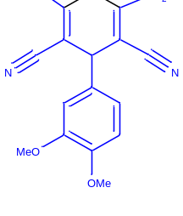
2,6-diamino-4-(3,4-dimethoxyphenyl)-4H-thiopyran-3,5-dicarbonitrile (5l)
Yellow solid; yield 81 %; m.p. 196-198 °C; ¹H NMR (500 MHz, DMSO-d₆) δ 3.73 (3H, s), 3.74 (3H, s), 4.21 (1H, s), 6.75 (1H, d, J = 10.0 Hz), 6.82 (1H, s), 6.88 (4H, s), 6.92 (1H, d, J = 10.0 Hz) ppm; ¹³C NMR (125 MHz, DMSO-d₆) δ 43.4, 55.9, 56.0, 72.8, 111.0, 112.4, 119.1, 119.3, 136.4, 148.4, 149.2, 151.3; IR (KBr) ν= 3450, 3395, 3313, 3184, 2170, 1600 cm⁻¹ .

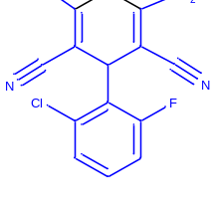
2,6-diamino-4-(2-chloro-6-fluorophenyl)-4H-thiopyran-3,5-dicarbonitrile (5m)
Yellow solid; yield 75 %; m.p. 170-172 °C; ¹H NMR (500 MHz, DMSO-d₆) δ 5.09 (1H, s), 6.93 (4H, s), 7.29-7.20 (1H, m), 7.41-7.34 (2H, m) ppm; ¹³C NMR (125 MHz, DMSO-d₆) δ 36.7, 68.2, 115.7, 118.5, 126.5, 127.5, 130.5, 134.0, 151.8, 160.9, 163.3 ppm; IR (KBr) ν= 3425, 3407, 3306, 3221, 2158, 1637 cm⁻¹ .
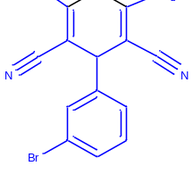
2,6-diamino-4-(3-bromophenyl)-4H-thiopyran-3,5-dicarbonitrile (5n)
White solid; yield 92 %; m.p. 198-200 °C; ¹H NMR (500 MHz, DMSO-d₆) δ 4.36 (1H, s), 7.03 (4H, s), 7.26 (1H, d, J = 10.0 Hz ), 7.34 (1H, t, d, J = 10.0 Hz), 7.39 (1H, s), 7.48 (1H, d, J = 10.0 Hz) ppm; ¹³C NMR (125 MHz, DMSO-d₆) δ 43.0, 71.7, 119.1, 122.3, 126.3, 129.7, 130.5, 131.5, 146.7, 152.0 ppm; IR (KBr) ν= 3400, 3395, 3302, 3241, 2168, 1635 cm⁻¹ .

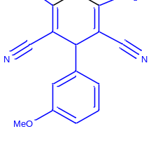
2,6-diamino-4-(3-methoxyphenyl)-4H-thiopyran-3,5-dicarbonitrile (5o)
White solid; yield 90 %; m.p. 168-170 °C; ¹H NMR (500 MHz, DMSO-d₆) δ 3.74 (3H, s), 4.21 (1H, s), 6.77 (1H, s), 6.83 (2H, t, J = 10.0 Hz ), 6.93 (4H, s), 7.28 (1H, t, J = 10.0 Hz) ppm; ¹³C NMR (125 MHz, DMSO-d₆) δ 43.7, 55.4, 72.3, 112.3, 113.3, 119.3, 130.3, 145.5, 151.7, 159.9 ppm; IR (KBr) ν= 3400, 3395, 3302, 3241, 2168, 1635 cm⁻¹ .

4. ¹H NMR, ¹³C NMR Spectra of Products 5a-5o.
2,6-diamino-4-phenyl-4H-thiopyran-3,5-dicarbonitrile (5a)
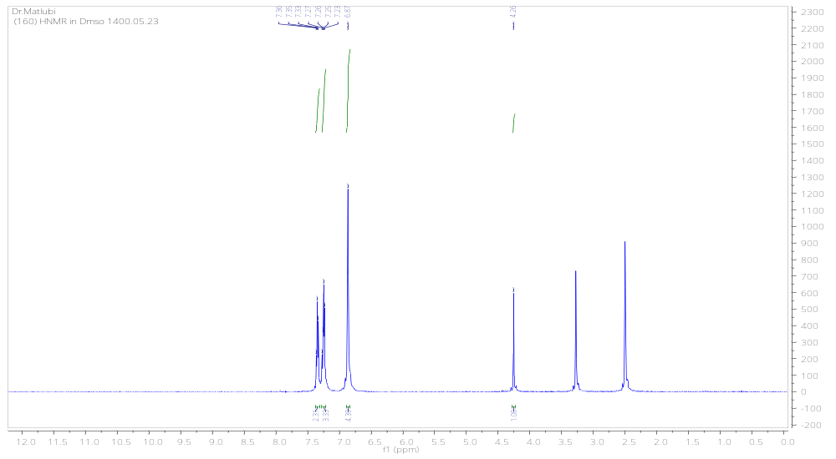
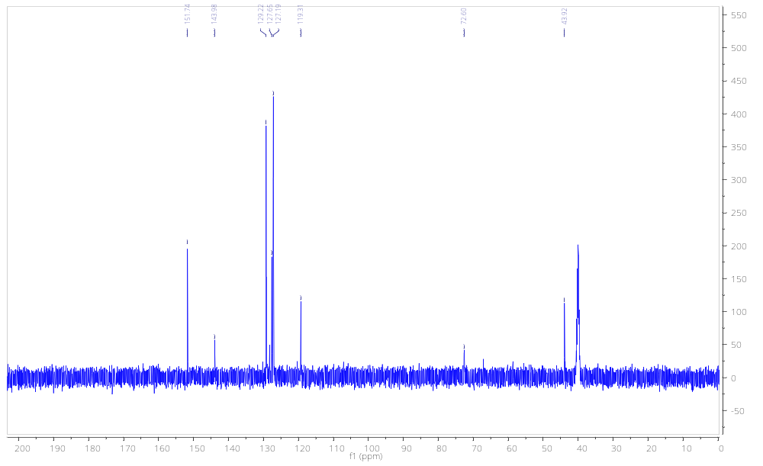

2,6-diamino-4-(2-chlorophenyl)-4H-thiopyran-3,5-dicarbonitrile (5b)
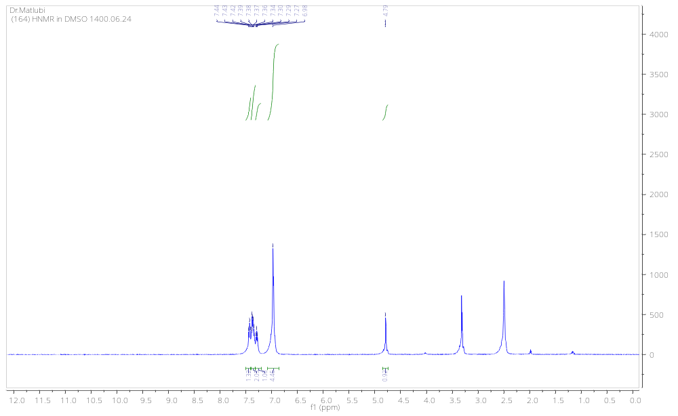
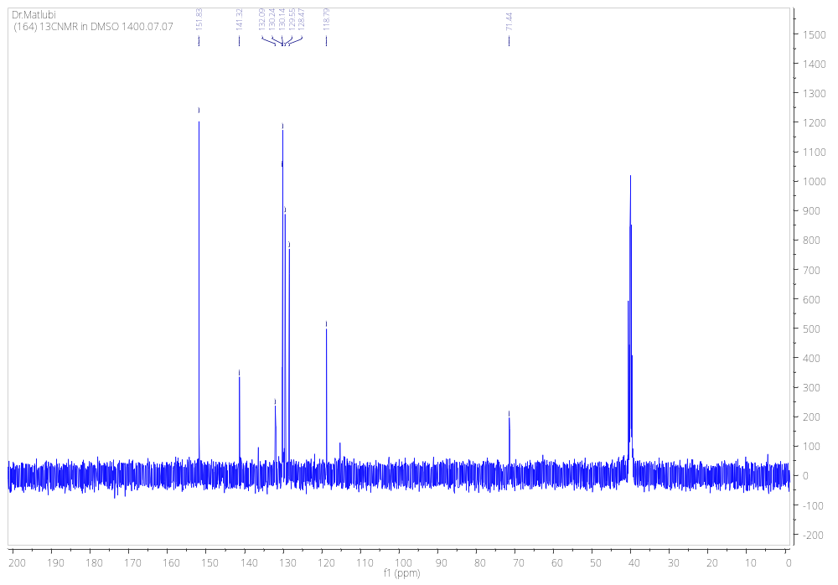
2,6-diamino-4-(4-chlorophenyl)-4H-thiopyran-3,5-dicarbonitrile (5c)
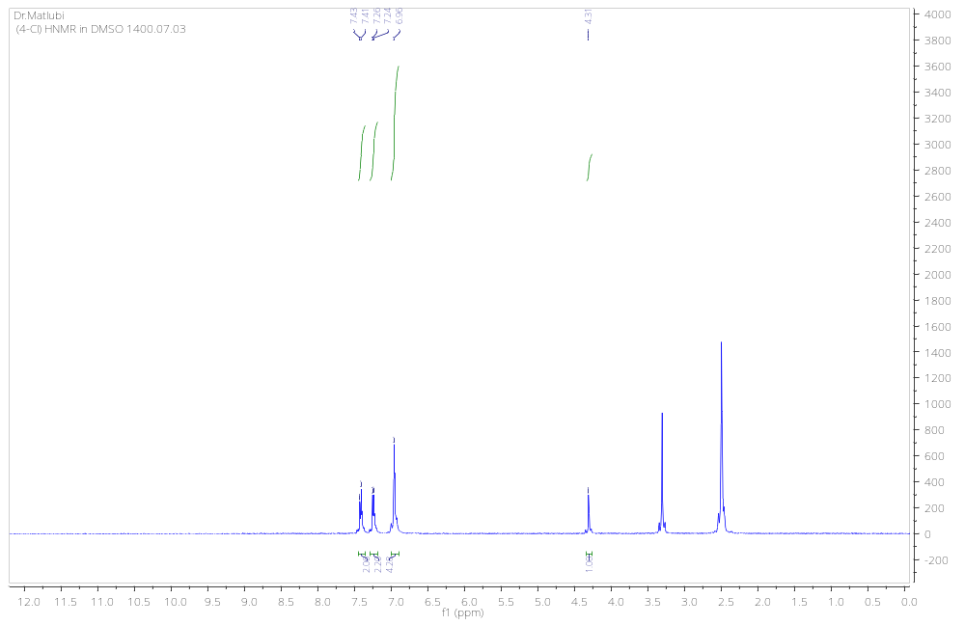
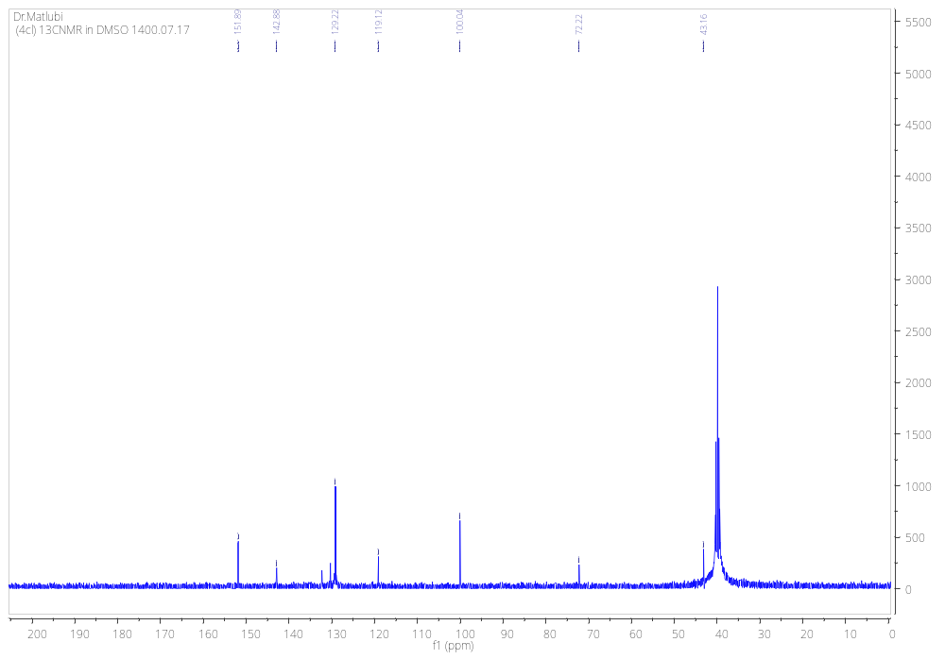
2,6-diamino-4-(2-nitrophenyl)-4H-thiopyran-3,5-dicarbonitrile (5d)
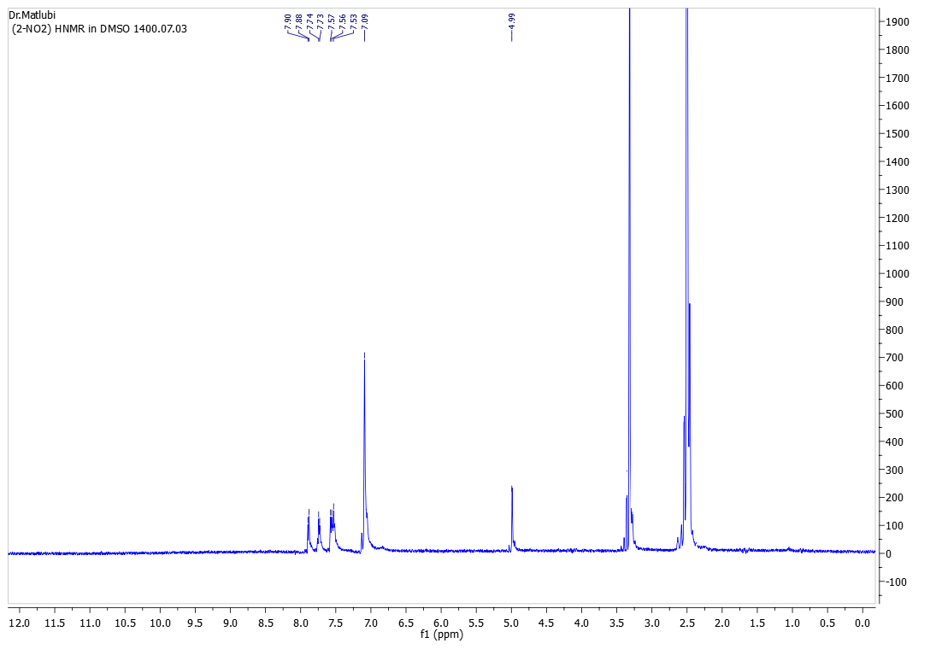
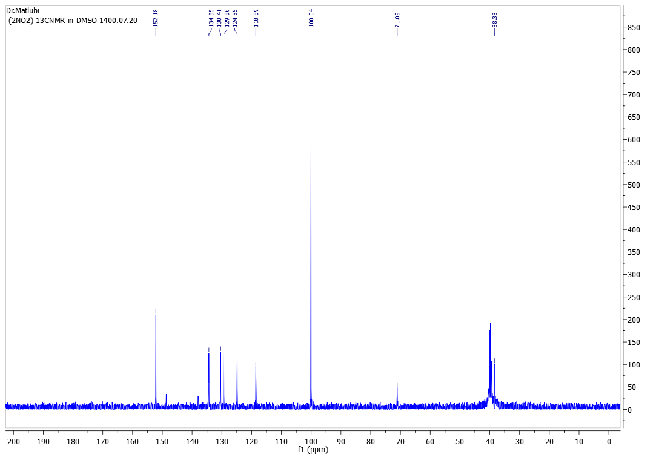
2,6-diamino-4-(4-fluorophenyl)-4H-thiopyran-3,5-dicarbonitrile (5e)
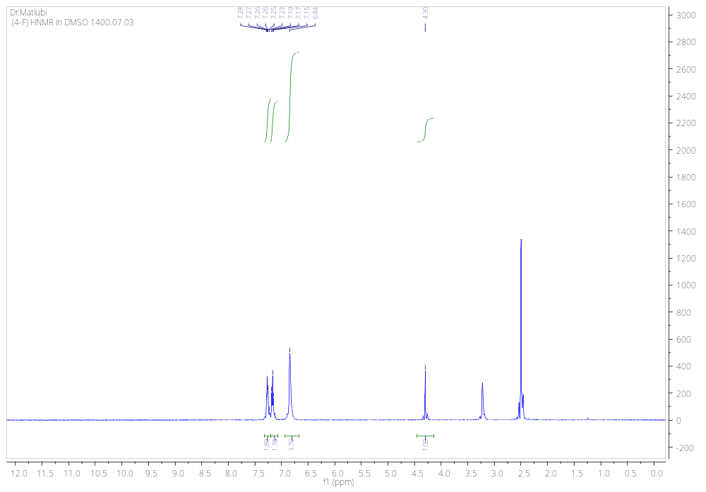
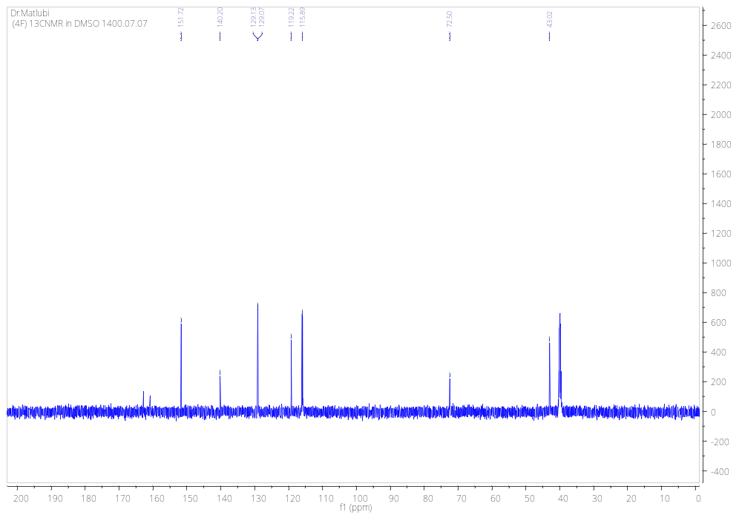
2,6-diamino-4-(3-nitrophenyl)-4H-thiopyran-3,5-dicarbonitrile (5f)
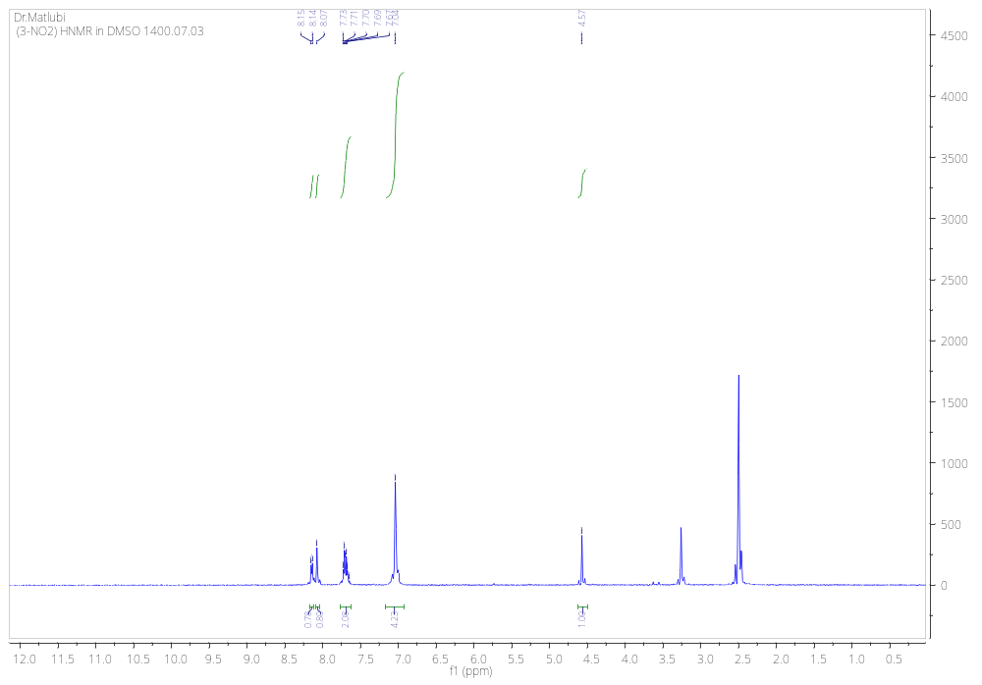
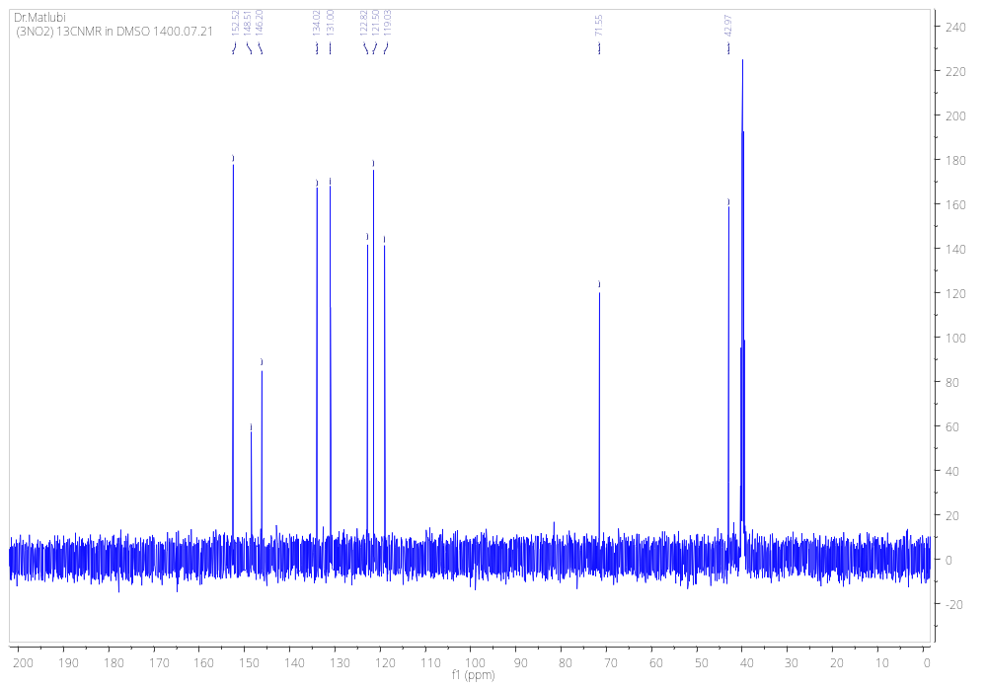

4-(2,6-diamino-3,5-dicyano-4H-thiopyran-4-yl)phenyl methyl carbonate (5g)
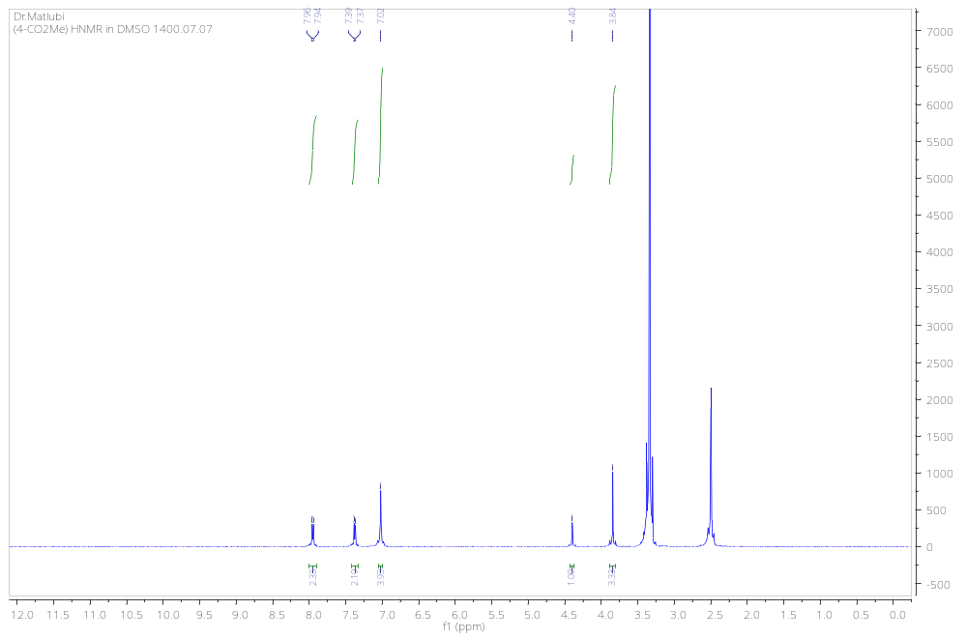
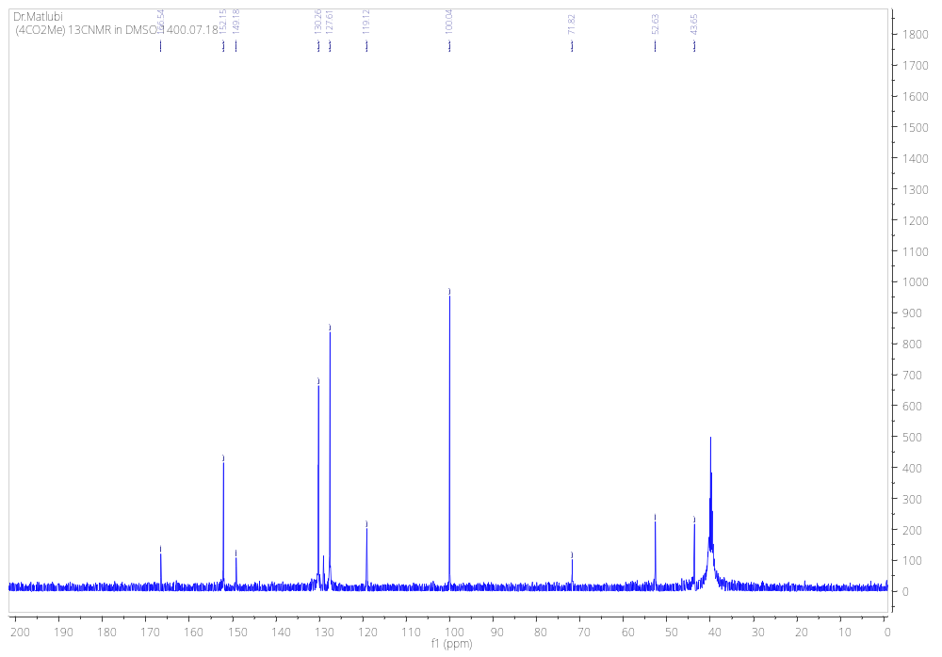
2,6-diamino-4-(2,4-dichlorophenyl)-4H-thiopyran-3,5-dicarbonitrile (5h)
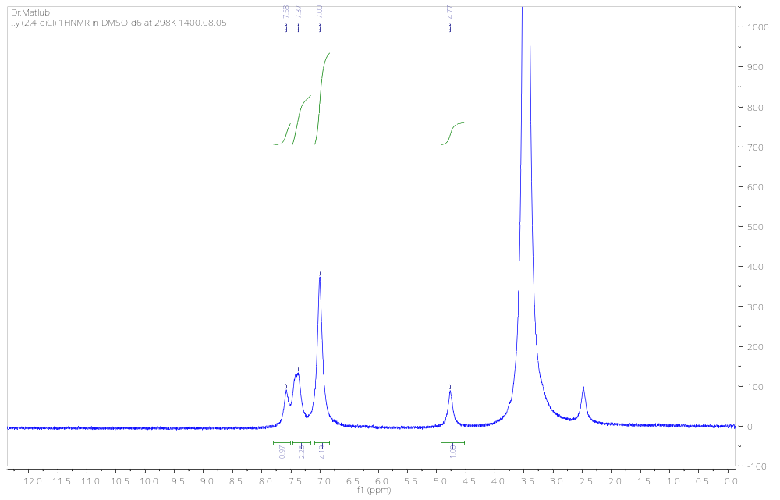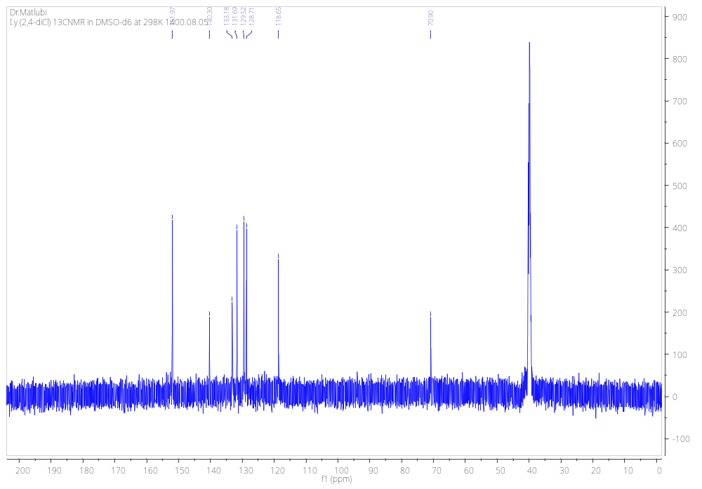

2,6-diamino-4-(p-tolyl)-4H-thiopyran-3,5-dicarbonitrile (5i)
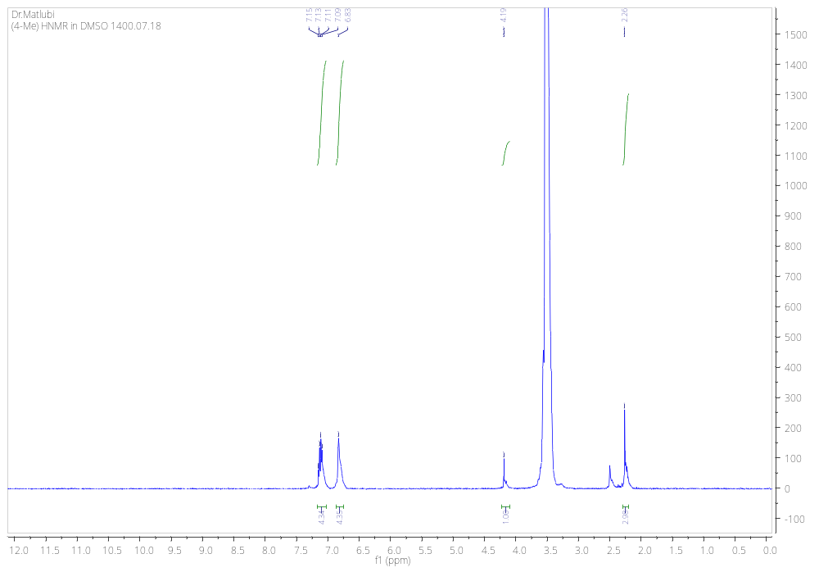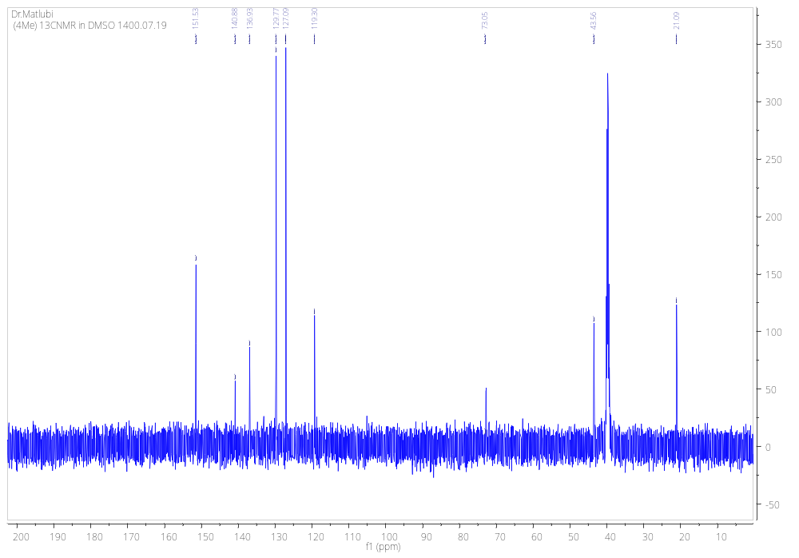

2,6-diamino-4-(4-(methylthio)phenyl)-4H-thiopyran-3,5-dicarbonitrile (5j)
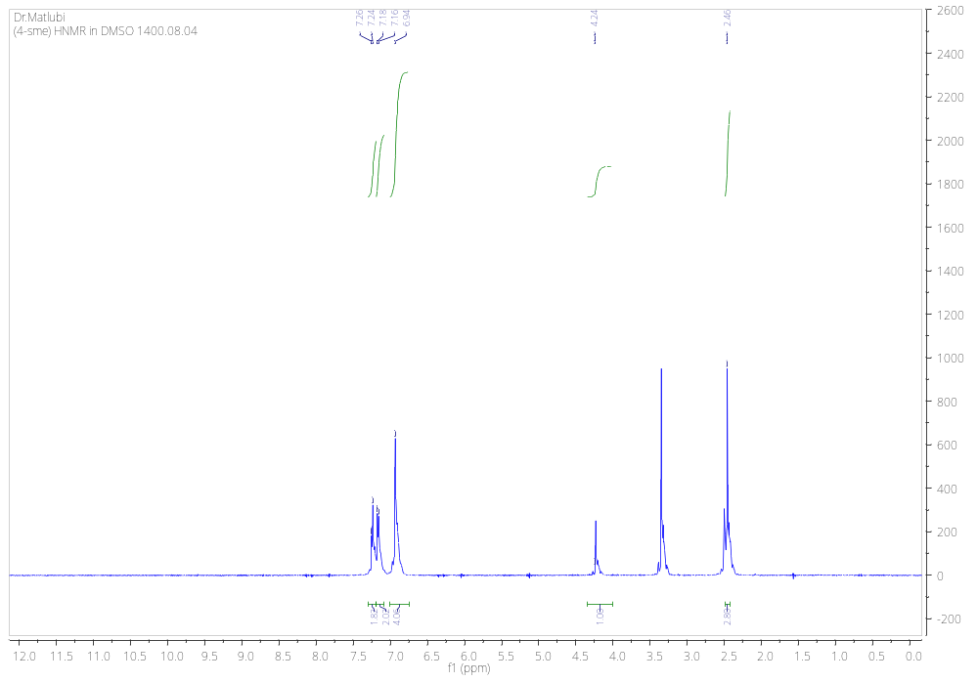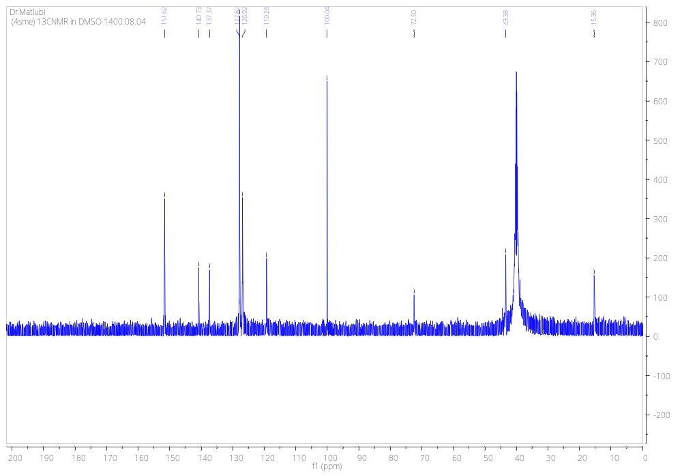
2,6-diamino-4-(4-methoxyphenyl)-4H-thiopyran-3,5-dicarbonitrile (5k)
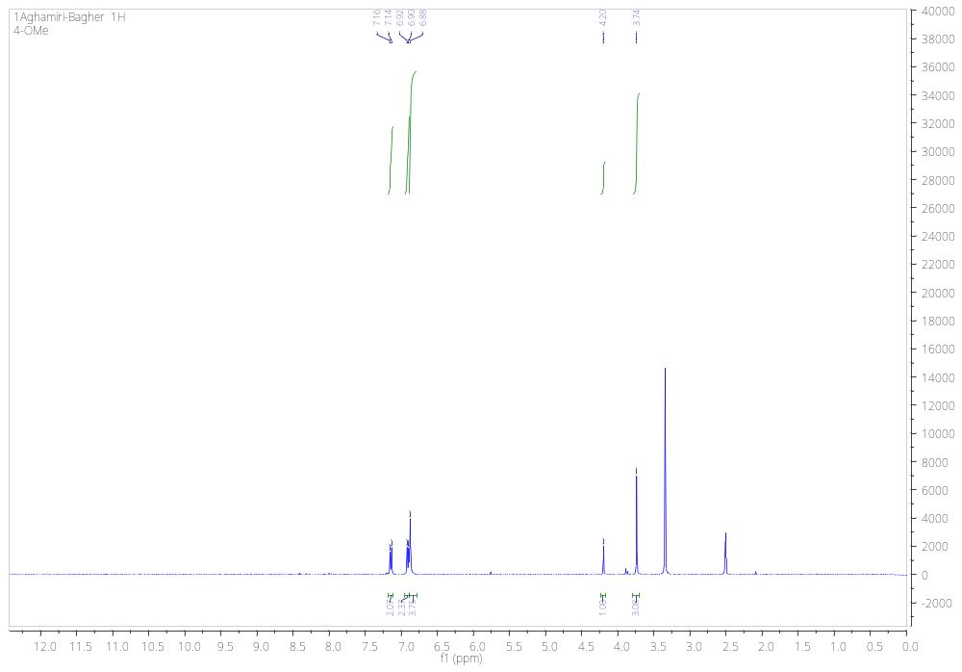
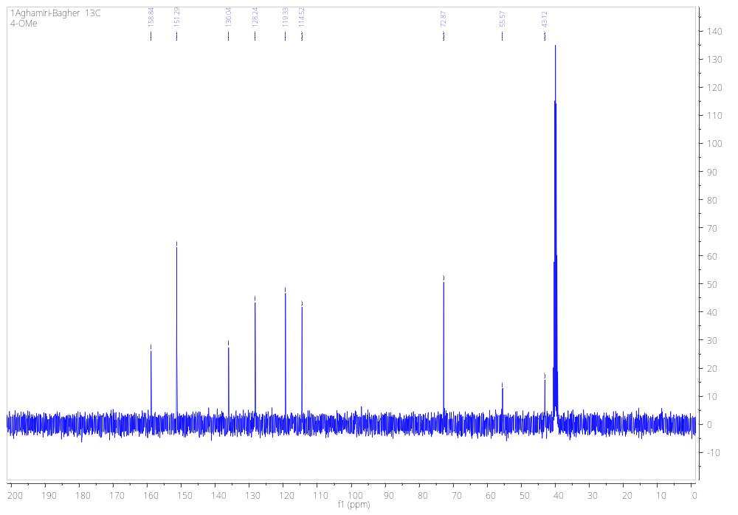
2,6-diamino-4-(3,4-dimethoxyphenyl)-4H-thiopyran-3,5-dicarbonitrile (5l)
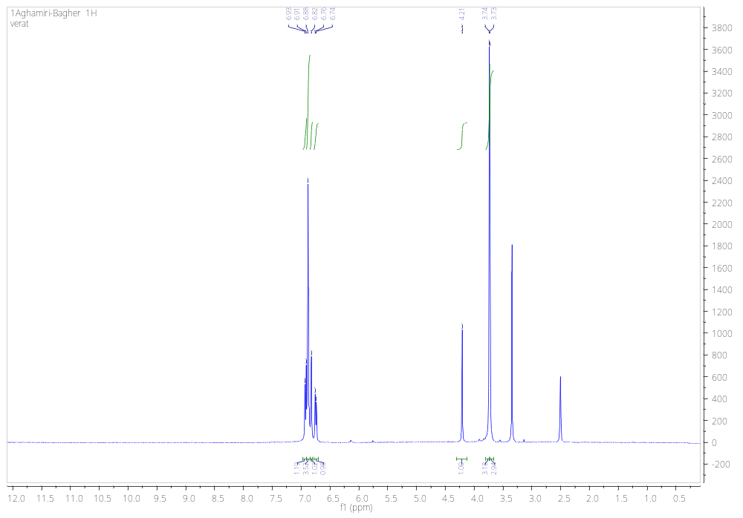
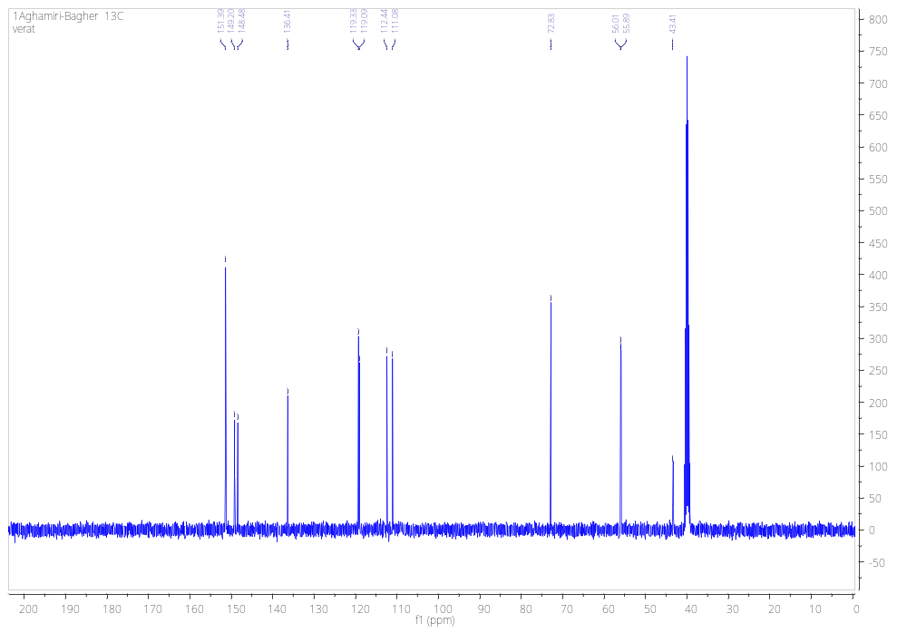
2,6-diamino-4-(2-chloro-6-fluorophenyl)-4H-thiopyran-3,5-dicarbonitrile (5m)
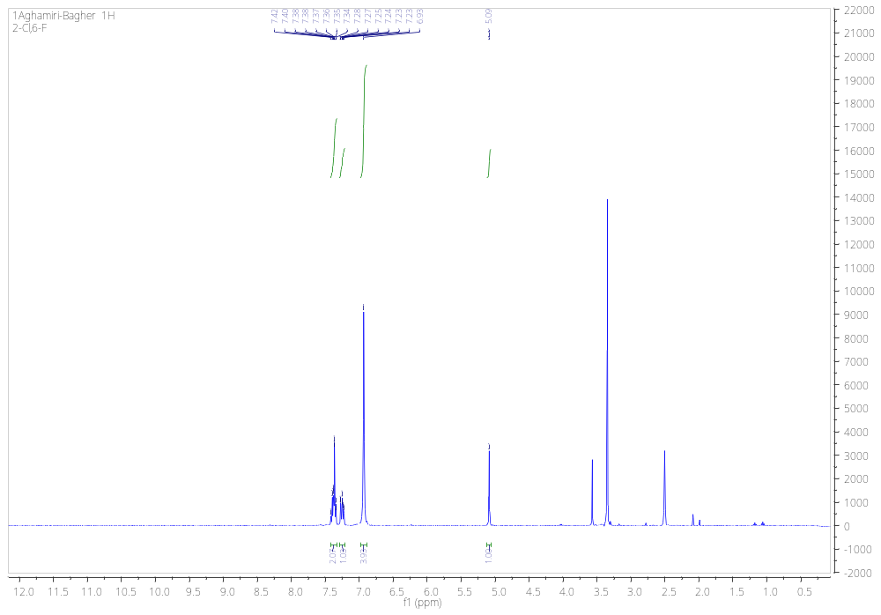
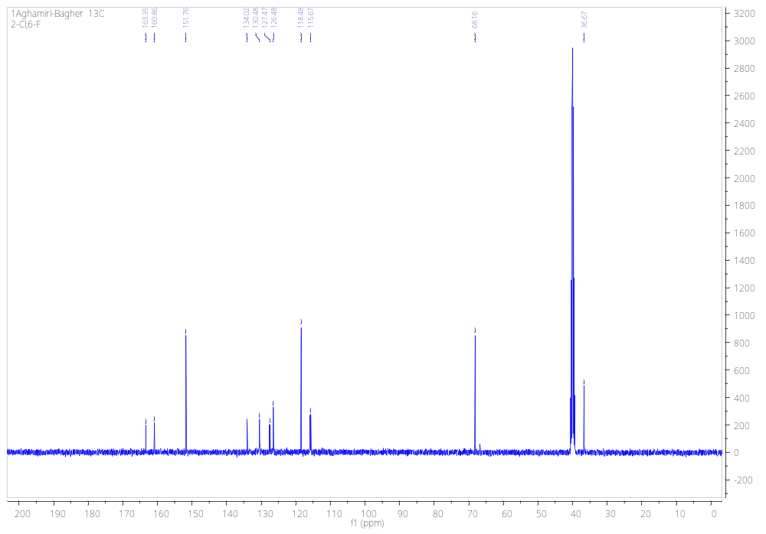
2,6-diamino-4-(3-bromophenyl)-4H-thiopyran-3,5-dicarbonitrile (5n)
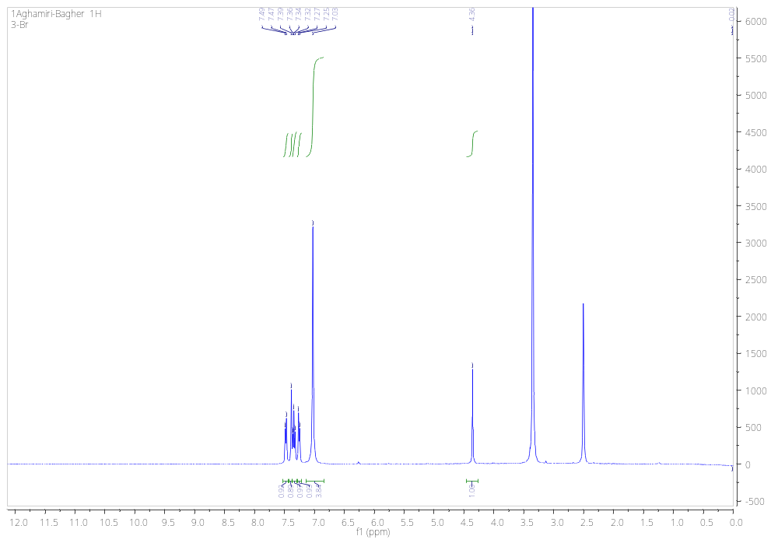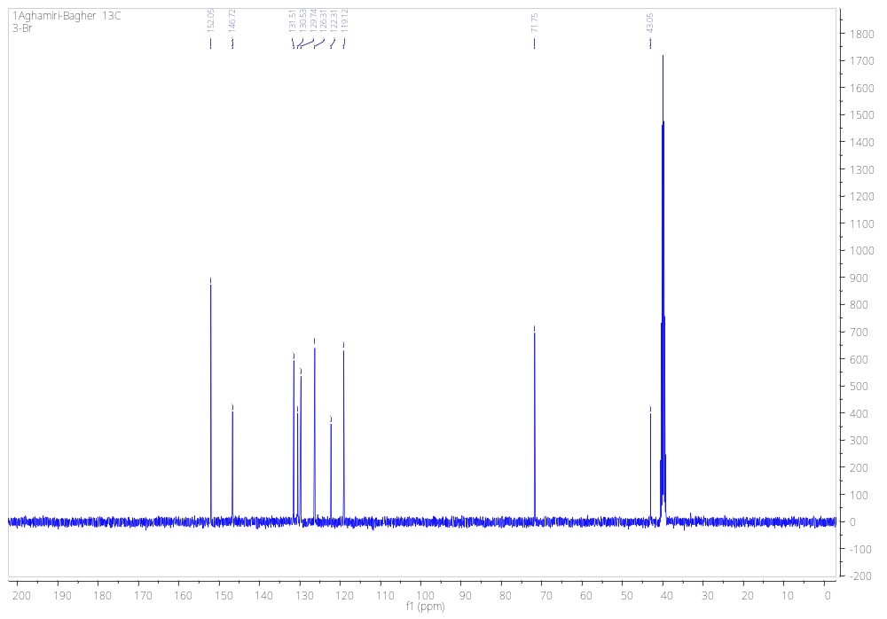
2,6-diamino-4-(3-methoxyphenyl)-4H-thiopyran-3,5-dicarbonitrile (5o)
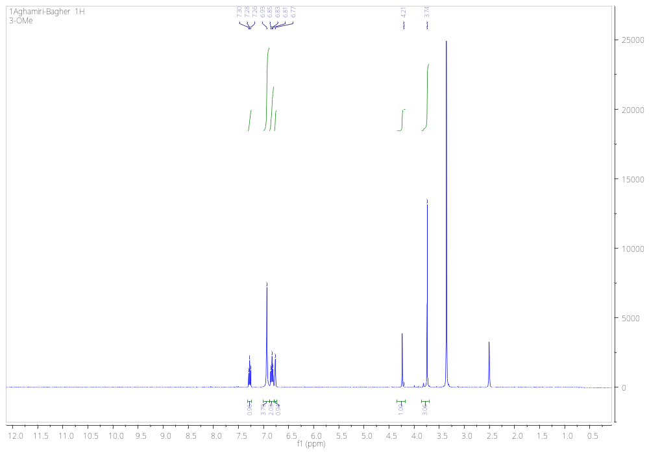
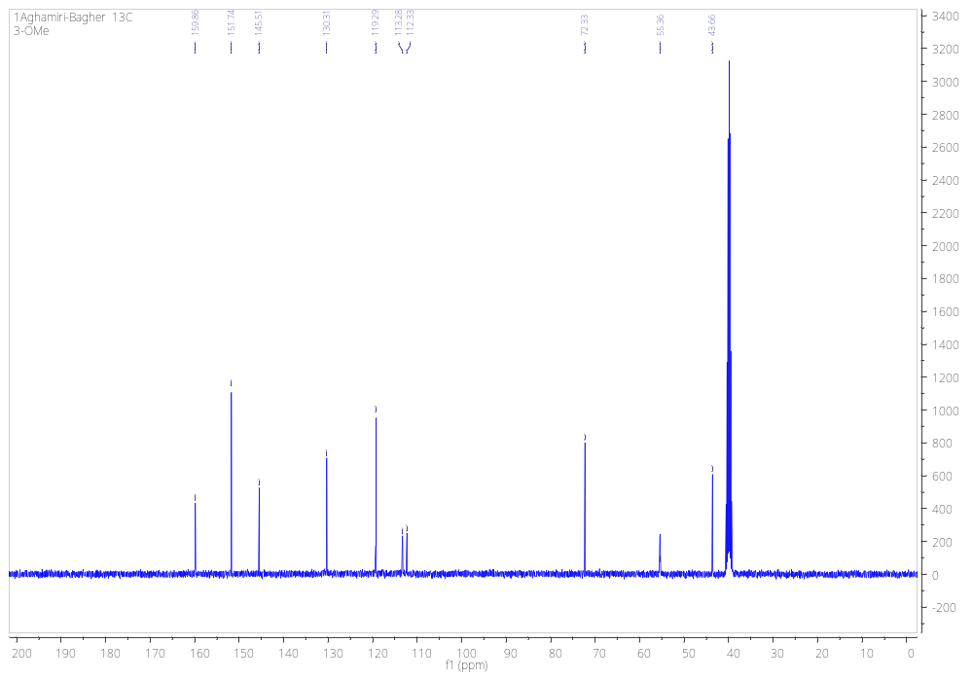
5. Figures

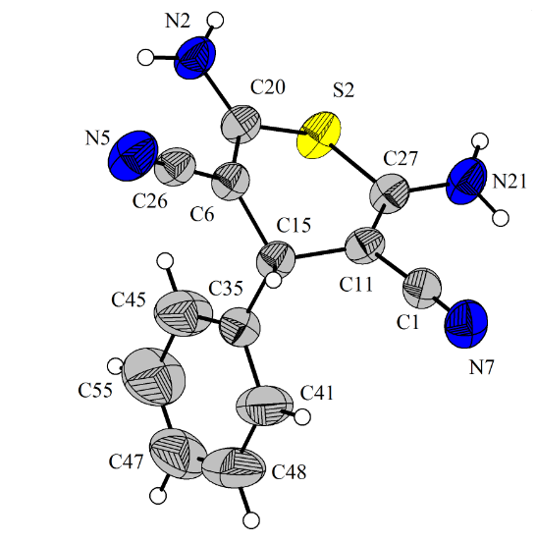
Figure S1. Single-crystal structure of 5a

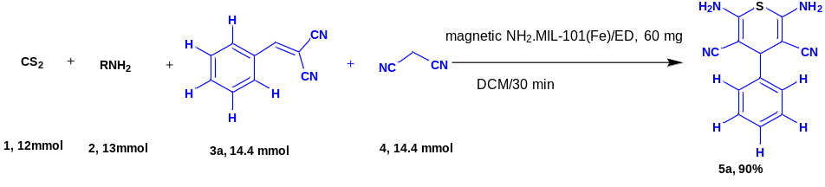
Figure S2. Scale up reacion

Figure S3. The recyclability of magnetic NH₂.MIL-101(Fe)/ED.

Figure S4. (a) FE-SEM and (b) TEM images of the recovered magnetic NH₂.MIL-101(Fe)/ED.

