Additional Files for:

Inhibition of TGFβ-induced Fibroblast to Myofibroblast Transition by conditioned medium from Human Rhinovirus-infected airway epithelial cells is mediated by Prostaglandin E₂

Diana M. Pham ^{1, 2}, Cora Kooi ^{1, 2}, David Proud ^{2, 3}, Richard Leigh ^{1, 2,3}

¹Department of Medicine, ²Snyder Institute for Chronic Diseases, ³Department of Physiology & Pharmacology, Cumming School of Medicine, University of Calgary, Alberta, Canada.

Correspondence to:
Dr. Richard Leigh
Cumming School of Medicine
TRW Building, 7E16
3280 Hospital Drive NW
Calgary. Alberta T2N 4Z6
Email: rleigh@ucalgary.ca
Phone: 403-220-4245

Additional File 1
Supplementary Table 1: Cell donor information

A. Epithelial Donors
Donor | Sex | Age | C.O.D.
1 | M | 40 | Head trauma
2 | M | 42 | Cerebral hemorrhage
3 | M | 43 | Stroke
4 | F | 57 | Cerebral hemorrhage
5 | F | 59 | Stroke
6 | F | 62 | Cerebral hemorrhage
C.O.D. – cause of death

B. Fibroblast Donors
Donor | Sex | Age | C.O.D.
1 | M | 41 | Anoxia
2 | F | 63 | Cerebral Hemorrhage
3 | F | 62 | Stroke
4 | M | 22 | Head Trauma
5 | F | 17 | Anoxia
6 | M | 55 | Anoxia
7 | M | 33 | Head Trauma
C.O.D. – cause of death

Additional File 2
Supplementary Table 2:

Gene | Primer Sequences
PTGER1 | F: 5’ CCAACTGCTTCGCCTCTT 3’  R: 5’ GCCTCTGGTTGTGCTTAGAA 3’
PTGER2 | F: 5’ CCTGGCCGTGCTGCCTGTCATC 3’  R: 5’ ATGGACACCCTTTCCCCTCTCC 3’
PTGER3 | F: 5’ CACACGGAGAAGCAGAAAGA 3’  R: 5’ CAGCAGGTAAACCCAAGGAT 3’
PTGER4 | F: 5’ AAAGCAGGTTGGAGGCGGGTCC 3’  R: 5’ GACGCATAGACTGCAAAGAGCG 3’

Additional File 3
Supplemental Fig. 1
ng/ml TGFβ1
0 10 3 1 0.3 0.1
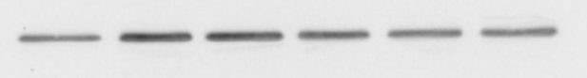
α-SMA 42 kDa
A
GAPDH 37 kDa

B

Supplemental Figure 1: Western blotting of human bronchial fibroblasts after 48 h of TGFβ1 treatment. A. Representative western blot analysis of α-SMA and GAPDH in a HBF donor in response to varying doses of TGFβ1. B. Densitometric analysis of α-SMA protein expression after HBFs are stimulated with TGFβ1 (n=5). Data were analyzed by one-way ANOVA comparing data to control using Dunnett’s multiple comparison test. Data are expressed as mean ± SEM.

Additional File 4
Supplemental Figure 2

Supplemental Figure 2: Cell viability assessment of HBFs treated with specified conditions for 48 h. HBFs treated with 1 ng/ml of TGFβ1 either in medium alone or in combination with conditioned medium from HRV-infected epithelial cells (HBE HRV). Data were analyzed using a paired student T-test. Data are expressed as a mean percentage ± SEM (n=6). ns = not significant.

Additional File 5
Supplemental Fig. 3
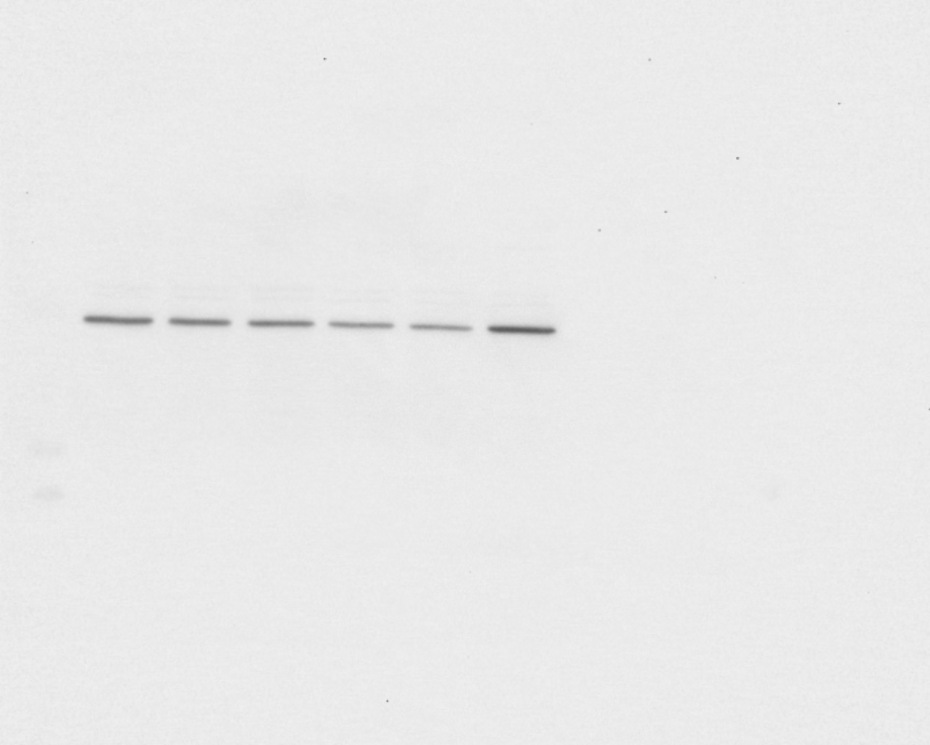
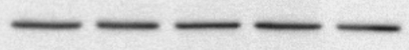
PGE₂ (M)
0
10⁻⁹
10⁻⁸
10⁻⁷
10⁻⁶
A
α-SMA 42 kDa

GAPDH 37 kDa
B

Supplemental Figure 3: Protein analysis of α-SMA in HBFs after 48 h of exposure to PGE₂. A. Representative western blot analysis of α-SMA and GAPDH in a HBF donor in response to varying doses of PGE₂. B. Densitometric analysis of α-SMA normalized over GAPDH expression in HBFs after 48 hours of exposure to PGE₂ (n=6). Data were analyzed using one-way ANOVA post-hoc comparisons using Dunnett’s multiple comparison test. Data are expressed as mean ± SEM.

Additional File 6
Supplemental Fig. 4

Supplemental Figure 4: Expression of mRNA expression of EP receptor subtypes in HBFs under basal conditions. EP receptor expression was normalized to GAPDH. Data are expressed as mean ± SEM (n=4).

