Supplementary Material
Supplementary Figure 1 – Surgical model Exposure and vessel clamping during the induction of warm ischemic injury in the mouse hind limb. Applying the (A) arterial and (B) venous vessel clamps after transection of the (C) ventral and dorsal muscle groups of the thigh while preserving all (D) major nerve branches allows for reliable induction of warm ischemic injury.
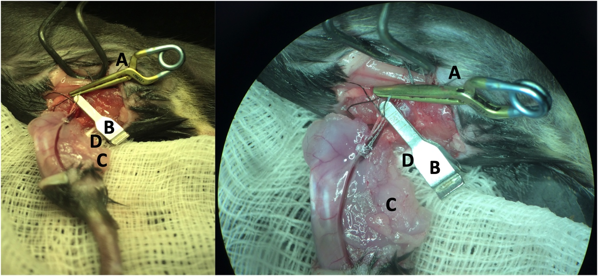

Supplementary Figure 2 – Cell injection (A) Injections of MPCs were performed in the tibialis anterior muscle after release of vascular clamps and successful reperfusion using a custom-made injector containing 4 needles (30G) mounted on a 1 ml syringe. (B) Sham injections were performed after exposure of the tibialis anterior muscle. (C) Co-injected FluoSpheres® polystyrene beads (15 µm, yellow-green) were visible macroscopically after injection in the tibialis anterior muscle. G, gauge; MPC, myogenic progenitor cell.
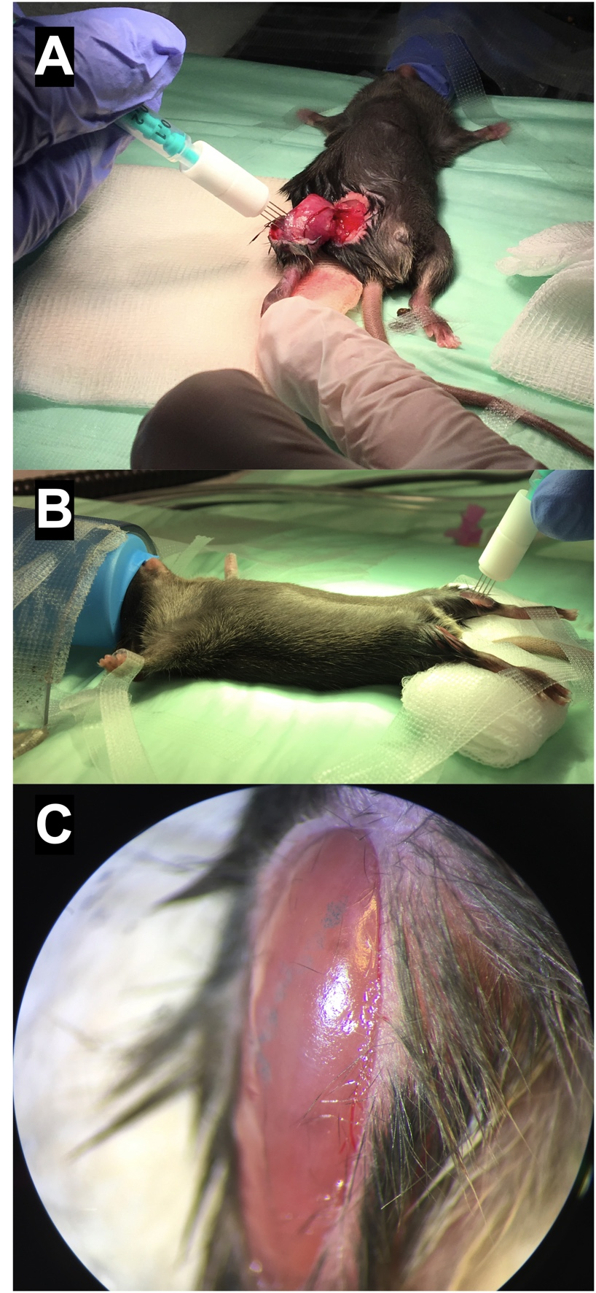

Supplementary Figure 3 – Customized injectors In order to assess the best mode of injection, different custom-made injectors were tested. While a standard 30 G injection needle consists of one needle (A), custom-made injectors containing 2 (B), 4 (C), and 8 (D) needles (30 G) were tested. The injector containing four needles (C) was most effective in cell aspiration, injection, and distribution of cells. With the injector containing 8 needles, aspiration of the 30 µl injection volume was not possible without aspiration of air. G, gauge.

