Alleviating continuous monocropping obstacle in melon：Biological elimination of phenolic acid
Huiqin Xie^{1a}, Yongli Ku^{2a}, Xiangna Yang¹, Le Cao³, Xueli Mei¹, Nan Yang¹, Cuiling Cao¹*
¹ College of Life Science, Northwest A&F University, Yangling 712100, China.
² College of Forestry, Northwest A&F University, Yangling 712100, China.
³ School of Plant Protection, Anhui Agricultural University, Hefei 230000, China.
ª Two authors made same contribution for this article.
*corresponding author: cuilingcao@163.com
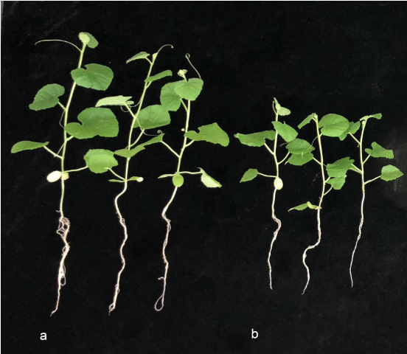
Fig. S1 Effects of CA amendment on melon seedling growth. a, CK1; b, CAG1. CK, control treatment; CAG1, 400 μg·kg⁻¹ soil CA.
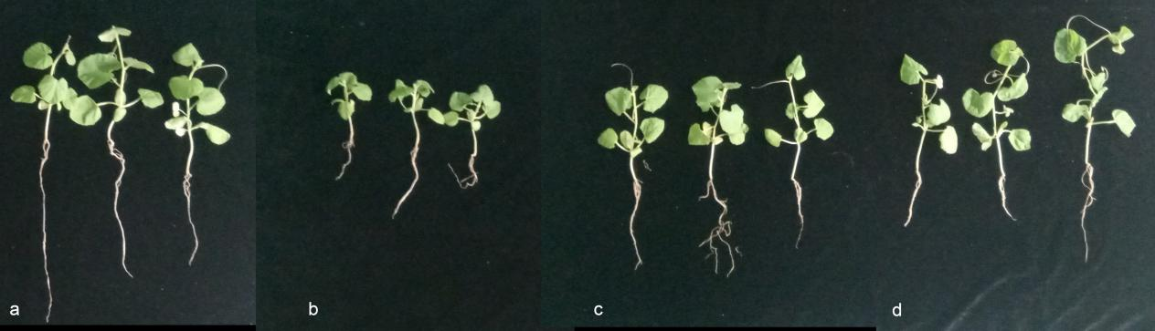
Fig. S2 Melon seedling growth in response to K3 inoculation. a, CK0; b, CK1; c, T1; and d, T2. CK0, control treatment with healthy soil; CK1, control treatment with monocropping soil; T1, low concentration of K3 inoculated treatment with monocropping soil (1 g· kg⁻¹ soil). T2, High concentration of K3 inoculated treatment with monocropping soil (3 g· kg⁻¹ soil).

