Extended data figures

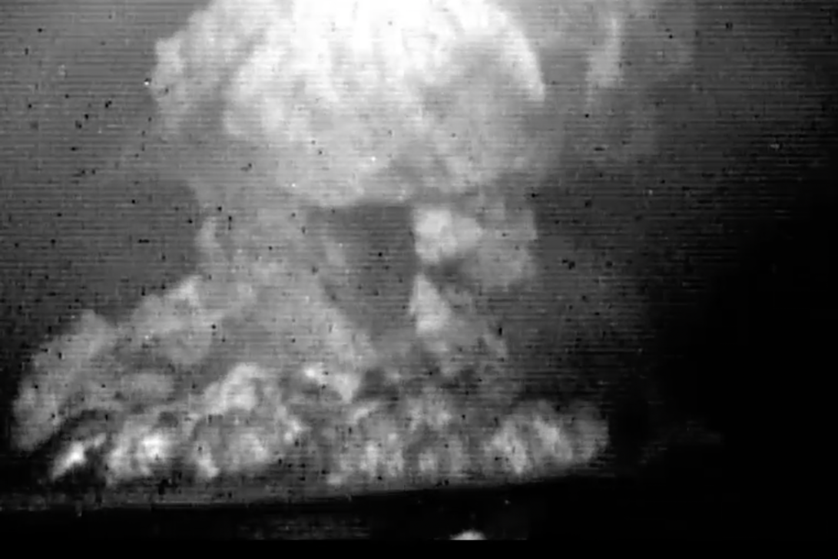

Extended Data Figure 1 | Infrared photo of the FOB eruption. The FOB eruption generated laterally spreading pyroclastic density currents at the source at 15:00-15:30 JST on 13 August 2021, taken from 6,000 m above sea level and approximately 90 km north of the volcano by the Japan Coast Guard⁴².
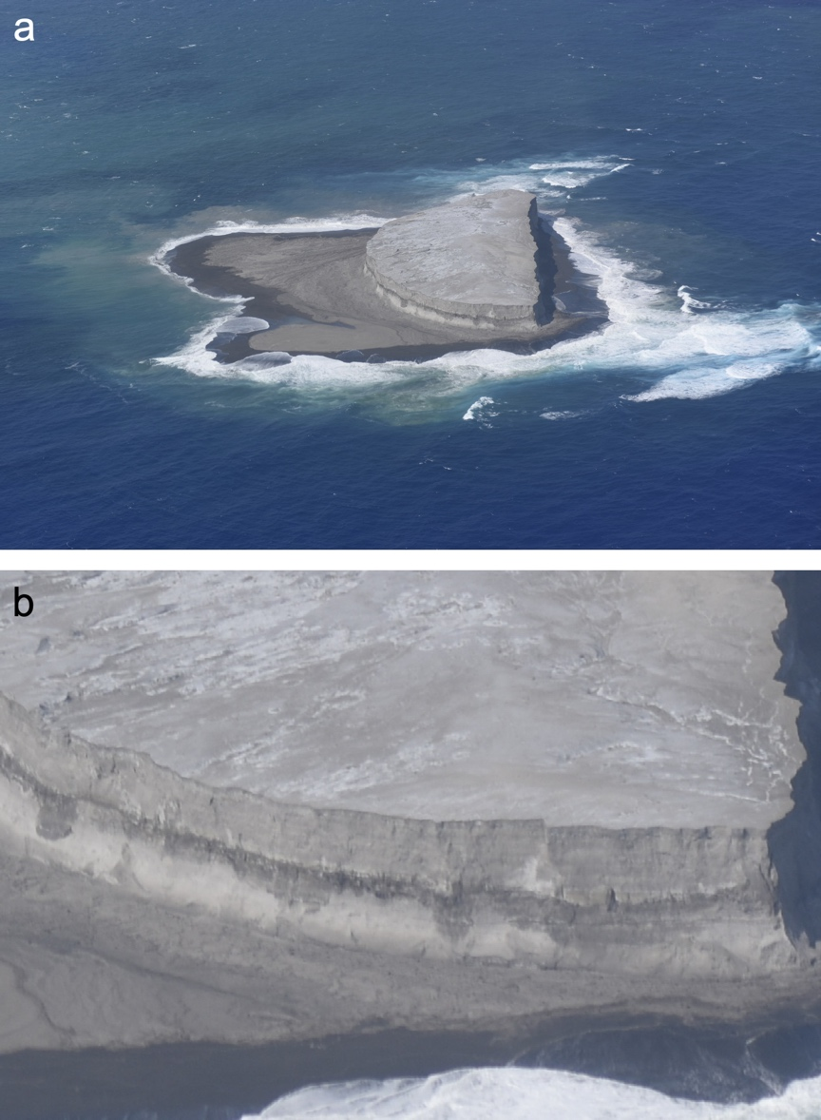

Extended Data Figure 2 | Photos of a new islet of FOB. a, The western island produced by the 2021 FOB eruption, taken on 12 October by the Japan Coast Guard⁴². b, Magnification of the island. The cone components are massive, poorly sorted loose pyroclastic units.
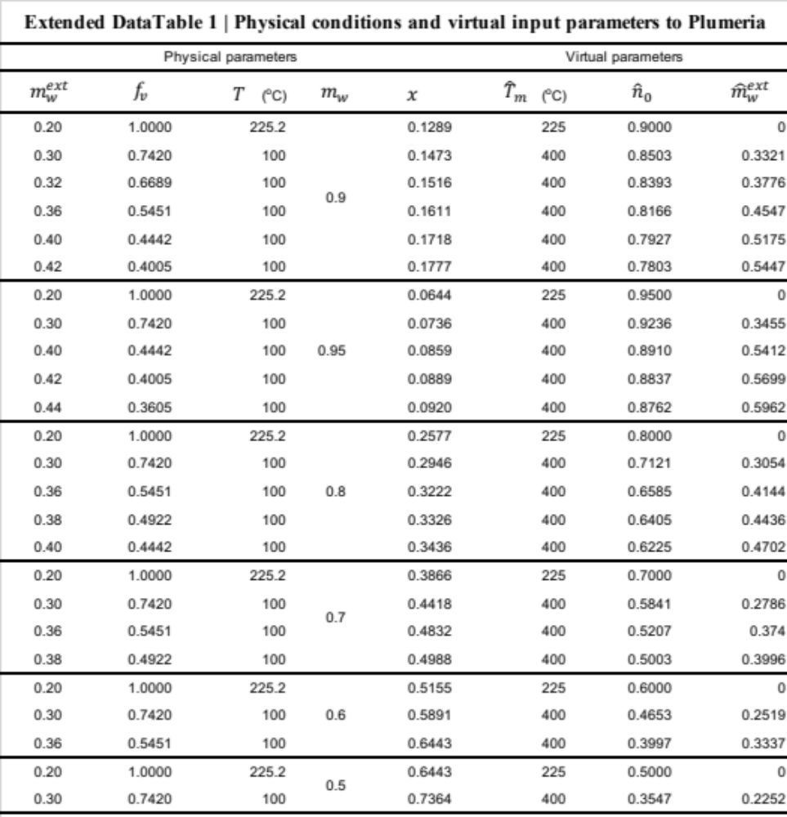
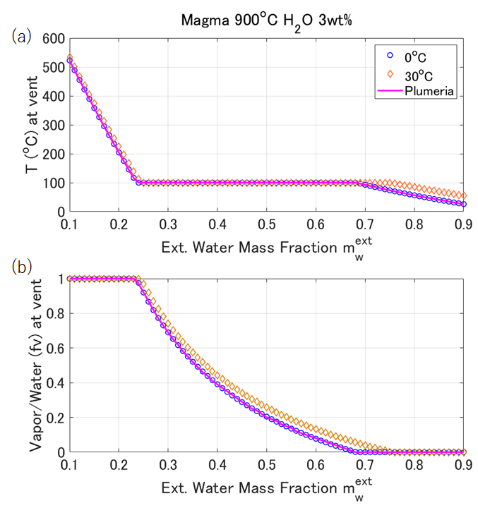
Extended Data Figure 3 | The relation between the external mass fraction added to magma ($m_{w}^{ext}$) and (a) the temperature ($T$) and (b) vapor mass fraction of total water in the plume ($f_{v}$) at the vent. The blue circles are for the external water temperature of 0ºC, which are consistent with the output values of Plumeria³¹ (the magenta line). The orange diamonds represent the external water temperature of 30ºC and are used in this study. See Supplementary Information for details.
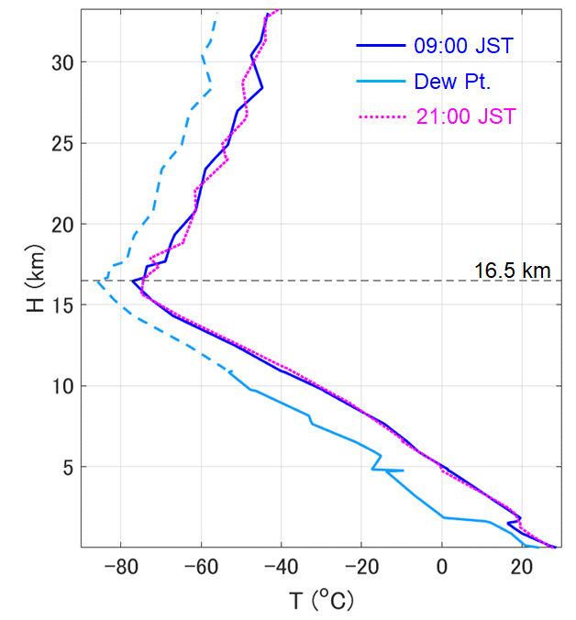
Extended Data Figure 4 | Atmospheric structure at the time of the FOB eruption. The atmospheric temperature (blue line) and the dew point (light blue line) used in the plume calculation. The data were taken by the radiosonde at 09:00 JST on 13 August at the Japan Meteorology Agency, Chichijima Observatory. The dew points above 11.03 km (dashed line) were not from the data but were estimated by the Tetens equation⁴³, assuming a humidity of 20%. The temperature measured at 21:00 JST on 13 August (magenta line) is displayed for comparison. See Supplementary Information for the details.
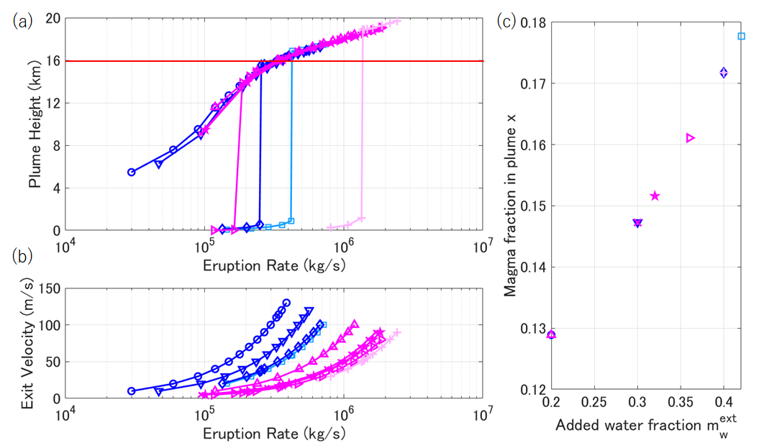

Extended Data Figure 5 | The relation between the total magma discharge rate $M_{e}$ and (a) the plume height $H_{p}$ obtained by Plumeria assuming a water mass fraction in plume $(m_{w})$ of 0.9. The given exit velocities are shown in (b). The initial magma temperature is fixed at 900 and the added water fraction $(m_{w}^{ext}$) is varied as in the horizontal axis of (c). The cases for exit diameters of 100 m and 200 m are shown by blue and magenta colors, respectively. The light-colored cases did not yield 16-km high plumes. The marker types are common among all of (a)-(c), indicating the values of $m_{w}^{ext}$. The plume height of 16 km is achieved with $M_{e}$ of $3-4×{10}^{5}$ kg/s. See Supplementary Information for the details.
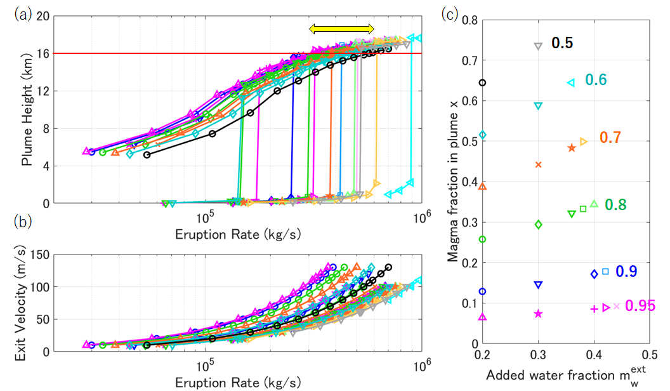

Extended Data Figure 6 | The relation between the total magma discharge rate $M_{e}$ and (a) the plume height $H_{p}$ and (b) the given exit velocity for a fixed exit diameter at 100 m. The water mass fraction $(m_{w})$ varies from 0.5 to 0.95 as the colors and numbers in (c) indicate (black: 0.5, light blue: 0.6, orange: 0.7, green: 0.8, blue: 0.9, and magenta: 0.95). The marker types are common among all of (a)-(c), indicating the values of $m_{w}^{ext}$ as shown on the horizontal axis of (c). The relatively light-colored cases did not yield 16-km high plumes. The plume height of 16 km is achieved with $M_{e}$ of $3-6×{10}^{5}$ kg/s (the yellow arrow in (a)). See Supplementary Information for the details.
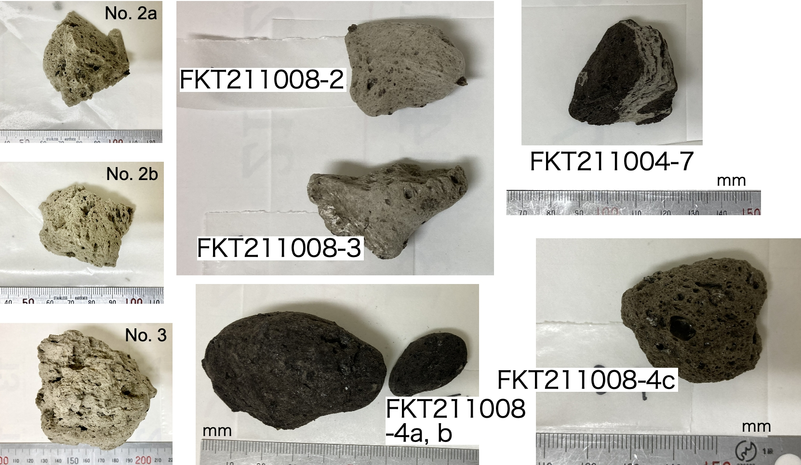

Extended Data Figure 7 | Pumice samples from the 2021 FOB eruption that were used for whole-rock major element analyses.
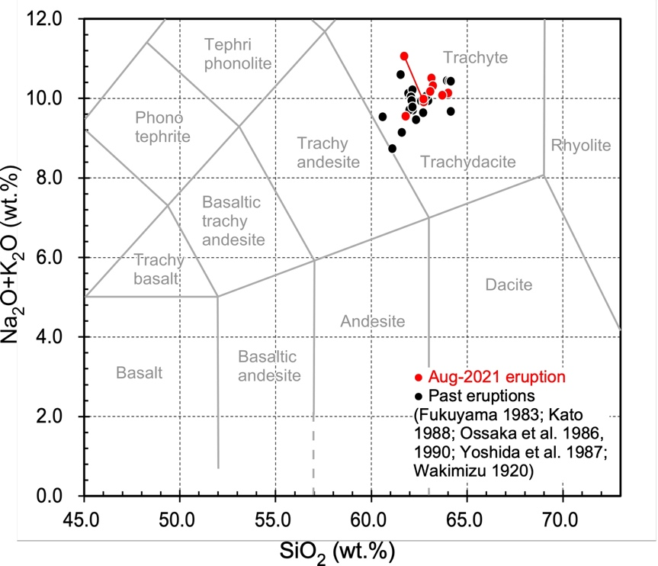

Extended Data Figure 8 | Whole-rock major element compositions of the 2021 FOB products (red symbols). Dots connected with a line indicate different portions of the same pumice clast. Black symbols indicate the products from the past eruptions of FOB⁴⁴⁻⁴⁹. Classification based on Le Bas et al. (1986)⁵⁰.
References:
- Hydrographic and Oceanographic Department, Japan Coast Guard. https://www1.kaiho.mlit.go.jp/GIJUTSUKOKUSAI/kaiikiDB/kaiyo24-2.htm, accessed on 29 November 2021.
- Murray, F.W. On the computation of saturation vapour pressure. J. Applied Meteorology 6, 203-204 (1967).
- Fukuyama, H. Geology of Minami-Iwo Volcano, Izu-Bonnin Islands, Japan. J. Geography (Chigaku Zasshi) 92, 55-67 (1983), in Japanese.
- Kato, Y. Gray pumices drifted from Fukuoku-oka-no-ba to the Ryuku Islands. Bull. Volcanol. Soc. Jap. 33, 21-30 (1988), in Japanese.
- Ossaka, J. et al. Chemical compositions of rocks erupted from submarine volcanoes in Izu-Ogasawara arc. Bull. Volcanol. Soc. Jap. 35, 57-61 (1990), in Japanese.
- Ossaka, J. et al. Volcanic activity of Fukutoku-oka-no-ba: Part 1. Topography. Bull. Volcanol. Soc. Jap. 31, 133-134 (1986), in Japanese.
- Yoshida, T. et al. Geochemical study of submarine Fukutoku-Oka-no-Ba volcano, Izu-Ogasawara Arc. Res. Rep. Lab. Nucl. Sci. Tohoku Univ. 20, 202-215 (1987), in Japanese.
- Wakimizu, T. Path of disappearance of the new Iwo Iojima erupted in the third year of the Taisho era. Toyo Gakugei Zasshi 37, 257-268 (1920), in Japanese.
- Le Bas, M.J., Le Maitre, R.W., Streckeisen, A., Zanettin, B., and IUGS Subcomission on the systematics of Igneous Rocks. (1986). A chemical classification of volcanic rocks based on the total alkali-silica diagram. J. Petrol. 27, 745–750. doi:10.1093/petrology/27.3.745.
Supplementary Information (Plume modelling)

1. Introduction
The eruption of Fukutoku-Oka-no-ba (FOB) formed 16-km-high white plumes. We estimate the magma discharge rate required to form the 16-km-high plume. The essential feature of this eruption was the existence of a large amount of pumice that should have provided thermal energy to the plume but did not rise in the plume. We apply a user-friendly plume model Plumeria (Mastin, 2011) to calculate the relation between the eruption parameters and the plume height. To incorporate the thermal energy from pumice, we adjusted the input parameters of the software to represent the water-rich high-enthalpy mixture at the vent. Below we use ‘magma’ to represent the nonvolatile part of magma and ‘whole magma’ to represent magma, including magmatic H₂O.

2. Method
2.1 Adjusting the input parameters
The Plumeria model (Mastin, 2007) assumes a homogeneous and equilibrium flow of mixtures consisting of magma, water (vapor, liquid, and ice), and entrained air. The software determines the mixture property at the vent (temperature $T$, H₂O mass fraction $m_{w}$, and vapor phase mass fraction of H₂O $f_{v}$), calculating the enthalpy balance with the input parameters (whole magma temperature $T_{m}$, mass fraction of magmatic H₂O in whole magma $n_{0}$, and mass fraction of external water added to the initial mixture $m_{w}^{ext}$). The external water temperature is fixed at 0 ºC. Then, using the mixture property and given vent diameter $2r_{0}$ and exit velocity $u_{0}$, the total mass discharge rate $M$ is determined. All the input material (magma and external water) is assumed to be ejected together so that the magma discharge rate is $(1-m_{w})M$.

To incorporate the thermal energy from the floating pumice, we independently calculate the enthalpy balance to obtain $T$ and $f_{v}$, assuming $T_{m}$ of 900 ºC and $n_{0}$ of 0.03. The amount of external water is varied in the range of $0.1<m_{w}^{ext}<0.9$. We have confirmed that our calculation yields equivalent values of $T$ and $f_{v}$ to Plumeria if the external water temperature is set at 0 ºC (Extended Data Fig. 3). Then, the external water temperature is assumed to be 30 ºC, which is realistic around the FOB in August. The obtained $T$ and $f_{v}$ are also shown in Extended Data Fig. 3 as functions of $m_{w}^{ext}$.

The mass fraction of H₂O with the above parameters is $m_{w}^{0}=m_{w}^{ext}+\left(1-m_{w}^{ext}\right)n_{0}$. Then, we assume a new H₂O mass fraction in the plume as $m_{w} (>m_{w}^{0})$. Namely, only a fraction $x=(1-m_{w})/(1-m_{w}^{0})$ of magma goes into the plume. We calculate virtual magma temperature ${\hat{T}}_{m}$, mass fraction of H₂O in whole magma ${\hat{n}}_{0}$, and external water at 0 ºC added to the initial mixture ${\hat{m}}_{w}^{ext}$ with which the Plumeria software has the specific mixture property at the vent $\left(T,f_{v},m_{w}\right)$. Note that the values of $\left(T,f_{v},m_{w}\right)$ are essential for plume dynamics, and the assumed values ($T_{m}, n_{0}, m_{w}^{ext}$) to obtain them are physical, while the virtual values (${\hat{T}}_{m},{\hat{n}}_{0},{\hat{m}}_{w}^{ext}$) are just technical for applying the Plumeria software to the current problem. When $f_{v}=1$, $\left({\hat{T}}_{m},{\hat{n}}_{0},{\hat{m}}_{w}^{ext}\right)=\left(T,m_{w},0\right)$. When $1>f_{v}>0$, $T$=100 ºC. Then, we assume ${\hat{T}}_{m}$=400 ºC and calculate the following equations:
$$\begin{aligned}\left(1-{\hat{m}}_{w}^{ext}\right)\left(1-{\hat{n}}_{0}\right)h_{m}\left({\hat{T}}_{m}\right)+\left(1-{\hat{m}}_{w}^{ext}\right){\hat{n}}_{0}h_{v}\left({\hat{T}}_{m}\right)+{\hat{m}}_{w}^{ext}h_{l}\left({\hat{T}}_{w}\right) \\ =\left(1-m_{w}\right)h_{m}\left(T\right)+ m_{w}f_{v}h_{v}\left(T\right)+m_{w}\left(1-f_{v}\right)h_{l}\left(T\right),\#\left(S1\right)\end{aligned}$$

$$\begin{aligned}{\hat{m}}_{w}^{ext}+\left(1-{\hat{m}}_{w}^{ext}\right){\hat{n}}_{0}=m_{w},\#\left(S2\right)\end{aligned}$$
where $h_{m}$, $h_{v}$, and $h_{l}$ are the enthalpy of a unit mass of magma, water vapor, and liquid water, respectively, and ${\hat{T}}_{w}$ is the external water temperature in Plumeria, which is 0 ºC.
For the total mass discharge rate, $M$, evaluated by Plumeria, $(1-m_{w})M$ represents the magma mass discharge rate in the plume. Then, the erupted magma discharge rate $M_{e}$, including the floating pumice, is
$$\begin{aligned}M_{e}={\left(1-m_{w}\right)M}/x=\left(1-m_{w}^{0}\right)M.\#\left(S3\right)\end{aligned}$$

2. 2 Atmospheric structure
The atmospheric data are measured by radiosonde, twice a day (at 09:00 and 21:00 JST) at Chichijima, 330 km to the north of FOB. We downloaded them from the University of Wyoming website (http://weather.uwyo.edu/upperair/sounding.html). The Plumeria uses the pressure, temperature, and dew point as functions of height. In the upper layers where dew point data were missing, we assumed a humidity of 20% and calculated the dew point using the following Tetens equation extended below 0 ºC (Murray, 1967):

$$\begin{aligned}P_{v}=610.78exp\left(\frac{21.875T_{d}}{T_{d}+265.5}\right),\#\left(S4\right)\end{aligned}$$
where $P_{v}$ is the vapor pressure in Pa and $T_{d}$ is the dew temperature in ºC. Extended Data Fig. 4 shows the atmospheric structure used with Plumeria. It shows a thin tropopause at 16.5 km high.

3. Results
We run the Plumeria for the input properties listed in Extended Data Table 1. Using the results of the Plumeria calculation for the mass discharge rate $M$ and plume height $H_{p}$, we obtain the relation between the total eruption rate $M_{e}$ in Eq. (S3) and $H_{p}$.
Extended Data Fig. 5 shows the relation for the water mass fraction in the plume of 0.9, assuming exit diameters of 100 m (blue) and 200 m (magenta). The $M_{e}-H_{p}$ relations are nearly identical when the plume heights reach 16 km. Regardless of the added water fractions to magma ($m_{w}^{ext}$) or the diameters, 16-km high plumes are formed with $M_{e}$ of $3-4×{10}^{5}$ kg/s. The exit velocities that give these results are smaller than 100 m/s, which is regarded as reasonable. When too much water is added ${(m}_{w}^{ext}>0.4)$, the plume becomes too high or collapses.
In Extended Data Fig. 6, we vary the water mass fraction in the plume from 0.5 to 0.95, fixing the exit diameter at 100 m. In the range of the parameters, we obtain 16-km high plumes with an eruption rate $M_{e}$ of $3-6×{10}^{5}$ kg/s.
The above results have constrained that the water-rich 16-km-high plume of the FOB is formed by an eruption rate of $3-6×{10}^{5}$ kg/s. Assuming a nine-hour sustained plume, the erupted mass is estimated to be $1-2×{10}^{10}$ kg. We regard these values as the lower limit, considering it accounts for only the magma that is thermally in equilibrium with the water at the vent.

References:
- Mastin, L.G., A user-friendly one-dimensional model for wet volcanic plumes. Geochemistry, Geophysics, Geosystems 8, Q03014. doi:10.1029/2006GC001455 (2007).
- Mastin, L.G., "Plumeria 2.3.1," https://vhub.org/resources/1194 (2011).
- Murray, F.W. On the computation of saturation vapour pressure. J. Applied Meteorology 6, 203-204 (1967).

