Supplementary Materials for

Deciphering cell lineage specification of human lung adenocarcinoma with single-cell RNA sequencing

Zhoufeng Wang^{1, 8†}, Zhe Li^{2†}, Kun Zhou^{4†}, Li, Zhang¹, Ying Yang¹, Wenxin Luo³, Wenliang Qiao⁵, Chengdi Wang³, Gang Wang⁶, Yinyun Ni¹, Shuiping Dai⁷, TingTing Guo¹, Guiyi Ji⁹, Minjie Xu², Yiying Liu², Zhixi Su², Guowei Che⁴*, and Weimin Li^{1,3,6,8}*
*Correspondence to: cheguowei_hx@aliyun.com (G. C.); weimi003@scu.edu.cn (W. L.)
†These authors contributed equally to this work.

This PDF file includes:
Figs. S1 to S9
Other Supplementary Materials for this manuscript include the following: Tables 1 to 4
Table legends
Table 1. Clinical characteristics of the 25 LUAD patients included in this study.
Table 2. scRNA-seq information of 52 samples.
Table 3. Antibody panel of 19 antibodies that was used to stain the normal and cancer tissue.
Table 4. Summary of plasma samples.

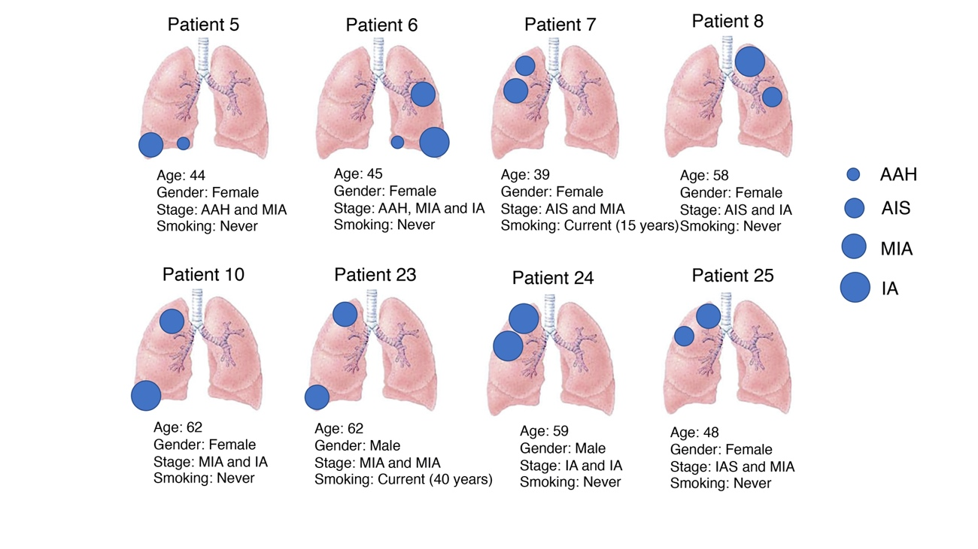
Fig. S1. Characteristics of 8 lung cancer patients with multiple nodules included in this study. Patients 5 to 10 represent the discovery cohort, and patients 23 to 25 represent the validation cohort.

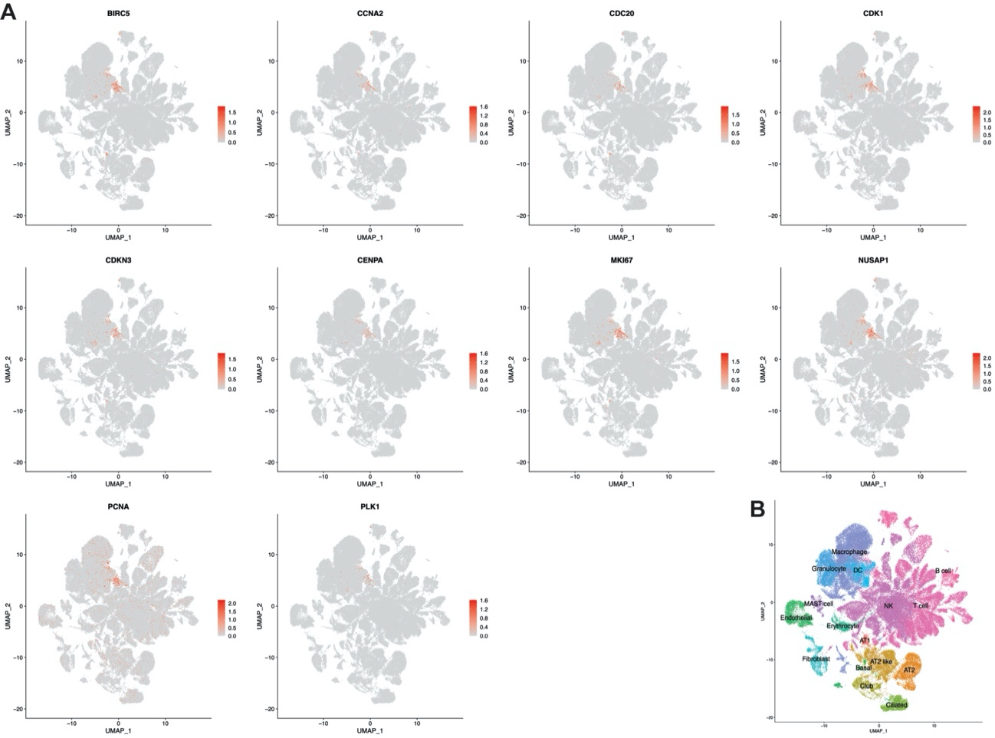
Fig. S2. Distinct cell proliferation markers and color-coded by their associated cluster. (A). Expression of cell proliferation markers in single cell transcriptomic profile. (B). UMAP visualization of the 16 major cell types identified and color-coded by their associated cluster for reference.

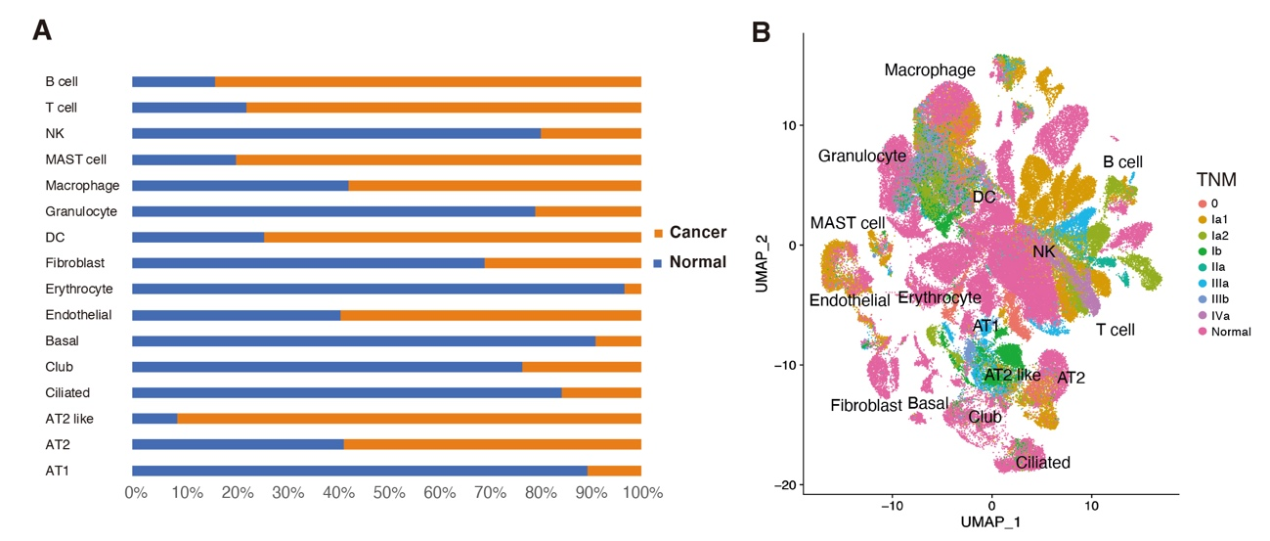
Fig. S3. Characterize the single cell transcriptomic profile of LUAD samples. (A). The percentage of each of the cell types from cancer and normal tissues. (B). UMAP visualization of 16 major cell types identified and color-coded by TNM stages.

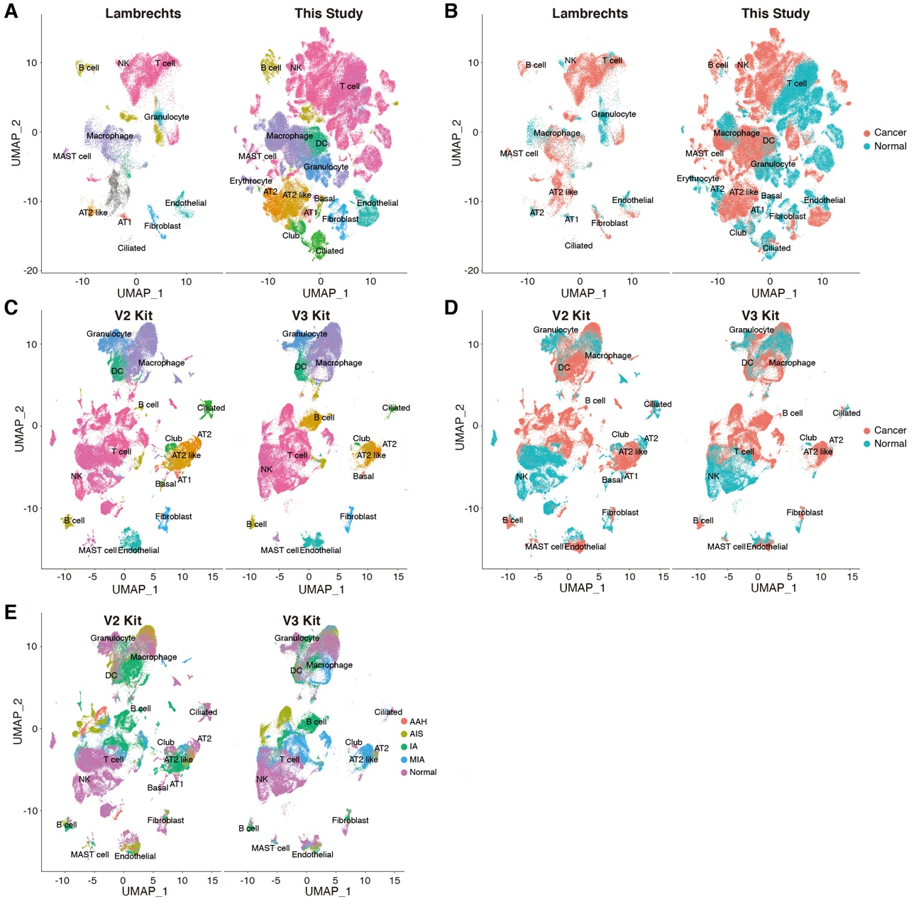
Fig. S4. Compare our data with two LUAD data from Lambrechts. (A). Transcriptomic identification of major cell types identified in Lambrechts et al and our study visualized by UMAP (NA: cancer cells from patients 6 and 7 identified in Lambrechts et al study); (B). UMAP visualization of major cell types from tumor and normal tissue. (C). UMAP visualization of the major cell types identified from patient samples processed by 10X Chromium V2 or V3 kits; (D) UMAP visualization of cell types from cancer and normal tissues; (E). UMAP visualization of cell types by clinicopathological stages.
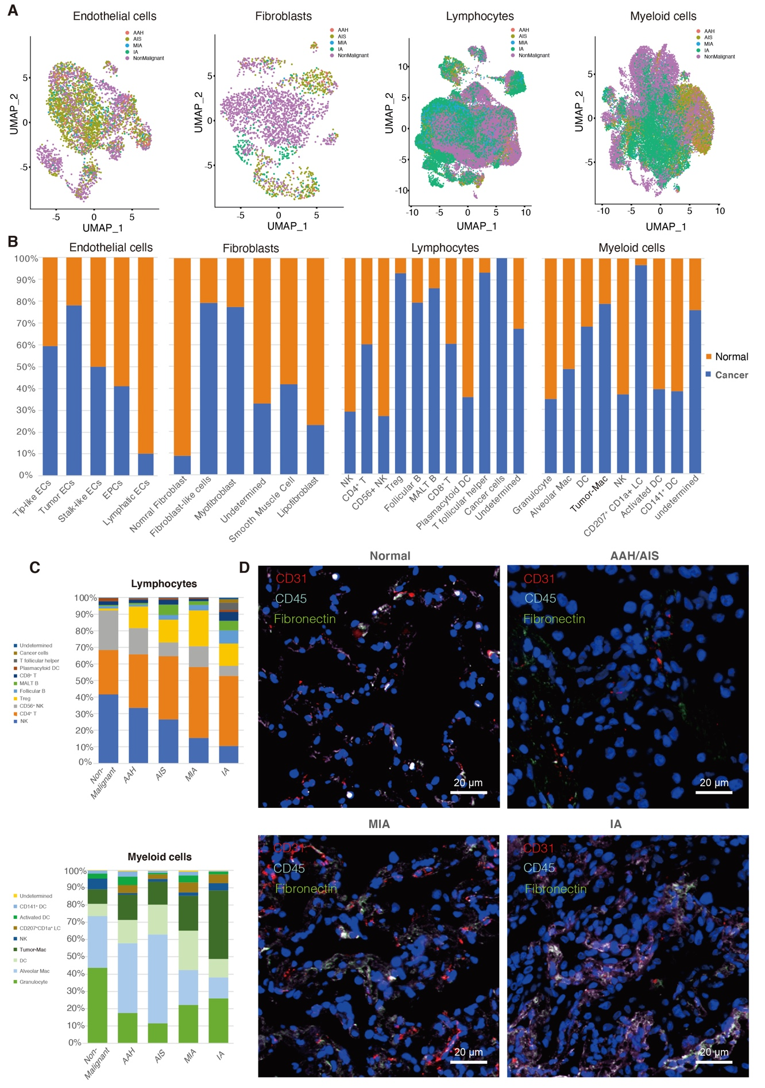
Fig. S5. Identification and characterization of stromal cell subtypes. (A). UMAP visualization of stromal and immune cells color-coded by clinicopathological stages. (B). The proportion of cells originating from different sample types of origin (tumor or non-malignant tissue) in the stromal and immune cell cluster subtypes. (C). The percentage of lymphocyte and myeloid cells present in their respective clusters stratified by clinicopathological stage. (D). Simultaneous immunofluorescence for ECs (CD31, red), immune cells (CD45, gray) and fibroblasts (fibronectin, green) in normal tissues and tumor tissues from different clinicopathological stages.

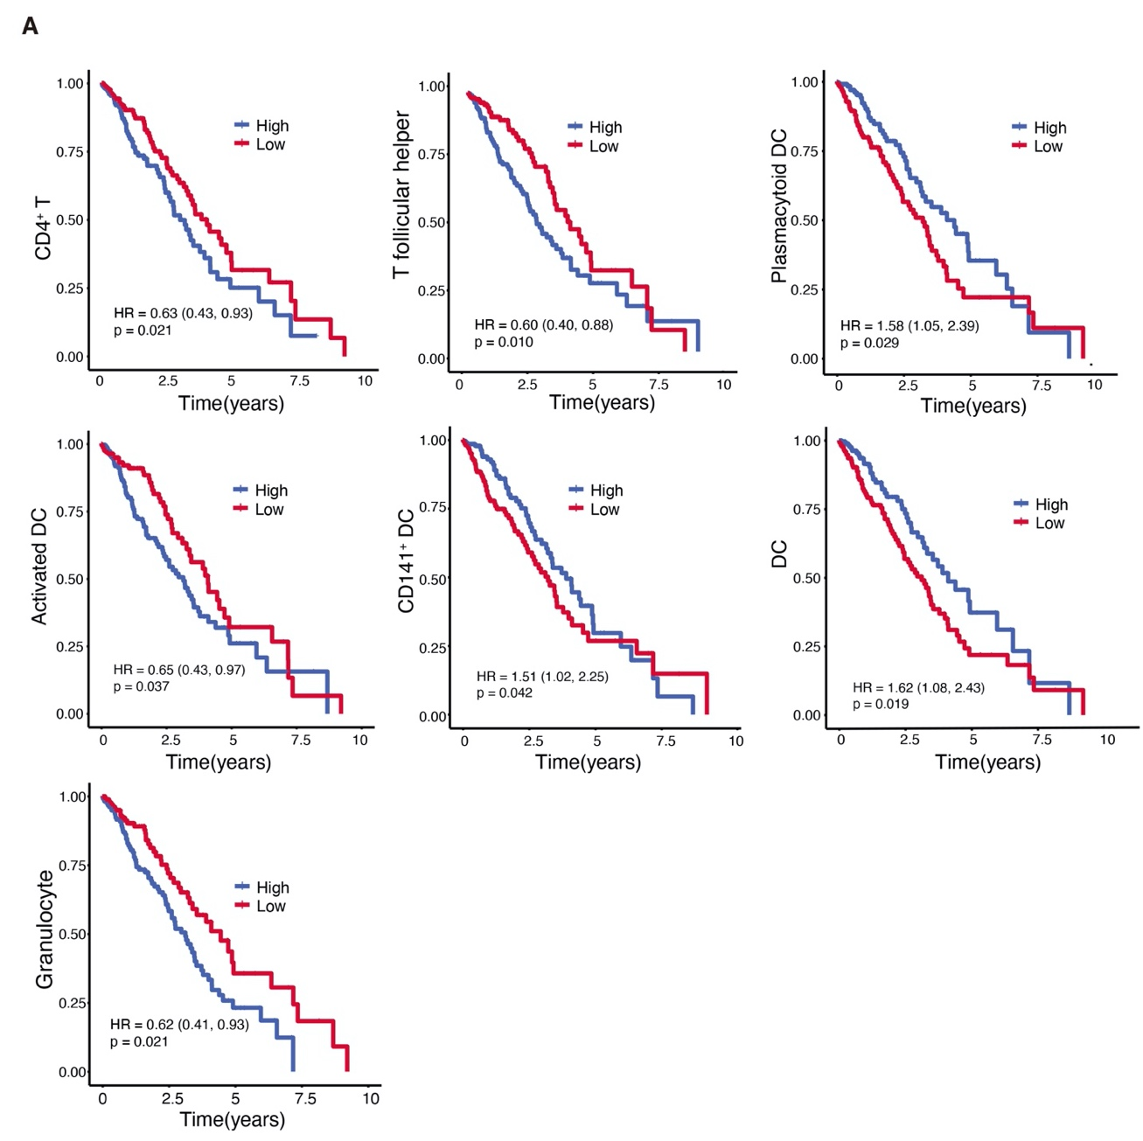
Fig. S6. Association between gene expression of subclusters in LUAD and patient survival. Kaplan–Meier survival curves for patients with LUAD (n=515) stratified for high versus low expression of markers genes (delineated by the respective median values) in specific cell subtypes among all the patients. Hazard ratios (HRs), with their 95% confidence intervals in brackets, and Cox regression P values obtained after correcting for age, sex, and tumor stage are shown.
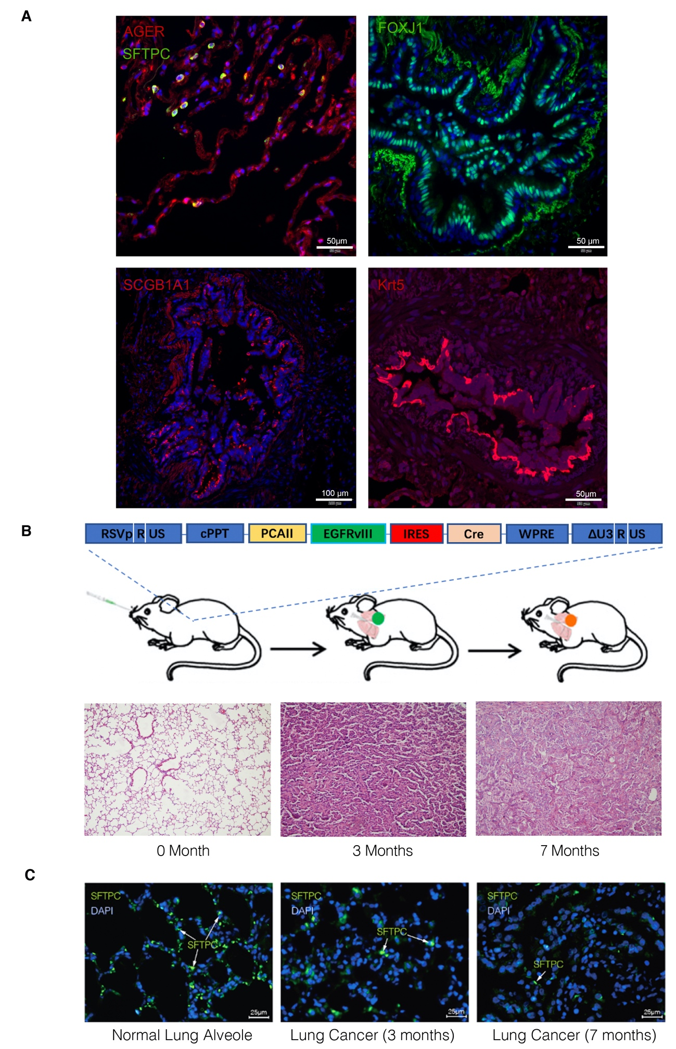
Fig. S7. Immunofluorescence confirmation of epithelial cell marker in human and mouse tumor samples. (A). Protein immunostaining of markers for AT1 cells (AGER, red), AT2 cells (SFTPC, green), ciliated cells (FOXJ1, green), club cells (SCGB1A1, red) and basal cells (Krt5, red) in normal lung resections from LUAD patients. Nuclei (DAPI) are stained blue. (B). Schematic of the lentiviral vector pTomo-EGFRVIII-IRES-Cre, EGFRVIII mice were sacrificed at different times after lentivirus infection. H&E staining of paraffin-embedded sections cut from the tumors showed different lung cancer burdens. (C). Protein fluorescent immunostaining for SFTPC in mouse lung tumor samples. Arrows indicate representative SFTPC protein expression in tumor tissues from different stages. Scale bars: 25μm, nuclei (DAPI) are stained blue.

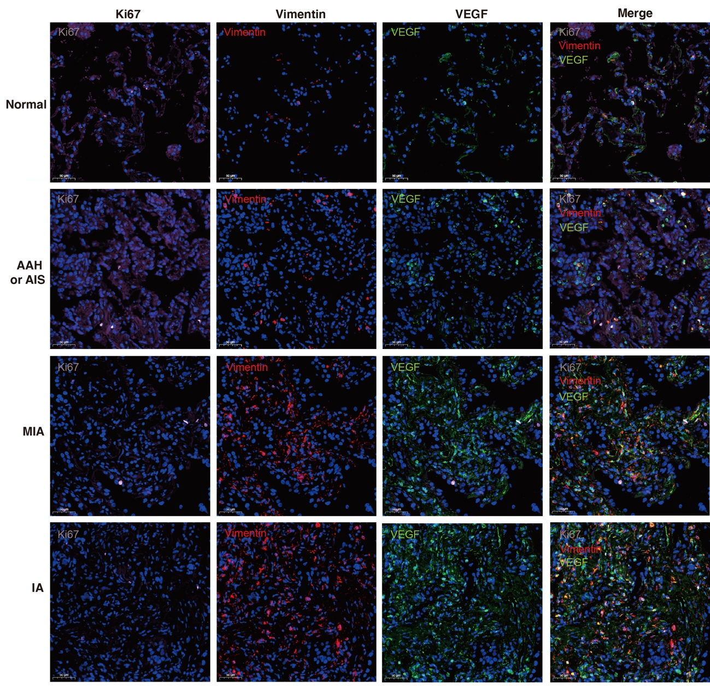
Fig. S8. Validation of gene expression features in human normal tissues and LUAD tissues from different stages. Multiplexed protein immunostaining of Ki67 (cell growth, gray), vimentin (EMT, red), and VEGF (angiogenesis, green) in normal tissues and tumor tissues from different stages. Scale bars: 50 μm, nuclei (DAPI) are stained blue.

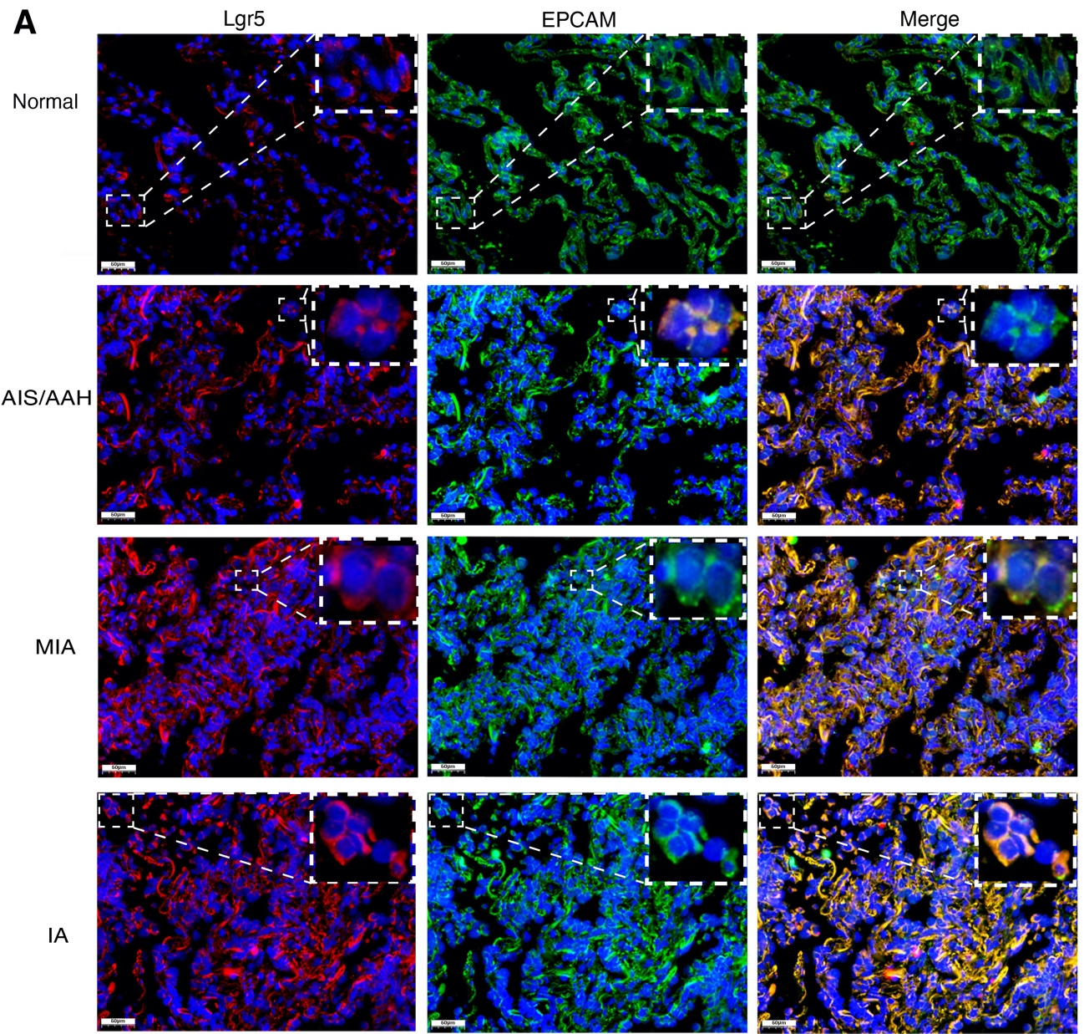
Fig. S9. Multiplexed fluorescent in situ hybridization staining of Lgr5 (red) and Epcam (green) in normal tissues and tumor tissues from different stages. Scale bars: 50μm, nuclei (DAPI) are stained blue.

