Supplemental materials

Table S1 Primary tumor parameters comparison
PT location | Parameters | PTs (N0-group) | PTs (non-N0 group) | P value
Cervical | K_{i}  SUV_{max} | 0.04 ± 0.01  9.23 ± 3.11  (n = 3) | 0.08 ± 0.05  1.27 ± 0.17  (n = 2) | 0.80  0.80  0.40  0.60  0.20  0.39  0.40  0.20
Upper thoracic | K_{i}  SUV_{max} | 0.04 ± 0.03  6.83 ± 5.51  (n = 4) | 0.05 ± 0.03  9.15 ± 4.26  (n = 3) | 0.80  0.80  0.40  0.60  0.20  0.39  0.40  0.20
Middle thoracic | K_{i}  SUV_{max} | 0.03 ± 0.03  7.14 ± 6.23  (n = 16) | 0.04 ± 0.01  6.79 ± 2.17  (n = 11) | 0.80  0.80  0.40  0.60  0.20  0.39  0.40  0.20
Lower thoracic  & Abdominal | K_{i}  SUV_{max} | 0.03 ± 0.02  4.95 ± 1.61  (n = 3) | 0.04 ± 0.02  8.16 ± 3.92  (n = 4) | 0.80  0.80  0.40  0.60  0.20  0.39  0.40  0.20
Total  (Mean ± SD) | K_{i}  SUV_{max} | 0.03 ± 0.03  7.08 ± 5.39 | 0.04 ± 0.02  8.01 ± 3.90 | 0.07  0.16
Total No. |  | 26 | 20

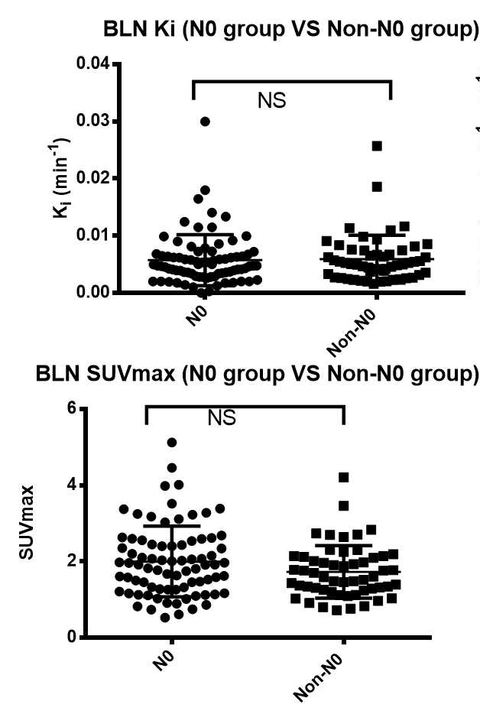
Fig. S1 There were no difference FDG uptake between N0 and non-N0 stage for BLN Comparison of K_{i}, SUV_{max} in benign lymph nodes (BLN) between N0 stage and non-N0 stage; p > 0.05 (non-significant difference, NS).

