Table 1 1,2,3-Benzotriazinone Sulfonamides and their reaction conditions
Sr. No. | Reactants | Products | Time | Yield  (%)
1. | 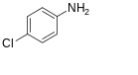 | 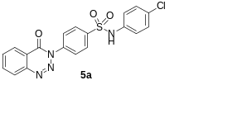 | 24h | 75
2. | 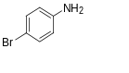 | 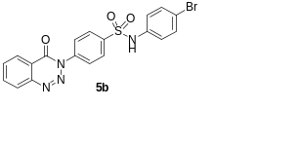 | 24h | 85
3. | 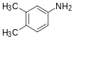 | 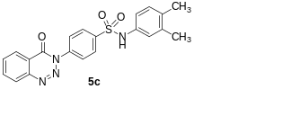 | 24h | 64
4. | 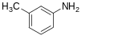 | 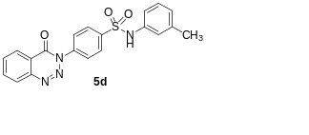 | 24h | 78
5. | 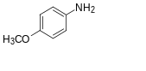 | 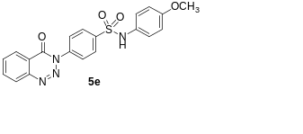 | 24h | 79
6. | 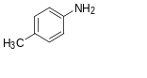 | 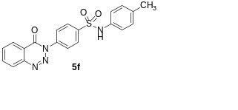 | 24h | 72
7. | 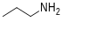 | 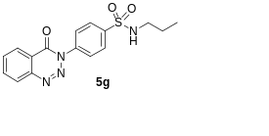 | 24h | 85
8. | 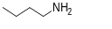 | 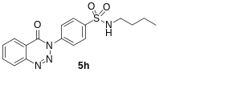 | 24h | 79
9. | 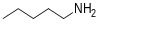 | 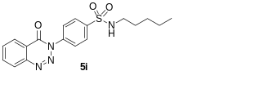 | 24h | 77
10. | 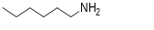 | 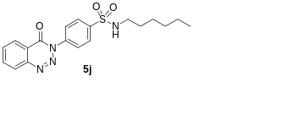 | 24h | 71
11. | 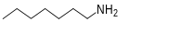 | 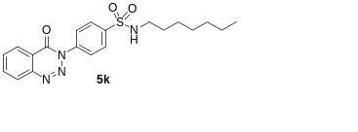 | 24h | 73
12. | 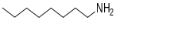 | 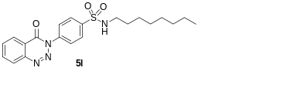 | 24h | 74
13. | 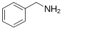 | 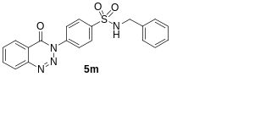 | 24h | 74

