Synthesis of 1,2,3-Benzotriazin-4(3H)-one derivatives as α-glucosidase inhibitor and their in-silico study
Zunera Khalid^{1,2}, Syed S. Shafqat³, Hafiz A. Ahmad², Hafiz Muzzamil⁴, Munawar A. Munawar^{2,5}, Matloob Ahmad⁶, Abdullah M. A. Asiri^{7,} Muhammad Ashraf⁸
¹Department of Chemistry, Kinnaird College for Women, Lahore, Pakistan
²School of Chemistry, University of the Punjab, Lahore, Pakistan
³Department of Chemistry, University of Education, Township, Lahore, Pakistan
⁴School of Biochemistry and Biotechnology, University of the Punjab, Lahore, Pakistan
⁵Department of Chemistry, University of the Central Punjab, Lahore, Pakistan
⁶Department of Chemistry, Government College University, Faisalabad, Pakistan
⁷Department of Chemistry, King Abdul Aziz University, Jeddah, Saudi Arabia
⁸Department of Biochemistry and Biotechnology, The Islamia University of Bahawalpur, Bahawalpur, Pakistan
Sulfonamide compounds found as alpha glucosidase inhibitor

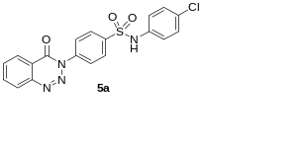 | 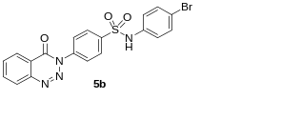 | 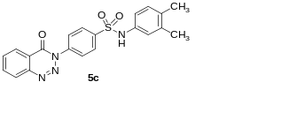
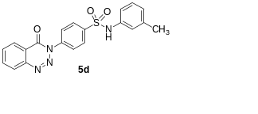 | 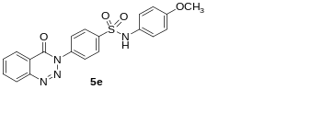 | 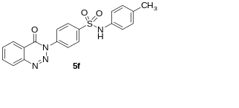
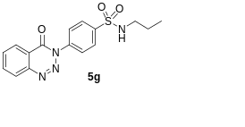 | 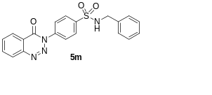 | 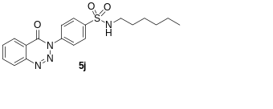

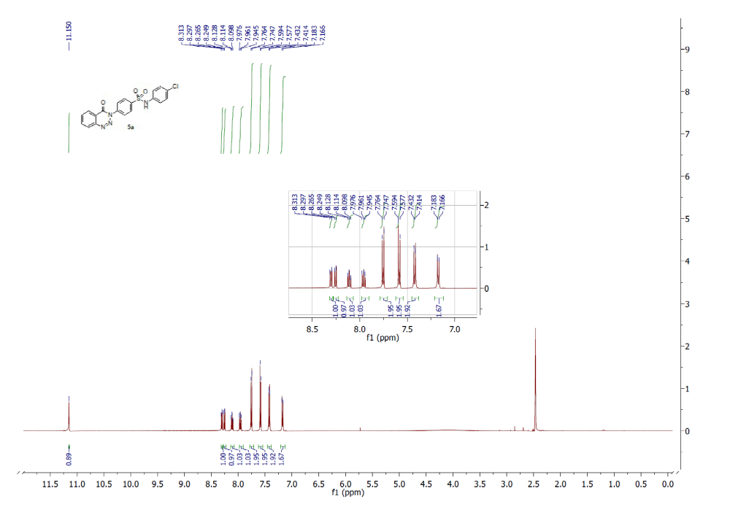
Fig. 1: ¹H-NMR of 5a

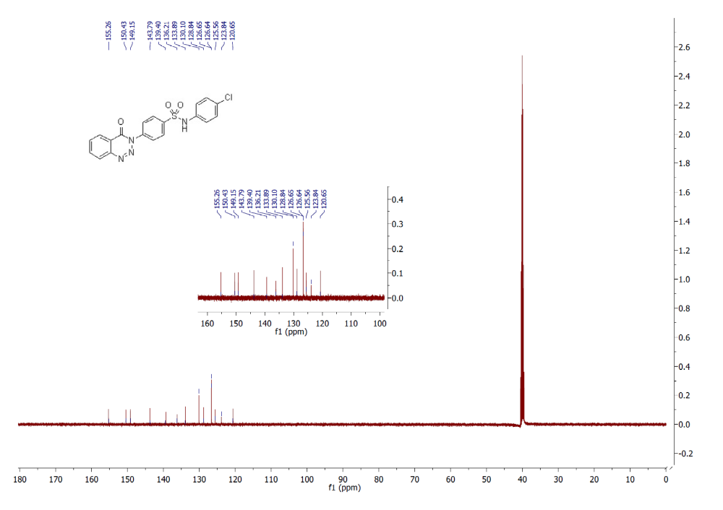
Fig. 2: ¹³C-NMR of 5a

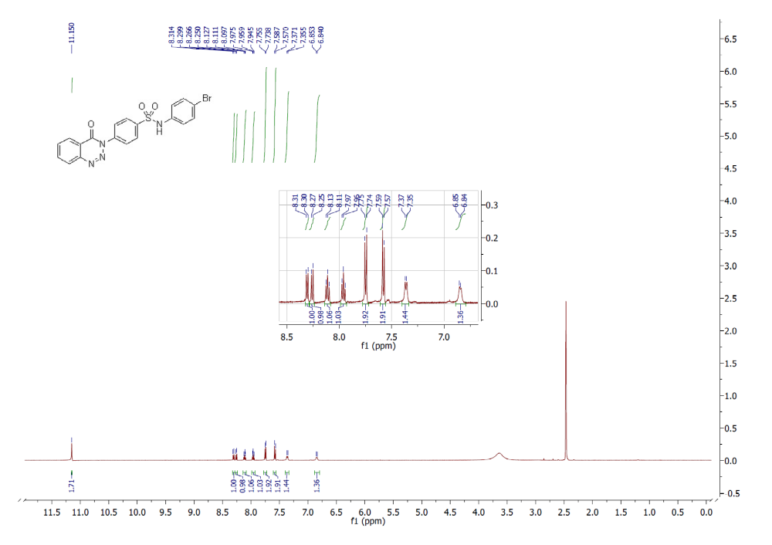
Fig. 3: ¹H-NMR of 5b
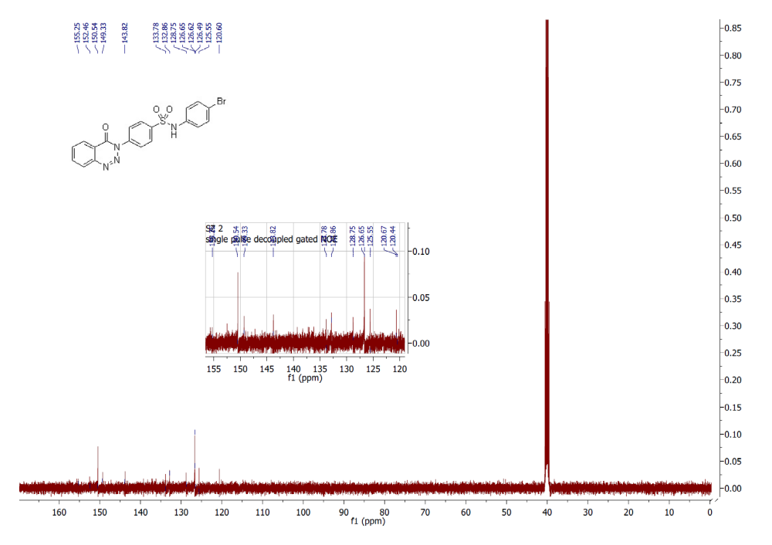
Fig. 4: ¹³C-NMR of 5b

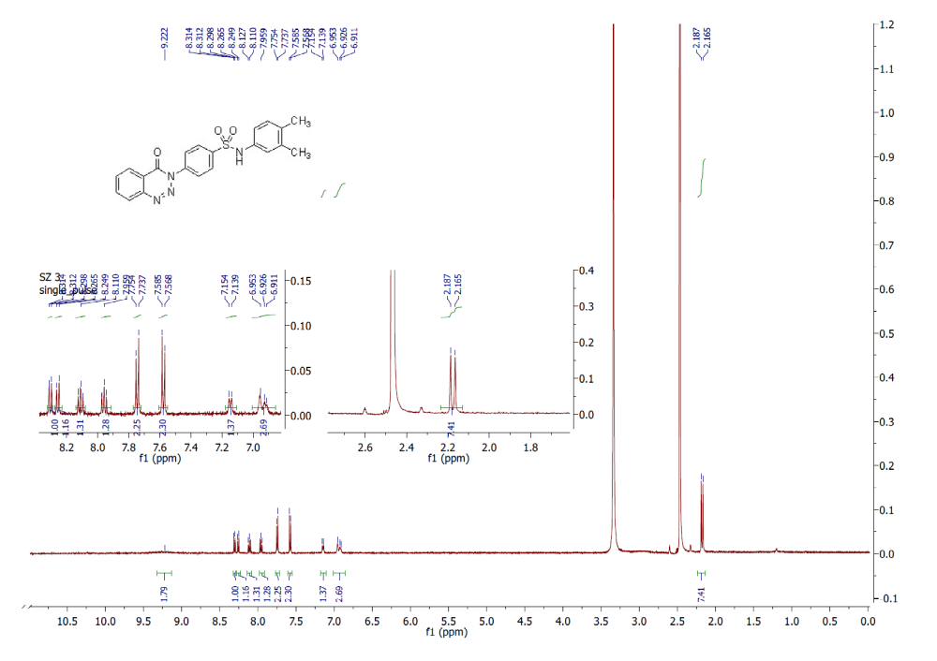
Fig. 5: ¹H-NMR of 5c

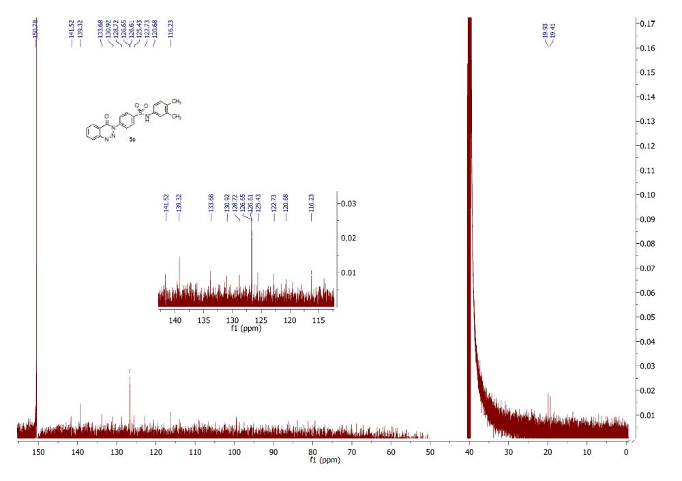
Fig. 6: ¹³C-NMR of 5c
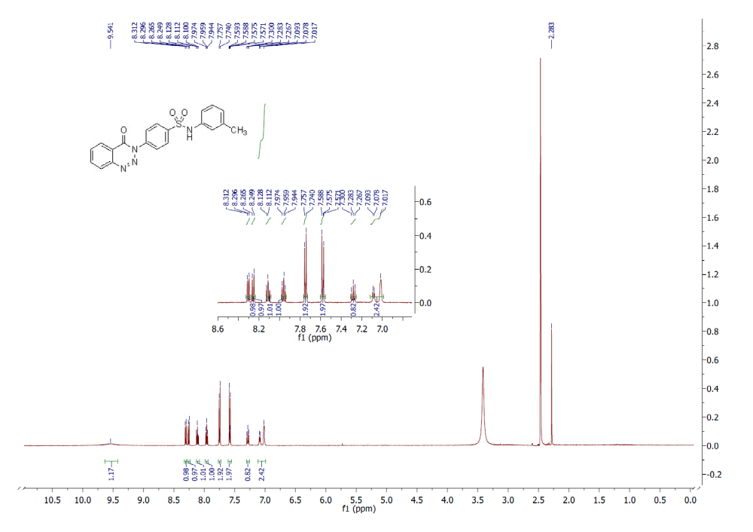
Fig. 7: ¹H-NMR of 5d

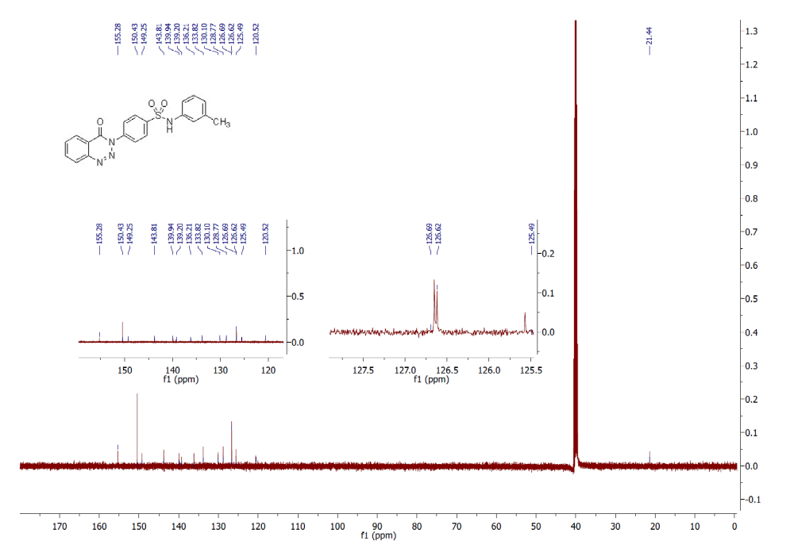
Fig. 8: ¹³C-NMR of 5d

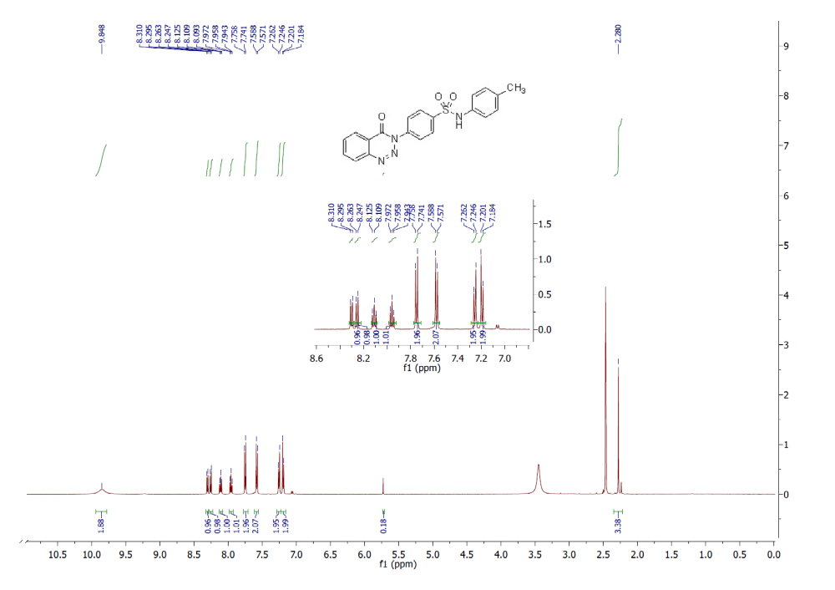
Fig. 9: ¹H-NMR of 5e

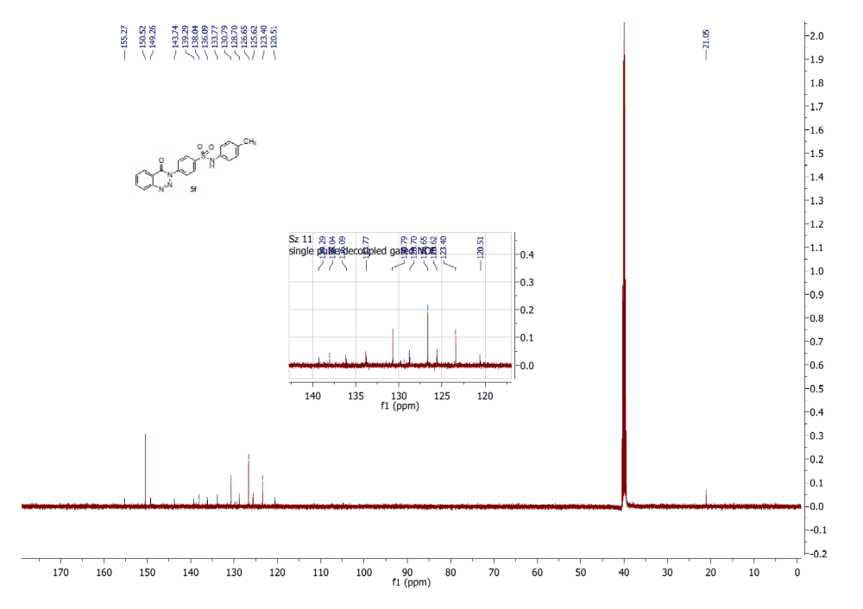
Fig. 10: ¹³C-NMR of 5e
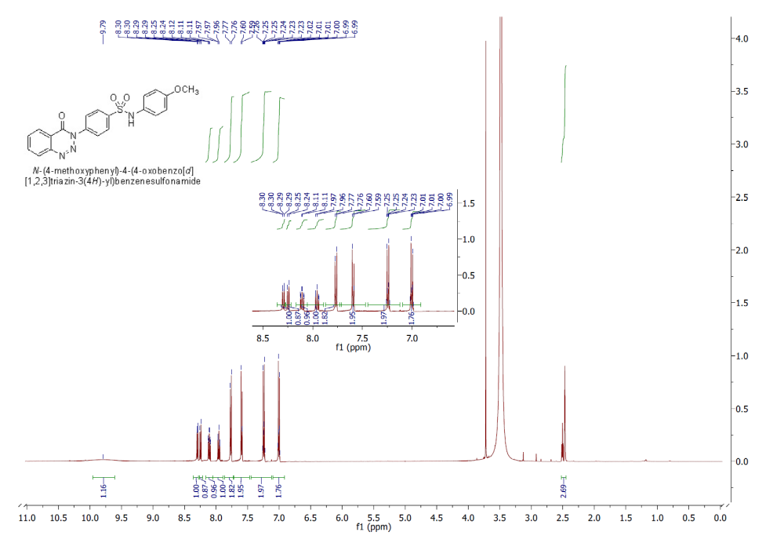
Fig. 11: ¹H-NMR of 5f

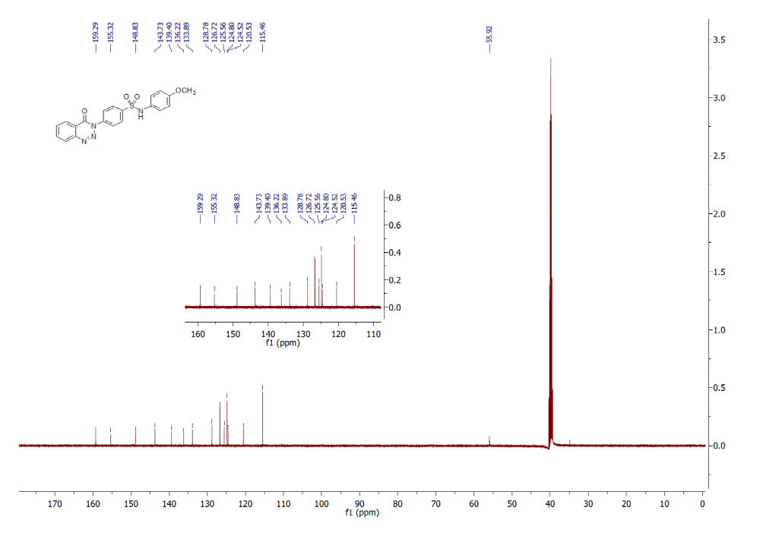
Fig. 12: ¹³C-NMR of 5f
Fig. 13: ¹H-NMR of 5g
Fig. 14: ¹H-NMR of 5i

Fig. 15: ¹H-NMR of 5j
Fig. 16: ¹³C-NMR of 5j
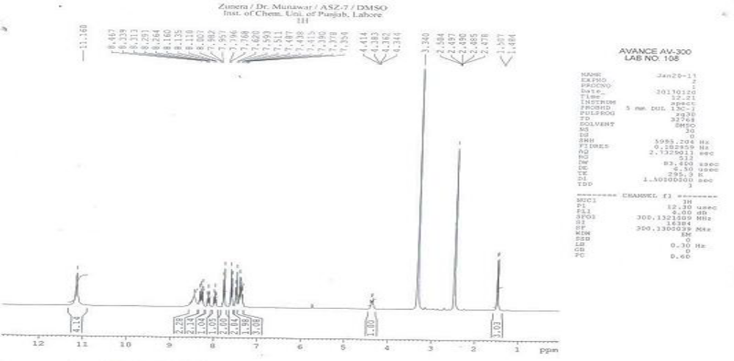
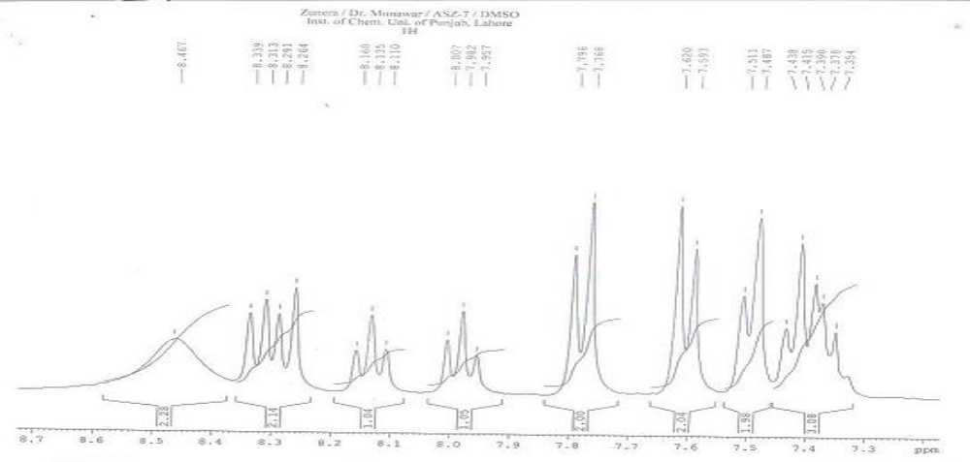
Fig. 17: ¹H-NMR of 5m

Fig. 18: ¹³C-NMR of 5m

