Supplymentary information

Decoration of graphene oxide with Cobalt(II) coordinated silica and its catalytic activity for the synthesis of functionalized Indenopyrazolones
Mahnaz Mirheidari and Javad Safaei-Ghomi*
Department of Organic Chemistry, Faculty of Chemistry, University of Kashan, Kashan, P.O. Box 87317-51167, I. R. Iran.
Corresponding Author Tel.: +98 31 55912385; fax: +98 31 55552935; *E-mail: safaei@kashanu.ac.ir

General procedure for the synthesis of cis-3-aryl-3a,8b-dihydro-3a,8b-dihydroxy-1 phenylindeno[1,2-c]pyrazol-4(1H)-ones
A mixture of aldehyde (1 mmol) and phenylhydrazine (1 mmol) and 15 mol% f-SiO₂@GO@Co as a catalyst in ethanol (5 ml) were stirred at 60ºC until an intermediate was formed. Next, ninhydrin (1 mmol) was added to the mixture reaction and allowed to stir until the completion of reaction (monitoring by TLC). After that, the heterogeneous catalyst was separated and the crude product was collected and washed with n-hexane and ethyl acetate to achieve the pure final product.

Results
Cis-3a,8b-Dihydro-3a,8b-dihydroxy-3-(4-Nitrophenyl)-1-phenyl-indeno[1,2-c]pyrazol-4(1H)-one(4a):
Yellow solid; m.p. 235-237 ºC
IR (KBr): ʋ = 3410, 1725, 1594,1528, 1493 cm⁻¹
¹H NMR (400 MHz, DMSO-d6): δ= 8.34-8.30 (d, J = 8.8 Hz, 2H), 8.28-8.24(d, J = 8.8 Hz, 2H), 8.07 (s, OH), 7.82-7.78 (d, J = 8.1 Hz, 2H), 7.76-7.72 (m, 2H), 7.68 (d, J = 8.0 Hz, 1H), 7.58 (t, J = 7.6 Hz, 1H), 7.43-7.38 (t, J = 8.0 Hz, 2H), 7.29 (s, OH), 7.09 (t, J = 7.6 Hz, 1H).

Cis-3a,8b-Dihydro-3a,8b-dihydroxy-3-(4-Chlorophenyl)-1-phenyl-indeno[1,2-c]pyrazol-4(1H)-one (4b):
Yellow solid, m.p. 229-232 ºC
IR (KBr): ʋ= 3273, 1701, 1595, 1489 cm⁻¹
¹H NMR (400 MHz, DMSO-d6): δ= 8.10-8.07 (d, J = 8.3 Hz, 2H), 7.84 (s, OH), 7.76-7.69 (m, 4H), 7.65 (d, J = 8 Hz, 1H), 7.54 (t, J = 7.2 Hz, 1H), 7.48-7.44 (d, J = 8.3 Hz, 2H), 7.39-7.34 (t, J = 8 Hz, 2H), 7.14 (s, OH), 7.03(t, J = 7.5 Hz, 1H).

Cis-3a,8b-Dihydro-3a,8b-dihydroxy-3-(4-Bromophenyl)-1-phenyl-indeno[1,2-c]pyrazol-4(1H)-one (4c):
Yellow solid; m.p. 222-225 ºC
IR (KBr): ʋ= 3307, 3073, 1701, 1595, 1489 cm⁻¹
¹H NMR (400 MHz, DMSO-d6): δ= 8.10-8.07 (d, J = 8.3 Hz, 2H), 7.97 (s, OH), 7.76-7.69 (m, 4H), 7.67-7.64 (d, J = 8 Hz, 1H), 7.55 (t, J = 7.2 Hz, 1H), 7.48-7.44 (d, J = 8.3 Hz, 2H), 7.33-7.25 (t, J = 8 Hz, 2H), 7.14 (s, OH), 7.02 (t, J = 7.5 Hz, 1H).

Cis-3a,8b-Dihydro-3a,8b-dihydroxy-3-(3-Nitrophenyl)-1-phenyl-indeno[1,2-c]pyrazol-4(1H)-one(4d):
Yellow solid; m.p. 242-244 ºC
IR (KBr): ʋ= 3474, 1725, 1596, 1494 cm⁻¹
¹H NMR (400 MHz, DMSO-d6): δ= 8.94 (s, 1H), 8.47 (d, J = 8.0 Hz, 1H), 8.17 (d, J = 8 Hz, 1H), 8.01 (s, OH), 7.81 – 7.72 (m, 4H), 7.69-7.65 (t, J = 6.1 Hz, 2H), 7.58 (t, J = 7.4 Hz, 1H), 7.42-7.36 (t, J = 7.8 Hz, 2H), 7.29 (s, OH), 7.08 (t, J = 7.4 Hz, 1H).

Cis-3a,8b-Dihydro-3a,8b-dihydroxy-3-(4-methylphenyl)-1-phenyl-indeno[1,2-c]pyrazol-4(1H)-one(4e):
Yellow solid; m.p. 253-255 ºC
IR (KBr): ʋ= 3439, 3267, 1707, 1595, 1491cm⁻¹
¹H NMR (400 MHz, DMSO-d6): δ= 7.99-7.96 (d, J = 7.9 Hz, 2H), 7.75 – 7.67 (m, 5H), 7.63(d, J = 7.9 Hz, 1H), 7.54 (t, J = 7.5 Hz, 1H), 7.39-7.33 (t, J = 7.2 Hz, 2H), 7.22-7.16 (d, J = 7.5Hz, 2H), 7.03 (s, OH), 6.99 (d, J = 6.7 Hz, 1H), 2.31 (s, 3H).

Cis-3a,8b-Dihydro-3a,8b-dihydroxy-3-(4-methoxyphenyl)-1-phenyl-indeno[1,2-c]pyrazol-4(1H)-one (4f):
Orange solid; m.p. 210-213 ºC
IR (KBr): ʋ= 3426, 1708, 1596, 1492 cm⁻¹
¹H NMR (400 MHz, DMSO): δ= 8.05-8.01 (d, J = 8.4 Hz, 2H), 7.73 – 7.68 (m, 5H), 7.63 (m, 1H), 7.54 (t, J = 6.2 Hz, 1H), 7.37-7.32 (t, J = 7.1 Hz, 2H), 7.04-6.94 (m, 4H), 3.78 (s, 3H).

Cis-3a,8b-Dihydro-3a,8b-dihydroxy-3-(2-hydroxyphenyl)-1-phenyl-indeno[1,2-c]pyrazol-4(1H)-one(4g):
Yellow solid; m.p. 190-193 ºC
IR (KBr): ʋ= 3392, 1724, 1595, 1491cm⁻¹
¹H NMR (400 MHz, DMSO): δ =10.4 (s, OH), 8.29 (d, J = 8 Hz, CH), 7.90 (s, OH), 7.75-–7.69 (m, 2CH), 7.58– 7.55 (m, 3CH), 7.51 (d, J = 7.9 Hz, 1H), 7.44-7.39 (t, J = 8 Hz, 2CH), 7.34 (s, OH), 7.24 (t, J = 8 Hz, 1H), 7.11 (t, J = 7.2 Hz, 1H), 6.96 (t, J = 7.2 Hz, 1H), 6.89 (d, J = 8.1 Hz, 1H).

cis-3a,8b-Dihydro-3a,8b-dihydroxy-1,3-diphenylindeno[1,2-c]pyrazol-4(1H)-one(4h):
Yellow solid; m.p. 219-222 ºC
IR (KBr): ʋ=3430, 1706, 1594,1491 cm⁻¹; ¹H NMR (400 MHz, DMSO-d6): δ= 8.12-8.07 (d, J = 8 Hz, 2H), 7.77-7.72 (d, J = 8.0 Hz, 2H), 7.69-7.62 (m, 3H), 7.52-7.48 (t, J = 7.2 Hz, 2H), 7.38 – 7.26 (m, 6H), 6.97(t, J = 7.2 Hz, 1H).

Cis-3a,8b-Dihydro-3a,8b-dihydroxy-3-(2-Nitrophenyl)-1-phenyl-indeno[1,2-c]pyrazol-4(1H)-one(4i):
Yellow solid; m.p. 165-168 ºC
IR (KBr): ʋ=3461, 1710, 1597, 1530 cm⁻¹
¹H NMR (400 MHz, DMSO-d6)= δ=8.38 (d, J = 8 Hz, 1H), 7.93(s, OH), 7.78-7.69 (m, 4H), 7.61 – 7.50 (m, 5H), 7.40-7.34 (t, J = 8 Hz, 2H), 7.31 (s, OH), 7.06 (t, J = 7.2 Hz, 1H)
¹³C NMR (DMSO): δ =196.63 (C=O), 148.54 (C), 147.60 (C), 141.732 (C), 137.56 (C), 137.24 (C), 136.78 (C), 134.34 (CH), 130.99 (CH), 130.76 (CH), 129.93 (CH), 129.04 (2CH), 125.35 (CH), 123.88 (CH), 123.28 (CH), 123.24 (CH), 122.74 (CH), 117.49 (2CH), 96.06 (C), 89.12 (C).

Cis-3a,8b-Dihydro-3a,8b-dihydroxy-3-(2,3-dihydroxyphenyl)-1-phenyl-indeno[1,2-c]pyrazol-4(1H)-one (4j):
Yellow solid; m.p. 222-224 ºC
IR (KBr): 3473, 3365,1726, 1598, 1494 cm⁻¹
¹H NMR (400 MHz, DMSO): δ =10.45 (s, OH), 8.91 (s, OH), 7.89 (s, OH), 7.78– 7.66 (m, 3H), 7.6– 7.54 (m, 3H), 7.50 (d, J = 6.9 Hz, 1H), 7.45 – 7.39 (dd, J=6.8, 2H), 7.32 (s, 1H), 7.18 – 7.07 (m, 1H), 6.81 – 6.71 (m, 2H)
¹³C NMR (DMSO-d6): δ =197.00 (C), 156.40 (C), 147.51 (C), 145.34 (C), 141.28 (C), 136.84 (C), 134.19 (C), 130.77 (C), 129.98 (CH), 129.34 (2CH), 129.25 (CH), 125.39 (CH), 123.42 (CH), 122.91 (CH), 118.89 (CH), 117.73 (2CH), 116.06 (CH), 115.08(CH), 94.71 (C), 89.66 (C).

Cis-3a,8b-Dihydro-3a,8b-dihydroxy-3-(2-hydroxy-5-Bromo-phenyl)-1-phenyl-indeno[1,2-c]pyrazol-4(1H)-one (4k):
Yellow solid, m.p. 226-228 ºC
IR (KBr): 3324, 3192, 1735, 1597, 1488 cm⁻¹
¹H NMR (400 MHz, DMSO): δ =10.47 (s, OH), 8.43 (s, 1H), 8.03 (s, 1H), 7.77 (d, J = 7.6 Hz, 1H), 7.72 (d, J = 7.6 Hz, 1H), 7.62-7.56 (t, J = 6.9 Hz, 3H), 7.53 (d, J = 8 Hz, 1H), 7.45-7.36 (m, 4H), 7.12 (t, J = 7.2 Hz, 1H), 6.87 (d, J = 8.3Hz, 1H).
¹³C NMR (DMSO-d₆): δ= 196.83 (C=O), 155.50 (C), 147.53 (C), 143.57 (C), 141.00(C), 137.00 (C),134.13(C), 132.19 (C), 131.14 (CH), 130.85 (CH), 129.28 (2CH), 125.40 (CH), 123.58 (CH), 123.22 (CH), 118.33 (CH), 117.93 (2CH), 117.10 (CH), 110.15 (CH), 94.80 (C), 89.27 (C).

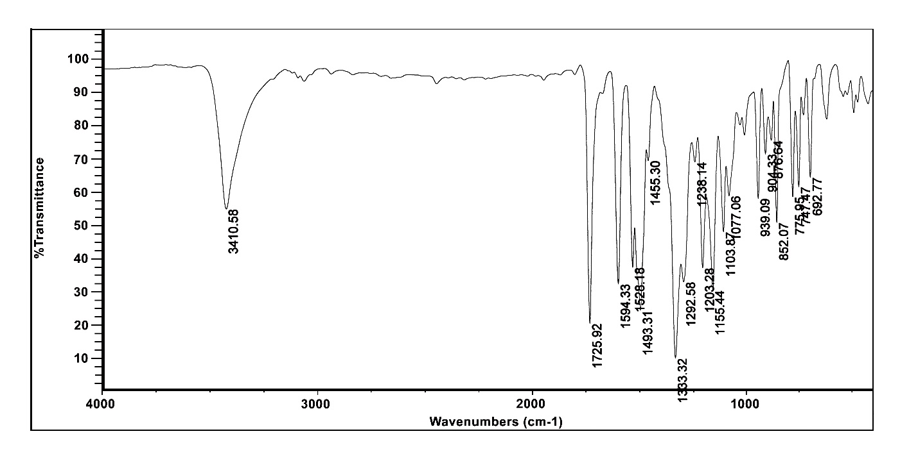
Figure S1. FT-IR spectrum of compound 4a.
Figure S2. ¹H NMR spectrum of compound 4a.
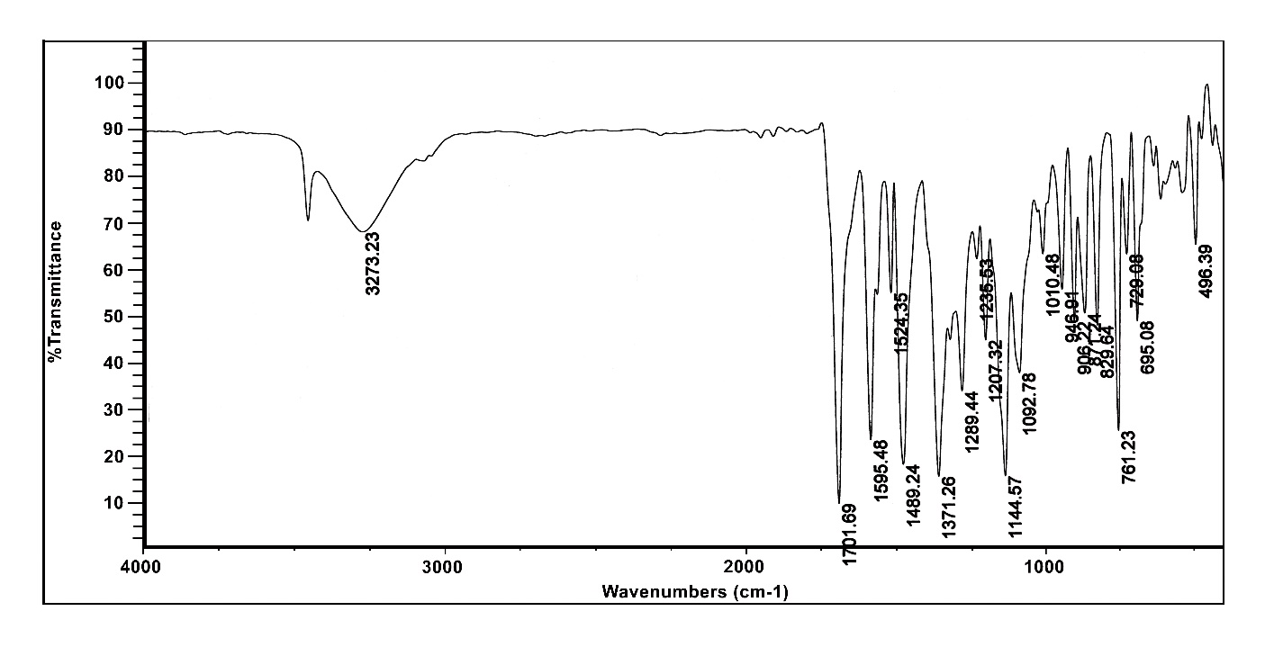
Figure S3. FT-IR spectrum of compound 4b.
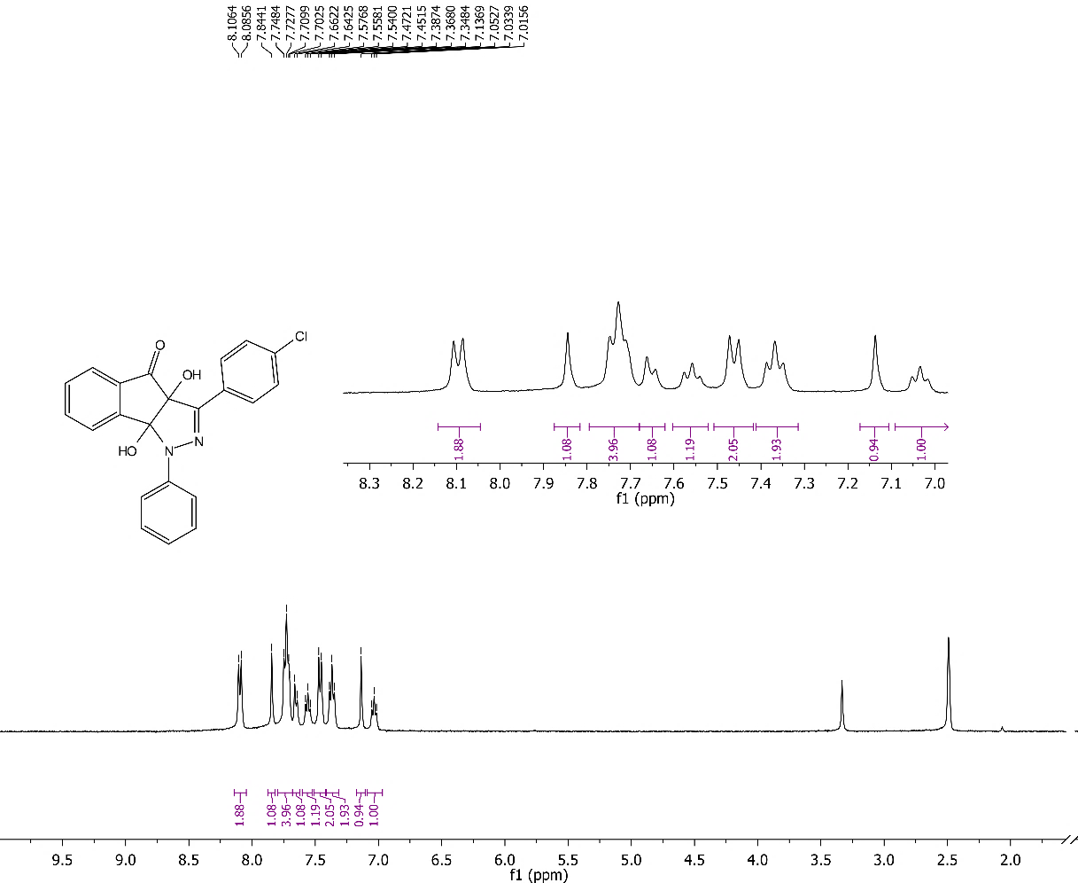
Figure S4. ¹H NMR spectrum of compound 4b.
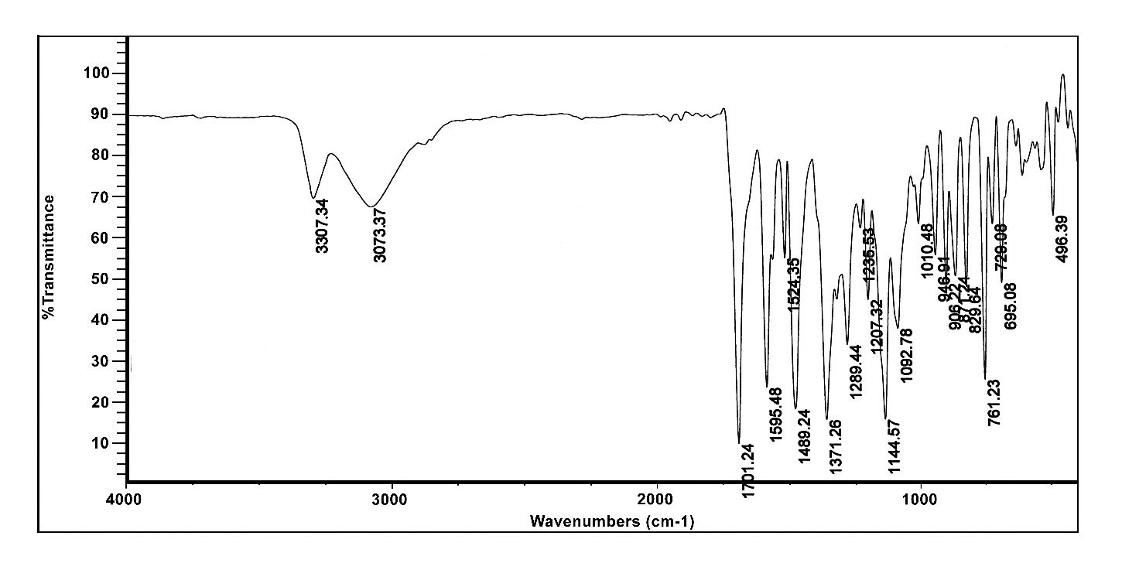
Figure S5. FT-IR spectrum of compound 4c.
Figure S6. ¹H NMR spectrum of compound 4c.
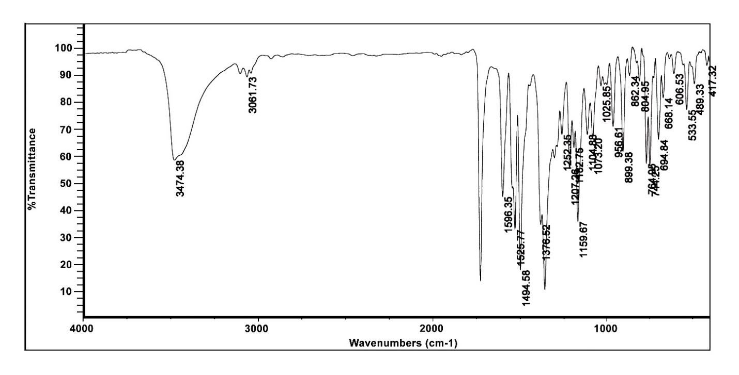
Figure S7. FT-IR spectrum of compound 4d.
Figure S8. ¹H NMR spectrum of compound 4d.
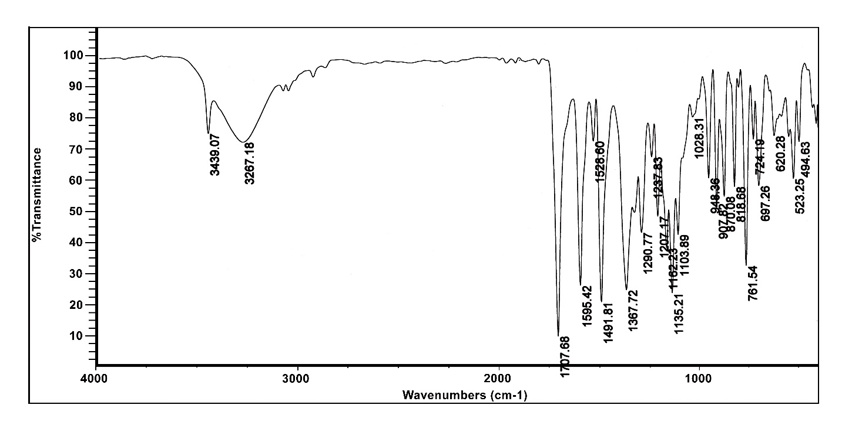
Figure S9. FT-IR spectrum of compound 4e.
Figure S10. ¹H NMR spectrum of compound 4e.

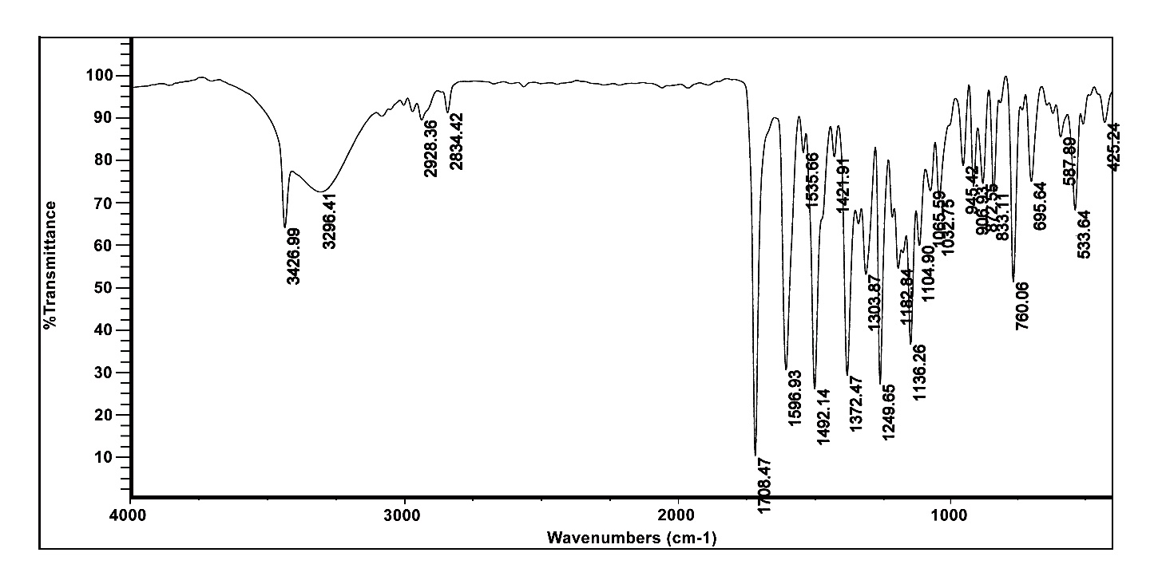
Figure S11. FT-IR spectrum of compound 4f.
Figure S12. ¹H NMR spectrum of compound 4f.
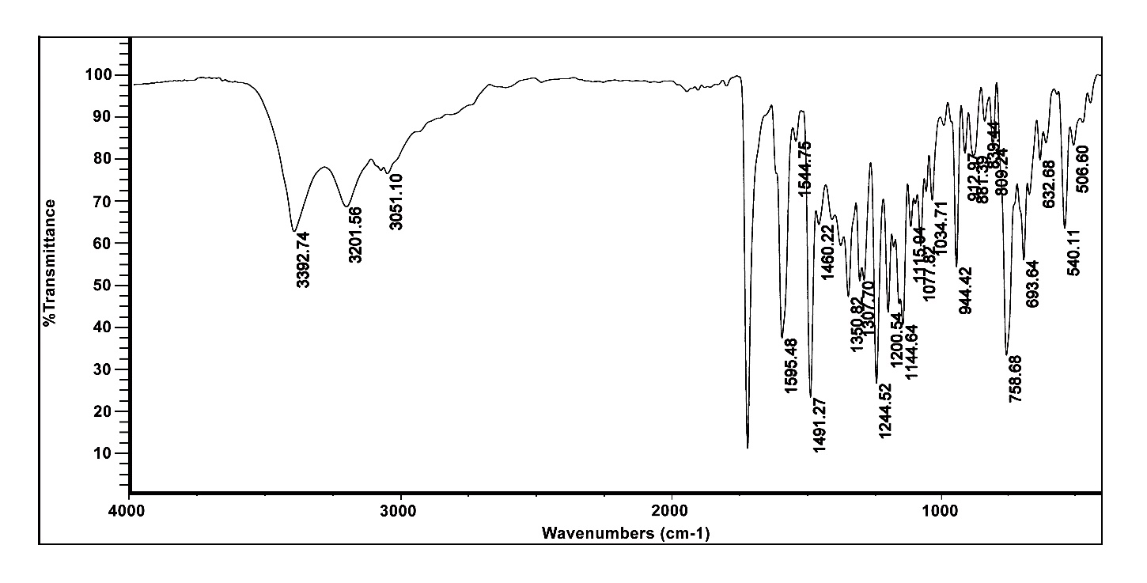
Figure S13. FT-IR spectrum of compound 4g.
Figure S14. ¹H NMR spectrum of compound 4g.
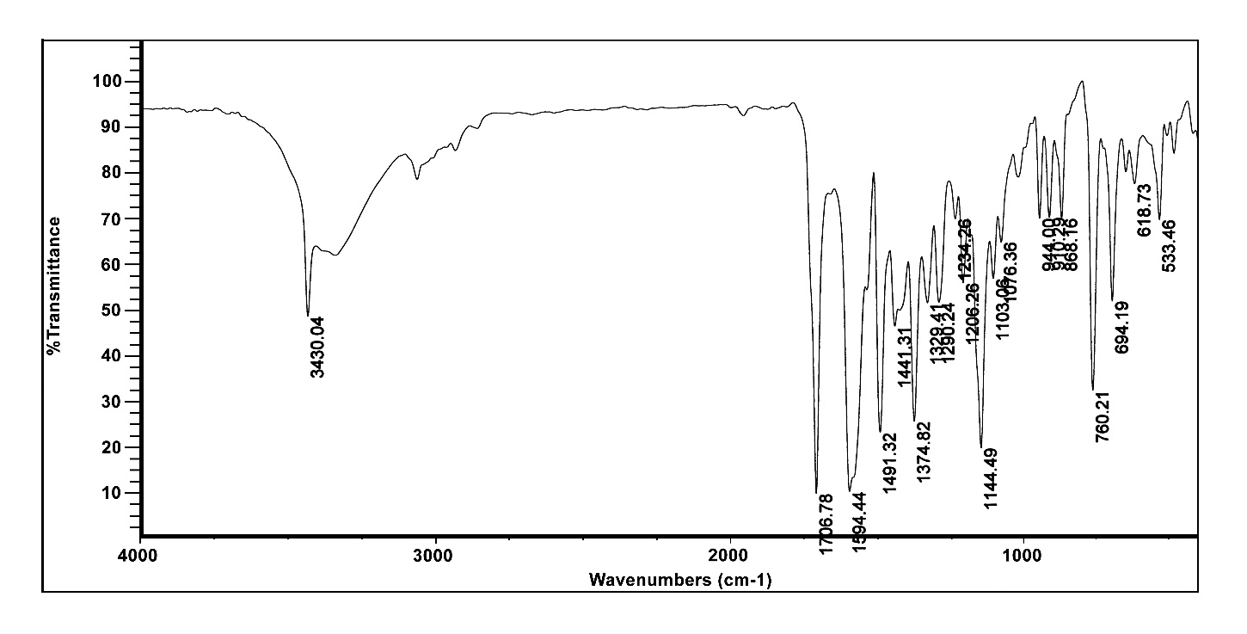
Figure S15. FT-IR spectrum of compound 4h.
Figure S16. ¹H NMR spectrum of compound 4h
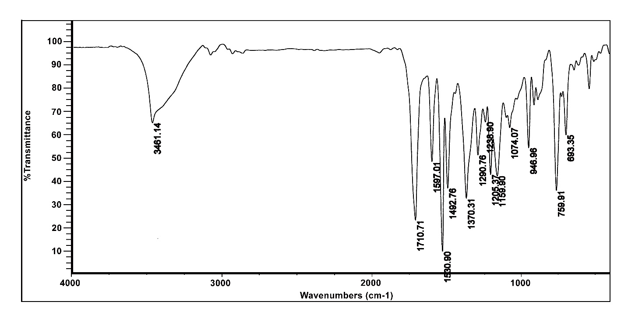
Figure S17. FT-IR spectrum of compound 4i

Figure S18. ¹H NMR spectrum of compound 4i
Figure S19. ¹³C NMR spectrum of compound 4i

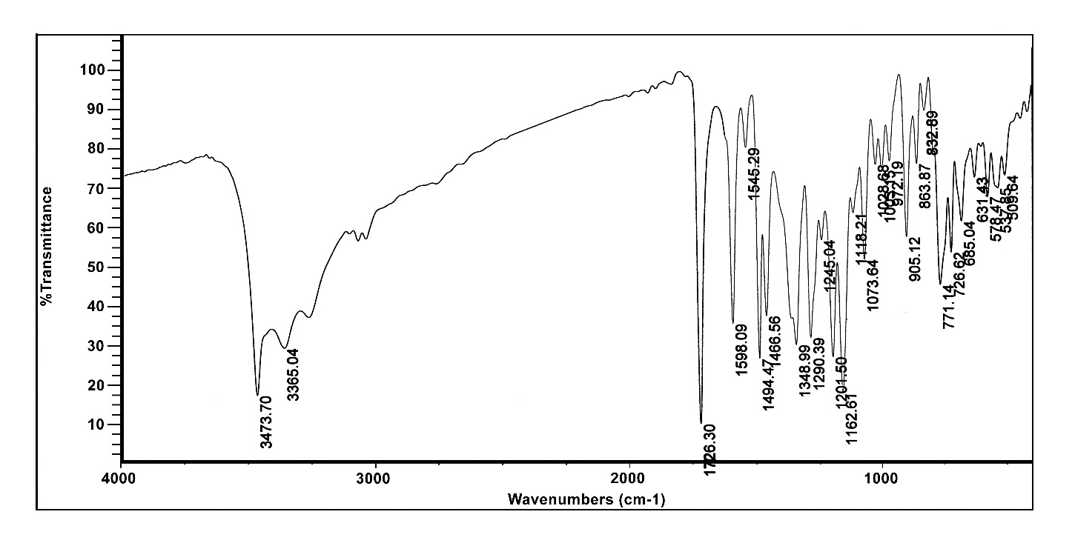
Figure S20. FT-IR spectrum of compound 4j

Figure S21. ¹H NMR spectrum of compound 4j

Figure S22. ¹³C NMR spectrum of compound 4j

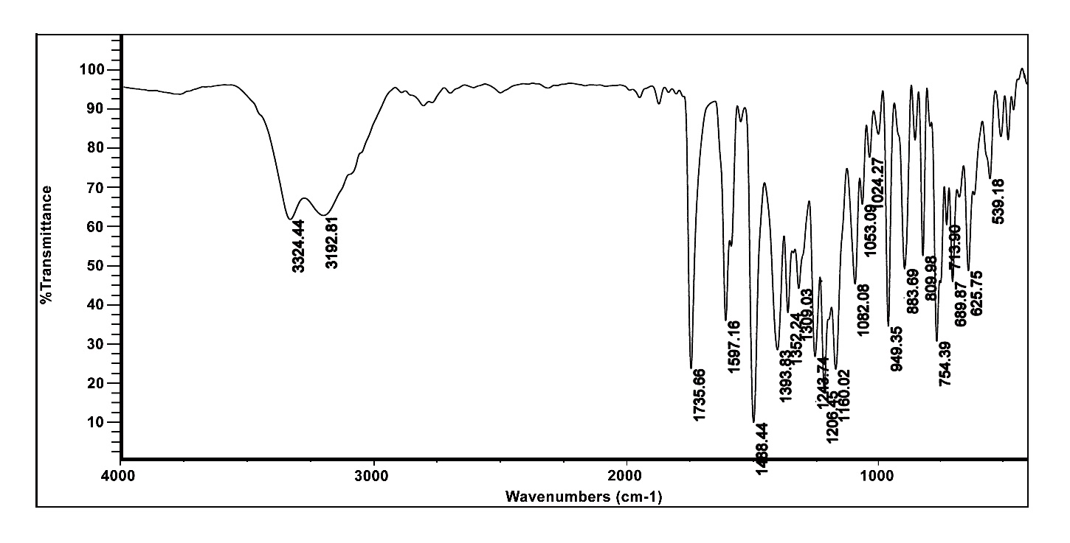
Figure S23. FT-IR spectrum of compound 4K

Figure S24. ¹H NMR spectrum of compound 4K
Figure S25. ¹³ CNMR spectrum of compound 4K

