Supplementary file 1

Identification and characterization of GAP50 binders with the goal to identify novel antimalarials

Prakhar Agrawal¹, Surekha Kumari^{2,3}, Upendra Sharma^{2,3} and Dinkar Sahal^{1*}

¹International Centre for Genetic Engineering and Biotechnology, New Delhi,110067, India
²Chemical Technology Division, CSIR-Institute of Himalayan Bioresource Technology, Palampur, 176061, India
³Academy of Scientific and Innovative Research (AcSIR), Ghaziabad-U.P. 201002, India

Corresponding author

DR. DINKAR SAHAL
GROUP LEADER, MALARIA DRUG DISCOVERY GROUP, ICGEB, NEW DELHI
EMAIL: dsahal@gmail.com

Table of contents

Serial no. | Contents | Page no.
 | Supplementary table 1: Structures of in-house Synthetic (quinolines and Azepino) molecules. | 4
 | Supplementary figure 1: Structures of molecules isolated from C. pareria. | 22
 | Supplementary figure 2: Dot plot showing docking and MMGBSA scores of 951 small molecules against PfGAP50. | 23
 | Supplementary figure 3: Effect of pathogen box (Plates A- E) compounds (400 molecules) on melting temperature (δ Tm) of PfGAP50 as seen by differential scanning fluorimetry (DSF). | 24
 | Supplementary figure 4: Effect of pandemic box (Plate A to E) compounds (400 molecules) on melting temperature (δ Tm) of PfGAP50 as seen by DSF. | 25
 | Supplementary figure 5: Effect of synthetic (quinolines and Azepino) molecules on melting temperature (δ Tm) of PfGAP50. | 26
 | Supplementary method 1: Isolation and characterization of Curine. | 27
 | Supplementary figure 6: Cloning of PfGAP50 in pET28a+ vector. | 28
 | Supplementary figure 7: Chromatographic purification of PfGAP50. | 28
 | Supplementary figure 8: In silico binding of Bedaquiline to GAP50 seen at the end of 100 ns MD simulation. | 29
 | Supplementary figure 9: Interaction mapping of Bedaquiline with GAP50. | 29
 | Supplementary figure 10: In silico binding of Brilacidin to GAP50 seen at the end of 100 ns MD simulation. | 30
 | Supplementary figure 11: Interaction mapping of Brilacidin with GAP50. | 30
 | Supplementary figure 12: In silico binding of MMV688271 to GAP50 seen at the end of 200 ns MD simulation. | 31
 | Supplementary figure 13: Interaction mapping of MMV688271 with GAP50. | 31
 | Supplementary figure 14: Sensorgram representing association, equilibrium and dissociation of phytometabolite from C. pareira. | 32
 | Supplementary figure 15: In silico determination of ligand and protein interaction type and its stability. | 32
 | Supplementary figure 16: In silico interactions of Hayatinine with GAP50 as seen at the end of 100 ns MD simulation. | 33
 | Supplementary figure 17: In silico interaction of Curine with GAP50 as seen at the end of 200 ns MD simulation. | 34
 | Supplementary table 2: Evaluation of binding of lead compounds to PfGAP50 by Surface Plasmon Resonance. thermal shift fluorimetry assay and in silico Schrodinger drug discovery suite. | 35
 | Supplementary table 3: FIC, ∑FIC and Mean ∑FIC of lead compounds in combination with standard antimalarial drugs. | 36
 | Supplementary table 4: Details of malaria proteins taken for cross docking to identify alternate targets for GAP50 inhibitors. | 37
 | Supplementary table 5: Proteins interacting with MMV688271, their docking score and MM-GBSA dG of binding score. | 45
 | Supplementary table 6: Proteins interacting with Bedaquiline, their docking score and MM-GBSA dG of binding score. | 47
 | Supplementary table 7: Proteins interacting with Brilacidin, their docking score and MM-GBSA dG of binding score. | 49
 | Supplementary table 8: Proteins interacting with Hayatinine, their docking score and MM-GBSA dG of binding score. | 50
 | Supplementary table 9: Proteins interacting with Curine, their docking score and MM-GBSA dG of binding score. | 51
 | Supplementary table 10: Acute toxicity parameters. | 53
 | Supplementary References | 54

Supplementary table 1: Structures of in-house Synthetic quinoline derivatives

S.No. | Sample Code | Structure
 | USRKNB5-131-1
 | USRKNB5-136-1
 | USRKNB5-135-6
 | USRKNB5-135-5
 | USRKNB5-136-5
 | USRKNB5-104-1
 | USRKNB5-138-6
 | USRKNB5-138-1
 | USRKNB5-117-1s
 | USRKNB5-138-3
 | USRKNB6-24-4
 | USRKNB5-158-4p
 | USRKNB5-155-3
 | USRKNB5-158-6
 | USRKNB5-158-5p
 | USRKNB5-151-7
 | USRKNB5-139-1
 | USRKNB5-158-3
 | USRKNB6-6-2
 | USRKNB6-6-3
 | USRKNB5-154-5RR
 | USRKNB6-6-1
 | USRKNB5-138-4
 | USRKNB5-135-7
 | USRKNB6-6-5b
 | USRKNB5-139-2
 | USRKNB5-139-3
 | USRKNB6-3-5
 | USRKNB6-6-6
 | USINB4-75-1
 | USINB4-104-2
 | USINB4-107-3
 | USINB4-121-2
 | USINB4-121-3
 | USINB4-124-8
 | USINB4-124-9
 | USINB5-11-10A
 | USINB5-12-2
 | USANB3-209
 | USANB3-213
 | USRCNB1-167-1 | C₁₄H₁₅NO₂
 | USRCNB1-167-4 | C₁₆H₁₇NO₂
 | USRCNB1-176-2 | C₁₈H₁₇NO
 | USRCNB1-177-5 | C₂₀H₁₉NO₂
 | USRCNB1-178-2 | C₁₅H₁₂F₅NO₂
 | USRCNB1-181-5 | C₂₃H₂₇NO₃
 | USRCNB1-184-6 | C₁₇H₂₁NO₂
 | USRCNB1-197-2 | C₁₉H₂₃NO₂
 | USRCNB1-197-3 | C₂₃H₂₁NO₂
 | USRCNB1-210-2
 | USRCNB1-211-2
 | USRCNB1-212-2
 | USRCNB1-212-3
 | USRCNB1-212-4
 | USRCNB1-215-3
 | USRCNB1-215-4
 | USRCNB1-215-6
 | USRCNB1-216-3
 | USRCNB1-225-5
 | USRCNB1-228-3
 | USRCNB1-230-4
 | USRCNB1-233-1
 | USRCNB1-235-2
 | USRCNB1-235-5
 | USRCNB1-235-6
 | USRCNB2-4-2
 | USANB3-103
 | USANB3-124
 | USANB3-132
 | USANB3-138
 | USD1077-9
 | USD1074-9
 | USD1072-4
 | USD1071-1
 | USD10113-6
 | USD10104-2
 | USD10100-2
 | USANB3-348
 | USANB3-352
 | USANB3-351
 | USANB3-372
 | USANB3-380
 | USANB3-381
 | USANB3-410
 | USANB3-418
 | USANB3-419
 | USRKNB6-75-1
 | USRKNB6-82-1
 | USRKNB6-97-4
 | USRKNB6-112-1
 | USRKNB6-133-2
 | USRKNB6-146-4
 | USRKNB6-147-3
 | USRKNB6-149-2
 | USRKNB6-155-4
 | USRKNB6-157-6
 | USRKNB6-128-4
 | USRKNB6-150-5
 | USRKNB6-151-4
 | USRKNB6-151-6
 | USRKNB6-152-7
 | USRKNB6-159-1
 | USRKNB6-162-1
 | USRKNB6-167-4
 | USRKDP-2
 | USRKDP-7
 | USSG-33-3
 | USSG-47-3
 | USDPN2-36-1
 | USDPN2-36-4
 | USDPN2-45-1
 | USDPN2-45-3
 | USDPN2-48-5
 | USDPN2-49-6
 | USDPN2-49-9
 | USDPN2-56-8
 | USDPN2-58-2
 | USDPN2-58-3
 | USDPN2-58-4
 | USDPN2-59-5
 | USDPN2-60-1
 | USDPN2-60-2
 | USDPN2-60-3
 | USDPN2-60-4
 | USDPN2-61-2
 | USDPN2-61-5
 | USDPN2-62-2
 | USDPN2-62-3
 | USDPN2-63-2
 | USDPN2-64-1
 | USDPN2-64-2
 | USDPN2-66-2
 | USDPN2-80-2
 | USDPN2-80-4
 | USDPN2-87-9
 | USINB4-103-4R
 | USINB4-107-2R
 | USINB4-132-4A
 | USINB4-132-4B
 | USINB5-12-1P

Supplementary figure 1: Structures of phytometabolites isolated from C. pareria

Screening of small molecules against PfGAP50 using in silico Schrödinger drug discovery suite

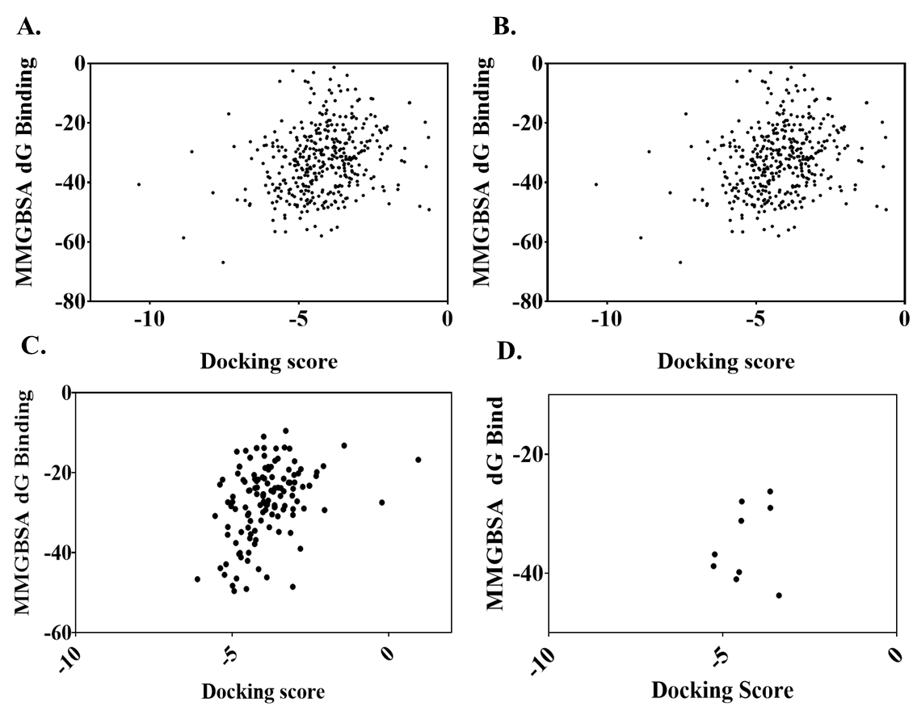

Supplementary figure 2: Dot plot showing docking and MMGBSA score of 951 small molecules against PfGAP50. (A) Pathogen box, (B) Pandemic box, (C) azepino quinolone derivatives, (D) isolated phytometabolites from Cissampelos pareira.

Screening of small molecules against PfGAP50 using differential scanning fluorimetry
Supplementary figure 3: Effect of pathogen box (Plate A, B, C, D and E) compounds (400 molecules) on melting temperature (δ T_{m}) of PfGAP50 as seen by differential scanning fluorimetry.

Supplementary figure 4: Effect of pandemic box (Plate A, B, C, D and E) compounds (400 molecules) on melting temperature (δ T_{m}) of PfGAP50 as seen by differential scanning fluorimetry.

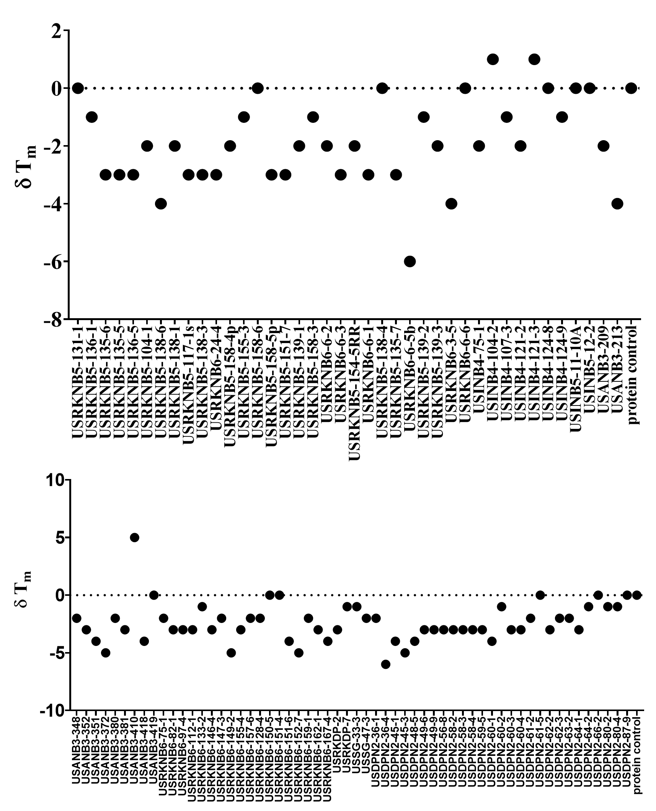

Supplementary figure 5: Effect of synthetic (quinolines and Azepino) molecules on melting temperature (δ Tm) of PfGAP50

Supplementary method 1: Isolation and characterization of Curine

Shade-dried 2 Kg powdered roots (Cissampelos pareira) were extracted thrice with ethanol: water (4:1, v/v) by percolation method and combined percolates were dried in rotary evaporator at 50 °C to obtain 239.2 g hydro-ethanolic crude extract. This dried crude extract was dissolved in 700 mL distilled water and fractionated with organic solvents i.e., n-hexane, chloroform, and n-butanol to yield fractions of different polarity [n-hexane (31.0 g), chloroform (12.4 g), n-butanol (33.4 g) and water (142.6 g).
Water fraction was chromatographed over HP-20 resin and eluted with H₂O: MeOH (10.0: 0.0, 7.5: 2.5, 5.0:5.0, 2.5: 7.5 and 0.0: 10.0, v/v). From this, we collected total five fractions. Formation of precipitates was observed in one fraction collected in pure MeOH. So, it was left overnight and then precipitates were separated from solution to obtain a pure compound which was characterized as Curine on the basis of comparison of 1D and 2D NMR and ESI-MS spectroscopic data with those reported in literature (L et al. 2000).

PfGAP50 cloning and expression

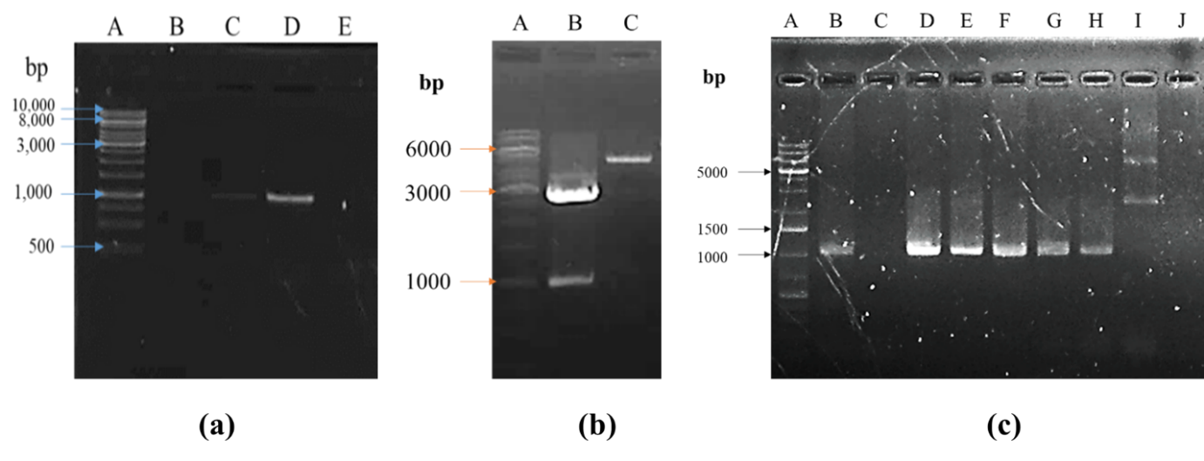
Supplementary figure 6: Cloning of PfGAP50 in pET28a⁺ vector; (a) Temperature gradient for selection of annealing temperature; lane A: 1 kb gene ruler marker, (b) Double digestion of pJET 1.2 vector with GAP50 and pET28a+ vector with Bam HI and Nde I. Lane A: 1 kb gene ruler marker, lane B: pJET 1.2 vector with GAP50 double digested, lane C: pET28a+ vector double digested. (c) colony PCR for GAP50 positive isolates; lane B, D-H are positive for GAP50.

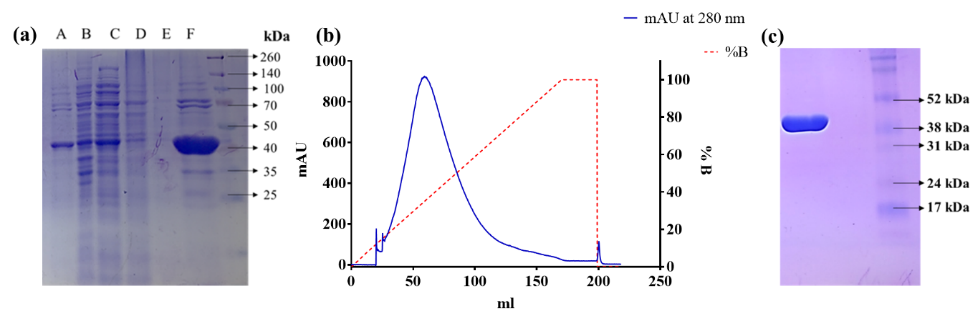
Supplementary figure 7: Purification of PfGAP50; Metal affinity purification: lane A: pellet, lane B: supernatant, lane C: flow through, lanes D and E: washes with 20 mM imidazole and lane F: elution with 300 mM imidazole; (b) Protein purification using phenyl sepharose column chromatography with right hand Y axis shows absorbance at 280 nm, left hand Y axis denotes % buffer B (100 mM Tris-HCl, pH 8.3) increase at 0.5 %/min (flow rate 0.5 mL/min, CV 5 mL) and (c) shows purity of concentrated protein (retention volume 50 mL to 100 mL).

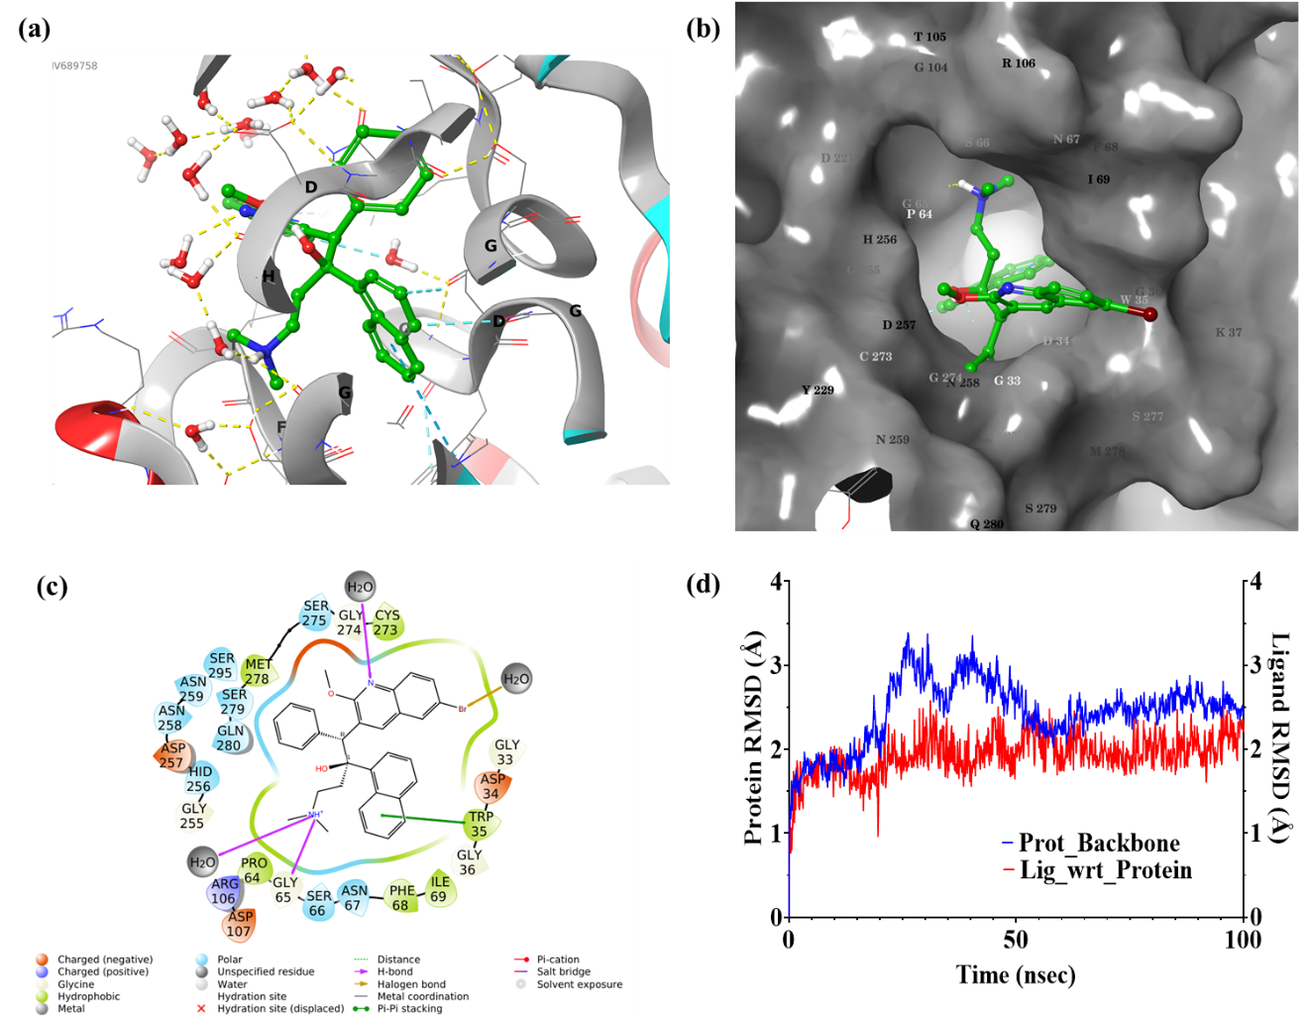

Supplementary figure 8: In silico binding of Bedaquiline to GAP50 seen at the end of 100 ns MD simulation. Pictorial representation of (a) water bridges between ligand and protein, (b) binding cavity of ligand, (c) binding site residues, and (d) RMSD plot of protein and ligand during the course of 100 ns simulation.

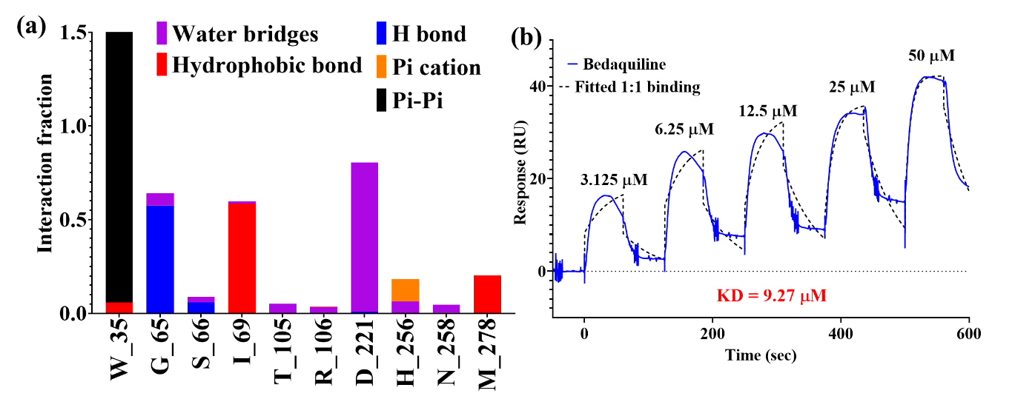

Supplementary figure 9: Interaction mapping of Bedaquiline with GAP50. (a) represents interaction type between amino acids of GAP50 and Bedaquiline, (b) shows single cycle kinetics of Bedaquiline with respect to GAP50.

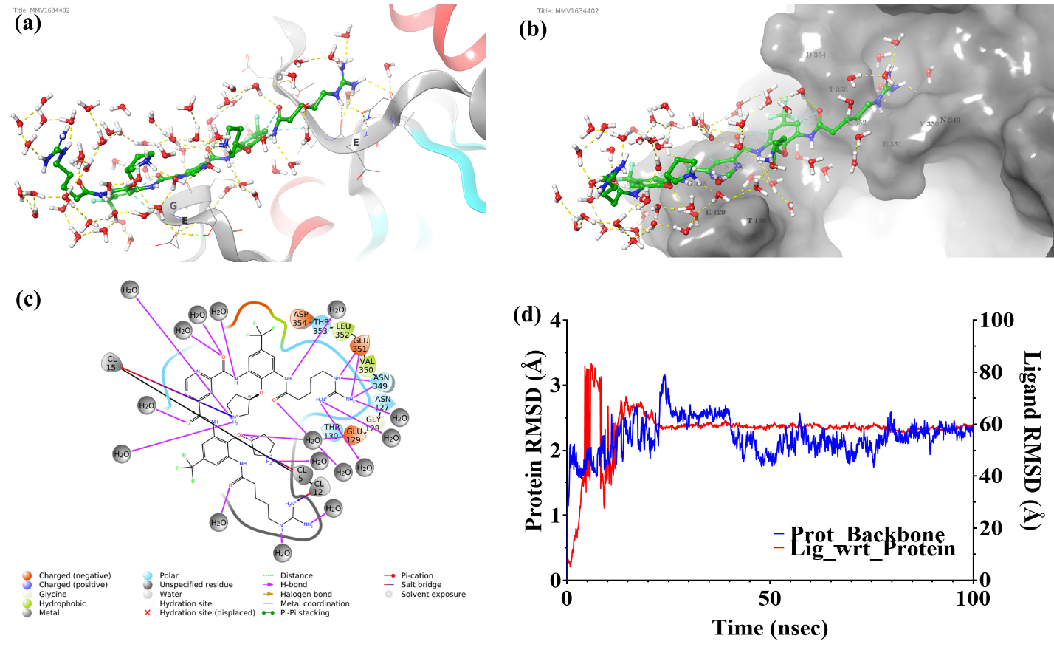

Supplementary figure 10: In silico binding of Brilacidin to GAP50 seen at the end of 100 ns MD simulation. Pictorial representation of (a) water bridges between ligand and protein, (b) binding cavity of ligand, (c) binding site residues, and (d) RMSD plot of protein and ligand during the course of 100 ns simulation.

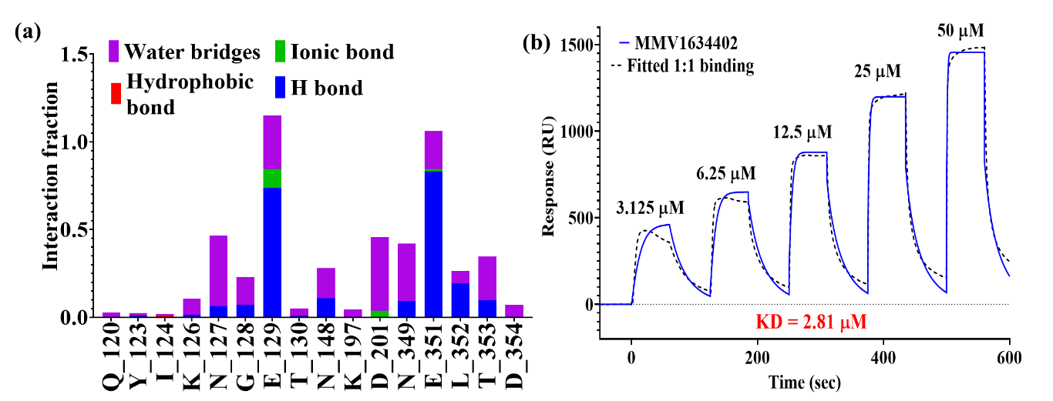

Supplementary figure 11: Interaction mapping of Brilacidin with GAP50. (a) represents interaction type between amino acids of GAP50 and Brilacidin (b) shows single cycle kinetics of Brilacidin with respect to GAP50.

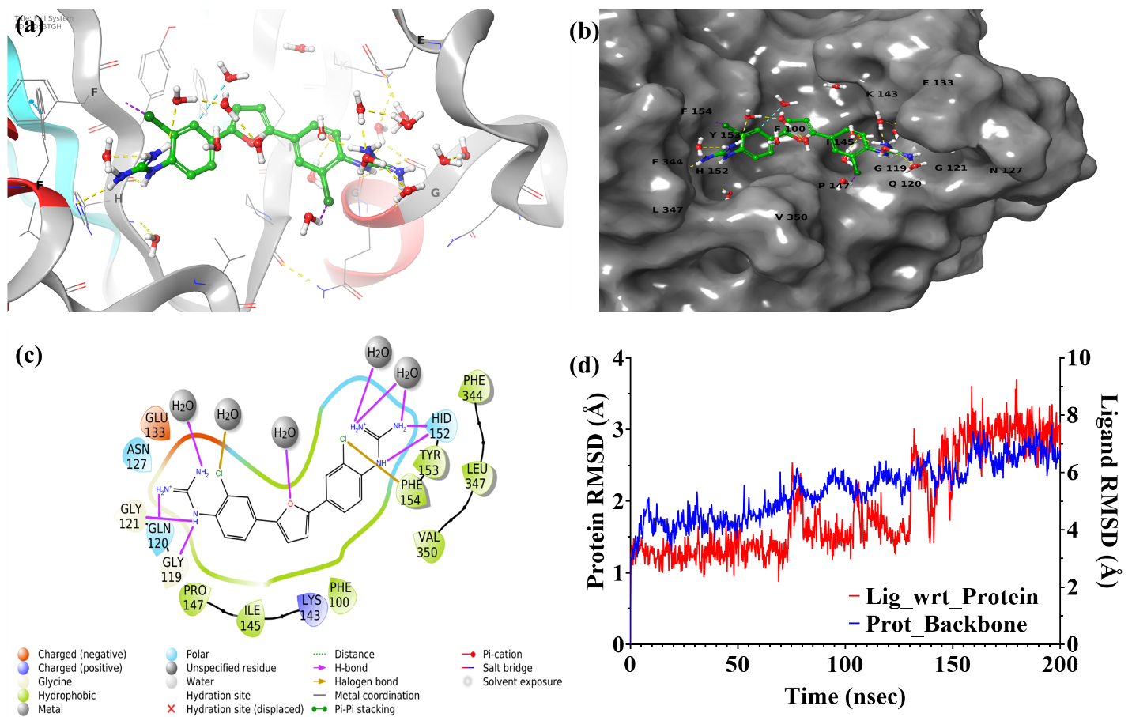

Supplementary figure 12: In silico binding of MMV688271 to GAP50 seen at the end of 200 ns MD simulation. Pictorial representation of (a) water bridges between ligand and protein, (b) binding cavity of ligand, (c) binding site residues, and (d) RMSD plot of protein and ligand during the course of 200 ns simulation.

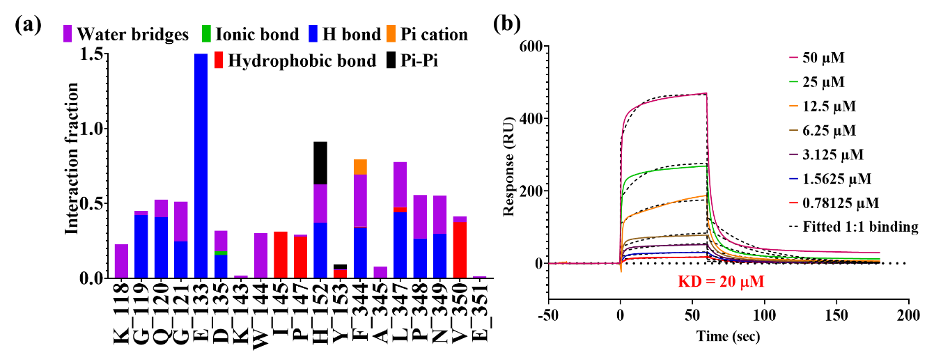

Supplementary figure 13: Interaction mapping of MMV688271 with GAP50. (a) represents interaction type between amino acids of GAP50 and MMV688271 (b) shows multi cycle kinetics of MMV688271 with respect to GAP50.

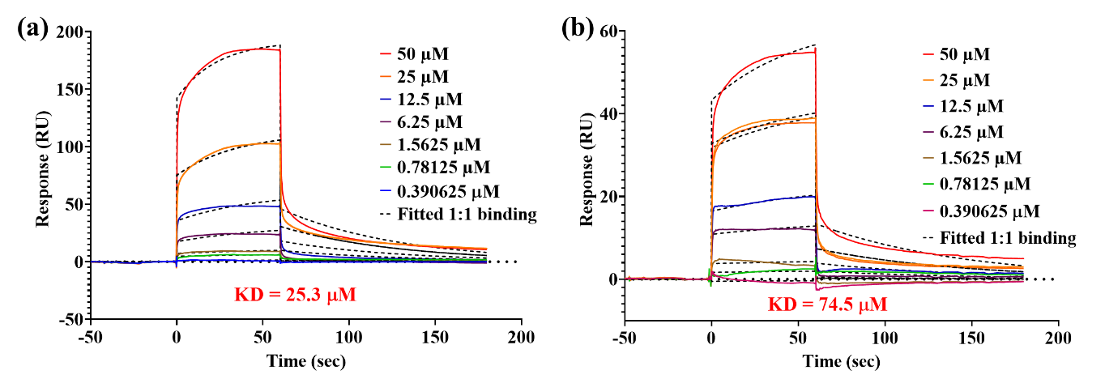
Supplementary figure 14: Sensorgram representing association, equilibrium and dissociation of phytometabolite from C. pareira. (a) shows 1:1 interaction of Hayatinine with GAP50, (b) binding kinetics (1:1) of Curine with GAP50. With similar structure, there is three times difference in KD values.

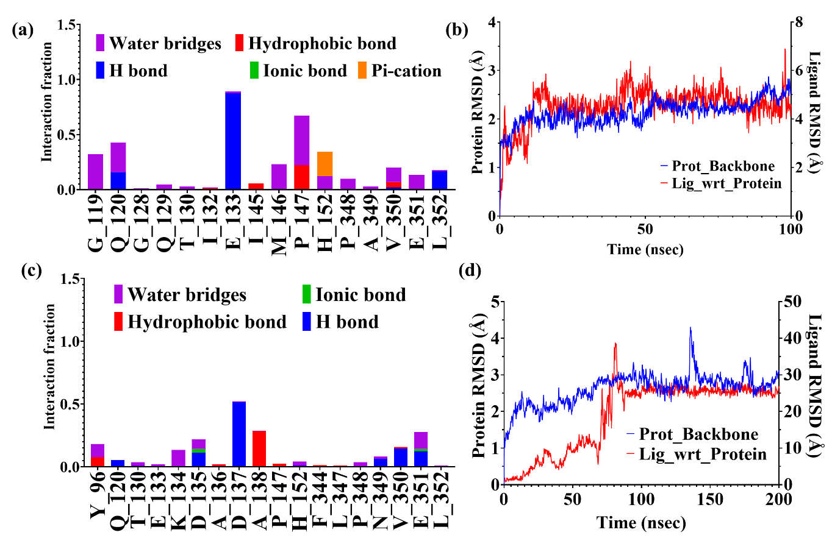

Supplementary figure 15: In silico determination of interaction type and its stability between ligand and protein molecule. (a) represents level of different interactions (hydrogen bond, water bridges etc.,) between Hayatinine and amino acid residues of GAP50 (b) shows RMSD deviation of Hayatinine bound with GAP50 (red curve), (c) represents level of different bond formation between Curine and GAP50. (d) shows RMSD deviation of Curine with respect to GAP50. Note, with similar structure of both these compounds, they are interacting with different amino acids of GAP50 and are having dissimilar protein-ligand RMSD plot.
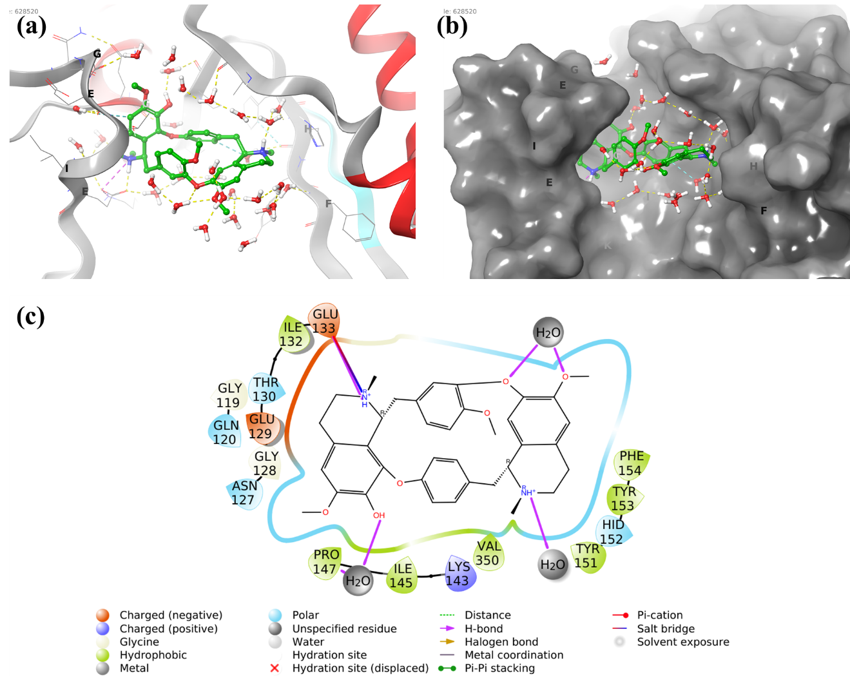

Supplementary figure 16: In silico interactions of Hayatinine with Pf GAP50 as seen at the end of 100 ns MD simulation. (a) shows involvement of water molecules in stabilizing the binding of Hayatinine, (b) shows binding cavity of Hayatinine. Note, Hayatinine is bridging two different regions of the protein. (c) amino acid residue constituting the Hayatinine binding region.

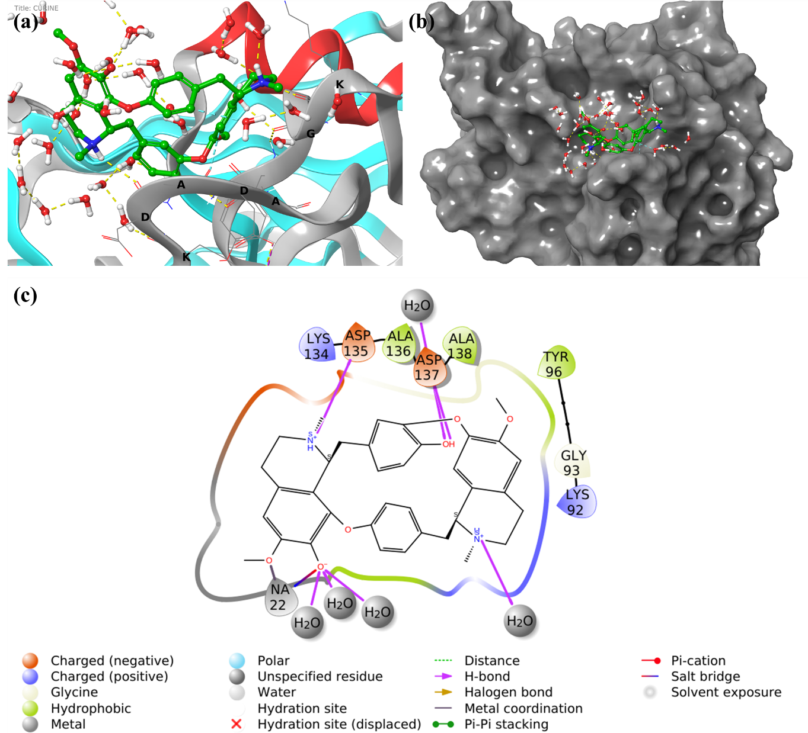

Supplementary figure 17: In silico interaction of Curine with Pf GAP50 as seen at the end of 200 ns MD simulation. (a) shows involvement of water molecules in bridging association between Curine and GAP50, (b) shows binding cavity of Curine. (c) amino acid residue constituting the binding region.

Supplementary table 2: Evaluation of binding of 8 lead compounds to PfGAP50 by Surface Plasmon Resonance, thermal shift fluorimetry assay and in silico Schrödinger drug discovery suite.

Serial No. | Test molecule | SPR |  |  | Thermal shift assay (TSA) | In silico PfGAP50 binding assay
Serial No. | Test molecule | ka (1/Ms) | kd (1/s) | KD (M) | Δ T_{m} | Docking score | MMGBSA dG binding (kcal/mol)
 | Bedaquiline | 1.97E+03 | 1.82E-02 | 9.27E-06 | - 4.5 | -4.32 | -36.9
 | Hayatinine | 5.75E+02 | 1.45E-02 | 2.53E-05 | + 2.0 | - 4.75 | - 48.94
 | USINB4-124-8 | 1.97E+03 | 7.57E-03 | 3.84E-06 | 0.0 | -2.82 | -39.02
 | MMV1782353 | 9.87E+04 | 1.22E-02 | 1.23E-07 | - 1.0 | - 4.85 | - 58.42
 | MMV642550 | 4.45E+02 | 2.57E-03 | 5.78E-06 | 0.0 | - 4.93 | - 51.30
 | MMV1634402 | 2.12E+04 | 5.96E-02 | 2.81E-06 | - 3.0 | - 8.80 | - 64.82
 | MMV688271 | 1.56E+03 | 3.12E-02 | 2.00E-05 | 17.0 | - 5.67 | - 41.89
 | Curine | 1.59E+02 | 1.18E-02 | 7.45E-05 | 0.0 | - 4.5 | - 52.13

Supplementary table 3: FIC, ∑FIC and Mean ∑FIC of lead compounds* in combination with standard antimalarial drugs

Ratio | 4:1 |  |  | 3:2 |  |  | 2:3 |  |  | 1:4 |  |  | Mean
 |  |  |  |  |  |  |  |  |  |  |  |  | ∑
Combinations | FIC1 | FIC2 | ∑ | FIC1 | FIC2 | ∑ | FIC1 | FIC2 | ∑ | FIC1 | FIC2 | ∑FIC | FIC
Combinations | FIC1 | FIC2 | FIC | FIC1 | FIC2 | FIC | FIC1 | FIC2 | FIC | FIC1 | FIC2 | ∑FIC
B:P | 0.69 | 0.53 | 1.2 | 0.4 | 1.8 | 2.2 | 0.21 | 1.54 | 1.7 | 0.02 | 1.03 | 1.05 | 1.56
B:M | 1.46 | 0.84 | 2.3 | 1.7 | 0.3 | 1.9 | 1.63 | 0.13 | 1.7 | 1.87 | 0.04 | 1.91 | 1.98
B:A | 1.5 | 0.15 | 1.6 | 2.3 | 0.2 | 2.5 | 1 | 0.19 | 1.2 | 0.32 | 0.05 | 0.37 | 1.43
H:P | 0.36 | 1.08 | 1.4 | 0.02 | 1.01 | 1 | 0.05 | 0.5 | 0.5 | 0.01 | 0.53 | 0.54 | 0.89
H:M | 0.91 | 0.83 | 1.7 | 1.3 | 0.3 | 1.7 | 1.34 | 0.16 | 1.5 | 1.18 | 0.04 | 1.21 | 1.54
H:A | 1.01 | 0.66 | 1.7 | 0.2 | 0.4 | 0.5 | 0.52 | 0.05 | 0.6 | 0.36 | 0.08 | 0.43 | 0.8
C:P | 1.19 | 1.05 | 2.2 | 0.7 | 0.9 | 1.6 | 0.43 | 0.68 | 1.1 | 0.18 | 0.44 | 0.61 | 1.41
C:M | 1.17 | 0.41 | 1.6 | 1.2 | 0.3 | 1.5 | 1.25 | 0.12 | 1.4 | 0.68 | 0.04 | 0.72 | 1.28
C:A | 0.32 | 0.46 | 0.8 | 0.3 | 0.3 | 0.6 | 0.33 | 0.13 | 0.5 | 0.16 | 0.06 | 0.22 | 0.52
E:P | 0.14 | 1.2 | 1.3 | 0.6 | 1.9 | 2.5 | 0.28 | 1.74 | 2 | 0.07 | 0.78 | 0.85 | 1.67
E:M | 0.21 | 1.53 | 1.7 | 0.8 | 0.7 | 1.5 | 0.63 | 0.91 | 1.5 | 0.47 | 0.22 | 0.68 | 1.38
E:A | 0.19 | 1.05 | 1.2 | 1 | 0.9 | 1.9 | 0.71 | 0.54 | 1.2 | 0.32 | 0.19 | 0.51 | 1.22
Z:P | 0.18 | 2.12 | 2.3 | 0.2 | 1.1 | 1.3 | 0.71 | 0.49 | 1.2 | 0.11 | 0.27 | 0.39 | 1.3
Z: M | 0.83 | 1.52 | 2.4 | 0.7 | 0.9 | 1.5 | 0.17 | 0.37 | 0.5 | 0.55 | 0.14 | 0.7 | 1.29
Z:A | 1.74 | 0.4 | 2.1 | 1 | 0.3 | 1.3 | 0.85 | 0.07 | 0.9 | 0.9 | 0.05 | 0.95 | 1.33
V:P | 0.65 | 1.63 | 2.3 | 0.7 | 1.9 | 2.6 | 0.58 | 1.04 | 1.6 | 0.19 | 0.35 | 0.54 | 1.76
V:M | 1.36 | 0.27 | 1.6 | 1.3 | 0.2 | 1.6 | 0.85 | 0.16 | 1 | 0.38 | 0.06 | 0.44 | 1.16
V:A | 1.02 | 0.72 | 1.7 | 0.7 | 0.3 | 1.1 | 0.62 | 0.16 | 0.8 | 0.55 | 0.09 | 0.65 | 1.06
U:P | 0.4 | 0.55 | 0.9 | 0.3 | 1.1 | 1.3 | 0.11 | 1.51 | 1.6 | 0.02 | 0.77 | 0.79 | 1.17
U:M | 1.25 | 9.59 | 10.84 | 1.5 | 1.1 | 2.6 | 1.4 | 0.52 | 1.9 | 4.53 | 0.17 | 4.69 | 2.61
U:A | 0.2 | 0.82 | 0.9 | 0.5 | 0.9 | 1.3 | 0.27 | 0.75 | 1.6 | 0.09 | 0.12 | 0.79 | 1.17

*Hayatinine (H), Bedaquiline (B), MMV688271 (Z), Curine (C), Brilacidin (E), MMV642550 (V) and USINB4-124-8 (U), ** Pyrimethamine (P), Mefloquine (MFQ) and ART(A). Colour coding Blue: strong synergy (∑FIC ≤ 0.5), green: weak synergy (∑FIC between 0.5 and 1), yellow: additive interaction ((∑FIC between 1 and 2) and pink: antagonism ((∑FIC ≥ 2).

Supplementary table 4: Details of malaria parasite proteins taken for cross docking to identify alternate targets for PfGAP50 binders
*Essential for parasite survival

S.No. | Protein (PDB) | PlasmoDb ID | Stage expressed | Co-Crystallised ligand | Co-Crystallised ligand Docking Score | Co-Crystallised ligand MMGBSA dG Binding (kcal/mol)
1 | Adenylate Kinase (ICJB) | PF3D7_1012400 | Trophozoites | (1S)-1(9-Deazahypoxanthin-9yl)1,4-dideoxy-1,4-imino-d-ribitol-5-phosphate | -8.027 | -59.48
2 | Plasmodium Falciparum Rab6* (1D5C) | PF3D7_1144900 | late trophozoites, schizonts, gametocyte stage V and ookinete | Guanosine Diphosphate (GDP) | 12.48 | -80.63
3 | Acyl-COA Binding Protein (1HBK) | PF3D7_1477800 | schizonts and merozoites | Coenzyme A | -10.95 | -59.25
4 | Dihydrofolate reductase-thymidylatesynthase (IJ3I) | PF3D7_0417200 | late trophozoites | WR99210 | -10.28 | -108.84
5 | Plasmepsin IV (1LS5) | PF3D7_1407800 | Rings and merozites | Pepstatin A | -7.52 | -97.34
6 | Phosphoglycerate Kinase*(1LTK) | PF3D7_0922500 | Rings and Trophozoites | AMP | -7.65 | -35.95
7 | Glutathione reductase (1ONF) | PF3D7_1419800 | Trophozoites | Flavin Adenine Dinucleotide (FAD) | -11.9 | -107
8 | Adenylosuccinate synthetase (1P9B) | PF3D7_1354500 | Trophozoites | 6-Phosphoryl-Inosine Monophosphate | 16.17 | -72.95
9 | Cyclophilin (1QNG) | PF3D7_1115600 | schizonts | Cyclosporin A | -1.948 | -65.44
10 | Peptide Deformylase* (1RL4) | PF3D7_0907900 | trophozoites, gametocyte stage V | 2-{N0-[2-(5-amino-1-phenylcarbamoyl-pentylcarbamoyl)-hexyl]-hydrazinomethyl}1.4-hexanoic acid-(5-amino-1-phenylcarbamoyl-pentyl)-amide | -2.268 | -93.57
11 | Lactate dehydrogenase*(1T24) | PF3D7_1324900 | Rings and trophozoites | -Hydroxy-1,2,5-oxadiazole-3-carboxylic acid | -3.78 | -17.66
12 | PfPK5 (1V0O) | PF3D7_1356900 | Rings | Indirubin-5-sulphonate | -7.03 | -46.32
13 | Erythrocyte Binding Antigen Region II Region 175 (1VYQ) | PF3D7_1127100 | Late trophozites and oocysts | ,3-deoxy-3-fluoro-5-O-trityluridine | -7.61 | -65.7
14 | Pyruvoyl Tetrahydropterin Synthase (1Y13) | PF3D7_0628000 | Trophozoites | Biopterin | -3.38 | -43.89
15 | Glyceraldehyde-3-PhosphateDehydrogenase*(1YWG) | PF3D7_1462800 | Late trophozites | Nicotinamide Adenine Dinucleotide (NAD) | -14.37 | -60.81
16 | Guanylate Kinase (1Z6G) | PF3D7_0928900 | Late rings and Trophozites | (2-Hydroxyethyl)-1-piperazine ethanesulfonic acid | -4.32 | -53.77
17 | Plasmepsin II (2BJU) | PF3D7_1408000 | Trophozoites | N-(R-CARBOXY-ETHYL)-ALPHA-(S)-(2-PHENYLETHYL) | -14.72 | -137.17
18 | Purine Nucleoside Phosphorylase* (2BSX) | PF3D7_0513300 | Trophozoites | Inosine | -8.38 | -54.43
19 | Protein-L-isoaspartateO-methyltransferaseb-aspartatemethyltransferase (2PBF) | PF3D7_1432700 | Late trophozoites | SAM | -8.22 | -112.68
20 | Ribosomal RNA Methyltransferase* (2PLW) | PF3D7_1309600 | Rings, Trophozoites and gametocytes | S-Adenosyl-L-homocysteine (SAM) | -8.051 | -87.05
21 | Ser/Thr protein kinase* (2PMO) | PF3D7_0213400 | Trophozoites and Schizonts | Hymenialdisine | -2.25 | -46.27
22 | Nucleolar GTP-binding protein 1* (2QU8) | PF3D7_0612900 | Rings | GDP | -13.5 | -71.61
23 | Pyrroline carboxylate reductase (2RCY) | PF3D7_1357900 | Trophozoites and gametocytes | NADP | -11.956 | -91.9
24 | Malaria Sporozoite Protein Uis3 (2VWA) | PF3D7_1302200 | Schizonts | Phosphatidylethanolamine | -4.445 | -51.09
25 | Glycerol Kinase (2W41) | PF3D7_1351600 | Schizonts, Merozoites, gametocytes V | ADP | -9.75 | -45.15
26 | Thymidylate Kinase (2YOG) | PF3D7_1251300 | Schizonts, Gametocytes II, V | 1-[4-Chloranyl-3-(trifluoromethyl)-phenyl]-3-[[(2R,3S)-5-[5-methyl-2,4-bis-(oxidanylidene)pyrimidin-1-yl]-3-oxidanyl-oxolan-2-yl]methyl]thiourea | -6.18 | -90.28
27 | Beta-Hydroxyacyl-Acyl Carrier Protein Dehydratase (3AZB) | PF3D7_1323000 | Rings | 5-chloro-8-[(3-chlorobenzyl)-oxy]-quinoline | -4.46 | -50.56
28 | GTPase Rab11 (3BFK) | PF3D7_1320600 | Rings and Schizonts | GDP | -10.559 | -62.66
29 | Aquaglyceroporin (3C02) | PF3D7_1132800 | Schizonts | beta-Octylglucoside | -2.74 | -47.11
30 | Rab5 protein (3CLV) | PF3D7_0211200 | Trophozoites and Schizonts | GDP | -17.36 | -95.62
31 | PfA-M1* (3EBH) | PF3D7_1311800 | Trophozoites | N-[(2-{2-[(N-{(2S,3R)-3-amino-4-[4-(benzyloxy)-phenyl]-2-hydroxybutanoyl}-L-alanyl)amino]ethoxy}ethoxy)acetyl]-4-benzoyl-L-phenylalanyl-N6-hex-5-ynoyllysinamide | -12.48 | -77.57
32 | HSP90* (3IED) | PF3D7_1443900 | Trophozoites | Adenylyl-Imidodiphosphate (AMPPN) | -8.11 | -56.01
33 | Aspartate Aminotransferase (3K7Y) | PF3D7_0204500 | Rings, Trophozoites | Pyridoxal phosphate (PLP) | -3.68 | -49.58
34 | Serine/threonine kinase-1* (3LLT) | PF3D7_1445400 | Rings, Trophozoites | Phosphoaminophosphonic acid-adenylate ester | -14.176 | -53.62
35 | Enoyl-ACP Reductase (3LT0) | PF3D7_0615100 | Schizonts | 4-(2,4-dichlorophenoxy)-3-hydroxybenzaldehyde | -9.03 | -64.26
36 | MAP-2 kinase (3NIE) | PF3D7_1113900 | schizonts and merozoites | Phosphoaminophosphonic acid-adenylate ester | -14.07 | -71.98
37 | HSP90* (3PEH) | PF3D7_1443900 | Trophozoites | 2-amino-4-{2,4-dichloro-5-[2-(diethylamino)-ethoxy]-phenyl}-N-ethylthieno[2,3-d]-pyrimidine-6-carboxamide | -5.421 | -90.33
38 | Glucose-6-phosphate isomerase* (3PR3) | PF3D7_1436000 | Late rings and Trophozites | Fructose-6-phosphate | -11.52 | -47.98
39 | Actin Depolymerizing Factor* (3Q2B) | PF3D7_0503400 | Late schizonts and merozoites | D(-)-tartaric acid | -4.63 | -14.79
40 | Histo-Aspartic Protease (3QVI) | PF3D7_1407900 | Rings | KNI-10,395 | -8.317 | -64.57
41 | Orotidine 50-MonophosphateDecarboxylase (3S9Y) | PF3D7_1023200 | Rings and Trophozoites | 6-amino-5-fluorouridine 50-(dihydrogen phosphate) | -16.29 | -56.03
42 | Arginase (3SL1) | PF3D7_0906500 | Rings, Schizonts and Merzoites | 6-(dihydroxyboranyl)-2-methyl-L-norleucine | -5.69 | -46.2
43 | Plasmodium falciparum dUTPase (3T64) | PF3D7_1127100 | Trophozoites | 20,50-Dideoxy-50-[(diphenylmethyl)amino]-uridine | -10.9 | -72.81
44 | PfA-M1* (3T8V) | PF3D7_1311800 | Trophozoites | N-[(2-{2-[(N-{(2S,3R)-3-amino-4-[4-(benzyloxy)-phenyl]-2-hydroxybutanoyl}-L-alanyl)amino]ethoxy}ethoxy)acetyl]-4-benzoyl-L-phenylalanyl-N6-hex-5-ynoyllysinamide | -10.91 | -104.69
45 | Glideosome associated protein 50* (3TGH) | PF3D7_0918000 | schizonts | - | - | -
46 | Sir2A (3U3I) | PF3D7_1328800 | Schizonts, Merzoites and Rings | NAD | -14.14 | -114.57
47 | PhosphoethanolamineMethyltransferase (3UJB) | PF3D7_1343000 | Trophozoites and Schizonts | Amodiaquine | -8.5 | -105.22
48 | PfA-M17 (3UOW) | PF3D7_1012600 | Rings | N-[(1R)-2-(hydroxyamino)-2-oxo-1-(30,40,50-trifluorobiphenyl-4-yl)-ethyl]-2,2-dimethylpropanamide | -8.5 | -33.49
49 | Orotidine 50-MonophosphateDecarboxylase (3VI2) | PF3D7_1023200 | Rings and Trophozoites | (2-Hydroxy-4-methoxyphenyl)-4-oxobutanoic acid | -5.27 | -24.13
50 | 2C-methyl-D-erythritol-2,4-cyclodiphosphate synthase (4C81) | PF3D7_0209300 | Trophozoites and Schizonts | Cytidine-50-diphosphate | -6.126 | -15.88
51 | Dihydroorotate dehydrogenase (4CQ8) | PF3D7_0603300 | Trophozoites | 5-(4-Cyano-2-methyl-1H-benzimidazol-1-yl)-N-cyclopropylthiophene-2-carboxamide | -11.19 | -114.82
52 | Phosphoethanolamine N-methyltransferase (4FGZ) | PF3D7_1343000 | Schizonts | Amodiaquine | -4.66 | -59.04
53 | Thioredoxin reductase (4J56) | PF3D7_0923800 | Trophozoites and Schizonts | FAD | -15.55 | -144.66
54 | Tryptophanyl-tRNA synthetase* (4J75) | PF3D7_1336900 | Trophozoties | Tryptophanyl-50-AMP | -18.87 | -140.51
55 | Erythrocyte Binding Antigen 140* (4JNO) | PF3D7_1301600 | Schizonts | O-sialic acid | -9.7 | -35.98
56 | CDPK2 (4MVF) | PF3D7_0610600 | Trophozoites and Schizonts | Staurosporine | -10.05 | -98.74
57 | PfGrx1 (4MZB) | PF3D7_0306300 | Trophozoties | 3-[N-morpholino]-propane sulfonic acid | -2.52 | -33.53
58 | Aminoacyl-tRNA deacylase (4NBI) | PF3D7_1108200 | Trophozoites and Schizonts | 30-deoxy-30-(D-tyrosylamino)-adenosine | -10.99 | -73.2
59 | cGMP-dependent protein kinase (4OFG) | PF3D7_1436600 | Schizonts | Cyclic Guanosine Monophosphate (cGMP) | -10.71 | -78.48
60 | CDPK4 (4QOX) | PF3D7_0717500 | Schizonts | 3-(3-bromobenzyl)-1-tert-butyl-1H-pyrazolo-[3,4-d]pyrimidin-4-amine | -11.063 | -89.1
61 | FK506 (4QT3) | PF3D7_1247400 | Trophozites | Rapamycin | -2.36 | -24.97
62 | MTIP* (4R1E) | PF3D7_1246400 | Schizonts | 5-{[(2-aminoethyl)-sulfanyl]methyl}furan-2-carbaldehyde | -4.44 | -30.97
63 | Prolyl-tRNA synthetase* (4WI1) | PF3D7_1213800 | Rings and Trophozoites | Halofuginone | -10.01 | -88.02
64 | PfHAD1 (4ZEV) | PF3D7_1033400 | Trophozoites | Mannose-6-Phosphate | -8.6 | -26.58
65 | PfA-M1* (4ZW3) | PF3D7_1311800 | Trophozoites | Tert-Butyl [(1S)-1-(4-bromophenyl)-2-(hydroxyamino)-2-oxoethyl]-carbamate | -8.23 | -41.69
66 | Glutathione-S-Transferase (4ZXG) | PF3D7_1419300 | Trophozoites | Ligandin | -3.1 | -36.82
67 | DXR* (5JAZ) | PF3D7_1467300 | Late Trophozoites and Early Schizonts | [(2R)-2-{2-[hydroxy(methyl)amino]-2-oxoethyl}-5-(naphthalen-1-yl)pentyl]phosphonicacid | -13.47 | -95.58
68 | Histone acetyltransferase GCN5* (5TPX) | PF3D7_0823300 | Rings, trophozoites and Schizonts | (1S, 2S)-N1,N1-dimethyl-N2-(3-methyl-[1,2,4]triazolo[3,4-a]phthalazin-6-yl)-1-phenylpropane-1,2-diamine | -5.87 | -88.77

Supplementary table 5: In silico binding scores for MMV688271 binding to PfGAP50 and diverse other shortlisted Plasmodial proteins

Serial no. | Protein | Docking Score | MMGBSA dG Binding (kcal/mol)
 | GAP50 (3TGH) | -5.67 | -41.89
 | FK506 (4QT3) | -9.321 | -71.68
 | Dihydroorotate dehydrogenase (4CQ8) | -8.428 | -78.81
 | MTIP (4R1E) | -7.411 | -76.02
 | HSP90 (3PEH) | -7.347 | -86.24
 | Ser/Thr protein kinase (2PMO) | -6.663 | -67.3
 | Plasmepsin IV (1LS5) | -5.575 | -80.69
 | Glutathione-S-Transferase (4ZXG) | -5.474 | -55.12
 | Ribosomal RNA Methyltransferase (2PLW) | -5.229 | -60.62
 | PfPK5 (1V0O) | -4.496 | -77
 | Histone acetyltransferase GCN5 (5TPX) | -4.459 | -76.79
 | Peptide Deformylase (1RL4) | -4.05 | -66.28
 | Pyruvoyl Tetrahydropterin Synthase(1Y13) | -3.35 | -61.15
 | Aspartate Aminotransferase (3K7Y) | -3.329 | -63.16
 | Guanylate Kinase (1Z6G) | -2.752 | -46.22
 | Orotidine 50-MonophosphateDecarboxylase (3VI2) | -2.658 | -28.26
 | PfGrx1 (4MZB) | -2.526 | -47.13
 | Cyclophilin (1QNG) | -2.475 | -49.78
 | Malaria Sporozoite Protein Uis3 (2VWA) | -2.303 | -36.84
 | Beta-Hydroxyacyl-Acyl Carrier Protein Dehydratase (3AZB) | -2.25 | -57.6
 | Aquaglyceroporin (3C02) | -2.225 | -43.76

Supplementary table 6: In silico binding scores for PfGAP50 and diverse other shortlisted Plasmodial Proteins interacting with Bedaquiline.

Serial no. | Protein | Docking Score | MMGBSA dG Binding (kcal/mol)
 | GAP50 (3TGH) | -4.32 | -36.9
 | HSP90 (3PEH) | -8.752 | -83.75
 | Histo-Aspartic Protease (3QVI) | -8.03 | -70.95
 | Plasmepsin IV (1LS5) | -7.119 | -82.36
 | Enoyl-ACP Reductase (3LT0) | -6.695 | -81.49
 | Ser/Thr protein kinase (2PMO) | -6.108 | -2.53
 | Phosphoglycerate Kinase (1LTK) | -5.249 | -59.61
 | Beta-Hydroxyacyl-Acyl Carrier Protein Dehydratase (3AZB) | -4.273 | -68.5
 | Thymidylate Kinase (2YOG) | -3.195 | -45.06
 | Cyclophilin (1QNG) | -3.088 | -44.39
 | Peptide Deformylase (1RL4) | -3.04 | -64.29
 | Guanylate Kinase (1Z6G) | -3.028 | -53.73
 | Pyruvoyl Tetrahydropterin Synthase(1Y13) | -2.626 | -45.19
 | Aquaglyceroporin (3C02) | -2.619 | -38.45
 | PfGrx1 (4MZB) | -2.019 | -30.82
 | Actin Depolymerizing Factor (3Q2B) | -1.896 | -33.32
 | Malaria Sporozoite Protein Uis3 (2VWA) | -1.585 | -32.33
 | Aspartate Aminotransferase (3K7Y) | -1.08 | -45.89

Supplementary table 7: In silico binding scores for Brilacidin binding to PfGAP50 and diverse other shortlisted Plasmodial proteins

Serial no. | Protein | Docking Score | MMGBSA dG Binding (kcal/mol)
 | GAP50 (3TGH) | -8.8 | -64.82
 | Plasmepsin IV (1LS5) | -13.159 | -143.48
 | PfA-M1 (3T8V) | -10.217 | -125.38
 | Histo-Aspartic Protease (3QVI) | -6.026 | -96.96
 | Malaria Sporozoite Protein Uis3 (2VWA) | -5.901 | -52.9
 | 2C-methyl-D-erythritol-2,4-cyclodiphosphate synthase (4C81) | -4.94 | -84.86
 | Cyclophilin (1QNG) | -4.902 | -58.4
 | Peptide Deformylase (1RL4) | -3.877 | -62.31
 | Aquaglyceroporin (3C02) | -2.971 | -53.83

Supplementary table 8: In silico binding scores for Hayatinine binding with PfGAP50 and diverse other shortlisted Plasmodial proteins.

Serial no. | Protein | Docking Score | MMGBSA dG Binding (kcal/mol)
 | GAP50 (3TGH) | -4.75 | -48.94
 | Plasmepsin IV (1LS5) | -7.025 | -64.81
 | Pyruvoyl Tetrahydropterin Synthase(1Y13) | -3.163 | -26.1
 | HSP90 (3PEH) | -2.935 | -53.74
 | Malaria Sporozoite Protein Uis3 (2VWA) | -2.927 | -41.9
 | Guanylate Kinase (1Z6G) | -2.302 | -13
 | Beta-Hydroxyacyl-Acyl Carrier Protein Dehydratase (3AZB) | -2.286 | -42.57
 | Cyclophilin (1QNG) | -0.609 | -50.6

Supplementary table 9: In silico binding scores for Curine binding with PfGAP50 and diverse other shortlisted Plasmodial proteins.

Serial no. | Protein | Docking Score | MMGBSA dG Binding (kcal/mol)
 | GAP50 (3TGH) | -4.5 | -52.13
 | Histo-Aspartic Protease (3QVI) | -8.029 | -70.49
 | Plasmepsin IV (1LS5) | -4.962 | -67.15
 | Peptide Deformylase (1RL4) | -4.099 | -47.87
 | Pyruvoyl Tetrahydropterin Synthase(1Y13) | -3.931 | -20.35
 | Thymidylate Kinase (2YOG) | -3.38 | -22.94
 | HSP90 (3PEH) | -3.274 | -47.93
 | Cyclophilin (1QNG) | -3.182 | -38.52
 | Malaria Sporozoite Protein Uis3 (2VWA) | -2.283 | -31.23
 | Guanylate Kinase (1Z6G) | -1.721 | -12.54
 | PfGrx1 (4MZB) | -0.397 | -11.4

Supplementary table 10: Observations of Acute toxicity studies in mice after oral dosing (50 mg/Kg) dosing of USINB4-124-8

All mice were observed for 45 min after dosing of small molecules in each group. The Control group was given vehicle solutions only.

 | USINB4-124-8 | Control
Bodyweight | No change | No change
Temperature | No change | No change
Appetite Loss | No | No
Water intake | Normal | Normal
Urination | Normal | Normal
Rate of respiration | Normal | Normal
Changes in skin | No change | No change
Drowsiness | No | No
Sedation | No | No
Eye color | No change | No change
Diarrhea | No | No
Lacrimation | No | No
Coma | No | No
Death | No | No

SI-1 References

- Bhatt Vinod, Surekha Kumari, Pooja Upadhyay, Prakhar Agrawal, Anmol, Dinkar Sahal, and Upendra Sharma. 2020. Chemical Profiling and Quantification of Potential Active Constituents Responsible for the Antiplasmodial Activity of Cissampelos Pareira. Journal of Ethnopharmacology 262 (November): 113185.

- L, Mambu, Martin MT, Razafimahefa D, Ramanitrahasimbola D, Rasoanaivo P, and Frappier F. 2000. Spectral Characterisation and Antiplasmodial Activity of Bisbenzylisoquinolines from Isolona Ghesquiereina.” Planta Medica 66 (6): 537–40. https://doi.org/10.1055/S-2000-8610.

- Kumar, Inder, Shiv Shankar Gupta, Rakesh Kumar, Rohit Kumar, Prakhar Agrawal, Dinkar Sahal, and Upendra Sharma. 2020. Photocatalytic Unsymmetrical Coupling of 2-Substituted Quinolines: Synthesis and Evaluation of the Antiplasmodial Potential of β-Norbenzomorphan Frameworks. ACS Sustainable Chemistry & Engineering 8 (34): 12902–10. https://doi.org/10.1021/ACSSUSCHEMENG.0C03415.

