Supplement Material

**Consensus sequence Analysis:
>Consensus/1-2662 Percentage Identity Consensus MLRSASPFSLLIPDRIVMMDDDDDSCLLDLICDPQALNDFLHGPENKLDNDDLLNAGGSAANSNSIFANSPG
LHPKSSVKEASGQAQLGEGEPDGPALSVDLDFLEDDILGSPSPATGGGGGGDGTADQPCDILQQSLQEANIT
EQTLAEAEAELDLSPFQLPQLAQADQPLPDGGAGPTGAGGAAQLAPNQGGPQALFPGASDLLGLQGPTLQPI
VLTHQALVPVGAQDVSNKAGSVQPFLQHVGLGNVTLQPIPGLQGLPNGSPGGATAAILGLGQIQVVGSFGNQ
PSMMTINPLDGQQIAKQVPVSGYLAKAAGPQEPVNLASPGLGAGVSPQGAGLVIQKNLSAAHAQTLNGNSVF
GGSSSTSNSATTMATAGAASAPTGSPSGQPLTVAFGSLGFQPLLPAHNVIIQRTPTPNSNKVPINIQPKPAQ
MGQLPPKLYNLTPKPFAPAGATLTIQGELGAQQHHPKAPQNITFAAAGKPGQNVVLSGFPAPALQANVFKQP
PATTTGAAPPQPPGALGKPMSVHLLNQQQNTRKPVTSQAVSNQGGSIVIPSQHGLPGAQNQQFLLPGALAVQ
LNQQLSALPQNIGGQILAAQAAQHTGGQLIANHILTNQNLAGMLRTNQPSLGPVLANQSGAHAAHILSGQTF
AAPGQVGQPALFQMPVSLAAGSLPTQSQPAPAGPAATTVLQGVTLPPSAVAESLSPAVSLQMLNTPDGIVNH
ATNGSTAMPAAATGEAAPVLGGQMPAPQAPPTVLHPLPLGLQQPQAQQVSQAPTPFAAAPPQATTPQSMPGL
SRFPASSPEKIVLGSPPSAGPTAILSQDSLQMFLGQERSQQPLSAEGPHLSVPASVIVSAPPPAQDPAPATP
VAKETRQRQSPGDQLGPQAPDSQASPAPAPQHSQTIKIPNASAAQPNRTPVPVSSLPSLPHQAPLGDSPHLP
SPHPTRPPSRPPSRPQSVSRPPSEPPLHPCPPPQAPPTLPGIFVIQNQLGVPPPASNPAPTAPGPPQPPLRP
QSQPPEMGILPSPGMPMSLSLVSLLSFSETSSRTPAPGPQQFQFQFPQKKVLHKSPTGSSTLHLLMGCVAET
GMWLFLSLLPLVSSQCVNLTTRTQLPPAYTNSFTREAEGVYYPDKVFRSSVNLHSTQDLFLPFNEAFSNVTW
FHAIHVSGTNGTKAYPLQEIQNLARFDNPVLPFNDGVYFASTEKSNIMIRGTALSRLTIKRQLQALQWIFGT
TLDSDKTQSLNTILNTMSTILIVCKSTGKVCKPANNPQECLFRLEDLLNNATNVVIKVCEFQFCNDPFLGVY
YHKNNKSWMESEFRVYSSKQANNCTFEYVSQPFLMDLEGKQGNFKNLREFVFKNIDGYFKIYSKHTPINLVR
DLPQGFSALEPLVDLPIGINITRFQTLLALHRSYLTPGDSSSGWTAGAAAYYVGYLQPRTFLLKYNENGTIT
DAERVDCALDPLSETKCTLKSFTVEKGYISHISPTGEEFETCLPAHLLGDQYQTSNFRVQPTESIVRFPNIT
NLCPFGEVFNATRFASVYAWNRKRISNCVADYSVLYNSAPNSFSTFKCYGVSPTKLNDLISSCFTNVHYADS
FVIRGDEVRQIAPGQTGKIADYNYKLPGDGDDFTGCVIAWNSNNLDSKVGGNYNYLYRLFRKSNLKPFELQR
DISTEIYQAGSTFQETQFGPCNGSHGVEGFSNCYFPLPHQSYGRLPGFQPTNGVGYHPIVQPYRVVVLSFEL
LHAPATVCGPKKSTNLVKNKCVNFNFNGLTGTGVLTESNKKFLPSEESFQQLSFGRDIADTTDAVRDPQTLE
ILDITPCSFGGVSVITPGTNTSNQVAVLYQDVNCTEVPVAIHADQLTPTWRVYSTGSNVFQTRAGCLIGAEH
VNNSYECDIPIGAGICASYQTQTNSPRRASSVASQSIIAYTMSLGAENSVAYSNNSIARSLLKPVEEESHQP
GEIPTNFTVAEPPQWMKKWISVTTEILPVSMTKPHVLHIPTSVDCTMYICGDSTECSNLLLQYSTPYTRGSF
CTQLNRALTGIAVEQDKNTQEVFAQVKQIYKTPPIKDFGEAGFNFSXQILPDPSKPSKRSFIEDLLFNKAPV
TLGKNMDVRPLLGEADAGFIKQYGDCLGDIAARDLICAQKFNGLTVLPPLLTDEMIAQYTSALLAGTITSGW
TFGAXNXXGADAALQIPFSLKSAAMQMAYRFNGIGVTQNVEMEQLYENQKLIANQFNSAIGKIQDSLSSTYA
SALGKLQDVVNQNQTIPFRAEAQALNTLVKQLSSNFGAISSVLNDILSRLDPPEAEVQIDRLITGRLQSLQT
YVTQQLIRAAEIRASANLAATKMSECVLGQSKRVDFCGKGYHLMIQPTLSFPQSAPHGVVFLHFGVVMTYVP
AQEKNFTTAPAICHDGKAHRKFNQAXPREGVFSSVNLQAVKVDVSKGENNGTHWFVTQRDVQTNFYEPQIIT
TDNTFVSGNCDVVIGIVNNTVAPYRTPDPLQPELDSSFKEELDKYFKNHTSPDVDLGDISGINASVVNSHNG
GIQKEIDRLNEVAKNLNESLIDLQELGKYEVVVLESRQYIKWSGRENLYFQGGGGSGYIPEAPRDGQAYVRK
DGEWVLLSTFLGHSLEVLFQGPGHHHHHHHHHSAWSHPQFEKGGGSGGGGSKGGSAWSHPQFEKVKLHYT
>MT434757.2_1_29817/0-120

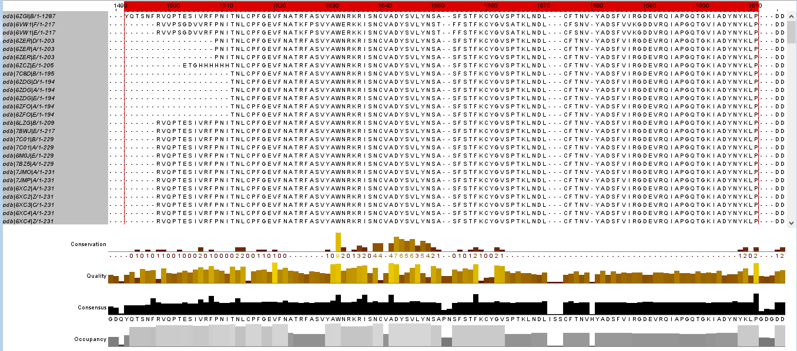
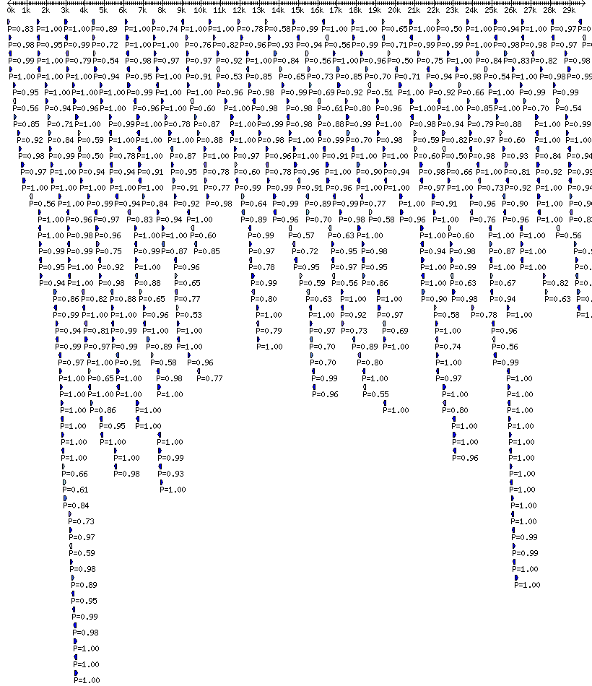 Figure1a. SARS-COV-2 Immunity Interaction 3D Map sequence allignement analysis.
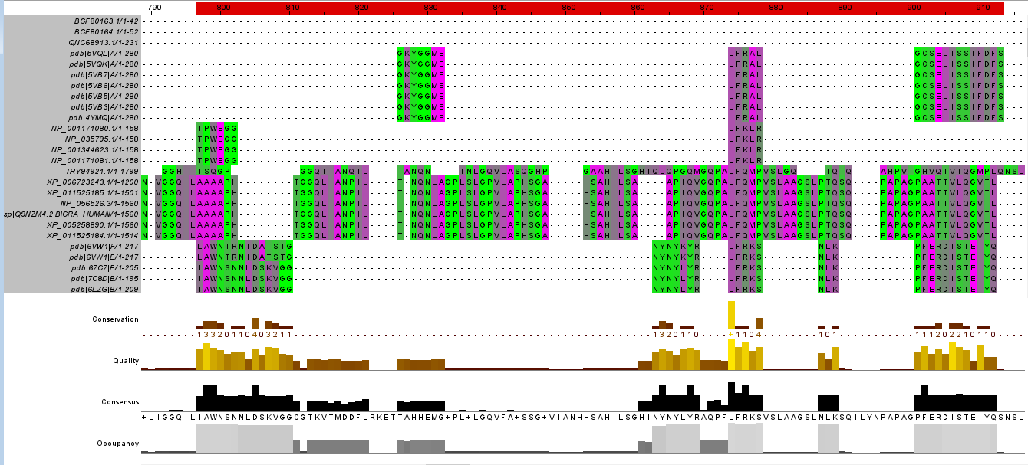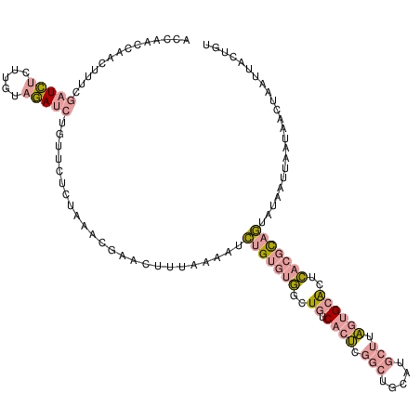Figure1b. Alignment of consensus sequence for regions of -MEP1A-FN1-MDN1-UBC-MRPS5-FURIN-
ADAMTS1-ROR-GAMMA found in SARS-COV-2 Interactome to the MEP1B-MEP1A-FN1-MDN1-UBC-MRPS5-FURIN-ADAMTS1-ROR-GAMMA

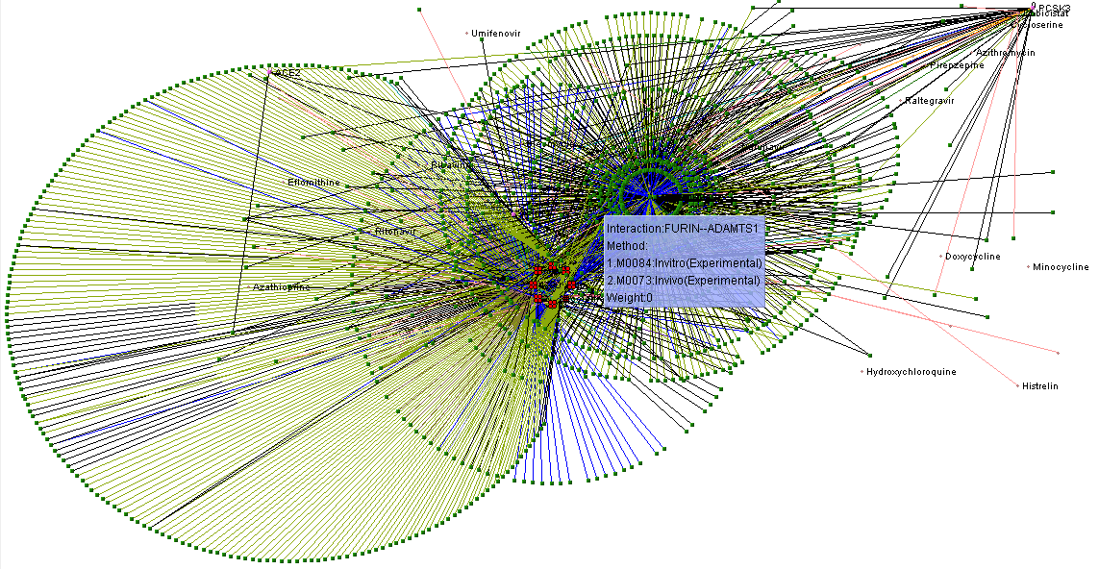

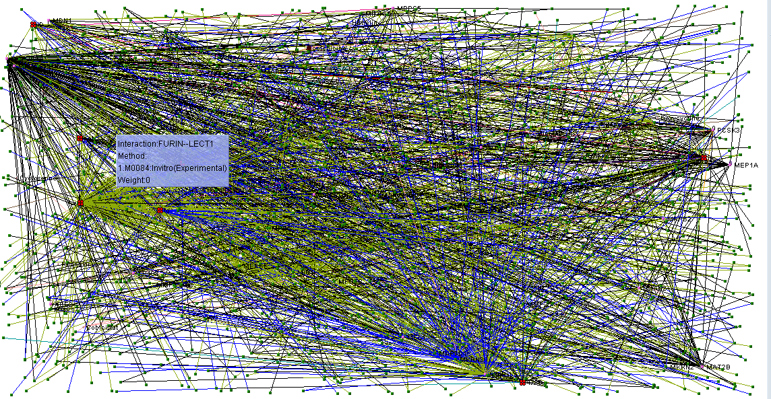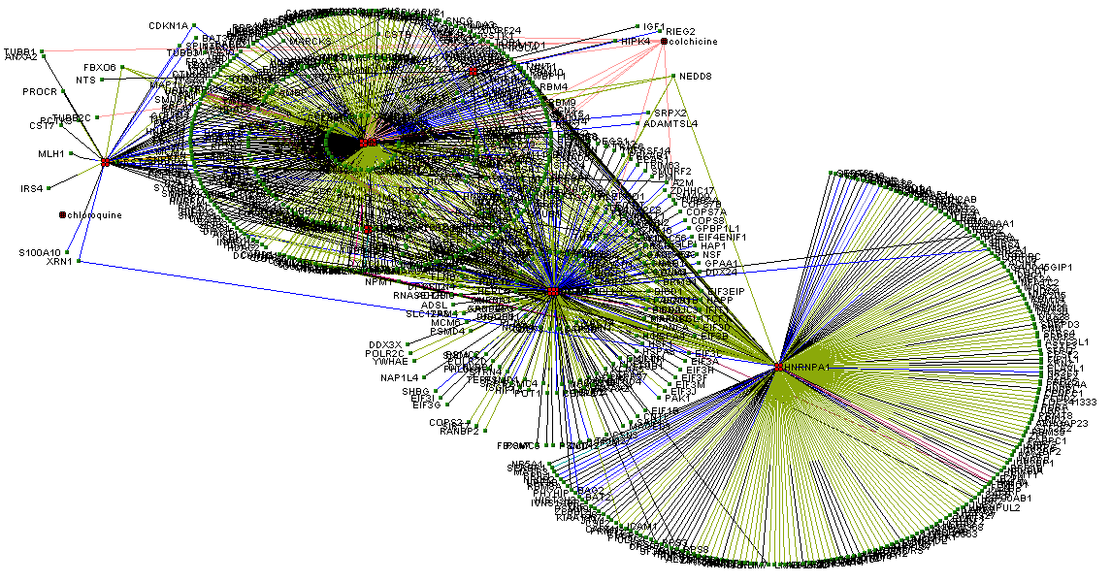Figure2. 3D Map Interactions of the key residues involved in this drug combination interaction (7 out of 9 residues) as potential SARS-COV2-RORγ-STAT3-DDX- FURIN-NF-Κβ-FURIN hot spots.

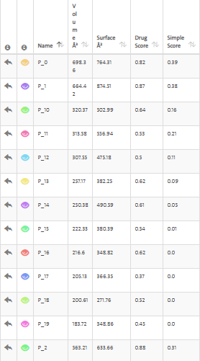
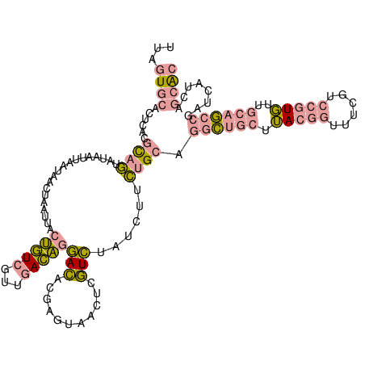
Figure3a. Remdesivir small molecule binding domains.

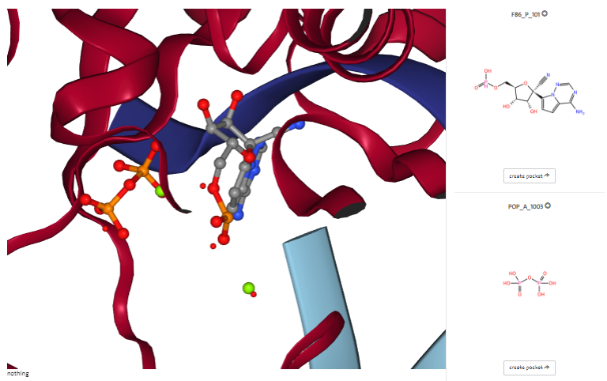

Figure3b. 3D Docking interactions of the Remdesivir small molecule inside the, 7BV2 protein targets.

name | lig_cov | poc_cov | lig_name | volume | enclosure | surface | depth | surf/vol | lid/hull | ellVol | ell c/a | ell b/a | siteAtms | accept | donor | hydrophobic_interactions | hydrophobicity | metal | Cs | Ns | Os | Ss | Xs | negAA | posAA | polarAA | apolarAA | ALA | ARG | ASN | ASP | CYS | GLN | GLU | GLY | HIS | ILE | LEU | LYS | MET | PHE | PRO | SER | THR | TRP | TYR | VAL | simpleScore | drugScore
P_0 | 0.00 | 0.00 | "" | 698.36 | 0.05 | 764.31 | 20.32 | 1.094435534681253 | - | - | 0.13 | 0.37 | 177 | 52 | 23 | 21 | 0.22 | 0 | 122 | 25 | 30 | 0 | 0 | 0.13 | 0.13 | 0.39 | 0.34 | 5 | 2 | 3 | 5 | 1 | 1 | 0 | 1 | 1 | 0 | 4 | 2 | 0 | 2 | 0 | 2 | 1 | 0 | 6 | 2 | 0.39 | 0.823072
P_1 | 0.00 | 0.00 | "" | 664.42 | 0.06 | 874.51 | 24.96 | 1.3162005960085488 | - | - | 0.18 | 0.33 | 174 | 68 | 20 | 30 | 0.25 | 0 | 114 | 25 | 31 | 4 | 0 | 0.00 | 0.09 | 0.44 | 0.47 | 3 | 2 | 2 | 0 | 1 | 0 | 0 | 3 | 0 | 3 | 1 | 1 | 3 | 2 | 0 | 2 | 4 | 0 | 3 | 4 | 0.38 | 0.866577
P_2 | 0.00 | 0.00 | "" | 563.21 | 0.04 | 633.66 | 26.77 | 1.1250865574119777 | - | - | 0.11 | 0.22 | 183 | 56 | 13 | 24 | 0.26 | 0 | 129 | 22 | 30 | 2 | 0 | 0.03 | 0.06 | 0.38 | 0.53 | 1 | 2 | 1 | 1 | 2 | 3 | 0 | 0 | 0 | 1 | 9 | 0 | 1 | 1 | 2 | 0 | 5 | 0 | 2 | 3 | 0.31 | 0.881316
P_3 | 0.00 | 0.00 | "" | 519.77 | 0.02 | 675.57 | 27.25 | 1.2997479654462551 | - | - | 0.05 | 0.12 | 172 | 52 | 18 | 20 | 0.22 | 0 | 115 | 25 | 31 | 1 | 0 | 0.11 | 0.17 | 0.34 | 0.37 | 2 | 4 | 2 | 3 | 3 | 0 | 1 | 1 | 1 | 2 | 5 | 1 | 0 | 2 | 0 | 3 | 3 | 0 | 0 | 2 | 0.27 | 0.88488
P_4 | 0.00 | 0.00 | "" | 501.52 | 0.12 | 891.14 | 11.74 | 1.7768782899984048 | - | - | 0.07 | 0.16 | 111 | 38 | 18 | 28 | 0.33 | 0 | 78 | 13 | 20 | 0 | 0 | 0.12 | 0.20 | 0.20 | 0.48 | 2 | 0 | 0 | 1 | 0 | 0 | 2 | 1 | 0 | 0 | 3 | 5 | 1 | 4 | 0 | 3 | 0 | 0 | 1 | 2 | 0.30 | 0.650145
P_5 | 0.00 | 0.00 | "" | 440.59 | 0.06 | 473.75 | 17.93 | 1.0752627159036747 | - | - | 0.22 | 0.67 | 125 | 34 | 14 | 14 | 0.23 | 0 | 88 | 17 | 17 | 3 | 0 | 0.07 | 0.10 | 0.31 | 0.52 | 1 | 1 | 2 | 0 | 2 | 1 | 2 | 1 | 1 | 1 | 2 | 1 | 1 | 3 | 5 | 1 | 1 | 0 | 1 | 2 | 0.20 | 0.772032
P_6 | 0.00 | 0.00 | "" | 433.35 | 0.05 | 675.82 | 14.05 | 1.5595246336679358 | - | - | 0.25 | 0.49 | 118 | 37 | 12 | 19 | 0.28 | 0 | 84 | 14 | 20 | 0 | 0 | 0.11 | 0.11 | 0.30 | 0.48 | 1 | 1 | 3 | 2 | 0 | 0 | 1 | 0 | 1 | 2 | 2 | 1 | 0 | 2 | 1 | 2 | 1 | 0 | 2 | 5 | 0.22 | 0.681283
P_7 | 0.00 | 0.00 | "" | 432.29 | 0.06 | 604.75 | 17.73 | 1.3989451525596241 | - | - | 0.06 | 0.22 | 141 | 39 | 11 | 23 | 0.32 | 0 | 98 | 19 | 23 | 1 | 0 | 0.03 | 0.10 | 0.38 | 0.48 | 1 | 2 | 5 | 0 | 0 | 1 | 1 | 1 | 0 | 0 | 3 | 1 | 2 | 1 | 4 | 1 | 2 | 0 | 1 | 3 | 0.23 | 0.76409
P_8 | 0.00 | 0.00 | "" | 392.32 | 0.09 | 618.69 | 17.85 | 1.577003466557912 | - | - | 0.16 | 0.23 | 90 | 33 | 22 | 11 | 0.17 | 0 | 57 | 16 | 16 | 1 | 0 | 0.14 | 0.24 | 0.38 | 0.24 | 2 | 3 | 0 | 2 | 0 | 0 | 1 | 0 | 0 | 0 | 0 | 2 | 1 | 0 | 0 | 2 | 4 | 0 | 2 | 2 | 0.14 | 0.729074
P_9 | 0.00 | 0.00 | "" | 342.85 | 0.09 | 403.97 | 15.95 | 1.1782703806329298 | - | - | 0.14 | 0.21 | 92 | 26 | 11 | 18 | 0.33 | 0 | 62 | 15 | 14 | 1 | 0 | 0.20 | 0.20 | 0.25 | 0.35 | 0 | 3 | 1 | 3 | 2 | 1 | 1 | 0 | 1 | 1 | 2 | 0 | 0 | 2 | 0 | 0 | 1 | 0 | 0 | 2 | 0.16 | 0.671095
P_10 | 0.00 | 0.00 | "" | 320.37 | 0.10 | 502.99 | 14.57 | 1.5700284046571151 | - | - | 0.24 | 0.30 | 85 | 22 | 12 | 22 | 0.39 | 0 | 62 | 11 | 12 | 0 | 0 | 0.00 | 0.28 | 0.22 | 0.50 | 2 | 2 | 1 | 0 | 0 | 1 | 0 | 0 | 0 | 1 | 1 | 3 | 0 | 3 | 1 | 1 | 0 | 0 | 1 | 1 | 0.16 | 0.636872
P_11 | 0.00 | 0.00 | "" | 313.58 | 0.17 | 556.94 | 11.74 | 1.7760699024172462 | - | - | 0.07 | 0.09 | 78 | 22 | 6 | 31 | 0.53 | 0 | 57 | 9 | 12 | 0 | 0 | 0.13 | 0.13 | 0.27 | 0.47 | 0 | 1 | 0 | 0 | 0 | 0 | 2 | 0 | 0 | 1 | 1 | 1 | 0 | 1 | 2 | 1 | 2 | 1 | 1 | 1 | 0.21 | 0.534974
P_12 | 0.00 | 0.00 | "" | 307.55 | 0.19 | 475.18 | 11.28 | 1.5450495854332629 | - | - | 0.14 | 0.17 | 64 | 30 | 8 | 16 | 0.30 | 0 | 44 | 7 | 13 | 0 | 0 | 0.18 | 0.06 | 0.35 | 0.41 | 3 | 0 | 1 | 2 | 0 | 1 | 1 | 1 | 0 | 0 | 0 | 1 | 0 | 1 | 1 | 2 | 1 | 2 | 0 | 0 | 0.11 | 0.5
P_13 | 0.00 | 0.00 | "" | 257.17 | 0.15 | 382.25 | 15.16 | 1.4863708830734532 | - | - | 0.10 | 0.12 | 70 | 26 | 7 | 20 | 0.38 | 0 | 51 | 7 | 12 | 0 | 0 | 0.05 | 0.05 | 0.37 | 0.53 | 0 | 0 | 1 | 1 | 1 | 0 | 0 | 0 | 0 | 1 | 5 | 1 | 0 | 1 | 1 | 1 | 3 | 0 | 1 | 2 | 0.09 | 0.619331
P_14 | 0.00 | 0.00 | "" | 250.38 | 0.00 | 490.59 | 15.15 | 1.9593817397555715 | - | - | 0.16 | 0.28 | 99 | 34 | 16 | 21 | 0.30 | 0 | 66 | 16 | 16 | 1 | 0 | 0.04 | 0.04 | 0.44 | 0.48 | 4 | 1 | 2 | 1 | 1 | 1 | 0 | 3 | 0 | 1 | 2 | 0 | 2 | 1 | 0 | 1 | 2 | 0 | 1 | 2 | 0.05 | 0.611253
P_15 | 0.00 | 0.00 | "" | 222.33 | 0.00 | 380.39 | 13.97 | 1.7109252012773803 | - | - | 0.13 | 0.27 | 83 | 18 | 9 | 10 | 0.27 | 0 | 60 | 13 | 10 | 0 | 0 | 0.05 | 0.18 | 0.41 | 0.36 | 0 | 0 | 0 | 0 | 0 | 1 | 1 | 3 | 1 | 0 | 1 | 3 | 1 | 1 | 2 | 0 | 1 | 1 | 4 | 2 | 0.01 | 0.536145
P_16 | 0.00 | 0.00 | "" | 216.60 | 0.10 | 348.82 | 16.17 | 1.6104339796860572 | - | - | 0.07 | 0.08 | 90 | 28 | 8 | 11 | 0.23 | 0 | 58 | 15 | 17 | 0 | 0 | 0.09 | 0.18 | 0.27 | 0.45 | 2 | 1 | 1 | 2 | 0 | 1 | 0 | 2 | 1 | 2 | 2 | 2 | 0 | 3 | 0 | 1 | 1 | 0 | 0 | 1 | 0.00 | 0.621577
P_17 | 0.00 | 0.00 | "" | 205.13 | 0.11 | 366.35 | 9.36 | 1.7859406230195487 | - | - | 0.28 | 0.70 | 65 | 16 | 6 | 10 | 0.31 | 0 | 44 | 11 | 10 | 0 | 0 | 0.00 | 0.07 | 0.33 | 0.60 | 5 | 0 | 2 | 0 | 0 | 0 | 0 | 1 | 0 | 1 | 2 | 1 | 0 | 0 | 1 | 1 | 1 | 0 | 0 | 0 | 0.00 | 0.36894
P_18 | 0.00 | 0.00 | "" | 200.61 | 0.15 | 271.76 | 13.85 | 1.3546682618015053 | - | - | 0.12 | 0.15 | 77 | 18 | 5 | 4 | 0.15 | 0 | 55 | 11 | 10 | 1 | 0 | 0.06 | 0.06 | 0.44 | 0.44 | 1 | 1 | 1 | 1 | 0 | 3 | 0 | 0 | 0 | 1 | 1 | 0 | 1 | 1 | 0 | 0 | 1 | 0 | 2 | 2 | 0.00 | 0.524737
P_19 | 0.00 | 0.00 | "" | 183.72 | 0.07 | 348.86 | 12.07 | 1.8988678423688221 | - | - | 0.17 | 0.22 | 57 | 21 | 3 | 6 | 0.20 | 0 | 40 | 5 | 11 | 1 | 0 | 0.07 | 0.00 | 0.36 | 0.57 | 1 | 0 | 2 | 1 | 0 | 1 | 0 | 0 | 0 | 1 | 0 | 0 | 1 | 1 | 0 | 1 | 1 | 0 | 0 | 4 | 0.00 | 0.454169
P_20 | 0.00 | 0.00 | "" | 182.96 | 0.22 | 381.04 | 9.20 | 2.0826410144293837 | - | - | 0.28 | 0.75 | 50 | 16 | 10 | 13 | 0.33 | 0 | 33 | 9 | 8 | 0 | 0 | 0.00 | 0.27 | 0.36 | 0.36 | 1 | 1 | 2 | 0 | 0 | 1 | 0 | 0 | 1 | 1 | 1 | 1 | 0 | 0 | 0 | 0 | 0 | 0 | 1 | 1 | 0.00 | 0.313932
P_21 | 0.00 | 0.00 | "" | 171.20 | 0.23 | 326.60 | 12.16 | 1.907710280373832 | - | - | 0.13 | 0.19 | 52 | 17 | 6 | 7 | 0.23 | 0 | 36 | 6 | 8 | 2 | 0 | 0.17 | 0.17 | 0.17 | 0.50 | 0 | 0 | 0 | 2 | 1 | 0 | 0 | 0 | 0 | 0 | 0 | 2 | 1 | 1 | 1 | 1 | 0 | 1 | 0 | 2 | 0.00 | 0.440302
P_22 | 0.00 | 0.00 | "" | 169.08 | 0.19 | 226.47 | 8.57 | 1.3394251242015613 | - | - | 0.40 | 0.54 | 42 | 8 | 10 | 9 | 0.33 | 0 | 27 | 8 | 7 | 0 | 0 | 0.00 | 0.15 | 0.38 | 0.46 | 2 | 1 | 2 | 0 | 0 | 0 | 0 | 0 | 0 | 1 | 1 | 1 | 0 | 0 | 0 | 1 | 1 | 0 | 1 | 2 | 0.00 | 0.293787
P_23 | 0.00 | 0.00 | "" | 158.83 | 0.00 | 212.59 | 12.35 | 1.3384750991626266 | - | - | 0.15 | 0.29 | 62 | 15 | 2 | 5 | 0.23 | 0 | 45 | 8 | 8 | 1 | 0 | 0.13 | 0.07 | 0.33 | 0.47 | 1 | 1 | 1 | 1 | 0 | 2 | 1 | 1 | 0 | 1 | 3 | 0 | 1 | 0 | 0 | 0 | 0 | 0 | 1 | 1 | 0.00 | 0.433317
P_24 | 0.00 | 0.00 | "" | 154.76 | 0.00 | 354.92 | 11.14 | 2.2933574567071595 | - | - | 0.28 | 0.35 | 57 | 18 | 8 | 12 | 0.32 | 0 | 38 | 11 | 8 | 0 | 0 | 0.25 | 0.17 | 0.25 | 0.33 | 1 | 1 | 1 | 3 | 1 | 0 | 0 | 0 | 0 | 0 | 1 | 1 | 0 | 0 | 1 | 0 | 0 | 0 | 1 | 1 | 0.00 | 0.35845
P_25 | 0.00 | 0.00 | "" | 150.08 | 0.00 | 161.37 | 11.47 | 1.0752265458422174 | - | - | 0.17 | 0.39 | 73 | 17 | 9 | 1 | 0.04 | 0 | 52 | 8 | 11 | 2 | 0 | 0.12 | 0.06 | 0.41 | 0.41 | 1 | 0 | 3 | 2 | 1 | 0 | 0 | 0 | 0 | 0 | 1 | 1 | 1 | 1 | 2 | 1 | 1 | 0 | 1 | 1 | 0.00 | 0.381461
P_26 | 0.00 | 0.00 | "" | 141.63 | 0.00 | 184.42 | 13.39 | 1.3021252559485985 | - | - | 0.12 | 0.18 | 65 | 28 | 9 | 6 | 0.14 | 0 | 42 | 7 | 16 | 0 | 0 | 0.13 | 0.00 | 0.60 | 0.27 | 1 | 0 | 1 | 1 | 0 | 1 | 1 | 2 | 0 | 1 | 0 | 0 | 0 | 0 | 0 | 2 | 3 | 0 | 0 | 2 | 0.00 | 0.433203
P_27 | 0.00 | 0.00 | "" | 126.10 | 0.29 | 281.68 | 8.40 | 2.2337827121332277 | - | - | 0.22 | 0.34 | 30 | 12 | 2 | 11 | 0.44 | 0 | 20 | 4 | 6 | 0 | 0 | 0.29 | 0.00 | 0.14 | 0.57 | 0 | 0 | 0 | 2 | 0 | 0 | 0 | 0 | 0 | 0 | 0 | 0 | 0 | 0 | 1 | 0 | 0 | 0 | 1 | 3 | 0.00 | 0.264233
P_28 | 0.00 | 0.00 | "" | 120.52 | 0.22 | 290.90 | 8.58 | 2.413707268503153 | - | - | 0.29 | 0.67 | 38 | 20 | 7 | 8 | 0.23 | 0 | 24 | 6 | 8 | 0 | 0 | 0.12 | 0.12 | 0.50 | 0.25 | 2 | 1 | 1 | 1 | 0 | 1 | 0 | 0 | 0 | 0 | 0 | 0 | 0 | 0 | 0 | 1 | 0 | 0 | 1 | 0 | 0.00 | 0.22373
P_29 | 0.00 | 0.00 | "" | 115.39 | 0.17 | 257.89 | 5.68 | 2.2349423693560966 | - | - | 0.24 | 0.48 | 48 | 20 | 5 | 6 | 0.19 | 0 | 33 | 5 | 10 | 0 | 0 | 0.12 | 0.12 | 0.50 | 0.25 | 0 | 0 | 0 | 1 | 1 | 0 | 0 | 1 | 0 | 1 | 1 | 1 | 0 | 0 | 0 | 0 | 0 | 0 | 2 | 0 | 0.00 | 0.136729
P_30 | 0.00 | 0.00 | "" | 114.94 | 0.24 | 169.27 | 8.02 | 1.4726813989907779 | - | - | 0.48 | 0.66 | 29 | 10 | 3 | 7 | 0.35 | 0 | 21 | 2 | 4 | 2 | 0 | 0.00 | 0.09 | 0.45 | 0.45 | 0 | 0 | 0 | 0 | 1 | 1 | 0 | 1 | 0 | 0 | 1 | 1 | 1 | 1 | 0 | 1 | 1 | 1 | 0 | 1 | 0.00 | 0.23024
P_31 | 0.00 | 0.00 | "" | 112.22 | 0.34 | 183.75 | 7.18 | 1.6374086615576546 | - | - | 0.59 | 0.73 | 28 | 6 | 7 | 3 | 0.19 | 0 | 18 | 6 | 4 | 0 | 0 | 0.10 | 0.20 | 0.10 | 0.60 | 1 | 2 | 0 | 1 | 0 | 0 | 0 | 1 | 0 | 1 | 1 | 0 | 0 | 2 | 0 | 0 | 0 | 0 | 0 | 1 | 0.00 | 0.215594
P_32 | 0.00 | 0.00 | "" | 110.86 | 0.23 | 234.70 | 9.17 | 2.1170846112213604 | - | - | 0.27 | 0.30 | 34 | 16 | 5 | 5 | 0.19 | 0 | 20 | 5 | 9 | 0 | 0 | 0.20 | 0.10 | 0.50 | 0.20 | 0 | 1 | 1 | 2 | 0 | 0 | 0 | 0 | 0 | 1 | 0 | 0 | 0 | 0 | 0 | 1 | 1 | 0 | 2 | 1 | 0.00 | 0.228273
P_33 | 0.00 | 0.00 | "" | 110.71 | 0.16 | 215.03 | 6.84 | 1.9422816367085178 | - | - | 0.38 | 0.54 | 36 | 14 | 2 | 5 | 0.24 | 0 | 25 | 3 | 8 | 0 | 0 | 0.22 | 0.11 | 0.33 | 0.33 | 0 | 0 | 0 | 1 | 0 | 1 | 1 | 1 | 0 | 0 | 0 | 1 | 0 | 1 | 0 | 1 | 0 | 0 | 0 | 2 | 0.00 | 0.17542
P_34 | 0.00 | 0.00 | "" | 109.35 | 0.00 | 87.16 | 11.91 | 0.7970736168267033 | - | - | 0.09 | 0.18 | 50 | 14 | 3 | 0 | 0.00 | 0 | 41 | 2 | 7 | 0 | 0 | 0.08 | 0.08 | 0.23 | 0.62 | 0 | 0 | 0 | 1 | 0 | 0 | 0 | 0 | 0 | 2 | 2 | 1 | 0 | 1 | 0 | 1 | 0 | 0 | 2 | 3 | 0.00 | 0.381955
P_35 | 0.00 | 0.00 | "" | 109.05 | 0.00 | 159.17 | 9.30 | 1.4596056854653827 | - | - | 0.30 | 0.53 | 55 | 15 | 1 | 3 | 0.16 | 0 | 38 | 8 | 8 | 1 | 0 | 0.27 | 0.18 | 0.00 | 0.55 | 0 | 2 | 0 | 2 | 0 | 0 | 1 | 0 | 0 | 0 | 3 | 0 | 1 | 0 | 0 | 0 | 0 | 0 | 0 | 2 | 0.00 | 0.279055
P_36 | 0.00 | 0.00 | "" | 108.45 | 0.18 | 224.82 | 7.58 | 2.0730290456431533 | - | - | 0.45 | 0.72 | 36 | 14 | 4 | 5 | 0.22 | 0 | 26 | 4 | 6 | 0 | 0 | 0.22 | 0.11 | 0.33 | 0.33 | 0 | 0 | 0 | 1 | 0 | 0 | 1 | 0 | 0 | 0 | 1 | 1 | 0 | 0 | 1 | 2 | 0 | 0 | 1 | 1 | 0.00 | 0.196
P_37 | 0.00 | 0.00 | "" | 100.15 | 0.15 | 298.70 | 6.78 | 2.982526210683974 | - | - | 0.49 | 0.68 | 39 | 14 | 5 | 13 | 0.41 | 0 | 25 | 6 | 8 | 0 | 0 | 0.09 | 0.09 | 0.36 | 0.45 | 3 | 1 | 1 | 0 | 0 | 0 | 1 | 1 | 0 | 0 | 2 | 0 | 0 | 0 | 0 | 0 | 2 | 0 | 0 | 0 | 0.00 | 0.181166
Table1a. Fitness scoring ranking of the Remdesivir small molecule inside the, 7BV2 protein targets.

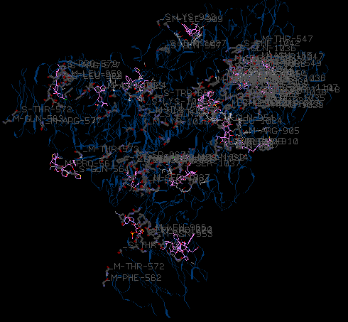
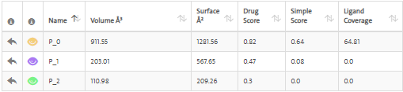
Figure3c. Binding domains (colors) of the docking interactions of the Colchicine, Remdesivir and Hydroxychloroquine small molecules inside the pdb:6AJZ protein targets.

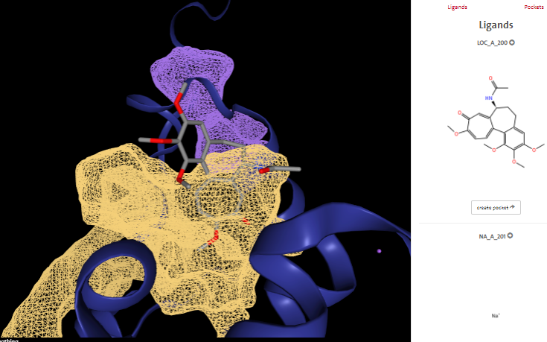
Figure3d. 3D Docking interactions of the Colchicine small molecule inside the pdb:6AJZ protein targets.

name | lig_cov | poc_cov | lig_name | volume | enclosure | surface | depth | surf/vol | lid/hull | ellVol | ell c/a | ell b/a | siteAtms | accept | donor | hydrophobic_interactions | hydrophobicity | metal | Cs | Ns | Os | Ss | Xs | negAA | posAA | polarAA | apolarAA | ALA | ARG | ASN | ASP | CYS | GLN | GLU | GLY | HIS | ILE | LEU | LYS | MET | PHE | PRO | SER | THR | TRP | TYR | VAL | simpleScore | drugScore
P_0 | 64.81 | 19.22 | LOC_A_200 | 911.55 | 0.11 | 1281.56 | 19.05 | 1.4059130053206077 | - | - | 0.26 | 0.38 | 186 | 51 | 20 | 78 | 0.52 | 0 | 131 | 25 | 28 | 2 | 0 | 0.05 | 0.08 | 0.34 | 0.53 | 1 | 0 | 3 | 2 | 1 | 2 | 0 | 1 | 0 | 2 | 2 | 3 | 3 | 2 | 7 | 0 | 3 | 2 | 3 | 1 | 0.64 | 0.820003
P_1 | 0.00 | 0.00 | LOC_A_200 | 203.01 | 0.19 | 567.65 | 12.38 | 2.7961676764691394 | - | - | 0.12 | 0.14 | 64 | 22 | 10 | 32 | 0.50 | 0 | 41 | 12 | 11 | 0 | 0 | 0.07 | 0.14 | 0.36 | 0.43 | 1 | 0 | 1 | 1 | 0 | 0 | 0 | 0 | 0 | 0 | 1 | 2 | 1 | 0 | 2 | 1 | 1 | 0 | 2 | 1 | 0.08 | 0.467499
P_2 | 0.00 | 0.00 | LOC_A_200 | 110.98 | 0.00 | 209.26 | 10.77 | 1.8855649666606595 | - | - | 0.16 | 0.26 | 59 | 18 | 4 | 9 | 0.29 | 0 | 41 | 9 | 9 | 0 | 0 | 0.00 | 0.27 | 0.45 | 0.27 | 0 | 2 | 1 | 0 | 0 | 2 | 0 | 0 | 0 | 0 | 3 | 1 | 0 | 0 | 0 | 0 | 0 | 0 | 2 | 0 | 0.00 | 0.300362
Table1b. Fitness scoring ranking of the 6ajz-colchicine: 6AJZ Joint nentron and X-ray structure of BRD4 in complex with colchicin.

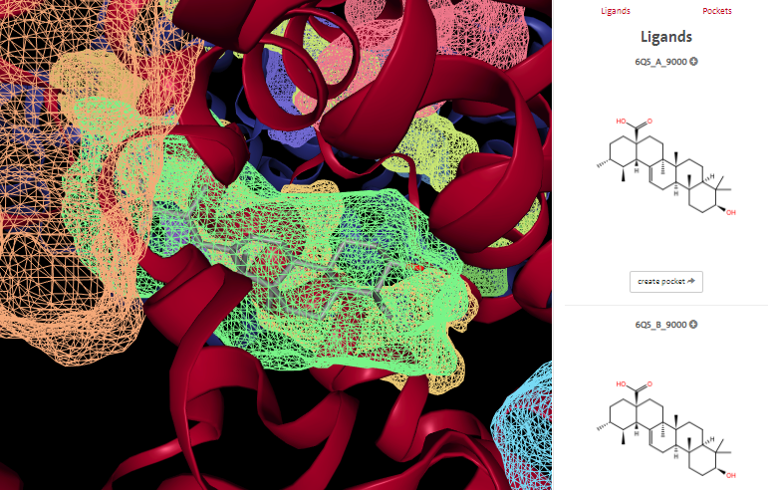
Figure3e. Crystal Structure of the mutant Human ROR gamma Ligand Binding Domain With Ursolic acid.
name lig_cov poc_cov lig_name volume enclosure surface depth surf/vol lid/hull ellVol ell c/a ell b/a siteAtms accept donor hydrophobic_interactions hydrophobicity metal Cs Ns Os Ss Xs negAA posAA polarAA apolarAA ALA ARG ASN ASP CYS GLN GLU GLY HIS ILE LEU LYS MET PHE PRO SER THR TRP TYR VAL simpleScore drugScore
P_0 0.00 0.00 6Q5_A_9000 686.02 0.21 902.43 22.67 1.3154572752980962 - - 0.02 0.03 167 60 7 47 0.41 0 113 22 32 0 0 0.05 0.19 0.22 0.54 5 1 0 0 0 6 2 0 5 0 2 1 1 2 2 0 2 4 0 4 0.46 0.85352
P_1 0.00 0.00 6Q5_A_9000 630.46 0.07 548.67 15.54 0.870269327157948 - - 0.13 0.18 116 21 8 31 0.52 0 91 12 11 2 0 0.00 0.15 0.15 0.69 2 2 0 0 2 1 0 0 2 2 5 0 1 4 0 0 0 1 1 3 0.46 0.788771
P_2 98.77 81.91 6Q5_A_9000 592.99 0.09 481.11 17.02 0.8113290274709523 - - 0.12 0.18 110 19 6 26 0.51 0 88 10 10 2 0 0.00 0.15 0.15 0.69 2 2 0 0 2 1 0 0 2 2 5 0 1 4 0 0 0 1 1 3 0.43 0.799819
P_3 0.00 0.00 6Q5_A_9000 465.48 0.19 653.11 17.80 1.4030892841797713 - - 0.09 0.26 108 25 11 24 0.40 0 79 16 11 2 0 0.04 0.17 0.25 0.54 2 1 2 0 1 1 1 1 1 4 1 2 1 0 2 1 0 0 0 3 0.29 0.777717
P_4 0.00 0.00 6Q5_A_9000 407.45 0.12 621.86 13.25 1.5262240765738129 - - 0.12 0.29 79 26 14 28 0.41 0 55 11 13 0 0 0.11 0.26 0.21 0.42 0 2 1 0 0 1 2 1 2 0 4 1 0 1 2 0 0 0 1 1 0.25 0.636122
P_5 0.00 0.00 6Q5_A_9000 345.66 0.03 547.52 31.78 1.5839842619915523 - - 0.02 0.03 144 34 8 9 0.18 0 106 13 23 2 0 0.00 0.19 0.23 0.58 0 0 0 0 0 7 0 0 4 4 6 2 2 2 1 0 0 0 0 3 0.10 0.899648
P_6 0.00 0.00 6Q5_A_9000 310.75 0.17 438.56 10.78 1.4112952534191472 - - 0.21 0.46 81 20 6 22 0.46 0 57 11 12 1 0 0.05 0.16 0.32 0.47 2 2 1 0 1 0 1 0 1 1 5 0 0 1 0 2 0 0 2 0 0.18 0.5
P_7 0.00 0.00 6Q5_A_9000 307.34 0.31 484.87 14.56 1.5776338908049719 - - 0.12 0.20 67 20 13 26 0.44 0 48 10 9 0 0 0.11 0.28 0.17 0.44 0 2 1 0 0 0 2 1 1 0 4 2 0 1 2 0 0 0 1 1 0.16 0.62362
P_8 0.00 0.00 6Q5_A_9000 285.66 0.17 403.86 10.67 1.413778617937408 - - 0.18 0.41 77 24 6 10 0.25 0 51 12 13 1 0 0.11 0.16 0.26 0.47 2 2 1 1 1 0 1 0 1 1 5 0 0 1 0 1 0 0 2 0 0.07 0.474819
P_9 0.00 0.00 6Q5_A_9000 208.16 0.11 311.89 12.99 1.4983186010760954 - - 0.19 0.38 74 13 8 10 0.32 0 51 13 8 2 0 0.06 0.24 0.24 0.47 2 2 0 0 1 1 1 1 1 2 1 1 1 0 1 1 0 0 0 1 0.01 0.5
P_10 0.00 0.00 6Q5_A_9000 163.35 0.08 301.57 8.66 1.8461585552494644 - - 0.24 0.59 46 10 6 9 0.36 0 35 5 6 0 0 0.00 0.08 0.31 0.62 1 1 1 0 0 0 0 1 0 1 4 0 0 1 0 2 0 0 0 1 0.00 0.309531
P_11 0.00 0.00 6Q5_A_9000 159.26 0.09 277.21 8.77 1.74061283435891 - - 0.22 0.54 53 12 4 6 0.27 0 41 5 7 0 0 0.00 0.07 0.36 0.57 1 1 1 0 0 0 0 1 0 1 4 0 0 1 0 3 0 0 0 1 0.00 0.30591
P_12 0.00 0.00 6Q5_A_9000 110.18 0.09 308.18 7.73 2.797059357415139 - - 0.30 0.52 38 9 3 16 0.57 0 26 5 6 1 0 0.12 0.12 0.38 0.38 0 1 0 0 1 0 1 1 0 1 0 0 1 1 0 1 0 0 0 0 0.00 0.207291
P_13 0.00 0.00 6Q5_A_9000 102.50 0.08 297.31 9.08 2.9005853658536584 - - 0.22 0.40 49 11 4 14 0.48 0 33 8 6 2 0 0.10 0.10 0.40 0.40 0 1 0 0 1 0 1 1 0 1 1 0 1 1 0 2 0 0 0 0 0.00 0.249806
5x8s

Table2. Fitness scoring ranking of the Ursolic acid small molecule inside the mutant Human ROR gamma Ligand Binding Domain pdb:5x8s protein targets

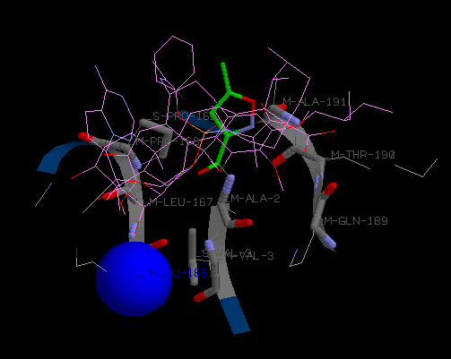
Figure4a. 3D Docking Interaction visualizations of the Colchicine, Remdesivir and Ursolic acid chemical strucutures in the pdb:6lu7 protein targets.

Compound | Energy | V-M-GLU-166 | V-M-LEU-167 | V-M-PRO-168 | V-S-PRO-168 | V-M-GLN-189 | V-M-THR-190 | V-M-ALA-191 | V-M-ALA-2 | V-M-VAL-3 | V-S-VAL-3
cav6lu7_02J-Colchicine-0.pdb | -67.4 | -2.06654 | -4.97965 | -10.4743 | -8.98984 | -4.03283 | -6.24897 | -3.46474 | -11.5726 | -3.22075 | -5.20269
cav6lu7_02J-Ursolic acid-0.pdb | -54.8 | -2.47196 | 0.546601 | -10.3582 | -8.03218 | -4.03691 | -7.35473 | -4.92237 | 1.26903 | -2.68435 | -4.65453
cav6lu7_02J-Remdesivir_Gilead_-0.pdb | -50.8 | -4.00794 | 3.29678 | -3.37184 | -9.07342 | -5.2667 | -8.94194 | -1.94094 | -4.27299 | -4.25681 | 0.931221

Table3a. Docking energy ranking analysis of the Colchicine, Remdesivir and Ursolic acid chemical strucutures in the pdb:6lu7 protein targets.

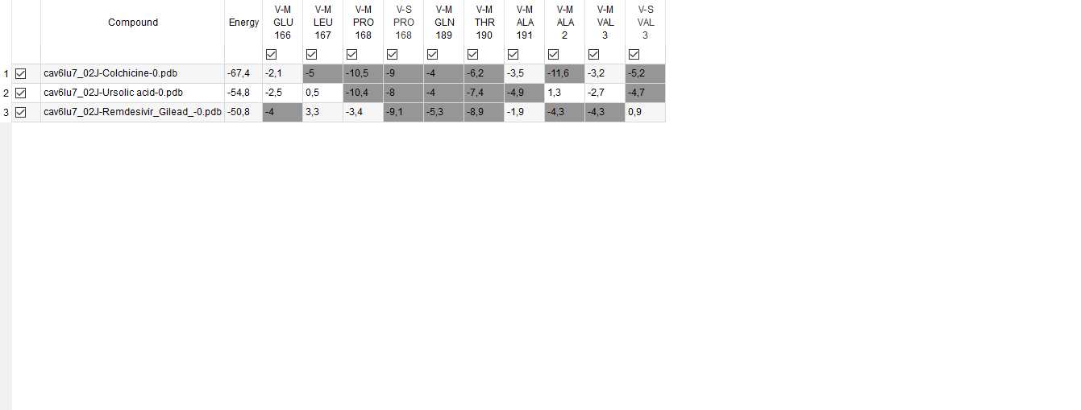

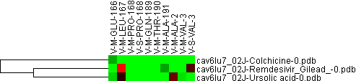
Figure4b. 3D Docking Cluster analysis of the Colchicine, Remdesivir and Ursolic acid chemical strucutures in the pdb:6lu7 protein targets.
GID | Compound | NAME | GWEIGHT | V-M-GLU-166 | V-M-LEU-167 | V-M-PRO-168 | V-S-PRO-168 | V-M-GLN-189 | V-M-THR-190 | V-M-ALA-191 | V-M-ALA-2 | V-M-VAL-3 | V-S-VAL-3
EWEIGHT |  |  |  | 1.0 | 1.0 | 1.0 | 1.0 | 1.0 | 1.0 | 1.0 | 1.0 | 1.0 | NaN
GENE2X | cav6lu7_02J-Remdesivir_Gilead_-0.pdb | cav6lu7_02J-Remdesivir_Gilead_-0.pdb | 1.0 | -4.00794 | 3.29678 | -3.37184 | -9.07342 | -5.2667 | -8.94194 | -1.94094 | -4.27299 | -4.25681 | 0.931221
GENE1X | cav6lu7_02J-Ursolic acid-0.pdb | cav6lu7_02J-Ursolic acid-0.pdb | 1.0 | -2.47196 | 0.546601 | -10.3582 | -8.03218 | -4.03691 | -7.35473 | -4.92237 | 1.26903 | -2.68435 | -4.65453
Table3b. FWEIGHT Docking energy ranking analysis of the Colchicine, Remdesivir and Ursolic acid chemical strucutures in the pdb:6lu7 protein targets.

ION

ZN (zinc ion)

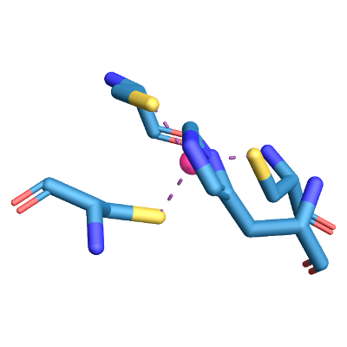

ZN-A-1001
Interacting chains: A
Figure4c. ZN-A-1001 Ion binding sites of the Ursolic acid into the 7BV2 protein targets.
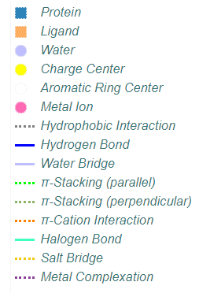
Recomborovir in PyMol (.pse) format | as (.png) image

Metal Complexes
Index | Residue | AA | Metal | Target | Distance | Location
Complex 1: Zn, tetrahedral (4)
1 | 295A | HIS | 8594 | 1771 | 2.09 | protein.sidechain
2 | 301A | CYS | 8594 | 1816 | 2.31 | protein.sidechain
3 | 306A | CYS | 8594 | 1857 | 2.31 | protein.sidechain
4 | 310A | CYS | 8594 | 1889 | 2.31 | protein.sidechain

ZN-A-1002
Interacting chains: A
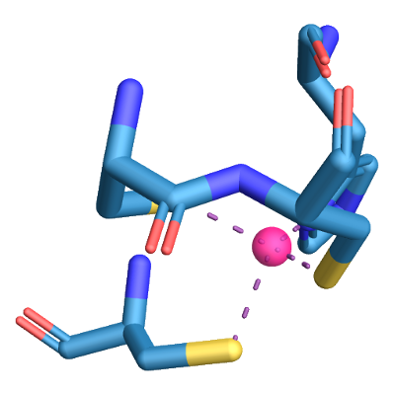
Figure4d. ZN-A-1002 Ion Metal complexes of the Ursolic acid into the 7BV2 protein targets.
Recomborovir in PyMol (.pse) format | as (.png) image

Metal Complexes
Index | Residue | AA | Metal | Target | Distance | Location
Complex 1: Zn, tetrahedral (4)
1 | 487A | CYS | 8595 | 3297 | 2.38 | protein.sidechain
2 | 642A | HIS | 8595 | 4527 | 1.87 | protein.sidechain
3 | 645A | CYS | 8595 | 4550 | 2.39 | protein.sidechain
4 | 646A | CYS | 8595 | 4556 | 2.34 | protein.sidechain

RNA

Starting with U (composite ligand, containing Uridine Monophosphate)

U-U-U-A-U-A-A-C-U-U-A-A-U-C
Composite ligand consists of U:T:8, U:T:9, U:T:10, A:T:11, U:T:12, A:T:13, A:T:14, C:T:15, U:T:16, U:T:17, A:T:18, A:T:19, U:T:20, C:T:21.
Interacting chains: A
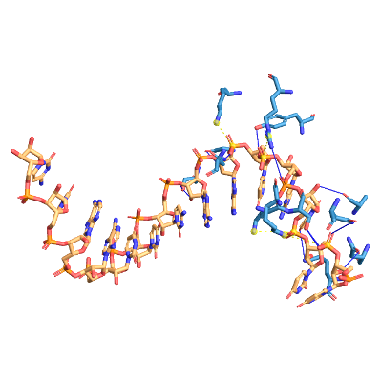
Figure4e. U-U-U-A-U-A-A-C-U-U-A-A-U-C with U (composite Ursolic acid ligand, containing Uridine Monophosphate) binding sites into the 7BV2 protein targets.
Recomborovir in PyMol (.pse) format | as (.png) image

Hydrogen Bonds
Index | Residue | AA | Distance H-A | Distance D-A | Donor Angle | Protein donor? | Sidechain | Donor Atom | Acceptor Atom
1 | 496A | ASN | 1.91 | 2.64 | 128.77 |  |  | 3365 (Nam) | 8407 (O3)
2 | 501A | SER | 2.48 | 3.21 | 132.45 |  |  | 8325 (O3) | 3404 (O3)
3 | 501A | SER | 2.12 | 2.99 | 148.42 |  |  | 3404 (O3) | 8326 (O3)
4 | 507A | ASN | 2.58 | 3.43 | 143.55 |  |  | 3450 (Nam) | 8324 (O2)
5 | 543A | ASN | 3.04 | 3.54 | 113.10 |  |  | 8313 (O3) | 3752 (O2)
6 | 545A | LYS | 2.96 | 3.86 | 146.92 |  |  | 3770 (N3) | 8360 (O2)
7 | 558A | ALA | 2.91 | 3.52 | 121.77 |  |  | 8353 (O3) | 3868 (O2)
8 | 569A | ARG | 3.38 | 3.85 | 111.72 |  |  | 3947 (Ng+) | 8364 (O2)
9 | 590A | GLY | 3.17 | 3.91 | 133.56 |  |  | 8415 (O3) | 4104 (O2)
10 | 592A | SER | 2.73 | 3.08 | 101.92 |  |  | 4117 (O3) | 8435 (O3)
11 | 592A | SER | 2.19 | 2.61 | 104.41 |  |  | 8437 (O3) | 4117 (O3)
12 | 689A | TYR | 2.77 | 3.27 | 112.65 |  |  | 8395 (O3) | 4872 (O3)

Salt Bridges
Index | Residue | AA | Distance | Protein positive? | Ligand Group | Ligand Atoms
1 | 500A | LYS | 4.74 |  | Phosphate | 8343, 8343, 8331, 8344, 8345, 8346
2 | 511A | LYS | 5.37 |  | Phosphate | 8323, 8323, 8311, 8324, 8325, 8326
3 | 569A | ARG | 5.03 |  | Phosphate | 8385, 8385, 8371, 8388, 8386, 8387
4 | 577A | LYS | 4.21 |  | Phosphate | 8405, 8405, 8393, 8406, 8407, 8408

RNA+ION

Starting with G (composite ligand, containing Guanosine Monophosphate)

G-A-U-U-A-A-G-U-U-A-U-F86-MG
Composite ligand consists of G:P:10, A:P:11, U:P:12, U:P:13, A:P:14, A:P:15, G:P:16, U:P:17, U:P:18, A:P:19, U:P:20, F86:P:101, MG:A:1005.
Interacting chains: A, P
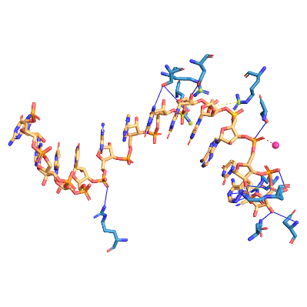
Figure4f. G-A-U-U-A-A-G-U-U-A-U-F86-MG with G (composite ligand, containing Guanosine Monophosphate) binding sites of the Ursolic acid into the into the 7BV2 protein targets.
Recomborovir in PyMol (.pse) format | as (.png) image

Hydrogen Bonds
Index | Residue | AA | Distance H-A | Distance D-A | Donor Angle | Protein donor? | Sidechain | Donor Atom | Acceptor Atom
1 | 513A | ARG | 3.09 | 3.45 | 102.67 |  |  | 3502 (Ng+) | 8154 (O3)
2 | 555A | ARG | 3.47 | 4.04 | 119.47 |  |  | 3849 (Ng+) | 8617 (Nar)
3 | 555A | ARG | 3.16 | 3.92 | 134.87 |  |  | 3850 (Ng+) | 8615 (Nar)
4 | 623A | ASP | 3.55 | 3.98 | 109.70 |  |  | 8628 (O3) | 4372 (N2)
5 | 691A | ASN | 2.89 | 3.60 | 129.54 |  |  | 4885 (Nam) | 8628 (O3)
6 | 759A | SER | 2.21 | 3.00 | 137.32 |  |  | 5447 (O3) | 8292 (O3)
7 | 760A | ASP | 3.12 | 3.82 | 130.09 |  |  | 8292 (O3) | 5454 (O2)
8 | 760A | ASP | 2.51 | 3.45 | 163.02 |  |  | 8629 (O3) | 5455 (O3)
9 | 814A | SER | 2.91 | 3.53 | 122.40 |  |  | 5880 (O3) | 8284 (O2)
10 | 861A | SER | 2.90 | 3.87 | 169.93 |  |  | 8217 (Npl) | 6248 (O3)
11 | 861A | SER | 2.89 | 3.64 | 135.36 |  |  | 6248 (O3) | 8226 (O3)
12 | 865A | ASP | 3.03 | 3.36 | 102.95 |  |  | 6277 (O3) | 8230 (O3)
13 | 865A | ASP | 2.75 | 3.36 | 121.52 |  |  | 8230 (O3) | 6277 (O3)

π-Cation Interactions
Index | Residue | AA | Distance | Offset | Protein charged? | Ligand Group | Ligand Atoms
1 | 555A | ARG | 3.61 | 1.61 |  | Aromatic | 8618, 8608, 8610, 8621, 8625

Salt Bridges
Index | Residue | AA | Distance | Protein positive? | Ligand Group | Ligand Atoms
1 | 836A | ARG | 4.57 |  | Phosphate | 8240, 8240, 8243, 8228, 8241, 8242
2 | 836A | ARG | 4.24 |  | Phosphate | 8260, 8260, 8248, 8261, 8262, 8263
3 | 849A | LYS | 4.64 |  | Phosphate | 8220, 8220, 8205, 8222, 8223, 8221
4 | 858A | ARG | 4.87 |  | Phosphate | 8220, 8220, 8205, 8222, 8223, 8221

Metal Complexes
Index | Residue | AA | Metal | Target | Distance | Location
Complex 1: Mg, NA (1)
1 | 10P | G | 8606 | 8283 | 2.33 | ligand

SMALLMOLECULE+ION

POP (composite ligand, containing Diphosphate, dihydrogen)

POP-A-1003
Composite ligand consists of POP:A:1003, MG:A:1004.
Interacting chains: A
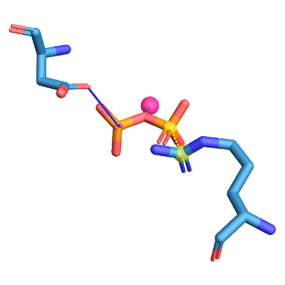
Figure4g. Hydrogen bonds, Salt bridges and Metal complexes of the Ursolic acid POP (composite ligand, containing Diphosphate, dihydrogen) ION binding sites into the 7bv2 protein targets.
Recomborovir in PyMol (.pse) format | as (.png) image

Hydrogen Bonds
Index | Residue | AA | Distance H-A | Distance D-A | Donor Angle | Protein donor? | Sidechain | Donor Atom | Acceptor Atom
1 | 623A | ASP | 2.09 | 2.73 | 122.27 |  |  | 8604 (O3) | 4378 (O2)

Salt Bridges
Index | Residue | AA | Distance | Protein positive? | Ligand Group | Ligand Atoms
1 | 553A | ARG | 5.33 |  | Phosphate | 8596, 8596, 8597, 8598, 8599, 8600

Metal Complexes
Table3c Ursolic acid binding site(s) in 7BV2 protein targets.

SMALLMOLECULE

02J (5-Methylisoxazole-3-carboxylic acid)

02J-C-1
Interacting chains: A
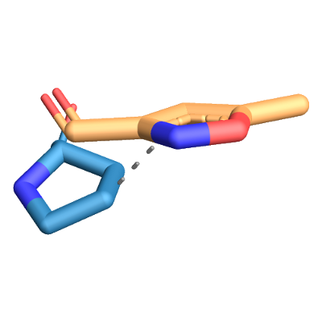
Figure5a. Hydrophobic interactions of the Colchicine 02J (5-Methylisoxazole-3-carboxylic acid)binding site(s) into the 6LU7 protein targets.
Recomborovir in PyMol (.pse) format | as (.png) image

Hydrophobic Interactions
Index | Residue | AA | Distance | Ligand Atom | Protein Atom
1 | 168A | PRO | 3.53 | 2369 | 1303

PJE (composite ligand)

PJE-C-5
Composite ligand consists of PJE:C:5, 010:C:6.
Interacting chains: A
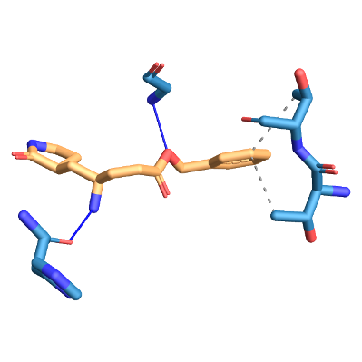
Figure5b.Hydrogen bonds and hydrophobic interactions of the Colchicine PJE:C:5, 010:C:6. binding site(s) into the 6LU7 protein targets.
Recomborovir in PyMol (.pse) format | as (.png) image

Hydrophobic Interactions
Index | Residue | AA | Distance | Ligand Atom | Protein Atom
1 | 25A | THR | 3.73 | 2415 | 179
2 | 26A | THR | 3.81 | 2415 | 186

Hydrogen Bonds
Index | Residue | AA | Distance H-A | Distance D-A | Donor Angle | Protein donor? | Sidechain | Donor Atom | Acceptor Atom
1 | 143A | GLY | 1.93 | 2.80 | 145.29 |  |  | 1105 (Nam) | 2411 (O3)
2 | 164A | HIS | 2.16 | 3.07 | 153.73 |  |  | 2408 (N3) | 1266 (O2)

SMALLMOLECULE

6Q5

6Q5-A-9000
Interacting chains: A
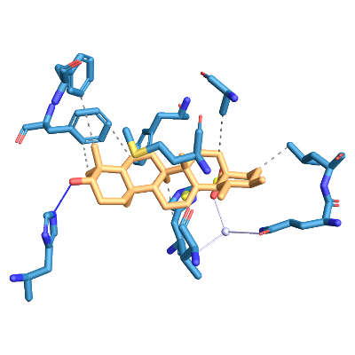
Figure5c. Remdesivir binding site(s) in 5X8S protein targets. Hydrophobic Interactions, Hydrogen Bonds, Water Bridges and Salt Bridges within the the 6Q5-A-9000 Interacting chains.
Recomborovir in PyMol (.pse) format | as (.png) image

Hydrophobic Interactions
Index | Residue | AA | Distance | Ligand Atom | Protein Atom
1 | 287A | LEU | 3.99 | 3849 | 200
2 | 323A | HIS | 3.56 | 3848 | 516
3 | 361A | VAL | 3.98 | 3857 | 816
4 | 365A | MET | 3.80 | 3846 | 848
5 | 368A | ALA | 3.88 | 3843 | 873
6 | 378A | PHE | 3.86 | 3870 | 957
7 | 388A | PHE | 3.84 | 3867 | 1036
8 | 388A | PHE | 3.78 | 3870 | 1039
9 | 401A | PHE | 3.92 | 3868 | 1133

Hydrogen Bonds
Index | Residue | AA | Distance H-A | Distance D-A | Donor Angle | Protein donor? | Sidechain | Donor Atom | Acceptor Atom
1 | 479A | HIS | 1.99 | 2.81 | 141.07 |  |  | 3865 (O3) | 1769 (N2)

Water Bridges
Index | Residue | AA | Dist. A-W | Dist. D-W | Donor Angle | Water Angle | Protein donor? | Donor Atom | Acceptor Atom | Water Atom
1 | 286A | GLN | 3.86 | 2.74 | 109.20 | 83.72 |  | 3841 (O.co2) | 192 (O2) | 3919
2 | 323A | HIS | 2.79 | 2.74 | 109.20 | 82.73 |  | 3841 (O.co2) | 515 (O2) | 3919

Salt Bridges
Index | Residue | AA | Distance | Protein positive? | Ligand Group | Ligand Atoms
1 | 323A | HIS | 3.76 |  | Carboxylate | 3839, 3841

6Q5-B-9000
Interacting chains: B
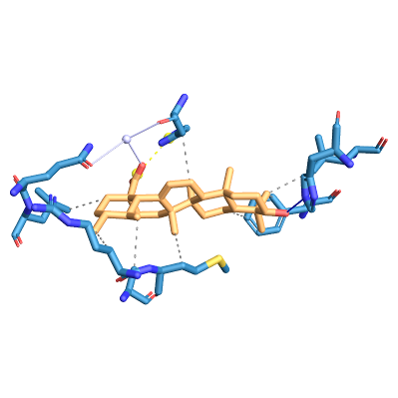

Figure5d. Hydrophobic Interactions, Hydrogen Bonds, Water Bridges and Salt Bridges of the 6Q5-A-9000 Interacting chains: B Remdesivir binding site(s) into the 5X8S protein targets.
Recomborovir in PyMol (.pse) format | as (.png) image

Hydrophobic Interactions
Index | Residue | AA | Distance | Ligand Atom | Protein Atom
1 | 287B | LEU | 3.94 | 3882 | 2109
2 | 323B | HIS | 3.62 | 3881 | 2425
3 | 364B | ARG | 3.89 | 3885 | 2746
4 | 365B | MET | 3.86 | 3879 | 2757
5 | 368B | ALA | 3.88 | 3876 | 2782
6 | 388B | PHE | 3.79 | 3903 | 2948
7 | 388B | PHE | 3.77 | 3900 | 2945
8 | 391B | LEU | 3.99 | 3900 | 2971

Hydrogen Bonds
Index | Residue | AA | Distance H-A | Distance D-A | Donor Angle | Protein donor? | Sidechain | Donor Atom | Acceptor Atom
1 | 479B | HIS | 1.92 | 2.69 | 134.37 |  |  | 3898 (O3) | 3684 (N2)

Water Bridges
Index | Residue | AA | Dist. A-W | Dist. D-W | Donor Angle | Water Angle | Protein donor? | Donor Atom | Acceptor Atom | Water Atom
1 | 286B | GLN | 3.78 | 2.79 | 111.72 | 79.32 |  | 3874 (O.co2) | 2101 (O2) | 4074
2 | 323B | HIS | 2.82 | 2.79 | 111.72 | 86.96 |  | 3874 (O.co2) | 2424 (O2) | 4074

Salt Bridges
Index | Residue | AA | Distance | Protein positive? | Ligand Group | Ligand Atoms
1 | 323B | HIS | 3.83 |  | Carboxylate | 3872, 3874

