Supporting Information
Handily etching nickel foams into catalyst-substrate fusion self-stabilized electrodes toward industrial-level water electrolysis
Zexuan Zhu¹, Xiaotian Yang¹, Jiao Liu¹, Mingze Zhu² & Xiaoyong Xu✉
College of Physics Science and Technology, Center for Interdisciplinary Research, Yangzhou University, Yangzhou 225002, PR China.
²Jiuchang New Energy Technology Co. LTD, Yangzhou, 225001, PR China.
*Correspondence email: xxy@yzu.edu.cn (X.X.)

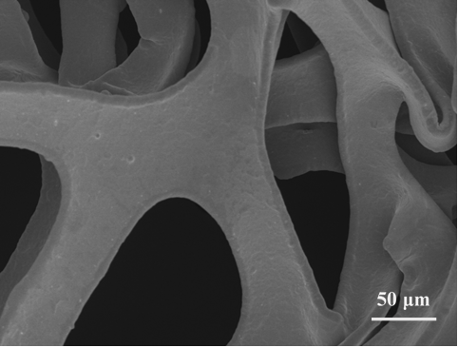
Supplementary Figure 1. SEM image of bare NF.

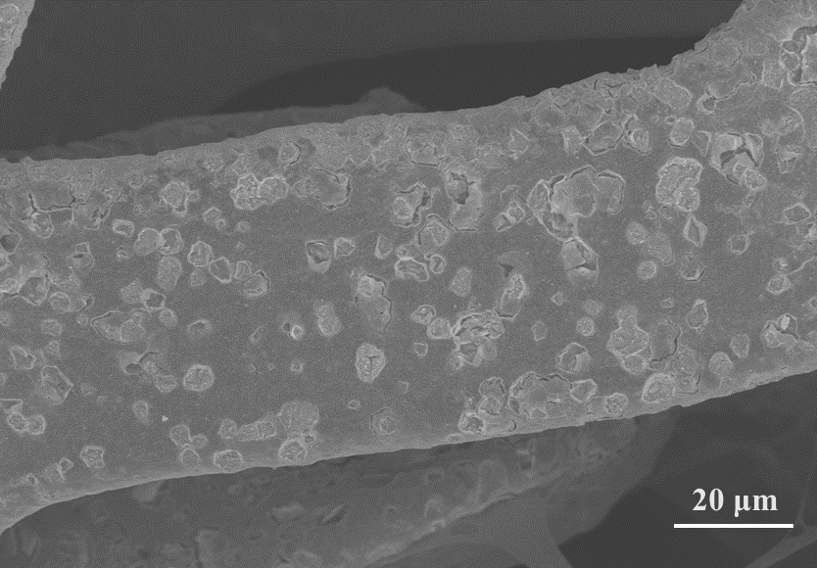
Supplementary Figure 2. SEM image of etched NF.

Supplementary Figure 3. SAED pattern of P-NiFeOOH.

Supplementary Figure 4. (A) XPS survey spectrum, and high-resolution profiles of (B) Ni 2p, (C) Fe 2p, (D) O 1s, and (E) P 2p for P-NiFeOOH.

Supplementary Figure 5. SEM images of NF surface etched with different etching times of (A) 3 min, (B) 5 min, (C) 8 min and (D) 10 min.

Supplementary Figure 6. Comparison of overpotentials at 10, 100 and 1000 mA cm⁻² for NF, IrO₂ and P-NiFeOOH electrodes in 1 M KOH electrolytes.

Supplementary Figure 7. Polarization curves for as-prepared electrodes with different etching times of 3, 5, 8 and 10 min.

Supplementary Figure 8. (A-E) CV curves at different scan rates for etched electrodes with different times from 0 to 10 min, and (F) their corresponding capacitive current densities versus scan rates for determination.

Supplementary Figure 9. Time sequence photo captures for ultra-fast water wetting processes on (A) bare NF and (B) P-NiFeOOH electrodes.

Supplementary Figure 10. Photos of oxygen bubbles evolving on (A) bare NF and (B) P-NiFeOOH electrodes.

Supplementary Figure 11. EIS Nyquist plots of P-NiFeOOH, IrO₂ and NF electrodes

Supplementary Figure 12. Comparison of overpotentials at current densities of 100, 500 and 1000 mA cm⁻² for P-NiFeOOH electrode in 6 M KOH electrolyte at different temperatures.

Supplementary Figure 13. (A) SEM image, (B) TEM, (C) HRTEM, (D) EDS elemental mappings of Fe, Ni, O and P elements for used P-NiFeOOH electrode after durability tests.

Supplementary Figure 14. (A) XRD pattern, and (B) XPS survey and (C-F) high-resolution spectra of Ni 2p, Fe 2p, O 1s, P 2p for P-NiFeOOH electrode after durability tests.

Supplementary Figure 15. Polarization curves of P-NiFeOOH ‖ Pt electrolyzer with different alkali electrolytes of 1 M and 6 M KOH.

Supplementary Figure 16. Time-dependent GC signals of evolved H₂ and O₂ over P-NiFeOOH ‖ Pt electrolyzer operating at 100 mA cm⁻² current density.

Supplementary Figure 17. Polarization curves NiFeOOH ‖ Pt electrolyzer before and after CP stability test.

Supplementary Figure 18. Unit electricity consumption ($W_{u}$) and electricity-to-hydrogen energy conversion efficiency ($ETH$) for P-NiFeOOH ‖ Pt electrolyser with benchmark indexes of three levels of current commercial electrolysers as references.
The unit electricity consumption ($W_{u}$, kW·h m⁻³) required to produce one standard cubic meter of hydrogen gas was calculated using the unit electric quantity ($Q_{u}$, A·h m⁻³) and cell voltage ($V$, V) at a certain current density of 500 mA cm⁻² that is commonly operated in industrial alkali water electrolysis as following (note: $N_{A}$ is the avogadro number and $e$ is the electron charge):
$$Q_{u}={2N_{A}e}/{\left(3600×22.43×{10}^{-3}\right)=2390 A·h m^{-3}}$$
For P-NiFeOOH ‖ Pt electrolyser,
$W_{u}={Q_{u}×V}/{1000=2390×1.652}÷1000=3.95 kW·h$ m⁻³
$$ETH=\frac{1.48×Q_{u}}{W_{u}×1000}×100\%=\frac{1.48×2390}{3.95×1000}×100\%=89.5\%$$
The three grades of benchmark indexes for currrent commercial electrolysers refer to the PRC National Standard (GB 32311-2015).

Supplementary Figure 19. (A) Schematic of the one-step etching process for P-NiFeOOH electrode, and (B) photo of scaled-up preparation for P-NiFeOOH electrode.

Supplementary Table 1. Performance comparison for some transition metal-based WOR electrodes reported recently in 1 M KOH.

Supplementary Table 2. Performance comparison with industrially relevant conditions for some transition metal-based WOR electrodes reported recently. The asterisk-marked values are estimates from polarization curves shown in the literatures.

Supplementary Table 3. Performance comparison of water overall splitting with industrially relevant conditions for some two-electrode electrolyzers reported recently in alkali media.

Supplementary Movie 1. Video of oxygen bubbles evolving on pristine NF electrode.
Supplementary Movie 2. Video of oxygen bubbles evolving on P-NiFeOOH electrode.

College of Physics Science & Technology, Center for Interdisciplinary Research, Yangzhou University, Yangzhou 225002, PR China. ²Jiuchang New Energy Technology Co. LTD, Yangzhou, 225001, PR China. ✉Correspondence and requests for materials should be addressed to X.X. (email: xxy@yzu.edu.cn).

