Supplementary Information for
Facile synthesis of magnetic ZnFe₂O₄/AC composite to activate peroxydisulfate for dye degradation under visible light irradiation
Tingting Song¹, Quanbao He¹, Xiaoyan Meng¹, Zhangxing He^{1,2,*}, Ming Ge^{1,*}
¹College of Chemical Engineering, North China University of Science and Technology, Tangshan 063210, China
²Tangshan Sanyou Group Co., Ltd., Tangshan 063305, China
Fig. S1 The TG curves of the as-obtained catalysts in air.
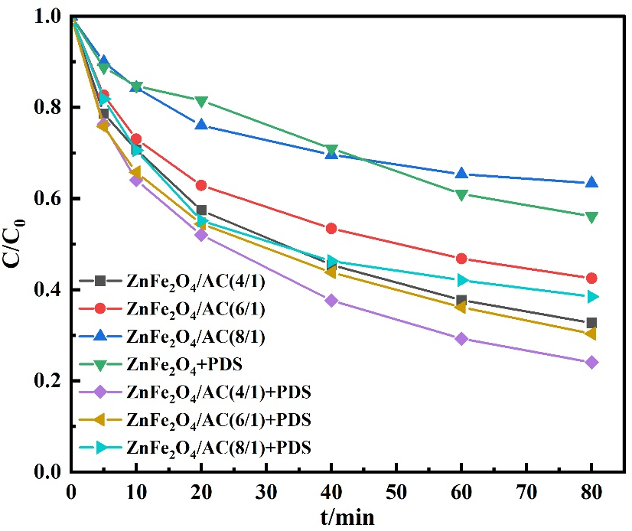
Fig. S2 Decolorization of RhB under different conditions. Experimental conditions: 20 mg/L RhB solution, 0.30 g/L catalyst, 1.5 g/L PDS, 25 °C.
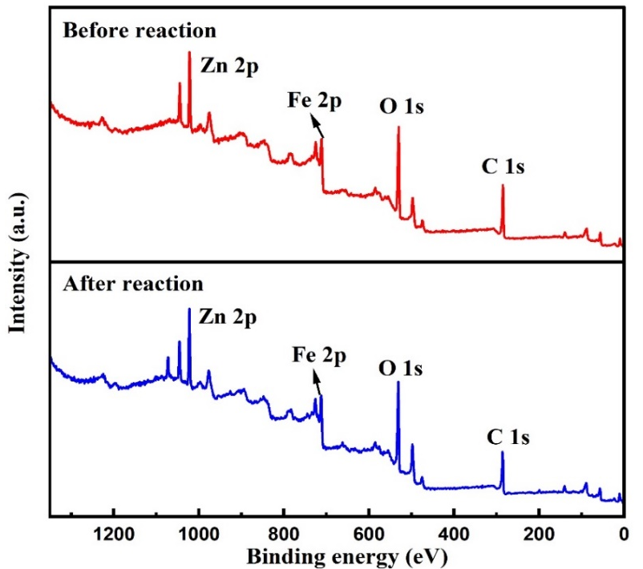
Fig. S3 XPS survey of ZnFe₂O₄/AC nanocomposites before and after t reaction.
Fig. S4 The second order kinetic on RhB degradation by the Vis/ZnFe₂O₄/AC/PDS system.

Table S1 The molecule structure of dyes, the pH value of dye solution and the surface charge of ZnFe₂O₄/AC
dye | Structural formula | pH of dye solution | charge of ZnFe₂O₄/AC
MO |  | 7.72 | negative charge
CR |  | 7.31 | negative charge
RhB |  | 6.15 | positive charge
MB |  | 7.17 | positive charge

