Supplementary Information for
The role of aromaticity in the cyclization and polymerization of alkyne-substituted porphyrins on Au(111)

Nan Cao,¹ Jonas Björk,² Eduardo Corral-Rascon,¹ Zhi Chen,^{3,4} Mario Ruben,³ Mathias O. Senge,⁵ Johannes V. Barth,^{1*} Alexander Riss^{1*}

Affiliations:
¹ Physics Department E20, Technical University of Munich, D-85748 Garching, Germany
² Department of Physics, Chemistry and Biology, IFM, Linköping University, 58183 Linköping, Sweden
³ Institute of Nanotechnology (INT), Karlsruhe Institute of Technology (KIT), 76344 Eggenstein-Leopoldshafen, Germany
⁴ College of Chemistry and Environmental Engineering, Shenzhen University, 518071, Shenzhen, China
⁵ Institute for Advanced Study (TUM-IAS), Focus Group – Molecular and Interfacial Engineering of Organic Nanosystems, Technical University of Munich, D-85748 Garching, Germany

This PDF file includes:

Supplementary Methods
Supplementary Figures 1-7
Supplementary References 1-11

Supplementary Methods
Synthesis and characterization of the precursors
5,15-bis((trimethylsilyl)ethynyl)porphyrin (1a)
Compound 1a was synthesized according to literature process.^{1,2} ¹H NMR (500 MHz, CDCl₃) δ ppm 10.04 (s, 2H, meso-H), 9.64 (d, J = 4.50 Hz, 4H, pyrrole-H), 9.25 (d, J = 4.51 Hz, 4H, pyrrole-H), 0.66 (s, 18H, -Si(CH₃)₃), -2.94 (s, 2H, pyrrole -NH). ¹³C NMR (126 MHz, CDCl₃) δ ppm 131.87, 130.43, 106.74, 106.08, 102.62, 99.63, 0.37. Matrix-assisted laser desorption ionization time-of-flight (MALDI-ToF) Calc. for C₃₀H₃₀N₄Si₂: [M]⁻, 502.2; Found: m/z 502.1.
[5,15-bis((trimethylsilyl)ethynyl)porphinato]copper(II) (1b)
1a (0.025 g, 0.05 mmol) and Cu(OAc)₂·H2O (0.030 g, 0.15 mmol) were added to a mixture of THF/CH₂Cl₂/Et₃N (10/10/5 ml) and were stirred at 60 °C under argon atmosphere for 24 hours. Then, the mixture was filtered through Celite and washed by CH₂Cl₂ (3 × 50 ml). The combined filtrates were concentrated under reduced pressure and the residue was purified by flash column chromatography on silica gel (hexane:CH₂Cl₂ = 1:1). After washing by methanol, a dark purple solid 1b (0.024 g, 85%) was afforded. MALDI ToF Calc. for C₃₀H₂₈N₄Si₂Cu: [M]⁻, 563.1; Found: m/z 562.9.
Thin-layer chromatography was performed on aluminum plates pre-coated with Merck 5735 silica gel 60 F254. Column chromatography was performed with Merck silica gel 60 (230 - 400 mesh). ¹H NMR and ¹³C NMR spectra were recorded on a Bruker DRX 500 spectrometer; chemical shifts are given in ppm using residual proton resonances of the solvents as references. The MALDI-ToF mass spectrometry measurements were carried out on a Synapt G2-S HDMS spectrometry workstation. All the synthetic reactions were conducted in oven-dried (140 °C) glassware under an argon atmosphere. THF was distilled from sodium prior to use. Et₃N was distilled over CaH₂ and stored under argon. Unless otherwise stated, commercially available chemicals were used as received.

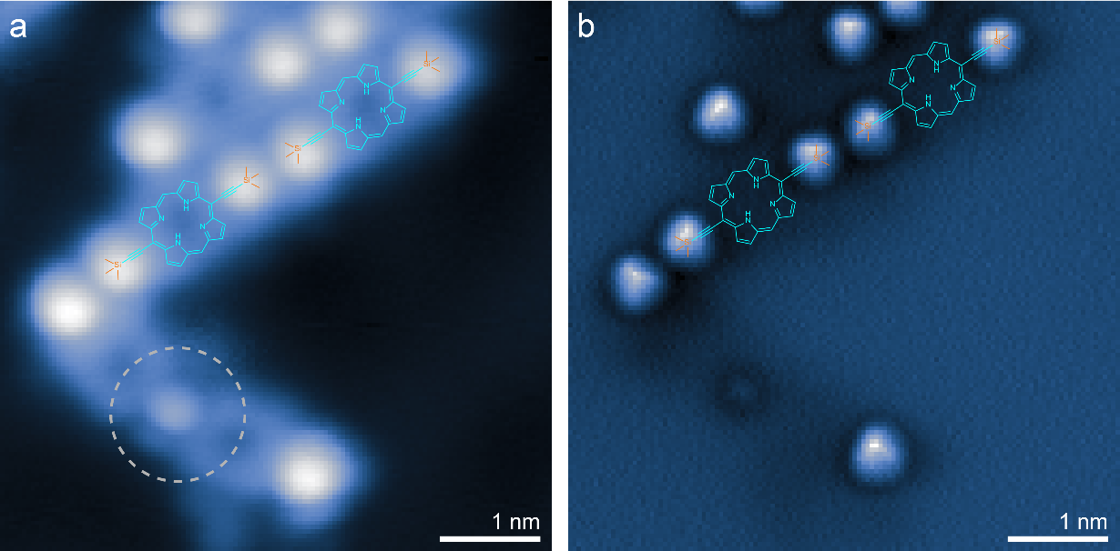
Supplementary Figure 1. Self-assembled structures of 1a. (a) STM image of a small island of self-assembled molecules after annealing at 205 °C shows predominantly unreacted molecules (scan parameters: I_{t} = 2 pA, V_{s} = 50 mV). The alignment of the molecules indicates interaction between the -SiMe₃ groups, which appear as bright spots at the termini of the rod-shaped molecules. (b) The corresponding AFM image of the same area as (a) reveals protrusions at the positions of the -SiMe₃ groups (scan parameters: V_{s} = 0 V, constant height). The dashed gray circle marks a region with less brightness, which possibly emerged from an initial reaction step, in which the partial cleavage of -SiMe₃ leads to an intermediate connection motif between the molecules (see also Supplementary Fig. 3).

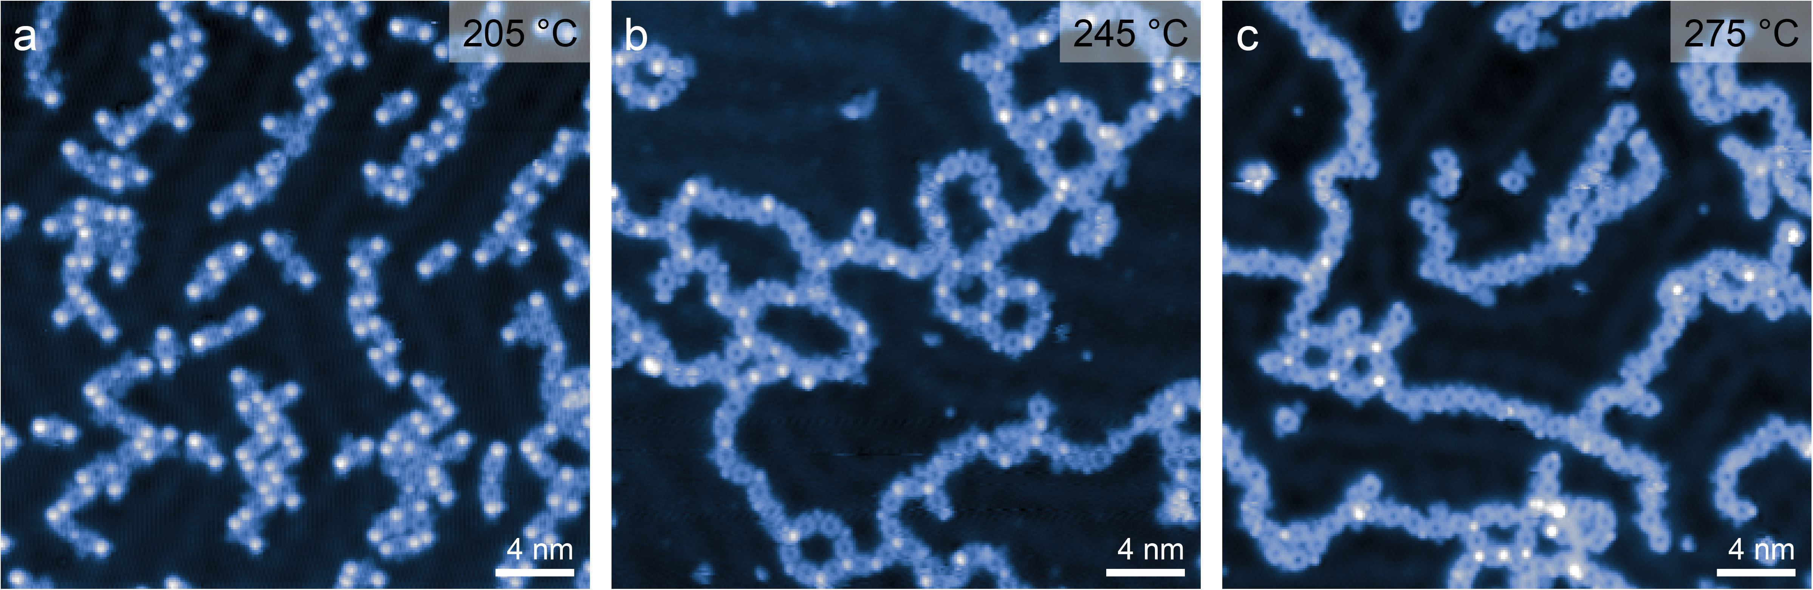
Supplementary Figure 2. Thermally induced -SiMe₃ cleavage and coupling. (a) After annealing at 205 °C, most of the precursors were seen to be in self-assembled islands; additionally, some reaction intermediates were formed (see also Supplementary Fig. 1). (b) After annealing at 245 °C, most of the bright spots (i.e. -SiMe₃) were removed. (c) At higher temperatures (> 275 °C), almost all bright spots were removed, and almost all molecules have undergone cyclization and coupling reactions. The duration of all annealing steps was 10 minutes. The dark appearance of the molecular centers in the STM images does not unambiguously confirm the absence of metal centers,^{3–5} but as no change in the appearance of the interior of the molecules was seen after annealing, we conclude that self-metalation with substrate atoms does not play a role, as expected from previous studies of porphyrins on Au(111).⁶ Scan parameters: (a) and (c) I_{t} = 2 pA, V_{s} = 50 mV, (b) I_{t} = 2 pA, V_{s} = 100 mV.

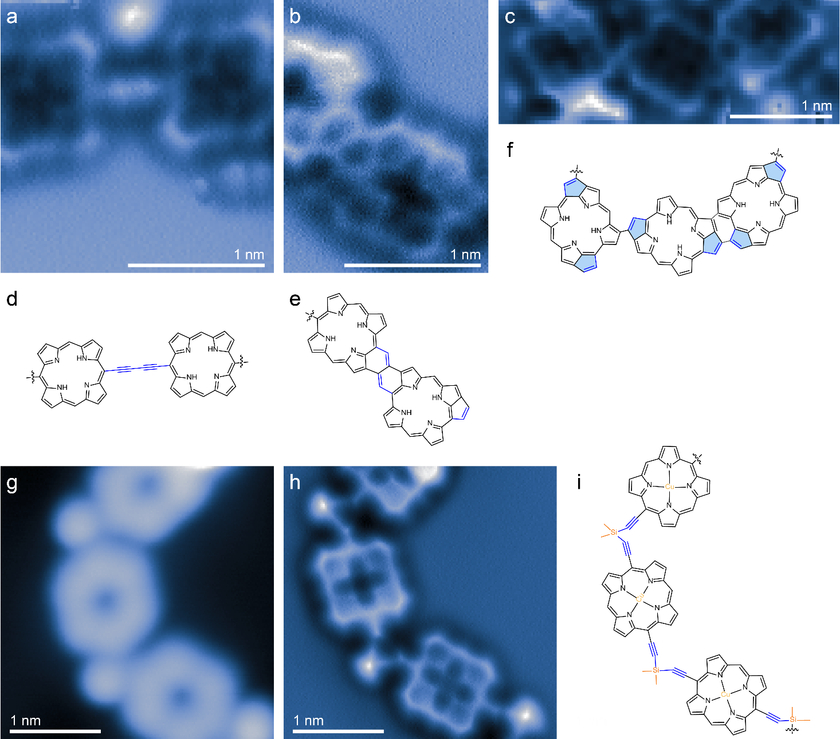
Supplementary Figure 3. Side products. Bond-resolved AFM images and derived chemical structures of minority products that emerged from side reactions of 1a. (a) Alkyne homo-coupling. (b) Formation of six-membered rings. (c) Unspecific cyclodehydrogenative coupling at the porphyrin periphery. (d)-(f) Chemical structures derived from the bond-resolved AFM images of (a)-(c). (g),(h) STM and AFM images of intermediate species obtained by annealing 1b adsorbed substrate at 245 °C; such intermediates were also observed for 1a (see also Supplementary Fig. 2). (i) Tentative chemical structure of the coupling motif shown in (g),(h). Scan parameters: (a)-(c) and (h): V_{s} = 0 V, constant height, (g) I_{t} = 10 pA, V_{s} = 100 mV.

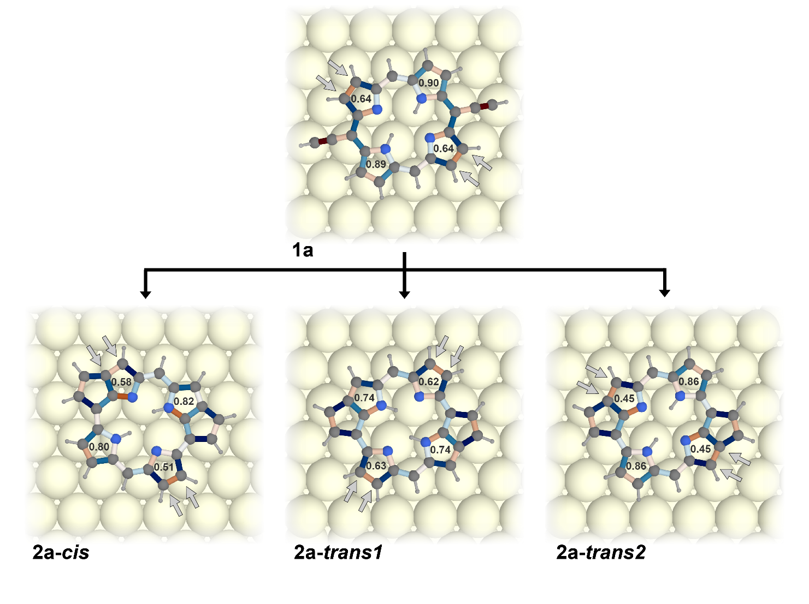
Supplementary Figure 4. Local HOMA indices and relative bond lengths. The images show the local HOMA indices for the pyrrole rings, as well as the relative bond lengths of each C-C and C-N bond (red for shortened and blue for elongated bond lengths, compared with the “optimal” aromatic bond lengths). The precursor 1a exhibits a significant asymmetry, with one pair of two pyrrole rings at opposite “corners” having higher HOMA indices than the other pair. This is in line with the aromatic diaza[18]annulene pathway (see Fig. 1 in the main text) observed in porphyrins.^{7–9} The two pairs of carbon atoms with olefinic character outside of the aromatic pathway are indicated by gray arrows. The cyclized products also exhibit this twofold symmetry, but there are significant changes in the HOMA indices for the rings. The newly formed five-membered rings lead to a reduction of the HOMA indices of the pyrrole rings that they are attached to.

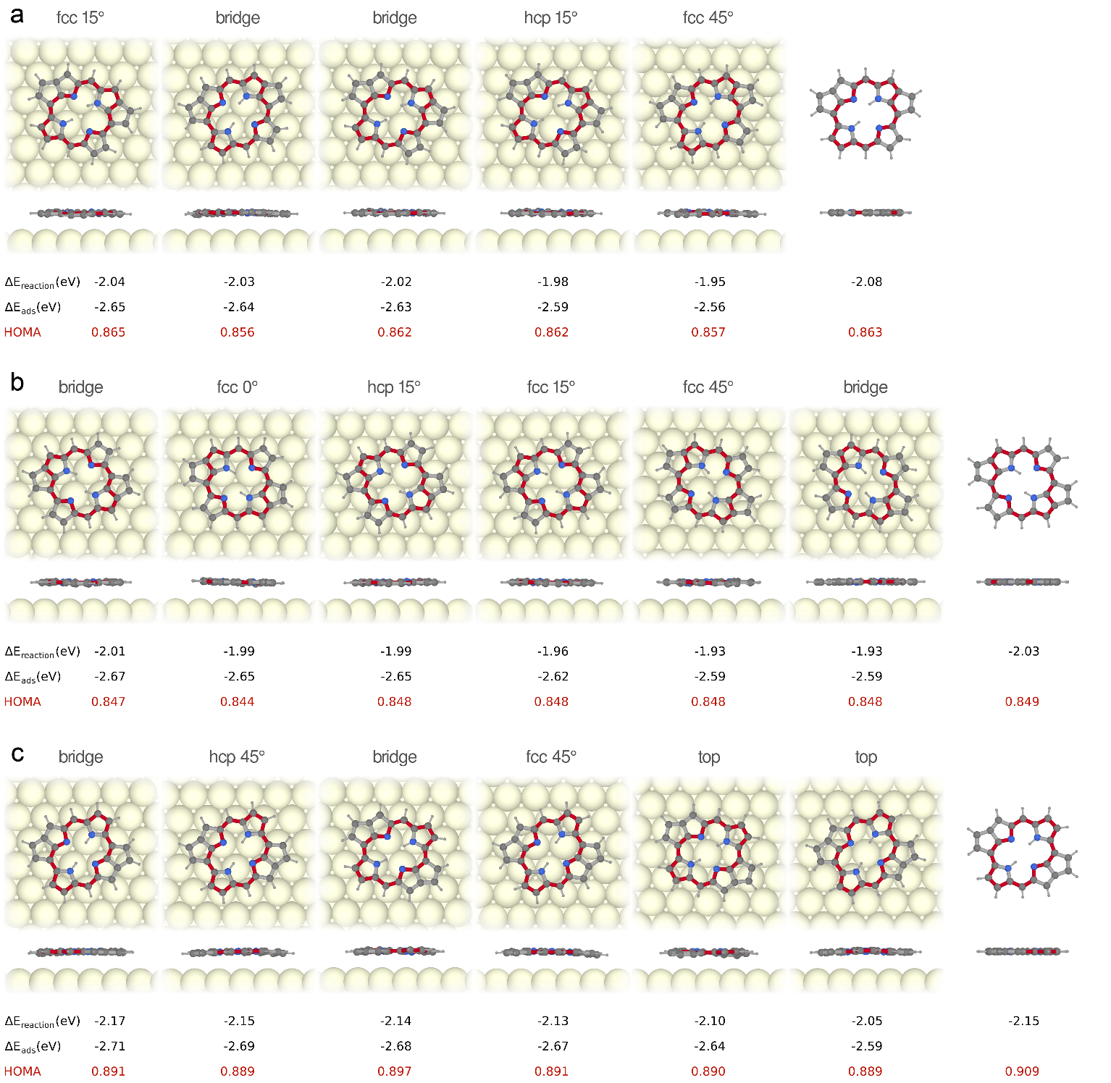
Supplementary Figure 5. Relaxed geometries of the cyclization products. Top and side views of relaxed structures of (a) 2a-cis, (b) 2a-trans1 and (c) 2a-trans2 at different adsorption positions, as well as in their free-standing geometry. For each structure, the reaction energies (with respect to the model of the precursor 1a), the adsorption energies, as well as the HOMA indices associated with the aromatic diaza[18]annulene pathway are shown.

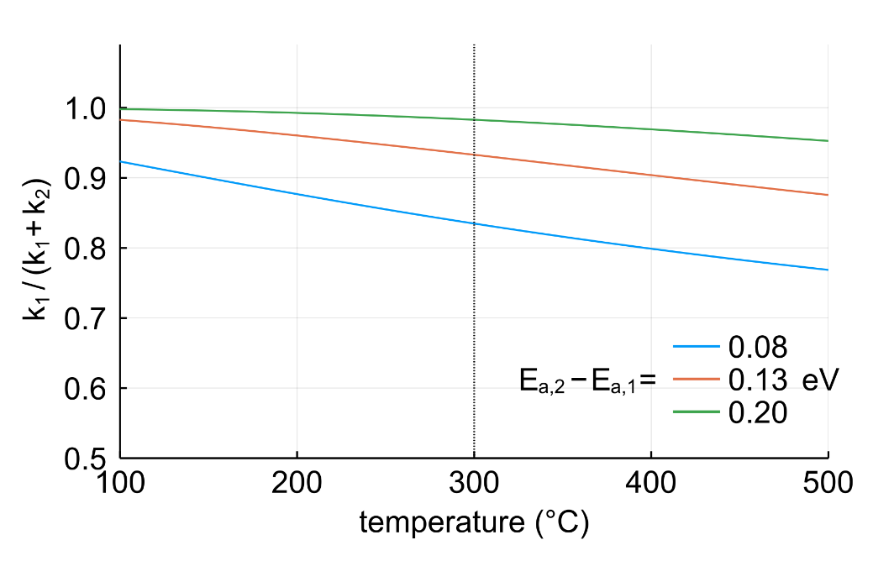
Supplementary Figure 6. Rate constants for a reaction with two competing pathways. The ratio of rate constants for two competing pathways, $k_{1}$ and $k_{2}$, respectively, can be estimated by the ratio of the Arrhenius equations:
$$\frac{k_{2}}{k_{1}}= e^{-\frac{(E_{a,2}- E_{a,1})}{k_{B}T}}$$
where $E_{a,1}$ and $E_{a,2}$ are the activation energies for the two pathways, $k_{B }$ is the Boltzmann constant and $T$ is the reaction temperature. $k_{2}/k_{1}$ corresponds to the ratio of product concentrations $c_{2}/c_{1}$. The graph plots the relative abundance of the first product, calculated as $k_{1}/{(k}_{1}+k_{2})$ for better comparison with the Fig. 3d in the main text. The traces show the computed values for differences in activation energies of 0.20, 0.13 and 0.08 eV. These values are chosen to be in a similar range as the differences in reaction energies as computed by DFT (0.13 eV for $ΔE_{2a-cis}- ΔE_{2a-trans2}$; see Fig. 4b). We emphasize, however, that we did not compute activation energies. Nevertheless, the reaction barriers for the same type of reaction are expected to be correlated with the reaction energies according to the Bell-Evans-Polanyi principle.^{10,11} Based on such assumptions, the simulations yield relative abundances of the energetically preferred product at the reaction temperature of around 300 °C (dotted vertical line) in the range between 0.83 to 0.98, similar to the relative abundance of 0.85 obtained experimentally for the trans-cyclized product (see Fig. 3d).

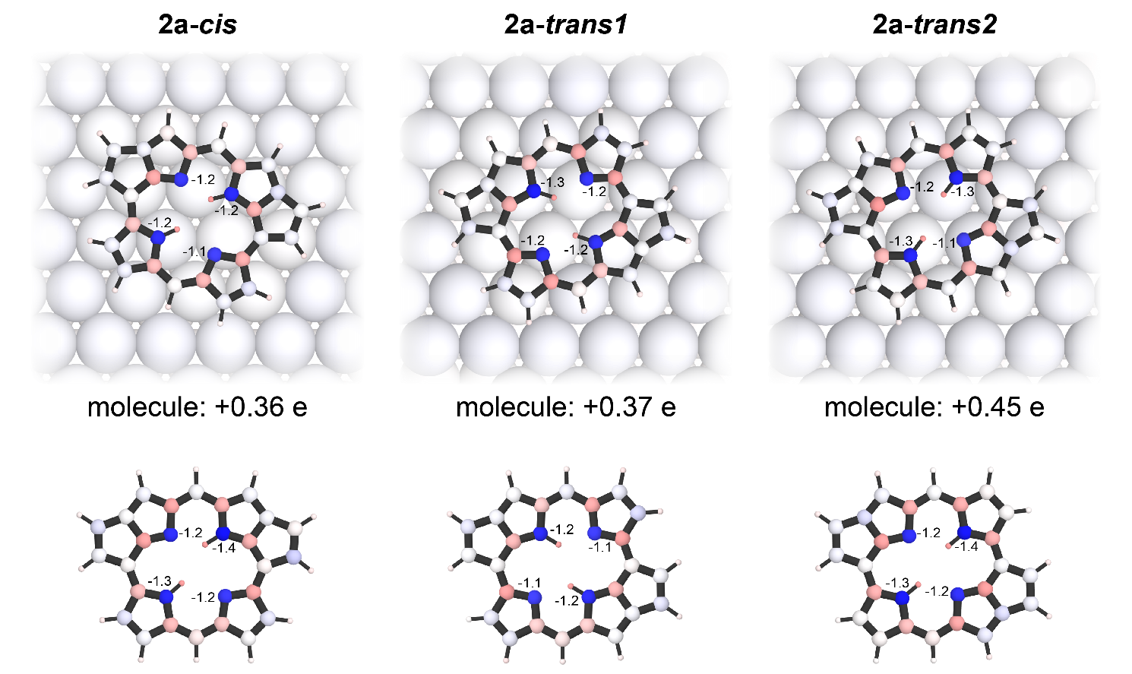
Supplementary Figure 7. Bader charge analysis for 2a-cis, 2a-trans1 and 2a-trans2. The DFT calculations for the most stable adsorption configurations show a charge transfer of ~0.4 electrons from the molecules to the substrate. For all structures, the nitrogen atoms are negatively charged (-1 e), which is balanced by positively charged carbon neighbors.

Supplementary References
1. Anderson, H. L. Meso-alkynyl porphyrins. Tetrahedron Lett. 33, 1101–1104 (1992).
2. Hayashi, N., Sato, M., Miyabayashi, K., Miyake, M. & Higuchi, H. Synthesis and electronic properties of trimeric octaethylporphyrin (OEP) derivative connected with diacetylene linkage. A comparative study with vinylene-group connected OEP trimer. Sci. Technol. Adv. Mater. 7, 237–242 (2006).
3. Cirera, B. et al. On-surface synthesis of gold porphyrin derivatives via a cascade of chemical interactions: Planarization, self-metalation, and intermolecular coupling. Chem. Mater. 31, 3248–3256 (2019).
4. Diller, K. et al. In vacuo interfacial tetrapyrrole metallation. Chem. Soc. Rev. 45, 1629–1656 (2016).
5. Marbach, H. Surface-Mediated in Situ Metalation of Porphyrins at the Solid–Vacuum Interface. Acc. Chem. Res. 48, 2649–2658 (2015).
6. Seufert, K. et al. Porphine homocoupling on Au(111). J. Phys. Chem. C 123, 16690–16698 (2019).
7. Cyrañski, M. K., Krygowski, T. M., Wisiorowski, M., Van Eikema Hommes, N. J. R. & Ragué Schleyer, P. V. Global and local aromaticity in porphyrins: An analysis based on molecular geometries and nucleus-independent chemical shifts. Angew. Chem. Int. Ed. 37, 177–180 (1998).
8. Islyaikin, M. K., Ferro, V. R. & García De La Vega, J. M. Aromaticity in tautomers of triazoleporphyrazine. J. Chem. Soc. Perkin Trans. 2, 2104–2109 (2002).
9. Aihara, J. I., Kimura, E. & Krygowski, T. M. Aromatic conjugation pathways in porphyrins. Bull. Chem. Soc. Jpn. 81, 826–835 (2008).
10. Bell, P. R. The theory of reactions involving proton transfers. Proc. R. Soc. London. Ser. A - Math. Phys. Sci. 154, 414–429 (1936).
11. Evans, M. G. & Polanyi, M. Further considerations on the thermo-dynamics of chemical equilibria and reaction rates. Trans. Faraday Soc. 32, 1333–1360 (1936).

