Supplementary Table ST1: Sequences of COI and CR of Sperata spp included from GenBank for present study with accession number and location.
Gene | GenBank Accession | Location  (River, State) | Species name in GenBank | Species as per our study | Reference
COI | MT448041 | Krishna, Andhra Pradesh | Sperata seenghala | Sperata seenghala | Kumar et al., 2020
COI | MT448042 | Krishna, Andhra Pradesh | Sperata seenghala | Sperata seenghala | Kumar et al., 2020
COI | MT448043 | Krishna, Andhra Pradesh | Sperata seenghala | Sperata seenghala | Kumar et al., 2020
COI | MT448044 | Tunga, Karnataka | Sperata seenghala | Sperata seenghala | Kumar et al., 2020
COI | MT448045 | Tunga, Karnataka | Sperata seenghala | Sperata seenghala | Kumar et al., 2020
COI | MT448040 | Tunga, Karnataka | Sperata seenghala | Sperata seenghala | Kumar et al., 2020
COI | MT448046 | Hooghly, West Bengal | Sperata aorella | Sperata aorella | Kumar et al., 2020
COI | MT448047 | Hooghly, West Bengal | Sperata aor | Sperata aor | Kumar et al., 2020
COI | MT448048 | Hooghly, West Bengal | Sperata aor | Sperata aor | Kumar et al., 2020
COI | MT448049 | Hooghly, West Bengal | Sperata lamarrii | Sperata lamarrii | Kumar et al., 2020
COI | MT448050 | Hooghly, West Bengal | Sperata lamarrii | Sperata lamarrii | Kumar et al., 2020
COI | MT448051 | Cauvery river, Tamil Nadu | Sperata aorides | Sperata aorides | Kumar et al., 2020
COI | MT448052 | Cauvery river, Tamil Nadu | Sperata aorides | Sperata aorides | Kumar et al., 2020
COI | MT448053 | Cauvery river, Tamil Nadu | Sperata aorides | Sperata aorides | Kumar et al., 2020
COI | KT762382 | Surma, Bangladesh | Sperata seenghala | Sperata spp. | Ahmed et al., 2015
COI | KU588160 | Unknown | Sperata seenghala | Sperata spp. | Acharya & Kumar, 2017
COI | KU588164 | Unknown | Sperata seenghala | Sperata spp. | Acharya & Kumar, 2017
COI | KU588165 | Unknown | Sperata seenghala | Sperata spp. | Acharya & Kumar, 2017
COI | KU588161 | Unknown | Sperata seenghala | Sperata spp. | Acharya & Kumar, 2017
CR | KT022186 | Ganga, Allahabad, Uttar Pradesh | Sperata seenghala | Sperata lamarrii | Kumari et al., 2016
CR | KT022189 | Ganga, Allahabad, Uttar Pradesh | Sperata seenghala | Sperata lamarrii | Kumari et al., 2016
CR | KT022192 | Ganga, Allahabad, Uttar Pradesh | Sperata seenghala | Sperata lamarrii | Kumari et al., 2016
CR | KT022198 | Ganga, Allahabad, Uttar Pradesh | Sperata seenghala | Sperata lamarrii | Kumari et al., 2016
CR | KT306672 | Ganga, Allahabad, Uttar Pradesh | Sperata seenghala | Sperata lamarrii | Kumari et al., 2016
CR | KT022183 | Ganga, Allahabad, Uttar Pradesh | Sperata seenghala | Sperata lamarrii | Kumari et al., 2016
CR | KT022193 | Ganga, Allahabad, Uttar Pradesh | Sperata seenghala | Sperata lamarrii | Kumari et al., 2016
CR | KT022197 | Ganga, Allahabad, Uttar Pradesh | Sperata seenghala | Sperata lamarrii | Kumari et al., 2016
CR | KT022185 | Ganga, Allahabad, Uttar Pradesh | Sperata seenghala | Sperata lamarrii | Kumari et al., 2016
CR | KT022188 | Ganga, Allahabad, Uttar Pradesh | Sperata seenghala | Sperata lamarrii | Kumari et al., 2016
CR | KT022194 | Ganga, Allahabad, Uttar Pradesh | Sperata seenghala | Sperata lamarrii | Kumari et al., 2016
CR | KT022195 | Ganga, Allahabad, Uttar Pradesh | Sperata seenghala | Sperata lamarrii | Kumari et al., 2016
CR | KT022196 | Ganga, Allahabad, Uttar Pradesh | Sperata seenghala | Sperata lamarrii | Kumari et al., 2016
CR | KT306667 | Ganga, Allahabad, Uttar Pradesh | Sperata seenghala | Sperata lamarrii | Kumari et al., 2016
CR | KT306668 | Ganga, Allahabad, Uttar Pradesh | Sperata seenghala | Sperata lamarrii | Kumari et al., 2016
CR | KT022180 | Ganga, Allahabad, Uttar Pradesh | Sperata seenghala | Sperata lamarrii | Kumari et al., 2016
CR | KT022191 | Ganga, Allahabad, Uttar Pradesh | Sperata seenghala | Sperata lamarrii | Kumari et al., 2016
CR | KT306669 | Ganga, Allahabad, Uttar Pradesh | Sperata seenghala | Sperata lamarrii | Kumari et al., 2016
CR | KT306670 | Ganga, Allahabad, Uttar Pradesh | Sperata seenghala | Sperata lamarrii | Kumari et al., 2016
CR | KT022182 | Ganga, Allahabad, Uttar Pradesh | Sperata seenghala | Sperata lamarrii | Kumari et al., 2016
CR | KT306671 | Ganga, Allahabad, Uttar Pradesh | Sperata seenghala | Sperata lamarrii | Kumari et al., 2016
CR | KT022187 | Ganga, Allahabad, Uttar Pradesh | Sperata seenghala | Sperata lamarrii | Kumari et al., 2016
CR | KT022190 | Ganga, Allahabad, Uttar Pradesh | Sperata seenghala | Sperata lamarrii | Kumari et al., 2016
CR | KT022181 | Ganga, Allahabad, Uttar Pradesh | Sperata seenghala | Sperata lamarrii | Kumari et al., 2016
CR | KT022184 | Ganga, Allahabad, Uttar Pradesh | Sperata seenghala | Sperata lamarrii | Kumari et al., 2016
CR | KT022202 | Mahanadi, Sambalpur, Odisha | Sperata seenghala | Sperata spp. | Kumari et al., 2016
CR | KT022203 | Mahanadi, Sambalpur, Odisha | Sperata seenghala | Sperata spp. | Kumari et al., 2016
CR | KT022204 | Mahanadi, Sambalpur, Odisha | Sperata seenghala | Sperata spp. | Kumari et al., 2016
CR | KT022205 | Mahanadi, Sambalpur, Odisha | Sperata seenghala | Sperata spp. | Kumari et al., 2016
CR | KT022206 | Mahanadi, Sambalpur, Odisha | Sperata seenghala | Sperata spp. | Kumari et al., 2016
CR | KT022207 | Mahanadi, Sambalpur, Odisha | Sperata seenghala | Sperata spp. | Kumari et al., 2016
CR | KT306645 | Mahanadi, Sambalpur, Odisha | Sperata seenghala | Sperata spp. | Kumari et al., 2016
CR | KT306640 | Mahanadi, Sambalpur, Odisha | Sperata seenghala | Sperata spp. | Kumari et al., 2016
CR | KT306641 | Mahanadi, Sambalpur, Odisha | Sperata seenghala | Sperata spp. | Kumari et al., 2016
CR | KT306642 | Mahanadi, Sambalpur, Odisha | Sperata seenghala | Sperata spp. | Kumari et al., 2016
CR | KT306643 | Mahanadi, Sambalpur, Odisha | Sperata seenghala | Sperata spp. | Kumari et al., 2016
CR | KT022211 | Mahanadi, Sambalpur, Odisha | Sperata seenghala | Sperata spp. | Kumari et al., 2016
CR | KT022212 | Mahanadi, Sambalpur, Odisha | Sperata seenghala | Sperata spp. | Kumari et al., 2016
CR | KT022213 | Mahanadi, Sambalpur, Odisha | Sperata seenghala | Sperata spp. | Kumari et al., 2016
CR | KT022214 | Mahanadi, Sambalpur, Odisha | Sperata seenghala | Sperata spp. | Kumari et al., 2016
CR | KT022215 | Mahanadi, Sambalpur, Odisha | Sperata seenghala | Sperata spp. | Kumari et al., 2016
CR | KT022216 | Mahanadi, Sambalpur, Odisha | Sperata seenghala | Sperata spp. | Kumari et al., 2016
CR | KT022217 | Mahanadi, Sambalpur, Odisha | Sperata seenghala | Sperata spp. | Kumari et al., 2016
CR | KT306644 | Mahanadi, Sambalpur, Odisha | Sperata seenghala | Sperata spp. | Kumari et al., 2016
CR | KT022208 | Mahanadi, Sambalpur, Odisha | Sperata seenghala | Sperata spp. | Kumari et al., 2016
CR | KT022209 | Mahanadi, Sambalpur, Odisha | Sperata seenghala | Sperata spp. | Kumari et al., 2016
CR | KT022210 | Mahanadi, Sambalpur, Odisha | Sperata seenghala | Sperata spp. | Kumari et al., 2016
CR | KT022199 | Mahanadi, Sambalpur, Odisha | Sperata seenghala | Sperata aor | Kumari et al., 2016
CR | KT022200 | Mahanadi, Sambalpur, Odisha | Sperata seenghala | Sperata aor | Kumari et al., 2016
CR | KT022201 | Mahanadi, Sambalpur, Odisha | Sperata seenghala | Sperata aor | Kumari et al., 2016
CR | KT022220 | Brahmaputra, Raha, Assam | Sperata seenghala | Sperata lamarrii | Kumari et al., 2016
CR | KT306656 | Brahmaputra, Raha, Assam | Sperata seenghala | Sperata lamarrii | Kumari et al., 2016
CR | KT306657 | Brahmaputra, Raha, Assam | Sperata seenghala | Sperata spp. | Kumari et al., 2016
CR | KT022221 | Brahmaputra, Raha, Assam | Sperata seenghala | Sperata spp. | Kumari et al., 2016
CR | KT306647 | Brahmaputra, Raha, Assam | Sperata seenghala | Sperata spp. | Kumari et al., 2016
CR | KT306649 | Brahmaputra, Raha, Assam | Sperata seenghala | Sperata spp. | Kumari et al., 2016
CR | KT306651 | Brahmaputra, Raha, Assam | Sperata seenghala | Sperata spp. | Kumari et al., 2016
CR | KT306652 | Brahmaputra, Raha, Assam | Sperata seenghala | Sperata spp. | Kumari et al., 2016
CR | KT306659 | Brahmaputra, Raha, Assam | Sperata seenghala | Sperata spp. | Kumari et al., 2016
CR | KT306661 | Brahmaputra, Raha, Assam | Sperata seenghala | Sperata spp. | Kumari et al., 2016
CR | KT306663 | Brahmaputra, Raha, Assam | Sperata seenghala | Sperata spp. | Kumari et al., 2016
CR | KT306664 | Brahmaputra, Raha, Assam | Sperata seenghala | Sperata spp. | Kumari et al., 2016
CR | KT022218 | Brahmaputra, Raha, Assam | Sperata seenghala | Sperata spp. | Kumari et al., 2016
CR | KT306654 | Brahmaputra, Raha, Assam | Sperata seenghala | Sperata spp. | Kumari et al., 2016
CR | KT306653 | Brahmaputra, Raha, Assam | Sperata seenghala | Sperata spp. | Kumari et al., 2016
CR | KT306665 | Brahmaputra, Raha, Assam | Sperata seenghala | Sperata spp. | Kumari et al., 2016
CR | KT306666 | Brahmaputra, Raha, Assam | Sperata seenghala | Sperata spp. | Kumari et al., 2016
CR | KT306646 | Brahmaputra, Raha, Assam | Sperata seenghala | Sperata spp. | Kumari et al., 2016
CR | KT306658 | Brahmaputra, Raha, Assam | Sperata seenghala | Sperata spp. | Kumari et al., 2016
CR | KT306648 | Brahmaputra, Raha, Assam | Sperata seenghala | Sperata spp. | Kumari et al., 2016
CR | KT306660 | Brahmaputra, Raha, Assam | Sperata seenghala | Sperata spp. | Kumari et al., 2016
CR | KT306650 | Brahmaputra, Raha, Assam | Sperata seenghala | Sperata spp. | Kumari et al., 2016
CR | KT306662 | Brahmaputra, Raha, Assam | Sperata seenghala | Sperata spp. | Kumari et al., 2016
CR | KT022219 | Brahmaputra, Raha, Assam | Sperata seenghala | Sperata spp. | Kumari et al., 2016
CR | KT306655 | Brahmaputra, Raha, Assam | Sperata seenghala | Sperata spp. | Kumari et al., 2016

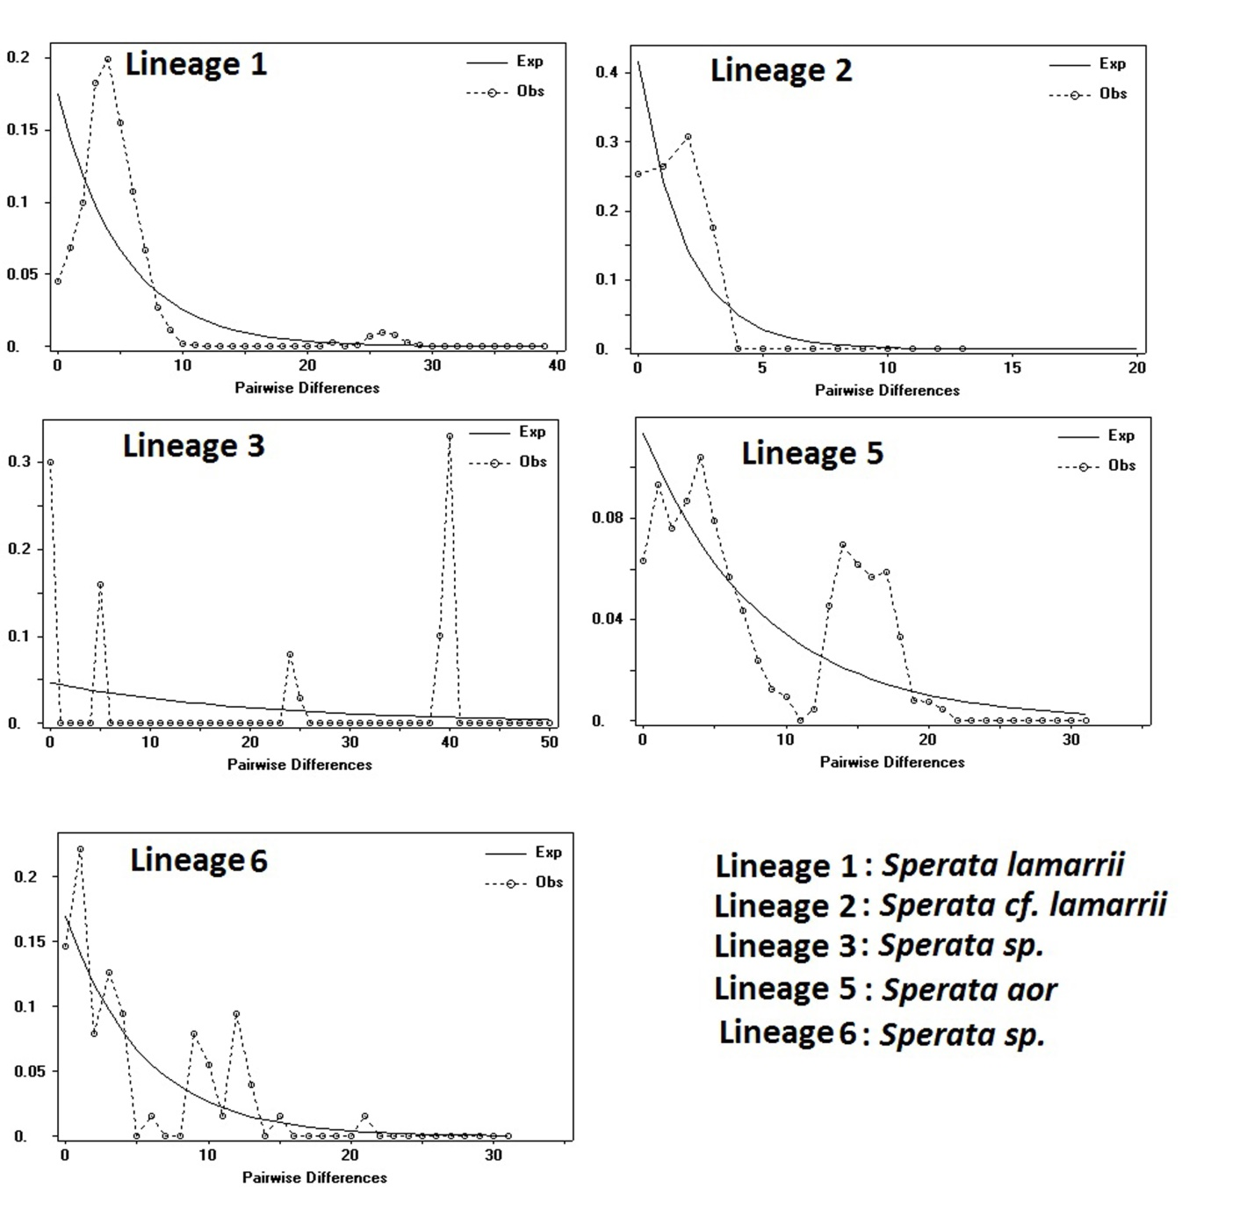
Figure ST1. Mismatch distribution graph for Sperata species. The x-axis shows the number of pairwise differences; the y-axis shows the frequency of pairwise comparisons. The observed and expected frequency under the population expansion model is represented by a dotted and continuous line.

