Supplemental Materials

Table S1. Effects of N deposition on microbial taxonomic and functional diversity, as assessed by Shannon index.
 | Control samples | N deposited samples | P-value
Taxonomic diversity | 8.21 | 8.19 | 0.480
Functional diversity | 10.42 | 10.36 | 0.200

Table S2. Significantly changed representative OTUs calculated by difference analyses.
OTU | Phylum | Genus | BaseMean | log₂FoldChange | Adjust P§
Increased OTU
OTU_59267 | Proteobacteria | Pseudomonas | 2.14 | 1.86 | 0.001
OTU_541 | Proteobacteria | Pseudomonas | 0.81 | 1.77 | 0.016
OTU_29947 | Bacteroidetes | Ohtaekwangia | 6.58 | 1.71 | 0.000
OTU_23187 | Bacteroidetes | Ohtaekwangia | 3.74 | 1.70 | 0.049
OTU_34480 | Bacteroidetes | Ohtaekwangia | 2.15 | 1.54 | 0.019
OTU_17675 | Bacteroidetes | Ohtaekwangia | 1.93 | 1.34 | 0.027
OTU_18113 | Bacteroidetes | Ohtaekwangia | 2.84 | 1.34 | 0.009
OTU_85448 | Bacteroidetes | Ohtaekwangia | 5.06 | 1.30 | 0.001
OTU_79487 | Bacteroidetes | Ohtaekwangia | 1.23 | 1.28 | 0.041
OTU_25095 | Bacteroidetes | Ohtaekwangia | 1.08 | 1.27 | 0.038
OTU_18853 | Bacteroidetes | Ohtaekwangia | 3.13 | 0.78 | 0.047
OTU_41997 | Bacteroidetes | Ohtaekwangia | 11.32 | 0.74 | 0.019
OTU_13142 | Bacteroidetes | Ohtaekwangia | 22.77 | 0.65 | 0.009
OTU_19070 | Bacteroidetes | Unclassified | 1.67 | 1.03 | 0.034
OTU_26226 | Bacteroidetes | Fluviicola | 0.84 | 1.28 | 0.049
OTU_18080 | Bacteroidetes | Unclassified | 0.85 | 1.90 | 0.003
OTU_106695 | Bacteroidetes | Unclassified | 1.70 | 1.80 | 0.003
OTU_29992 | Bacteroidetes | Flavobacterium | 1.82 | 3.40 | 0.000
OTU_11281 | Bacteroidetes | Flavobacterium | 1.39 | 2.98 | 0.000
OTU_19061 | Bacteroidetes | Flavobacterium | 0.89 | 2.66 | 0.002
OTU_48464 | Bacteroidetes | Flavobacterium | 0.93 | 1.94 | 0.019
OTU_28836 | Bacteroidetes | Flavobacterium | 2.81 | 1.77 | 0.002
OTU_84843 | Bacteroidetes | Flavobacterium | 3.03 | 1.70 | 0.016
OTU_76917 | Bacteroidetes | Flavobacterium | 6.17 | 1.60 | 0.000
OTU_126479 | Bacteroidetes | Flavobacterium | 0.92 | 1.54 | 0.020
OTU_89477 | Bacteroidetes | Flavobacterium | 2.60 | 1.28 | 0.014
OTU_19969 | Bacteroidetes | Flavobacterium | 1.99 | 1.13 | 0.025
OTU_26206 | Bacteroidetes | Flavobacterium | 27.53 | 1.01 | 0.004
OTU_129324 | Bacteroidetes | Flavobacterium | 5.95 | 0.99 | 0.004
OTU_17095 | Bacteroidetes | Flavobacterium | 12.03 | 0.91 | 0.015
OTU_16850 | Bacteroidetes | Flavobacterium | 18.79 | 0.59 | 0.016
OTU_30355 | Bacteroidetes | Unclassified | 1.96 | 1.92 | 0.001
OTU_88250 | Bacteroidetes | Chitinophaga | 0.87 | 2.37 | 0.000
OTU_31009 | Bacteroidetes | Ferruginibacter | 3.53 | 3.00 | 0.000
OTU_112311 | Bacteroidetes | Ferruginibacter | 4.95 | 1.50 | 0.000
OTU_18079 | Bacteroidetes | Ferruginibacter | 2.41 | 1.46 | 0.009
OTU_113080 | Bacteroidetes | Ferruginibacter | 2.30 | 1.44 | 0.001
OTU_44662 | Bacteroidetes | Ferruginibacter | 6.16 | 1.30 | 0.000
OTU_39127 | Bacteroidetes | Ferruginibacter | 1.28 | 1.23 | 0.016
OTU_55603 | Bacteroidetes | Ferruginibacter | 2.65 | 0.90 | 0.027
OTU_25973 | Bacteroidetes | Ferruginibacter | 4.39 | 0.80 | 0.039
OTU_48613 | Bacteroidetes | Ferruginibacter | 17.27 | 0.78 | 0.002
OTU_16990 | Bacteroidetes | Flavitalea | 7.21 | 1.14 | 0.018
OTU_18074 | Bacteroidetes | Niabella | 3.05 | 1.33 | 0.023
OTU_19334 | Bacteroidetes | Niastella | 12.33 | 1.27 | 0.000
OTU_56646 | Bacteroidetes | Sediminibacterium | 6.48 | 0.71 | 0.007
OTU_117823 | Bacteroidetes | Segetibacter | 5.12 | 0.86 | 0.009
OTU_9280 | Bacteroidetes | Terrimonas | 4.27 | 2.52 | 0.000
OTU_25305 | Bacteroidetes | Terrimonas | 2.57 | 1.53 | 0.000
OTU_161598 | Bacteroidetes | Terrimonas | 1.71 | 1.50 | 0.020
OTU_33709 | Bacteroidetes | Terrimonas | 3.52 | 0.96 | 0.001
OTU_21521 | Bacteroidetes | Terrimonas | 12.61 | 0.88 | 0.045
OTU_24513 | Bacteroidetes | Unclassified | 1.63 | 1.97 | 0.000
OTU_34668 | Bacteroidetes | Unclassified | 4.23 | 1.95 | 0.000
OTU_18296 | Bacteroidetes | Unclassified | 1.10 | 1.83 | 0.005
OTU_85176 | Bacteroidetes | Unclassified | 1.06 | 1.81 | 0.012
OTU_16931 | Bacteroidetes | Unclassified | 8.60 | 1.62 | 0.000
OTU_22589 | Bacteroidetes | Unclassified | 6.03 | 1.58 | 0.002
OTU_18742 | Bacteroidetes | Unclassified | 2.15 | 1.48 | 0.008
OTU_89651 | Bacteroidetes | Unclassified | 9.82 | 1.35 | 0.001
OTU_143142 | Bacteroidetes | Unclassified | 6.69 | 1.28 | 0.003
OTU_73044 | Bacteroidetes | Unclassified | 3.38 | 1.21 | 0.001
OTU_17204 | Bacteroidetes | Unclassified | 1.16 | 1.21 | 0.048
OTU_18127 | Bacteroidetes | Unclassified | 2.01 | 1.19 | 0.021
OTU_19091 | Bacteroidetes | Unclassified | 9.62 | 1.02 | 0.000
OTU_19982 | Bacteroidetes | Unclassified | 2.51 | 0.92 | 0.028
OTU_30812 | Bacteroidetes | Unclassified | 7.91 | 0.89 | 0.006
OTU_72139 | Bacteroidetes | Unclassified | 8.73 | 0.79 | 0.005
OTU_76350 | Bacteroidetes | Unclassified | 82.49 | 0.57 | 0.003
OTU_105375 | Bacteroidetes | Unclassified | 24.08 | 0.50 | 0.003
OTU_17090 | Bacteroidetes | Adhaeribacter | 6.94 | 1.36 | 0.001
OTU_41270 | Bacteroidetes | Adhaeribacter | 18.89 | 0.74 | 0.001
OTU_25503 | Bacteroidetes | Adhaeribacter | 10.99 | 0.67 | 0.045
OTU_18230 | Bacteroidetes | Cytophaga | 11.27 | 1.39 | 0.001
OTU_4372 | Bacteroidetes | Sporocytophaga | 0.80 | 1.37 | 0.039
OTU_33961 | Bacteroidetes | Cesiribacter | 1.34 | 1.38 | 0.024
OTU_76402 | Bacteroidetes | Fabibacter | 1.31 | 1.50 | 0.004
OTU_18259 | Bacteroidetes | Unclassified | 2.99 | 1.07 | 0.023
OTU_18321 | Bacteroidetes | Pedobacter | 1.06 | 1.93 | 0.001
OTU_26812 | Bacteroidetes | Unclassified | 1.11 | 2.32 | 0.001
OTU_21016 | Bacteroidetes | Unclassified | 5.24 | 3.03 | 0.000
OTU_29297 | Bacteroidetes | Unclassified | 1.32 | 2.38 | 0.001
OTU_40756 | Bacteroidetes | Unclassified | 1.15 | 1.16 | 0.025
OTU_21809 | Bacteroidetes | Unclassified | 1.57 | 1.08 | 0.023
OTU_62337 | Bacteroidetes | Unclassified | 11.29 | 0.95 | 0.038
OTU_18471 | Bacteroidetes | Unclassified | 16.94 | 0.58 | 0.005
OTU_119048 | Bacteroidetes | Unclassified | 1.38 | 3.08 | 0.000
OTU_97392 | Bacteroidetes | Unclassified | 2.68 | 2.11 | 0.000
OTU_19521 | Bacteroidetes | Unclassified | 1.13 | 1.78 | 0.003
OTU_10064 | Bacteroidetes | Unclassified | 29.54 | 1.73 | 0.000
OTU_19963 | Bacteroidetes | Unclassified | 1.62 | 1.66 | 0.003
OTU_72001 | Bacteroidetes | Unclassified | 1.39 | 1.59 | 0.001
OTU_100887 | Bacteroidetes | Unclassified | 1.60 | 1.53 | 0.004
OTU_31229 | Bacteroidetes | Unclassified | 3.76 | 1.46 | 0.000
OTU_46231 | Bacteroidetes | Unclassified | 2.33 | 1.22 | 0.001
OTU_20516 | Bacteroidetes | Unclassified | 7.99 | 1.17 | 0.000
OTU_33281 | Bacteroidetes | Unclassified | 10.66 | 1.02 | 0.000
OTU_52833 | Bacteroidetes | Unclassified | 1.89 | 1.01 | 0.036
OTU_21922 | Bacteroidetes | Unclassified | 2.21 | 1.01 | 0.029
OTU_21989 | Bacteroidetes | Unclassified | 2.93 | 0.76 | 0.040
OTU_74737 | Bacteroidetes | Unclassified | 16.57 | 0.58 | 0.048
Decreased OTU
OTU_52819 | Bacteroidetes | Ohtaekwangia | 1.50 | -1.48 | 0.032
OTU_42440 | Bacteroidetes | Ohtaekwangia | 7.80 | -0.51 | 0.049
OTU_15251 | Bacteroidetes | Unclassified | 5.57 | -1.68 | 0.001
OTU_17111 | Bacteroidetes | Unclassified | 4.15 | -0.92 | 0.012
OTU_18664 | Bacteroidetes | Flavisolibacter | 3.76 | -1.22 | 0.000
OTU_121490 | Bacteroidetes | Flavitalea | 5.84 | -1.28 | 0.001
OTU_19791 | Bacteroidetes | Hydrotalea | 1.59 | -1.09 | 0.023
OTU_17536 | Bacteroidetes | Niastella | 1.75 | -1.10 | 0.044
OTU_105475 | Bacteroidetes | Niastella | 2.86 | -0.90 | 0.015
OTU_136639 | Bacteroidetes | Sediminibacterium | 1.45 | -2.12 | 0.001
OTU_37300 | Bacteroidetes | Sediminibacterium | 2.49 | -0.87 | 0.040
OTU_30027 | Bacteroidetes | Unclassified | 1.75 | -1.44 | 0.004
OTU_23626 | Bacteroidetes | Unclassified | 0.90 | -1.36 | 0.029
OTU_42664 | Bacteroidetes | Unclassified | 1.39 | -1.27 | 0.016
OTU_294 | Bacteroidetes | Unclassified | 2.24 | -1.04 | 0.020
OTU_18642 | Bacteroidetes | Unclassified | 5.36 | -0.90 | 0.007
OTU_22058 | Bacteroidetes | Unclassified | 3.29 | -0.79 | 0.024
OTU_18654 | Bacteroidetes | Unclassified | 22.97 | -0.68 | 0.001
OTU_27943 | Bacteroidetes | Cytophaga | 0.94 | -3.38 | 0.000
OTU_19490 | Bacteroidetes | Cytophaga | 1.10 | -1.27 | 0.031
OTU_4196 | Bacteroidetes | Sporocytophaga | 2.39 | -1.36 | 0.001
OTU_43195 | Bacteroidetes | Mucilaginibacter | 1.05 | -1.48 | 0.020
OTU_120 | Bacteroidetes | Mucilaginibacter | 1.16 | -1.45 | 0.010
OTU_18163 | Bacteroidetes | Unclassified | 4.95 | -2.30 | 0.000
OTU_21842 | Bacteroidetes | Unclassified | 3.88 | -0.84 | 0.014
OTU_43427 | Actinobacteria | Mycobacterium | 0.92 | -1.27 | 0.041
OTU_25203 | Actinobacteria | Mycobacterium | 1.11 | -1.24 | 0.022
OTU_17016 | Proteobacteria | Anaeromyxobacter | 30.54 | -0.98 | 0.002
OTU_111042 | Proteobacteria | Anaeromyxobacter | 2.15 | -0.93 | 0.045
OTU_3076 | Proteobacteria | Anaeromyxobacter | 81.21 | -0.92 | 0.001
OTU_43651 | Proteobacteria | Anaeromyxobacter | 17.69 | -0.41 | 0.047
§P-values were adjusted with the Benjamini and Hochberg correction method.
Table S3. Topological properties of microbial functional gene networks
Network properties | Control samples | N deposited samples
Total nodes | 130 | 61
Total links | 548 | 207
Positive links (%) | 83 | 77
Negative links (%) | 17 | 23
R square of power-law | 0.91 | 0.75
Modularity | 0.40 | 0.33
Average degree (avgK) | 8.43 | 6.79
Average clustering coefficient (avgCC) | 0.39 | 0.51
Average path distance (GD) | 3.28 | 2.94
Geodesic efficiency (E) | 0.37 | 0.43
Harmonic geodesic distance (HD) | 2.68 | 2.31
Maximal degree | 37 | 26
Nodes with max degree | acetyl_CoA_carboxylase | cutinase
Centralization of degree (CD) | 0.23 | 0.33
Maximal betweenness | 1178.31 | 337.05
Nodes with max betweenness | nosZ | cutinase
Centralization of betweenness (CB) | 0.13 | 0.16
Maximal stress centrality | 8182 | 1407
Nodes with max stress centrality | nosZ | cutinase
Centralization of stress centrality (CS) | 0.88 | 0.67
Maximal eigenvector centrality | 0.28 | 0.33
Nodes with max eigenvector centrality | acetyl_CoA_carboxylase | cutinase
Centralization of eigenvector centrality (CE) | 0.23 | 0.25
Density (D) | 0.07 | 0.11
Transitivity (Trans) | 0.47 | 0.51
Connectedness (Con) | 0.94 | 0.91
Efficiency | 0.94 | 0.89

Table S4. Summary of soil and vegetation attributes in control and N deposited samples
Environmental attributes | Control samples | N deposited samples | P-value
Soil attributes
Temperature (ºC) | 16.13 (0.97)* | 15.55 (0.96) | 0.001†
pH | 6.20 (0.18) | 6.34 (0.23) | 0.005
Moisture Fraction (%) | 8.52 (2.01) | 8.35 (2.08) | 0.732
NO₃⁻ (mg/L) | 79.7 (44.24) | 612 (337.67) | 0.001
NH₄⁺ (mg/L) | 666 (128) | 1001 (461) | 0.349
TC (%)§ | 1.23 (0.19) | 1.39 (0.22) | 0.001
TN (%) | 0.12 (0.01) | 0.13 (0.02) | 0.001
Soil CO₂ efflux (μmol m⁻² s⁻¹) | 5.04 (1.67) | 6.03 (2.13) | 0.019
Vegetation attributes
(g/141cm⁻²)
AG | 2.22 (0.96) | 2.90 (1.71) | 0.050
AF | 1.26 (0.78) | 3.97 (3.83) | 0.001
PF | 0.54 (0.51) | 0.74 (0.41) | 0.429
PG | 0.32 (0.02) | 0.38 (0.02) | 0.853
Total aboveground biomass | 4.35 (1.34) | 7.99 (3.27) | 0.001
Litter | 2.00 (1.24) | 2.69 (1.96) | 0.117
Belowground biomass | 0.21 (0.15) | 0.16 (0.09) | 0.118
§Abbreviations: TC—total C; TN—total N; AG—annual grass biomass; AF—annual forb biomass; PF—perennial forb biomass; PG —perennial grass biomass.
†P-value means the main effect of N deposition calculated by ANOVA. Factors including experimental block, elevated CO₂, warming, nitrate deposition, and enhanced precipitation were all considered in the ANOVA model. Significant P (less than 0.050) is shown in bold.
*The value in the bracket is the standard deviation.

Table S5. Mantel tests for correlations between a range of environmental attributes and quantitative measures of microbial community dissimilarity
 | Taxonomic |  | Functional
 | r | P | r | P
Soil attributes
Temperature (ºC) | 0.002 | 0.46 | -0.035 | 0.74
pH | 0.245 | 0.001† | -0.128 | 0.99
Moisture Fraction (%) | 0.052 | 0.20 | -0.075 | 0.88
NO₃⁻ (mg/L) | 0.081 | 0.16 | 0.037 | 0.28
NH₄⁺ (mg/L) | -0.120 | 0.95 | -0.033 | 0.55
TC (%)§ | 0.082 | 0.07 | 0.091 | 0.09
TN (%) | 0.013 | 0.40 | 0.136 | 0.07
Vegetation attributes
AG | 0.183 | 0.01 | -0.007 | 0.49
AF | -0.023 | 0.57 | 0.019 | 0.36
PF | -0.023 | 0.59 | 0.302 | 0.02
PG | -0.064 | 0.74 | -0.054 | 0.68
Aboveground biomass | 0.023 | 0.34 | 0.125 | 0.08
Litter | 0.023 | 0.34 | 0.313 | 0.01
Belowground biomass | 0.125 | 0.11 | -0.082 | 0.83
§Abbreviations: TC—total C; TN—total N; AG—annual grass biomass; AF—annual forb biomass; PF—perennial forb biomass; PG—perennial grass biomass.
†Significant (P < 0.050) correlations are shown in bold.

Fig. S1 Comparison of the percentage change by N deposition for (a) microbial phyla; (b) N cycling genes; and (c) C cycling genes between using 32 and 4 samples as biological replicates.

Fig. S2 The percentage change in relative abundances of microbial class induced by long-term N deposition. Asterisks indicate significant differences. *, P < 0.050; **, P < 0.010.
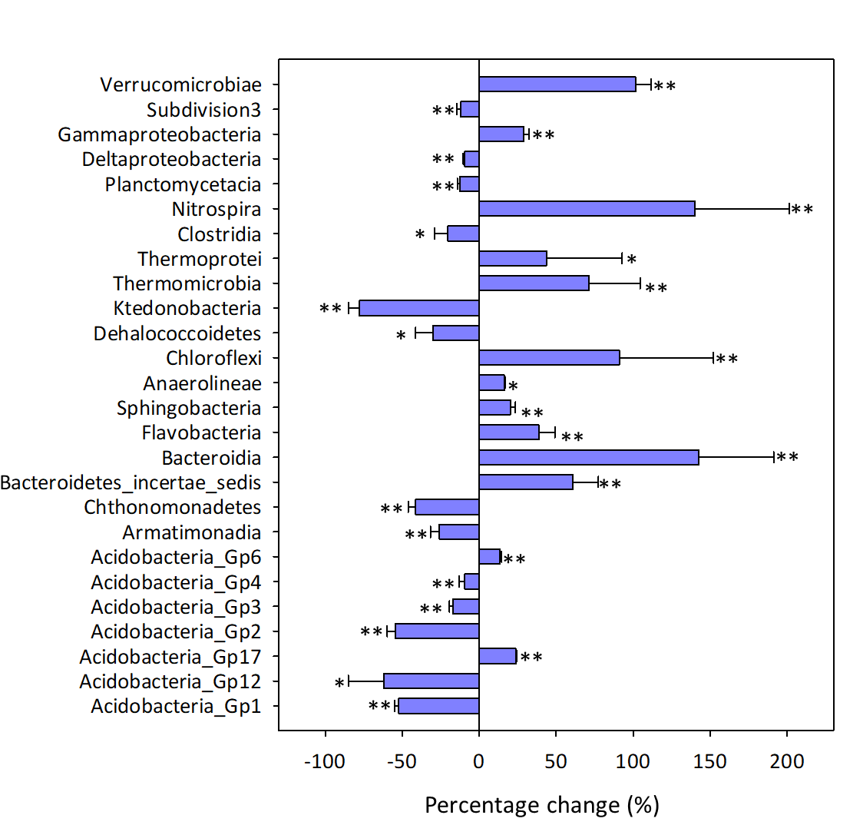

Fig. S3 The percentage change in the relative abundance of major microbial genera induced by long-term N deposition treatment. All selected genera are significantly changed by N deposition treatment as calculated by the response ratio analysis.
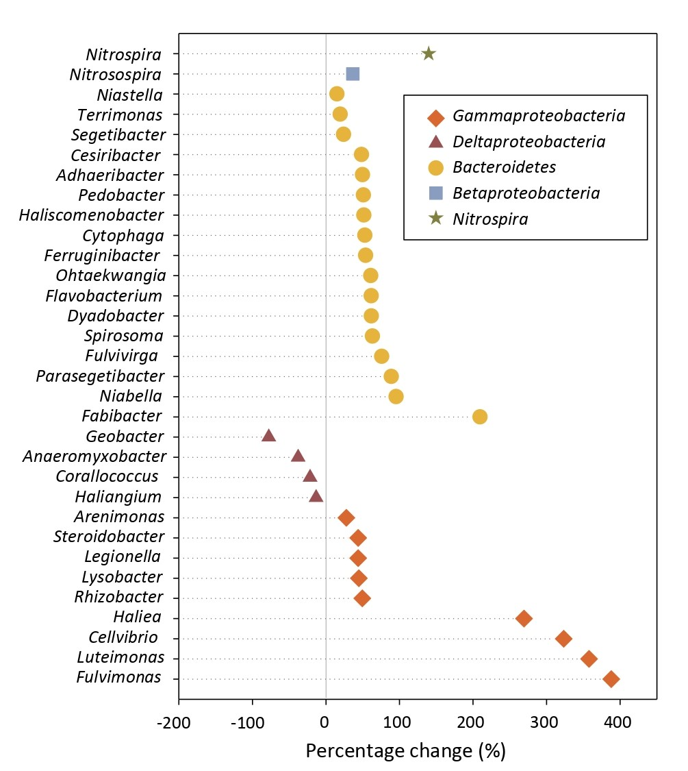

Fig. S4 The percentage change in the relative abundance of genes associated with C fixation induced by N deposition, calculated as 100*(( mean value in N deposited samples/mean value in control samples) ‒ 1). Mean values and standard deviations are presented. Asterisks indicate significant differences. *, P < 0.050; **, P < 0.010. The numbers in the figure represent the pathways of C fixation. (i) 3-hydroxypropionate bicycle, (ii) Bacterial microcompartments, (iii) Calvin cycle, and (iv) Reductive tricarboxylic acid cycle.

Fig. S5 The percentage change in the relative abundance of genes associated with methane and phosphorus cycling genes induced by N deposition, calculated as 100*((mean value in N deposited samples/mean value in control samples) ‒ 1). Mean values and standard deviations are presented. Asterisks indicate significant differences. *, P < 0.050; **, P < 0.010.
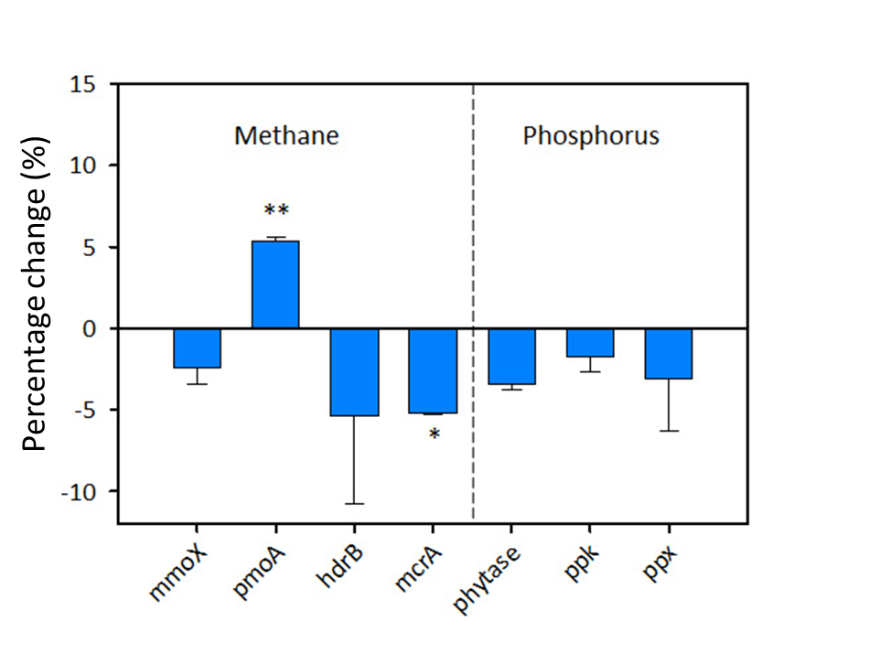

Fig. S6 N deposition effects on amoA gene. The relative abundance of amoA is presented as the signal intensity difference between control and N deposited samples. Error bars represent standard errors. Blue bars represent genes derived from archaea (AOA), and pink bars represent genes derived from bacteria (AOB). Asterisks indicate significant differences. *, P < 0.050; **, P < 0.010.
