Title:
The role of different linkage disequilibrium patterns in genomic prediction: The gBULP based exploratory method in Tehran cardiometabolic genetic study

Running Title: Improve Genomic Prediction using Mutually Uncorrelated SNPs
Authors' name:
- Mahdi Akbarzadeh, Ph.D., Cellular, and Molecular Research Center, Research Institute for Endocrine Sciences, Shahid Beheshti University of Medical Sciences, Tehran, Iran. Email: ​akbarzadehms@sbmu.ac.ir
- Saeid Rasekhi Dehkordi, MSc, Cellular and Molecular Research Center, Research Institute for Endocrine Sciences, Shahid Beheshti University of Medical Sciences, Tehran, Iran. Email: dehkordi.s.r@gmail.com
- Mahmoud Amiri Roudbar, Department of Animal Science, Safiabad-Dezful Agricultural and Natural Resources Research and Education Center, Agricultural Research, Education & Extension Organization (AREEO), Dezful, Iran, Email: mahmood.amiri225@gmail.com
- Parisa Riahi, MSc, Cellular and Molecular Research Center, Research Institute for Endocrine Sciences, Shahid Beheshti University of Medical Sciences, Tehran, Iran. Email: parisaariyahii@gmail.com
- Mehdi Sargolzaei, Department of Pathobiology, Ontario Veterinary College, University of Guelph, Guelph, Canada, and Select Sires Inc., Plain City, USA, Email: msargol@uoguelph.ca
- Kamran Guity, MSc, Cellular and Molecular Research Center, Research Institute for Endocrine Sciences, Shahid Beheshti University of Medical Sciences, Tehran, Iran. Email: kamran.guity@gmail.com
- Bahareh Sedaghati-khayat, MSc, Cellular and Molecular Research Center, Research Institute for Endocrine Sciences, Shahid Beheshti University of Medical Sciences, Tehran, Iran. Email: b.s.khayat@gmail.com
- Hossein Lanjanian, Ph.D., Endocrine research center, Research Institute for Endocrine Sciences, Shahid Beheshti University of Medical Sciences, Tehran, Iran Email: H.Lanjanian@ut.ac.ir
- Fereidoun Azizi, MD, Ph.D., Endocrine research center, Research Institute for Endocrine Sciences, Shahid Beheshti University of Medical Sciences, Tehran, Iran. Email: azizi@endocrine.ac.ir
- Maryam S Daneshpour, Ph.D., Cellular and Molecular Research Center, Research Institute for Endocrine Sciences, Shahid Beheshti University of Medical Sciences, Tehran, Iran. Email: daneshpour@sbmu.ac.ir

Correspondence Author:
Maryam S Daneshpour, Cellular, and Molecular Research Center, Research Institute for Endocrine Sciences, Shahid Beheshti University of Medical Sciences, Tehran, Iran; POBox: 19195-4763, Tel: +982122432500, Fax: +982122416264, Email: daneshpour@sbmu.ac.ir

Supplementary Table 1 Basic Characteristics of Participants
 |  | Age |  | BMI |  | Lipid Traits
 |  | Mean (SD) | P-value | Mean (SD) | P-value | Mean (SD) | P-value
HDL-C | Men (n= 4683( | 40.03(19.42) | 0.4133 | 25.91(5.00) | < 0.001 | 43.91(10.11) | < 0.001
HDL-C | Women (n= 5618( | 39.72(17.79) | 0.4133 | 27.47(5.89) | < 0.001 | 50.95(11.20) | < 0.001
LDL-C | Men (n= 4790( | 40.31(19.72) | 0.8262 | 25.33(6.25) | < 0.001 | 108.62(33.25) | 0.1849
LDL-C | Women (n= 5796( | 40.22(18.20) | 0.8262 | 26.64(7.66) | < 0.001 | 109.49(34.35) | 0.1849
TG | Men (n= 4686( | 40.02(19.42) | 0.4034 | 25.92(5.00) | < 0.001 | 4.83(0.54) | < 0.001
TG | Women (n= 5617( | 39.72(17.79) | 0.4034 | 27.47(5.89) | < 0.001 | 4.70(0.53) | < 0.001
TC | Men (n= 4686( | 40.02(19.42) | 0.4034 | 25.92(5.00) | < 0.001 | 181.16(39.31) | < 0.001
TC | Women (n= 5617( | 39.72(17.79) | 0.4034 | 27.47(5.89) | < 0.001 | 185.59(41.00) | < 0.001

As shown, the differences between the mean ages of gender levels for all traits are not significant (p-value > 0.4). The mean age of the participants with valid measurements of HDL-C (N=10301) were 40.03±19.42 and 39.72±17.79 (P-value= 0.4133), and for participants with LDL-C (N=10583) were 40.31±19.72 and 40.22±18.20 (P-value= 0.8262) for men and women, respectively. Also, the mean age of the participants with valid measurements of TG (N=10303) were 40.02±19.42 and 39.72±17.79 (P-value= 0.4034) and in TC (N=10303) were 40.02±19.42 and 39.72±17.79 (P-value= 0.4034) for males and females, respectively. Body Mass Index for the participants with valid measurements of HDL-C were 25.91±5.00 and 27.47±5.89, in LDL-C 25.33±6.25 and 26.64±7.66, for men and women (P-value < 0.001), respectively. Furthermore, BMI for the individuals with valid measurements of TG were 25.92±5.00 and 27.47 ±5.89, and for the TC were 39.72±17.79 and 25.92±5.00 (P-value < 0.001), for men and women, respectively.
Supplementary Table 2. Heritability of HDL-C by different LD patterns (N=10301)
LD Threshold | Number of SNPs | V(G)  (SE) | V(P)  (SE) | V(G) / V(P)  (SE) | Total | V(G)  (SE) | V(P)  (SE) | V(G) / V(P)  (SE)
0.01 | 17349 | 32.26  (1.9) | 107.50  (1.6) | 0.3  (0.015) | 0.32 | 53.21  (2.4) | 107.54  (1.61) | 0.495  (0.02)
0.03 | 27215 | 38.46  (2.1) | 107.45  (1.58) | 0.36  (0.017)
0.05 | 35704 | 42.03  (2.2) | 107.38  (1.6) | 0.39  (0.017)
0.07 | 44783 | 45.15  (2.26) | 107.31  (1.59) | 0.42  (0.018)
0.09 | 54131 | 47.2  (2.32) | 107.41  (1.6) | 0.44  (0.018)
0.1 | 58807 | 49.13  (2.39) | 107.36  (1.6) | 0.45  (0.018)
0.2 | 106683 | 51.89  (2.4) | 107.31  (1.6) | 0.48  (0.02)
0.3 | 153804 | 53.24  (2.45) | 107.32  (1.6) | 0.496  (0.02)
0.5 | 247642 | 53.92  (2.5) | 107.32  (1.6) | 0.50  (0.02)
0.6 | 294416 | 54.23  (2.46) | 107.36  (1.6) | 0.505  (0.02)
0.7 | 341081 | 54.32  (2.5) | 107.40  (1.6) | 0.51  (0.02)
0.8 | 387071 | 54.09  (2.46) | 107.42  (1.6) | 0.503  (0.02)
0.9 | 435798 | 53.8  (2.45) | 107.46  (1.6) | 0.5  (0.02)
V(G); Variance of genotype, V(P); Variance of phenotype, SE; Standard error estimation

Supplementary Table 3. Heritability of LDL-C by different LD patterns (N=10583)
LD Threshold | Number of SNPs | V(G)  (SE) | V(P)  (SE) | V(G) / V(P)  (SE) | Total | V(G)  (SE) | V(P)  (SE) | V(G) / V(P)  (SE)
0.01 | 17349 | 240.26  (16.58) | 1006.07  (14.24) | 0.24  (0.015) | 0.27 | 389.21  (21.33) | 1004.3  (14.45) | 0.3  8(0.019)
0.03 | 27215 | 289.21  (18.48) | 1006.46  (14.3) | 0.287  (0.016)
0.05 | 35704 | 322.53  (19.47) | 1006.50  (14.39) | 0.32  (0.02)
0.07 | 44783 | 343  (20) | 1006.6  (14.4) | 0.34  (0.018)
0.09 | 54131 | 358.9  (20.6) | 1006.6  (14.4) | 0.35  (0.018)
0.1 | 58807 | 369.52  (21.02) | 1006.76  (14.43) | 0.36  (0.018)
0.2 | 106683 | 381.29  (21.45) | 1005.40  (14.42) | 0.38  (0.02)
0.3 | 153804 | 394.53  (21.7) | 1005  (14.4) | 0.4  (0.02)
0.5 | 247642 | 396.35  (21.78) | 1004.73  (14.44) | 0.39  (0.02)
0.6 | 294416 | 398.33  (21.7) | 1004.6  (14.4) | 0.4  (0.02)
0.7 | 341081 | 411.88  (0.005) | 1004.6  (14.4) | 0.41  (0.02)
0.8 | 387071 | 394.16 (21.6) | 1004.4 (14.4) | 0.4  (0.02)
0.9 | 435798 | 392.5 (21.5) | 1004.3 (14.44) | 0.4  (0.02)
V(G); Variance of genotype, V(P); Variance of phenotype, SE; Standard error estimation

Supplementary Table 4. Heritability of TG by different LD patterns (N=10303)
LD Threshold | Number of SNPs | V(G)  (SE) | V(P)  (SE) | V(G) / V(P)  (SE) | Total | V(G)  (SE) | V(P)  (SE) | V(G) / V(P)  (SE)
0.01 | 17349 | 0.06  (0.004) | 0.22  (0.004) | 0.27  (0.003) | 0.29 | 0.093  (0.005) | 0.22  (0.003) | 0.43  (0.02)
0.03 | 27215 | 0.072 (0.004) | 0.22 (0.003) | 0.33  (0.017)
0.05 | 35704 | 0.08  (0.004) | 0.22  (0.003) | 0.36  (0.018)
0.07 | 44783 | 0.081 (0.004) | 0.22 (0.003) | 0.37  (0.018)
0.09 | 54131 | 0.083 (0.004) | 0.217 (0.003) | 0.38  (0.018)
0.1 | 58807 | 0.08  (0.004) | 0.217  (0.003) | 0.406  (0.018)
0.2 | 106683 | 0.09  (0.005) | 0.22  (0.003) | 0.41  (0.02)
0.3 | 153804 | 0.091 (0.005) | 0.217 (0.003) | 0.42 (0.018)
0.5 | 247642 | 0.09  (0.005) | 0.22  (0.003) | 0.43  (0.02)
0.6 | 294416 | 0.094 (0.005) | 0.217 (0.003) | 0.43 (0.02)
0.7 | 341081 | 0.09  (0.005) | 0.22  (0.003) | 0.43  (0.02)
0.8 | 387071 | 0.094 (0.005) | 0.094 (0.003) | 0.43 (0.02)
0.9 | 435798 | 0.094 (0.005) | 0.217 (0.003) | 0.43 (0.02)
V(G); Variance of genotype, V(P); Variance of phenotype, SE; Standard error estimation

Supplementary Table 5. Heritability of TC by different LD patterns (N=10303)
LD Threshold | Number of SNPs | V(G)  (SE) | V(P)  (SE) | V(G) / V(P)  (SE) | Total | V(G)  (SE) | V(P)  (SE) | V(G) / V(P)  (SE)
0.01 | 17349 | 335.76  (22.88) | 1354.31  (19.46) | 0.25  (0.015) | 0.26 | 526.67  (29.2) | 1351.97  (19.7) | 0.39  (0.02)
0.03 | 27215 | 399.5  (25.4) | 1354.7  (19.5) | 0.29 (0.017)
0.05 | 35704 | 435.04  (26.5) | 1353.87  (19.6) | 0.32  (0.018)
0.07 | 44783 | 456.04  (27.32) | 1354.05  (19.6) | 0.33  (0.018)
0.09 | 54131 | 474.4  (28) | 1353.7  (19.6) | 0.35  (0.018)
0.1 | 58807 | 489.68  (28.65) | 1353.03  (19.63) | 0.36  (0.018)
0.2 | 106683 | 508.15  (29.18) | 1352.72  (19.64) | 0.38  (0.019)
0.3 | 153804 | 526.2  (29.5) | 1352  (19.65) | 0.39  (0.02)
0.5 | 247642 | 530.56  (29.66) | 1351.80  (19.66) | 0.39  (0.02)
0.6 | 294416 | 532.52  (29.6) | 1351.6  (19.6) | 0.4  (0.02)
0.7 | 341081 | 533.24  (29.59) | 1351.53  (19.66) | 0.39  (0.019)
0.8 | 387071 | 530.35  (29.5) | 1351.7  (19.6) | 0.39  (0.02)
0.9 | 435798 | 528.8  (29.41) | 1351.7  (19.67) | 0.39  (0.02)
V(G); Variance of genotype, V(P); Variance of phenotype, SE; Standard error estimation

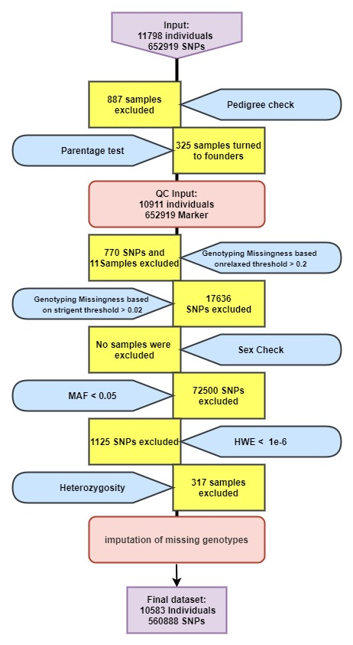
Supplementary Figure 1 Quality Control Process Flowchart
The steps and pre-steps of the study's quality control stage for 11,798 individuals with 652919 SNPs are described briefly in the picture. Two tests of Pedigree check and Parentage test is done before quality control. The quality control phase starts with 10902 samples. Thresholds for the exclusion of the genotypes with missing rates are 0.2 and 0.02. The sex check, MAF test, and HWE test were conducted before the heterozygosity test. The final dataset included 10583 samples with 546339 SNPs.

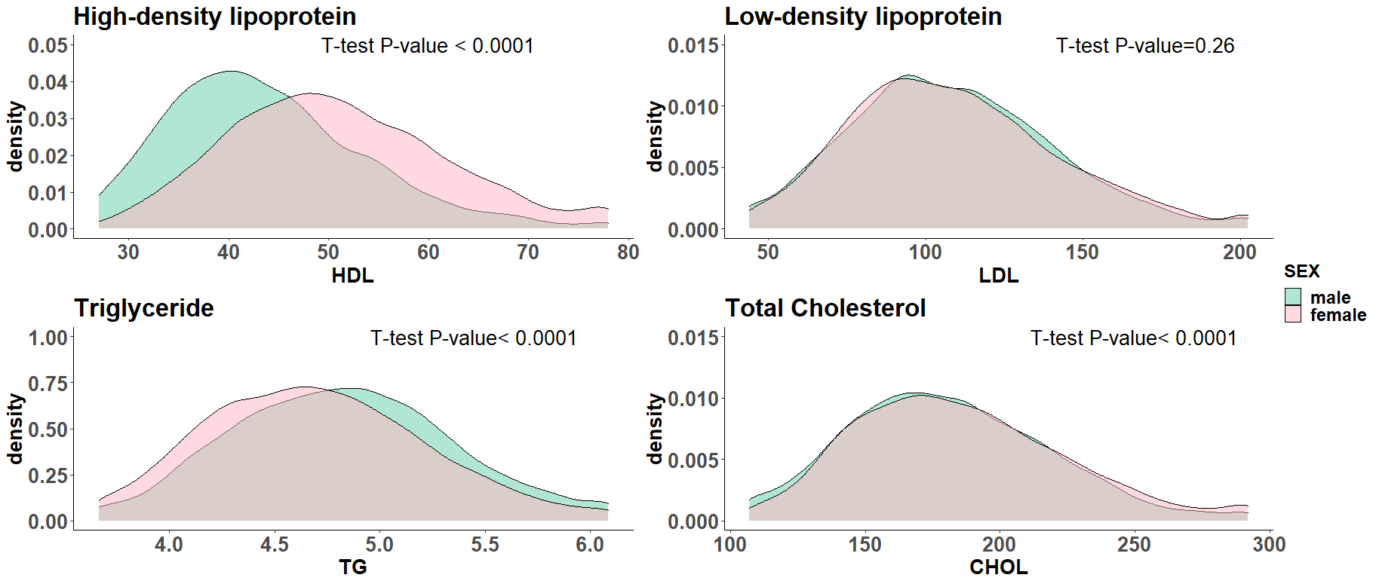
Supplementary Figure 2: Lipid Profile traits density of males and females

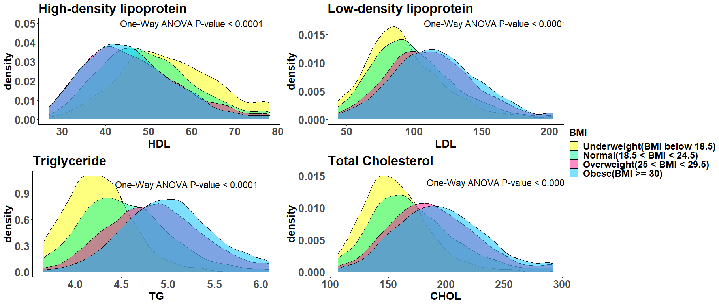
Supplementary Figure 3: Lipid Profile Traits density of the subjects with different levels of BMI

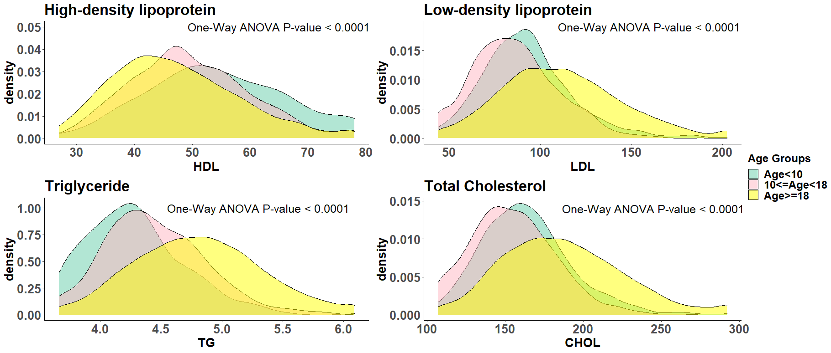
Supplementary Figure 4: Lipid Profile Traits density of different age groups

