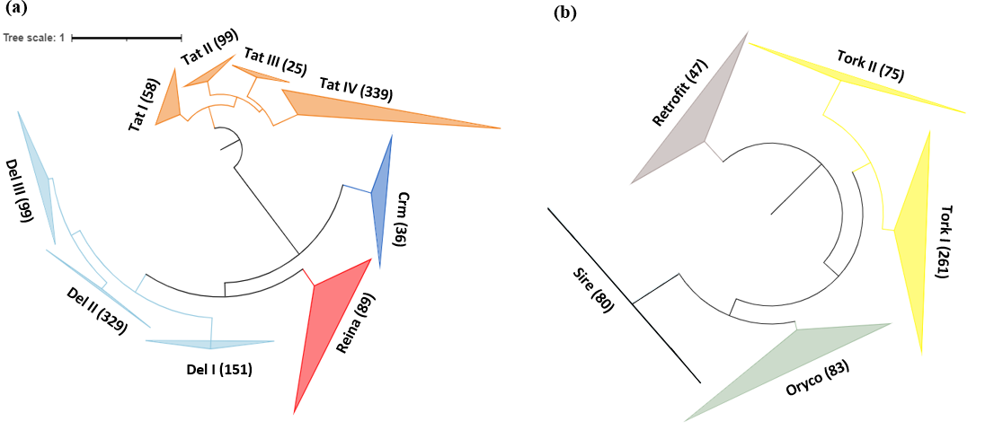 Fig S1. Phylogenetic analysis of active long terminal repeat retrotransposons (LTR-RTs) based on the reverse-transcriptase (RT) domain. Maximum likelihood phylogenies of (a) Gypsy and (b) Copia superfamily members. In the tree, branch color denotes each family of LTR-RTs. Numbers indicate the number of members in each family. The amino acid sequences of the RT domains were aligned using MAFFT.
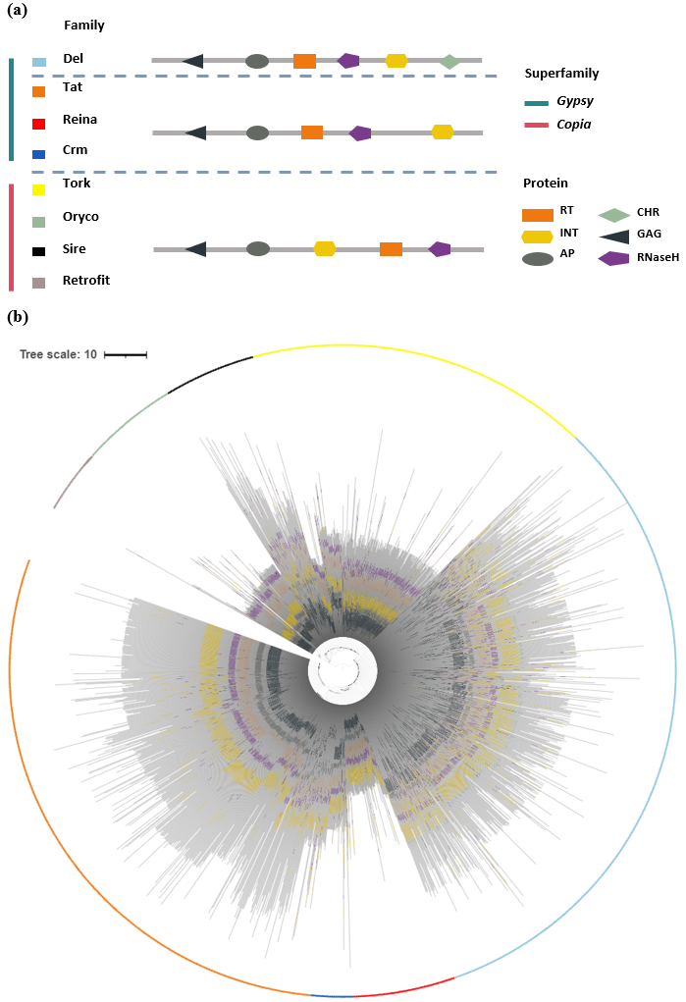
Fig S2. Domain structures and phylogenetic analysis of LTR-RT family members (a) Representative domain structures in each family. (b) Phylogenetic tree constructed using reverse-transcriptase (RT) domain sequences based on the maximum-likelihood method. Black triangle represents the GAG domain; gray circle represents the AP domain; orange rectangle represents the RT domain; yellow hexagon represents the INT domain; green diamond represents the CHR domain; purple pentagon represents the RNaseH domain. In the tree, the colors represent each LTR-RT family. Gray line indicates each amino acid sequence length in the LTR-RTs.

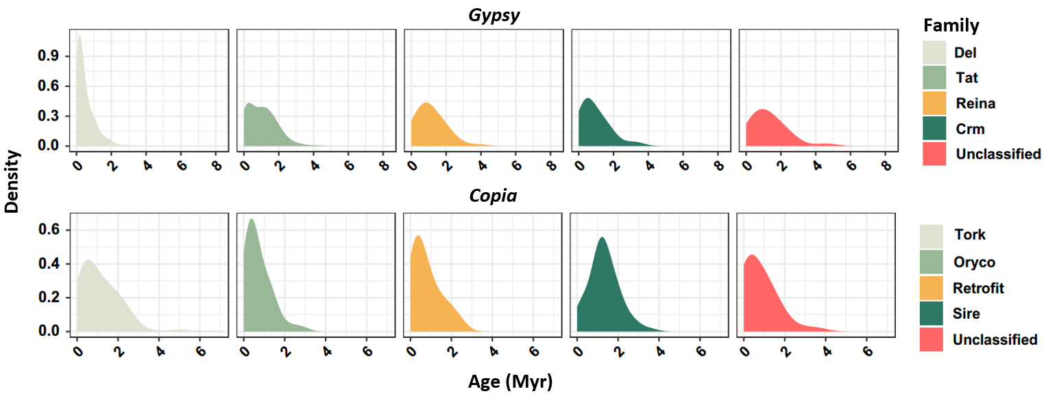 Fig S3. Age distribution of LTR-RTs for each family.
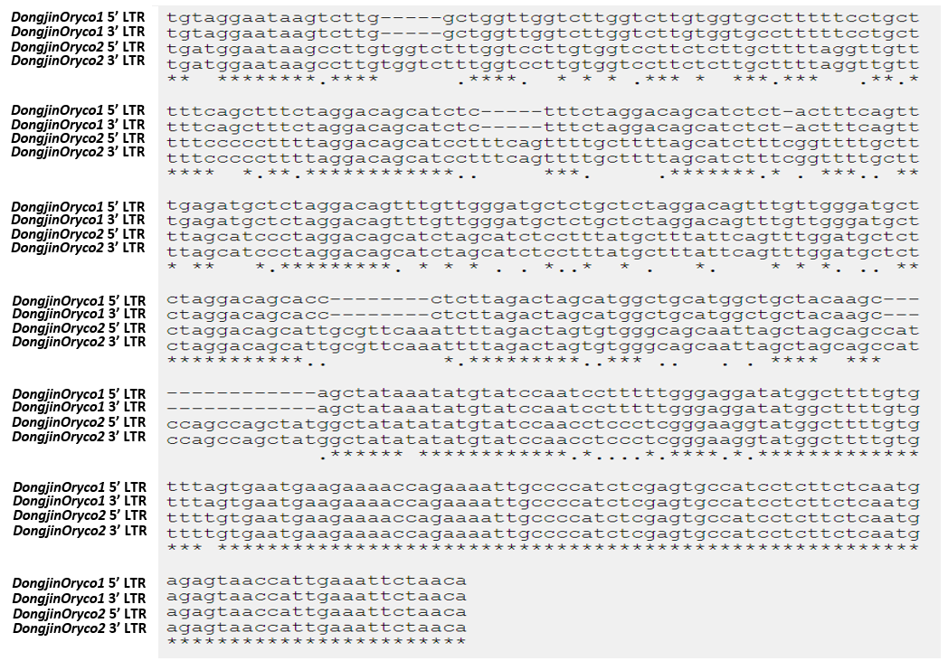 Fig S4. Sequence alignment of the LTR sequences of the two active LTR-RTs.
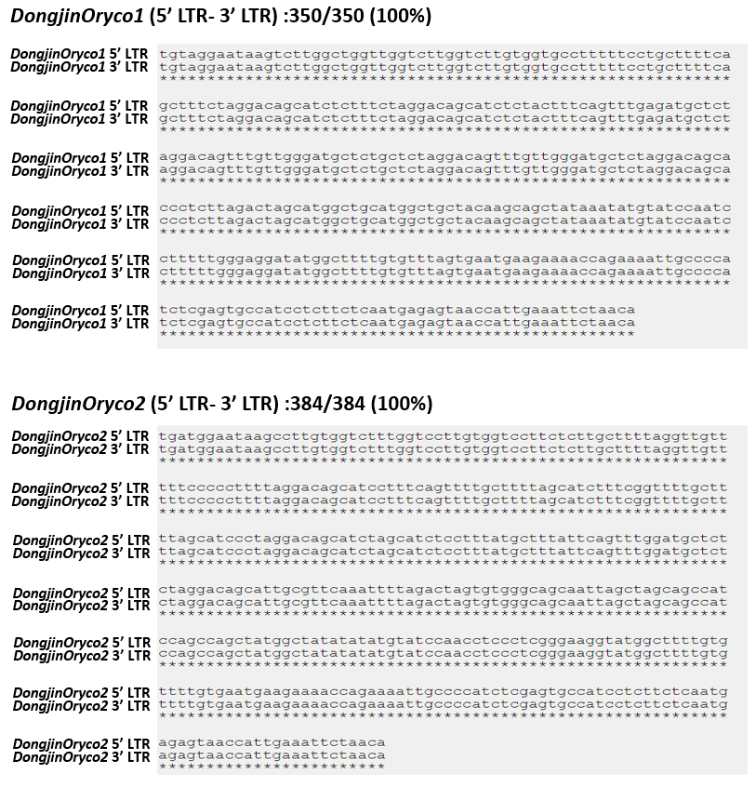 Fig S5. Sequence alignment of LTR pairs for each active LTR-RT belonging to the Oryco family.
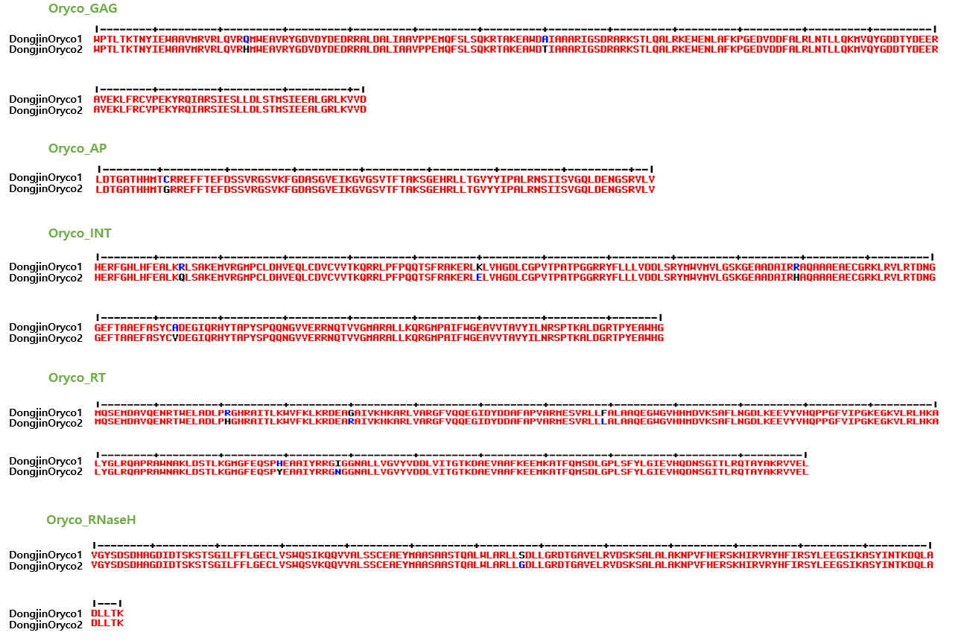
Fig S6. Multiple sequence alignment of the internal domain sequences of active LTR-RTs belonging to the Oryco family. Red represents the same amino acid sequence, whereas black and blue indicate amino acid sequence variations.
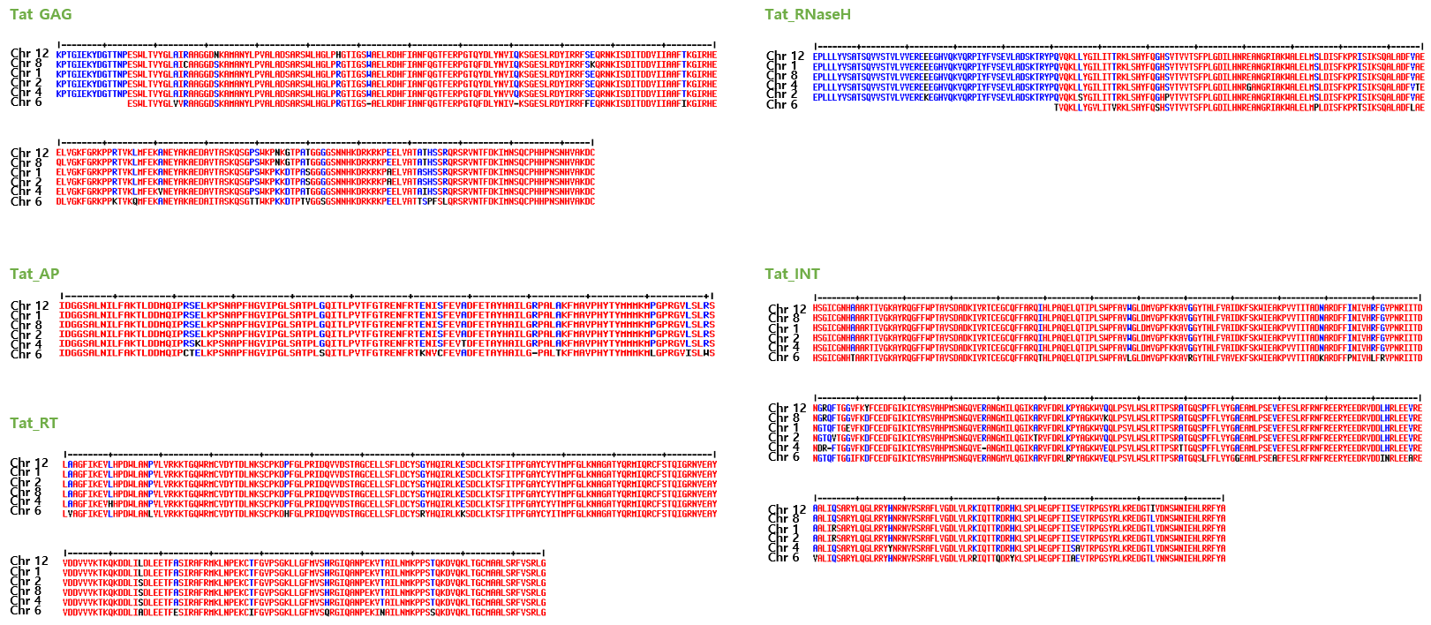 Fig S7. Multiple sequence alignment of the internal domain sequences of LTR-RTs belonging to the Tat family with slightly increasing transpositional potential. Red represents the same amino acid sequence, whereas black and blue indicate amino acid sequence variations.

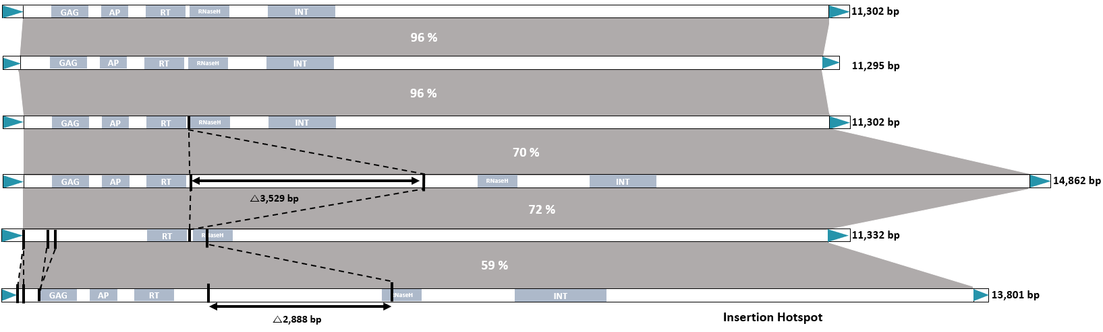
Fig S8. Structural characteristics of six LTR-RTs with slightly increasing transpositional potential in the Dongjin variety. Green triangles indicate LTR regions. Gray boxes indicates the internal domains of the LTR-RTs: GAG: capsid protein, AP: aspartic protease, INT: integrase, RT: reverse-transcriptase. Gray panels represent the sequence similarity for the internal regions among six Tat family members. Indel variations for each family member are indicated.

Fig S9. Pipeline for LTR-RT identification in the O. sativa genome (MSU7 version).

