Supplementary material to:
Extracellular enzyme activities in tropical soils are driven by seasonal litter input

Karst J. Schaap^{1, 2} (ORCID 0000-0003-1627-9029)
Lucia Fuchslueger³ (ORCID 0000-0002-9615-4439)
Carlos Alberto Quesada²
Florian Hofhansl⁴ (ORCID 0000-0003-0073-0946)
Oscar Valverde-Barrantes⁵ (ORCID 0000-0002-7327-7647)
Plínio B. Camargo⁶
Marcel R. Hoosbeek¹ (ORCID 0000-0003-0617-0089)

Corresponding author: Karst J. Schaap, karstsch@gmail.com
1: Soil Chemistry, Wageningen University, P.O. Box 47, 6700AA Wageningen, The Netherlands
2: CODAM, National Institute of Amazonian Research (INPA), Av. André Araújo 2936, Petrópolis, CEP 69067-375, Manaus, Brazil
3: Centre of Microbiology and Environmental Systems Science, Div. Terrestrial Ecosystem Research, University of Vienna, Althanstrasse 14, 1090 Vienna, Austria
4: Biodiversity and Natural Resources Program, International Institute for Applied Systems Analysis (IIASA), Schlossplatz 1, A-2361 Laxenburg, Austria
5: Institute of Environment, Department of Biological Sciences, Florida International University, Miami, FL 33199 USA
6: CENA, University of São Paulo, Piracicaba, Brazil
Table S1: Soil nutrient data for the respective sampling dates. Total C and total N in mass percent of dry soil. All values ± standard error, sample groups not analyzed as “na”.
 | Month | n | Total C | Total N
0-5 cm | 2016-02 | 5 | 6.44 ± 0.31 | 0.41 ± 0.02
0-5 cm | 2016-03 | 6 | 5.18 ± 0.08 | 0.30 ± 0.00
0-5 cm | 2016-04 | 6 | 6.08 ± 0.19 | 0.37 ± 0.01
0-5 cm | 2016-05 | 6 | 7.28 ± 0.27 | 0.42 ± 0.01
0-5 cm | 2016-06 | 6 | 4.99 ± 0.18 | 0.34 ± 0.01
0-5 cm | 2016-07 | 6 | 5.01 ± 0.13 | 0.32 ± 0.01
0-5 cm | 2016-08 | 6 | 7.02 ± 0.16 | 0.41 ± 0.01
0-5 cm | 2016-09 | 6 | 5.51 ± 0.17 | 0.36 ± 0.01
0-5 cm | 2016-10 | 6 | 4.4 ± 0.16 | 0.3 ± 0.01
0-5 cm | 2016-11 | 6 | 5.02 ± 0.15 | 0.33 ± 0.01
0-5 cm | 2017-01 | 6 | 4.19 ± 0.09 | 0.29 ± 0.00
5-15 cm | 2016-02 | 5 | 3.38 ± 0.26 | 0.26 ± 0.01
5-15 cm | 2016-03 | 6 | 3.55 ± 0.08 | 0.22 ± 0.00
5-15 cm | 2016-04 | 6 | 3.18 ± 0.03 | 0.23 ± 0.00
5-15 cm | 2016-05 | 6 | 2.84 ± 0.04 | 0.21 ± 0.00
5-15 cm | 2016-06 | 6 | 3.58 ± 0.07 | 0.26 ± 0.00
5-15 cm | 2016-07 | 6 | 2.19 ± 0.04 | 0.18 ± 0.00
5-15 cm | 2016-08 | 6 | 2.87 ± 0.05 | 0.21 ± 0.00
5-15 cm | 2016-09 | 6 | 3.14 ± 0.17 | 0.23 ± 0.01
5-15 cm | 2016-10 | 6 | 2.2 ± 0.02 | 0.18 ± 0.00
5-15 cm | 2016-11 | 6 | 2.4 ± 0.05 | 0.19 ± 0.00
5-15 cm | 2017-01 | 6 | 2.03 ± 0.03 | 0.17 ± 0.00

Table S2: Soil nutrient data for the respective sampling dates (continued). Total P, eoC, eN and Olsen P µg g⁻¹ dry soil. All values ± standard error, sample groups not analyzed as “na”.
 | Month | n | Total P | eoC | eN | Olsen P
0-5 cm | 2016-02 | 15 | 204.52 ± 3.46 | 1264.06 ± 18.57 | 82.1 ± 1.54 | 2.91 ± 0.11
0-5 cm | 2016-03 | 18 | na | na | na | 3.52 ± 0.06
0-5 cm | 2016-04 | 18 | na | na | na | 1.16 ± 0.02
0-5 cm | 2016-05 | 17 | 153.22 ± 1.41 | 1806.59 ± 31.33 | 97.8 ± 1.50 | 2.98 ± 0.07
0-5 cm | 2016-06 | 18 | na | na | na | 2.16 ± 0.04
0-5 cm | 2016-07 | 18 | na | na | na | 1.81 ± 0.03
0-5 cm | 2016-08 | 18 | 141.8 ± 2.13 | 594.69 ± 5.98 | 135.3 ± 1.19 | 2.03 ± 0.08
0-5 cm | 2016-09 | 18 | na | na | na | 1.34 ± 0.05
0-5 cm | 2016-10 | 18 | na | na | na | 1.89 ± 0.06
0-5 cm | 2016-11 | 18 | 148.64 ± 2.34 | 594.76 ± 9.67 | 104.75 ± 1.13 | 1.37 ± 0.03
0-5 cm | 2017-01 | 17 | na | na | na | 1.65 ± 0.12
5-15 cm | 2016-02 | 15 | 143.24 ± 3.24 | 1115.11 ± 24.32 | 58.24 ± 0.74 | 1.62 ± 0.02
5-15 cm | 2016-03 | 18 | na | na | na | 2.87 ± 0.04
5-15 cm | 2016-04 | 18 | na | na | na | 0.81 ± 0.03
5-15 cm | 2016-05 | 18 | 107.86 ± 1.61 | 1727.64 ± 31.61 | 72.57 ± 1.42 | 1.66 ± 0.03
5-15 cm | 2016-06 | 18 | na | na | na | 1.7 ± 0.02
5-15 cm | 2016-07 | 18 | na | na | na | 1.17 ± 0.02
5-15 cm | 2016-08 | 17 | 110.44 ± 1.21 | 455.73 ± 2.80 | 95.92 ± 0.58 | 0.58 ± 0.02
5-15 cm | 2016-09 | 18 | na | na | na | 0.77 ± 0.03
5-15 cm | 2016-10 | 17 | na | na | na | 0.88 ± 0.03
5-15 cm | 2016-11 | 18 | 124.28 ± 1.41 | 504.8 ± 8.15 | 87.43 ± 0.44 | 0.60 ± 0.01
5-15 cm | 2017-01 | 18 | na | na | na | 0.52 ± 0.02

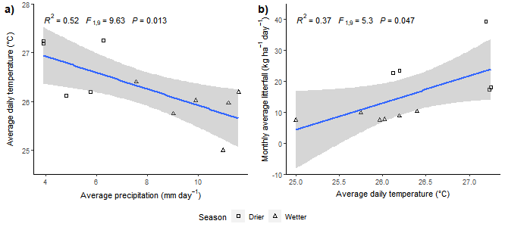
Figure S1: The relation between a) average temperature and average precipitation, and b) the relation between average temperature and average litterfall.

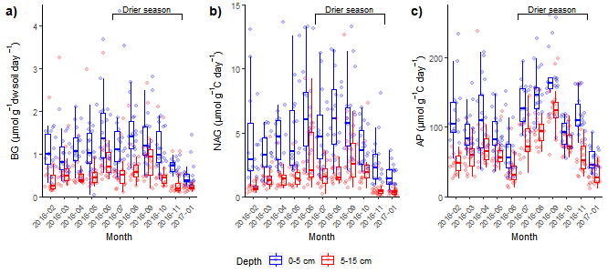Figure S2: C, N and P related extracellular enzyme activities (BG, NAG and AP per gram dry soil) from February 2016 till January 2017. Showing the median, the lower and upper hinges correspond to the first and third quartiles.
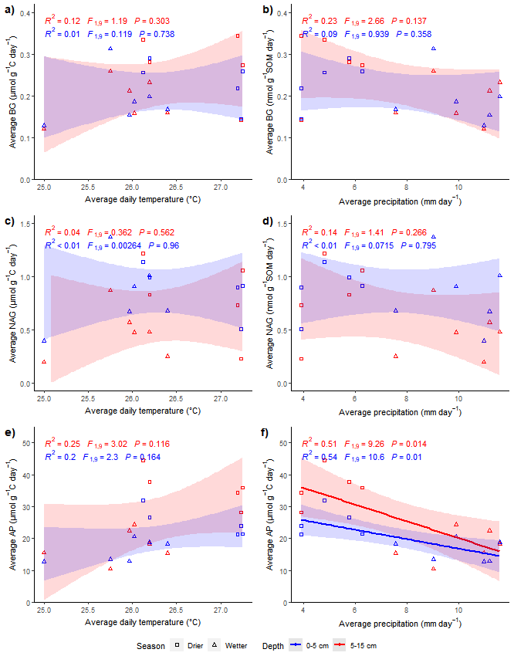
Figure S3: Relation between average enzyme activities and temperature and precipitation. Regression line only shown for significant relationships
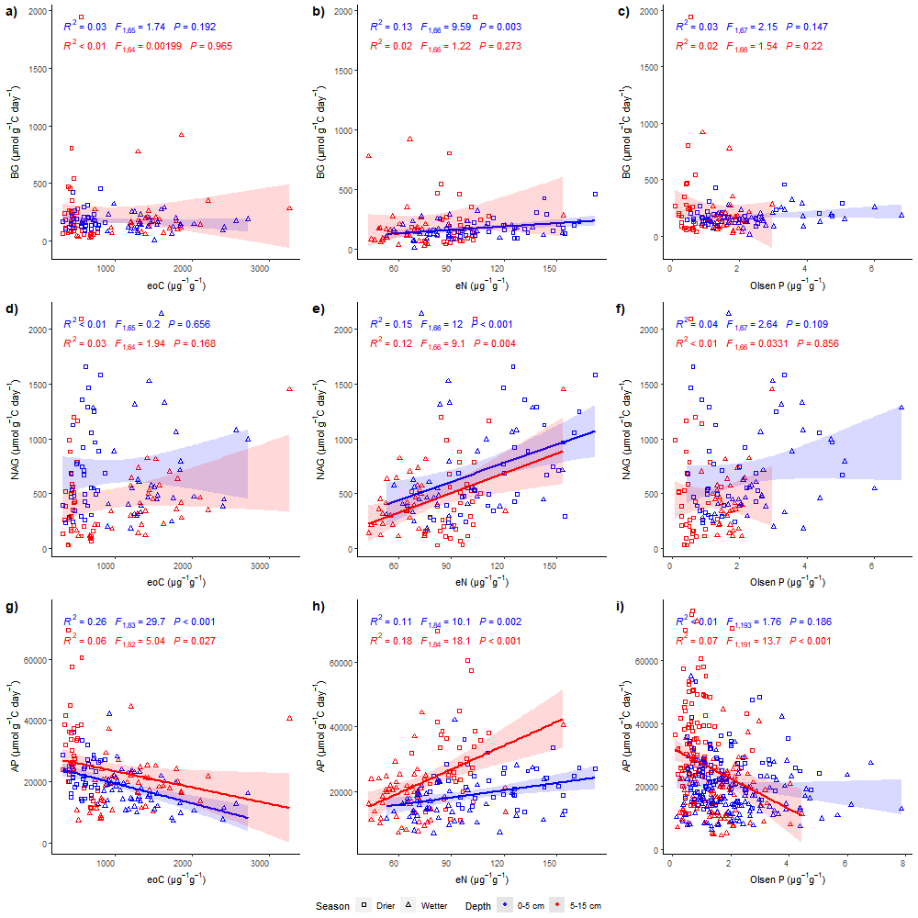
Figure S4: Extractable C, N and P and as related to the corresponding enzymatic activities.
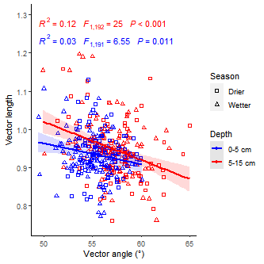
Figure S5: Relation between enzyme vector length (unitless) and vector angle (°)

