Supplementary Information
Operando Analyses of Highly Enhanced Water Splitting by Electronically Modulated Non-noble Metal Carbides

Soumyabrata Roy^{1,2},# Debabrata Bagchi^{1,2},# Lakshay Dheer^{2,3}, Saurav Ch. Sarma^{1,2} Vincent Rajaji^{2,3}, Chandrabhas Narayana^{2,3}, Umesh V. Waghmare^{2,4} and Sebastian C. Peter^{1,3*}

¹New Chemistry Unit, Jawaharlal Nehru Centre for Advanced Scientific Research, Bangalore, India
²School of Advanced Materials, Jawaharlal Nehru Centre for Advanced Scientific Research, Bangalore 560 064, India
³Chemistry and Physics of Materials Unit, Jawaharlal Nehru Centre for Advanced Scientific Research, Bangalore 560 064, India
⁴Theoretical Sciences Unit, Jawaharlal Nehru Centre for Advanced Scientific Research, Bangalore 560 064, India

# The authors contributed equally (Joint first authorship)

Keywords: Water splitting, alkaline electrolyzer, transition metal carbides, operando XAS analyses

*Corresponding author. Phone: 080-22082998, Fax: 080-22082627
sebastiancp@jncasr.ac.in (S. C. Peter)

Experimental details
- Chemicals and Reagents
Phosphotungstic acid (H₃PW₁₂O₄₀), phosphomolybdic acid (H₃PMo₁₂O₄₀) and nickel chloride hexahydrate (NiCl₂. 6H₂O) were purchased from SDFCL. Melamine (C₃H₆N₆) was purchased from Sigma Aldrich. Sulfuric acid (H₂SO₄) and potassium hydroxide (KOH) were purchased from SDFCL. All the reagents were used without further purification. Deionized water (TKA, 18.2 MΩ.cm) was used throughout the syntheses and all measurements.
2. Synthesis of Ni-WC(1:5)@NGC and Ni-MoC(1:5)@NGC:
Phosphotungstic acid (1.2002 g), nickel(II) chloride hexahydrate (0.2377 g) and melamine (2.5224 g) were mixed properly so that the mole ratio of Ni:W:Melamine is 1:5:20. Mixing process was done either by ~20 min of mechanical grinding or by ball milling using agate balls (10 mm diameter) at 600 rpm for 4 minute for 3 times. 100 mg of that homogeneous mixture was then placed in a vacuum sealed quartz tube (diameter 13 mm) and annealed at 900 °C in a tube furnace for 5 h with a heating rate of 3 °C/min. In this process melamine would be thermally converted first to carbon nitride (g-C₃N₄) around 500 °C and then to N-doped graphitic carbon (NGC) as the temperature increases. It will also act as the carbon source for carbonization and reduction of the transition metal salts following a similar reactions¹ shown below.
H₃PW(Mo)₁₂O₄₀.xH₂O + C₃H₆N₆→ W(Mo)O₃ + CH₄ → W(Mo)C + C(N&P doped) Equation 1
H₃PW(Mo)₁₂O₄₀.xH₂O+NiCl₂+C₃H₆N₆ →Ni-W(Mo)O₃+CH₄→Ni-W(Mo)C + C(N&P doped) Equation 2
From TGA analysis (Figure S1) it is evident that phosphotungstic acid will be decomposed at that high temperature and will form tungsten carbides by reaction with melamine. The schematic diagram for the synthesis of Ni-WC@NGC and temperature program applied during the synthesis are presented in Figure S2.
The obtained samples after carbonization were subsequently etched with 0.5 M H₂SO₄ at 80 °C for 12 h. Then the acid-etched solution was washed several times with deionized water and ethanol alternatively by centrifuging at 8000 rpm to remove unstable and inactive species. Then the sample was properly dried to obtain the desired nickel-doped tungsten carbide nano-systems on nitrogen doped graphitic carbon labelled as Ni-WC(1:5)@NGC. For comparative studies elucidating the structure-electrocatalytic activity relationships, we synthesised three more samples coded as WC@NGC (without Ni), Ni-WC(2:5)@NGC, Ni-WC(3:5)@NGC having corresponding mole ratio of the same precursors (i.e. W:Ni:Melamine) as 5:0:20, 5:2:20 and 5:3:20 respectively maintaining all other synthetic conditions the same. Interestingly, from the characterization studies it was later revealed, that in the cases of Ni-WC(2:5)@NGC & Ni-WC(3:5)@NGC, lesser Ni was incorporated into carbide lattice, and phase separated elemental Ni was obtained along with the hexagonal WC phase. The difference of mechanical hand grinding and systematic ball milling was understood from the Raman studies and elemental analyses. From Raman studies it was observed that ball milling enriched the carbon with higher defect density, and elemental analyses revealed that BM enhanced Ni diffusion into the carbide lattice.
Following similar synthetic methods the Ni-MoC(1:5)@NGC compound was also synthesised taking phosphomolybdic acid (0.7606 g), nickel(II) chloride hexahydrate (0.2377 g) and melamine (2.5224 g) as precursor materials, keeping all other conditions same. MoC@NC, Ni-MoC(2:5)@NGC, Ni-MoC(3:5)@NGC compounds were also synthesized following similar strategy.
3. Characterisation
  - Powder X-ray Diffraction (PXRD). PXRD measurements were done at room temperature on a Rigaku Miniflex X-ray diffractometer with a Cu−Kα X-ray source (λ = 1.5406 Å), equipped with a position sensitive detector in the angular range of 10° ≤ 2θ ≤ 90° with the step size 0.02° and a scan rate of 0.5 s/step calibrated against corundum standards. The experimental XRD patterns were compared to the patterns simulated from the data reported in the literature.
  - Elemental Analysis. Quantitative microanalysis on all the samples was performed with an FEI NOVA NANOSEM 600 instrument equipped with an EDAX instrument. Data were acquired with an accelerating voltage of 20 kV and a 100 s accumulation time. The EDAX analysis was performed using the P/B-ZAF standard less method (where Z = atomic no. correction factor, A = absorption correction factor, F = fluorescence factor, P/B = peak to background model) on selected spots and points.
  - Transmission Electron Microscopy (TEM). TEM images and selected area electron diffraction (SAED) patterns were collected using TECNAI and JEOL 200 kV TEMs. TEM samples for these measurements were prepared by sonicating the nanocrystalline powders in ethanol and dropping a small volume onto a carbon-coated copper grid.
  - X-ray Photoelectron Spectroscopy (XPS). XPS measuremnt was performed on an Omicron Nanotechnology spectrometer using a Mg−Kα (1253.6 eV) X-ray source with a relative composition detection better than 0.1%.
  - Raman Spectroscopy: Raman experiments were performed in backscattering
geometry (180◦) using a commercial Raman spectrometer [LabRam HR evolution (Horiba)] equipped with a solid-state frequency-doubled 532 nm CW Nd-YAG laser and 800 mm focal length monochromator. The room temperature Raman spectra were collected with a laser power of less than 0.5 mW at the sample.
  - ICP-OES. ICP-OES was performed using a Perkin Elmer Optima 7000 DV instrument. The samples were digested in concentrated aqua regia, followed by dilution with distilled water. In a typical experiment 2mg of the sample was dissolved in 3 ml aqua regia and left overnight (12 hrs) for digestion. The digested sample was then diluted to 15 ml volume with deionised water. The solid particles were separated by thorough centrifugation before measurements.
  - X-ray Absorption Spectroscopy.: X-ray absorption near edge spectroscopy (XANES) and quick-Extended X-ray Absorption Fine Structure (quick-EXAFS) experiments at 300 K were performed at PETRA III, beamline P64, of DESY, Germany. Measurements of Ni-K, W-L_{III} and Mo-L_{III} at ambient pressure were performed in fluorescence as well as transmission mode using gas ionization chambers to monitor the incident and transmitted X-ray intensities. Monochromatic X-rays were obtained using a Si (111) double crystal monochromator which was calibrated by defining the inflection point (first derivative maxima) of Cu foil as 8980.5 eV. The beam was focused by employing a Kirkpatrick-Baez (K-B) mirror optic. A rhodium- coated X-ray mirror was used to suppress higher order harmonics. A CCD detector was used to record the transmitted signals. Pellets for the ex-situ measurements were made by homogeneously mixing the sample with an inert cellulose matrix to obtain an X-ray absorption edge jump close to one. In case of in-situ XANES and EXAFS measurements, a customised electrochemical cell setup was used and electrochemical measurements were performed on a CHI 760E electrochemical workstation. In this three-electrode setup the working electrode (customized circular GCE, 10 mm dia) was placed in such a way so that the sample (WE surface plane) perpendicularly faces the Synchrotron X-ray source and the detector was placed at an angle of 45° with the direction of x-ray. The path length of the incident X-ray beams inside the electrolyte was minimized by placing the WE surface at a distance of 1 mm from the inner wall of the electrochemical cell.
The complete in-situ XAS study are conducted on the Ni-WC@NGC sample due to proximity of the W-L_{III} (10.2068 keV) and Ni-k (8.3328 keV) edges, allowing easy and fast shift in the energy range. Consecutive XAS spectra are measured on the as-coated electrode, electrode dipped in electrolyte, after 1000 cycles ADT and finally during and after 1 hr chronoamperometric studies.
- Electrochemical Studies. All the electrochemical measurements were performed on a CHI 760E electrochemical workstation using a three-electrode setup with commercial glassy carbon (GC) electrode (having diameter 3 mm) coated with different catalysts as the working electrode, platinum wire and carbon rod as the counter electrodes, and saturated calomel electrode (SCE) as reference electrode in case of acidic medium. Hg/HgO (MMO) electrode was used as reference electrode in case of electrochemical study performed in alkaline medium. The catalyst ink was prepared by dispersing 2 mg of catalyst in 200 µL of mixed solvent solution (IPA: H₂O=1:2 v/v). From the prepared catalyst ink, 5 µL was drop casted on GC electrode (3 mm diameter) along with 5 µL of 0.1% nafion solution binder on the top to protect the film which was dried overnight in air. An uniform catalyst loading of 0.7 mg/cm² was coated on the GCE for all the electrochemical measurements. While using the customized 10 mm dia GCE for EXAFS or Faradaic efficiency measurements, the same mass loading was maintained. Before depositing the catalyst, the GC electrode was polished with 0.05 µm alumina slurry and washed several times with distilled water/IPA. Commercial Pt/C (20 wt%, Sigma Aldrich) and Pd/C (20 wt%, Sigma Aldrich) were used for comparison of activity with the reported electrocatalysts. Linear sweep voltammetry (LSV) was recorded for HER and OER at a scan rate of 5 mV s⁻¹ at 25 °C. Electrochemical impedance studies were performed in the frequency range from 10 mHz to 100 kHz at different applied DC potentials for different reactions depending on their onset potential values. The electrolyte solution was deaerated by purging nitrogen gas into the solution at least for 30 min before each experiment. All the reference electrodes were calibrated with respect to the reversible hydrogen electrode (RHE), using Pt as working and counter electrodes in the respective electrolytes. The values obtained are as follows: acidic medium, E_{RHE} = E_{SCE} + 0.26905 V; alkaline medium, E_{RHE} = E_{MMO} + 0.9414 V.
To understand the mechanism of HER and reactions kinetics the Tafel slopes were calculated near the onset region, by fitting to the Tafel equation ( η = b log j + a) where η is the overpotential, j is the current density and b gives the value of the Tafel slope.
To further elucidate the electron transfer kinetics, comparative electrochemical impedance spectroscopy (EIS) in the AC mode was conducted for the catalysts at -0.13 V vs RHE (~50 mV above the onset) using an AC frequency in the range of 10⁻² to 10⁵ Hz with an amplitude of 5 mV. The Nyquist plots obtained from electrochemical impedance spectroscopy (EIS) can be fitted with a simplified Randles model,² which yields the relevant series resistances (R_{s}) and charge-transfer resistances (R_{CT}).
  - Estimation of effective electrode surface area. According to reported literature,³ cyclic voltammetry (CV) can be used to determine the electrochemical double layer capacitance of different samples at non-Faradaic overpotentials for estimating the effective electrode surface areas. For that a series of CV measurements were performed at various scan rates (10, 20, 30, 50, 80, 100 mV s⁻¹) between 0.27V to 0.47 V vs. RHE region, and the sweep segments of the measurements were set to 6 to ensure consistency. A linear trend was obtained from the plot of the difference of current density ($\frac{1}{2}$ΔJ) in the anodic and cathodic sweeps (J_{anodic} – J_{cathodic}) at 0.369 V vs. RHE against the scan rate. The slope of the fitting line is equal to twice the geometric double layer capacitance (C_{dl}), which is proportional to the effective electrode surface area of the materials. Therefore, the electrochemical surface areas of different samples can be compared with one another based on their C_{dl} values keeping other experimental condition same for each case.⁴
  - Overall water splitting. The overall water splitting activity of Ni-WC@NGC and Ni-MoC@NGC in 0.5M KOH towards oxygen and hydrogen evolution reaction was measured in a two-electrode configuration where the individual catalysts were used as both cathode and anode in a closed electrochemical cell. The electrolyte and cell were first degassed with N₂ gas for 30 min under stirring. Then the cell was connected with Keithley 2400 source meter SMU instrument. With the help of this Keithley electrometer change of overall cell potential with respect to time can be measured at different current densities. In this case overall cell potential ( at fixed current density of 10 mA/cm²) was plotted over two hour time duration for both the catalysts. At the same current density, the overall cell potential of other combinations of catalysts (acting as cathode or anode) were also determined and compared with that of Ni-WC@NGC and Ni-MoC@NGC catalyst. The reported catalysts (this work) could also split water by the potential of 1.5 V battery in the same medium. For that experiment, a commercial 1.5 V AA battery was connected to two working electrodes coated with the same catalyst, in a commercial single chamber electrochemical cell. The theoretical value of E_{cell} is given by E = E⁰ + ƞ(cathode) + ƞ(anode) + ƞ(CP) + ƞ(ohmic) + ƞ(other), where E⁰ = 1.23 V, ƞ(CP) is overpotential due to concentration polarisation, ƞ(ohmic) is loses due to Ohmic solution resistance and ƞ(other) consists of bubble resistance, membrane resistance, contact resistance etc.
  - Calculation of Faradaic Efficiency. Faradaic efficiency was calculated by comparing the experimentally obtained volume of hydrogen or oxygen gas (from cathodic and anodic compartments respectively) evolved to the theoretical values calculated from Faraday’s law. Chronoamperometric (CA) experiment was done using a three electrode set up in a customized bicompartmental electrochemical cell. Two 10 mm diameter GCEs, coated with specific catalysts, were used as the working electrodes and kept in each compartment (cathodic and anodic) of the cell along with Ag/AgCl (1M KCl) or Hg/HgO as the reference electrode. The cathodic and anodic compartments were separated by a pre-treated nafion-117 membrane. The quantity of gas evolved was measured using inverse burette method. Ni-MoC@NGC evolved around 6.1 ml of H₂ gas and 2.9 ml of O₂ gas after 40 mins of CA. The volume of evolved H₂ and O₂ gases evolved during the reaction matched closely with the calculated valued from Faraday’s law, suggesting nearly 100% faradaic efficiency in for both the electrochemical process. The theoretical amount of H₂/O₂ gas was calculated from the equation S1 based on Faraday’s law, (1) where I is the applied current, n is the number of electrons involved in the particular electrochemical process, t is the time and F is Faraday constant, 96485 C.
Moles of H₂/O₂ produced = $\frac{1}{n}\frac{\int_{0}^{t}{Idt}}{F}$ (Equation 3)
- Computational details
Our first-principles calculations are based on density functional theory (DFT) as implemented in the Quantum ESPRESSO code⁵ employing plane-wave basis and ultra-soft pseudopotentials⁶ to represent the interaction between ionic cores and valence electrons. We adopt the exchange-correlation energy functional of Perdew-Zunger⁷ obtained within a local density approximation (LDA). We smear the discontinuity in occupation numbers of electronic states with Fermi–Dirac distribution having a smearing width (k_{B}T) of 0.04 eV. An energy cutoff of 50 Ry is used to truncate the plane-wave basis used in representation of Kohn-Sham wave functions, and of 400 Ry to represent the charge density. Optimized structures were determined through minimization of energy until the Hellmann-Feynman force on each atom is smaller than 0.03 eV/Å in magnitude. We use a supercell to model surfaces introducing a vacuum layer of 14.5$Å$ thickness parallel to the slab separating its adjacent periodic images. Each supercell contains a slab of 6 atomic planes of which, the bottom 3 atomic planes were kept fixed and the top 3 were allowed to relax. We sampled Brillouin-zone integrations on uniform grid of 6x6x1 k-points in the Brillouin zones of (100) and (101) surfaces of pristine and Ni substituted WC and MoC. The projected density of states of each structure was obtained from calculations on a denser, 15x15x1, k-point mesh. Calculated lattice constants of bulk WC $(a_{WC}=2.89 Å)$ and MoC $(a_{MoC}=2.88 Å)$ are within the typical LDA errors with respect to their observed values $(a_{WC}=2.906 Å$ and $a_{MoC}=2.9 Å)$.
The estimated formation energies are as follows.
(Equation 4)
$$E_{form}= \frac{E_{M_{1-x}{Ni}_{x}C \left(100\right)/(101) }-\{E_{MC \left(100\right)/(101)}- xE_{Ni}+{xE}_{M}\}}{x},$$
where, $E_{M_{1-x}{Ni}_{x}C (100)/(101)}$, $E_{ MC\left(100\right)/(101)}$, $E_{Ni}$, and $E_{M}$ are the energies of Ni substituted (100)/(101) surface of MC, pristine MC (100)/(101) surface, and Ni and M atoms, respectively. Here, x is giving the fraction of M atoms substituted with Ni atoms.
(Equation 5)
$${∆E}_{ads}= E_{adsorbate+M_{1-x}{Ni}_{x}C}- \left(E_{M_{1-x}{Ni}_{x}C}+ E_{adsorbate}\right)$$
where, $E_{adsorbate+M_{1-x}{Ni}_{x}C}$, $E_{M_{1-x}{Ni}_{x}C}$, $E_{adsorbate}$ are the energies of adsorbate adsorbed on pristine/Ni-substituted MC (100) and (101) surfaces, pristine or Ni-substituted MC (100) and (101) surfaces, and energy of adsorbate atom taken as $1/2E_{H_{2}}$respectively.
(Equation 6)
$$∆G_{H}= ∆E_{ads}^{H}-T∆S_{H}+ E_{ZPE}^{H}$$
where, $∆E_{ads}^{H}$is the H-adsorption energy (Eqn. 5), $∆S_{H}= 1/2S_{H_{2}}^{°}$, $S_{H_{2}}^{°}$ is the entropy of H₂ molecule and $E_{ZPE}^{H}$ = $1/2E_{ZPE}^{H_{2}}$, $E_{ZPE}^{H_{2}}$ is the zero-point energy of an isolated H₂ molecule.
Tables

Table S1. Comparison of the formation energy of different crystal planes of Ni-WC/MoC crystal lattice.⁸
System | Unit Cell | Total Energy | No of atoms | Energy/atom (Ha)
WC | 100 | -3791.976832 | 72 | -52.66634489
WC | 101 | -3792.32172 | 72 | -52.671135
Ni-WC | 100 | -3999.45986 | 72 | -55.54805361
Ni-WC | 101 | -3896.055821 | 72 | -54.11188641
MoC | 100 | -3831.786148 | 72 | -53.21925206
MoC | 101 | -3832.051709 | 72 | -53.2229404
Ni-MoC | 100 | -4345.012741 | 72 | -60.34739918
Ni-MoC | 101 | -3934.678422 | 72 | -54.64831141

Tables S2. Atomic percentage of different elements present in Ni-doped WC@NGC and Ni-doped MoC@NGC catalysts through ICP-OES and FESEM-EDS.
Sample | Ni | Mo | W | C | N | P | Method
Ni-WC(1:5)-BM | 5.135 | -- | 19.23 | -- | -- | -- | ICP-OES  (mg/L)
Ni-WC(1:5)-NBM | 2.314 | -- | 18.52 | -- | -- | -- | ICP-OES  (mg/L)
Ni-MoC(1:5)-BM | 4.371 | 20.37 |  | -- | -- | -- | ICP-OES  (mg/L)
Ni-MoC(1:5)-NBM | 2.279 | 22.69 |  | -- | -- | -- | ICP-OES  (mg/L)
Ni-WC(1:5)-BM | 1.38 | -- | 6.32 | 89.44 | 2.42 | 0.44 | FESEM-EDS
Ni-WC(1:5)-NBM | 1.34 | -- | 12.73 | 83 | 2.37 | 0.56 | FESEM-EDS
Ni-MoC(1:5)-BM | 1.54 | 6.01 | -- | 89.32 | 2.47 | 0.66 | FESEM-EDS
Ni-MoC(1:5)-NBM | 1.47 | 12.4 | -- | 84.21 | 1.32 | 0.6 | FESEM-EDS
Ni-WC(1:5)-BM | 1.92 | -- | 8.61 | 86.53 | 2.16 | 0.78 | TEM-EDS
Ni-MoC(1:5)-BM | 1.83 | 7.15 | -- | 88.1 | 2.12 | 0.8 | TEM-EDS

Tables S3. Calculation of ratio of Ni and Mo/W of different elements present in Ni-doped WC@NGC and Ni-doped MoC@NGC catalysts through ICP-OES and FESEM-EDS.
Sample | Mo/Ni | W/Ni | Method
Ni-WC(1:5)-BM | -- | 3.75 | ICP-OES  (mg/L)
Ni-WC(1:5)-NBM | -- | 8.04 | ICP-OES  (mg/L)
Ni-MoC(1:5)-BM | 4.66 | -- | ICP-OES  (mg/L)
Ni-MoC(1:5)-NBM | 9.95 | -- | ICP-OES  (mg/L)
Ni-WC(1:5)-BM |  | 4.57 | FESEM-EDS
Ni-WC(1:5)-NBM |  | 9.5 | FESEM-EDS
Ni-MoC(1:5)-BM | 3.9 | -- | FESEM-EDS
Ni-MoC(1:5)-NBM | 8.43 | -- | FESEM-EDS
Ni-WC(1:5)-BM | -- | 4.48 | TEM-EDS
Ni-MoC(1:5)-BM | 3.91 | -- | TEM-EDS
Ni-WC(1:5)-BM |  | 4.27 | Average
Ni-WC(1:5)-NBM |  | 8.77 | Average
Ni-MoC(1:5)-BM | 4.16 |  | Average
Ni-MoC(1:5)-NBM | 9.19 |  | Average

Table S4. Comparison of the electrocatalytic HER and OER activity of different Ni-doped and undoped WC@NGC and MoC@NGC with state-of-the-art catalysts.
Catalyst | Onset | η₁₀ | η₂₀ | η₅₀ | η₁₀₀ | η₁₄₀ | η₁₅₀ | Tafel | R_{CT} | Electrolyte
Catalyst | (mV vs RHE) |  |  |  |  |  |  | (mV/dec) | Ω
WC@NGC | 218 | -- | -- | -- | -- | -- | -- | 124 | 1169 @0.13V | HER,  0.5 M H₂SO₄
MoC@NGC | 131 | 297 | 348 | -- | -- | -- | -- | 102 | 530 @0.13V | HER,  0.5 M H₂SO₄
Ni-WC@NGC | 66 | 209 | 245 | 312 | -- |  | -- | 88 | 117 @0.13V | HER,  0.5 M H₂SO₄
Ni-MoC@NGC | 69 | 202 | 228 | 277 | 338 | 379 | -- | 76 | 78 @0.13V | HER,  0.5 M H₂SO₄
20%Pt@C | -- | -- | -- | 54 | 196 | 257 | -- | 31 |  | HER,  0.5 M H₂SO₄
20%Pd@C | -- | -- | -- | 105 | 115 | 164 | -- | 55 |  | HER,  0.5 M H₂SO₄
Ni-WC@NGC | 101 | 241 | 295 | 398 | 523 | 610 | 630 | 135 | 133 @0.18V | HER,  0.5 M KOH
Ni-MoC@NGC | 102 | 240 | 292 | 393 | 518 | 608 | 628 | 124 | 95 @0.18V | HER,  0.5 M KOH
20%Pt@C | -- | 62 | 117 | 235 | 401 | 526 | 566 | 102 |  | HER,  0.5 M KOH
20%Pd@C | -- | 142 | 239 | 423 | 611 | 730 |  | 194 |  | HER,  0.5 M KOH
 | Potential (Volts v RHE) |  |  |  |  |  |  | (mV/dec) | Ω
Ni-WC@NGC | 1.45 | 1.54 | 1.57 | 1.64 | 1.75 | -- | -- | 57 | 71 @ 1.6V | OER, 0.5 M KOH
Ni-MoC@NGC | 1.46 | 1.54 | 1.57 | 1.64 | 1.75 | -- | -- | 60 | 60 @ 1.6V | OER, 0.5 M KOH
IrO₂ | 1.52 | 1.61 | 1.69 | 1.92 | -- | -- | -- | 75 | 188 @ 1.6V | OER, 0.5 M KOH

Table S5. Comparison of the electrocatalytic HER activity of Ni-WC@NGC and Ni-MoC@NGC (reported here) under acidic and basic medium with some efficient solid-state HER catalysts that have been recently reported in the same medium.
Catalysts | WE | CE | RE | Electrolyte | Onset | Tafel | R_{CT} | J₀ | η10 | η50 | η100 | Ref
Ni-WC@NGC | GC | Pt | SCE | 0.5 M H₂SO₄ | 66 | 88 | 117 @0.13V |  | 209 | 312 |  | This Work
Ni-MoC@NGC | GC | Pt | SCE | 0.5 M H₂SO₄ | 69 | 76 | 78 @0.13V |  | 202 | 277 | 338 | This Work
Mo₂C-NCNT | Carbon sheet | Carbon rod | Ag/AgCl | 0.5 M H₂SO₄ | 72 | 71 | 53 @0.1V | 114 | 147 |  |  | ⁹
α-Mo₂C-NP | GC-RDE | Carbon rod | MMO | 0.5 M H₂SO₄ | - | 56 | - |  | 198 |  |  | ¹⁰
Mo_{0.06}W_{1.94}C/CB | GC | Pt | Ag/AgCl | 0.5 M H₂SO₄ | - | - | - |  | 220 |  |  | ¹¹
Mo₂C-carbon  nanocomposite | GC-RDE | Carbon rod | Ag/AgCl | 0.5 M H₂SO₄ | 100 | 110 | - |  | N/A |  |  | ¹²
β- Mo₂C | GC |  |  | 0.1 M HClO₄ | N/A | 120 |  |  | N/A |  |  | ¹³
np-Mo₂C | GC-RDE | Pt mesh | SCE | 0.5 M H₂SO₄ | N/A | 100.7 |  |  | 229 |  |  | ¹⁴
Mo₂B₄ | Carbon sheet | Graphite rod | SCE | 0.5 M H₂SO₄ |  | 80 | 46 @0.2V |  | 270 (η_{3.5}) |  |  | ¹⁵
W₂C/MWNT | GC | Carbon rod | SCE | 0.5 M H₂SO₄ | 50 | 45 | 20 @0.18 V |  | 123 |  |  | ¹⁶
WC/MWNT | GC | Graphite rod | SCE | 0.5 M H₂SO₄ | ~150 | 78 | 300 @0.18 V |  | 250 |  |  | ¹⁶
WC | CFP | Carbn rod | Ag/AgCl | 0.5 M H₂SO₄ | - | 166 | - |  | 193 | 322 |  | ¹⁷
WC nano array | CFP | Carbn rod | Ag/AgCl | 0.5 M H₂SO₄ | - | 110 | - |  | 160 | 245 |  | ¹⁷
Ni-WC@NGC | GC | Pt | MMO | 0.5 M KOH | 120 | 85 | 134 @0.18V |  | 295 | 438 | 550 | This Work
Ni-MoC@NGC | GC | Pt | MMO | 0.5 M KOH | 90 | 83 | 103 @0.18V |  | 260 | 408 | 550 | This Work
Mo₂C-NCNT | Carbon sheet | Carbon rod | SCE | 1 M KOH | 72 | N/A |  |  | 257 |  |  | ⁹
Ni/Mo₂C-PC | GC-RDE | Carbon rod | SCE | 1.0 M KOH | 60 | 101 | 29@0.245V | 0.2 | 179 |  |  | ¹⁸
NiFe LDH/NF | NiFe LDH/NF | Pt | Ag/AgCl | 1.0 M NaOH | 75 | - | - | N/A | 210 |  |  | ¹⁹
Ni(OH)₂/NF | NiFe LDH/NF | Pt | Ag/AgCl | 1.0 M NaOH | 120 | - | - | - | 250 |  |  | ¹⁹
CoOx@CN | GC | Pt | SCE | 1 M KOH | 85 | 115 | 41 @0.25 V |  | 232 |  |  | ²⁰
Co-NRCNTs | GC | Carbon rod | SCE | 0.5 M KOH | 50 | 69 |  |  | 260 |  |  | ²¹
Co-NRCNTs | GC | Carbon rod | SCE | 1 M KOH | 100 | - |  |  | 370 |  |  | ²¹
α-Mo₂C-NP | GC-RDE | Graphite rod | MMO | 1.0 M KOH | 100 | 58 |  |  | 176 |  |  | ¹⁰
2-cycle NiFeO_{x}/CFP | CNP | Ni foam | SCE | 1.0 M KOH | 40 | 150.2 |  |  | 88 |  |  | ²²
Pristine NiFeO_{x}/CFP | CNP | Ni foam | SCE | 1.0 M KOH | 310 | 84.6 |  |  |  |  |  | ²²
NiSe/NF | Ni foam | Carbon rod | MMO | 1 M NaOH | - |  |  |  | 223 |  |  | ²³
CoP_{x}/NC | GC-RDE | Pt wire | Ag/AgCl | 1.0 M KOH | - | 51 |  |  | 154 |  |  | ²⁴

Table S6. Comparison of the electrocatalytic OER activity of Ni-WC@NGC and Ni-MoC@NGC (reported here) under acidic and basic medium with some efficient solid-state OER catalysts that have been recently reported in the same medium.
Catalysts | WE | CE | RE | Electrolyte | Onset | Tafel | η10 | η50 | η100 | Ref
Ni-WC@NGC | GC | Pt | MMO | 0.5 M KOH | 145 |  | 154 | 1.64 | 1.75 | This Work
Ni-MoC@NGC | GC | Pt | MMO | 0.5 M KOH | 146 |  | 154 | 1.64 | 1.75 | This Work
Ni/Mo₂C-PC | GC-RDE | Carbon rod | SCE | 1.0 M KOH | 150 |  | 368 |  |  | ¹⁸
NiFe LDH/NF | NiFe LDH/NF | Pt | Ag/AgCl | 1.0 M NaOH | - |  | 240 |  |  | ¹⁹
PMo/ZIF-67-6-7N | GC | Carbon rod | Ag/AgCl | 1.0 M KOH |  | 50 | 295 |  |  | ²⁵
Ni–Mo nitride | Carbon paper | Carbon rod | Ag/AgCl | 1.0 M KOH |  | 94 | 297 |  |  | ²⁶
MoNi₄-NF | Ni foam | Carbon rod | RHE | 1.0 M KOH | ~150 | 79 | 280 |  |  | ²⁷
NiFe-PVP | Carbon cloth | Carbon rod | Ag/AgCl | 1.0 M KOH | - | 48 | 297 |  |  | ²⁶
Exfoliated NiFe LDH | GC | Pt | MMO | 1.0 M KOH | 148 | 40 | 302 |  |  | ²⁸
NiCo_{2.7}(OH)_{x} | GC | Pt | Ag/AgCl | 1.0 M KOH²⁴ | 148 | 65 | 350 |  |  | ²⁹
NiFeO_{x} | GC | Carbon rod | SCE | 1.0 M NaOH | ~153 |  | 350 |  |  | ³⁰
2-cycle NiFeO_{x}/CFP | CNP | Pt | SCE | 1.0 M KOH | 143 | 31.5 | 146 |  |  | ²²
Pristine NiFeO_{x}/CFP | CNP | Pt | SCE | 1.0 M KOH | 155 | 44 | - |  |  | ²²
NiSe/NF | Ni foam | Carbon rod | MMO | 1.0 M NaOH | - | - | 260 |  |  | ²³
Ni₅P₄/NF | Ni foam | Pt wire | SCE | 1.0 M KOH | - | 53 | 150 |  |  | ³¹
CoP_{x}/NC | GC-RDE | Pt wire | Ag/AgCl | 1.0 M KOH |  | 52 | 319 |  |  | ²⁴
Co_{x}PO₄/CoP | Glass slide | Pt foil | MMO | 1.0 M KOH | 145 | 65 | ~155 |  |  | ³²

Table S7. Comparison of the bifunctional water-splitting activity of different combinations of catalysts Ni-WC/MoC@NGC with other state-of-the-art catalysts.

Sl. No | HER (Cathode) | OER (Anode) | E_{cell} (V)
1. | Ni-WC@NGC | Ni-WC@NGC | 1.81
2. | Ni-MoC@NGC | Ni-MoC@NGC | 1.75
3. | Pt-C (20%) | Pt-C (20%) | 1.6
4. | Pt wire | Pt wire | 2.1
5. | Pt-C (20%) | Pt wire | 1.6
6. | Pt-C (20%) | IrO₂ | 1.68
7. | Pt-C (20%) | Ni-WC@NGC | 1.6
8. | Ni-WC@NGC | Pt-C (20%) | 2.15
9. | Pt-C (20%) | Ni-MoC@NGC | 1.6
10. | Ni-MoC@NGC | Pt-C (20%) | 2.06
11. | Ni-MoC@NGC | Ni-WC@NGC | 1.81
12. | Ni-WC@NGC | Ni-MoC@NGC | 2

Table S8. Comparison of the overall water-splitting activity of Ni-WC/MoC@NGC catalyst with other reported bifunctional catalysts in basic electrolytes (1 M NaOH or 1 M KOH).
Catalyst | Loading density (mg/cm²) | Current density j | Voltage at the corresponding j | Reference
Ni-WC@NGC | 0.7 | 10 mA/cm² | 1.81 | This Work
Ni-MoC@NGC | 0.7 | 10 mA/cm² | 1.75 | This Work
Ni/Mo₂C-PC/NF | 2.0 | 10 mA/cm² | 1.66 V | ³³
NiFe LDH/NF | N/A | 10 mA/cm² | 1.7 V | ¹⁹
Pristine NiFeOx/CFP | 1.6 | 10 mA/cm² | ~1.88 V | ²²
2-cycle NiFeOx/CFP | 1.6 | 10 mA/cm² | 1.61 V | ²²
NiSe/NF | 2.8 | 10 mA/cm² | 1.63 V | ²³
Ni₅P₄/NF | 3.5 | 10 mA/cm² | 1.69 V | ³¹
CoP_{x}/NC | 1 | 10 mA/cm² | 1.71 V | ²⁴
Ni₃S₂/NF | 1.6 | 13 mA/cm² | 1.76 V | ³⁴
Co_{x}PO₄/CoP | N/A | 10 mA/cm² | 1.91 V | ³²
Ni–Mo nitride |  | 10 mA/cm² | 1.6 V | ²⁶
MoNi₄-NF | 1.09 | 10 mA/cm² | 1.58 V | ²⁷
NiFe-PVP |  | 10 mA/cm² | 1.66 V | ³⁵

Table S9. Formation energy per Ni-atom substituted in (100) and (101) surfaces of MC (M = W/Mo)
 | $E_{form}(eV/Ni atom)$
 | 100 |  | 101
Catalyst | Ni-W/Mo(1:10) | Ni-W/Mo(1:5) | Ni-W/Mo(1:10) | Ni-W/Mo(1:5)
WC | -0.57 | -0.66 | -1.01 | -1.80
MoC | -0.69 | -0.98 | -1.01 | -1.29

Table S10. Work functions for pristine and Ni substituted (100) and (101) surfaces of MC (M = W/Mo)
 | $$φ (eV)$$
 | 100 |  | 101
Catalyst | Pristine | Ni-W/Mo(1:5) | Pristine | Ni-W/Mo(1:5)
WC | 5.85 | 5.63 | 5.71 | 5.4
MoC | 5.41 | 4.54 | 4.81 | 4.62

Figures
Figure S1. Thermogravimetric analysis of (a) phosphomolybdic acid and (b) phosphotungstic acid.
Figure S2. (a) Schematic diagram of the annealing process used for the synthesis of nanoelectrocatalyst. (b) Temperature program applied for the synthesis of the nanoelectrocatalyst.
Figure S3. (a) Comparative PXRD patterns of different amount of Ni-doping with respect in Ni-MoC@NGC catalyst; (b) PXRD patterns of undoped MoC@NGC and WC@NGC. Profile matching of the PXRD pattern of (c) Ni-WC@NGC, (d) Ni-MoC@NGC. Effect of Ni substitution in the intensities of the (e) (100 plane -Structure Factor (SF) :31) and (101 plane -SF:29) in MoC, (f) (100 plane -SF:54) and (101 plane -SF:50) in WC.
Figure S4. Spectroscopic characterization of Ni-WC@NGC & Ni-MoC@NGC: (a) EDS spectra and SEM images of Ni-MoC@NGC, (b) EDS spectra and SEM images of Ni-WC@NGC; (c) XPS spectra of Mo-3d edge of Ni-MoC@NGC, (d) XPS spectra of W-4f edge of Ni-WC@NGC.
Figure S5. (a) XPS line scan spectra Ni-WC@NGC and Ni-MoC@NGC; of XPS spectra of Mo-3d edge of Ni-MoC@NGC; XPS spectra of (b) C-1s edge and (c) N-1s edge.

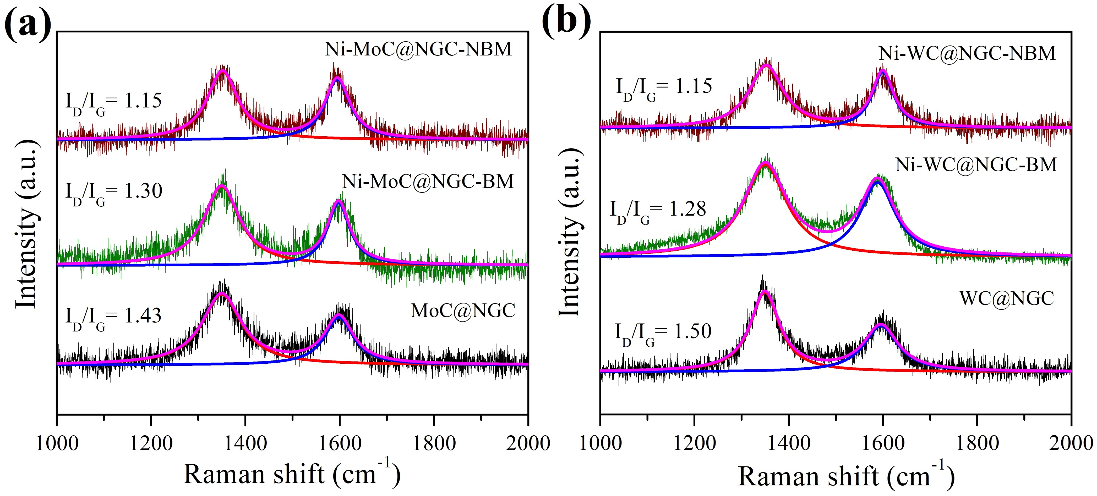
Figure S6. I_{D}, I_{G} bands in Raman spectra of (a) Ni-MoC@NGC based non-ball milled, ball milled and undoped samples, (b) Ni-WC@NGC based non-ball milled, ball milled and undoped samples.
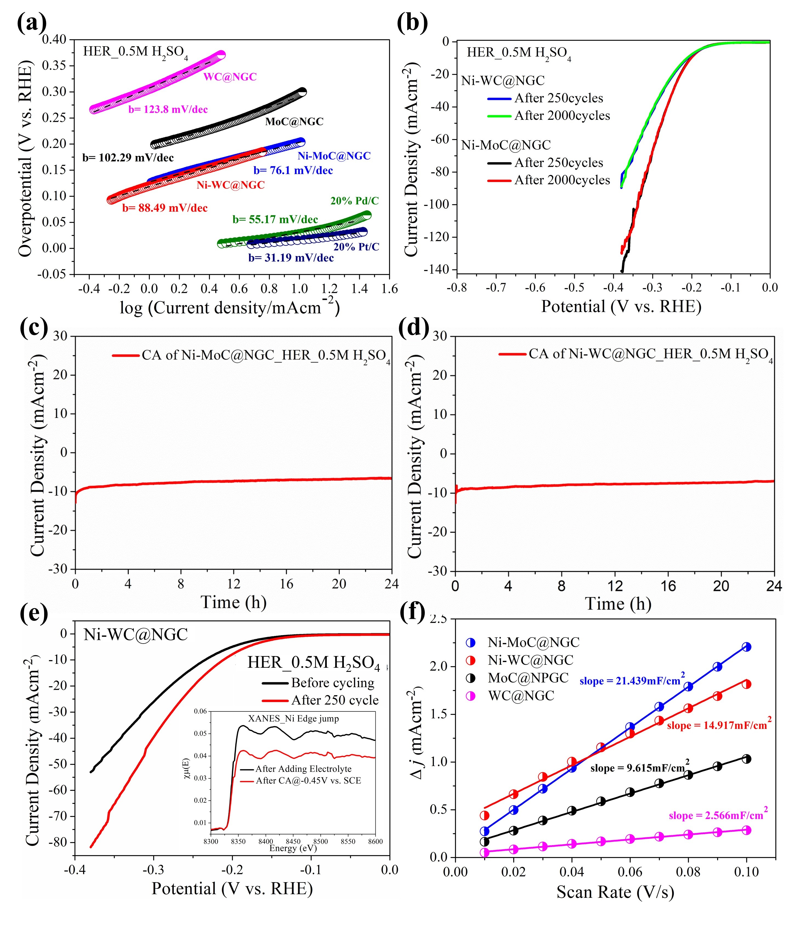
Figure S7. Electrochemical HER studies of Ni-WC@NGC & Ni-MoC@NGC in acidic media: (a) Tafel slopes of Ni-WC@NGC & Ni-MoC@NGC and other related catalysts (b) Electrochemical HER stability of Ni-WC@NGC & Ni-MoC@NGC after 2000 ADT cycles (100 mV/s) in 0.5M H₂SO₄; Chronoamperometric study of the catalyst (c) Ni-MoC@NGC, (d) Ni-WC@NGC during HER in the 0.5 M H₂SO₄ medium. (e) Comparative polarization curves of Ni-WC@NGC after 250 ADT cycle for HER in 0.5M H₂SO₄ (inset; unnormaised EXAFS plot of Ni-edge of Ni-WC@NGC taken during HER study). (f) Plots of ½ ∆J vs. scan rate for Ni-WC@NGC, Ni-MoC@NGC, WC@NGC & MoC@NGC where slope of the fitted line gives the corresponding C_{dl} values.
Figure S8. Post electrochemical (HER in acid medium) TEM colour mapping on particles of (a) Ni-MoC@NGC, (b) Ni-WC@NGC; (c) Line scanning EDS spectra of Ni-MoC@NGC; (d) EDX spectra of Ni-MoC@NGC; (e) TEM analysis to show the particle distribution in Ni-MoC@NGC.
Figure S9. Cyclic voltammograms (CVs) of (a) WC@NGC, (b) MoC@NC, (c) Ni-WC@NGC and (d) Ni-MoC@NGC sweeping over the potential area from 0.269 V (vs. RHE) to 0.469 V (vs. RHE) for the determination of double-layer capacitance (C_{dl}) and thereby estimation if effective surface area (ECSA).
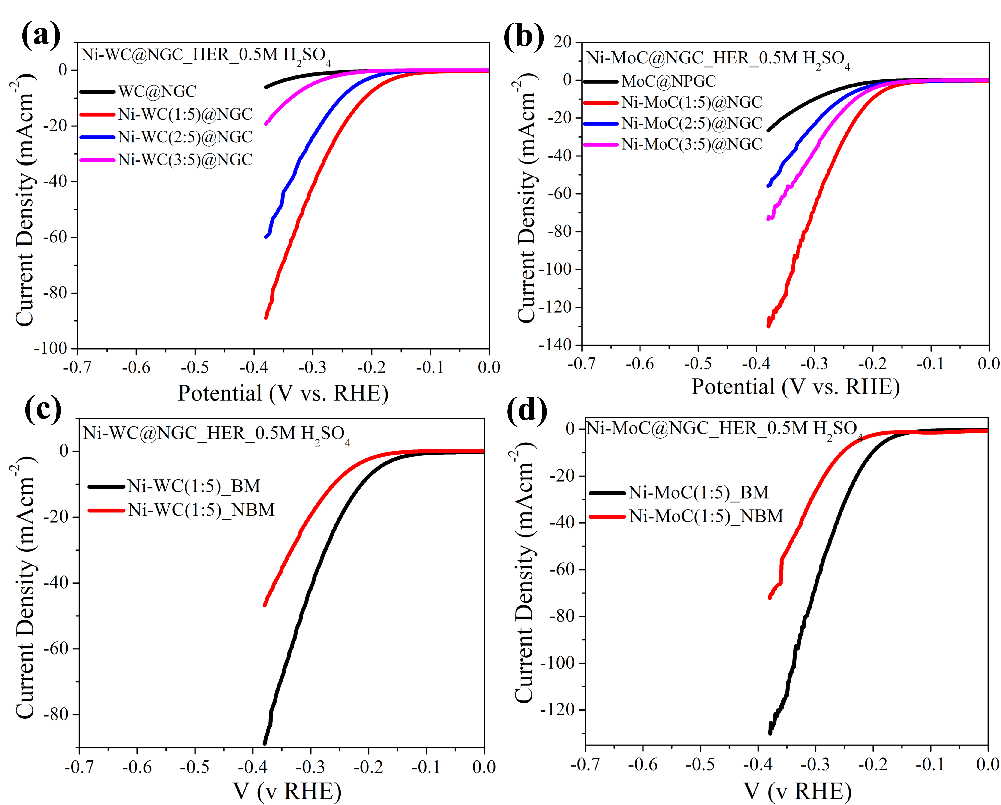
Figure S10. Electrochemical HER studies of Ni-WC@NGC & Ni-MoC@NGC in acidic and alkaline media: Comparative polarization curves of (a) different amount of Ni-substituted WC@NGC samples, (b) different amount of Ni-substituted MoC@NGC samples; (c) Ni-WC(1:5)@NGC and (d) Ni-MoC(1:5)@NGC for both ball milled and non-ball milled samples, HER in 0.5M H₂SO₄ under a scan rate of 5 mV/s using SCE as the reference and Pt coil as the counter electrode.

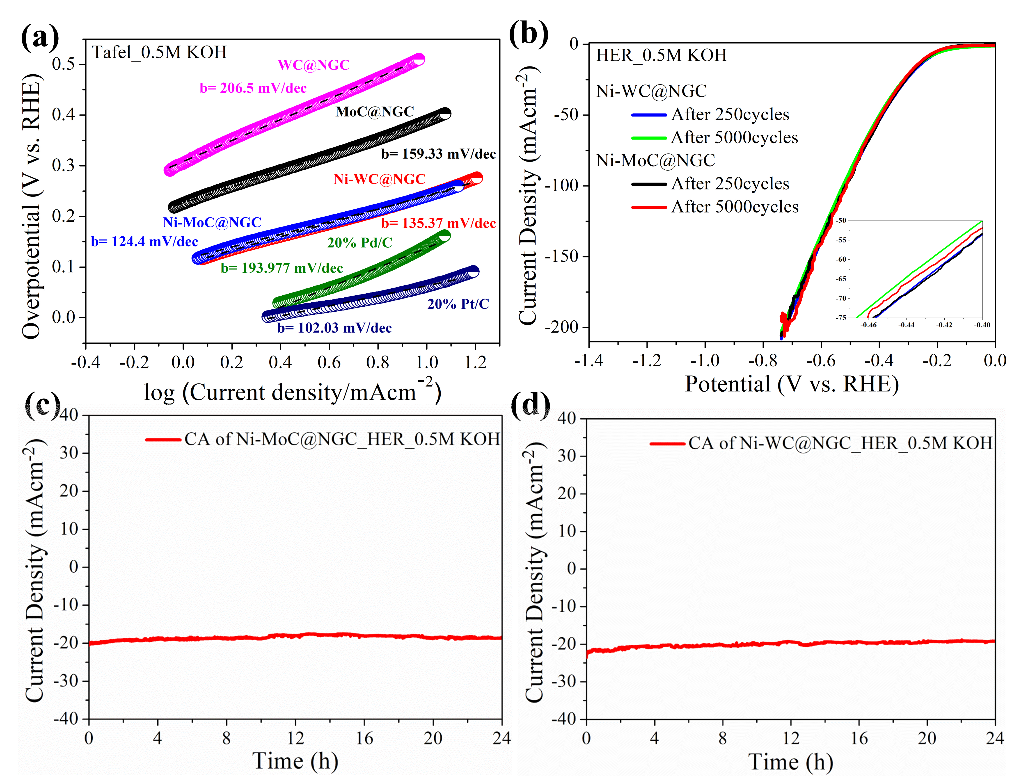
Figure S11. Electrochemical HER studies of Ni-WC@NGC & Ni-MoC@NGC in alkaline media: (a) Tafel slopes of Ni-WC@NGC & Ni-MoC@NGC and other related catalysts (b) Polarization curves before and after 5000 ADT cycles of Ni-WC@NGC & Ni-MoC@NGC for HER in 0.5M KOH under a scan rate of 5 mV/s using Hg/HgO as the reference and Pt coil as the counter electrode dueing electrochemical stability testing; Chronoamperometric study of the catalyst (c) Ni-MoC@NGC, (d) Ni-WC@NGC during HER in the 0.5 M KOH medium.
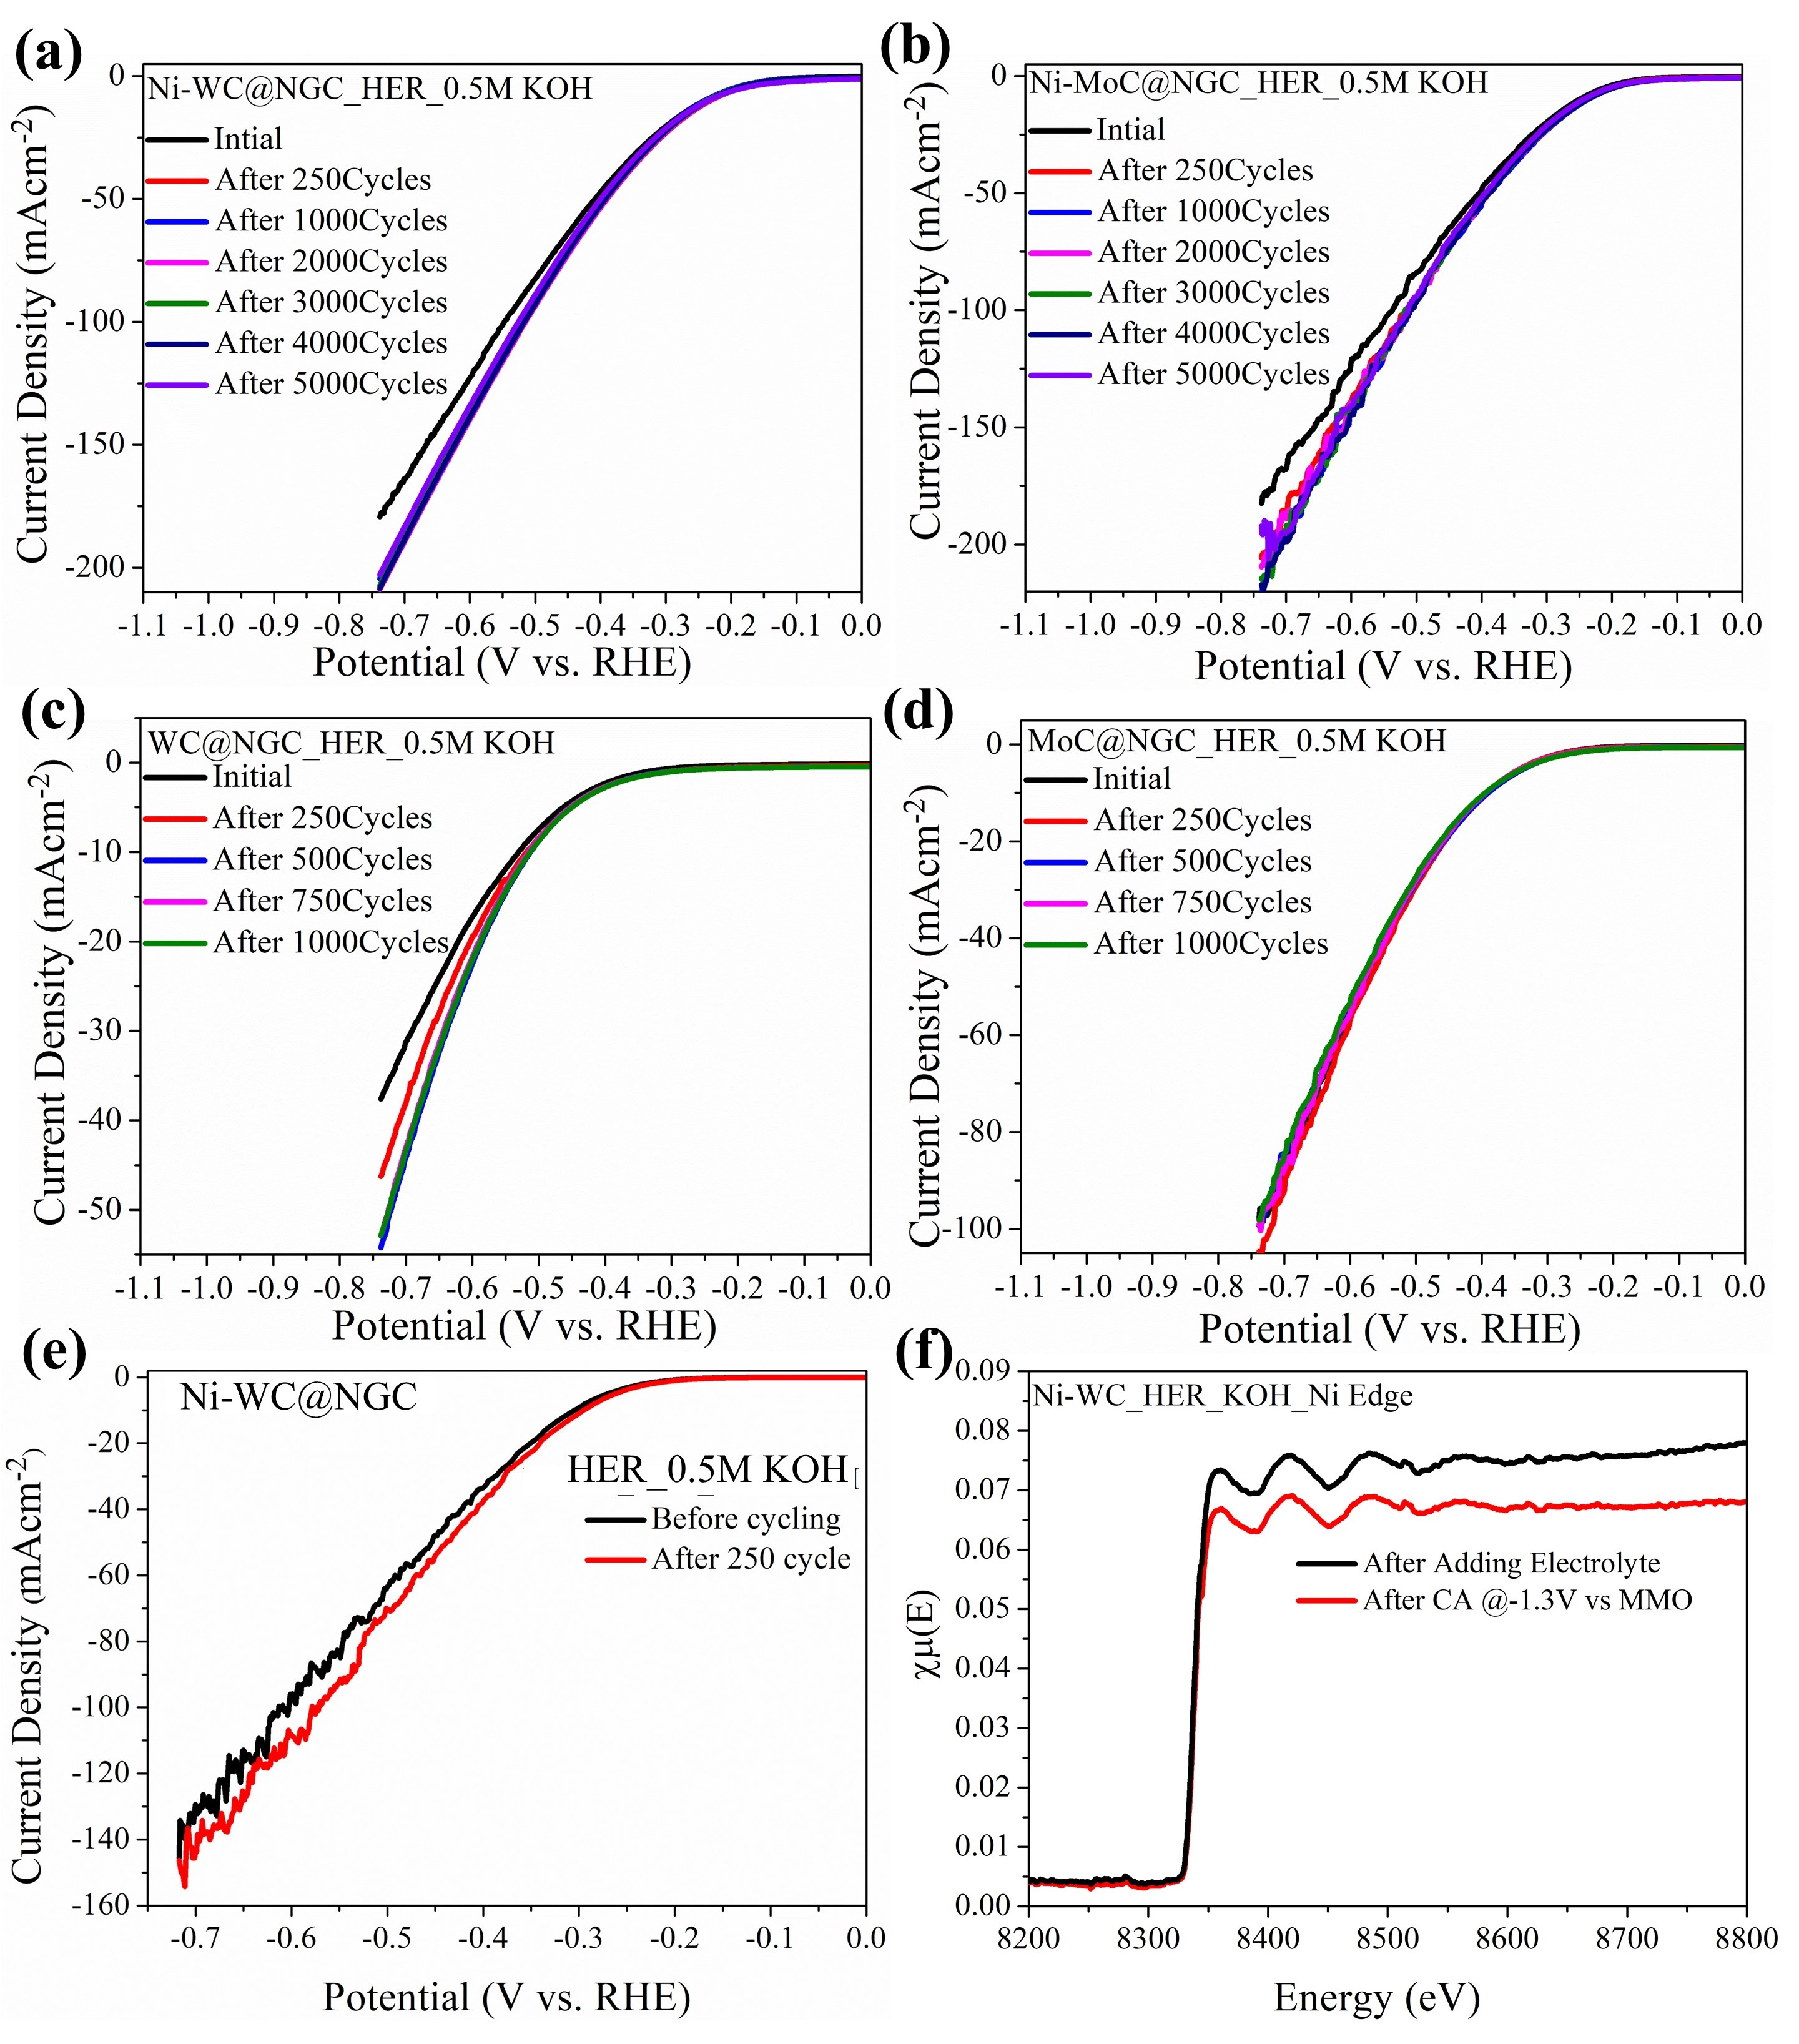
Figure S12. Electrochemical HER stability of (a) WC@NGC, (b) MoC@NGC, (c) Ni-WC@NGC & (d) Ni-MoC@NGC after different number of ADT cycles (100 mV/s) in 0.5M KOH medium. (e) Comparative polarization curves of Ni-WC@NGC after 250 ADT cycle for HER 0.5 M KOH. (f) unnormaised EXAFS plot of Ni-edge of Ni-WC@NGC taken during HER study in 0.5M KOH medium.
Figure S13. Electrochemical OER studies of Ni-WC@NGC & Ni-MoC@NGC in alkaline media: (a) Tafel slopes of Ni-WC@NGC & Ni-MoC@NGC and other related catalysts. LSV for OER showing electrochemical stability before and after 1000 ADT cycles for (b) Ni-WC@NGC and (c) Ni-MoC@NGC.
Figure S14. Overall water splitting activity of Ni-WC@NGC & Ni-MoC@NGC in 0.5 M KOH: (a) Comparison of theortical and experimental volumes of gases evolved for HER and OER activities of Ni-MoC@NGC (both cathode & anode, coated on 10 mm dia customized GCE) during overall ater splitting in 0.5M KOH using SCE as the reference in two-compartement H-type cell separated by pre-treated Nafion-117 membrane, inset of (a) shows customized Faradaic Efficiency measurement setup, (b) Images of the 1.5 V battery aided water splitting setup in 0.5 M KOH.

Figure S15. Optimized structures on H adsorbed on pristine (left) and Ni-W(1:5) substituted (right) surfaces of (a) WC (100), (b) WC (101) surfaces. Magenta, blue, yellow and green spheres correspond to Ni, W, C and H atoms respectively.

Figure S16. Optimizes structures on H adsorbed on pristine (left) and Ni-Mo(1:5) substituted (right) surfaces of (a) MoC (100) and (b) MoC (101) surfaces. Magenta, grey, yellow and green spheres correspond to Ni, Mo, C and H atoms respectively.

Figure S17. Free energy $∆G_{H}$ of hydrogen adsorption on pristine and Ni substituted (100) and (101) surfaces of MC (M = W/Mo). Blue, red, and green lines correspond to H-adsorption on pristine, 11%/12.5% Ni-substituted, and 22%/25% Ni-substituted surfaces, respectively.
Figure S18. Projected density of states (PDOS) of structures with H-adsorbed on pristine (top) and Ni-W/Mo(1:5) substituted surfaces (bottom) of (a) MoC (100), (b) MoC (101), (c) WC (100) and (d) WC (101) surfaces. Dashed black lines represent the Fermi level (E_{F}).
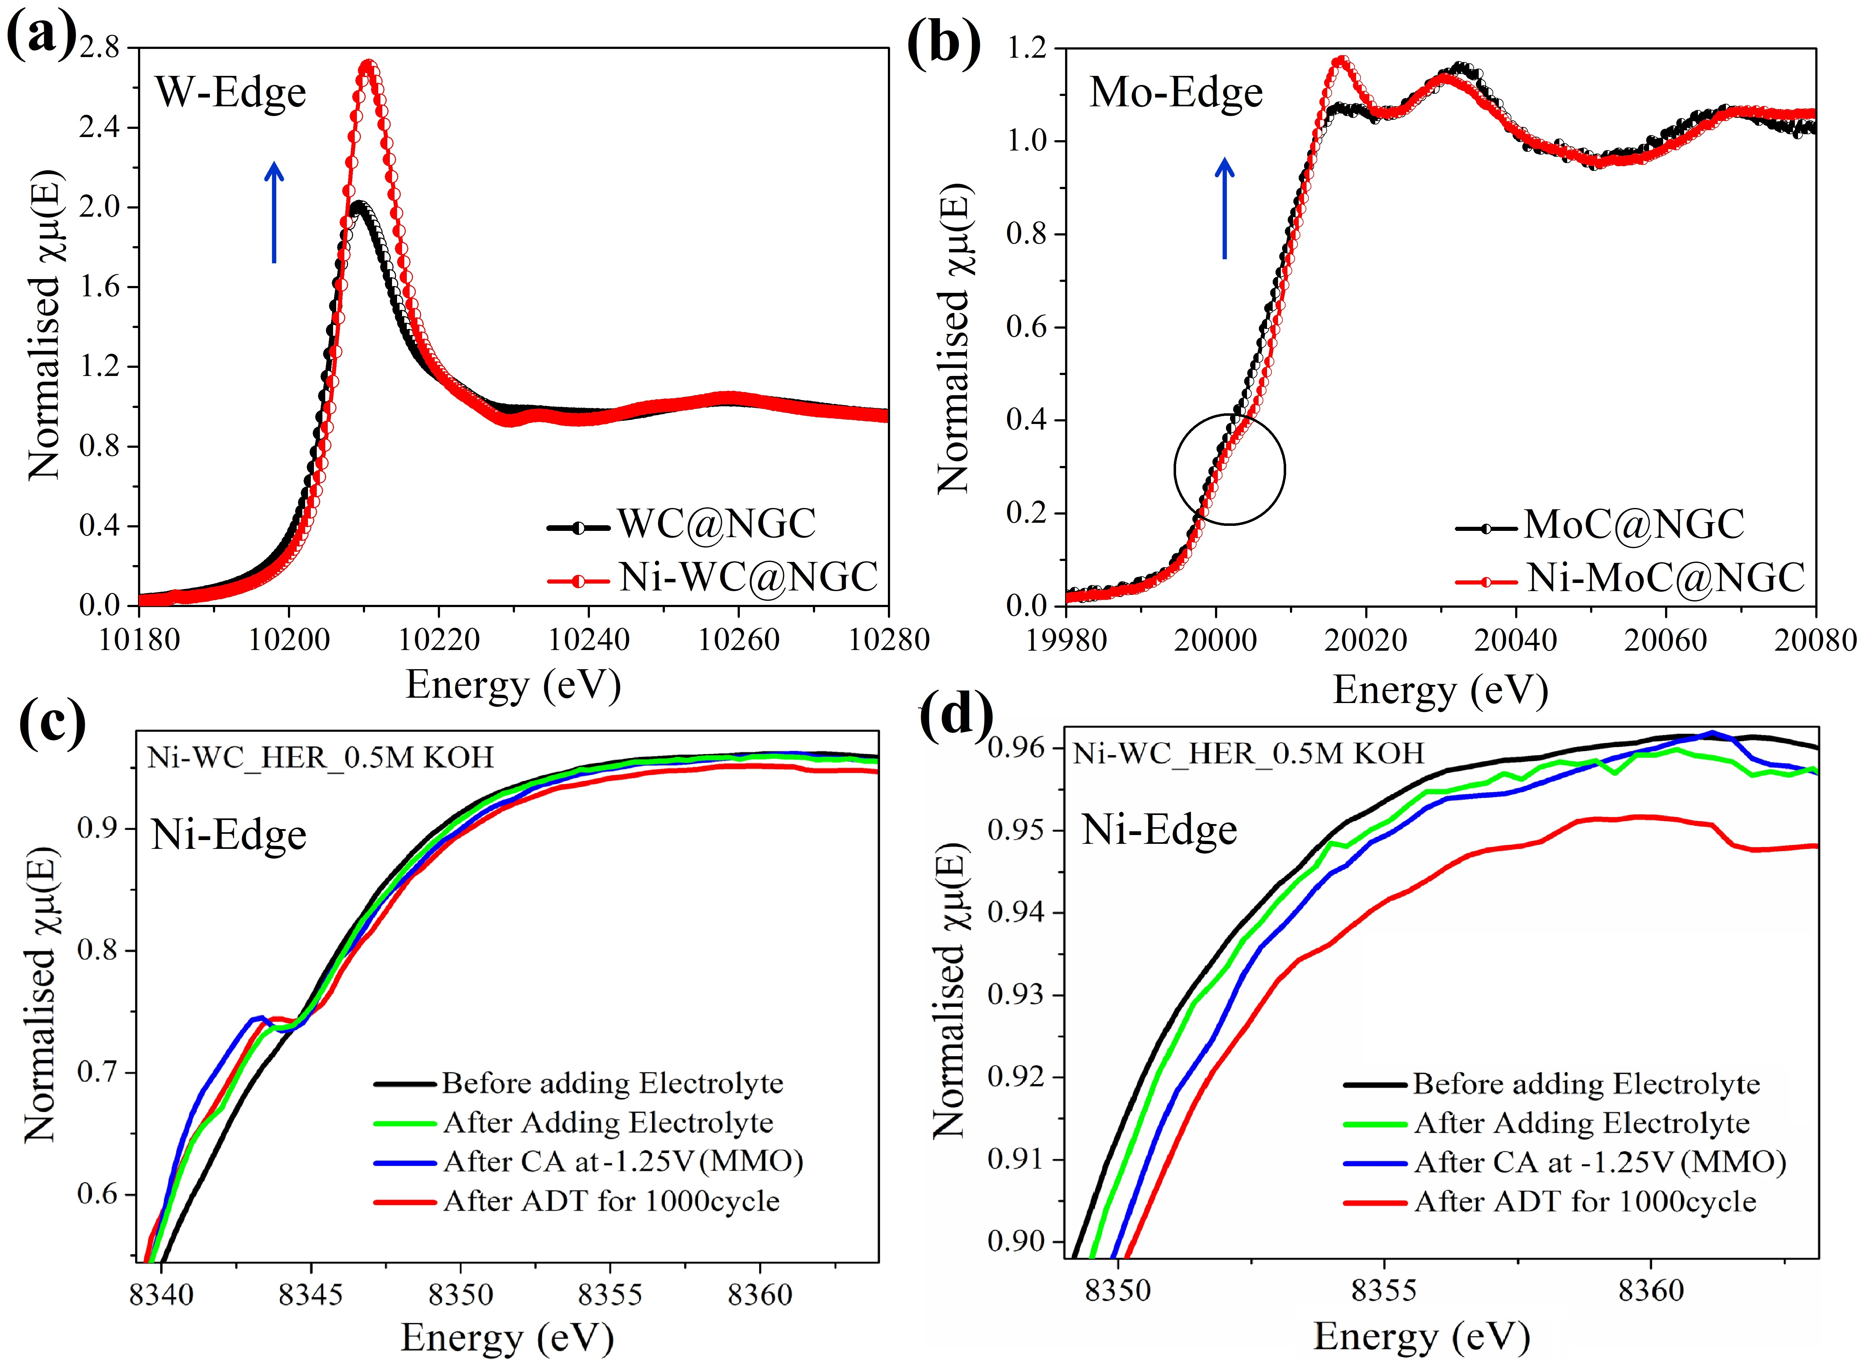
Figure S19. Ex-situ X-ray absorption near edge spectroscopy of W K-edge of (a) WC@NGC and Ni-WC@NGC, (b) MoC@NGC and Ni-MoC@NGC; In-situ XANES studies at (c) Ni edges of Ni-WC@NGC during HER in 0.5M KOH and (d) zoomed version of (c).
Figure S20. Schematic of the in-situ XAS experimental setup during electrochemistry.

Figure S21. Schematic of the mechanisms of HER (acidic & alkaline) and OER (alkaline) elucidating the role of Ni in activity enhancement in Ni-WC@NGC and Ni-MoC@NGC.

References
1. Roy, S. et al. Deconvolution of phase–size–strain effects in metal carbide nanocrystals for enhanced hydrogen evolution. Nanoscale 12, 15414-15425 (2020).
2. Wang, Y., Ma, B. & Chen, Y. Iron phosphides supported on three-dimensional iron foam as an efficient electrocatalyst for water splitting reactions. J. Mat. Sci. 54, 14872-14883 (2019).
3. Xie, J. et al. Atomically-thin molybdenum nitride nanosheets with exposed active surface sites for efficient hydrogen evolution. Chem. Sci. 5, 4615-4620 (2014).
4. Liu, Y. et al. Coupling Mo₂C with Nitrogen-Rich Nanocarbon Leads to Efficient Hydrogen-Evolution Electrocatalytic Sites. Angew. Chem. Int. Ed. 54, 10752-10757 (2015).
5. Giannozzi, P. et al. QUANTUM ESPRESSO: a modular and open-source software project for quantum simulations of materials. J. Phys.: Condens. Matter 21, 395502 (2009).
6. Vanderbilt, D. Soft self-consistent pseudopotentials in a generalized eigenvalue formalism. Phys. Rev. B 41, 7892-7895 (1990).
7. Perdew, J. P. & Zunger, A. Self-interaction correction to density-functional approximations for many-electron systems. Phys. Rev. B 23, 5048-5079 (1981).
8. Takeno, N. Atlas of Eh-pH diagrams. Geological survey of Japan open file report 419, 102 (2005).
9. Zou, X. X. & Zhang, Y. Noble metal-free hydrogen evolution catalysts for water splitting. Chem. Soc. Rev. 44, 5148-5180 (2015).
10. Ma, L., Ting, L. R. L., Molinari, V., Giordano, C. & Yeo, B. S. Efficient hydrogen evolution reaction catalyzed by molybdenum carbide and molybdenum nitride nanocatalysts synthesized via the urea glass route. J. Mater. Chem. A 3, 8361-8368 (2015).
11. Hunt, S. T., Nimmanwudipong, T. & Román-Leshkov, Y. Engineering Non-sintered, Metal-Terminated Tungsten Carbide Nanoparticles for Catalysis. Angew. Chem. Int. Ed. 53, 5131-5136 (2014).
12. Alhajri, N. S., Anjum, D. H. & Takanabe, K. Molybdenum carbide–carbon nanocomposites synthesized from a reactive template for electrochemical hydrogen evolution. J. Mater. Chem. A 2, 10548-10556 (2014).
13. Wan, C., Regmi, Y. N. & Leonard, B. M. Multiple Phases of Molybdenum Carbide as Electrocatalysts for the Hydrogen Evolution Reaction. Angew. Chem. Int. Ed. 53, 6407-6410 (2014).
14. Guo, Y. N. et al. Elaborately assembled core-shell structured metal sulfides as a bifunctional catalyst for highly efficient electrochemical overall water splitting. Nano Energy 47, 494-502 (2018).
15. Park, H. et al. Graphene- and Phosphorene-like Boron Layers with Contrasting Activities in Highly Active Mo₂B₄ for Hydrogen Evolution. J. Am. Chem. Soc. 139, 12915-12918 (2017).
16. Gong, Q. et al. Ultrasmall and phase-pure W₂C nanoparticles for efficient electrocatalytic and photoelectrochemical hydrogen evolution. Nat. Commun. 7, 13216-13224 (2016).
17. Zhuang, T.-T. et al. Steering post-C–C coupling selectivity enables high efficiency electroreduction of carbon dioxide to multi-carbon alcohols. Nat. Catal. 1, 421-428 (2018).
18. Yu, Z.-Y. et al. A one-dimensional porous carbon-supported Ni/Mo₂C dual catalyst for efficient water splitting. Chem. Sci. 8, 968-973 (2017).
19. Luo, J. et al. Water photolysis at 12.3% efficiency via perovskite photovoltaics and Earth-abundant catalysts. Science 345, 1593-1596 (2014).
20. Jin, H. et al. In situ Cobalt–Cobalt Oxide/N-Doped Carbon Hybrids As Superior Bifunctional Electrocatalysts for Hydrogen and Oxygen Evolution. J. Am. Chem. Soc. 137, 2688-2694 (2015).
21. Zou, X. et al. Cobalt-Embedded Nitrogen-Rich Carbon Nanotubes Efficiently Catalyze Hydrogen Evolution Reaction at All pH Values. Angew. Chem. Int. Ed. 53, 4372-4376 (2014).
22. Wang, H. et al. Bifunctional non-noble metal oxide nanoparticle electrocatalysts through lithium-induced conversion for overall water splitting. Nat. Commun. 6, 7261-7269 (2015).
23. Stern, L.-A., Feng, L., Song, F. & Hu, X. Ni₂P as a Janus catalyst for water splitting: the oxygen evolution activity of Ni₂P nanoparticles. Energy Environ. Sci. 8, 2347-2351 (2015).
24. You, B. et al. High-Performance Overall Water Splitting Electrocatalysts Derived from Cobalt-Based Metal–Organic Frameworks. Chem. Mater. 27, 7636-7642 (2015).
25. Chen, C. et al. Trapping [PMo₁₂O₄₀]³⁻ clusters into pre-synthesized ZIF-67 toward Mo_{x}Co_{x}C particles confined in uniform carbon polyhedrons for efficient overall water splitting. Chem. Sci. 9, 4746-4755 (2018).
26. Yin, Z. et al. Bimetallic Ni–Mo nitride nanotubes as highly active and stable bifunctional electrocatalysts for full water splitting. J. Mater. Chem. A 5, 13648-13658 (2017).
27. Jin, Y., Yue, X., Shu, C., Huang, S. & Shen, P. K. Three-dimensional porous MoNi₄ networks constructed by nanosheets as bifunctional electrocatalysts for overall water splitting. J. Mater. Chem. A 5, 2508-2513 (2017).
28. Song, F. & Hu, X. Exfoliation of layered double hydroxides for enhanced oxygen evolution catalysis. Nat. Commun. 5, 4477-4486 (2014).
29. Nai, J. et al. Electrochemistry: Efficient Electrocatalytic Water Oxidation by Using Amorphous Ni–Co Double Hydroxides Nanocages. Adv. Energy Mater. 5, 1401880-1401887 (2015).
30. McCrory, C. C. L., Jung, S., Peters, J. C. & Jaramillo, T. F. Benchmarking Heterogeneous Electrocatalysts for the Oxygen Evolution Reaction. J. Am. Chem. Soc. 135, 16977-16987 (2013).
31. Ledendecker, M. et al. The Synthesis of Nanostructured Ni₅P₄ Films and their Use as a Non-Noble Bifunctional Electrocatalyst for Full Water Splitting. Angew. Chem. Int. Ed. 54, 12361-12365 (2015).
32. Yang, Y., Fei, H., Ruan, G. & Tour, J. M. Porous Cobalt-Based Thin Film as a Bifunctional Catalyst for Hydrogen Generation and Oxygen Generation. Adv. Mater. 27, 3175-3180 (2015).
33. Song, Y. et al. Metal-Free Nitrogen-Doped Mesoporous Carbon for Electroreduction of CO₂ to Ethanol. Angew. Chem. Int. Ed. 56, 10840-10844 (2017).
34. Tang, C., Cheng, N., Pu, Z., Xing, W. & Sun, X. NiSe Nanowire Film Supported on Nickel Foam: An Efficient and Stable 3D Bifunctional Electrode for Full Water Splitting. Angew. Chem. Int. Ed. 54, 9351-9355 (2015).
35. Zhang, Y. et al. Ultrafine Metal Nanoparticles/N-Doped Porous Carbon Hybrids Coated on Carbon Fibers as Flexible and Binder-Free Water Splitting Catalysts. Adv. Energy Mater. 7, 1700220-1700228 (2017).

